SUPPORTING INFORMATION

Supplementary Tables and Figures

Table S1 Onset and resolution of ALT/AST elevationsª
Patients (%) | Placebo  (n = 76) | CBD25  (n = 75) | CBD50  (n = 73)
ALT/AST elevations >3 × ULN | 0 | 9/75 (12) | 19/73 (26)
On valproate | 0 | 7/9 (78) | 15/19 (79)
Off valproate | 0 | 2/9 (22) | 4/19 (21)
Time to onset of ALT/AST elevations
Within 30 days | 0 | 6/9 (67) | 14/19 (74)
>30 days | 0 | 3/9 (33) | 5/19 (26)
Resolved ALT/AST elevations
Spontaneously (on treatment) | 0 | 5/9 (56) | 8/19 (42)
After CBD/ASM dose reduction | 0 | 3/9 (33) | 7/19 (37)
Following discontinuation of trial medication | 0 | 1/9 (11) | 4/19 (21)
ªElevations in ALT/AST levels were determined by laboratory testing, regardless of whether or not they were reported as an adverse event.
Abbreviations: ASM, antiseizure medication; ALT, alanine aminotransferase; AST, aspartate aminotransferase; CBD, cannabidiol; CBD25, cannabidiol 25 mg/kg/day; CBD50, cannabidiol 50 mg/kg/day; ULN, upper limit of normal.

.

Figure S1. Titration schedule.
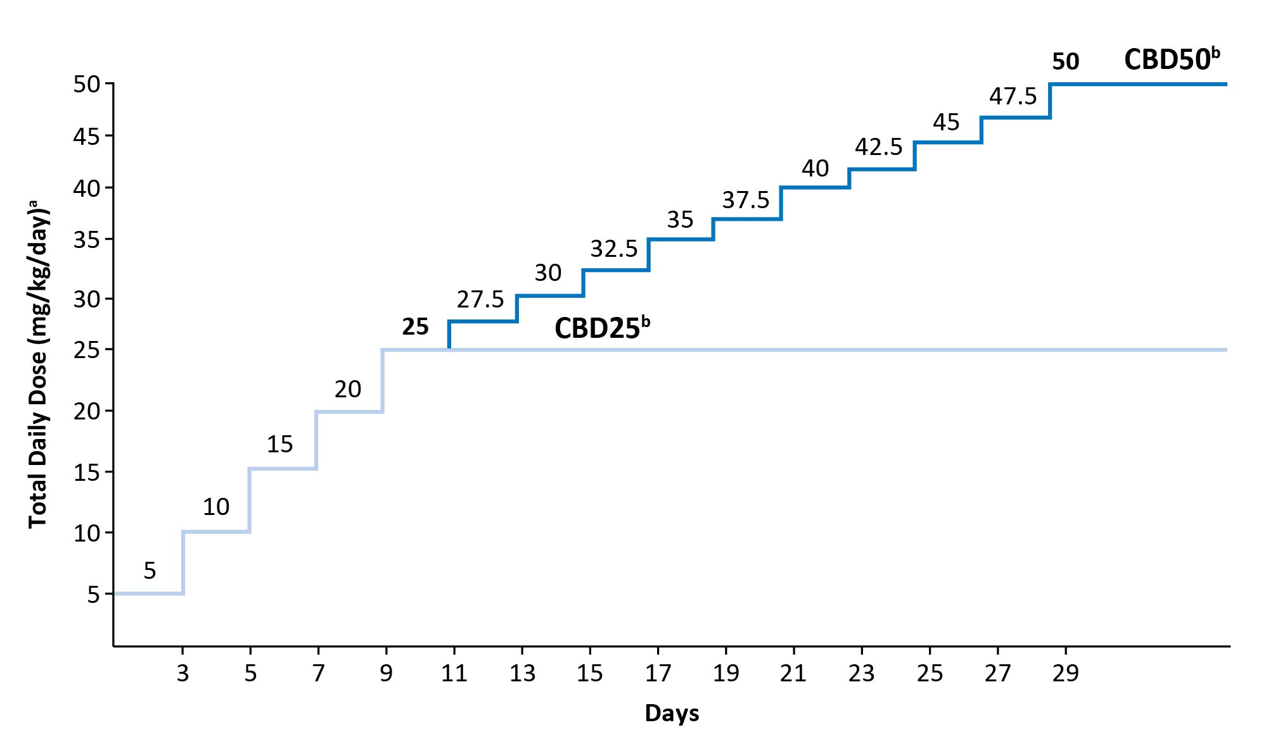
ªMedication was taken daily in 2 equally divided doses. ^{b}Not all patients reached or remained on their assigned dose; mean modal dose during follow-up was 24 mg/kg/day for CBD25 and 36 mg/kg/day for CBD50.
CBD25, cannabidiol 25 mg/kg/day; CBD50, cannabidiol 50 mg/kg/day. Adapted with permission of the author from “Add-on Cannabidiol Treatment for Drug-Resistant Seizures in Tuberous Sclerosis Complex: A Placebo-Controlled Randomized Clinical Trial,” by Elizabeth A. Thiele et al., JAMA Neurol. 2021;78:285-92; supplementary eFigure. 2.

