Supplementary data
Supplementary Text 1

Flomoxef Bioanalysis. The internal standard, Moxalactam (Cayman Chemicals, USA) was prepared in acetonitrile (25 mg/L, Fisher Scientific UK) and 200 μL was added to a 96-well protein precipitation plate (Phenomenex, Cheshire, UK). Fifty μL each of samples, blanks, calibrators in the range 0.1 – 50 mg/L and quality controls (0.75, 7.5 and 37.5 mg/L) were mixed with the internal standard on an orbital shaker. Liquid was drawn through the protein precipitation plate into a collection plate using a positive pressure manifold with water and water containing 0.1% formic acid (200 μL) added to each well, before sealing and mixing on an orbital shaker prior to analysis by liquid chromatography-tandem mass spectrometry (LC-MS/MS).
LC-MS/MS analysis was performed using an Agilent 1290 Infinity high-performance liquid chromatography (HPLC) system coupled to an Agilent 6420 triple-quadrupole mass spectrometer fitted with an electrospray source controlled using Agilent MassHunter data acquisition software (version B.06.00). Analytes were injected (4 μL) onto an Phenomenex Kinetex C18 column (100 A, 2.1 mm x 50 mm, 2.6 µm) and separated over a 4 min. gradient using a mixture of solvents A (LC-MS grade water containing 0.1% formic acid) and B (HPLC grade acetonitrile containing 0.1% formic acid). Separations were performed by applying a linear gradient of 95% to 5% solvent A over 2.50 mins at 0.6 mL/min followed by an equilibration step (1.5 mins at 95% solvent A).
The mass spectrometer was operated in positive ion mode using a Multiple Reaction Monitoring (MRM) method with the specified mass transitions and collision energies: flomoxef 497.0 > 199.0 (Ce 15 ev) and moxalactam 521.0 > 377.0 (Ce 10 ev). Mass spectrometry readouts were processed using Agilent MassHunter quantitative analysis (version B.05.02). Prior to sample analysis, the analytical method was validated to assess recovery and matrix effects, inter-day and intra-day accuracy and precision, carryover, dilution integrity, stability in the matrix (4 h at room temperature and three-freeze thaw cycles), and processed sample stability (reinjection of extracts after 24 h).
The average recovery from matrix was 83%. The LLQ was defined as 0.1 mg/L and the LOD 0.05 mg/L. The inter- and intra-day %CV on the three QC levels ranged from 5.04% – 7.65% and -5.68% – 2.16% respectively. The analyte was found to be stable in all conditions described above.

Fosfomycin Bioanalysis. The internal standard, Ethyl Phosphonic acid (Sigma Aldrich, UK) was prepared in acetonitrile (5 mg/L, Fisher Scientific UK) and 200 μL was added to a 96-well protein precipitation plate (Phenomenex, Cheshire, UK). Fifty μL each of samples, blanks, calibrators in the range 1 – 500 mg/L and quality controls (3.5, 35 and 350 mg/L) were mixed with the internal standard on an orbital shaker. Liquid was drawn through the protein precipitation plate into a collection plate using a positive pressure manifold with water and 2mM Ammonium acetate (150 μL) added to each well, before sealing and mixing on an orbital shaker.
LC-MS-MS analysis was carried out using the same technical setup as described above. Analytes were injected (5 μL) onto an Agilent ZORBAX RRHD HILIC Plus 95Å Column (2.1 mm x 50 mm, 1.8 µm, 40°C) and separated over a 3.5 min. gradient using a mixture of solvents A (LC-MS grade water with 2mM (v/v) ammonium acetate) and B (HPLC grade acetonitrile). Separations were performed by applying a linear gradient of 100% to 0% solvent B over 2 mins at 0.4 mL/min followed by an equilibration step (1.5 mins at 100% solvent B).
The mass spectrometer was operated in negative ion mode using a Multiple Reaction Monitoring (MRM) method with the specified mass transitions and collision energies: fosfomycin 137.1 > 79.0 (Ce 20 ev) and EPA 109.1 > 79.0 (Ce 20 ev). Mass spectrometry readouts were processed as described above.
This fosfomycin analytical method underwent the same validation process as the flomoxef method described above. The average recovery from matrix was 80.9%. The LLQ was defined as 1 mg/L and the LOD 0.5 mg/L. The inter- and intra-day %CV on the three QC levels ranged from 6.5% – 8.1% and 4.7% – 6.9% respectively. The analyte was found to be stable in all conditions described above.

Supplementary Text 2
The structural PKPD model incorporating Greco’s model of synergy is as follows:
$$[1]. \frac{dX1}{dt}=R\left(1\right)-\left(\frac{Cl1}{V1}\right)*X1$$
$$[2]. \frac{dX2}{dt}=R\left(2\right)-\left(\frac{Cl2}{V2}\right)*X2$$
$$[3a]. \frac{dX3}{dt}=X3*(Kgs*(1-\frac{\left(X3+X4+X5\right)}{POPmax})-\frac{Kks*XMs}{(1+XMs)})$$
$$\left[3b\right]. if X1=0 then XMs={\left(\frac{\frac{X2}{V2}}{E{50}_{2}s}\right)}^{H2s}$$
$$\left[3c\right]. if X2=0 then XMs={\left(\frac{\frac{X1}{V1}}{{E50}_{1}s}\right)}^{H1s}$$
$$\left[3d\right]. Else: \frac{(\frac{X1}{V1})}{{E50}_{1}s*{XMs}^{H1s}}+\frac{(\frac{X2}{V2})}{{E{50}_{2}s*XMs}^{H2s}}+\frac{{(α}_{s}* \frac{X1}{V1}*\frac{X2}{V2})}{{E50}_{1}s*E{50}_{2}s*{XMs}^{\frac{H1s+H2s}{2}}}=1$$
$$\left[4a\right]. \frac{dX4}{dt}=X4*(Kgr1*(1-\frac{\left(X3+X4+X5\right)}{POPmax})-\frac{Kkr1*XMr1}{(1+XMr1)})$$
$$\left[4b\right]. if X1=0 then XMr1={\left(\frac{\frac{X2}{V2}}{E{50}_{2}r1}\right)}^{H2r1}$$
$$\left[4c\right]. if X2=0 then XMr1={\left(\frac{\frac{X1}{V1}}{{E50}_{1}r1}\right)}^{H1r1}$$
$$\left[4d\right]. Else: \frac{(\frac{X1}{V1})}{{E50}_{1}r1*{XMr1}^{H1r1}}+\frac{(\frac{X2}{V2})}{{E{50}_{2}r1*XMr1}^{H2r1}}+\frac{{(α}_{r1}* \frac{X1}{V1}*\frac{X2}{V2})}{{E50}_{1}r1*E{50}_{2}r1*{XMr1}^{\frac{H1r1+H2r1}{2}}}=1$$
$$[5a]. \frac{dX5}{dt}=X5*(Kgr2*(1-\frac{\left(X3+X4+X5\right)}{POPmax})-\frac{Kkr2*XMr2}{(1+XMr2)})$$
$$\left[5b\right]. if X1=0 then XMr2={\left(\frac{\frac{X2}{V2}}{E{50}_{2}r2}\right)}^{H2r2}$$
$$\left[5c\right]. if X2=0 then XMr2={\left(\frac{\frac{X1}{V1}}{{E50}_{1}r2}\right)}^{H1r2}$$
$$\left[5d\right]. Else: \frac{(\frac{X1}{V1})}{{E50}_{1}r2*{XMr2}^{H1r2}}+\frac{(\frac{X2}{V2})}{{E{50}_{2}r2*XMr2}^{H2r2}}+\frac{{(α}_{r2}* \frac{X1}{V1}*\frac{X2}{V2})}{{E50}_{1}r2*E{50}_{2}r2*{XMr2}^{\frac{H1r2+H2r2}{2}}}=1$$
Equations 1 and 2 model the mass of flomoxef (X1) and fosfomycin (X2) over time (t). R(1) and R(2) refer the rate of addition of each drug to the HFIM system; Cl1 and Cl2 refer to the clearance of each drug; and V1 and V2 refer to the volume of distribution.
Equations 3, 4 and 5 model the bacterial populations that are fully susceptible (X3), resistant to flomoxef (X4), and resistant to fosfomycin (X5) over time (t). All equations are identical except for the suffixes on equation terms associated with each population (s, r1 and r2, respectively).
Equation 3a-5a model the growth bacterial population and kill due any present antibiotics. Kgs, Kgr1 and Kgr2 are the growth constant for each population; POPmax is the maximum bacterial population concentration within the HFIM; and Kks, Kkr1 and Kkr2 are the kill constants for each population.
XMs, XMr1 and XMr2 are conditional composite terms. If X1 or X2 = 0 (i.e., one drug is absent), then equations 3-5b-c define these functions, where H1 and H2 refer to the Hill constant for flomoxef and fosfomycin suffixed by the relevant population marker (s, r1 or r2) and E50₁ and E50₂ refer to the concentrations of flomoxef and fosfomycin required to achieve 50% of maximal efficacy in each bacterial population. In these circumstances, equations 3-5a describe a standard Emax model.
When X1 > 0 and X2 > 0 (i.e., either drug is present), equations 3-5d define XMs, XMr1 and XMr2. These equations replicate Greco’s model of synergy³⁶, with α_{s}, α_{r1} and α_{r2} representing the interaction term for flomoxef and fosfomycin in each bacterial population. Under these conditions, XMs, XMr1 and XMr2 represent the composite term (E/(Econ-E)), where E is the measured effect of the present drugs and Econ is the control response. As the equations 3-5d are in an unclosed form, the values of XMs, XMr1 and XMr2 were determined via a Nelder-Mead algorithm.

Supplementary Tables
Species | Isolate | Known Resistance Mechanisms | Source | Flomoxef MIC (mg/L) | Fosfomycin MIC  (mg/L)
E. coli | NCTC 13352* | TEM-10 | PHE | 0.125 | 4
E. coli | NCTC 13353* | CTX-M-15 | PHE | 0.125 | 2
E. coli | NCTC 13451* | CTX-M-15, OXA-1, TEM-1, aac6'-lb-cr, mph(A), catB4, tet(A), dfrA7, aadA5, sulI | PHE | 0.125 | 4
E. coli | SPT 719*† | SHV ESBL, TEM ESBL | JMI | 0.25 | 2
E. coli | SPT 717 | CMYII | JMI | >32 | 2
E. coli | SPT 731 | CTX-M-1, TEM, ST131, O25b | JMI | 0.125 | >32
E. coli | I1025* | ESBL, Fos | University of Birmingham | 8 | 32
E. coli | I1057*† | CTX-M-15, CMY-23, FQ-resistant | University of Birmingham | 0.0625 | 2
E. coli | I779* | CTX-M-14 | University of Birmingham | 0.25 | 2
E. coli | ATCC BAA2523*† | OXA-48 | LGC Standards | 0.5 | 8
E. coli | ST195†‡ | CTX-M-14 | University of Birmingham | 0.125 | 1
K. pneumoniae | ATCC 700603 | SHV-18 ESBL | LGC Standards | 0.25 | >32
K. pneumoniae | NCTC 13438 | KPC3 | PHE | >32 | >32
K. pneumoniae | 1091463 | SHV-OSBL, TEM-OSBL, CTX-M-3 | IHMA | 8 | >32
K. pneumoniae | H207 | Unspecified ESBL | University of Birmingham | 0.125 | >32
K. pneumoniae | 1256506† | SHV-OSBL; TEM-OSBL; CTX-M-2; CMY-2 | IHMA | 32 | >32
K. pneumoniae | 1216477† | SHV-OSBL, TEM-OSBL, CTX-M-15 | IHMA | 0.25 | >32
K. pneumoniae | 1237221 | SHV-OSBL, CTX-M-15 | IHMA | 0.25 | >32
K. pneumoniae | 1280740*† | SHV-OSBL, TEM-OSBL, CTX-M-15, DHA-1 | IHMA | 32 | 4
K. pneumoniae | 1203217 | SHV-12, CTX-M-9, OXA-48 | IHMA | 0.5 | >32
K. pneumoniae | SPT 723* | CP_CTX-M_Group1, CP_SHV_ESBL, CP_SHV_WT, CTX-M-15 ,OXA-1/30, SHV-5 | JMI Laboratories | 0.25 | 32
MRSA | NCTC 13656* | MecA | PHE | 4 | 0.25
MRSA | NCTC 13435* | MecA | PHE | 1 | 0.5
MRSA | NCTC 13616 | MecA | PHE | 4 | 4
MRSA | NCTC 13626 | MecA | PHE | 16 | 2
MRSA | NCTC 13813* | MecA | PHE | 2 | 1
MRSA | F656 (USA300)* | MecA | University of Birmingham | 4 | 4
MRSA | F40* | MecA | University of Birmingham | 0.25 | 2
MRSA | F89 | MecA | University of Birmingham | 4 | >32
MRSA | F82 | MecA | University of Birmingham | 0.5 | 0.5
MRSA | F471 | MecA | University of Birmingham | 4 | 1
S. agalactiae | NCTC 14091 | None | PHE | 0.5 | 4
S. agalactiae | NCTC 14093 | None | PHE | 0.25 | 2
S. agalactiae | NCTC 14095 | None | PHE | 0.25 | 8
S. agalactiae | NCTC 14092 | None | PHE | 0.25 | 4
S. agalactiae | 313566 (C13) | None | Royal Liverpool Hospital | 0.25 | 8
S. agalactiae | 412909 (C14) | None | Royal Liverpool Hospital | 0.25 | 32
S. agalactiae | 529312 (C15) | None | Royal Liverpool Hospital | 0.125 | >32
S. agalactiae | 629129 (C16) | None | Royal Liverpool Hospital | 0.25 | 2
S. agalactiae | 729701 (C17) | None | Royal Liverpool Hospital | 0.0625 | 16
S. agalactiae | 824843 (C18)* | None | Royal Liverpool Hospital | 0.25 | 32
Table S1 : Details of isolates used in initial MIC assays. * denotes strains selected for assessment in checkerboard assays. † denotes strain used in HFIM experiments. ‡ denotes strains used only in HFIM; not included in the panel of strains for MIC determination. IHMA = International Health Management Associates; PHE = Public Health England.

Supplementary Figures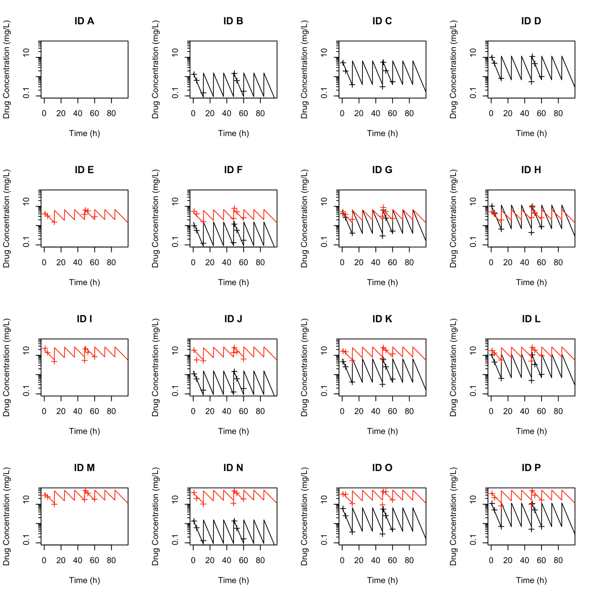
Figure S1 – Time concentration profiles predicted from the population PK model of the 16 arm combination arm HFIM experiment using mean parameter estimates (solid lines) with overlaid drug concentrations measured by bioanalysis (crosses). ID A-P refer to identically placed arms as in Fig. 3; Red = fosfomycin; black = flomoxef
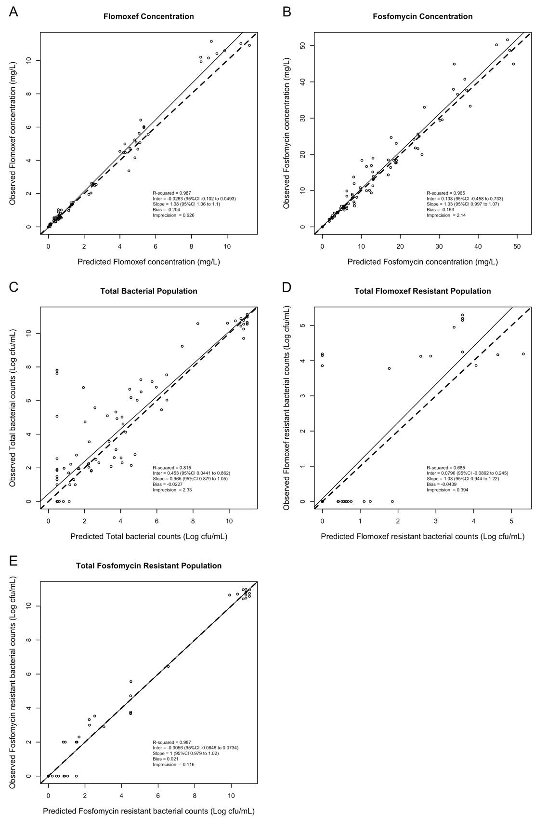
Figure S2 – Observed versus Predicted (OP) plots of the individual Bayesian posteriors using mean parameter estimates for the PKPD model of the output from the 16 arm fosfomycin and flomoxef HFIM experiment. A – Flomoxef concentration in the HFIM system; B – Fosfomycin concentration in the HFIM system; C – Total bacterial population quantity in the hollow fiber cartridge; D – Flomoxef bacterial population quantity in the hollow fiber cartridge; E – Fosfomycin resistant bacterial population quantity in the hollow fiber cartridge. Solid lines indicate observed versus predicted regression line of the model; the dashed lines indicate a hypothetical perfect 1:1 observed versus predicted regression line.

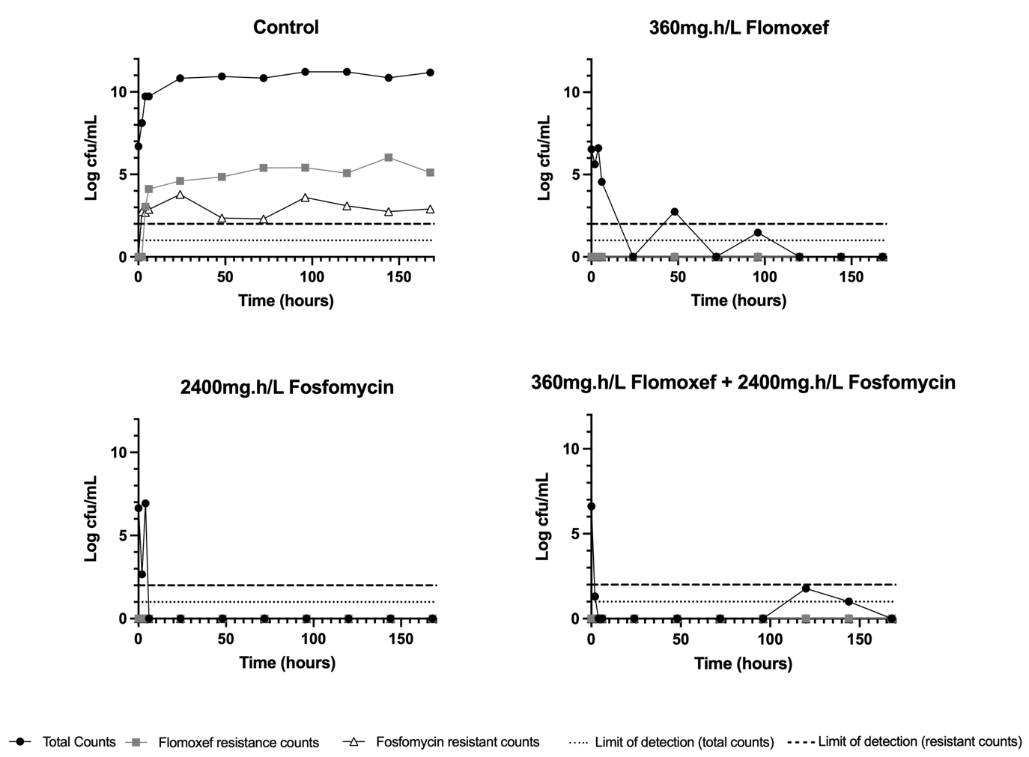
Figure S3 – HFIM pharmacodynamic results from 2x2 dosing matrix for E. coli SPT719 strain (Flomoxef MIC 0.25mg/L, Fosfomycin MIC 2mg/L)

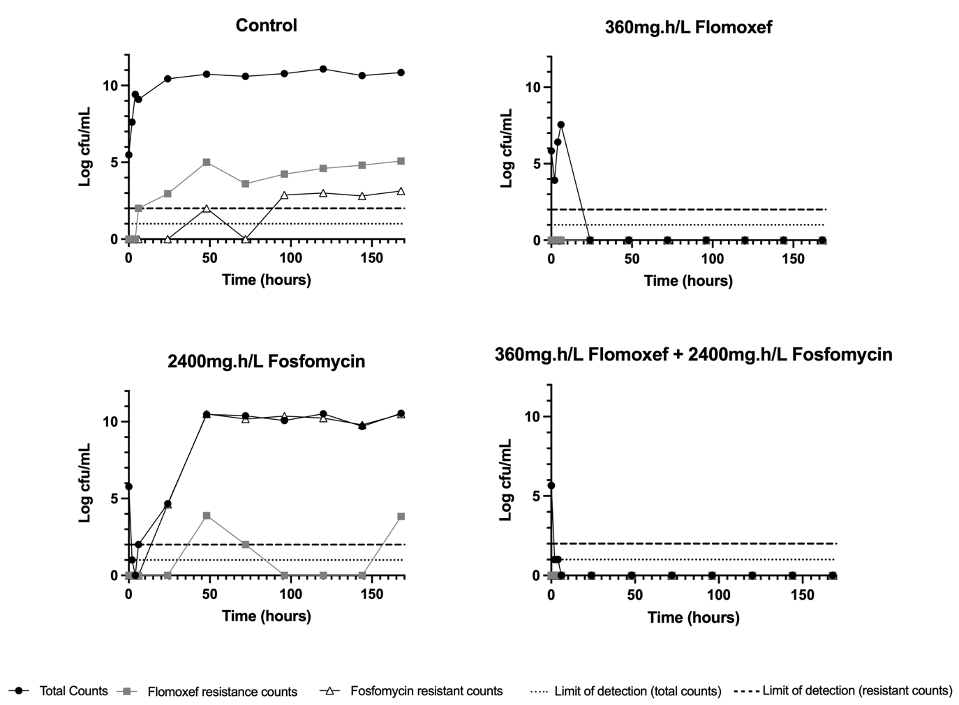
Figure S4 – HFIM pharmacodynamic results from 2x2 dosing matrix for E. coli BAA2523 strain (Flomoxef MIC 0.5mg/L, Fosfomycin MIC 8mg/L)

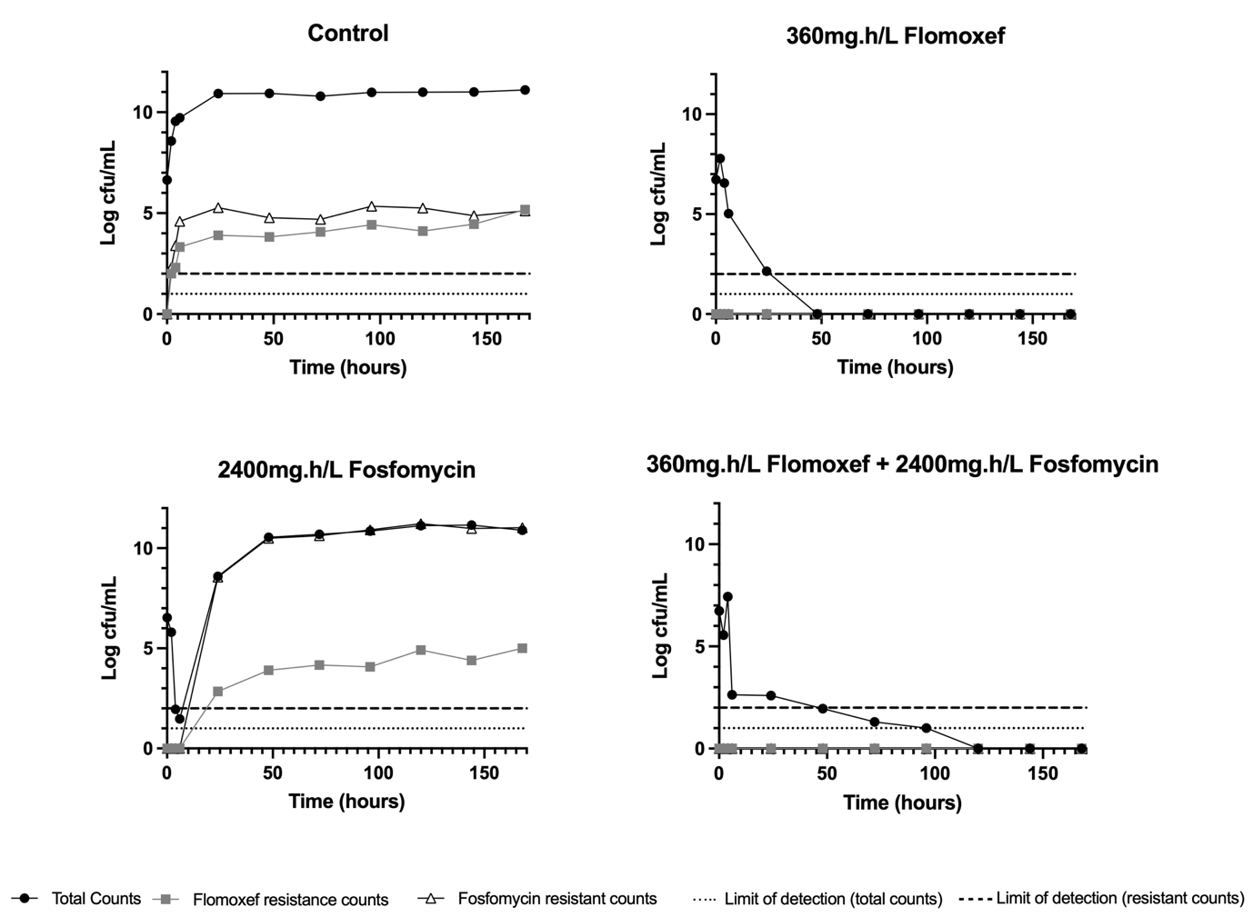
Figure S5 – HFIM pharmacodynamic results from 2x2 dosing matrix for K. pneumoniae 1216477 strain (Flomoxef MIC 0.25mg/L, Fosfomycin MIC 32mg/L)

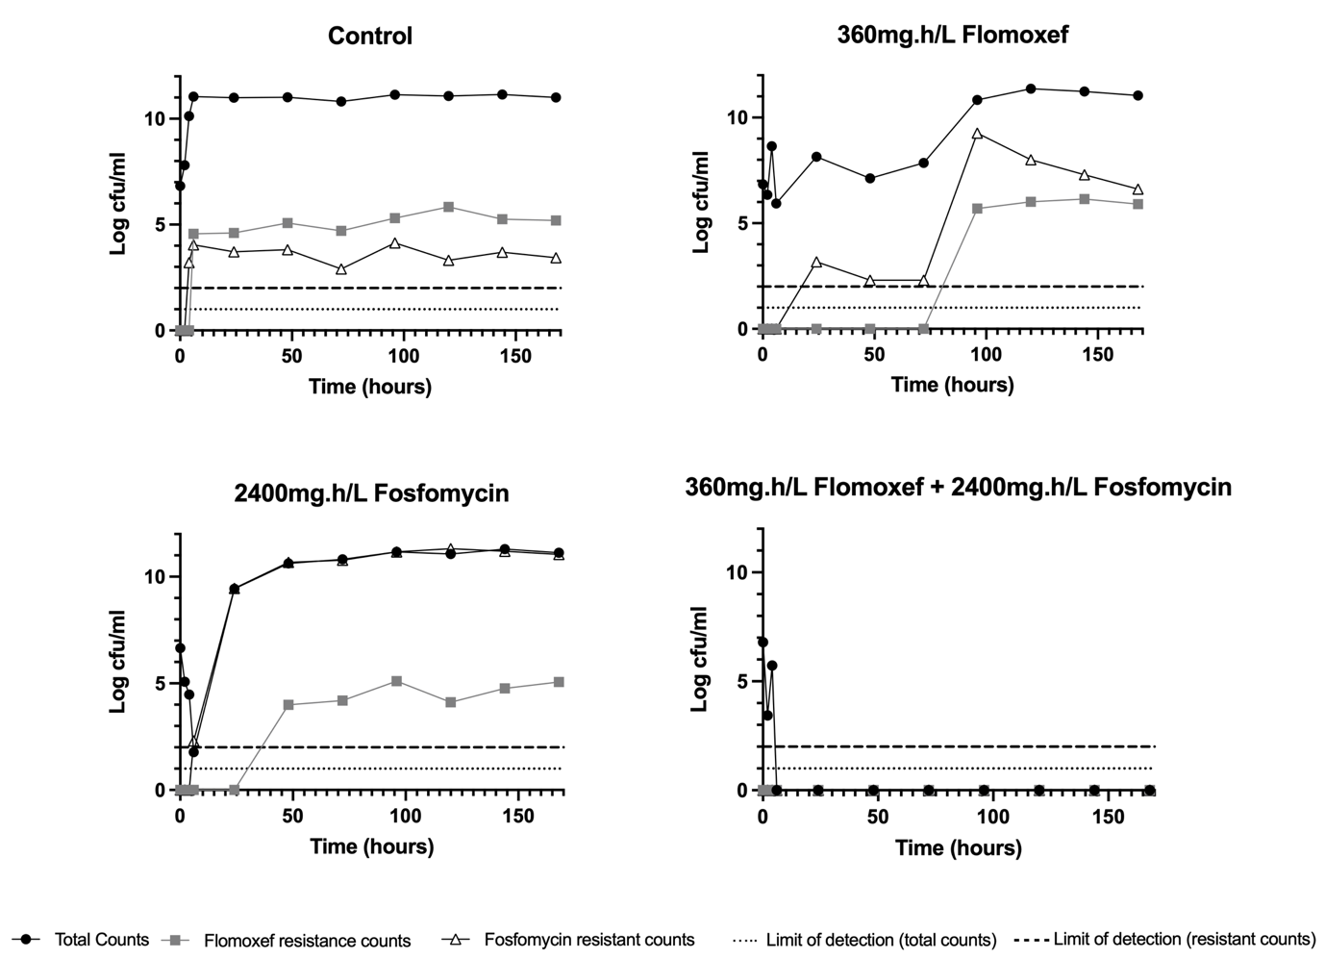
Figure S6 – HFIM pharmacodynamic results from 2x2 dosing matrix for E. coli I1025 strain (Flomoxef MIC 8mg/L, Fosfomycin MIC 32mg/L)

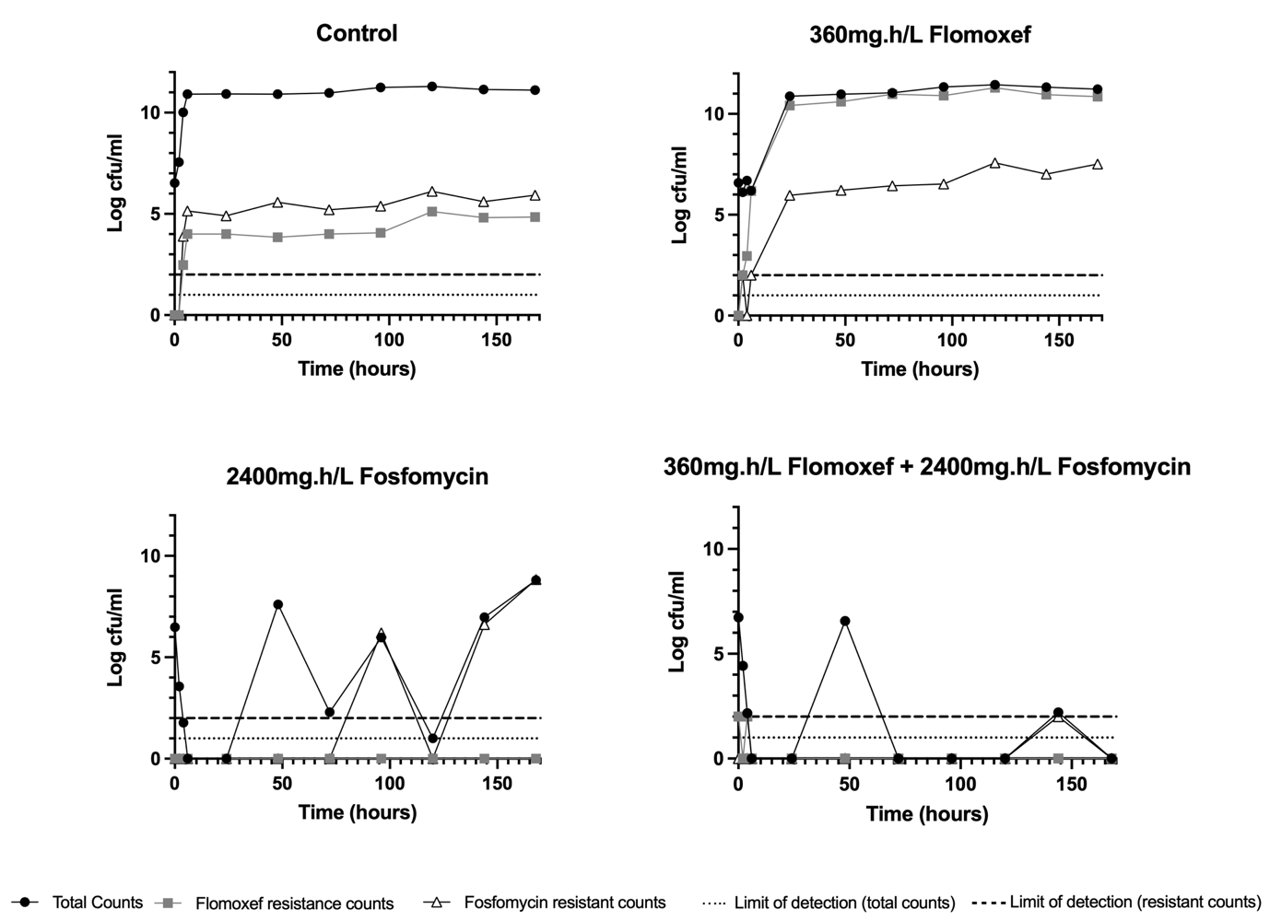
Figure S7 – HFIM pharmacodynamic results from 2x2 dosing matrix for K. pneumoniae 1280740 strain (Flomoxef MIC 32mg/L, Fosfomycin MIC 4mg/L)

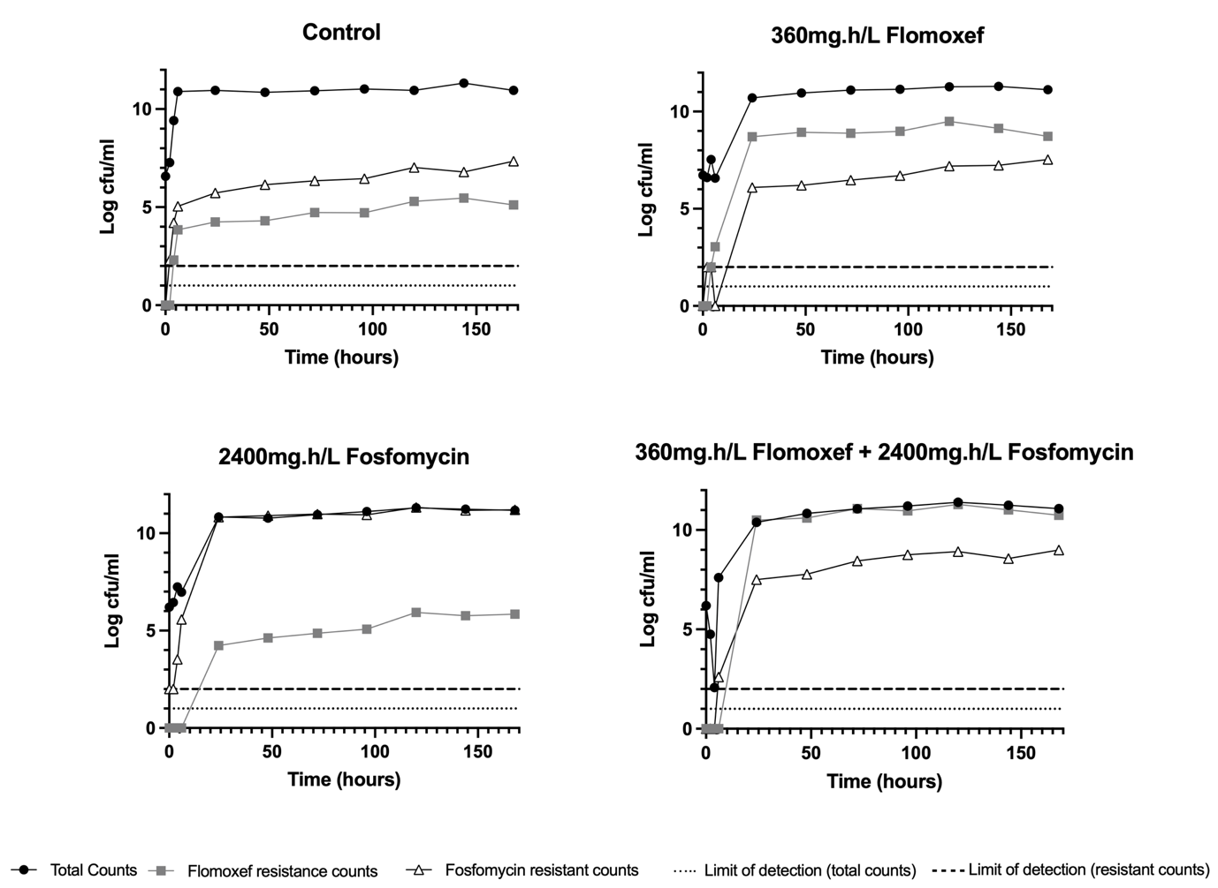
Figure S8 – HFIM pharmacodynamic results from 2x2 dosing matrix for K. pneumoniae 1256506 strain (Flomoxef MIC 32mg/L, Fosfomycin MIC 128mg/L)

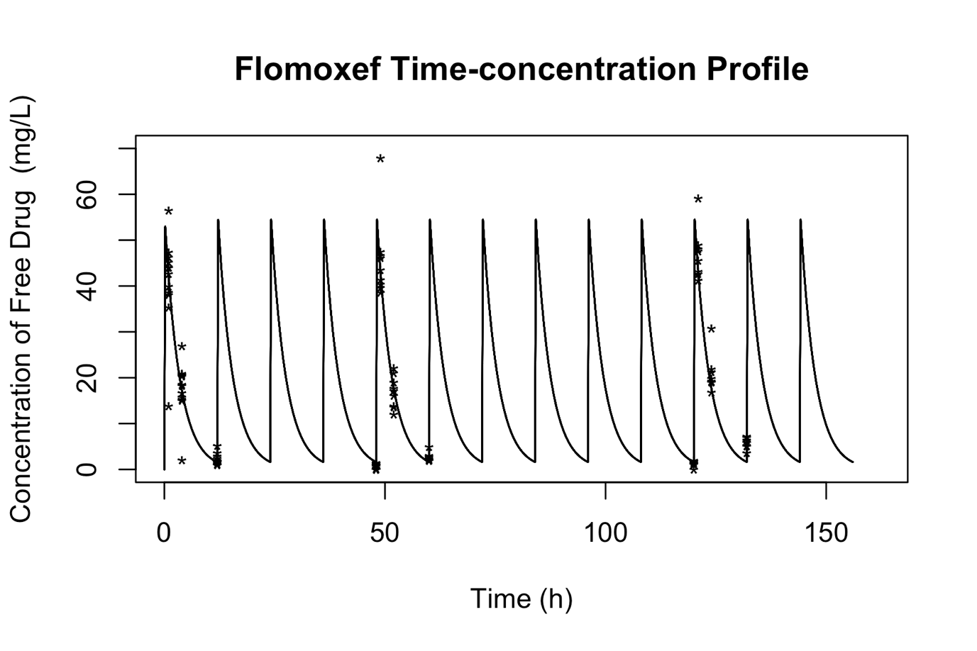
Figure S9 – Measured flomoxef drug concentrations (*) overlaid on modelled time-concentration time profile (solid line) for HFIM experiments assessing a neonatal-like regimen of flomoxef.

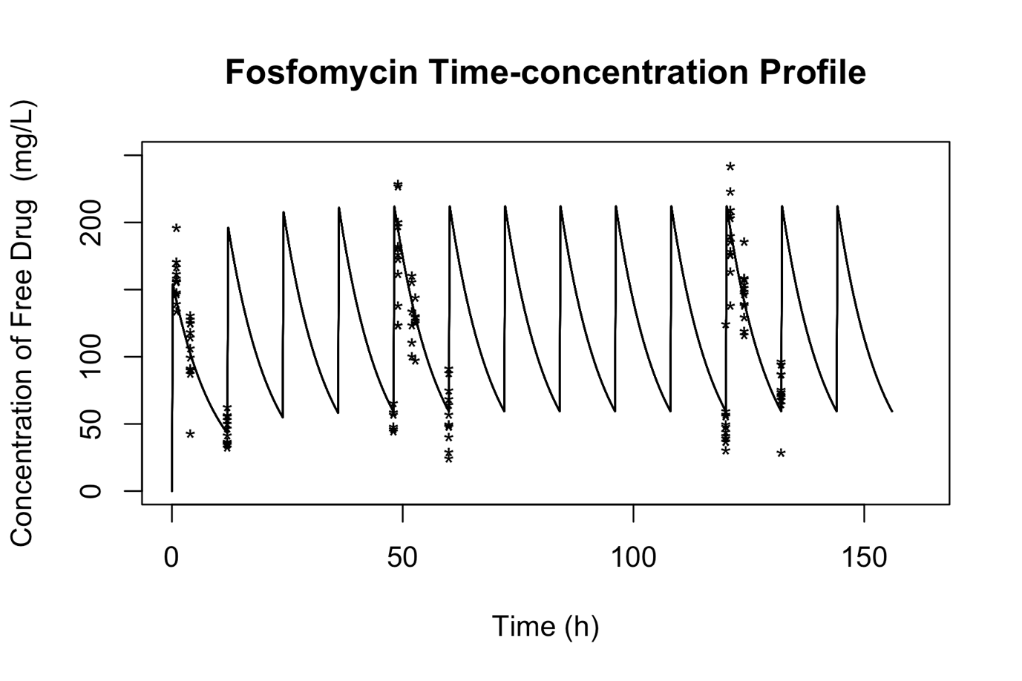
Figure S10 – Measured fosfomycin drug concentrations (*) overlaid on modelled time-concentration time profile (solid line) for HFIM experiments assessing a neonatal-like regimen of fosfomycin

