Web Appendices

Feasibility assessment
For both studies, a feasibility assessment was undertaken for patients in the whole patient cohort and for the intracranial hemorrhage (ICH), gastrointestinal (GI) bleed, and other major bleeds subgroups to determine whether the “overlap” and “ignorability of treatment” assumptions were satisfied so propensity score matching (PSM) would generate robust results. PSM methods were informed using the UK National Institute for Health and Care Excellence Decision Support Unit technical support document 17² and by Caliendo and Kopeinig.³
In the feasibility assessment, 2 potential sources of bias were identified: (1) differences in study design due to different eligibility criteria used to enroll patients in each study and (2) differences in the variables measured and how they were observed. The former caused some uncertainty around the comparability of study populations. The latter meant that certain desired covariates could not be included in the propensity score regression model.
Age was the only continuous variable measured, so quantile-quantile plots were used to assess whether the distribution of age became more similar between the treated and control groups after matching, as shown by a smaller deviation from the 45-degree line. Web Appendices Figure 1 shows quantile-quantile plots which indicate an improved balance between the age distributions in the andexanet alfa and PCC populations in the whole cohort, and in ICH and GI bleed subgroups, though not in the other major bleeds cohort.
Jitter plots (Web Appendices Figure 2) were used to present the distribution of propensity scores in the matched and unmatched subsets of each of the treated and untreated individuals in the whole cohort and in the ICH, GI bleed, and other major bleeds subgroups. Jitter plots were used to assess what proportion of patients were matched in each group and whether matched and unmatched patients differed visibly in the distribution of propensity scores.
Histograms (Web Appendices Figure 3) were used to visually assess the improvement in overlap between the treated and control groups on propensity score following matching. Web Appendices Figure 3 shows the density of propensity scores in each range and indicated improved overlap between the treated and control groups after matching, relative to before matching.

Web Appendices Figure 1. Quantile-quantile plots comparing the probability distributions of the andexanet alfa and PCC populations before and after matching.
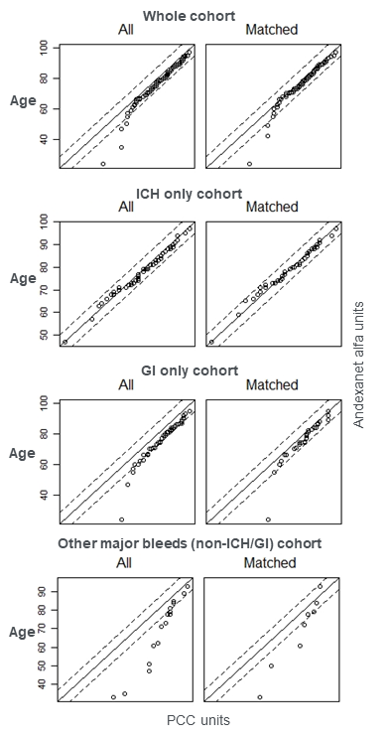
Abbreviations: GI, gastrointestinal; ICH, intracranial hemorrhage; PCC, prothrombin complex concentrate.

Web Appendices Figure 2. Jitter plots showing the distribution of propensity scores for andexanet alfa and PCC, matched and unmatched.
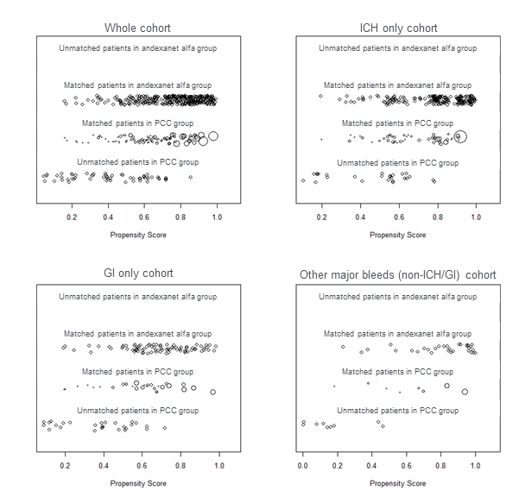
Abbreviations: GI, gastrointestinal; ICH, intracranial hemorrhage; PCC, prothrombin complex concentrate.

Web Appendices Figure 3. Histograms showing the density of propensity score distribution in the andexanet alfa (treated) and PCC (control) whole cohorts, before and after matching.
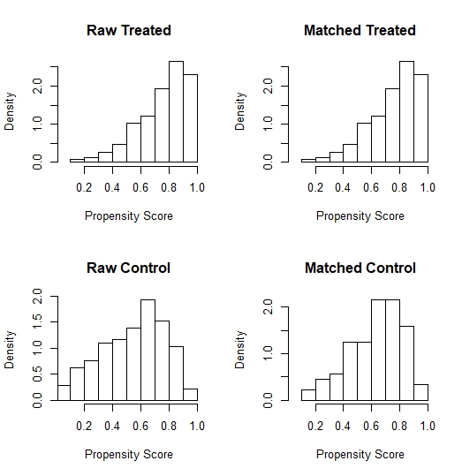
Abbreviation: PCC, prothrombin complex concentrate.

Web Appendices Table 1. Baseline characteristics for whole cohort, before and after matching (sensitivity analysis).
Characteristic | Before matching |  |  |  | After matching
 | Andexanet alfa | PCC | Abs dif | P value | Andexanet alfa | PCC | Abs dif | P value
Total (N) | 322 | 145 | – | – | 322 | 81 | – | –
Age (years), mean ± SD | 77.7 ± 10.8 | 81.0 ± 9.5 | –3.29 | 0.001 | 77.7 ± 10.8 | 73.3 ± 9.8 | 4.45 | 0.641
Type of bleed, %
Intracerebral hemorrhage | 37.9% | 31.0% | 6.90% | – | 37.9% | 28.9% | 9.01% | –
Subarachnoid hemorrhage | 8.4% | 2.8% | 5.63% | – | 8.4% | 11.8% | –3.42% | –
Subdural/epidural hemorrhage | 18.6% | 16.6% | 2.08% | – | 18.6% | 21.7% | –3.11% | –
GI bleed | 25.5% | 37.9% | –12.47% | – | 25.5% | 31.1% | –5.59% | –
Other major bleed* | 9.6% | 11.7% | –2.10% | – | 9.6% | 6.5% | 3.11% | –
Medical history, %
Atrial fibrillation | 83.9% | 77.9% | 5.92% | 0.158 | 83.9% | 81.4% | 2.48% | >0.999
Hypertension | 78.3% | 55.9% | 22.40% | <0.001 | 78.3% | 74.8% | 3.42% | 0.007
Diabetes | 30.4% | 22.1% | 8.36% | 0.079 | 30.4% | 38.2% | –7.76% | >0.999
Cancer | 26.7% | 16.6% | 10.16% | 0.023 | 26.7% | 22.4% | 4.35% | 0.362
Renal dysfunction | 23.3% | 15.2% | 8.12% | 0.060 | 23.3% | 18.6% | 4.66% | 0.595
Stroke | 18.9% | 6.2% | 12.74% | 0.001 | 18.9% | 10.3% | 8.70% | 0.009
CAD | 13.0% | 22.8% | –9.72% | 0.012 | 13.0% | 10.6% | 2.48% | 0.057
TIA | 7.5% | 24.1% | –16.69% | <0.001 | 7.5% | 7.8% | –0.31% | 0.029
*non-ICH/GI. Abbreviations: abs dif, absolute difference; CAD, coronary artery disease; GI, gastrointestinal; PCC, prothrombin complex concentrate; SD, standard deviation; TIA, transient ischemic attack. Individual data were extracted from the ANNEXA-4 study for the andexanet alfa–treated group and from the ORANGE study for the PCC-treated group.

Web Appendices Table 2. Sensitivity analysis including matching by ICH subcategories (intracerebral, subarachnoid, and subdural/epidural hemorrhage), adjusted (after matching) all-cause 30-day mortality for andexanet alfa and PCC.
Population | Number of matches* | 30-day mortality for andexanet alfa (%) | 30-day mortality for PCC (%) | Relative reduction (%)
Whole cohort | Andexanet alfa=322  PCC=81 | 14.60 | 33.33 | –56.20
ICH subgroup | Andexanet alfa=209  PCC=50 | 15.31 | 50.00 | –69.38
GI bleeds subgroup | Andexanet alfa=82  PCC=28 | 12.20 | 25.00 | –51.20
Other major bleeds†  (non-ICH/GI) subgroup | Andexanet alfa=31  PCC=8 | 16.13 | 12.50 | 29.04
Abbreviations: GI, gastrointestinal; ICH, intracranial hemorrhage; PCC, prothrombin complex concentrate. In the sensitivity analysis, ICH patients were further matched based on intracranial compartment: intracerebral, subarachnoid, and subdural in ANNEXA-4 (no patients had epidural intracranial bleeds) and intracerebral, subarachnoid, and subdural/epidural in ORANGE.
*The number of PCC matches in the subgroups does not add up to 81 as in the whole cohort due to the automatic weighting of individuals based on propensity score in the MatchIt® package.
†In the other major bleeds subgroup, <10 suitable matching partners were identified in the PCC group.

