Oral Anticoagulation in patients with non-valvular atrial fibrillation and a CHA2DS2-VASc score of 1

Patrick Sulzgruber¹, Sven Wassmann ², Anne Grete Semb ³, Wolfram Doehner ^{4,5}, Petr Widimsky⁶, Thomas Gremmel^{1,7}, Juan Carlos Kaski ⁸, Gianluigi Savarese ⁹, Giuseppe M.C. Rosano ^{10, 11}, Claudio Borghi ¹², Keld Kjeldsen ^{13, 14}, Christian Torp-Pedersen^{15, 16}, Thomas Andersen Schmidt ¹⁷, Basil S. Lewis ^{18, 19}, Heinz Drexel ^{20, 21}, Juan Tamargo²², Dan Atar ²³, Stefan Agewall ²³, Alexander Niessner¹

Affiliations:
- Division of Cardiology, Department of Internal Medicine II, Medical University of Vienna, Austria
- Cardiology Pasing, Munich, Germany; and University of the Saarland, Homburg/Saar, Germany
- Preventive Cardio-Rheuma Clinic, Department of Rheumatology, Diakonhjemmet Hospital, Oslo, Norway
- Department of Cardiology (Virchow Klinikum), German Centre for Cardiovascular Research (DZHK), Berlin
- BIH Center for Regenerative Therapies (BCRT), Charité Universitätsmedizin Berlin, Germany
- Cardiocenter, Third Faculty of Medicine, Charles University, Prague, Czech Republic
- Department of Internal Medicine, Cardiology and Nephrology, Landesklinikum Wiener Neustadt, Wiener Neustadt, Austria
- Molecular and Clinical Sciences Research Institute, St George's, University of London, London, UK
- Department of Medicine, Cardiology Division, Karolinska Institute, Karolinska University Hospital Solna, Stockholm, Sweden
- IRCCS San Raffaele Roma, Italy
- St George’s Hospitals NHS Trust University of London
- Atherosclerosis Research Unit, Medical and Surgical Sciences Department, Sant'Orsola-Malpighi Hospital, University of Bologna, Bologna, Italy
- Department of Cardiology, Copenhagen University Hospital (Hvidovre-Amager), Copenhagen, Denmark
- Department of Health Science and Technology, The Faculty of Medicine, Aalborg University, Aalborg, Denmark
- Department of Health Sciences and Technology, Aalborg University, Aalborg, Denmark.
- Department of Cardiology, Aalborg University Hospital, Aalborg, Denmark.
- Emergency Department, Bispebjerg and Frederiksberg Hospital, University of Copenhagen, Denmark
- Lady Davis Carmel Medical Center, Haifa, Israel
- Technion-Israel Institute of Technology, Ruth and Bruce Rappaport School of Medicine, Haifa, Israel
- VIVIT Research, Landeskrankenhaus Feldkirch, Austria
- Private University of the Principality of Liechtenstein, Principality of Liechtenstein
- Department of Pharmacology and Toxicology, School of Medicine, Universidad Complutense, Madrid, Spain
- Department of Cardiology, Oslo University Hospital and Institute of Clinical Medicine, Oslo University, Oslo, Norway

Short title: Anticoagulation in patients with a CHA₂DS₂-Vasc of 1
Word count: 697
Number of figures/tables: 1
Keywords: anticoagulation, atrial fibrillation, CHA₂DS₂-VASc score, intermediate risk
Background
Current ESC guidelines recommend the initiation of oral anticoagulation (OAC; preferably non-Vitamin K antagonist oral anticoagulants [NOAC] or Vitamin K antagonists [VKA]) in AF patients with a CHA₂DS₂-VASc score ≥ 2 for lowering the individual stroke risk, while an OAC approach in individuals with a CHA₂DS₂-VASc score of 0 is not recommended. (1) However, OAC in patients presenting with a CHA₂DS₂-VASc of 1 (CHA₂DS₂-VASc of 2 in women) remains a challenging approach in clinical practice and physicians need to carefully balance the individual benefit of reducing thromboembolic risk with OAC against the potential harm due to an increase in bleeding risk in this patient population.

Within the current opinion statement of the ESC working group of cardiovascular pharmacotherapy and the ESC council on stroke the authors summarized currently available evidence in this field. (2) Most importantly, an easily applicable approach for a personalized refinement of the individual thromboembolic risk in patients with AF and a CHA₂DS₂-VASc score of 1 that guide clinicals through the question whether to anticoagulated or not was provided.

The focus on doing no harm
The assessment of patients’ individual risk for major bleedings is a key prerequisite for initiation of OAC. The HAS-BLED score mirrors a widely validated and accepted tool for this purpose. Based on the individual bleeding risk of 0.59% to 1.51% per year in HAS-BLED score of 1 and an annual thromboembolic risk of 0.6% to 1.3% in CHA₂DS₂-VASc of 1, physicians are not able to draw a definite conclusion concerning the net benefit of OAC in respective patients. Therefore, a general recommendation of OAC therapy in these individuals is not justified and patients that benefit form OAC need to be identified using a personalized approach. In contrast, in patients with a HAS-BLED score of 2 (or even greater) an OAC should not be initiated in intermediate thromboembolic risk patients based on an annual bleeding rates of 1.88% to 3.20% per year. (3-6)

Personalised risk stratification in CHA₂DS₂-Vasc of 1
Considering the predictive potential for thromboembolic events in characteristics used for the calculation of the CHA₂DS₂-VASc score, age (>65 years) and diabetes mellitus type II may be the most important isolated risk factors. (7) Moreover, the authors conclude that the burden of atrial arrythmia – such as atrial fibrillation (not atrial flutter) and permanence/persistence (not paroxysmal) of the arrythmia need to be taken into account. (8-11) Further patient characteristics that proved to be associated with an increased thromboembolic risk were outlined as obesity (body mass index ≥30) and impaired kidney function – objectified via proteinuria (>150mg/24h or equivalent) or estimated glomerular filtration rate of <45ml/h. (X) Additionally, imaging values, such as enlarged left atrial volume (≥73mL) or diameter (≥4.7cm) or left atrial appendage emptying velocity (<20cm/s) seems reasonable and easily assessable imaging marker for risk stratification. (12-14) Of utmost importance, routinely available biomarkers such as cardiac troponin (high sensitivity troponin T or I) and Nt-proBNP (1400ng/l) may provide additional prognostic information to enhance risk estimation and decision making for OAC particularly in intermediate-risk individuals. (1)

Of note, despite an individualized weighing of risk and additional prognostic values, the patients’ preferences are crucial for a decision on OAC in order to ensure adherence which strongly influences outcome.

Impact of the manuscript
The ESC working group of cardiovascular pharmacotherapy and the ESC council on stroke concludes that decisions should be based on the individual balance between thromboembolic and bleeding risk. The major therapeutic preference should be on doing no harm rather than avoiding stroke. In this regard, several values and strategies for risk stratification were provided for clinicians to determine the individual thromboembolic risk in patients presenting with a CHA₂DS₂-VASc Score of 1. If the decision of OAC initiation in AF patients presenting with a CHA₂DS₂-VASc Score of 1 has been made, NOACs with a superior net-clinical benefit should be preferred over VKAs. There is no evidence that patients with AF presenting with a CHA₂DS₂-VASc score of 1 benefit from ASA therapy – therefore, ASA for stroke prevention should not be considered in this intermediate-risk patient population. Of utmost importance an easily applicable tool – including patient characteristics that favor OAC and a decision tree for the initiation of OAC – is now available to guide clinicians through the question whether to anticoagulated or not and to offer AF patients with a CHA₂DS₂-VASc Score of 1 the currently most possible benefit. (see Figure 1)
Acknowledgements
None

Funding
None

References

- Kirchhof P, Benussi S, Kotecha D, Ahlsson A, Atar D, Casadei B, Castella M, Diener HC, Heidbuchel H, Hendriks J, Hindricks G, Manolis AS, Oldgren J, Popescu BA, Schotten U, Van Putte B, Vardas P; ESC Scientific Document Group. 2016 ESC Guidelines for the management of atrial fibrillation developed in collaboration with EACTS. Eur Heart J. 2016 Oct 7;37(38):2893-2962.

- Sulzgruber P, Wassmann S, Semb AG, Doehner W, Widimsky P, Gremmel T, Kaski JC, Savarese G, Rosano GMC, Borghi C, Kjeldsen K, Torp-Pedersen C, Schmidt TA, Lewis BS, Drexel H, Tamargo J, Atar D, Agewall S, Niessner A. Oral Anticoagulation in patients with non-valvular atrial fibrillation and a CHA2DS2-VASc score of 1 – a current opinion of the European Society of Cardiology Working Group on Cardiovascular Pharmacotherapy and European Society of Cardiology Council on Stroke. Eur Heart J Cardiovasc Pharmacother, pvz016, doi.org/10.1093/ehjcvp/pvz016

- Lip GY, Nieuwlaat R, Pisters R, Lane DA, Crijns HJ. Refining clinical risk stratification for predicting stroke and thromboembolism in atrial fibrillation using a novel risk factor-based approach: the euro heart survey on atrial fibrillation. Chest. 2010 Feb;137(2):263-72. doi: 10.1378/chest.09-1584. Epub 2009 Sep 17.

- Pisters R, Lane DA, Nieuwlaat R, de Vos CB, Crijns HJ, Lip GY. A novel userfriendly score (HAS-BLED) to assess 1-year risk of major bleeding in patients with atrial fibrillation: the Euro Heart Survey. Chest 2010;138:1093–1100.

- Lip GY, Frison L, Halperin JL, Lane DA. Identifying patients at high risk for stroke despite anticoagulation: a comparison of contemporary stroke risk stratification schemes in an anticoagulated atrial fibrillation cohort. Stroke. 2010 Dec;41(12):2731-8. doi: 10.1161/STROKEAHA.110.590257. Epub 2010 Oct 21.

- Friberg L, Skeppholm M, Terént A. Benefit of anticoagulation unlikely in patients with atrial fibrillation and a CHA2DS2-VASc score of 1. J Am Coll Cardiol. 2015 Jan 27;65(3):225-32. doi: 10.1016/j.jacc.2014.10.052.
- Chao TF, Liu CJ, Wang KL, Lin YJ, Chang SL, Lo LW, Hu YF, Tuan TC, Chen TJ, Lip GY, Chen SA. Should atrial fibrillation patients with 1 additional risk factor of the CHA2DS2-VASc score (beyond sex) receive oral anticoagulation? J Am Coll Cardiol. 2015 Feb 24;65(7):635-42. doi: 10.1016/j.jacc.2014.11.046.

- Savelieva I, Camm AJ. Clinical relevance of silent atrial fibrillation: prevalence, prognosis, quality of life, and management. J Interv Card Electrophysiol. 2000 Jun;4(2):369-82

- Vanassche T, Lauw MN, Eikelboom JW, Healey JS, Hart RG, Alings M, Avezum A, Díaz R, Hohnloser SH, Lewis BS, Shestakovska O, Wang J, Connolly SJ. Risk of ischaemic stroke according to pattern of atrial fibrillation: analysis of 6563 aspirin-treated patients in ACTIVE-A and AVERROES. Eur Heart J. 2015 Feb 1;36(5):281-7a.

- Ganesan AN, Chew DP, Hartshorne T, Selvanayagam JB, Aylward PE, Sanders P, McGavigan AD. The impact of atrial fibrillation type on the risk of thromboembolism, mortality, and bleeding: a systematic review and meta-analysis. Eur Heart J. 2016 May 21;37(20):1591-602.

- Scardi S, Mazzone C, Pandullo C, Goldstein D, Poletti A, Humar F. Loneatrialfibril- lation: prognostic differences between paroxysmal and chronic forms after 10 years of follow-up. Am Heart J 1999;137(4 Pt 1):686–691.

- Zeng WT, Sun XT, Tang K, Mei WY, Liu LJ, Xu Q, Cheng YJ. Risk of thromboembolic events in atrial fibrillation with chronic kidney disease. Stroke. 2015 Jan;46(1):157-63.

- Piccini JP, Stevens SR, Chang Y, Singer DE, Lokhnygina Y, Go AS, et al. Renal dysfunction as a predictor of stroke and systemic embolism in patients with nonvalvular atrial fibrillation: validation of the R2CHADS2 index in the ROCKET AF (Rivaroxaban Once-Daily, Oral, Direct Factor Xa Inhibition Compared with Vitamin K Antagonism for Prevention of Stroke and Embolism Trial in Atrial Fibrillation) and ATRIA (Anticoagulation and Risk Factors in Atrial Fibrillation) study cohorts. Circulation. 2013;127:224–32.

- Singer DE, Chang Y, Borowsky LH, Fang MC, Pomernacki NK, Udaltsova N, et al. A new risk scheme to predict ischemic stroke and other thromboembolism in atrial fibrillation: the ATRIA study stroke risk score. J Am Heart Assoc. 2013;2:e000250.

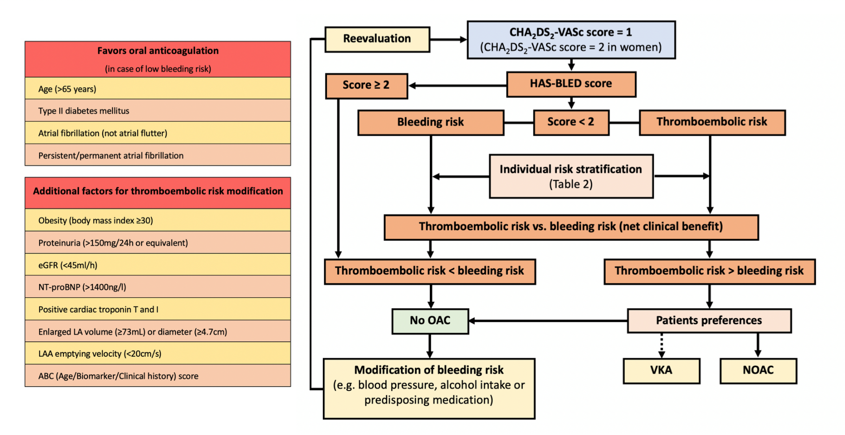

Figure 1: Decision tree for OAC in patients with AF and a CHA₂DS₂-VASc score of 1 and values for individual risk stratification. Values that favor oral anticoagulation and allow individual thromboembolic risk stratification in AF patients with a CHA₂DS₂-Vasc of 1. eGFR = estimated Glomerular Filtration Rate; LA = Left Atrium; LAA = Left Atrial Appendage; Nt-proBNP = N-terminal pro-B-type natriuretic peptide; NOAC = non-Vitamin K antagonist oral anticoagulants; OAC = Oral Anticoagulation; VKA = Vitamin K Antagonist.

