**SUPPLEMENTARY MATERIALS**

**COV001 Inclusion and exclusion criteria (Protocol Version 2.0 18th March 2020)**

This study will be conducted in healthy adults, who meet the following inclusion and exclusion criteria:

**Inclusion Criteria**

The volunteer must satisfy all the following criteria to be eligible for the study:

* Healthy adults aged 18-55 years.
* Able and willing (in the Investigator’s opinion) to comply with all study requirements.
* Willing to allow the investigators to discuss the volunteer’s medical history with their General Practitioner and access all medical records when relevant to study procedures.
* For females only, willingness to practice continuous effective contraception (see below) during the study and a negative pregnancy test on the day(s) of screening and vaccination.
* Agreement to refrain from blood donation during the course of the study.
* Provide written informed consent.

**6.3.2 Exclusion Criteria**

The volunteer may not enter the study if any of the following apply:

* Prior receipt of any vaccines (licensed or investigational) ≤30 days before enrolment
* Planned receipt of any vaccine other than the study intervention within 30 days before and after each study vaccination .
* Prior receipt of an investigational or licensed vaccine likely to impact on interpretation of the trial data (e.g. Adenovirus vectored vaccines, any coronavirus vaccines).
* Administration of immunoglobulins and/or any blood products within the three months preceding the planned administration of the vaccine candidate.
* Any confirmed or suspected immunosuppressive or immunodeficient state, including HIV infection; asplenia; recurrent severe infections and chronic use (more than 14 days) immunosuppressant medication within the past 6 months (inhaled and topical steroids are allowed).
* History of allergic disease or reactions likely to be exacerbated by any component of the vaccine.
* Any history of hereditary angioedema or idiopathic angioedema.
* Any history of anaphylaxis in relation to vaccination.
* Pregnancy, lactation or willingness/intention to become pregnant during the study.
* History of cancer (except basal cell carcinoma of the skin and cervical carcinoma in situ).
* History of serious psychiatric condition likely to affect participation in the study.
* Bleeding disorder (e.g. factor deficiency, coagulopathy or platelet disorder), or prior history of significant bleeding or bruising following IM injections or venepuncture.
* Any other serious chronic illness requiring hospital specialist supervision.
* Suspected or known current alcohol abuse as defined by an alcohol intake of greater than 42 units every week.
* Suspected or known injecting drug abuse in the 5 years preceding enrolment.
* Any clinically significant abnormal finding on screening biochemistry, haematology blood tests or urinalysis.
* Any other significant disease, disorder or finding which may significantly increase the risk to the volunteer because of participation in the study, affect the ability of the volunteer to participate in the study or impair interpretation of the study data.
* History of laboratory confirmed COVID-19.
* New onset of fever and a cough or shortness of breath in the 30 days preceding screening and/or enrolment

**SUPPLEMENTARY FIGURES**

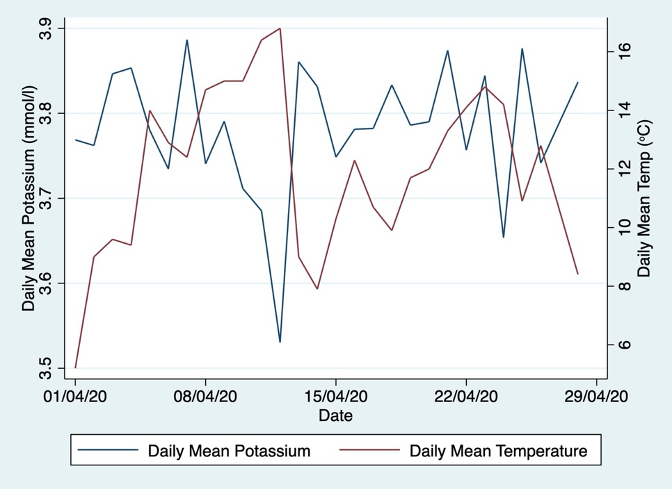

***Supplementary Figure 1: Relationship between mean serum potassium (mmol/L) and daily mean temperature (°C) at a local weather station (Heathrow airport) over a one-month period in April 2020 at the Oxford study site.***

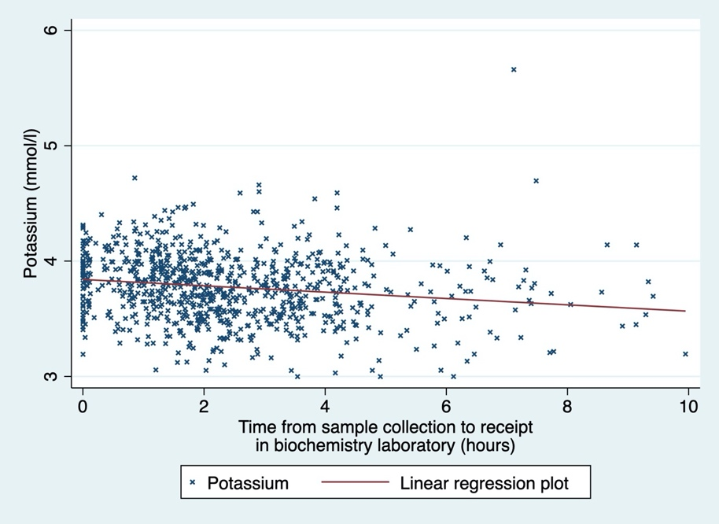

***Supplementary Figure 2: Relationship between mean serum potassium (mmol/L) and time between sample collection and receipt in laboratory at the Oxford study site.*** *R2=0.026 (small effect size by Cohen’s convention), p<0.001, coefficient -0.027, intercept 3.84*

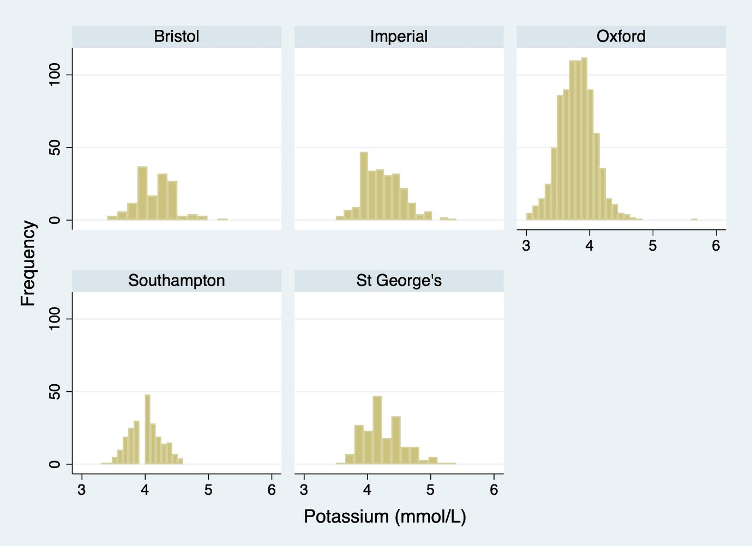

***Supplementary Figure 3: Distribution of potassium results by site.*** *The mean of the Oxford site, which use plasma samples, is 0.23-0.47 mmol/L less than the other sites which perform assays using serum samples.*

**SUPPLEMENTARY TABLES**

|  |  |  |  |  |  |  |  |
| --- | --- | --- | --- | --- | --- | --- | --- |
| **Haematology** |  |  | **Lab Range** | **Grade 1** | **Grade 2** | **Grade 3** | **Grade 4** |
| Haemoglobin Absolute | **Male** | g/L | 130-170 | 115-125 | 100-114 | 85-99 | <85 |
| Haemaglobin Absolute | **Female** |  | 120-150 | 105-113 | 90-104 | 80-89 | <80 |
| White blood cells | **Elevated** |  | 11 | 11.5-15.00 | 15.01-20 | 20.01-25 | >25 |
| White blood cells | **Low** | x10^9/L | 40 | 2.5-3.5 | 1.5-2.49 | 1.0-1.49 | <1.0 |
| Platelets | **Low** |  | 150-400 | 125-140 | 100-124 | 25-99 | <25 |
| Neutrophils | **Low** |  | 2.0-7.0 | 1.5-1.99 | 1.0-1.49 | 0.5-0.99 | <0.50 |
| Lymphocytes | **Low** |  | 1.0-4.0 | 0.75-0.99 | 0.5-0.74 | 0.25-0.49 | <0.25 |
| Eosinophils | **Elevated** | x10^9/L | 0.02-0.5 | 0.65-1.5 | 1.51-5.00 | >5.00 | Hypereosinophila |
| **Biochemistry** |  |  |  |  |  |  |  |
| Sodium | **Elevated** | mmol/L | 145 | 146-147 | 148-149 | 150-155 | >155 |
| Sodium | **Low** |  | 135 | 132-134 | 130-131 | 125-129 | <125 |
| Potassium | **Elevated** | mmol/L | 5 | 5.1-5.2 | 5.3-5.4 | 5.5-6.5 | >6.5 |
| Potassium | **Low** |  | 3.5 | 3.2-3.3 | 3.1 | 2.5-3.0 | <2.5 |
| Urea | **Elevated** | mmol/L | 2.5-7.4 | 8.2-9.3 | 9.4-11.0 | >11.0 | requires dialysis |
| Creatinine | **Elevated** | umol/L | 49-104 | 114-156 | 157-312 | >312 | requires dialysis |
| Bilirubin | **Normal LFTs** | umol/L | 0-21 | 23-32 | 33-42 | 43-63 | >64 |
| ALT |  | IU/L | Site specific | 1.1-2.5x ULN | >2.5 – 5x ULN | >5-10x ULN | >10x ULN |
| Alk Phosphatase | **Elevated** | IU/L | 30-130 | 143-260 | 261-390 | 391-1300 | >1300 |
| Albumin |  | g/L | 32-50 | 28-31 | 25-27 | <25 | - |

***Supplementary Table 1: Classification of Laboratory Abnormalities.*** *Those considered incidental findings are coloured in red (as determined by our centre). This grading system is a modified version of that outlined in the* US Food and Drug Administration (FDA) ‘*Toxicity Grading Scale for Healthy Adult and Adolescent Volunteers Enrolled in Preventative Vaccine Clinical Trials*, *Guidance for Industry*11’ which does not provide guidance on which abnormalities are of potential or definite clinical significance. ULN = upper limit of normal.

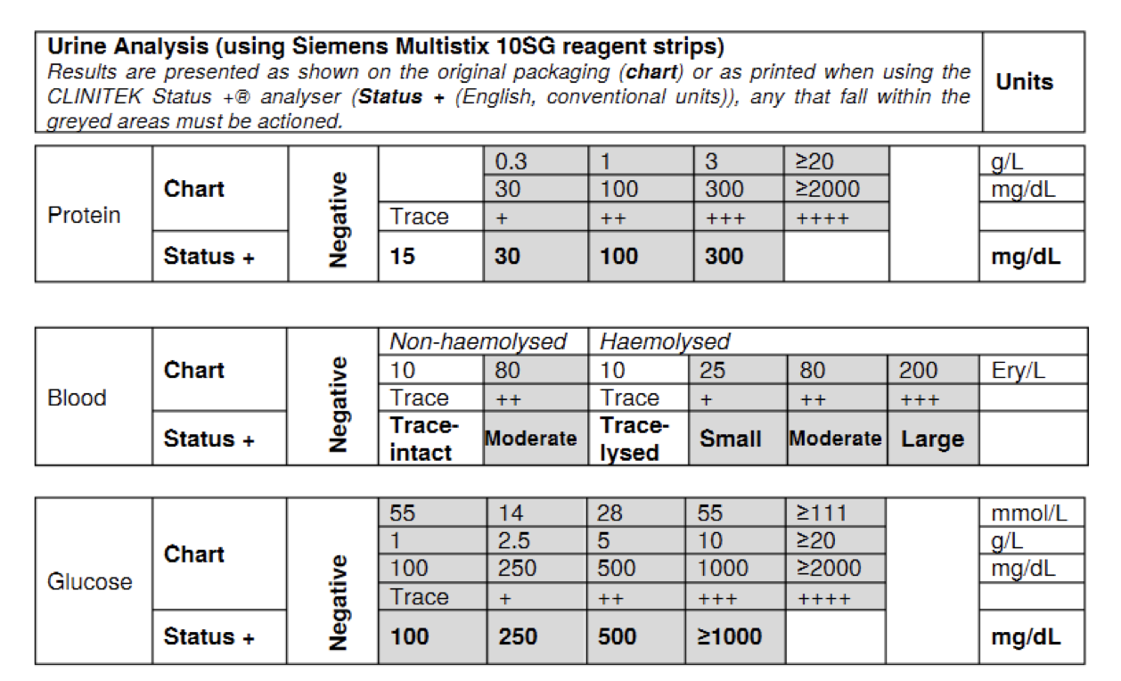

***Supplementary Table 2: Urine analysis***

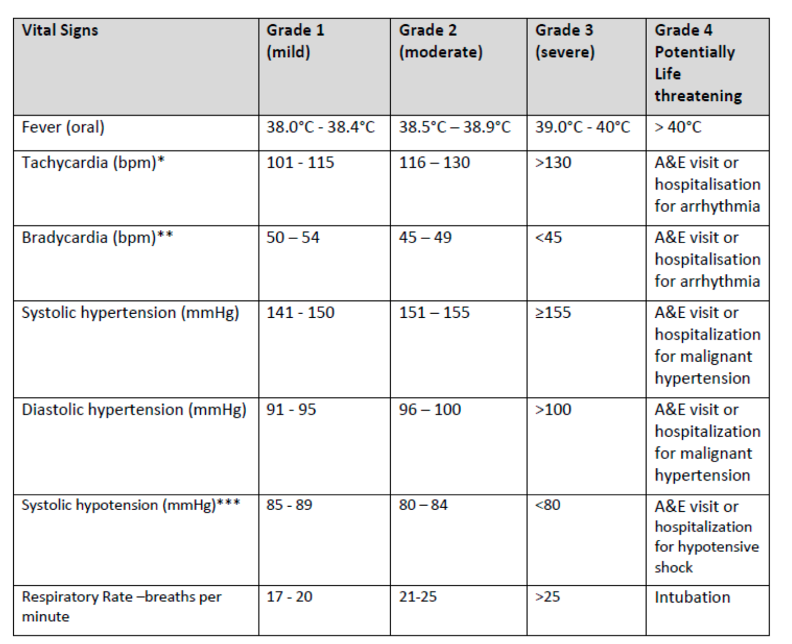

***Supplementary Table 3: Grading of Abnormal Physical Observations. A&E = Hospital Accident and Emergency department***

|  |  |  |
| --- | --- | --- |
|  | **Laboratory Reference Range (IU/L)** | |
|  | **MALE** | **FEMALE** |
| **Southampton** | 10-40 | 7-35 |
| **Imperial** | 0-45 | 0-34 |
| **Bristol** | 10-60 | 10-40 |
| **St George's** | <52 | <40 |
| **Oxford** | 10-45 | 10-45 |

***Supplementary Table 4: Alanine Transaminase (ALT) Laboratory Reference Ranges at Laboratories processing COV001 screening samples. IU = international units.***

|  |  |  |  |
| --- | --- | --- | --- |
| *n=1838* | **Female** | **Male** | **TOTAL** |
| **Oxford** | 465 (49%) | 489 (51%) | 954 (52%) |
| **Southampton** | 131 (51%) | 126 (49%) | 257 (14%) |
| **Imperial** | 129 (42%) | 177 (58%) | 306 (17%) |
| **Bristol** | 119 (54%) | 102 (46%) | 221 (12%) |
| **St George's** | 51 (51%) | 49 (49%) | 100 (5%) |

***Supplementary Table 5: Distribution of screened participants across COV001 sites***

|  |  |
| --- | --- |
| **Participant Outcomes with regard to Enrolment** | n=1838 |
| Enrolled | 60.2% (1106) |
| Eligible but not enrolled | 8.1% (149) |
| Excluded Participants | 31.7% (583) |
| *Incidental finding detected at screening* | *19.3% (355)* |
| *Pre-existing medical condition meeting exclusion criteria* | *5.8% (107)* |
| *History or evidence of SARS-COV2 exposure or disease* | *3.4% (63)* |
| *Incomplete screening data (e.g. no response from*  *primary care physician)* | *1.3% (23)* |
| *Technical issue at screening e.g. vasovagal, difficult*  *venepuncture* | *1.1% (20)* |
| *Household contacts with vulnerability to severe COVID* | *0.7% (12)* |
| *Body weight* | *0.7% (13)* |
| *Logistical factors e.g. lack of transport or phone* | *0.5% (9)* |
| *Prior receipt of adenovirus vectored vaccine* | *0.1% (2)* |

***Supplementary Table 6: Participant outcome with regard to enrolment in COV001****. Of note some participants had more than one reason for exclusion.*



***Supplementary Table 7: Alcohol, smoking and recreational drug use for individuals screened for eligibility for COV001.*** *\*As reported by participants. **Calculated using UK NHS guidelines which recommend a weekly limit of 14 units29. ^Any history of recreational drug use in the 5 years preceding screening. Mann Whitney or Fishers exact test used as appropriate.*



***Supplementary Table 8: Body mass index of individuals screened for COV001.*** *\*UK NHS criteria for interpretation of Body Mass Index (BMI)30. IQR = interquartile range.*

|  |  |  |  |
| --- | --- | --- | --- |
|  | **Male** | **Female** | **Total** |
| **All sites** | 16.0% (136/848) | 8.3% (66/799) | 12.3% (203/1647) |
| **Bristol** | 14.1% (11/78) | 5.7% (4/70) | 10.1% (15/148) |
| **Imperial** | 23.4% (34/145) | 13% (13/100) | 18.2% (47/245) |
| **Oxford** | 12.3% (53/430) | 7.4% (30/408) | 9.9% (83/838) |
| **Southampton** | 18.9% (20/106) | 9.9% (12/121) | 14.1% (32/227) |
| **St George's** | 19.8% (18/91) | 7.1% (7/98) | 13.2% (25/189) |

***Supplementary Table 9: Incidence of abnormal blood results at screening according to site.*** *Individuals could have had more than one laboratory incidental finding.*

|  |  |  |  |
| --- | --- | --- | --- |
|  | **G1 % (n)** | **G2 % (n)** | **G3 % (n)** |
| **Hyponatraemia** | * | 0.5% (1) | 0% |
| **Hypernatraemia** | * | 0 | 0% |
| **Hypokalaemia** | * | 5% (10) | 2.5% (5) |
| **Hyperkalaemia** | * | 1% (3) | 0.5%(1) |
| **Urea** | * | 3% (7) | 0% |
| **Creatinine** | * | 0% | 0% |
| **Bilirubin (normal LFTs)** | * | 13% (27) | 1% (3) |
| **ALT** | 46% (93) | 2% (4) | 0% |
| **Alkaline phosphatase** | 1% (3) | 0% | 0% |
| **Albumin** | * | 0% | 0% |

|  |  |  |  |
| --- | --- | --- | --- |
|  | **G1 % (n)** | **G2 % (n)** | **G3 % (n)** |
| **Anaemia^** | * | 2% (4) | 0% |
| **Leucocytosis** | * | 0% | 0% |
| **Leucopenia** | * | 0% | 0% |
| **Thrombocytopenia** | * | 2% (4) | 0.5% (1) |
| **Neutropenia** | * | 5% (10) | 0% |
| **Lymphopenia** | * | 0% | 0% |
| **Eosinophilia** | 7% (15) | 1% (2) | 0% |

|  |  |  |
| --- | --- | --- |
|  | **Positive** | **Further testing required** |
| **Hep C Ab +** | 2% (4) | 1% (2) |
| **HIV Ab/Ag +** | 0.5% (1) | 0 |
| **Hep B SAg +** | 0 | 0 |

***Supplementary Table 10: Laboratory incidental findings from participants screened for COV001.*** *Total = 203. % = % of all laboratory incidental findings. N = number of times laboratory incidental finding identified. *=abnormality not deemed an incidental finding. Some individuals had more than one laboratory incidental finding. ^Low haemoglobin was noted in 3 females and 1 male. LFTs= liver function tests. ALT = Alanine transaminase.*

|  |  |  |
| --- | --- | --- |
|  | ***Male*** | ***Female*** |
| ***Abnormal ALT grade 1*** | *9.0% (76/847)* | *2.1% (17/791)* |
| ***Abnormal ALT grade 2*** | *0.3% (3/847)* | *0.1% (1/791)* |
| ***Normal ALT*** | *91.0% (771/847)* | *97.9% (774/791)* |

***Supplementary Table 11: Alanine Transaminase in individuals screened for COV001.*** *Data for two individuals for whom sex was not recorded were excluded.*



***Supplementary Table 12: hypokalaemia at screening in individuals screened for COV001 according to site. % = % of all hypokalaemia incidental findings identified***

|  |  |  |  |
| --- | --- | --- | --- |
|  | **G1 % (n)** | **G2 % (n)** | **G3 % (n)** |
| **Hyponatraemia** | * | 0% | 0% |
| **Hypernatraemia** | * | 0% | 1.8% (1) |
| **Hypokalaemia** | * | 1.8% (1) | 0% |
| **Hyperkalaemia** | * | 1.8% (1) | 0% |
| **Urea** | * | 5.6% (3) | 1.8% (1) |
| **Creatinine** | * | 0% | 0% |
| **Bilirubin (normal LFTs)** | * | 3.8% (2) | 1.8% (1) |
| **ALT** | 39.6% (21) | 0% | 0% |
| **Alk phos** | 0% | 1.8% (1) | 0% |
| **Albumin** | * | 0% | 0% |

|  |  |  |  |
| --- | --- | --- | --- |
|  | **G1 % (n)** | **G2 % (n)** | **G3 % (n)** |
| **Anaemia** | * | 1.8% (1) | 0% |
| **Leucocytosis** | * | 0% | 0% |
| **Leucopenia** | * | 0% | 0% |
| **Thrombocytopenia** | * | 3.8% (2) | 1.8% (1) |
| **Neutropenia** | * | 15.1% (8) | 0% |
| **Lymphopenia** | * | 0% | 0% |
| **Eosinophilia** | 18.9% (10) | 0% | 0% |

***Supplementary Table 13: New laboratory incidental findings detected at enrolment in individuals with normal bloods at screening. n=53.*** *\*=abnormality not deemed incidental finding. Total = 55. % = % of all laboratory incidental findings detected. N = number of times laboratory incidental finding identified. *=abnormality not deemed incidental finding. Individuals could have had more than one laboratory incidental finding. LFTs= liver function tests. ALT = Alanine transaminase.*

|  |  |  |  |
| --- | --- | --- | --- |
|  | **G1 % (n)** | **G2 % (n)** | **G3 %(n)** |
| **Hyponatraemia** | * | 0% | 0% |
| **Hypernatraemia** | * | 0% | 0% |
| **Hypokalaemia** | * | 21.7% (5) | 13.0% (3) |
| **Hyperkalaemia** | * | 4.3% (1) | 4.3% (1) |
| **Urea** | * | 0% | 0% |
| **Creatinine** | * | 0% | 0% |
| **Bilirubin (normal LFTs)** | * | 13.0% (3) | 0% |
| **ALT** | 0% | 30.4% (7) | 0% |
| **Alk phos** | 0% | 0% | 0% |
| **Albumin** | * | 0% | 0% |

|  |  |  |  |
| --- | --- | --- | --- |
|  | **G1 % (n)** | **G2 % (n)** | **G3 % (n)** |
| **Anaemia** | * | 0% | 0% |
| **Leucocytosis** | * | 0% | 0% |
| **Leucopenia** | * | 0% | 0% |
| **Thrombocytopenia** | * | 0% | 0% |
| **Neutropenia** | * | 4.3% (1) | 0% |
| **Lymphopenia** | * | 0% | 0% |
| **Eosinophilia** | 0% | 4.3% (1) | 4.3% (1) |

***Supplementary Table 14: Laboratory incidental findings in participants at screening which had resolved by enrolment*** *(n=23)**% = % of laboratory incidental findings.*



***Supplementary Table 15: Frequency of haematuria, proteinuria and glycosuria in participants screened for COV001 using urinalysis strips.*** *\*deemed incidental finding.*