Figure S1. Examples of images rejected during initial quality check.
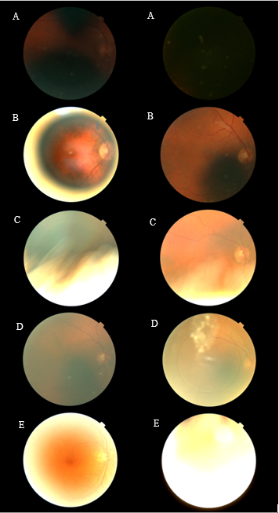
Figure S1. Examples of images rejected during initial quality check. A: dark images; B: images obscured by poor camera and light positioning; C: images obscured by eyelids and lashes; D: clouded images (N.B. contact lens visible in right image); E: images obscured by excessive lighting.

Table S1. Comparison of participant characteristics for those with and without imaging data.
 |  | RMP available | RMP not available
 |  | Mean (SD) | Mean (SD) | p
Age (years) |  | 58 (8) | 59 (8) | <0.001
Waist circumference (cm) |  | 93 (15) | 94 (15) | 0.10
Systolic blood pressure (mmHg) |  | 146 (22) | 147 (22) | 0.15
eGFR (ml/min/1.73m²) |  | 88.8 (16.0) | 87.0 (16.4) | <0.001
IOP (mmHg) |  | 16.48 (4.48) | 16.2 (4.33) | 0.02
LogMAR |  | 0.03 (0.2) | 0.06 (0.22) | <0.001
 |  | Number (%) | Number (%) | p
Sex (Female) |  | 1042 (55) | 2687 (53) | 0.06
Blood pressure-lowering medication usage |  | 347 (18) | 1043 (21) | 0.049
Diabetes mellitus |  | 209 (11) | 627 (12) | 0.16
Ever smoked |  | 1104 (59) | 3069 (60) | 0.20
White ethnicity |  | 1654 (88) | 4374 (86) | 0.04
Ever consumed alcohol |  | 1764 (93) | 4752 (93) | 0.72
Ever eye surgery |  | 127 (7) | 433 (9) | 0.02
Table S1. SD: standard deviation; eGFR: Estimated glomerular filtration rate; IOP: Intraocular pressure; LogMAR: visual acuity assessed using a Logarithm of the Minimum Angle of Resolution chart CRAE: central retina arteriolar equivalent; CRVE: central retinal venular equivalent; px: pixels; AVR: arteriovenous ratio; FDa/v: arteriolar/venular fractal dimension; Torta/v: arteriolar/venular tortuosity.

