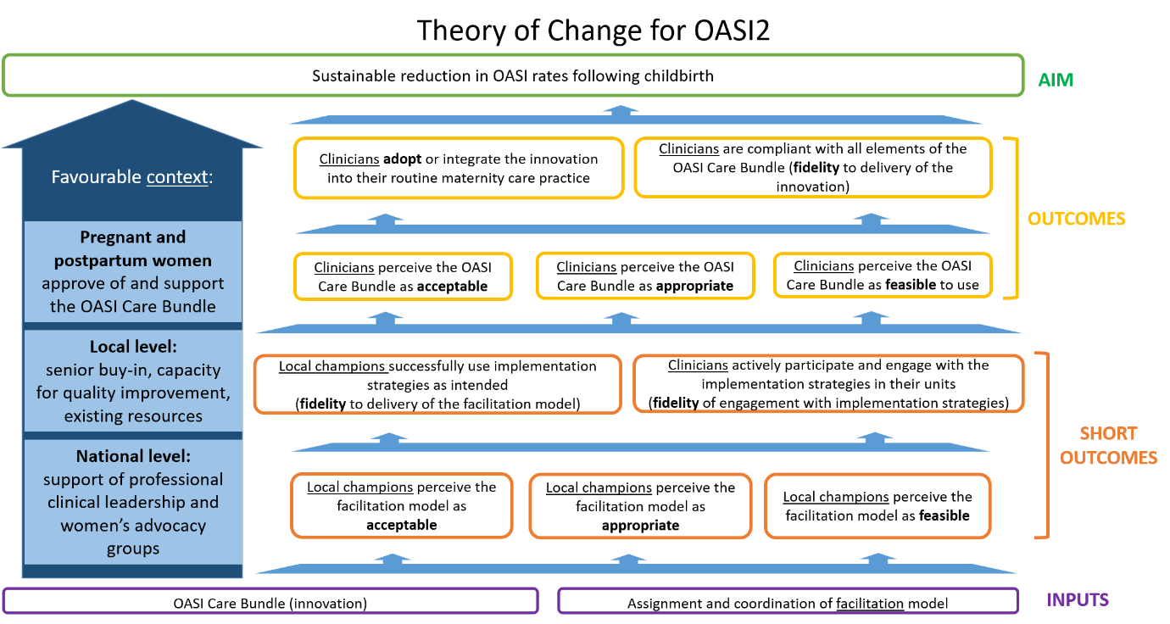
Additional File 1. Theory of Change for OASI2

