Supplementary Material

Supplementary file 1. Division of countries of origin by areas of origin.

Areas of Origin | Countries of Origin
Southern Europe | Albania, Andorra, Bosnia and Herzegovina, Bulgaria, Croatia, Slovenia, France, Gibraltar, Greece, Italy, North Macedonia, Malta, Island of Man, Montenegro, Portugal, San Marino, Turkey, Vatican, Cyprus
Central and Eastern Europe | Armenia, Azerbaijan, Belarus, Slovakia, Estonia, Russian Federation, Hungary, Kazakhstan, Kyrgyzstan, Latvia, Lithuania, Moldova, Poland, Romania, Serbia, Tajikistan, Czech Republic, Republic Ukraine, Uzbekistan,
Northern Europe | Aland Islands, Germany, Antarctica, Austria, Bouvet Island (Norway), Denmark, Faroe Islands, Finland, Georgia, Greenland, Guernsey, Ireland, Iceland, Jersey, Liechtenstein, Luxembourg, Monaco, Norway, Netherlands, United Kingdom, Sweden, Swiss, Svalbard and Jan Mayen, French Australian and Antarctic Land,
Anglo-Saxon America | Canada, United States of America, Minor Peripheral Islands of the USA, Saint-Pierre and Miquelon,
Latin-America and the Caribbean | Anguilla, Ancient and Barbuda, Netherlands Antilles, Argentina, Aruba, The Bahamas, Barbados, Belgium, Belize, Benin, Bermuda Islands, Bolivia, Brazil, Caiman Islands, Chile, Colombia, Costa Rica, Cuba, Dominica, Dominican Republic, Ecuador, Falkland Islands, South Georgia and South Sandwich Islands, Grenada, Guadeloupe, French Guiana, Guatemala, Guyana, Haiti, Honduras, Jamaica, Martinique, Mexico, Federated States of Micronesia, Montserrat, Nicaragua, Panama, Paraguay, Peru, Puerto Rico, Saint Christopher and Nevis, Saint Helena, Saint Lucia, Saint Vincent and the Grenadines, El Salvador, Surinam, Trinity and Tobago, Turks and Caicos Islands, Uruguay, Venezuela, Virgin Islands (USA), Virgin Islands (Great Britain)
Northern Africa | Algeria, Egypt, Libya, Morocco, Western Sahara, Tunisia
Sub-Saharan Africa | Angola, Botswana, Burkina Phase, Burundi, Cameroon, Cape Verde, Central African Republic, Comoros, Congo, Democratic Republic of Congo, Ivory Coast, Djibouti, Eritrea, Ethiopia, Gabon, Gambia, Ghana, Guinea, Guinea Bissau, Equatorial Guinea, Kenya, Lesotho, Liberia, Madagascar, Malawi, Mali, Mauritia, Mauritania, Mayotte, Mozambique, Namibia, Niger, Nigeria, Reunion, Rwanda, Saint Thomas and Prince, Senegal, Seychelles, Sierra Leone, Somalia, Republic of South Africa, Sudan, Swaziland, United Republic of French Tanzania, Togo, Chad, Uganda,
Southern Asia and Middle East | Afghanistan, Saudi Arabia, Bahrain, Yemen, India, Iran Islamic Republic of Iraq, Iraq, Israel, Jordan, Kuwait, Lebanon, Oman, Pakistan, Territory Occupied by Palestine, Qatar, Syria, Turkmenistan, Union of the Arab Emirates
Eastern and Southeast Asia | Bangladesh, Bhutan, Brunei, Cambodia, Republic of Korea, Popular Democratic Republic of Korea, Philippines, Hong Kong, Indonesia, Japan, Popular Democratic Republic of Laos, Macau, Malaysia, Mongolia, Myanmar, Nepal, Singapore, Sri Lanka, Thailand, Taiwan, Eastern Timor, Vietnam,
Oceania | Australia, Christmas Island, Cocoons Islands, Cook Islands, Fiji, Guam, Heard and McDonald Islands, Kiribati, Maldives, Island of Marianne del Man, Northern Marine Islands, Marshall Islands, Nauru, Niue, Norfolk Island, New Caledonia, New Zealand, Palau, Papa New Guinea, Pitcairn, French Polynesia, Solomon, Samoa, American Samoa, British Territory of the Indian Ocean, Tokelau, Tonga, Tuvalu, Vanuatu, Wallis and Futuna Islands, Zambia, Zimbabwe

Supplementary material

Supplementary file 2. Comparative study conducted for the selection of Primary Care Centres (PCCs).

For Manresa and Tortosa, there were only two public primary care centres in each area, therefore we checked if both PCCs for each area were comparable.

Concerning the Barcelona (4 PCC in the neighborhood) and Lleida (6 public PCC evaluated in the city), differences were checked in order to find the most similar PCC.
Differences where assessed using two-sample tests of proportions when comparing proportions and prevalences.
A binomial based two-sided exact test was carried out to compare incidence rates.

In Barcelona, the PCC Barcelona_3 and Barcelona_4 were finally selected whereas in Lleida the PCC Lleida_1 and Lleida_2 were finally selected to participate in the study. For Manresa and Tortosa we checked that the PCC were comparable.

BARCELONA

PCC | Target population | Total population
Barcelona_1 | 1007 | 26,533
Barcelona _2 | 1042 | 27,382
Barcelona_3 | 1270 | 29,960
Barcelona _4 | 1784 | 20,961
Cell content: counts

PCC | Type of PCC | Number of subjects for each GP | Proportion of GPs corresponding to each subject | Number of subjects for each nurse | Proportion of nurses corresponding to each subject
Barcelona_1 | 1u | 1474.1 | 0.0007 | 1768.9 | 0.0006
Barcelona_2 | 1u | 1521.2 | 0.0007 | 1955.9 | 0.0005
Barcelona_3 | 1u | 1576.8 | 0.0006 | 1997.3 | 0.0005
Barcelona_4 | 1u | 1612.4 | 0.0006 | 2329.0 | 0.0004
Cell content: counts and proportions

PCC | HIV prevalence | AIDS prevalence | HCV prevalence | HBV prevalence | ACUTE HEP prevalence | TB prevalence
Barcelona_1 | 0.002 | 0.001 | 0.008 | 0.000 | 0.000 | 0.003
Barcelona_2 | 0.004 | 0.002 | 0.006 | 0.000 | 0.001 | 0.002
Barcelona_3 | 0.008 | 0.003 | 0.006 | 0.000 | 0.001 | 0.002
Barcelona_4 | 0.003 | 0.001 | 0.005 | 0.003 | 0.002 | 0.002
Cell content: proportions

PCC | HIV 2016 incidence | AIDS 2016 incidence | HCV 2016 incidence | HBV 2016 incidence | ACUTE HEP 2016 incidence | TB 2016 incidence
Barcelona_1 | 0.4 | 0.0 | 1.1 | 1.1 | 0.4 | 0.4
Barcelona_2 | 1.5 | 0.7 | 4.7 | 1.1 | 2.2 | 0.7
Barcelona_3 | 3.0 | 0.3 | 5.3 | 1.0 | 2.0 | 0.3
Barcelona_4 | 1.4 | 0.0 | 4.3 | 2.4 | 2.4 | 1.0
Cell content: Number of cases per 10,000 person-years

PCC | Proportion of subjects from target population | Proportion of subjects from America | Proportion of subjects from Magreb | Proportion of subjects from east EU | Proportion of subjects from west EU | Proportion of subjects from SSA | Proportion of subjects from south Asia | Proportion of subjects from west Asia | Proportion of subjects from others Asia
Barcelona_1 | 0.038 | 0.023 | 0.002 | 0.006 | 0.010 | 0.001 | 0.002 | 0.002 | 0.002
Barcelona_2 | 0.038 | 0.022 | 0.001 | 0.006 | 0.015 | 0.000 | 0.002 | 0.004 | 0.002
Barcelona_3 | 0.042 | 0.024 | 0.002 | 0.006 | 0.024 | 0.001 | 0.002 | 0.005 | 0.004
Barcelona_4 | 0.085 | 0.043 | 0.008 | 0.011 | 0.025 | 0.001 | 0.006 | 0.012 | 0.005
Cell content: proportions

PCC | Proportion of subjects aged 15-29 | Proportion of subjects aged 30-59 | Proportion of subjects aged 60 and more
Barcelona_1 | 0.16 | 0.48 | 0.36
Barcelona_2 | 0.16 | 0.51 | 0.34
Barcelona_3 | 0.16 | 0.54 | 0.30
Barcelona_4 | 0.14 | 0.45 | 0.28
Cell content: proportions

Associations (p-value) between Barcelona PCC 2 (Barcelona_3) and the rest of PCC in Barcelona

Variable name | Barcelona_1 | Barcelona _2 | Barcelona_4
PCC size difference | 0 | 0 | 0
Proportion of GPs corresponding to each subject | 0.8375 | 0.9130 | 0.9506
Proportion of nurses corresponding to each subject | 0.7392 | 0.9550 | 0.7153
HIV prevalence | 0.0000 | 0.0000 | 0.0000
AIDS prevalence | 0.0000 | 0.0026 | 0.0000
HCV prevalence | 0.0778 | 0.8151 | 0.1620
HBV prevalence | 0.2077 | 0.1863 | 0.0000
ACUTE HEP prevalence | 0.2327 | 0.4460 | 0.0000
TB prevalence | 0.0094 | 0.8424 | 0.0623
HIV 2016 incidence | 0.0191 | 0.2360 | 0.2732
AIDS 2016 incidence | 0.5303 | 0.5752 | 0.5884
HCV 2016 incidence | 0.0057 | 0.7590 | 0.6141
HBV 2016 incidence | 0.8865 | 0.9158 | 0.2496
ACUTE HEP 2016 incidence | 0.0967 | 0.8787 | 0.7721
TB 2016 incidence | 0.9393 | 0.5752 | 0.4386
Proportion of subjects from target population | 0.0074 | 0.0084 | 0.0000
Proportion of subjects from America | 0.5734 | 0.0594 | 0.0000
Proportion of subjects from Magreb | 0.0718 | 0.8177 | 0.0000
Proportion of subjects from east EU | 0.9169 | 0.5921 | 0.0000
Proportion of subjects from west EU | 0.0000 | 0.0000 | 0.4716
Proportion of subjects from SSA | 0.7392 | 0.4377 | 0.0811
Proportion of subjects from south Asia | 0.9096 | 0.5508 | 0.0000
Proportion of subjects from east Asia | 0.0000 | 0.5212 | 0.0000
Proportion of subjects from others Asia | 0.0004 | 0.0009 | 0.3070
Proportion of subjects aged 15-29 | 0.2820 | 0.1184 | 0.0000
Proportion of subjects aged 30-59 | 0.0000 | 0.0000 | 0.0000
Proportion of subjects aged 60 and more | 0.0000 | 0.0000 | 0.0000
Cell content: except for the first row, p-values from two sample tests of proportions or binomial based exact test for incidence rates.

LLEIDA

PCC | Target population | Total population
Lleida_1 | 7294 | 19,527
Lleida_2 | 4144 | 25,811
Lleida_3 | 4352 | 23,950
Lleida_4 | 3330 | 28,968
Lleida_5 | 2360 | 15,817
Lleida_6 | 1622 | 15,947
Cell content: counts

PCC | Type of PCC | Number of subjects for each GP | Proportion of GPs corresponding to each subject | Number of subjects for each nurse | Proportion of nurses corresponding to each subject
Lleida_1 | u3 | 1627.3 | 0.0006 | 1502.1 | 0.0007
Lleida_2 | u3 | 1518.3 | 0.0007 | 1358.5 | 0.0007
Lleida_3 | u1 | 1710.7 | 0.0006 | 1330.6 | 0.0008
Lleida_4 | u2 | 1931.2 | 0.0005 | 1448.4 | 0.0007
Lleida_5 | u2 | 2259.6 | 0.0004 | 1977.1 | 0.0005
Lleida_6 | u2 | 1771.9 | 0.0006 | 1594.7 | 0.0006
Cell content: counts and proportions

PCC | HIV prevalence | AIDS prevalence | HCV prevalence | HBV prevalence | ACUTE HEP prevalence | TB prevalence
Lleida_1 | 0.005 | 0.003 | 0.006 | 0.004 | 0.003 | 0.003
Lleida_2 | 0.002 | 0.002 | 0.008 | 0.003 | 0.002 | 0.004
Lleida_3 | 0.002 | 0.001 | 0.006 | 0.002 | 0.003 | 0.004
Lleida_4 | 0.002 | 0.001 | 0.007 | 0.002 | 0.001 | 0.003
Lleida_5 | 0.002 | 0.001 | 0.004 | 0.002 | 0.001 | 0.002
Lleida_6 | 0.002 | 0.001 | 0.006 | 0.002 | 0.002 | 0.003
Cell content: Prevalence

PCC | HIV 2016 incidence | AIDS 2016 incidence | HCV 2016 incidence | HBV 2016 incidence | ACUTE HEP 2016 incidence | TB 2016 incidence
Lleida_1 | 0.0 | 0.0 | 4.6 | 8.2 | 2.0 | 3.6
Lleida_2 | 1.2 | 0.0 | 2.3 | 5.4 | 3.5 | 0.8
Lleida_3 | 0.4 | 0.0 | 2.1 | 7.5 | 1.7 | 2.5
Lleida_4 | 0.3 | 0.3 | 3.5 | 6.2 | 3.1 | 0.7
Lleida_5 | 1.3 | 0.6 | 0.0 | 6.3 | 1.3 | 0.6
Lleida_6 | 0.0 | 0.0 | 1.3 | 1.3 | 0.6 | 0.0
Cell content: Number of cases per 10,000 person-years

PCC | Proportion of subjects from target population | Proportion of subjects from America | Proportion of subjects from Magreb | Proportion of subjects from east EU | Proportion of subjects from west EU | Proportion of subjects from SSA | Proportion of subjects from south Asia | Proportion of subjects from west Asia | Proportion of subjects from others Asia
Lleida_1 | 0.374 | 0.053 | 0.114 | 0.090 | 0.007 | 0.093 | 0.013 | 0.011 | 0.001
Lleida_2 | 0.161 | 0.026 | 0.045 | 0.047 | 0.004 | 0.032 | 0.003 | 0.007 | 0.001
Lleida_3 | 0.182 | 0.037 | 0.044 | 0.059 | 0.004 | 0.024 | 0.004 | 0.014 | 0.001
Lleida_4 | 0.115 | 0.012 | 0.031 | 0.043 | 0.003 | 0.019 | 0.006 | 0.003 | 0.000
Lleida_5 | 0.149 | 0.023 | 0.028 | 0.068 | 0.004 | 0.023 | 0.003 | 0.005 | 0.000
Lleida_6 | 0.102 | 0.015 | 0.032 | 0.039 | 0.003 | 0.014 | 0.001 | 0.001 | 0.000
Cell content: proportions

PCC | Proportion of subjects aged 15-29 | Proportion of subjects aged 30-59 | Proportion of subjects aged 60 and more
Lleida_1 | 0.15 | 0.54 | 0.19
Lleida_2 | 0.16 | 0.44 | 0.26
Lleida_3 | 0.17 | 0.43 | 0.26
Lleida_4 | 0.15 | 0.48 | 0.19
Lleida_5 | 0.15 | 0.49 | 0.19
Lleida_6 | 0.16 | 0.48 | 0.19
Cell content: proportions

Associations (p-value) between Lleida PCC 1 (Lleida_1) and the rest of PCC

Variable name | Lleida_2 | Lleida_3 | Lleida_4 | Lleida_5 | Lleida_6
PCC size difference | 0 | 2 | 1 | 1 | 1
Proportion of GPs corresponding to each subject | 0.8541 | 0.8988 | 0.6579 | 0.4880 | 0.8468
Proportion of nurses corresponding to each subject | 0.7799 | 0.7388 | 0.9186 | 0.5395 | 0.8868
HIV prevalence | 0.0000 | 0.0000 | 0.0000 | 0.0000 | 0.0000
AIDS prevalence | 0.6131 | 0.0015 | 0.0022 | 0.0000 | 0.0058
HCV prevalence | 0.1804 | 0.5996 | 0.9231 | 0.0107 | 0.6072
HBV prevalence | 0.0444 | 0.0162 | 0.0014 | 0.0189 | 0.0122
ACUTE HEP prevalence | 0.0113 | 0.2960 | 0.0000 | 0.0000 | 0.0214
TB prevalence | 0.0223 | 0.0654 | 0.2187 | 0.2403 | 0.3097
HIV 2016 incidence | 0.1845 | 0.5509 | 0.5973 | 0.2003 | 1.0000
AIDS 2016 incidence | 1.0000 | 1.0000 | 0.5973 | 0.4475 | 1.0000
HCV 2016 incidence | 0.2011 | 0.1596 | 0.5340 | 0.0048 | 0.0796
HBV 2016 incidence | 0.2647 | 0.8006 | 0.4243 | 0.5303 | 0.0029
ACUTE HEP 2016 incidence | 0.3912 | 0.7798 | 0.5094 | 0.6132 | 0.3074
TB 2016 incidence | 0.0452 | 0.5310 | 0.0300 | 0.0736 | 0.0153
Proportion of subjects from target population | 0.0000 | 0.0000 | 0.0000 | 0.0000 | 0.0000
Proportion of subjects from America | 0.0000 | 0.0000 | 0.0000 | 0.0000 | 0.0000
Proportion of subjects from Magreb | 0.0000 | 0.0000 | 0.0000 | 0.0000 | 0.0000
Proportion of subjects from east EU | 0.0000 | 0.0000 | 0.0000 | 0.0000 | 0.0000
Proportion of subjects from west EU | 0.0002 | 0.0010 | 0.0000 | 0.0049 | 0.0000
Proportion of subjects from SSA | 0.0000 | 0.0000 | 0.0000 | 0.0000 | 0.0000
Proportion of subjects from south Asia | 0.0000 | 0.0000 | 0.0000 | 0.0000 | 0.0000
Proportion of subjects from east Asia | 0.0000 | 0.0203 | 0.0000 | 0.0000 | 0.0000
Proportion of subjects from others Asia | 0.4303 | 0.0328 | 0.0000 | 0.0130 | 0.0003
Proportion of subjects aged 15-29 | 0.3758 | 0.0000 | 0.3822 | 0.1994 | 0.0028
Proportion of subjects aged 30-59 | 0.0000 | 0.0000 | 0.0000 | 0.0000 | 0.0000
Proportion of subjects aged 60 and more | 0.0000 | 0.0000 | 0.6389 | 0.8016 | 0.9200
Cell content: except for the first row, p-values from two sample tests of proportions or binomial based exact test for incidence rates.

MANRESA
PCC | Target population | Total population
Manresa_1 | 3308 | 22,558
Manresa_2 | 2703 | 22,449
Cell content: counts

PCC | Type of PCC | Number of subjects for each GP | Proportion of GPs corresponding to each subject | Number of subjects for each nurse | Proportion of nurses corresponding to each subject
Manresa_1 | u1 | 1326.9 | 0.0008 | 1503.9 | 0.0007
Manresa_2 | u3 | 1496.6 | 0.0007 | 1320.5 | 0.0008
Cell content: counts and proportions

PCC | HIV prevalence | AIDS prevalence | HCV prevalence | HBV prevalence | ACUTE HEP prevalence | TB prevalence
Manresa_1 | 0.001 | 0.001 | 0.006 | 0.002 | 0.002 | 0.004
Manresa_2 | 0.002 | 0.001 | 0.006 | 0.002 | 0.002 | 0.004
Cell content: Prevalence

PCC | HIV 2016 incidence | AIDS 2016 incidence | HCV 2016 incidence | HBV 2016 incidence | ACUTE HEP 2016 incidence | TB 2016 incidence
Manresa_1 | 0.9 | 0.0 | 2.7 | 2.7 | 0.0 | 0.0
Manresa_2 | 0.0 | 0.0 | 1.3 | 3.1 | 0.9 | 0.9
Cell content: Number of cases per 10,000 person-years

PCC | Proportion of subjects from target population | Proportion of subjects from America | Proportion of subjects from Magreb | Proportion of subjects from east EU | Proportion of subjects from west EU | Proportion of subjects from SSA | Proportion of subjects from south Asia | Proportion of subjects from west Asia | Proportion of subjects from others Asia
Manresa_1 | 0.147 | 0.027 | 0.065 | 0.030 | 0.004 | 0.012 | 0.004 | 0.008 | 0.001
Manresa_2 | 0.120 | 0.018 | 0.056 | 0.023 | 0.002 | 0.013 | 0.004 | 0.005 | 0.001
Cell content: proportions

PCC | Proportion of subjects aged 15-29 | Proportion of subjects aged 30-59 |  | Proportion of subjects aged 60 and more
Manresa_1 | 0.15 | 0.44 |  | 0.26
Manresa_2 | 0.14 | 0.45 |  | 0.24
Cell content: proportions

Associations (p-value) between Manresa PCCs (Manresa_1 vs. Manresa_2)

Variable name | Manresa_1 vs. Manresa_2
PCC size difference | 2
Proportion of GPs corresponding to each subject | 0.7339
Proportion of nurses corresponding to each subject | 0.7133
HIV prevalence | 0.4413
AIDS prevalence | 0.2309
HCV prevalence | 0.7721
HBV prevalence | 0.7616
ACUTE HEP prevalence | 0.4340
TB prevalence | 0.5777
HIV 2016 incidence | 0.2512
AIDS 2016 incidence | 1.0000
HCV 2016 incidence | 0.3473
HBV 2016 incidence | 0.7839
ACUTE HEP 2016 incidence | 0.2488
TB 2016 incidence | 0.2488
Proportion of subjects from target population | 0.0000
Proportion of subjects from America | 0.0000
Proportion of subjects from Magreb | 0.0001
Proportion of subjects from east EU | 0.0000
Proportion of subjects from west EU | 0.0007
Proportion of subjects from SSA | 0.3059
Proportion of subjects from south Asia | 0.9751
Proportion of subjects from east Asia | 0.0000
Proportion of subjects from others Asia | 0.3673
Proportion of subjects aged 15-29 | 0.0310
Proportion of subjects aged 30-59 | 0.0060
Proportion of subjects aged 60 and more | 0.0000
Cell content: except for the first row, p-values from two sample tests of proportions or binomial based exact test for incidence rates.

TORTOSA

PCC | Target population | Total population
Tortosa_1 | 3341 | 17,580
Tortosa_2 | 2655 | 22,512
Cell content: counts

PCC | Type of PCC | Number of subjects for each GP | Proportion of GPs corresponding to each subject | Number of subjects for each nurse | Proportion of nurses corresponding to each subject
Tortosa_1 | r2 | 1598.2 | 0.0006 | 1465.0 | 0.0007
Tortosa_2 | 1r | 1125.6 | 0.0009 | 1125.6 | 0.0009
Cell content: counts and proportions

PCC | HIV prevalence | AIDS prevalence | HCV prevalence | HBV prevalence | ACUTE HEP prevalence | TB prevalence
Tortosa_1 | 0.002 | 0.001 | 0.007 | 0.003 | 0.002 | 0.003
Tortosa_2 | 0.001 | 0.001 | 0.005 | 0.001 | 0.002 | 0.003
Cell content: Prevalence

PCC | HIV 2016 incidence | AIDS 2016 incidence | HCV 2016 incidence | HBV 2016 incidence | ACUTE HEP 2016 incidence | TB 2016 incidence
Tortosa_1 | 0.6 | 0.0 | 2.3 | 2.3 | 0.6 | 0.0
Tortosa_2 | 0.0 | 0.0 | 0.4 | 0.0 | 1.3 | 0.0
Cell content: Number of cases per 10,000 person-years

PCC | Proportion of subjects from target population | Proportion of subjects from America | Proportion of subjects from Magreb | Proportion of subjects from east EU | Proportion of subjects from west EU | Proportion of subjects from SSA | Proportion of subjects from south Asia | Proportion of subjects from west Asia | Proportion of subjects from others Asia
Tortosa_1 | 0.190 | 0.026 | 0.069 | 0.053 | 0.011 | 0.010 | 0.025 | 0.007 | 0.001
Tortosa_2 | 0.118 | 0.013 | 0.056 | 0.029 | 0.010 | 0.004 | 0.012 | 0.004 | 0.000
Cell content: proportions

PCC | Proportion of subjects aged 15-29 | Proportion of subjects aged 30-59 | Proportion of subjects aged 60 and more
Tortosa_1 | 0.19 | 0.54 | 0.28
Tortosa_2 | 0.17 | 0.50 | 0.33
Cell content: proportions

Associations (p-value) between Tortosa PCCs (Tortosa_1 vs. Tortosa_2)

Variable name | Tortosa_1 vs. Tortosa_2
PCC size difference | 1
Proportion of GPs corresponding to each subject | 0.3477
Proportion of nurses corresponding to each subject | 0.4690
HIV prevalence | 0.0002
AIDS prevalence | 0.6525
HCV prevalence | 0.0221
HBV prevalence | 0.0007
ACUTE HEP prevalence | 0.4684
TB prevalence | 0.7830
HIV 2016 incidence | 0.4385
AIDS 2016 incidence | 1.0000
HCV 2016 incidence | 0.1362
HBV 2016 incidence | 0.0370
ACUTE HEP 2016 incidence | 0.5093
TB 2016 incidence | 1.0000
Proportion of subjects from target population | 0.0000
Proportion of subjects from America | 0.0000
Proportion of subjects from Magreb | 0.0000
Proportion of subjects from east EU | 0.0000
Proportion of subjects from west EU | 0.4767
Proportion of subjects from SSA | 0.0000
Proportion of subjects from south Asia | 0.0000
Proportion of subjects from east Asia | 0.0000
Proportion of subjects from others Asia | 0.0037
Proportion of subjects aged 15-29 | 0.0000
Proportion of subjects aged 30-59 | 0.0000
Proportion of subjects aged 60 and more | 0.0000
Cell content: except for the first row, p-values from two sample tests of proportions or binomial based exact test for incidence rates.

Supplementary file 3. Workflow of the tool.

https://vimeo.com/368313593

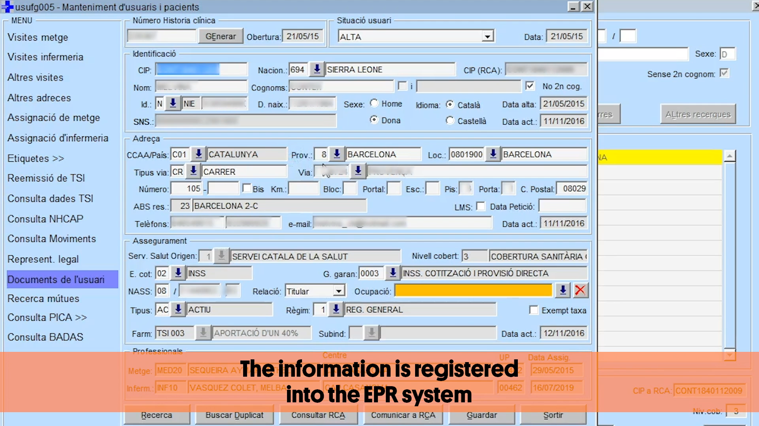

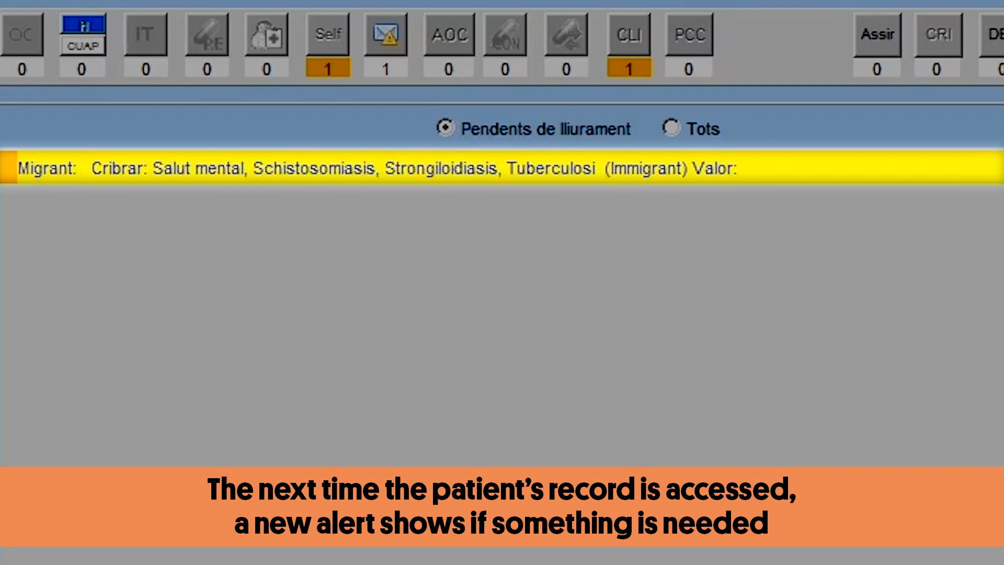

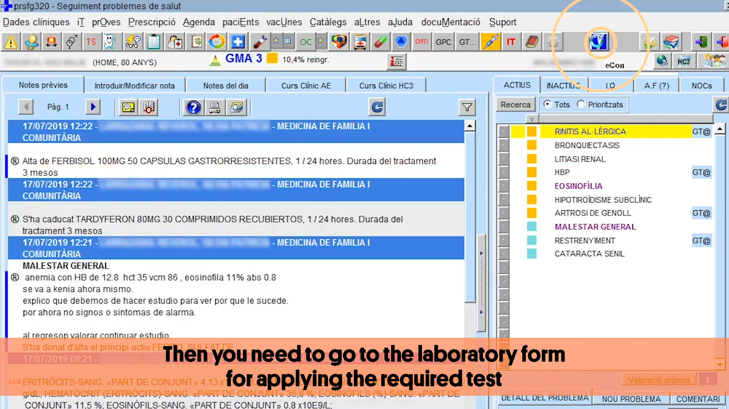

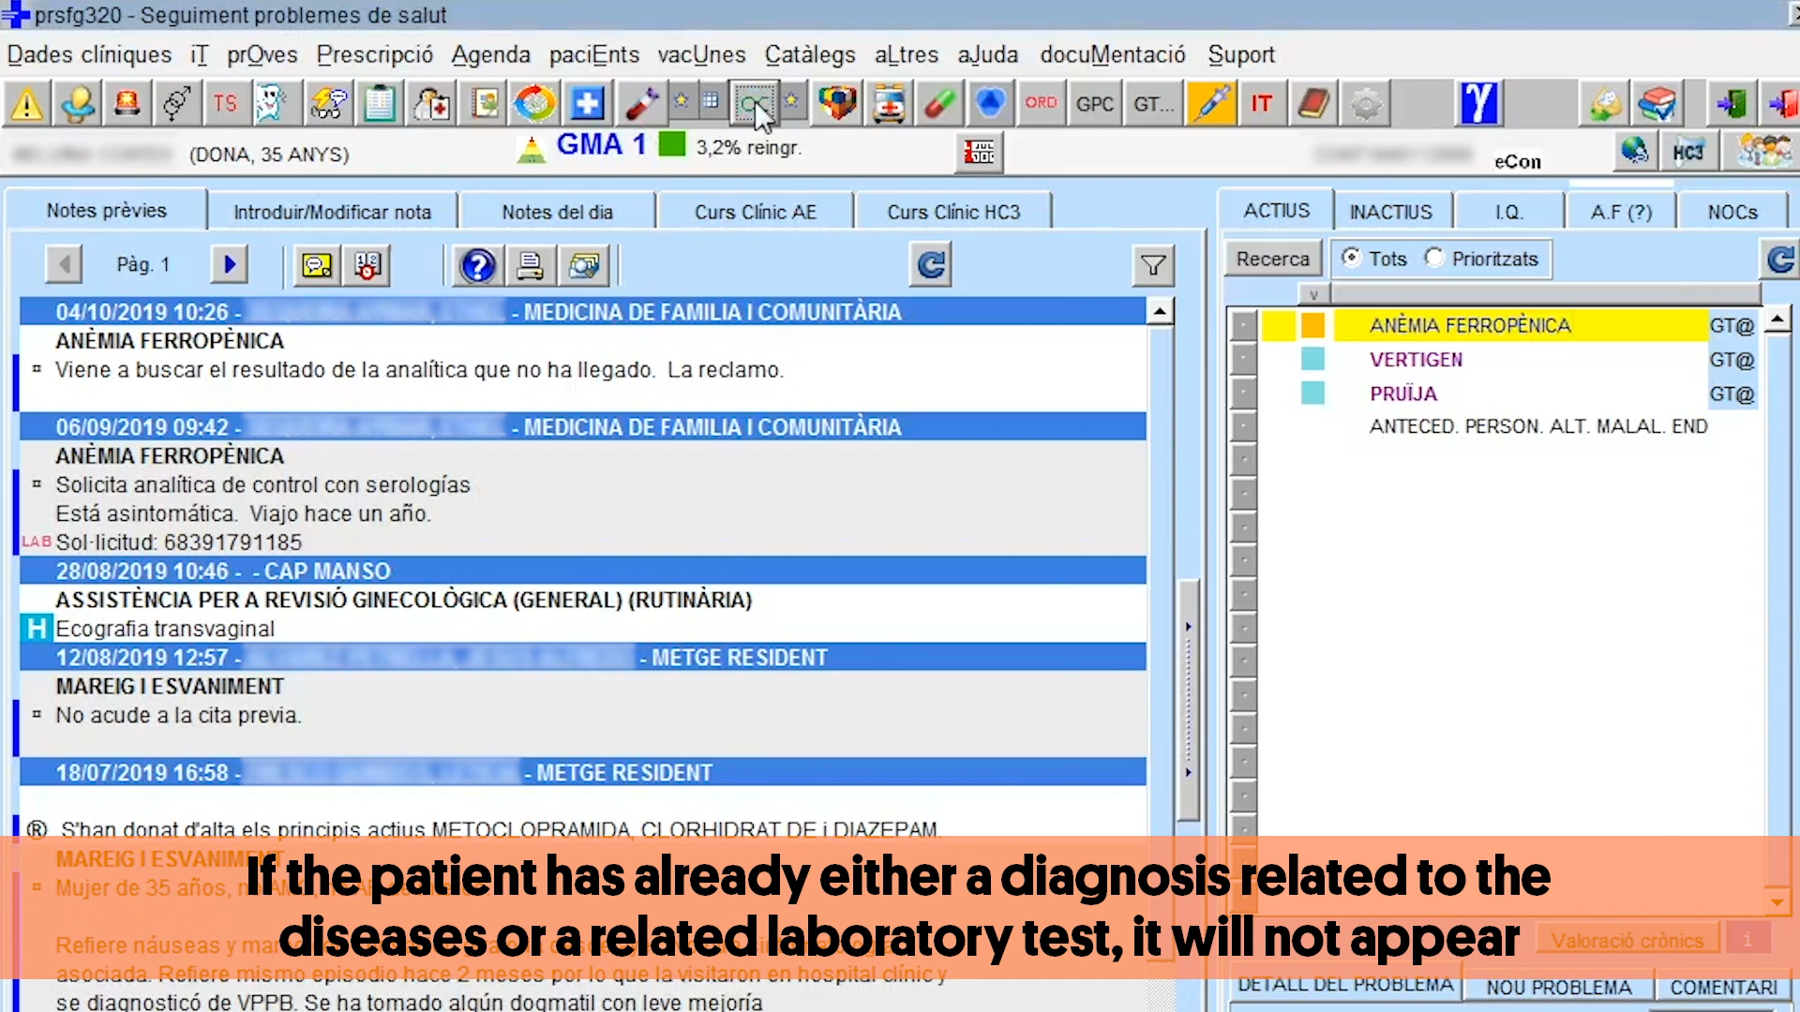

Supplementary File 4. R Packages used in the analyses.
R Core Team (2020). R: A language and environment for statistical computing. R Foundation for Statistical Computing, Vienna, Austria. URL https://www.R-project.org/.

- Wickham et al., (2019). Welcome to the tidyverse. Journal of Open Source Software, 4(43), 1686, https://doi.org/10.21105/joss.01686
- Garrett Grolemund, Hadley Wickham (2011). Dates and Times Made Easy with lubridate. Journal of Statistical Software, 40(3), 1-25. URL http://www.jstatsoft.org/v40/i03/.
- Zeileis A (2004). “Econometric Computing with HC and HAC Covariance Matrix Estimators.” _Journal of Statistical Software_, *11*(10), 1-17. doi: 0.18637/jss.v011.i10 (URL: https://doi.org/10.18637/jss.v011.i10 ).
- Achim Zeileis, Torsten Hothorn (2002). Diagnostic Checking in Regression Relationships. R News 2(3), 7-10. URL https://CRAN.R-project.org/doc/Rnews/
- Alboukadel Kassambara (2020). ggpubr: 'ggplot2' Based Publication Ready Plots. R package version 0.2.5. https://CRAN.R-project.org/package=ggpubr

Supplementary file 5. CONSORT 2010 checklist of information to include when reporting a cluster randomised trial.

Section/Topic | Item No | Standard Checklist item | Extension for cluster designs | Page No *
Title and abstract
 | 1a | Identification as a randomised trial in the title | Identification as a cluster randomised trial in the title | 1
 | 1b | Structured summary of trial design, methods, results, and conclusions (for specific guidance see CONSORT for abstracts) | See table 2 | 4-5
Introduction
Background and objectives | 2a | Scientific background and explanation of rationale | Rationale for using a cluster design
 | 2b | Specific objectives or hypotheses | Whether objectives pertain to the cluster level, the individual participant level or both | 8
Methods
Trial design | 3a | Description of trial design (such as parallel, factorial) including allocation ratio | Definition of cluster and description of how the design features apply to the clusters | 9
 | 3b | Important changes to methods after trial commencement (such as eligibility criteria), with reasons |  | NA
Participants | 4a | Eligibility criteria for participants | Eligibility criteria for clusters | 9
 | 4b | Settings and locations where the data were collected |  | 9
Interventions | 5 | The interventions for each group with sufficient details to allow replication, including how and when they were actually administered | Whether interventions pertain to the cluster level, the individual participant level or both | 11
Outcomes | 6a | Completely defined pre-specified primary and secondary outcome measures, including how and when they were assessed | Whether outcome measures pertain to the cluster level, the individual participant level or both | 13
 | 6b | Any changes to trial outcomes after the trial commenced, with reasons |  | NA
Sample size | 7a | How sample size was determined | Method of calculation, number of clusters(s) (and whether equal or unequal cluster sizes are assumed), cluster size, a coefficient of intracluster correlation (ICC or k), and an indication of its uncertainty | NA (pilot)
 | 7b | When applicable, explanation of any interim analyses and stopping guidelines |  | NA
Randomisation:
Sequence generation | 8a | Method used to generate the random allocation sequence |  | 10
 | 8b | Type of randomisation; details of any restriction (such as blocking and block size) | Details of stratification or matching if used | 10
Allocation concealment mechanism | 9 | Mechanism used to implement the random allocation sequence (such as sequentially numbered containers), describing any steps taken to conceal the sequence until interventions were assigned | Specification that allocation was based on clusters rather than individuals and whether allocation concealment (if any) was at the cluster level, the individual participant level or both | 10
Implementation | 10 | Who generated the random allocation sequence, who enrolled participants, and who assigned participants to interventions | Replace by 10a, 10b and 10c | 10
 | 10a |  | Who generated the random allocation sequence, who enrolled clusters, and who assigned clusters to interventions | 10
 | 10b |  | Mechanism by which individual participants were included in clusters for the purposes of the trial (such as complete enumeration, random sampling)
 | 10c |  | From whom consent was sought (representatives of the cluster, or individual cluster members, or both), and whether consent was sought before or after randomisation
Blinding | 11a | If done, who was blinded after assignment to interventions (for example, participants, care providers, those assessing outcomes) and how |  | NA
 | 11b | If relevant, description of the similarity of interventions
Statistical methods | 12a | Statistical methods used to compare groups for primary and secondary outcomes | How clustering was taken into account | 13-14
 | 12b | Methods for additional analyses, such as subgroup analyses and adjusted analyses |  | 14
Results
Participant flow (a diagram is strongly recommended) | 13a | For each group, the numbers of participants who were randomly assigned, received intended treatment, and were analysed for the primary outcome | For each group, the numbers of clusters that were randomly assigned, received intended treatment, and were analysed for the primary outcome | Figure 1, page 15
 | 13b | For each group, losses and exclusions after randomisation, together with reasons | For each group, losses and exclusions for both clusters and individual cluster members | Figure 1, page 15
Recruitment | 14a | Dates defining the periods of recruitment and follow-up |  | 15
 | 14b | Why the trial ended or was stopped |  | 15
Baseline data | 15 | A table showing baseline demographic and clinical characteristics for each group | Baseline characteristics for the individual and cluster levels as applicable for each group | Table 1
Numbers analysed | 16 | For each group, number of participants (denominator) included in each analysis and whether the analysis was by original assigned groups | For each group, number of clusters included in each analysis | Table 1 and table 2
Outcomes and estimation | 17a | For each primary and secondary outcome, results for each group, and the estimated effect size and its precision (such as 95% confidence interval) | Results at the individual or cluster level as applicable and a coefficient of intracluster correlation (ICC or k) for each primary outcome | 15 and 16
 | 17b | For binary outcomes, presentation of both absolute and relative effect sizes is recommended |  | Page 15 and figure 2
Ancillary analyses | 18 | Results of any other analyses performed, including subgroup analyses and adjusted analyses, distinguishing pre-specified from exploratory |  | Page 16 and 17
Harms | 19 | All important harms or unintended effects in each group (for specific guidance see CONSORT for harms) |  | NA
Discussion
Limitations | 20 | Trial limitations, addressing sources of potential bias, imprecision, and, if relevant, multiplicity of analyses |  | 20
Generalisability | 21 | Generalisability (external validity, applicability) of the trial findings | Generalisability to clusters and/or individual participants (as relevant) | 18, 20
Interpretation | 22 | Interpretation consistent with results, balancing benefits and harms, and considering other relevant evidence |  | 19
Other information
Registration | 23 | Registration number and name of trial registry |  | 14
Protocol | 24 | Where the full trial protocol can be accessed, if available |  | 14
Funding | 25 | Sources of funding and other support (such as supply of drugs), role of  funders |  | 14

Supplementary file 6. Main characteristics of the Primary Care Centres included in the study.
Sanitary area | Barcelona |  | Manresa |  | Lleida |  | Tortosa
Study group | Control | Intervention | Control | Intervention | Control | Intervention | Control | Intervention
 | n(%) | n(%) | n(%) | n(%) | n(%) | n(%) | n(%) | n(%)
Socio-demographic characteristics of Centres
Population assigned | 30,831 | 20,738 | 19,323 | 19,875 | 21,844 | 16,122 | 17,408 | 22,273
Population attended | 20,882  (67.7) | 13,574  (64.5) | 17,067  (88.3) | 17,331  (87.2) | 18,705  (85.6) | 13,619  (84.5) | 15,077  (86.6) | 20,019  (89.9)
Migrant population | 4,348  (20.8) | 2,070  (15.2) | 2,461  (14.4) | 3,043  (17.6) | 3,644  (19.5) | 6,188  (45.4) | 3,501  (23.2) | 2,924  (14.6)
Migrant population with at least one visit during the intervention | 2,343  (53.89) | 1,161  (56.09) | 1,423  (57.82) | 1,864  (61.26) | 1,929  (52.94) | 3,410  (55.11) | 1,914  (54.67) | 1,736  (59.37)
Number of health professionals | 40 | 32 | 18 | 17 | 22 | 18 | 19 | 29
MEDEA index* | 1 | 0.75 | 0.74 | 0.07 | 0.54 | 0.55 | 0.95 | 0.85
*Medea Index: Deprivation index by census tract in cities, that identifies the tracts with the least favorable socioeconomic conditions¹

- Dominguez-Berjon F, et al. Constructing a deprivation index based on census data in large Spanish cities(the MEDEA project). Gac Sanit. May-Jun 2008;22(3):179-87

Supplementary file 7. Screening tests performed for infectious diseases during the intervention period (March – December 2018 ) by study area

 | Barcelona |  |  | Manresa |  |  | Lleida |  |  | Tortosa
 | Control | Intervention | p-value | Control | Intervention | p-value | Control | Intervention | p-value | Control | Intervention | p-value
Total population | 2,343 | 1,161 |  | 1,423 | 1,864 |  | 1,929 | 3,410 |  | 1,914 | 1,736
Number of T· cruzi disease screening tests  Screening number among those with screening criteria | 8 (0·34)  6/813 (0·74) | 22 (1·89)  22/475 (4·63) | <0·001  <0·001 | 8 (0·56)  7/239 (2·93) | 35 (1·88)  33/401 (8·23) | 0·001  0·007 | 3 (0·16)  2/326 (0·61) | 39 (1·14)  34/413 (8·23) | <0·001  <0·001 | 5 (0·26)  5/285 (1·75) | 6 (0·35)  6/165 (3·64) | 0·642  0·213
Number of Strongyloides screening tests  Screening number among those with screening criteria | 27 (1·15)  23/1449 (1·59) | 49 (4·22)  49/865 (5·66) | <0·001  <0·001 | 5 (0·35)  5/1346 (0·37) | 100 (5·36)  100/1752 (5·71) | <0·001  <0·001 | 0 (0·00)  0/1840 (0·00) | 226 (6·63)  224/3261 (6·87) | <0·001  <0·001 | *  * | *  * | --  --
Number of Schistosoma screening tests  Screening number among those with screening criteria | 1 (0·04)  0/124 (0·00) | 7 (0·60)  1/31 (3·23) | 0·001  0·045 | 1 (0·07)  1/146 (0·68) | 27 (1·45)  23/170 (13·53) | <0·001  <0·001 | 0 (0·00)  0/415 (0·00) | 66 (1·94)  58/883 (6·57) | <0·001  <0·001 | *  * | *  * | --  --
Total screening number of any parasitic infection  Screening number among those with screening criteria | 33 (1·41)  28/1457  (1·92) | 53 (4·57)  53/869  (6·10) | <0·001  <0·001 | 13 (0·91)  13/1347 (0·97) | 113 (6·06)  113/1756 (6·44) | <0·001  <0·001 | 3 (0·16)  3/1840 (0·16) | 241 (7·07)  239/3261 (7·33) | <0·001  <0·001 | *  * | *  * | --  --
Number of HIV screening tests  Screening number among those with screening criteria | 5 (0·21)  0/110 (0·00) | 80 (6·89)  4/56 (7·14) | <0·001  0·005 | 128 (9·00)  24/192 (12·50) | 158 (8·48)  33/220 (15·00) | 0·601  0·463 | 177 (9·18)  42/422 (9·95) | 406 (11·91)  153/956 (16·00) | 0·002  0·003 | 93 (4·86)  18/224 (8·04) | 82 (4·72)  11/141 (7·80) | 0·848  0·936
Number of HBV screening tests  Screening number among those with screening criteria | 215 (9·18)  60/628 (9·55) | 90 (7·75)  39/351 (11·11) | 0·159  0·438 | 135 (9·49)  47/405 (11·60) | 176 (9·44)  61/549 (11·11) | 0·965  0·812 | 170 (8·81)  83/956 (8·68) | 445 (13·05)  255/1879 (13·57) | <0·001  <0·001 | 119 (6·22)  66/795 (8·30) | 116 (6·68)  51/666 (7·66) | 0·568  0·651
Number of HCV screening tests  Screening number among those with screening criteria | 223 (9·52)  54/527 (10·25) | 89 (7·67)  29/262 (11·07) | 0·070  0·723 | 141 (9·91)  42/384 (10·94) | 178 (9·55)  61/499 (12·22) | 0·730  0·555 | 158 (8·19)  87/942 (9·24) | 431 (12·64)  269/1882 (14·29) | <0·001  <0·001 | 106 (5·54)  53/791 (6·70) | 92 (5·30)  54/656 (8·23) | 0·751  0·268
Number of active TB screening tests  Screening number among those with screening criteria | 63 (2·69)  24/687 (3·49) | 53 (4·57)  26/443 (5·87) | 0·003  0·058 | 53 (3·72)  7/166 (4·22) | 135 (7·24)  18/182 (9·89) | <0·001  0·041 | 61 (3·16)  9/206 (4·37) | 145 (4·25)  11/428 (2·57) | 0·047  0·225 | 44 (2·30)  1/156 (0·64) | 43 (2·48)  4/115 (3·48) | 0·725  0·086
Number of screening tests for any condition  Screening number among those with screening criteria | 320 (13·66)  250/1814 (13·78) | 185 (15·93)  172/1021  (16·85) | 0·071  0·028 | 204 (14·34)  194/1371 (14·15) | 332 (17·81)  321/1805 (17·78) | 0·008  0·006 | 271 (14·05)  265/1867 (14·19) | 714 (20·94)  699/3316 (21·08) | <0·001  <0·001 | 189 (9·87)  176/1799 (9·78) | 180 (10·37)  167/1605 (10·40) | 0·621  0·547
* Not included in the screening programme· 1. The Tortosa region is excluded· 2. Multilevel mixed-effect logistic regression

Supplementary file 8 Difference-in-differences model estimates and their 95% confidence interval.
Supplementary file 8. The figure presents the combined Chagas disease, strongyloidiasis, and schistosomiasis diagnostic rate diagnostic rate (top), the HIV, Hep-B, Hep-C, and TB combined diagnostic rate (middle) and the combined diagnostic rate (down). Estimates are referenced to the 2012-2014 period, estimates of 2014-16 and 2016-18 serve as a test for the parallel trends' assumption, and the post March 2018 estimate reflects the effect of the intervention. Abbreviations: HIV: human immunodeficiency virus, Hep-B: hepatitis B virus, Hep-C: hepatitis C virus, TB: tuberculosis, 95%CI: 95% confidence interval

