THE VALUE OF PERFUSION FLUID CULTURE ANALYSIS IN DECEASED DONOR RENAL TRANSPLANTS. A 10 YEAR SINGLE CENTRE EXPERIENCE.

Declaration of interest: none

Keywords:
Bacterial
Infection
Transplant
Perfusion fluid
Kidney

Introduction

Infections are a common cause of morbidity and mortality after kidney transplantation [1, 2]. Infection may occur as a consequence of the immunocompromised host being exposed to both hospital- and community-acquired pathogens or it can be transmitted from the donor. In the immunocompromised patient the post operative sequelae can range from local wound infection to systemic life-threatening sepsis. Contamination of the transplanted kidney is a preventable cause of these infective complications.

An important source of graft contamination is via contaminated perfusion fluid (PF), which is used to perfuse the donor kidney after nephrectomy [3, 4, 5]. This PF, initially sterile, does not routinely contain antibiotics and therefore microorganisms can grow in this solution. It has been estimated that contamination of the perfusion fluid may occur in 7% to 24% of kidney transplantation [2,4,6]. Pathogens isolated include both Gram positive and negative bacteria as well as yeast species. The contamination of PF can have devastating infective consequences such as mycotic aneurysm and can ultimately lead to graft loss or patient mortality [7, 8].

The perfusion fluid may become contaminated at any step during the transplant process including at organ retrieval, packaging of the graft and transplantation into the recipient. The contaminating organisms may further be classified as exogenous (derived from handling of the organs), or endogenous (derived from the donor). The origin of these organisms is not always clear. The perfusion fluid can come into contact with bacteria and fungi via direct inoculation, airborne transmission or from contaminated surfaces [1].

The Royal Free Hospital performs around 140 kidney transplants each year. The Royal Free transplant unit has routinely cultured perfusion fluid for over 10 years, though this practice is not routinely carried out by all transplant centres. In 2016 the NHS Blood and Transplant (NHS BT) wrote to all abdominal transplant centres and advised that they begin the routine microbiological testing of perfusion fluid after incidents relating to possible donor transmission of Candida to recipients. Though pre-emptive therapy is advised for PF which is positive for Candida spp [9, 10, 11, 12] there is less consensus on how to interpret and manage a PF which yields a positive bacterial culture. This paper seeks to review the experience of routine culture and pre-emptive treatment of positive PF in a single-transplant centre.

Aims

The aim of this study is to assess the incidence of perfusion fluid contamination and to review the organisms identified, as well as the impact of this routine analysis has on patient management.

Method

Data were collected retrospectively on all deceased donor transplants performed between
2009 and December 2018. Live donors, simultaneous pancreas kidney (SPK) transplant and islet transplants were excluded from this analysis. Data was collected from the pathology results system and patient medical records (including discharge letters and clinic visits).

A 5-10ml sample of PF was obtained at the time of benching the donor kidney prior to transplantation at the Royal Free site. Prior to 2017 all fluid samples were centrifuged at 3000 rpm for 10 minutes. The deposit was then prepared to inoculate the culture media (which included Sabouraud, chocolate, Maconkey, blood and enrichment broth). These plates were read at 18 hours and culture plates with no bacterial growth were re-incubated for a further 24 hours. On day one, enrichment broth was subcultured onto chocolate and neomycin plates and incubated for a further 18 hours. 48 hour anaerobic culture was also performed.

In 2017 the culture medium changed to a liquid broth only, to allow for increased sensitivity for Candida sp. Perfusate fluid was directly inoculated into Bactec blood culture bottles, which were then incubated for five days. All organisms grown were reported, and the significance discussed with the transplant team. Identification was carried out the MALDI-ToF system and sensitivities were performed using BD Phoenix automated system.

As per policy at our unit all transplant recipients received a dose of prophylactic broad-spectrum antibiotics IV at the time of surgery. This would be either co-amoxiclav (1.2g IV) or, if there was a history of penicillin allergy ceftriaxone (1g IV). Co-trimoxazole 480mg OD) was continued for 3 months, as prophylaxis for urinary tract infection and pneumocystis pneumonia. In special circumstances such as a CD4 count under 200 cells/mm³
, rejection or a depleting antibody, this antibiotic was extended. In the case of a PF+ the microbiology team would liaise with ward staff and advise upon initial empirical therapy and further antibiotic or antifungal treatment if necessary. These decisions would be modified as per sensitivities.

Ethics

Retrospective review. No ethical approval sought.

Results

Between January 2009 and 31st December 2018 there was a total of 782 deceased donor transplants. 661 specimens were sent for analysis. The remaining transplants either did not have a specimen sent to the laboratory (n=114) or a specimen was leaking or inappropriate (n=7).

Of the 661 transplants performed where a specimen was analysed 393 were from DBD (59.5%) and 239 (36.2%) were obtained from DCD. In 29 cases (4.4%) it was not possible to ascertain the status of the donor. In this instance they were recorded as unknown deceased donor. The number and type of transplant done per year can be seen in figure 1.

Organisms were cultured in 168/661 (25.4%) of cases. The majority of positive perfusate cultures isolated a single organism (n=120, 71.4%). In 22.6% of cases (n=38) 2 organisms were cultured. In a small minority (n=10, 6%) 3 organisms were identified. A total of 226 organisms were identified in total (see table 1). Figure 2 identifies the number of organisms identified per year.

Given the frequency of positive results and the potential for difficulty when interpreting the significance of an isolate, the microbiology department created a generic protocol for clinicians (see table 2), which was formally shared within the department in August 2014. Organisms were categorised into groups; 1) skin and oral flora (SO), 2) enteric organisms (ET), 3) environmental organisms (EV), 4) other pathogens (OP) and 5) yeast (YE).

Recipients with a PF+ were treated if the organism identified was an environmental organism, enteric organism, other pathogen or yeast species even if there was no suspicion of infection. Antimicrobials were initiated upon the advice of the microbiology department with the spectrum narrowed once sensitivities were available.

By this classification the most frequent organisms identified were skin and oral flora (n=95, 42%), figure 3. The majority of organisms identified (131/226, 58%) would have necessitated prophylactic treatment upon the advice of our microbiology department. Of note there were 7 instances of the perfusion fluid cultures growing organisms resistant to the standard surgical prophylaxis at our institute (see table 3).
There were 15 PF+ in which Candida albicans was detected (see figure 4). 14/15 (93.3%) of these specimens were from DBD donors. All patients received at least 1 month of treatment with an anti-fungal. None of the patients with PF contaminated with Candida albicans developed infective sequelae post transplantation. After the 1st of September 2017 the method to culture the perfusate was switched to a liquid broth, to increase the yield of Candida sps. In 2018 the number of PF+ which isolated Candida was at its highest and accounted for 40% of the total Candida yield. The change in culture method also likely resulted in an increase in PF+ with organisms likely to be contaminants such as skin and oral flora. 62.1% (n=59) of PF+ with skin and oral flora were identified after the method change. There was no rise in PF+ with environmental or enteric organisms after the method change.

The average length of stay was 9.5 days for patients with positive perfusate cultures and 9.4 for those with a negative culture.
For an infection to be classed as related to a perfusion fluid contamination the microbial agent isolated in the infection must be the same as found within the perfusion fluid and occur within 2 weeks of transplantation [2].

Discussion
Infection can be a serious complication post renal transplantation. The perfusion fluid is a possible source of infection and this sample can be readily cultured, with potential infective complications avoided if appropriate antibiotics or antifungals are used. Currently there is only consensus for the pre-emptive treatment of fungal contamination. As other studies have eluded, it is unclear whether a pre-emptive antibacterial treatment could reduce the rate of complications in this group of recipients.
This descriptive study presents one of the largest sample populations over a long time period. This study aligns with previous research which states that organisms are commonly identified in perfusate fluid. Our rate of PF+ of 25.5% is in line with previous studies [2, 13]. Some of these organisms are of low-virulence and of a relatively small inoculum. However, given the immunocompromised host and potentially devastating effects of infection in the recipient prophylactic antibiotics were given to the majority of our transplant recipients.

For an infection to be classed as related to a perfusion fluid contamination the microbial agent isolated in the infection must be the same as found within the perfusion fluid and occur within 2 weeks of transplantation. There was only 1 case where the organism identified in a perfusate fluid culture was isolated again within this 2 week period. In this instance the organism (Enterococcus faecalis) was isolated from a urine culture. It is difficult to infer causation in this instance.

This similarity in outcomes between PF+ and PF- recipients may be secondary to the pro-active identification and treatment of the organisms found in PF+ in combination with the prophylactic antibiotics given at induction.

There are case reports in the literature of severe complications such as renal artery aneurysm, graft arteritis and anastomotic rupture in recipients with perfusion fluid contaminated by Candida spp [7, 11] Of the patients with a PF+ for Candida albicans (n=15) none had these complications. This is likely due to the prophylactic use of anti-fungal treatment once a yeast species was identified on culture.

The significance of other organisms isolated in perfusion fluid is more contentious. A review by Sharma et al [2] of over 600 renal allograft recipients in a centre where pre-emptive antibiotics were not routinely given in the event of a positive perfusion fluid culture. In their retrospective review grafts contaminated with lactose fermenting coliforms were associated with graft loss and bacteraemia. In contrast, contamination with skin flora seemed to pose less risk to the transplant recipient. Overall, though the incidence of infection may be low, a meta-analysis by Oriol et al [3] reported a high mortality rate in the infected recipients of 35% (95%CI 21.0-53.0%).

Though a minority (7/168 4.2% ) of PF+ isolated an organism that was resistant to routine surgical prophylaxis these organisms may pose a more significant risk to the recipient [4]. The lag time between culture and antibiotic sensitivities for PF may increase the risk of recipient infection secondary to such organisms. As antimicrobial resistance increases, there could be increased numbers of drug resistant organisms in PF+ in the future. Though local antibiotic protocols consider local resistance rates donor kidneys can come from great distances within the UK and, less frequently, abroad. These differing resistance rates should be considered carefully by the transplant and microbiology team. In our own department, led to surgical prophylaxis changing from co-amoxiclav to flucloxacillin and temocillin to improve coverage for extended spectrum beta lactamase (ESBL) organisms in 2019.
The limitations of this study include it being a single centre and retrospective. From 2016 NHSBT were notified of all significant pathogens so that the recipients of the both donor kidneys could be contacted. If any of these other patients were untreated it may allow for a direct comparison of patients and improve understanding of the impact of treatment a positive PF. Gaining information about PF+ rates in sister kidneys and the clinical outcome of recipients in other centres would be a useful addition to this study. This information, if available in the future, may allow for a better analysis of pre-emptive antibiotic use in PF+ recipients.

Conclusion
The contamination of PF occurs commonly and is due to a range of factors. Regardless of the aetiology a subsequent infection in the immunocompromised recipient may lead to significant morbidity and mortality. Given the high rate of PF+, the use of routine broth culture can be justified to ensure that virulent organisms are identified, and early treatment initiated. Culture techniques may be optimised to ensure the best conditions for growth. A strong link between microbiology, medic and surgeon is required to ensure that positive results can be interpreted, communicated and acted upon quickly. The surgeon’s important role in sending PF routinely must also be stressed.
Sharing positive PF results if they yield more virulent organisms with NHSBT should be commonplace. Further studies are needed to assess the impact of pre-emptive treatment so that a more standardised approach between transplant centres could be considered.

Abbreviations:
PF : perfusion fluid
PF+: perfusion fluid culture positive
PF- : perfusion fluid culture negative
DBD : donor after brain death
DCD : donor after cardiac death

Works Cited

[1] | F. J. M. P. Wakelin S, “Incidence and importance of bacterial contaminants of cadaveric renal perfusion fluid.,” Transpl Int., pp. Jan;17(11):680-6., 2005.
[2] | Sharma et al , “Clinical outcome of cadaveric renal allografts contaminated before transplantation,” Transplant Int , p. 8(7):824–827. , 2005.
[3] | Oriol et al , “Clinical impact of culture-positive preservation fluid on solid organ transplantation: A systematic review and meta-analysis,” Transplantation Reviews , pp. Volume 32, Issue 2, April 2018, Pages 85-91, 2018 .
[4] | Kieslichova, E et al , “Single mutidrug resistant enterobacteriacae donor-derived infection in four solid organ transplant recipients: a case report,” BMC Surg, pp. 19(1):111. doi: 10.1186/s12893-019-0574-9., 2014 .
[5] | Sonia J. Wakelin ,John Casey ,Amanda Robertson ,Peter Friend ,Bryon C. Jaques ,Hester Yorke ,Sue P. Rigden ,Xavier F. S. Emmanuel ,Lucia Pareja-Cebrian ,John L. R. Forsythe ,Peter J. Morris, “The incidence and importance of bacterial contaminants of cadaveric renal perfusion fluid,” Transpl Int, pp. 17: 680-686, 2005.
[6] | P. M. N. D. U. E. Kieslichova E, “Single mutidrug resistant enterobacteriacae donor-derived infection in four solid organ transplant recipients: a case report.,” BMC Surg., p. Aug 14;19(1):111, 2019 .
[7] | Levesque E et al, “Fungal complications after Candida preservation fluid contamination in liver transplant recipients.,” Transpl Int, pp. Nov;28(11):1308-16. doi: 10.1111/tri.12633. Epub 2015 Jul 27., 2015.
[8] | Rodrigues et al , “Candida Species Contamination of Preservation Fluid Outcome of Renal Transplantation in 6 Patients.,” Transplant Proc., pp. Jul-Aug;45(6):2215-9. doi: 10.1016/j.transproceed.2013.03.024., 2013.
[9] | Matignon, M et al. , “Outcome of renal transplantation in eight patients with Candida sp. contamination of preservation fluid,” Am J Transplant , p. 8(3):697–700, 2008.
[10] | Albano, L et al , “Evidence that graft-site candidiasis after kidney transplantation is acquired during organ recovery: a multicenter study in France,” Clin Infect Dis, p. 48(2):194–202, 2009.
[11] | Ranghino, A et al , “Clinical impact of bacterial contamination of perfusion fluid in kidney transplantation.,” Springerplus, pp. 4;5:7. doi: 10.1186/s40064-015-1658-3. eCollection 2016., 2016.
[12] | Anderson, C et al , “Significance of microbial contamination of stored cadaver kidneys.,” Arch Surg, p. 1. 113:269–271. doi: 10.1001/archsurg.1978.01370150041006. , 1978.
[13] | Taksin, L et al , “Mycotic aneurysm and renal transplant. A case report,” Prog Urol , pp. Feb;19(2):149-52. doi: 10.1016/j.purol.2008.10.005. Epub 2008 Nov 28., 2009 .
[14] | Karuthu,S; Blumberg,E, “Common Infections in Kidney Transplant Recipients,” CJASN, pp. 7 (12) 2058-2070; DOI: https://doi.org/10.2215/CJN.04410512 , 2012.
[15] | Benoit, G et al, “Incidence of transport medium contamination in cadaver kidney procurement.,” Transplant Proc, p. 20:895, 1988.

Table 1: List of organisms identified
Organism | Frequency
Acinetobacter radioresistens | 2
Acinetobacter spp. | 1
Bacillus cereus | 2
Bacillus mycoides | 1
Bacillus subtilis | 1
Bacteroides uniformis | 1
Bacteroides vulgatus | 1
Beta-haemolytic streptococcus (Group A Streptococcus) | 1
Candida albicans | 15
Citrobacter freundii  Inducible Chromosomal Cephalosporinase (AmpC) | 2
Citrobacter spp. | 1
Coagulase-negative Staphylococcus | 4
Corynebacterium (JK) spp. | 1
Corynebacterium accolens | 1
Corynebacterium spp. | 1
Delftia acidovorans | 2
Enterobacter cloacae¬† | 7
Enterococcus faecalis | 6
Enterococcus faecalis (VRE) | 1
Enterococcus faecium | 3
Enterococcus faecium (VRE) | 1
Enterococcus spp. (Vancomycin Resistant) | 1
Escherichia coli | 22
Escherichia coli ESBL confirmed | 3
Haemophilus influenzae | 1
Klebsiella oxytoca | 1
Klebsiella pneumoniae | 5
Lactobacillus spp. | 3
Massilia timonae | 1
Micrococcus luteus | 4
mixed anaerobes | 1
Pantoea proteolytica | 1
Pantoea spp. | 1
Propionibacterium avidum | 1
Propionibacterium spp. | 1
Proteus mirabilis | 3
Pseudomonas aeruginosa | 3
Pseudomonas brenneri | 1
Pseudomonas fluorescens | 5
Pseudomonas oryzihabitans | 1
Pseudomonas spp. | 11
Sphingomonas spp. | 1
Staphylococcus aureus | 8
Staphylococcus aureus (MRSA) | 1
Staphylococcus capitis | 10
Staphylococcus caprae | 1
staphylococcus epidermidis | 44
Staphylococcus haemolyticus | 2
Staphylococcus hominis | 4
Staphylococcus lugdunensis | 3
Staphylococcus pasteuri | 2
Staphylococcus pettenkoferi | 1
Staphylococcus warneri | 11
Streptococcus anginosus | 2
Streptococcus gordonii | 1
Streptococcus mitis | 1
Streptococcus oralis | 3
Streptococcus parasanguinis | 1
Streptococcus salivarius | 2
Streptococcus spp. | 1
Viridans type streptococcus | 2

Table 2: Microbiology policy regarding the interpretation of positive perfusion fluid cultures
Skin flora and oral flora  E.g. staphylococcus epidermidis, staphylococcus hominis | Unlikely to be clinically significant. Likely contaminants. | No antibiotics required
Environmental organisms  E.g. pseudomonas non aeruginosa species | Uncertain clinical significance. | Treat for 5-7 days with antibiotic choice guided by sensitivity testing
Enteric organisms  E.g. enterococcus species, e. coli, anaerobes, pseudomonas aeruginosa | Clinically significant. | Treat for 5-7 days with antibiotic choice and duration guided by sensitivity testing and patient progress
Other gram positive pathogens  E.g.  Staphylococcus aureus, Staphylococcus lugdanensis , | Clinically significant. | Treat with 2 weeks of appropriate antibiotics.
Yeast  E.g. Candida spp | Clinically significant. | Minimum treatment duration of 1 month.

Table 3: Organisms not covered by routine surgical prophylaxis
Organism | Frequency
Enterococcus faecalis (VRE) | 1
Enterococcus faecium (VRE) | 1
Enterococcus spp. (Vancomycin Resistant) | 1
Escherichia coli ESBL confirmed | 3
Staphylococcus aureus (MRSA) | 1

Figure 1
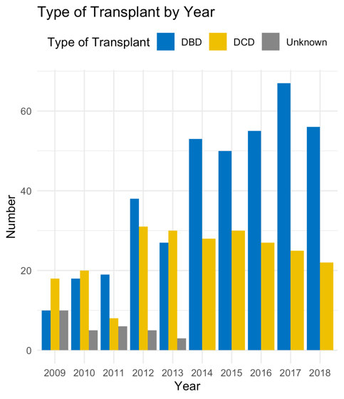

Figure 2
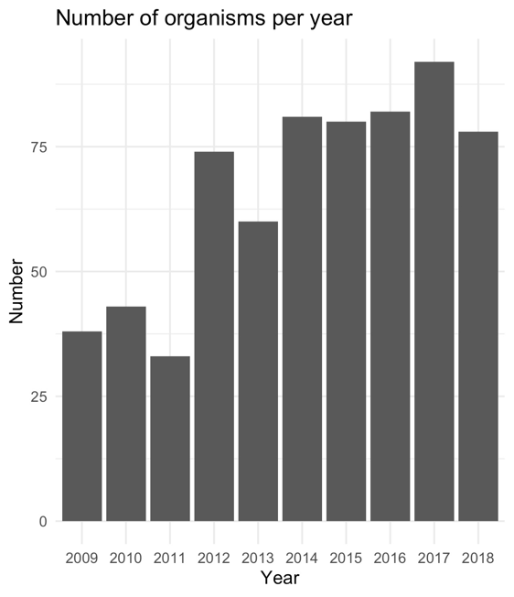

Figure 3: Organisms identified by class

Figure 4
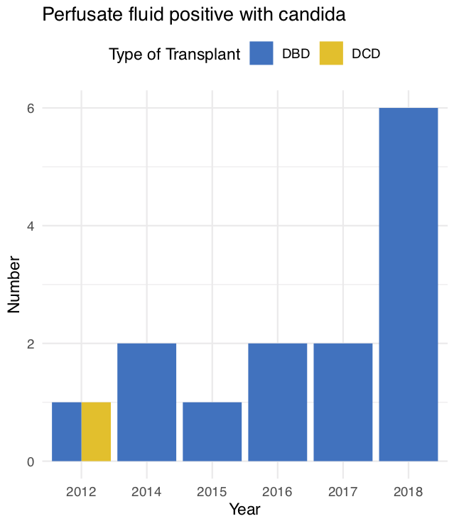

https://www.royalfree.nhs.uk/news-media/news/how-transplant-surgery-started-at-the-royal-free/

