INVESTIGATION OF SARS-CoV-2 OUTBREAKS IN SIX CARE HOMES IN LONDON, APRIL 2020

The London Care Home Investigation

Ladhani S et al.

SUPPLEMENT
INFORMATION

Supplement Figure 1: Epidemic curves for the 6 London care homes with a COVID-19 outbreak that were investigated by Public Health England. Testing across the six care homes took place during the weekend ending 12 April 2020. The vertical column denotes the number of COVID-19 confirmed (orange), suspected (blue) and fatal (grey) cases among residents

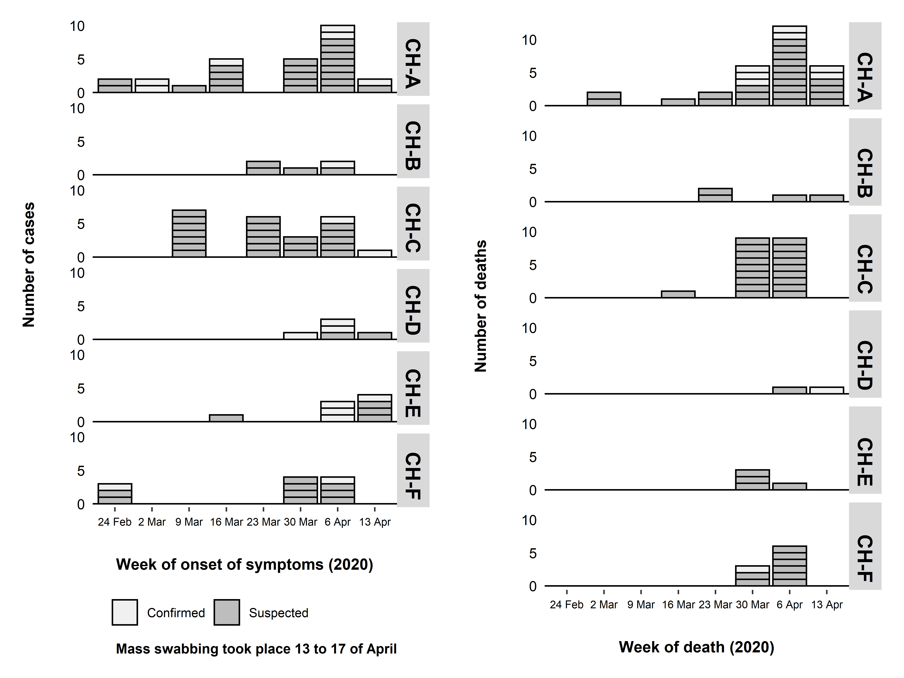

Supplement Table 1: Summary of infection prevention and control advice

General infection prevention and control advice
Hand hygiene | Reinforce education of staff and visitors about hand and respiratory hygiene and display PHE posters widely. Ensure PHE infection control policies are up to date, read and followed by all staff. Ensure liquid soap and disposable paper towels are available at each sink, and alcohol-based hand rub (at least 70%) is in every room/communal area, and stocks are adequately maintained. If it is not possible to have alcohol hand rub in rooms/communal areas, consider providing staff with individual containers.
Personal protective equipment (PPE) | Ensure that PPE is available, i.e. disposable gloves, aprons, and splash proof surgical masks, plus eye protection for procedures that may generate splashback. Ensure PPE is changed between residents (masks and eyewear can be sessional). PPE should be worn for all care activities regardless of whether residents have a suspected/confirmed case.
Linen and waste | Ensure linen management and clinical waste disposal systems are in place, including foot operated bins. Guidance on linen and waste handling is provided by PHE.
Environmental cleaning | Enhanced cleaning in home during outbreak e.g. 2 hourly cleaning in communal areas that are not closed. Clean surfaces, and high touch areas frequently (e.g. door handles). Clean common equipment between residents, e.g. hoists, aids, baths, showers. Maintain adequate levels of equipment in anticipation of increased cleaning (e.g. disposable cloths, mop heads, detergent, etc).
Staffing | Allocate a separate staff cohort to support residents with symptoms. Avoid, where possible allocating agency staff to this task. Any staff who have recovered from confirmed COVID-19 should be allocated to this.  Staff should be advised not to rotate within groups of care homes.
Visitors | Any visitors should be limited to only essential persons, i.e. main carer. Discourage visits by children. Family and friends should be advised not to visit care homes, except next of kin in exceptional situations such as end of life.  Healthcare visits should be restricted to those that are essential. Advise any visiting health professionals of an outbreak and rearrange non-urgent visits to the home.
Transfers | Transfer of residents to hospital or other institutions should be avoided unless clinically necessary/medical emergency and, if possible, advised by the GP.  If transfer is required, transport services (including emergency ambulances) and the receiving hospital/setting should be made aware of any suspected outbreak in the home, and/or if the resident is a suspected case BEFORE transfer.
Closure | Discuss any potential closure to new admissions to the affected area/care home during an outbreak. However, with heightened bed pressures across the health and care sector, decisions around closure are not straight-forward.  Where providers consider there to be imminent risks to the continuity of care, e.g. potential closure of a service, they should raise this with the Local Authority (Social Care commissioner) without delay.
For symptomatic or confirmed cases
Residents | Isolate residents for 14 days from the onset of symptoms, or date of test if asymptomatic.  - Cases should be isolated in their bedroom  - Discourage use of communal areas  - If communal areas remain open, advise that chairs should be 2 metres apart- magazines, books and games to be removed  - Avoid the use of fans that re-circulate the air
Staff | Self-isolate for 7 days after onset of symptoms or date of test if asymptomatic.  Household members should self-isolate for 14 days. If they develop symptoms, they should isolate for 7 days from the date of symptom onset.  Staff members who have completed 7 days isolation and no longer have symptoms do not require a negative test before returning to work

Source:

Adapted from:
Public Health England. Winter-readiness information for London care homes. 2018.

Reference:

Department of Health and Social Care. Admission and Care of Residents during COVID-19 Incident in a Care Home. Published 2 April 2020. https://www.gov.uk/government/publications/coronavirus-covid-19-admission-and-care-of-people-in-care-homes
Public Health England. How to work safely in care homes. https://www.gov.uk/government/publications/covid-19-how-to-work-safely-in-care-homes

Public Health England. COVID-19: infection prevention and control guidance. https://www.gov.uk/government/publications/wuhan-novel-coronavirus-infection-prevention-and-control
https://www.gov.uk/government/publications/wuhan-novel-coronavirus-infection-prevention-and-control/covid-19-personal-protective-equipment-ppe
Supplement Table 2: Summary of the six care homes by type and infection control measures in place at time of investigation

Care Home | Care home type | Layout of care home | Room types | Infection Control
A | Nursing & end of life care | 5 floors | Single occupancy rooms with ensuite | Staff did not have full PPE. They had gloves & aprons but  no face masks for 3 weeks
B | Nursing and Dementia care | 2 floors, 21 general nursing, 26 dementia | Single occupancy rooms with ensuite | Staff were using PPE for care duties regardless of residents’ symptoms. No issues with PPE stock
F | Nursing | Layout: 3 floors; ground floor 9 bedded unit, middle floor 18 bedded unit, top floor 18 bedded unit | Single occupancy rooms with ensuite | Staff using PPE for all the residents; increased cleaning of touch surfaces, hoists etc. since first case confirmed
E | ½ nursing, ½ residential for dementia | 4 floors: units 2 nursing, 2 residential | Single occupancy rooms with ensuite | PPE regardless of symptoms of residents, keeping all residents in isolation as much as possible.
C | Residential & Nursing | Distributed over 3 floors | Single occupancy rooms with ensuite | Adequate PPE and linen and waste management systems in place; closed to admissions and transfers
D | Nursing Care Home | 3 floors; currently most people staying in their rooms with social distancing in room | Single ensuite rooms for all but 3 residents who were sharing a room | Rigorous infection prevention and control measures already in place. All staff were using PPE throughout the care home
PPE (aprons, gloves, surgical masks and visors); IPC = infection control measures in place

Supplement Table 3: Live virus isolation among asymptomatic and symptomatic residents and staff, according to timing of symptom onset

RESIDENTS | STAFF
Post-symptomatic  -7 days (1/1 positive)  -6 days (1/1 positive)  -4 days (1/1 positive)  -3 days (0/1 positive)  -1 days (0/1 positive) | Post-symptomatic  -13 days (0/1 positive)  -9 days (0/2 positive)  -7 days (1/1 positive)  -6 days (0/1 positive)  -4 days (1/1 positive)  -2 day (1/1 positive)
Pre-symptomatic  +1 days (0/1 positive)  +9 days (0/1 positive)  +11 days (1/2 positive)  +13 days (1/1 positive) | Pre-symptomatic  +2 day (0/1 positive)  +4 days (1/1 positive)  +6 days (1/1 positive)
Symptomatic  -15 days (0/1 positive)  -12 days (1/2 positive)  -11 days (1/2 positive)  -10 days (0/1 positive)  -9 days (0/1 positive)  -8 days (0/1 positive)  -7 days (1/2 positive)  -6 days (0/3 positive)  -4 days (0/1 positive)  -2 days (1/1 positive)  0 days (1/1 positive) | Symptomatic  -10 days (0/1 positive)  -9 days (0/1 positive)  -5 days (1/1 positive)  -4 days (1/1 positive)  -3 days (0/1 positive)
Asymptomatic  5/17 (29.4%) positive | Asymptomatic  2/6 (33.3%) positive

Supplement Table 4: Live virus isolation by RT-PCR cycle threshold (Ct) values among asymptomatic and symptomatic residents and staff, according to timing of symptom onset. Numbers in parenthesis for residents and staff indicate timing of symptom onset from the day of testing (x denotes symptom onset date not available)

Ct Value | RESIDENTS | STAFF
<20  (2/2 positive, 100%) | 2 POSITIVE  Pre-symptomatic (11)  Symptomatic (-12) | -
20 to <25  (14/17 positive, 82.4%) | 10 POSITIVE  2 Asymptomatic  3 Symptomatic (-11, -7, -2)  3 Post-symptomatic (-4, -6, -7)  2 Pre-symptomatic (9, 13)  2 NEGATIVE  1 Asymptomatic  1 Symptomatic (-7) | 4 POSITIVE  2 Asymptomatic  1 symptomatic (-5)  1 post-symptomatic (-4)  1 NEGATIVE  Asymptomatic
25 to <30  (6/15 positive, 40.0%) | 2 POSITIVE  1 Asymptomatic  1 Symptomatic (0)  8 NEGATIVE  2 Asymptomatic  3 Symptomatic (-6, -10, -15)  3 Pre-symptomatic (1, 11, X) | 4 POSITIVE  1 Asymptomatic  1 Symptomatic (-4)  1 Post-symptomatic (-7)  1 Pre-symptomatic (+6)  5 NEGATIVE  5 Asymptomatic
30 to <35  (9/53 positive, 17.0%) | 5 POSITIVE  4 Asymptomatic  1 Pre-symptomatic (x)  21 NEGATIVE  10 Asymptomatic  8 Symptomatic (-4, -6, -6, -8, -9, -11, -12, X)  2 Post-symptomatic (-3, -1)  1 Pre-symptomatic (2) | 4 POSITIVE  2 Asymptomatic  1 Post-symptomatic (-2)  1 Pre-symptomatic (+4)  23 NEGATIVE  14 Asymptomatic  4 Symptomatic (-3, -6, -9, -10)  4 Post-symptomatic (-9, -9, -13)

Supplement Table 5. Whole genome sequence analysis of SARS-CoV-2 strains causing an outbreak in 6 London Care Homes

Care home | Number samples tried | Number sequences derived | Staff | Residents
Care home A | 55 | 21 | 8 | 13
Care home B | 14 | 7 | 0 | 7
Care home F | 21 | 13 | 5 | 8
Care home E | 19 (one duplicate) | 13 | 4 | 9
Care home C | 26 | 11 | 2 | 9
Care home D | 47 | 34 | 12 | 22
Table S6a. SARS-CoV-2 strains selected for whole genome sequencing by care homes
All 158 PCR positive samples were used for WGS analysis. Of these, 99 yielded sequence sufficient for WGS analysis distributed amongst all the care homes; 31/99 from staff and 68/99 from residents. Sequences were aligned using maaft (version 7.310), manually curated and a phylogenetic tree was built using IQtree (version 2.04). This phylogenetic tree (Figure 3 in the manuscript) was coloured to indicate care home of origin and annotated to indicate sequences derived from staff members and sequences from residents who had died.
Phylogenetic analysis indicated the presence of informal clusters from Care homes A, B, D, E present in both the phylogeny from care home sequences ((Figure 2 in the manuscript). The largest cluster (care home D) contained 28 sequences of which 15 sequences exhibited zero SNPs difference and the maximum distance between sequences was three SNPs. The presence of clusters containing care home sequences provided good evidence for introduction and subsequent spread of a SARS-CoV2 strain in a care home setting.
Each of the six care homes contained SARS-CoV-2 genomes from lineages B.1 and B.2 and the distance between sequences in the large cluster (n. 28) in care home D (lineage B.2.1) and the sequences in lineage B.1 was 13 - 18 SNPs. This provides good evidence for multiple introductions of the virus into care home settings. The placement of sequences in the phylogeny indicated that care home A exhibited three distinct sequence clusters along with six singletons, potentially representing up to nine separate introductions.
There were ten sequences that had a 0 SNP distance between them which were from three different care homes However, these sequences were part of a large clade of sequences within the B.1 lineage (n. > 5,500). . It is possible that identical viruses were introduced from other settings into all three homes separately or transferred from home to home. This observation means that genomics can neither exclude nor confirm that the cases in separate homes were linked.
All care home clusters of SARS-CoV-2 genomes included at least one staff member, apart from those from the care home with no PCR positive staff. Other than this observation, there was no genetic signal within the SARS-CoV-2 genomes that differentiated staff and residents or symptomatic and asymptomatic individuals. The ten available sequences from fatalities, were distributed across the diversity of sequences derived from the care homes (Figure 3 in the manuscript) and were closely matched to sequences derived from non-fatal cases in the same locations, indicating the absence of a particular strain associated with fatality in this study.

