Antiarrhythmic drugs for atrial fibrillation: Lessons from the past and opportunities for the future

Jordi Heijman, PhD¹, Stefan H. Hohnloser, MD², A. John Camm, MD³

¹Department of Cardiology, Cardiovascular Research Institute Maastricht, Faculty of Health, Medicine, and Life Sciences, Maastricht University, Maastricht, The Netherlands

²Department of Cardiology, J. W. Goethe-Universität Frankfurt am Main, Frankfurt/Main, Germany

³Cardiovascular and Cell Sciences Research Institute and Cardiology Clinical Academic Group St George's, University of London, London, United Kingdom

Running title: Heijman et al. – Antiarrhythmic Drugs for Atrial Fibrillation

Article type: Review Article

Length: 3592 words (excluding references and figure legends)

Corresponding Author:
Dr. Jordi Heijman, Department of Cardiology, Cardiovascular Research Institute Maastricht, Faculty of Health, Medicine, and Life Sciences, Maastricht University. PO Box 616, 6200 MD, Maastricht, The Netherlands; Phone: +31 43 38 76046; jordi.heijman@maastrichtuniversity.nl

Abstract
Atrial fibrillation (AF) remains a highly prevalent and troublesome cardiac arrhythmia, associated with substantial morbidity and mortality. Restoration and maintenance of sinus rhythm (rhythm-control therapy) is an important element of AF management in symptomatic patients. Despite significant advances and increasing importance of catheter ablation, antiarrhythmic drugs (AADs) remain a cornerstone of rhythm-control therapy. During the last 50 years experimental and clinical research has greatly increased our understanding of AADs. As part of the special issue on paradigm shifts in AF, this review summarizes important milestones in AAD research that have shaped their current role in AF management, including 1) awareness of the proarrhythmic potential of AADs; 2) increasing understanding of the pleiotropic effects of AADs; 3) the development of dronedarone; and 4) the search for AF-specific AADs. Finally, we discuss short- and long-term opportunities for better AF management through advances in AAD therapy, including personalization of AAD therapy based on individual AF mechanisms.

Key Words: atrial fibrillation, antiarrhythmic drugs, dronedarone, ion channels

Introduction
Atrial fibrillation remains a common and problematic cardiac arrhythmia that is associated with substantial morbidity and mortality, decreased quality of life, and significant healthcare costs.¹ AF management is multifaceted and requires an integrated approach addressing underlying risk factors, comorbidities, and stroke risk, as well as control of the arrhythmia itself.¹ Despite the increasing importance of catheter ablation for rhythm-control therapy, AADs continue to play an important role in the management of AF. The rate of AAD prescription has nearly tripled between 2004 and 2016 according to an insurance database from the United States covering 63 million individuals.² In this database, there were approximately 1,100 arrhythmia diagnoses (~70% of which concerned AF or atrial flutter) and 950 AAD prescriptions per 100,000 patients in 2016.² Similarly, in the RealiseAF survey including 10,523 AF patients from 26 countries, >80% of patients received AADs, with ~50% of patients receiving AADs typically used for rhythm-control therapy.³ Recently, the EAST trial showed that early rhythm-control therapy, primarily with AADs (<20% of patients had received ablation at 2-year follow-up), was associated with a lower risk of cardiovascular outcomes than usual care.⁴
AADs have a long history. As cited in Karagueuzian et al.⁵, cinchona extract, the botanical source of quinine was already used to treat palpitations by Jean Baptiste de Sénac in 1749, before AF was recognized as their underlying mechanism. Thereafter, several additional compounds with antiarrhythmic properties were identified through empirical observations and pharmacological approaches were used to obtain more favorable derivatives, giving rise to e.g., lidocaine, procainamide, bretylium and disopyramide, followed by amiodarone, flecainide and propafenone. In the early 1970s, these related antiarrhythmic agents were grouped into three classes based on their functional and electrophysiological effects: Class I drugs reduced myocardial excitability; Class II drugs (beta blockers) had sympatholytic effects; and Class III drugs prolonged repolarization duration.⁵ The effects of Class I drugs were later attributed to inhibition of cardiac Na⁺-channels, whereas repolarization prolongation was attributed to inhibition of repolarizing K⁺-channels, particularly the rapidly activating delayed-rectifier K⁺ current (I_{Kr}). The discovery of the antiarrhythmic potential of verapamil, a Ca²⁺-channel blocker, subsequently gave rise to Class IV. The organization of AADs in these four classes is commonly attributed to Vaughan Williams and Singh and remains extensively used to date, with members of all four classes used in AF management (Figure 1).
Since the development of the Vaughan Williams classification of AADs, 50 years of experimental and clinical research have greatly increased our understanding of AADs. The mechanism-of-action and pharmacological properties of individual AADs has been described in detail in previous work.^{6, 7} The remainder of this review provides a short conceptual overview of paradigm shifts in AAD research that have shaped their current role in AF management (Table 1) and discusses opportunities for better AF management through advances in AAD therapy. For a more detailed overview of AF mechanisms, novel therapeutic targets and translational considerations for the development of new AADs, the interested reader is referred to comprehensive recent reviews.⁸⁻¹⁰

‘First, do no harm’ – the proarrhythmic potential of AADs
The adverse potential of AADs was already known before the Vaughan Williams classification was established, with ‘quinidine syncope’ attributed to life-threatening Torsade de Pointes (TdP) arrhythmias in 1964.¹¹ However, in the early 1990s, two landmark clinical trials changed the future of AADs. The Cardiac Arrhythmia Suppression Trial (CAST) and Survival with Oral D-Sotalol (SWORD) study revealed increased mortality in post myocardial infarction patients receiving certain Class I or Class III AADs, respectively, in part due to drug-induced ventricular proarrhythmia.¹² Also when used for rhythm control of AF, many of the currently used AADs have considerable proarrhythmic potential.¹³ Because AF itself is not immediately life-threatening, drug-induced ventricular proarrhythmia is one of the major factors limiting the clinical use of AADs. For example, amiodarone and dofetilide (in the USA) are the only AADs approved in patients with heart failure.¹ In addition, the pro-arrhythmia implications from the CAST and SWORD trial have had a major impact on currently available AADs, resulting in suspended development (e.g., indecainide, recainam), failure to move from proof-of-concept to pivotal studies (e.g., budiodarone), failure to progress development from intravenous to oral formulation (e.g., vernakalant,), failed approval (e.g., tedisamil, vernakalant), choice not to further develop and seek approval (e.g., ranolazine), limited indications (e.g., dronedarone), restricted marketing (e.g., dofetilide, ibutilide, moricizine), or even withdrawal of several compounds (e.g., procainamide and quinidine). Some agents that did enter a development programme were ineffective (e.g., BMS 914392) or were complicated by unexpected off-target adverse effects (e.g., S66913). Overall, the development of AADs was severely hindered by these important trials that highlighted that a successful antiarrhythmic agent might do more harm than good. Therefore, hard outcome trials became required for every compound targeted directly at arrhythmia mechanisms.
Around the same time, it became clear that besides cardiovascular drugs also non-cardiovascular drugs could cause TdP; the most common underlying mechanism being unwanted off-target inhibition of I_{Kr}. This gave rise to the field of preclinical cardiac safety testing, which continues to play a major role in drug development and has itself provided relevant information on pro- and antiarrhythmic mechanisms.¹⁴

From Vaughan Williams to the Sicilian Gambit – understanding pleiotropic AAD effects
The traditional AADs were developed in the absence of knowledge about their molecular targets, but were selected empirically, based on observed antiarrhythmic characteristics, and grouped according to their effects on normal cardiac electrophysiological properties. Experimental research in the early 1990s revealed that most AADs in fact inhibit multiple molecular targets.¹⁵ The Sicilian Gambit classification of AADs was proposed to integrate the mechanistic actions of AADs with their clinical effects.¹⁵ Although the Sicilian Gambit and other, more recent classifications, more accurately capture the complexity of AADs, they have not been able to replace the Vaughan Williams classification in everyday use. However, the increasing awareness of pleiotropic effects, with different potencies for different channels (Table 2), did explain some of the challenges with predicting the exact electrophysiological effects of an AAD and their potential pro- or antiarrhythmic consequences.¹⁵ AADs also have important extra-cardiac effects, either because their molecular target in the heart is also expressed in other organs, or because their affinity profile is broad and includes non-cardiac targets. For example, the Class IB AAD lidocaine is more commonly known as a local anesthetic. In turn, extra-cardiac effects may indirectly affect an AAD’s pro- or antiarrhythmic effects, e.g., by altering autonomic regulation of cardiac electrophysiology.
Amiodarone is a prime example of an AAD with pronounced pleiotropic effects (Table 2).¹⁶ Although traditionally considered a Class III AAD, it affects a wide range of cardiac Na⁺, K⁺, and Ca²⁺ channels, as well as α- and β-adrenoceptors, thus in fact showing effects of all four Vaughan Williams classes. This unique combination of electrophysiological effects likely contributes to amiodarone’s relatively high antiarrhythmic efficacy and low proarrhythmic potential. Amiodarone also has significant extra-cardiac effects. For example, amiodarone has vasodilatory properties¹⁶ and is active against pathogenic fungi, notably those involved in leishmaniasis, by destabilization of intracellular Ca²⁺ homeostasis and collapse of mitochondrial membrane potential.¹⁷ However, amiodarone’s extreme lipophilic nature and iodine moieties also contribute to pronounced extra-cardiac toxicity, including thyroid dysfunction and pulmonary fibrosis,¹⁶ which limit its use for AF management.¹ For more information on pleiotropic AAD effects, the interested reader is referred to previous work.^{7, 18, 19}

Targeted drug development: Dronedarone and budiodarone
Several AADs were specifically developed to overcome the toxicity-related limitations of amiodarone. Dronedarone is an amiodarone analogue lacking the iodine moieties and with reduced lipophilicity, resulting in a compound with significantly shorter half-life. Like amiodarone, dronedarone inhibits targets of all four Vaughan Williams classes, although there are some differences in the relative affinities for different targets between amiodarone and dronedarone. As a relatively recent drug, dronedarone is the most extensively studied AAD for rhythm control of AF.²⁰ The DAFNE (Dronedarone Atrial Fibrillation Study after Electrical Cardioversion) trial published in 2003 and the twin studies EURIDIS (European Trial in Atrial Fibrillation or Flutter Patients Receiving Dronedarone for the Maintenance of Sinus Rhythm) and ADONIS (American-Australian-African Trial with Dronedarone for the Maintenance of Sinus Rhythm), published in 2007, revealed delayed recurrence and reduced incidence of AF in patients with paroxysmal or persistent AF treated with dronedarone.²¹ A recent post-hoc analysis showed that patients requiring baseline cardioversion in EURIDIS/ADONIS represent a distinct population with more underlying cardiovascular disease and shorter AF/AFL-recurrence time. However, dronedarone was associated with improved efficacy regardless of cardioversion status.²²
Importantly, a post-hoc analysis of EURIDIS/ADONIS highlighted a significant reduction in hospitalizations and deaths in AF patients treated with dronedarone.²¹ This prompted the large-scale ATHENA (A Placebo-Controlled, Double-Blind, Parallel Arm Trial to Assess the Efficacy of Dronedarone 400 mg bid for the Prevention of Cardiovascular Hospitalization or Death from any Cause in Patients with Atrial Fibrillation/Atrial Flutter) trial, which confirmed that dronedarone reduced the incidence of hospitalization due to cardiovascular events or death in patients with paroxysmal/persistent AF compared to placebo.²⁰ Interestingly, a post-hoc analysis suggested that this beneficial effect was also present in patients with permanent AF throughout the study period, suggesting that it was at least in part due to pleiotropic, rhythm-control-independent effects of dronedarone.²³
The potential beneficial effects of dronedarone in permanent AF prompted the PALLAS (Permanent Atrial Fibrillation Outcome Study Using Dronedarone on Top of Standard Therapy) trial. However, this trial was halted prematurely due to a 2.29-fold increase in the combined primary endpoint (stroke, myocardial infarction, systemic embolism, or cardiovascular death) with dronedarone therapy after enrollment of 3236 of the planned 10,800 patients. At least in part, this outcome could be attributed to interactions between dronedarone and digoxin increasing the number of arrhythmic deaths substantially.²⁰ A similar increase in adverse outcomes with dronedarone had already been observed in heart failure patients in the ANDROMEDA trial (Antiarrhythmic Trial with Dronedarone in Moderate to Severe CHF Evaluating Morbidity Decrease).²⁰ Thus, despite being the only AAD with positive impact on hard clinical endpoints in a large randomized controlled trial, dronedarone is only approved for use in non-permanent AF in patients without heart failure.
Budiodarone is another amiodarone analogue with reduced half-life. In contrast to dronedarone, budiodarone retains amiodarone’s iodine moieties. Budiodarone blocks multiple ion channels and significantly reduced AF burden in paroxysmal AF patients with pacemakers in the PASCAL trial.²⁴ Despite these initial promising results, the development of budiodarone was halted, in part due to the requirements for large-scale outcome trials and the negative results of ANDROMEDA and PALLAS.

The search for AF-specific drugs
At the turn of the century, the concern about ventricular proarrhythmic effects of AADs together with the characterization of electrophysiological differences between atrial and ventricular cardiomyocytes launched a search for AF-specific drugs. In theory, a lack of ventricular effects should create an improved safety profile, while also allowing higher doses to increase the antiarrhythmic efficacy against atrial arrhythmias.

Atrial-selective K⁺-channel inhibition
The first compounds developed for this purpose primarily targeted the atrial-selective ultra-rapid delayed-rectifier K⁺ current (I_{Kur}) and acetylcholine-activated inward-rectifier K⁺ current (I_{K,ACh}).²⁵ While drugs against both targets showed promise in cellular experiments and animal models, prolonging atrial refractory periods without affecting ventricular repolarization, their antiarrhythmic efficacy in clinical studies was limited.²⁵ For example, in the randomized, placebo-controlled DIAGRAF-IKUR trial with the I_{Kur} blocker S66913 (XEN-D0103) in patients with symptomatic paroxysmal AF that was terminated prematurely, there was no meaningful reduction in AF burden assessed using implantable continuous monitoring.²⁶ It has been suggested that I_{Kur} is downregulated in patients with AF, potentially contributing to the limited efficacy of I_{Kur} blockers.⁶

Atrial-predominant Na⁺-channel inhibition
The state-dependent block of cardiac Na⁺ channels by different Class I AADs, in combination with the high atrial rates during AF and more depolarized resting membrane potential in atrial compared to ventricular cardiomyocytes (both favoring channel inactivation), creates an opportunity for AF-predominant Na⁺-channel inhibition. Vernakalant is a relatively recent addition to the list of available AADs that combines atrial-predominant Na⁺-channel inhibition with inhibition of several K⁺ channels, including atrial selective I_{Kur} and I_{K,ACh}.²⁷ However, only an intravenous formulation is available. Vernakalant has been evaluated in several clinical trials and recent meta-analyses confirm that it is safe and effective for restoration of sinus rhythm in patients with recent-onset AF.²⁸ Despite widespread regulatory approval around the world, the resubmission of vernakalant for regulatory approval was rejected by the Food & Drug Administration due to safety concerns.

AADs for AF: Quo vadis?
Despite important advances in our understanding of AADs, the armamentarium for pharmacological rhythm control therapy has changed little over the last few decades. The concerns about drug-induced proarrhythmia and the associated regulatory requirements, involving large clinical trials with hard outcomes, have made the development of new AADs extremely costly. Together with the initial disappointments over AF-specific drugs and the simultaneous advances in AF ablation (themselves partially driven by financial considerations), have resulted in a decreased interest in the development of new pharmacological antiarrhythmic strategies for AF. Indeed there has been a relative reduction in the number of papers published on AADs in AF recent years (Figure 2), with many papers only using AADs as comparator or exclusion criterion for catheter ablation studies. At the same time, AADs remain commonly used in clinical practice and there is a clear need for improved pharmacological rhythm-control strategies.^{2, 8}

Tailored therapy
In current guidelines, the choice of AAD is largely based on which drugs cannot be used due to the presence of comorbidities associated with increased risk for adverse AAD effects,¹ or due to practical limitations (e.g., differences in availability per country or mode of application). In practice, considerable deviation from guideline recommendations has been reported for AADs,³ which may negatively affect patient outcomes. For example, non-recommended treatment with beta-blockers in patients with vagal AF is associated with progression of AF.²⁹ Thus, a better understanding of AF mechanisms in an individual patient may enable more effective, mechanism-based selection of currently available AADs.^{6, 8} Clinical and pharmacogenetic information, as well as patient-specific induced pluripotent stem cell (hIPSC)-derived cardiomyocytes and computer models may enable tailored AAD therapy (Figure 3).

Tailored therapy based on comorbidities and pharmacogenetics
Recent work suggests that Class I AADs are less effective in obesity-related AF³⁰ and there is evidence that pharmacogenetic information, e.g., presence of AF susceptibility alleles at chromosome 4q25 (near PITX2), could be used to decide between Class I and Class III AADs, at least in the absence of strong acquired AF-promoting risk factors such as obstructive sleep apnea.³¹ Similarly, the beta-blocker bucindolol prevents new-onset AF in heart failure patients, with its effect size depending on the presence of polymorphisms in β₁ and α_{2c} adrenergic receptors, as well as the duration of AF and heart failure.³²

Tailored therapy using induced pluripotent stem cell (hIPSC)-derived cardiomyocytes
hIPSC-derived cardiomyocytes retain a patient’s genetic information and may therefore help to elucidate patient-specific mechanisms. They can also support tailored therapy based on pharmacogenetics and mechanistic information, e.g., by comparing the effects of different AADs on arrhythmogenic indicators such as repolarization duration, presence of afterdepolarization and conduction velocity in monolayers. However, hIPSC-derived cardiomyocytes have a relatively immature electrophysiological phenotype and hIPSC technology cannot capture the AF-promoting structural remodeling resulting from a wide range of risk factors that is present in most patients with AF.

Tailored therapy based on computer models
Computer models of cardiac electrophysiology have advanced significantly over the last 20 years and now play an integral part in proarrhythmic risk assessment of new drugs, as part of the Comprehensive In-vitro Proarrhythmia Assay (CiPA) initiative.¹⁴ Software tools to assess the pleiotropic effects of AADs on cellular electrophysiology in different cell types and under a wide range of conditions have recently become available.¹⁹ Similarly, organ-level computational models with personalized anatomy and fibrosis patterns based on magnetic resonance imaging are being explored for tailored AF ablation therapy.³³ In the future, technological advances may enable integration of detailed ion-channel models required for simulation of state-dependent AAD effects in these personalized organ-level models to guide tailored AAD therapy, e.g., by testing inducibility and stability of arrhythmias in the simulated presence of different (combinations of) AADs.

New therapeutic options
Despite the limited success of AF-specific therapy via I_{Kur} or I_{K,ACh}, several promising options remain. Two-pore domain K⁺ (K_{2P}) channels are upregulated in AF patients (in the absence of concomitant left-ventricular dysfunction), contributing to AF-promoting shortening of repolarization duration and K_{2P}-channel inhibition has antiarrhythmic effects in animal and computational models.²⁵ Inhibition of small-conductance Ca²⁺-activated K⁺ (SK) channels similarly prolongs atrial repolarization duration, although the antiarrhythmic properties of available SK-channel blockers may also result from atrial-selective Na⁺-channel inhibition.³⁴ SK-channel blockers exhibit pronounced antiarrhythmic effects in large-animal models, converting vernakalant-resistant AF in pigs and preventing its reinduction.³⁵ Other potential therapeutic targets have also been suggested based on advances in the understanding of AF mechanisms, notably different components of abnormal atrial Ca²⁺-handling.⁶ Thus, numerous opportunities for the development of new therapeutic options remain.
Given the time required and costs associated with the development of a new AAD, repurposing strategies might more readily create new therapeutic options. For example, the antianginal agent ranolazine inhibits a range of ion currents, including I_{Kr} and the late Na⁺ current. Although it is not approved as an AAD, it protects against ventricular arrhythmias and is moderately effective for rhythm control therapy of AF.^{6, 36} Similarly, the beta-blocker carvedilol (as well as a derivative without beta-blocking properties) has antiarrhythmic properties in atrial and ventricular cardiomyocytes.^{6, 37} The respiratory stimulant doxapram has been identified as a potent inhibitor of K_{2P} channels²⁵ and is currently being evaluated for pharmacological cardioversion of AF in the DOCTOS trial (EudraCT number 2018-002979-17). Of note, combined inhibition of multiple atrial ion channels may have synergistic effects,³⁸ providing a rationale for combination therapy as an extension of the intrinsic pleiotropic effects of most AADs. As an example, the HARMONY trial showed a synergistic reduction in AF burden for combined dronedarone and ranolazine therapy.³⁹
Besides new AADs, alternative methods of application represent another potential shift in the pharmacological management of AF. For example, pulmonary delivery of flecainide produces a rapid rise in plasma levels and converts AF in pigs and is currently being investigated in the INSTANT trial (NCT03539302).⁴⁰ Similarly, etripamil nasal spray (a short-acting calcium-channel blocker) rapidly terminates induced supraventricular tachycardia and may theoretically provide urgent rate control in atrial fibrilaiton.⁴¹ Finally, botulinum toxin injection in epicardial fat pads during cardiac surgery, modifying atrial cholinergic stimulation, produces a long-term reduction in post-surgery AF burden.⁴²

Conclusions
AADs exemplify the need for multidisciplinary team science with a strong collaboration between experimental and clinical research. Due to such collaborations, our understanding of AADs has expanded greatly over the last decades (Figure 4), highlighting a range of pleiotropic effects that can have desirable or adverse consequences, and resulting in paradigm shifts in their clinical use. Despite an increased use of catheter ablation for rhythm control in AF, AAD therapy will continue to play a major role in AF management, often as hybrid therapy in combination with ablation. Although accumulating evidence suggests that rhythm control itself may improve outcomes in certain subpopulations of AF patients,^{4, 43, 44} the pleiotropic effects of AADs could, theoretically, provide both rhythm control and target the underlying mechanisms contributing to adverse outcomes in AF patients.⁴⁵ The clinical studies with dronedarone support this idea and suggest that we may have to rethink the concept of AAD therapy. In general, there is reason to remain confident that we can capitalize on the lessons learned for developing novel, personalized rhythm-control strategies involving advances in AAD therapy to improve AF management.

Disclosures
JH has no conflicts of interest to declare.
SHH reports consulting fees from Abbott, Bayer Healthcare, Boehringer Ingelheim, Boston Scientific, Bristol-Myers Squibb, Cardiome, Gilead, Johnson & Johnson, Pfizer, Portola, Sanofi Aventis, Servier, and Zoll; and lecture fees from Bayer Healthcare, BI, BMS, Medtronic, Pfizer, and Sanofi Aventis.
AJC reports institutional grants from Bayer, Boehringer Ingelheim Daiichi Sankyo and Pfizer/BMS. and, personal fees from Bayer, Boehringer Ingelheim Daiichi Sankyo, Pfizer/BMS, Cardiome, Sanofi, Boston Scientific, Abbott and Medtronic.

Funding Statement
No funding declared.

References
[1] Hindricks G, Potpara T, Dagres N, Arbelo E, Bax JJ, Blomstrom-Lundqvist C, et al. 2020 ESC Guidelines for the diagnosis and management of atrial fibrillation developed in collaboration with the European Association of Cardio-Thoracic Surgery (EACTS). Eur Heart J 2020.
[2] Markman TM, Geng Z, Epstein AE, Nazarian S, Deo R, Marchlinski FE, et al. Trends in Antiarrhythmic Drug Use Among Patients in the United States Between 2004 and 2016. Circulation 2020; 141: 937-939.
[3] Chiang CE, Goethals M, O'Neill JO, Naditch-Brule L, Brette S, Gamra H, et al. Inappropriate use of antiarrhythmic drugs in paroxysmal and persistent atrial fibrillation in a large contemporary international survey: insights from RealiseAF. Europace 2013; 15: 1733-1740.
[4] Kirchhof P, Camm AJ, Goette A, Brandes A, Eckardt L, Elvan A, et al. Early Rhythm-Control Therapy in Patients with Atrial Fibrillation. N Engl J Med 2020; 383: 1305-1316.
[5] Karagueuzian HS, Pezhouman A, Angelini M, Olcese R. Enhanced Late Na and Ca Currents as Effective Antiarrhythmic Drug Targets. Front Pharmacol 2017; 8: 36.
[6] Heijman J, Ghezelbash S, Dobrev D. Investigational antiarrhythmic agents: promising drugs in early clinical development. Expert Opin Investig Drugs 2017; 26: 897-907.
[7] Zimetbaum P. Antiarrhythmic drug therapy for atrial fibrillation. Circulation 2012; 125: 381-389.
[8] Heijman J, Guichard JB, Dobrev D, Nattel S. Translational Challenges in Atrial Fibrillation. Circ Res 2018; 122: 752-773.
[9] Calvo D, Filgueiras-Rama D, Jalife J. Mechanisms and Drug Development in Atrial Fibrillation. Pharmacol Rev 2018; 70: 505-525.
[10] Ang YS, Rajamani S, Haldar SM, Huser J. A New Therapeutic Framework for Atrial Fibrillation Drug Development. Circ Res 2020; 127: 184-201.
[11] Selzer A, Wray HW. Quinidine Syncope. Paroxysmal Ventricular Fibrillation Occurring during Treatment of Chronic Atrial Arrhythmias. Circulation 1964; 30: 17-26.
[12] Camm AJ. Hopes and disappointments with antiarrhythmic drugs. Int J Cardiol 2017; 237: 71-74.
[13] Valembois L, Audureau E, Takeda A, Jarzebowski W, Belmin J, Lafuente-Lafuente C. Antiarrhythmics for maintaining sinus rhythm after cardioversion of atrial fibrillation. Cochrane Database Syst Rev 2019; 9: CD005049.
[14] Gintant G, Sager PT, Stockbridge N. Evolution of strategies to improve preclinical cardiac safety testing. Nat Rev Drug Discov 2016; 15: 457-471.
[15] Katritsis D, Camm AJ. Antiarrhythmic drug classifications and the clinician: a gambit in the land of chaos. Clin Cardiol 1994; 17: 142-148.
[16] Mujovic N, Dobrev D, Marinkovic M, Russo V, Potpara TS. The role of amiodarone in contemporary management of complex cardiac arrhythmias. Pharmacol Res 2020; 151: 104521.
[17] Oryan A, Bemani E, Bahrami S. Emerging role of amiodarone and dronedarone, as antiarrhythmic drugs, in treatment of leishmaniasis. Acta Trop 2018; 185: 34-41.
[18] Heijman J, Voigt N, Dobrev D. New directions in antiarrhythmic drug therapy for atrial fibrillation. Future Cardiol 2013; 9: 71-88.
[19] Sutanto H, Laudy L, Clerx M, Dobrev D, Crijns H, Heijman J. Maastricht antiarrhythmic drug evaluator (MANTA): A computational tool for better understanding of antiarrhythmic drugs. Pharmacol Res 2019; 148: 104444.
[20] Boriani G, Blomstrom-Lundqvist C, Hohnloser SH, Bergfeldt L, Botto GL, Capucci A, et al. Safety and efficacy of dronedarone from clinical trials to real-world evidence: implications for its use in atrial fibrillation. Europace 2019; 21: 1764-1775.
[21] Singh BN, Connolly SJ, Crijns HJ, Roy D, Kowey PR, Capucci A, et al. Dronedarone for maintenance of sinus rhythm in atrial fibrillation or flutter. N Engl J Med 2007; 357: 987-999.
[22] Thind M, Crijns HJ, Naccarelli GV, Reiffel JA, Corp Dit Genti V, Wieloch M, et al. Dronedarone treatment following cardioversion in patients with atrial fibrillation/flutter: A post hoc analysis of the EURIDIS and ADONIS trials. J Cardiovasc Electrophysiol 2020; 31: 1022-1030.
[23] Nieuwlaat R, Hohnloser SH, Connolly SJ. P3565: Effect of dronedarone in patients with permanent atrial fibrillation during the ATHENA study. Eur Heart J 2011; 32: 618.
[24] Ezekowitz MD, Nagarakanti R, Lubinski A, Bandman O, Canafax D, Ellis DJ, et al. A randomized trial of budiodarone in paroxysmal atrial fibrillation. J Interv Card Electrophysiol 2012; 34: 1-9.
[25] Peyronnet R, Ravens U. Atria-selective antiarrhythmic drugs in need of alliance partners. Pharmacol Res 2019; 145: 104262.
[26] Camm AJ, Dorian P, Hohnloser SH, Kowey PR, Tyl B, Ni Y, et al. A randomized, double-blind, placebo-controlled trial assessing the efficacy of S66913 in patients with paroxysmal atrial fibrillation. Eur Heart J Cardiovasc Pharmacother 2019; 5: 21-28.
[27] Savelieva I, Graydon R, Camm AJ. Pharmacological cardioversion of atrial fibrillation with vernakalant: evidence in support of the ESC Guidelines. Europace 2014; 16: 162-173.
[28] McIntyre WF, Healey JS, Bhatnagar AK, Wang P, Gordon JA, Baranchuk A, et al. Vernakalant for cardioversion of recent-onset atrial fibrillation: a systematic review and meta-analysis. Europace 2019; 21: 1159-1166.
[29] de Vos CB, Nieuwlaat R, Crijns HJ, Camm AJ, LeHeuzey JY, Kirchhof CJ, et al. Autonomic trigger patterns and anti-arrhythmic treatment of paroxysmal atrial fibrillation: data from the Euro Heart Survey. Eur Heart J 2008; 29: 632-639.
[30] Ornelas-Loredo A, Kany S, Abraham V, Alzahrani Z, Darbar FA, Sridhar A, et al. Association Between Obesity-Mediated Atrial Fibrillation and Therapy With Sodium Channel Blocker Antiarrhythmic Drugs. JAMA Cardiol 2019.
[31] Goyal SK, Wang L, Upender R, Darbar D, Monahan K. Severity of obstructive sleep apnea influences the effect of genotype on response to anti-arrhythmic drug therapy for atrial fibrillation. J Clin Sleep Med 2014; 10: 503-507.
[32] Piccini JP, Abraham WT, Dufton C, Carroll IA, Healey JS, van Veldhuisen DJ, et al. Bucindolol for the Maintenance of Sinus Rhythm in a Genotype-Defined HF Population: The GENETIC-AF Trial. JACC Heart Fail 2019; 7: 586-598.
[33] Boyle PM, Zghaib T, Zahid S, Ali RL, Deng D, Franceschi WH, et al. Computationally guided personalized targeted ablation of persistent atrial fibrillation. Nat Biomed Eng 2019; 3: 870-879.
[34] Burashnikov A, Barajas-Martinez H, Hu D, Robinson VM, Grunnet M, Antzelevitch C. The Small Conductance Calcium-Activated Potassium Channel Inhibitors NS8593 and UCL1684 Prevent the Development of Atrial Fibrillation Through Atrial-Selective Inhibition of Sodium Channel Activity. J Cardiovasc Pharmacol 2020; 76: 164-172.
[35] Diness JG, Kirchhoff JE, Speerschneider T, Abildgaard L, Edvardsson N, Sorensen US, et al. The KCa2 Channel Inhibitor AP30663 Selectively Increases Atrial Refractoriness, Converts Vernakalant-Resistant Atrial Fibrillation and Prevents Its Reinduction in Conscious Pigs. Front Pharmacol 2020; 11: 159.
[36] Guerra F, Romandini A, Barbarossa A, Belardinelli L, Capucci A. Ranolazine for rhythm control in atrial fibrillation: A systematic review and meta-analysis. Int J Cardiol 2017; 227: 284-291.
[37] Martinez-Hernandez E, Blatter LA. Effect of carvedilol on atrial excitation-contraction coupling, Ca²⁺ release, and arrhythmogenicity. Am J Physiol Heart Circ Physiol 2020; 318: H1245-H1255.
[38] Ni H, Iseppe AF, Giles WR, Narayan SM, Zhang H, Edwards AG, et al. Populations of in silico myocytes and tissues reveal synergy of multi-atrial-predominant K⁺-current block in atrial fibrillation. Br J Pharmacol 2020.
[39] Reiffel JA, Camm AJ, Belardinelli L, Zeng D, Karwatowska-Prokopczuk E, Olmsted A, et al. The HARMONY Trial: Combined Ranolazine and Dronedarone in the Management of Paroxysmal Atrial Fibrillation: Mechanistic and Therapeutic Synergism. Circ Arrhythm Electrophysiol 2015; 8: 1048-1056.
[40] Verrier RL, Belardinelli L. Pulmonary Delivery of Antiarrhythmic Drugs for Rapid Conversion of New-Onset Atrial Fibrillation. J Cardiovasc Pharmacol 2020; 75: 276-283.
[41] Stambler BS, Dorian P, Sager PT, Wight D, Douville P, Potvin D, et al. Etripamil Nasal Spray for Rapid Conversion of Supraventricular Tachycardia to Sinus Rhythm. J Am Coll Cardiol 2018; 72: 489-497.
[42] Romanov A, Pokushalov E, Ponomarev D, Bayramova S, Shabanov V, Losik D, et al. Long-term suppression of atrial fibrillation by botulinum toxin injection into epicardial fat pads in patients undergoing cardiac surgery: Three-year follow-up of a randomized study. Heart Rhythm 2019; 16: 172-177.
[43] Marrouche NF, Brachmann J, Andresen D, Siebels J, Boersma L, Jordaens L, et al. Catheter Ablation for Atrial Fibrillation with Heart Failure. N Engl J Med 2018; 378: 417-427.
[44] Packer DL, Mark DB, Robb RA, Monahan KH, Bahnson TD, Poole JE, et al. Effect of Catheter Ablation vs Antiarrhythmic Drug Therapy on Mortality, Stroke, Bleeding, and Cardiac Arrest Among Patients With Atrial Fibrillation: The CABANA Randomized Clinical Trial. JAMA 2019; 321: 1261-1274.
[45] Packer M. Do amiodarone and dronedarone prevent thrombo-embolic stroke by treating the atrial myopathy of patients with atrial fibrillation? A provocative hypothesis. Europace 2020; 22: 681-683.

Table 1. Overview of important paradigm shifts in the use of AADs in AF patients
# | Paradigm shift
1 | Shift from development of AAD for all arrhythmias to AADs for rhythm-control of AF only (Figure 2)
2 | Shift from reducing symptomatic AF recurrences to reducing both symptomatic and asymptomatic recurrences, made possible by the shift from single ECGs to continuous monitoring
3 | Shift from treating the arrhythmia (acute cardioversion) to preventing the arrhythmia (rhythm control, upstream therapy and risk-factor modification)
4 | Shift from preventing arrhythmia recurrence to reducing major adverse cardiovascular events and improving mortality
5 | Shift from a single primary AAD target (Vaughan Williams and Singh classification) to appreciating pleiotropic drug effects
6 | Shift from traditional antiarrhythmic drugs targeting ion channels to drugs preventing or reducing substrate development
7 | Shift from antiarrhythmic monotherapy to hybrid therapy with ablation and (combinations of) AADs
8 | Shift from oral and intravenous administration to novel formulations to topical application, inhalation and nasal insufflation
9 | Shift from treating all AF to AF in particular settings (initial steps towards tailored therapy)

Table 2. Summary of pleiotropic effects of AADs commonly used for rhythm control of AF
AAD | Class | Primary target | Additional targets in atrial cardiomyocytes | Non-atrial pleiotropic and adverse effects
Amiodarone | I-IV | I_{Kr} | I_{K2P}, I_{K,ACh}, I_{Ca,L}, I_{Na}, β-AR, I_{K1}, α-AR; M₂R | Ventricular rate control; ↓ heart rate; CYP2D6/CYP3A4 inhibition; vasodilation; extra-cardiac toxicity (incl. pulmonary hepatic and thyroid)
Dofetilide | III | I_{Kr} | - | ↑ TdP risk
Dronedarone | I-IV | I_{Kr} | I_{K,ACh}, I_{Ca,L}, I_{Na}, β-AR, I_{K2P}, I_{Ks}, I_{NCX}, α-AR | Ventricular rate control; ↓ heart rate; ↓ blood-pressure; CYP2D6/CYP3A4 inhibition; ↓ I/R injury
Flecainide | IA | I_{Na} | I_{Kr}, RyR2 | Dizziness and visual disturbance
Ibutilide | III | I_{Kr} | - | ↑ TdP risk
Propafenone | IA | I_{Na} | I_{Kr}, RyR2, β-AR | Dizziness; ↓ heart rate; ↓ blood-pressure
Sotalol | II/III | β-AR | I_{Kr} | Ventricular rate control; ↓ heart rate; ↓ blood-pressure
Vernakalant | I/III | I_{Na} | I_{Kur}, I_{Kr}, I_{to} | ↓ blood-pressure
Detailed information on additional cardiomyocyte targets of commonly used AADs can be found in previous studies.^{7, 18, 19} Abbreviations: α-AR: α-adrenergic receptor; β-AR: β-adrenergic receptor; I_{Ca,L}: L-type Ca²⁺ current; I_{K1}: inward-rectifier K⁺ current; I_{K2P}: two pore-domain K⁺ current; I_{K,ACh}: acetylcholine-activated inward-rectifier K⁺ current; I_{Kr}: rapid delayed-rectifier K⁺ current; I_{Ks}: slow delayed-rectifier K⁺ current; I_{Kur}: ultra-rapid delayed-rectifier K⁺ current; I_{Na}: fast Na⁺ current; I_{NCX}: Na⁺/Ca²⁺-exchanger current; I/R: ischemia/reperfusion; I_{to}: transient-outward K⁺ current; M₂R: muscarinic receptor; RyR2: type-2 ryanodine receptor channel; TdP: torsades de pointes.

Figures
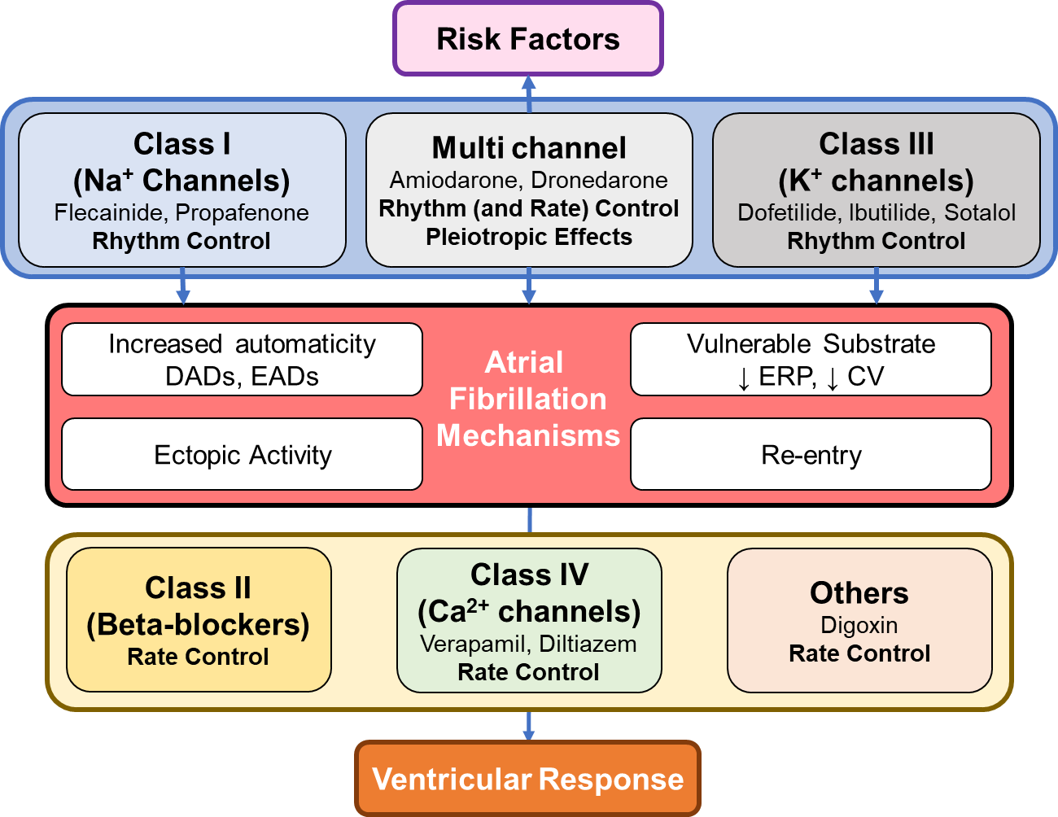
Figure 1. Conceptual mechanisms of atrial fibrillation (AF) and effect of antiarrhythmic drugs (AADs) used for rhythm control or rate control. AADs are grouped according to the classification by Vaughan Williams and Singh, with class I-IV AADs primarily targeting Na⁺ channels, beta-adrenergic receptors, K⁺ channels and Ca²⁺ channels, respectively. However, most AADs affect multiple ion channels and several have pleiotropic extra-cardiac effects.

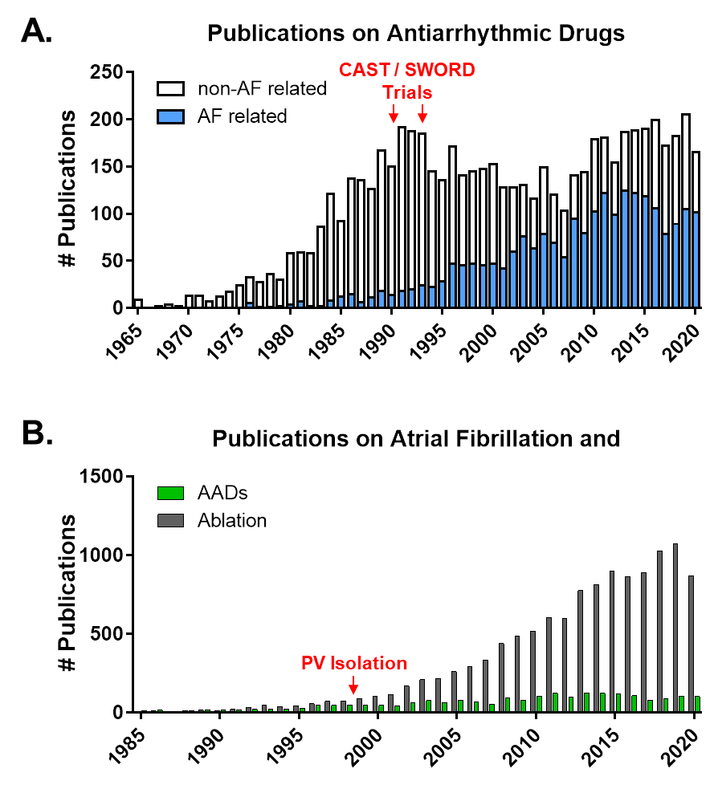
Figure 2. Number of publications in PubMed on antiarrhythmic drugs (AADs) and atrial fibrillation (AF) as of September 24, 2020. A. Number of publications per year in PubMed identified using “antiarrhythmic drugs” divided into those related to AF (blue bars), identified using “antiarrhythmic drugs” AND “atrial fibrillation”, and those not related to AF (white bars). There is a drop in publications on AADs following the publication of the CAST and SWORD trials, which is partially compensated by an increasing interest in AADs for the treatment of AF. B. Yearly number of publications in PubMed on AF and AADs (“atrial fibrillation” AND “antiarrhythmic drugs”) shown in green bars, or AF and ablation (“atrial fibrillation” AND “ablation”) shown in grey bars. Following the 1998 description on pulmonary vein (PV) triggers, there is a marked increase in publications on AF ablation.

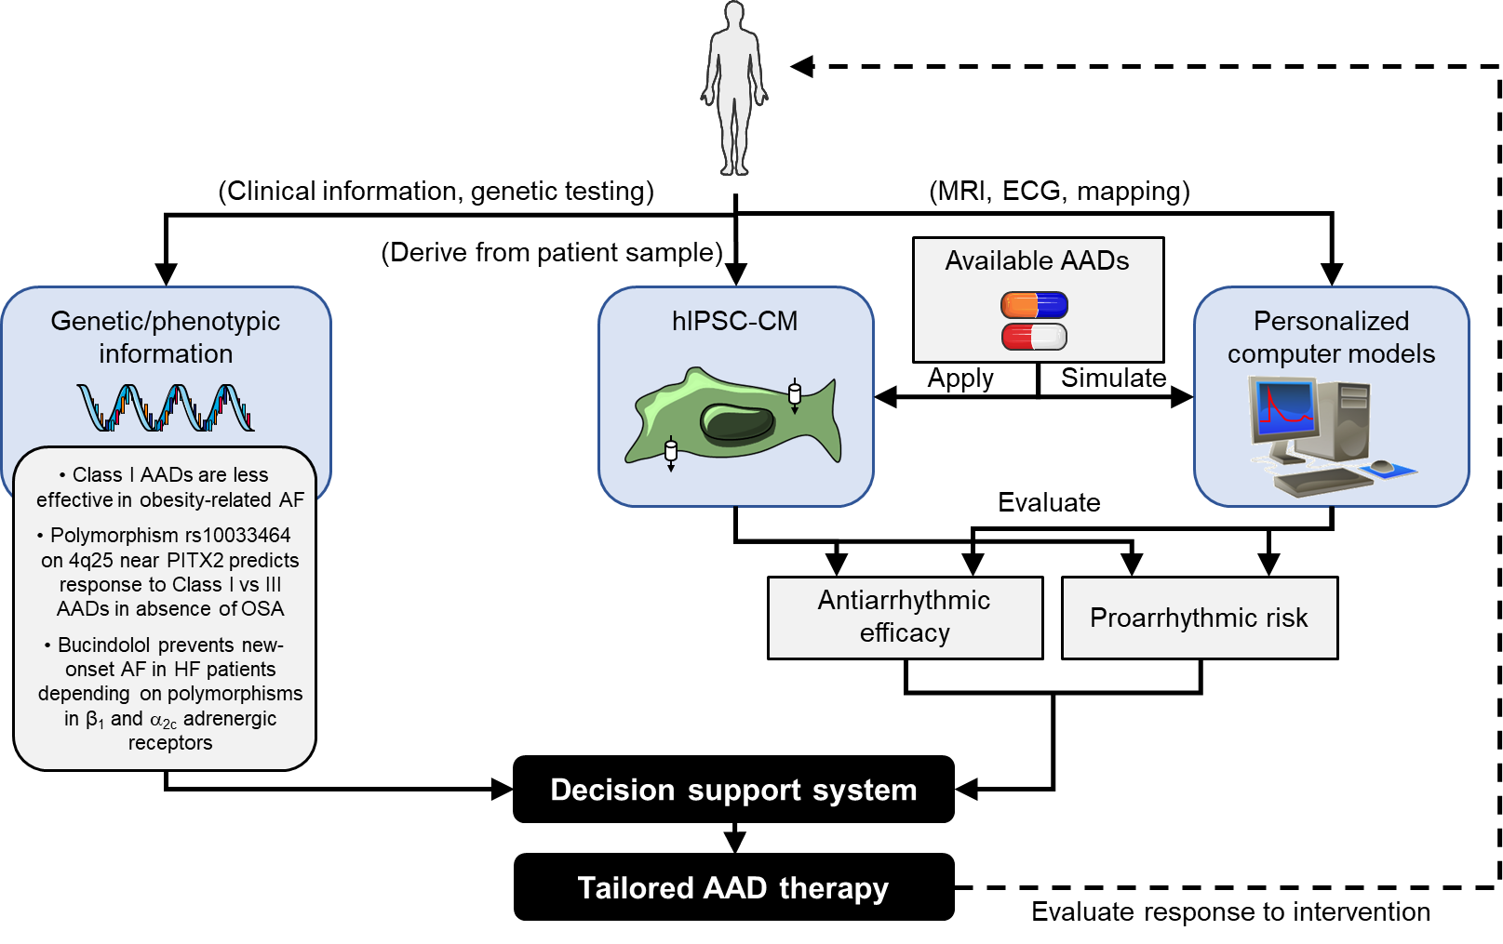
Figure 3. Integration of pharmacogenetic information and information about antiarrhythmic efficacy and proarrhythmic risk of different AADs using induced pluripotent stem cell-derived cardiomyocytes (hIPSC-CM) or personalized computer models in clinical decision support systems may enable safer, more effective tailored AAD therapy in AF patients.

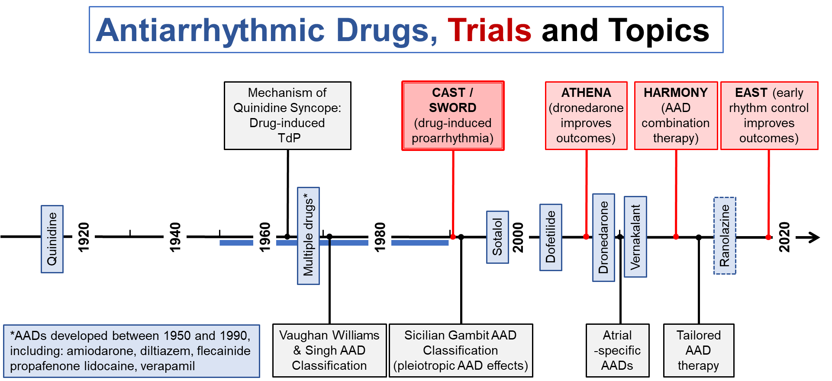
Figure 4. Historical overview of major advances in the available antiarrhythmic drugs (blue), key clinical trials (red) and important concepts and research topics (black) during the past 100 years. Together, these clinical trials and studies have greatly expanded our understanding of AADs, which has resulted in paradigm shifts in their clinical use.

