Low-density lipoprotein cholesterol and lifespan: a Mendelian randomization study
Iyas Daghlas BS¹, Dipender Gill BMBCh PhD²⁻⁵

Affiliations
¹Harvard Medical School, Boston, MA, USA.
²Department of Epidemiology and Biostatistics, School of Public Health, Imperial College London, London, UK.
³Clinical Pharmacology and Therapeutics Section, Institute of Medical and Biomedical Education and Institute for Infection and Immunity, St George’s, University of London, London, UK.
⁴Clinical Pharmacology Group, Pharmacy and Medicines Directorate, St George’s University Hospitals NHS Foundation Trust, London, UK.
⁵Novo Nordisk Research Centre Oxford, Old Road Campus, Oxford, UK.

Correspondence
Mr. Iyas Daghlas
Harvard Medical School
25 Shattuck Street
Boston, MA 02115, USA
Phone number: +1-573-823-3483
ORCiD ID: https://orcid.org/0000-0001-8735-284X
Email: iyas_daghlas@hms.harvard.edu

Data availability
All results presented in this manuscript were generated using publically available data, which may be accessed through links provided in the respective publications.

Funding
DG was supported by the British Heart Foundation Research Centre of Excellence (RE/18/4/34215) at Imperial College London and a National Institute for Health Research Clinical Lectureship at St. George's, University of London (CL-2020-16-001). The funding source had no role in the design, acquisition of data, analysis, interpretation or write up of this study.

Ethical approval, data availability and reporting
All data supporting this manuscript are publically available and de-identified. All included genetic association studies obtained informed consent and ethical approval. As such, no specific ethical approval for the present study is required.

Conflicts of interest
DG is employed part-time by Novo Nordisk and has received consultancy fees from Abbott Laboratories. ID has no conflicts of interest to declare.

What is already known
- Evidence from clinical trials supports that pharmacologic lowering of low-density lipoprotein cholesterol (LDL-c) prolongs lifespan in populations at elevated cardiovascular risk.
- It is unknown whether these beneficial effects of LDL-c lowering on lifespan generalize to a general population that is not selected for elevated cardiovascular risk.
- It is also unknown whether the effect of LDL-c lowering on lifespan is similar across various drug targets, particularly for PCSK9 and NPC1L1.

What this study adds
- This genetic evidence supports that lifelong higher LDL-c levels, both generally and through inhibition of PCKS9, reduce lifespan and longevity.
- A 1-standard deviation higher genetically proxied lifelong increase in LDL-c reduced lifespan by 1.2 years and reduced the odds of longevity to the 90th percentile age by 28%.
- In a general population that is not selected for increased cardiovascular risk, there is likely a net benefit of LDL-c lowering therapies, although randomized controlled trials are necessary before modification of clinical practice.

Abstract and Keywords
Background: It is unknown whether long-term low-density lipoprotein cholesterol (LDL-c) lowering increases lifespan and longevity in a general population not selected for elevated cardiovascular risk. The present study aimed to investigate the overall and gene-specific effect of circulating low-density lipoprotein cholesterol (LDL-c) levels on lifespan and longevity in a general population.
Methods and Results: Leveraging data from the Global Lipids Genetics Consortium (n=173,082), we identified genetic variants to proxy LDL-c levels generally, and also through perturbation of particular drug targets (HMGCR, NPC1L1 and PCSK9). We investigated their association with lifespan (n=1,012,240) using Mendelian randomization, and replicated results using the outcome of longevity to the 90th vs. 60th percentile age (11,262 cases / 25,483 controls). A 1-standard deviation (SD) increase in genetically proxied LDL-c was associated with 1.2 years lower lifespan (95% confidence interval (CI) -1.55- -0.87; P=3.83x10⁻¹²). Findings were consistent in statistical sensitivity analyses, and when considering the outcome of longevity (odds ratio for survival to the 90th vs 60th percentile age 0.72, 95% CI 0.64-0.81, P=7.83x10⁻⁸). Gene-specific MR analyses showed a significant effect of LDL-c modification through PCSK9 on lifespan (-0.99 years, 95% CI -1.43, -0.55, P=6.80x10⁻⁶), however estimates for HMGCR and NPC1L1 were underpowered.
Conclusions: This genetic evidence supports that higher LDL-c levels, both generally and through PCKS9, reduce lifespan and longevity. In a general population that is not selected for increased cardiovascular risk, there is likely a net benefit of LDL-c lowering therapies, although randomized controlled trials are necessary before modification of clinical practice.
Key words: HMGCR, LDL-c, lifespan, Mendelian randomization, NPC1L1, PCSK9.
Introduction
Higher low-density lipoprotein cholesterol (LDL-c) levels increase risk of atherosclerotic cardiovascular disease (CVD), with consistent evidence of effect identified across studies investigating genetically proxied variation in LDL-c levels and randomized-controlled trials (RCTs) of LDL-c lowering therapies¹. As CVD is the leading cause of mortality worldwide², it may be expected that interventions targeting LDL-c would reduce all-cause mortality. However, such effects may be mitigated by adverse effects of LDL-c lowering, such as increased risk of intracerebral hemorrhage^{3,}, type 2 diabetes⁴ , and weight gain⁴. While a meta-analysis of statin therapy trials found evidence for an all-cause mortality benefit⁵, no such effect has been found in meta-analyses of PCSK9 inhibitor trials^{6,7}. A meta-regression pooling data across all published trials investigating LDL-c lowering therapies only found evidence for an all-cause mortality benefit for patients with a baseline LDL-c greater than 100mg/dL⁸. Thus, effects of LDL-c lowering on all-cause mortality and lifespan may be heterogeneous across drug classes and patient subgroups. Alternatively, the lack of evidence for a mortality benefit for PCSK9 inhibitors may be a consequence of the limited follow-up data from clinical trials to date. As participants in trials of LDL-c lowering therapy are typically selected for higher CVD risk and followed for limited periods of time, it is unclear the extent to which long-term reductions in LDL-c may influence lifespan in a general population.

Results from prospective observational studies investigating this question have been conflicted^{9,10}, potentially due to residual confounding, reverse causality and survival bias. These potential limitations may be overcome by the use of Mendelian randomization (MR), an analytic approach that uses randomly allocated germline genetic variants as proxies for exposures to study causal effects on disease outcomes¹¹. Given that these randomly allocated germline genetic variants cannot typically be modified after conception, this approach is relatively robust to confounding and reverse causality. MR can be used to study effects of genetic variation in drug targets on disease outcomes¹², and to study effects of cardiovascular disease risk factors on lifespan and longevity¹³. Although prior MR studies have suggested beneficial effects of overall LDL-c lowering on lifespan, inferences from these studies have been limited due to low power, lack of independent replication, and potential bias by shared genetic associations with other lipid fractions^{14,15,16}. Moreover, to our knowledge, differential effects of LDL-c on lifespan by gene-specific drug targets have not been systematically assessed.

To address this evidence gap, we leveraged population-based data from over one million individuals to determine the effect of lifelong exposure to higher LDL-c on lifespan¹⁷. We explored whether this effect was independent of other lipid fractions and sought replication using a largely independent study of longevity¹⁸. Finally, we performed analyses investigating effects of LDL-c lowering mediated through drug targets (HMGCR, NPC1L1, and PCSK9). We aimed to complement evidence from randomized trials of LDL-c lowering and to provide insight into the net benefit of LDL-c lowering in a general population.

Methods
Genetic associations with LDL-c and mediators
The overall study design is shown in Figure 1. Genetic association estimates for low-density lipoprotein cholesterol (LDL-c) were obtained from a meta-analysis of genome-wide association studies (GWAS) conducted by the Global Lipids Genetics Consortium (GLGC)¹⁹. The meta-analysis was restricted to participants of European ancestry, and most contributing cohorts measured blood lipid levels after eight or more hours of fasting, with exclusion of individuals on lipid-lowering therapy. Values of LDL-c were inverse normal transformed with a sample standard deviation (SD) of 38.7mg/dL (approximately 1mmol/L)¹⁹. Genetic associations were adjusted for age, sex, and principal components (in 35% of individuals), and the double genomic control method was used to correct for potential population stratification¹⁹. We also obtained genetic associations reported by GLGC for high-density lipoprotein cholesterol (HDL-c; n up to 187,167) and triglycerides (n up to 177,861) for use in multivariable MR sensitivity analyses. These traits were similarly transformed and analyzed, with sample SDs of 15.5mg/dL for HDL-c and 41mg/dL for triglycerides. As a secondary data source, we obtained genetic associations with LDL-c measured in unrelated individuals of European ancestry in the UK Biobank cohort (n=343,621)^{20,21}. Here, LDL-c was directly measured and there was no exclusion of study participants on lipid-lowering therapy. Values of LDL-c were inverse normal transformed with a sample SD of 33.7mg/dL. We also obtained genetic associations with type 2 diabetes (74,124 cases / 824,006 controls; all of European ancestry)²² for use in multivariable MR sensitivity analyses. Genetic associations were not adjusted for BMI, and either principal components or linear mixed models were used to control for population stratification.

We considered coronary artery disease (CAD) and ischemic stroke as mediators of the effects of LDL-c on lifespan. Genetic associations with CAD were obtained from the CARDIoGRAMplusC4D Consortium, which used an inclusive case definition including myocardial infarction, acute coronary syndrome, chronic stable angina and coronary stenosis greater than 50% (60,801 cases / 123,504 controls; 77% European ancestry)²³. The double genomic control method was used to correct for potential population stratification²³. Genetic associations with ischemic stroke were obtained from the MEGASTROKE consortium, and were adjusted for age and sex (60,341 ischemic stroke cases / 454,450 controls; 86% of European ancestry)²⁴. The single genomic control method was used to correct for potential population stratification.

Genetic association estimates for lifespan and longevity
As the primary lifespan outcome, we obtained genetic association estimates with parental survival from a meta-analysis of the UK Biobank and the LifeGen consortium of 26 population cohorts (n=1,012,240; all of European ancestry)¹⁷. Although the GLGC sample did not include data from UK Biobank, some cohorts contributing data to the LifeGen consortium also contributed data to the GLGC (up to 9.6% sample overlap; Supplementary Methods). These studies used a Cox proportional hazards model to estimate offspring genetic variant effects on parental survival, with statistical adjustment made for sex, regional assessment center and genotyping batch and array (for the UK Biobank cohort), and 10 principal components of ancestry. Effect sizes obtained using genetic data from offspring are half of the actual variant effect size in the parent, and were therefore doubled to reflect the expected genetic effects in parents¹⁷. This approach effectively imputes the parental genotype data, permitting the use of a much larger sample in genetic analysis. The summary-level genetic effects from this study are reported as log hazard protection ratios. These coefficients can be multiplied by ten to estimate the absolute change in lifespan years per additive allele dosage¹⁷.

As a secondary outcome using a distinct phenotype definition in a largely independent sample, we obtained genetic associations from a meta-analysis of case-control studies of individual (i.e. non-parental) longevity to a sex and birth cohort-specific 90th vs. 60th percentile age (11,262 cases, 25,483 controls)¹⁸. Up to 2,311 cases (20.5% of total) and 5,968 controls (23.4% of total) overlapped with the GLGC GWAS, and up to 2,266 cases (18.5% of total) and 8,830 controls (34.7% of total) contributed to the lifespan GWAS (Supplementary Methods). As example survival percentiles, the 60th and 90th percentile ages in the 1920 US birth cohort correspond to 75 and 89 years for men and 83 and 94 years for women¹⁸. Genetic associations with longevity were obtained in participants of European ancestry and were adjusted for clinical site, family relationships, and principal components (if applicable)¹⁸. The genetic effects from this study are reported as log-odds of survival to the 90th percentile vs. 60th percentile age.

Genetic proxies for exposure traits
For univariable Mendelian randomization (MR) analyses investigating overall effects of LDL-c, we first identified genome-wide significant (P<5x10⁻⁸) single-nucleotide polymorphisms (SNPs) associated with LDL-c that were also present in the outcome GWAS dataset. To ensure independence of the genetic proxies, these SNPs were then clumped using a 10Mb window and pair-wise linkage disequilibrium (LD) r² < 0.001 (using the 1,000 Genomes Project Phase 3 European LD reference panel²⁵). This step was implemented using the TwoSampleMR²⁶ package. Instrument strength was quantified using the F-statistic²⁷, and percent variance explained was quantified using the R² value²⁸.

For multivariable MR analyses, we first pooled together all genome-wide significant SNPs that were associated with any of the exposures and that were also present in the lifespan GWAS dataset. These SNPs were then clumped with respect to the lowest P-value corresponding to any of the exposures²⁶ using a 10Mb window and pair-wise linkage disequilibrium (LD) r² < 0.001. This approach was used for analyses adjusting LDL-c estimates for genetic associations with i) HDL-c and triglycerides, ii) CAD, iii) ischemic stroke, and iv) CAD and ischemic stroke.

To proxy effects of modifying LDL-c through single genes encoding drug targets for LDL-c lowering therapies, we selected variants previously identified as genetic proxies for modulation of HMGCR (targeted by statins), NPC1L1 (targeted by ezetimibe), and PCSK9 (targeted by PCSK9 inhibitors)²⁹. For these single gene analyses, we considered variants with a genome-wide significant association with LDL-c and a genomic position within 100kb of the target gene³⁰. In contrast to the variants used to proxy overall LDL-c levels, clumping these variants using a pair-wise LD cutoff of r² < 0.001 yields very few variants for use in MR (1 for HMGCR, 1 for NPC1L1, and 2 for PCSK9). In keeping with prior work, we therefore clumped the variants in the gene regions using a pair-wise LD r² < 0.20 to include additional variants in the gene-specific MR analyses²⁹, and used appropriate methods to control for residual LD (see below).

Statistical analysis
Genetic associations with LDL-c and lifespan were harmonized by aligning beta coefficients to the same effect allele²⁶, with no exclusion made for potentially palindromic variants. We used the random-effects inverse-variance weighted (IVW) method as the primary MR approach²⁶. This method regresses the SNP-outcome association on the SNP-exposure association and weights the effects by the inverse of the standard error of the SNP-outcome associations, with the intercept fixed at the origin²⁶. This method estimates the causal effect of a 1-standard deviation (SD) increase in genetically proxied LDL-c on years of lifespan.

Causal effects estimated in this MR analysis are unbiased provided that the genetic proxies for LDL-c do not influence lifespan through pathways independent of LDL-c (also referred to as horizontal pleiotropy³¹). As a global test for potential horizontal pleiotropy, we conducted a statistical test for heterogeneity using Cochran’s Q, which assesses for over-dispersion in the causal effects estimated by each of the genetic proxies for LDL-c³². To assess whether over-dispersion may be biasing the MR estimate, we used methods that relax assumptions about horizontal pleiotropy, including the weighted median estimator³³, MR-Egger³⁴ (including a statistical test for unbalanced pleiotropy), contamination mixture method³⁵, and Mendelian randomization pleiotropy residual sum and outlier (MR-PRESSO)³⁶. To characterize the function of variants identified as heterogeneous by MR-PRESSO, we obtained gene-based annotation on the SNP and the identity of the nearest gene using PhenoScanner V2³⁷, and determined whether any SNPs were positioned within 1Mb of a lead SNP identified in the lifespan GWAS¹⁷. We conducted regression-based multivariable MR³⁸ including LDL-c, HDL-c, and triglycerides as exposures to account for pleiotropic effects of genetic proxies of LDL-c on different lipid fractions^{39,19}. As a complementary approach, we performed analyses using genetic proxies for LDL-c that did not associate with either HDL-c or with triglycerides at genome-wide significance (P<5x10⁻⁸). To determine whether results were influenced by winner’s curse or by exclusion of individuals on lipid-lowering therapy in the GLGC, we repeated IVW analyses using genetic associations with LDL-c measured in UK Biobank²⁰ and in the Million Veterans Program⁴⁰. We conducted a statistical test for heterogeneity to determine whether the magnitude of this effect differed from the effect estimated using variants from the GLGC dataset. As a secondary outcome, we conducted IVW analysis of genetically proxied LDL-c (using the GLGC weights) on the 90th vs. 60th percentile age outcome, and repeated the sensitivity analyses described above.

We performed multivariable MR adjusting genetic associations with LDL-c for CAD and ischemic stroke to estimate the direct effect of LDL-c on lifespan. These estimates were used to quantify the proportion of the total LDL-c effect on lifespan that was not mediated through CAD and ischemic stroke^{41,42}. Standard errors were estimated using the propagation of error method. In analyses of LDL-c restricted to predefined gene regions, we used the IVW method accounting for correlation between genetic variants (IVW-corr)⁴³. Correlations were estimated using the 1,000 Genomes Project Phase 3 European LD reference panel²⁵, accessed through the TwoSampleMR package of R²⁶. In a sensitivity analysis we further clumped these genetic proxies to an r² < 0.1 and used conventional IVW regression without accounting for correlation. This clumped set of variants was also used in weighted median and MR Egger sensitivity analyses for the genes that had at least three available genetic proxies for use in MR analyses. All MR analyses were conducted using the TwoSampleMR v0.4.23²⁶ and MendelianRandomization v0.4.1⁴³ packages.

Ethical approval, data availability and reporting
All included genetic association studies obtained informed consent and ethical approval^{17–19}. The data underlying this article were accessed from sources in the public domain (links provided in Supplementary Table 1). This study has been reported in accordance with the STROBE-MR guidelines (Supplementary Checklist). Code for conducting these analyses is available upon request. The study protocol was not pre-registered.

Results
Effect of genetically proxied LDL-c on lifespan
We identified 80 variants for use as genetic proxies for LDL-c. The mean F-statistic for all the proxies was 156 (range 28-1663). These variants collectively explained 9.92% of the variance in LDL-c. Genetic proxies for the lipid traits are presented in Supplementary Tables 2-5, and forest plots visualizing causal effects estimated by each individual variant are provided in Supplementary Figures 1-8.

In the primary analysis, we found that a genetically proxied 1-SD increase in LDL-c reduced lifespan by 1.21 years (95% confidence interval (CI) -1.55- -0.87, P=3.83x10⁻¹²). The causal effects estimated by the individual variants were more heterogeneous than expected by chance (Cochran’s Q P=1.02x10⁻³²). Results were consistent across all MR sensitivity analyses (Figure 2), and the Egger intercept test for unbalanced pleiotropy was consistent with the null hypothesis of no pleiotropy (P=0.35). MR-PRESSO identified seven significantly heterogeneous variants, with a significant global test for potential pleiotropy (P<2x10⁻⁴). Five of these variants were positioned within 1Mb of a lead SNP identified in the lifespan GWAS¹⁷ (including variants in APOE and LPA; Supplementary Table 6) and analyses removing these variants provided similar MR effect estimates (Figure 2; P_{distortion}=0.54). Multivariable MR models adjusting the LDL-c genetic proxies for genetic associations with HDL-c and triglycerides or for type 2 diabetes liability also provided similar effect estimates (Figure 2). Similarly, removing genetic proxies for LDL-c that were also associated with HDL-c or with triglycerides yielded similar MR estimates (Figure 2). The estimate for the effect of higher LDL-c on lifespan was consistent when using genetic associations with LDL-c from UKB and from MVP (Figure 2), with no evidence that this effect differed from that estimated when using genetic associations from the GLGC (P_{UKB}=0.28; P_{MVP}=0.15). When considering the outcome of longevity, genetically proxied higher LDL-c reduced the odds of survival to the 90th vs. the 60th percentile of age (odds ratio (OR) 0.72, 95% CI 0.64-0.81, P=7.83x10⁻⁸, Cochran’s Q P=1.46x10⁻⁵), with consistent results in sensitivity analyses (Supplementary Table 7).

Direct effects of LDL-c on lifespan after accounting for mediation through coronary artery disease and ischemic stroke
A 1-SD higher genetically proxied LDL-c had odds ratio 1.53 for CAD (95% CI 1.39-1.69, P=9.71x10⁻¹⁸) and odds ratio 1.10 for ischemic stroke (95% CI 1.03-1.18, P=5.05x10⁻³). For every log-odds increase in genetically proxied liability to CAD and ischemic stroke, there was a respective reduction of 1.72 (95% CI -2.21- -1.24, P=2.82x10⁻¹²) and 1.88 lifespan years (95% CI -2.61- -1.16, P=3.72x10⁻⁷).

We used multivariable MR to estimate the direct effect of genetically proxied LDL-c on lifespan after accounting for mediation through either genetically proxied liability to CAD, ischemic stroke, or both phenotypes (Figure 2). The estimated proportion of the LDL-c effect on lifespan that was not mediated through these phenotypes was 51% for CAD (95% CI 21%-81%), 79% for ischemic stroke (95% CI 44%-114%), and 42% when accounting for both CAD and ischemic stroke (95% CI 16%-69%).

Pathway and drug target-specific effects of LDL-c on longevity
Genetic variants used as proxies for LDL-lowering drug targets are presented in Supplementary Table 4. A 1-SD higher genetically proxied LDL-c through PCSK9 reduced lifespan by 0.99 years (95% CI -0.55- -1.43, P=6.80x10⁻⁶; Figure 3). Point estimates for the HMGCR and NPC1L1 genetic proxies were also consistent with a reduction in lifespan, however the confidence intervals for these estimates crossed the null (Figure 3), with consistent directions of effect estimated using the outcome of survival to the 90th vs. 60th percentile age (Supplementary Table 8). MR estimates in sensitivity analyses using the conventional IVW method with variants clumped to an r² < 0.1 were consistent for PCSK9 and HMGCR, however the sign of the coefficient for the effect of the NPC1L1 genetic proxy on lifespan was positive with wide confidence intervals (Figure 3). Sensitivity analyses using these clumped variants in weighted median and MR Egger analyses showed consistent evidence for an effect of the PCSK9 genetic proxy on lifespan (Supplementary Table 9).

Discussion
In this Mendelian randomization analysis, we found evidence for an association between higher genetically proxied LDL-c and reduced lifespan. This effect was robust in sensitivity analyses and replicated in a largely independent sample utilizing a distinct longevity outcome. We identified deleterious effects of higher genetically proxied LDL-c through the PCSK9 gene region on lifespan. Although analyses using the HMGCR and NPC1L1 genetic proxies provided concordant direction of effect, the confidence intervals were wide and overlapped the null. As such, these null results are likely attributable to insufficient power rather than absence of a biological effect.

Taken together, these data support the hypothesis that long-term LDL-c lowering increases lifespan and longevity in a general population not selected for elevated cardiovascular risk. This extends evidence for a mortality benefit with LDL-c lowering to a broader pool of individuals relative to the high-risk populations considered in RCTs⁸. In fact, participants in the UK Biobank are on average healthier than the UK population⁴⁴. These results reinforce the notion that, on average for the population considered, the beneficial effects of LDL-c lowering far outweigh any detrimental effects of LDL-c lowering^{3,4}. We provide mechanistic insight for this effect by showing that approximately 42% of the causal effect of LDL-c on lifespan is mediated through pathways independent of coronary artery disease and ischemic stroke. This is consistent with the observation that LDL-c has a causal effect on a range of outcomes beyond coronary artery disease, including peripheral vascular disease^{45,46} and abdominal aortic aneurysm^{46,47}. Additional work is needed to determine whether there are any direct effects of LDL-c on aging that may explain its effects on lifespan independently of cardiovascular disease risk.

Prior evidence from a meta-analysis of PCKS9 inhibitor trials⁷ and from genetic analyses using a weighted PCSK9 allele score¹⁵ have not supported effects of PCSK9 inhibition on all-cause mortality. In contrast, our analyses found robust evidence for an effect of higher genetically proxied LDL-c through the PCSK9 gene region on reduced lifespan. On the basis of this result, we anticipate that PCSK9 inhibitors will be found to have an all-cause mortality benefit as more mortality data accrues. This prediction assumes no substantial off-target effects of PCSK9 inhibitors on mortality, consistent with network meta-analyses that have not found any signal for such an effect⁴⁸. The deleterious point estimates of higher LDL-c on lifespan estimated using the HMGCR and NPC1L1 genetic proxies were not significant, but were underpowered as evidenced by the wide confidence intervals.

As the estimated effect in MR is most appropriately compared to the effect of adherence to a lifelong intervention on a given outcome, the point estimates we report should not be extrapolated to predict the effect of LDL-c lowering on lifespan from a shorter-term clinical intervention. An analogous intervention would require long-term adherence to LDL-c lowering therapies, and widespread uptake of such an intervention may be limited by side effects and pill burden^{49,50}. The development of novel, long-acting LDL-c lowering agents with infrequent dosing schedules may improve long-term adherence⁵¹. Alternatively, public health efforts, such as promotion of a healthy diet⁵², that create smaller but more widespread changes in the population distribution of LDL-c levels may be effective tools to increase overall lifespan and longevity⁵³.

There are several strengths to highlight in this analysis. Although the effect of genetically proxied LDL-c on lifespan has been previously studied^{16,14}, our study leverages the largest sample size to date, is the first to investigate the outcome of longevity, and is the first to investigate gene-specific effects of LDL-c modification through drug targets. An advantage of investigating outcomes such as lifespan and longevity is the implicit consideration of both beneficial and detrimental effects of a given intervention. By analyzing parental lifespan, we mitigate immortal time bias related to differential selection into a study by individual survival status. By using reported parental lifespans, we also mitigate bias due to potentially differential rates of loss to follow-up in strata of LDL-c. We reported effects on the scale of relative change in lifespan years, which is more clinically interpretable than the hazard ratio.

Our study also has limitations. Although we found consistent results across multiple sensitivity analyses, we cannot fully exclude potential bias attributable to effects of the genetic proxies on lifespan through pathways other than LDL-c (i.e. violation of the Mendelian randomization assumption of no horizontal pleiotropy). Our results may be biased by a small degree of overlap between the exposure and outcome samples. However, such bias is typically minimal in the setting of strong genetic instruments (F-statistic > 10)⁵⁴. The mediation analysis we performed using CAD and ischemic stroke may be biased due to the binary nature of these mediators⁴¹. The MR estimates obtained using parental lifespans may not generalize to contemporary populations given systematic differences in the environment and distribution of atherosclerotic risk factors⁵⁵. Finally, the MR method we used only considers the linear associations of small changes in genetically proxied LDL-c around the population mean, and cannot be extrapolated to infer the effect of changes in LDL-c at extremes of this distribution (e.g. in familial hypercholesterolemia).

In conclusion, we found genetic support for an effect of higher overall and PCSK9-mediated circulating LDL-c on reducing lifespan. Our approach considered the cumulative lifelong effect of genetically proxied modifications in LDL-c levels and was further applied in populations that were not selected for increased cardiovascular risk. These results therefore provide evidence that earlier and wider use of LDL-c lowering therapies may be an effective strategy for improving overall lifespan and longevity. Further investigation incorporating randomized controlled trial data is warranted to provide definitive evidence of such effects.

References
1. Ference BA, Ginsberg HN, Graham I, Ray KK, Packard CJ, Bruckert E, Hegele RA, Krauss RM, Raal FJ, Schunkert H, et al. Low-density lipoproteins cause atherosclerotic cardiovascular disease. 1. Evidence from genetic, epidemiologic, and clinical studies. A consensus statement from the European Atherosclerosis Society Consensus Panel. Eur Heart J. 2017;38:2459–2472.
2. GBD 2017 Causes of Death Collaborators. Global, regional, and national age-sex-specific mortality for 282 causes of death in 195 countries and territories, 1980–2017: a systematic analysis for the Global Burden of Disease Study 2017. Lancet. 2018;392:1736–1788.
3. Raymond E, Pisano E, Gatsonis C, Boineau R, Domanski M, Troutman C, Anderson J, Johnson G, Mcnulty SE, Clapp-channing N, et al. High-Dose Atorvastatin after Stroke or Transient Ischemic Attack. N Engl J Med. 2006;355:549–559.
4. Swerdlow DI, Preiss D, Kuchenbaecker KB, Holmes M V., Engmann JEL, Shah T, Sofat R, Stender S, Johnson PCD, Scott RA, et al. HMG-coenzyme A reductase inhibition, type 2 diabetes, and bodyweight: Evidence from genetic analysis and randomised trials. Lancet. 2015;385:351–361.
5. Yebyo HG, Aschmann HE, Kaufmann M, Puhan MA. Comparative effectiveness and safety of statins as a class and of specific statins for primary prevention of cardiovascular disease: A systematic review, meta-analysis, and network meta-analysis of randomized trials with 94,283 participants. Am Heart J. 2019;210:18–28.
6. Schmidt AF, Pearce LS, Wilkins JT, Overington JP, Hingorani AD, Casas JP. PCSK9 monoclonal antibodies for the primary and secondary prevention of cardiovascular disease. Cochrane Database Syst Rev. 2017;
7. Dicembrini I, Giannini S, Ragghianti B, Mannucci E, Monami M. Effects of PCSK9 inhibitors on LDL cholesterol, cardiovascular morbidity and all-cause mortality: a systematic review and meta-analysis of randomized controlled trials. J Endocrinol Invest. 2019;42:1029–1039.
8. Navarese EP, Robinson JG, Kowalewski M, Kolodziejczak M, Andreotti F, Bliden K, Tantry U, Kubica J, Raggi P, Gurbel PA. Association Between Baseline LDL-C Level and Total and Cardiovascular Mortality After LDL-C Lowering. JAMA. 2018;319:1566.
9. Doran B, Guo Y, Xu J, Weintraub H, Mora S, Maron DJ, Bangalore S. Prognostic Value of Fasting Versus Nonfasting Low-Density Lipoprotein Cholesterol Levels on Long-Term Mortality. Circulation. 2014;130:546–553.
10. Ravnskov U, Diamond DM, Hama R, Hamazaki T, Hammarskjöld B, Hynes N, Kendrick M, Langsjoen PH, Malhotra A, Mascitelli L, et al. Lack of an association or an inverse association between low-density-lipoprotein cholesterol and mortality in the elderly: A systematic review. BMJ Open. 2016;6:1–8.
11. Smith GD, Ebrahim S. “Mendelian randomization”: Can genetic epidemiology contribute to understanding environmental determinants of disease? Int J Epidemiol. 2003;32:1–22.
12. Gill D, Georgakis MK, Koskeridis F, Jiang L, Feng Q, Wei W-Q, Theodoratou E, Elliott P, Denny JC, Malik R, et al. Use of Genetic Variants Related to Antihypertensive Drugs to Inform on Efficacy and Side Effects. Circulation. 2019;140:270–279.
13. Daghlas I, Gill D. Blood Pressure Modification and Life Expectancy in a General Population. Circ Genomic Precis Med. 2020;13.
14. Sakaue S, Kanai M, Karjalainen J, Akiyama M, Kurki M, Matoba N, Takahashi A, Hirata M, Kubo M, Matsuda K, et al. Trans-biobank analysis with 676,000 individuals elucidates the association of polygenic risk scores of complex traits with human lifespan. Nat Med. 2020;26:542–548.
15. Benn M, Tybjærg-Hansen A, Nordestgaard BG. Low LDL Cholesterol by PCSK9 Variation Reduces Cardiovascular Mortality. J Am Coll Cardiol. 2019;73:3102–3114.
16. Joshi PK, Pirastu N, Kentistou KA, Fischer K, Hofer E, Schraut KE, Clark DW, Nutile T, Barnes CLK, Timmers PRHJ, et al. Genome-wide meta-analysis associates HLA-DQA1/DRB1 and LPA and lifestyle factors with human longevity. Nat Commun. 2017;8:1–13.
17. Timmers PR, Mounier N, Lall K, Fischer K, Ning Z, Feng X, Bretherick AD, Clark DW, Agbessi M, Ahsan H, et al. Genomics of 1 million parent lifespans implicates novel pathways and common diseases and distinguishes survival chances. Elife. 2019;8:1–40.
18. Deelen J, Evans DS, Arking DE, Tesi N, Nygaard M, Liu X, Wojczynski MK, Biggs ML, van der Spek A, Atzmon G, et al. A meta-analysis of genome-wide association studies identifies multiple longevity genes. Nat Commun. 2019;10:3669.
19. Willer CJ, Schmidt EM, Sengupta S, Peloso GM, Gustafsson S, Kanoni S, Ganna A, Chen J, Buchkovich ML, Mora S, et al. Discovery and refinement of loci associated with lipid levels. Nat Genet. 2013;45:1274–1283.
20. NealeLab. Rapid GWAS of thousands of phenotypes for 337,000 samples in the UK Biobank. [Internet]. 2020 [cited 2020 Jun 16];Available from: http://www.nealelab.is/uk-biobank/
21. Bycroft C, Freeman C, Petkova D, Band G, Elliott LT, Sharp K, Motyer A, Vukcevic D, Delaneau O, O’Connell J, et al. The UK Biobank resource with deep phenotyping and genomic data. Nature. 2018;562:203–209.
22. Mahajan A, Taliun D, Thurner M, Robertson NR, Torres JM, Rayner NW, Payne AJ, Steinthorsdottir V, Scott RA, Grarup N, et al. Fine-mapping type 2 diabetes loci to single-variant resolution using high-density imputation and islet-specific epigenome maps. Nat Genet. 2018;50:1505–1513.
23. Nikpay M, Goel A, Won H-H, Hall LM, Willenborg C, Kanoni S, Saleheen D, Kyriakou T, Nelson CP, Hopewell JC, et al. A comprehensive 1000 Genomes–based genome-wide association meta-analysis of coronary artery disease. Nat Genet. 2015;47:1121–1130.
24. Malik R, Chauhan G, Traylor M, Sargurupremraj M, Okada Y, Mishra A, Rutten-Jacobs L, Giese A-K, van der Laan SW, Gretarsdottir S, et al. Multiancestry genome-wide association study of 520,000 subjects identifies 32 loci associated with stroke and stroke subtypes. Nat Genet. 2018;50:524–537.
25. Auton A, Abecasis GR, Altshuler DM, Durbin RM, Bentley DR, Chakravarti A, Clark AG, Donnelly P, Eichler EE, Flicek P, et al. A global reference for human genetic variation. Nature. 2015;526:68–74.
26. Hemani G, Zheng J, Elsworth B, Wade KH, Haberland V, Baird D, Laurin C, Burgess S, Bowden J, Langdon R, et al. The MR-Base platform supports systematic causal inference across the human phenome. Elife. 2018;7:e34408.
27. Pierce BL, Ahsan H, VanderWeele TJ. Power and instrument strength requirements for Mendelian randomization studies using multiple genetic variants. Int J Epidemiol. 2011;40:740–752.
28. Burgess S, Dudbridge F, Thompson SG. Combining information on multiple instrumental variables in Mendelian randomization: Comparison of allele score and summarized data methods. Stat Med. 2016;35:1880–1906.
29. Yarmolinsky J, Bull CJ, Vincent EE, Robinson J, Walther A, Smith GD, Lewis SJ, Relton CL, Martin RM. Association Between Genetically Proxied Inhibition of HMG-CoA Reductase and Epithelial Ovarian Cancer. JAMA. 2020;323:646.
30. Stelzer G, Rosen N, Plaschkes I, Zimmerman S, Twik M, Fishilevich S, Stein TI, Nudel R, Lieder I, Mazor Y, et al. The GeneCards Suite: From Gene Data Mining to Disease Genome Sequence Analyses. Curr Protoc Bioinforma. 2016;54:1.30.1-1.30.33.
31. Davies NM, Holmes M V., Davey Smith G. Reading Mendelian randomisation studies: a guide, glossary, and checklist for clinicians. BMJ. 2018;362:k601.
32. Greco M F Del, Minelli C, Sheehan NA, Thompson JR. Detecting pleiotropy in Mendelian randomisation studies with summary data and a continuous outcome. Stat Med. 2015;34:2926–2940.
33. Bowden J, Davey Smith G, Haycock PC, Burgess S. Consistent Estimation in Mendelian Randomization with Some Invalid Instruments Using a Weighted Median Estimator. Genet Epidemiol. 2016;40:304–314.
34. Bowden J, Smith GD, Burgess S. Mendelian randomization with invalid instruments: Effect estimation and bias detection through Egger regression. Int J Epidemiol. 2015;44:512–525.
35. Burgess S, Foley CN, Allara E, Staley JR, Howson JMM. A robust and efficient method for Mendelian randomization with hundreds of genetic variants. Nat Commun. 2020;11.
36. Verbanck M, Chen C-Y, Neale B, Do R. Detection of widespread horizontal pleiotropy in causal relationships inferred from Mendelian randomization between complex traits and diseases. Nat Genet. 2018;50:693–698.
37. Kamat MA, Blackshaw JA, Young R, Surendran P, Burgess S, Danesh J, Butterworth AS, Staley JR, Kelso J. PhenoScanner V2: An expanded tool for searching human genotype-phenotype associations. Bioinformatics. 2019;35:4851–4853.
38. Burgess S, Thompson SG. Multivariable Mendelian randomization: The use of pleiotropic genetic variants to estimate causal effects. Am J Epidemiol. 2015;181:251–260.
39. Burgess S, Freitag DF, Khan H, Gorman DN, Thompson SG. Using multivariable Mendelian randomization to disentangle the causal effects of lipid fractions. PLoS One. 2014;9.
40. Klarin D, Damrauer SM, Cho K, Sun Y V, Teslovich TM, Honerlaw J, Gagnon DR, DuVall SL, Li J, Peloso GM, et al. Genetics of blood lipids among ~300,000 multi-ethnic participants of the Million Veteran Program. Nat Genet. 2018;50:1514–1523.
41. Burgess S, Thompson DJ, Rees JMB, Day FR, Perry JR, Ong KK. Dissecting causal pathways using mendelian randomization with summarized genetic data: Application to age at menarche and risk of breast cancer. Genetics. 2017;207:481–487.
42. Carter AR, Gill D, Davies NM, Taylor AE, Tillmann T, Vaucher J, Wootton RE, Munafò MR, Hemani G, Malik R, et al. Understanding the consequences of education inequality on cardiovascular disease: mendelian randomisation study. BMJ. 2019;365:l1855.
43. Yavorska OO, Burgess S. MendelianRandomization: an R package for performing Mendelian randomization analyses using summarized data. Int J Epidemiol. 2017;46:1734–1739.
44. Fry A, Littlejohns TJ, Sudlow C, Doherty N, Adamska L, Sprosen T, Collins R, Allen NE. Comparison of Sociodemographic and Health-Related Characteristics of UK Biobank Participants With Those of the General Population. Am J Epidemiol. 2017;186:1026–1034.
45. Heart Protection Study Collaborative Group. Randomized trial of the effects of cholesterol-lowering with simvastatin on peripheral vascular and other major vascular outcomes in 20,536 people with peripheral arterial disease and other high-risk conditions. J Vasc Surg. 2007;45:645-654; discussion 653–4.
46. Allara E, Morani G, Carter P, Gkatzionis A, Zuber V, Foley CN, Rees JMB, Mason AM, Bell S, Gill D, et al. Genetic Determinants of Lipids and Cardiovascular Disease Outcomes: A Wide-Angled Mendelian Randomization Investigation. Circ Genomic Precis Med. 2019;12:543–551.
47. Lindholt JS, Søgaard R. Population screening and intervention for vascular disease in Danish men (VIVA): a randomised controlled trial. Lancet. 2017;390:2256–2265.
48. Toth PP, Worthy G, Gandra SR, Sattar N, Bray S, Cheng LI, Bridges I, Worth GM, Dent R, Forbes CA, et al. Systematic review and network meta-analysis on the efficacy of evolocumab and other therapies for the management of lipid levels in hyperlipidemia. J Am Heart Assoc. 2017;6.
49. Thompson PD, Panza G, Zaleski A, Taylor B. Statin-associated side effects. J Am Coll Cardiol. 2016;67:2395–2410.
50. Lansberg P, Lee A, Lee Z-V, Subramaniam K, Setia S. Vascular Health and Risk Management Dovepress Nonadherence to statins: individualized intervention strategies outside the pill box. Vasc Health Risk Manag. 2018;14–91.
51. Ray KK, Wright RS, Kallend D, Koenig W, Leiter LA, Raal FJ, Bisch JA, Richardson T, Jaros M, Wijngaard PLJ, et al. Two Phase 3 Trials of Inclisiran in Patients with Elevated LDL Cholesterol. N Engl J Med. 2020;382:1507–1519.
52. Siervo M, Lara J, Chowdhury S, Ashor A, Oggioni C, Mathers JC. Effects of the dietary approach to stop hypertension (DASH) diet on cardiovascular risk factors: A systematic review and meta-analysis. Br J Nutr. 2015;113:1–15.
53. Rose G. Sick Individuals and Sick Populations. Int J Epidemiol. 1985;14:32–38.
54. Burgess S, Davies NM, Thompson SG. Bias due to participant overlap in two-sample Mendelian randomization. Genet Epidemiol. 2016;40:597–608.
55. Vartiainen E, Laatikainen T, Peltonen M, Juolevi A, Männistö S, Sundvall J, Jousilahti P, Salomaa V, Valsta L, Puska P. Thirty-five-year trends in cardiovascular risk factors in Finland. Int J Epidemiol. 2010;39:504–518.

Figure legends

Figure 1. Study design. LDL: low-density lipoprotein.

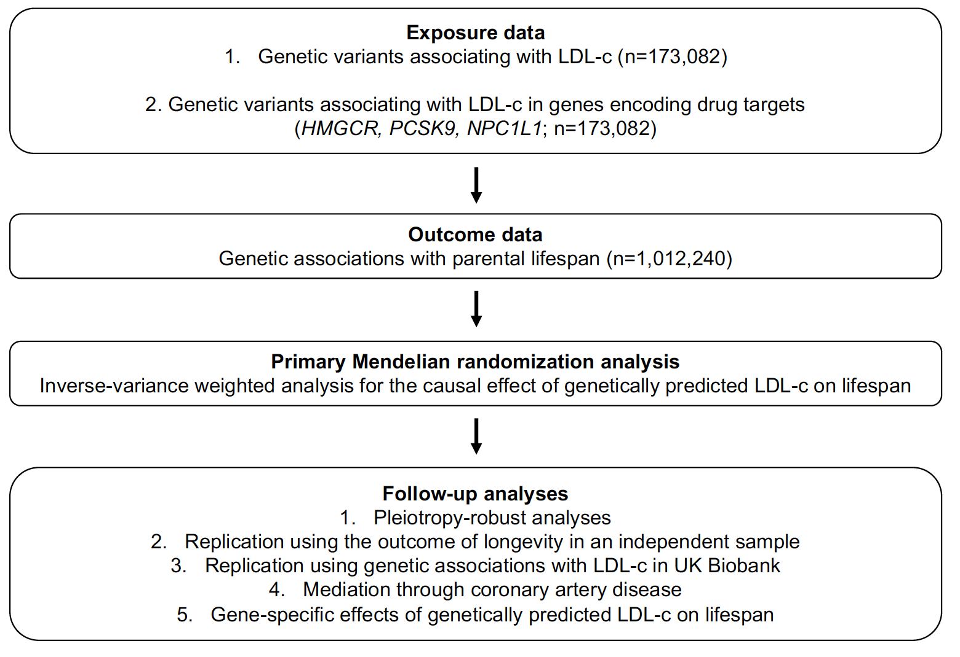

Figure 2. Forest plot of Mendelian randomization estimates and sensitivity analyses for the association between genetically proxied LDL-c and lifespan (n=1,012,240). Point estimates are expressed as the effect of a 1-standard deviation (SD) increase in low-density lipoprotein cholesterol (LDL-c) on years of lifespan. The MR- pleiotropy residual sum and outlier (MR-PRESSO) method identified and removed 8 variants. The “LDL-c specific variants” were not associated with either triglycerides or HDL-c at genome-wide significance. Adj: adjusted; CI: confidence interval; Con-Mix: contamination mixture; IVW: inverse-variance weighted; MVMR: multivariable Mendelian randomization; MVP: Million Veterans Program; T2D: type 2 diabetes; TG: triglycerides; WM: weighted median.

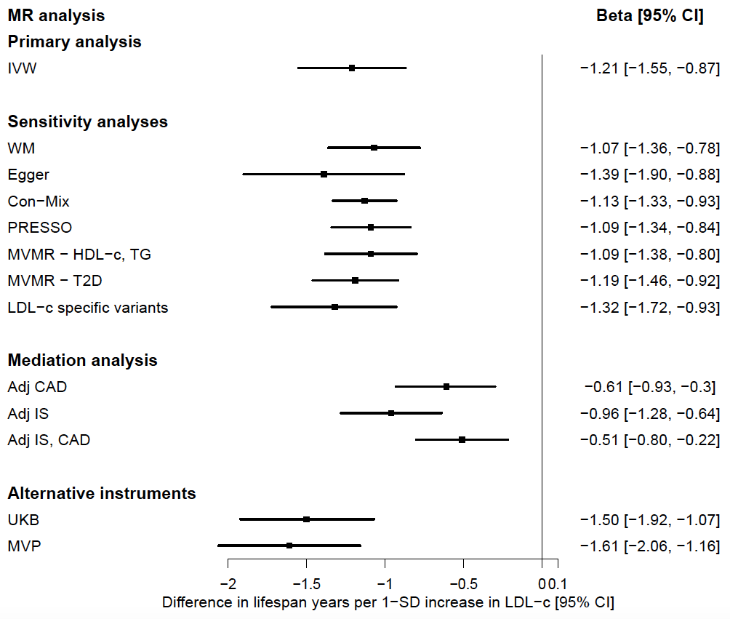

Figure 3. Forest plot of drug target-specific Mendelian randomization estimates for the association between genetically proxied LDL-c and lifespan (n=1,012,240). The primary random-effects IVW-corr method was used for variants with correlation r² < 0.2, while the conventional random-effects IVW method was used for variants with correlation r² < 0.1. Point estimates are expressed as the effect of a 1-standard deviation (SD) increase in low-density lipoprotein cholesterol (LDL-c) on years of lifespan. CI: confidence interval.
