Figure S1
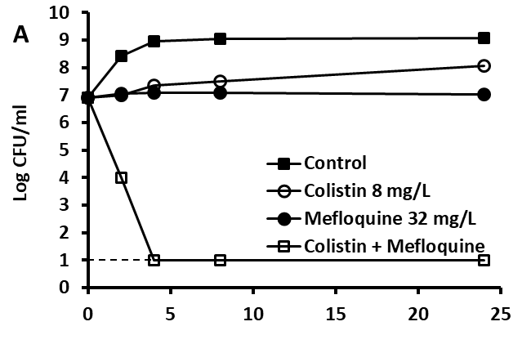
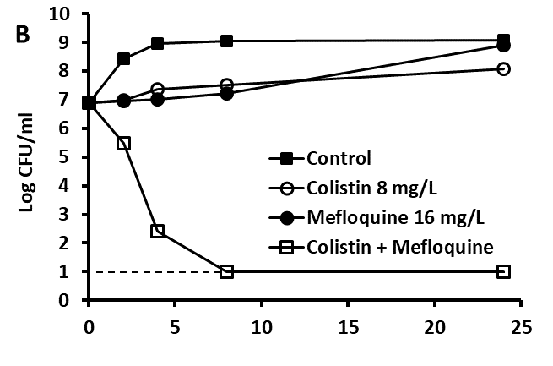

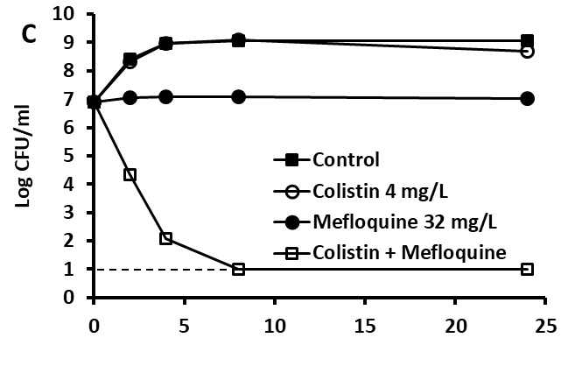
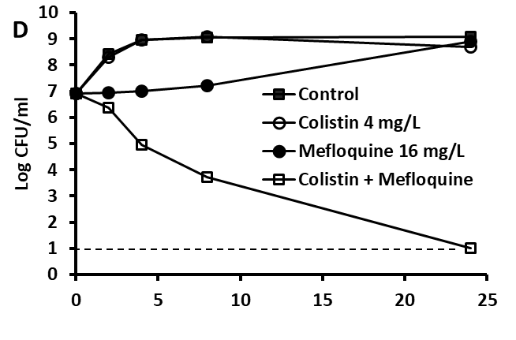

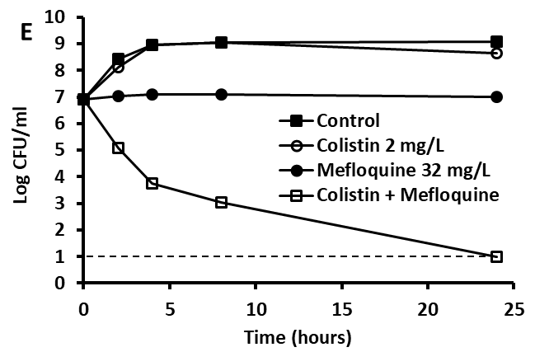
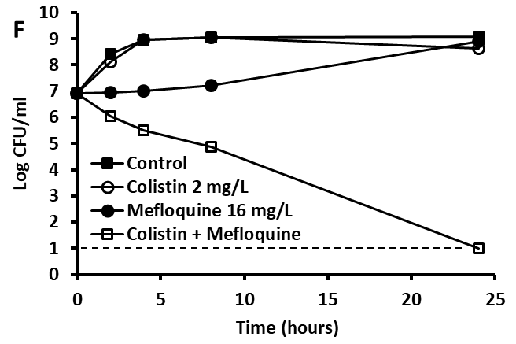

Figure S1. Time Kill analysis showing the effects of mefloquine in combination with colistin against mcr-1 colistin resistant E. coli Af45. Mefloquine and colistin alone or in combination were added to the log phase cultures and CFU counts were carried out at different time points. Combinations of the concentrations are colistin 8 mg/L + mefloquine 32 mg/L (A), colistin 8 mg/L + mefloquine 16 mg/L (B), colistin 4 mg/L + mefloquine 32 mg/L (C), colistin 4 mg/L + mefloquine 16 mg/L (D), colistin 2 mg/L + mefloquine 32 mg/L (E) and colistin 2 mg/L + mefloquine 16 mg/L (F). The dash line is the limit of detection in the assay (20 CFU/mL).

