Title
High-risk exposure without personal protective equipment and infection with SARS-CoV-2 in in-hospital workers - the CoV-CONTACT cohort

Authors
Sarah Tubiana^{1,2, 3,*}, Charles Burdet^{1,2,4,*}, Nadhira Houhou⁵, Michael Thy¹, Pauline Manchon^{1,4}, François Blanquart^{2,6}, Charlotte Charpentier^{2,5}, Jérémie Guedj^{1,2}, Loubna Alavoine¹, Sylvie Behillil^{7,8}, Anne Leclercq⁹, Jean-Christophe Lucet^{2,10}, Yazdan Yazdanpanah^{2,11}, Mikaël Attia¹², Caroline Demeret⁷, Thierry Rose¹³, Julia Anna Bielicki^{14,15}, Patricia Bruijning-Verhagen¹⁶, Herman Goossens¹⁷, Diane Descamps^{2,5}, Sylvie van der Werf^{7,8}, Bruno Lina^{18,19}, Xavier Duval^{1,2}
* Contributed equally

1 AP-HP, Hôpital Bichat, Centre d'Investigation Clinique, Inserm CIC 1425, F-75018 Paris, France
2 Université de Paris, IAME, INSERM, F-75018 Paris, France
3 AP-HP, Hôpital Bichat, Centre de Ressources Biologiques, F-75018 Paris, France
4 AP-HP, Hôpital Bichat, Département d'Epidémiologie, Biostatistique et Recherche, F-75018 Paris, France
5 AP-HP, Hôpital Bichat, Laboratoire de Virologie, F-75018 Paris, France
6 Center for Interdisciplinary Research in Biology (CIRB), Collège de France, CNRS, INSERM, PSL Research University, Paris, France
7 Molecular Genetics of RNA Viruses, Department of Virology, CNRS UMR3569, Université de Paris, Institut Pasteur, Paris, France
8 National Reference Center for Respiratory Viruses, Institut Pasteur, Paris, France
9 AP-HP, Beaujon Hospital, Direction des soins, F-92118 Clichy, France.
10 AP-HP, Hôpital Bichat, Equipe de Prévention du Risque Infectieux, F-75018 Paris, France
11 AP-HP, Hôpital Bichat, Service de Maladies Infectieuses et tropicales, F-75018 Paris, France
12 Physique des fonctions biologiques, CNRS UMR3738, Institut Pasteur, Paris, France
13 Biologie cellulaire des lymphocytes, INSERM – U1221, Department of Immunology, Institut Pasteur, Paris, France
14 Paediatric Infectious Diseases Research Group, Institute for Infection and Immunity, St George's University of London, London SW17 0RE, UK
15 Paediatric Pharmacology and Paediatric Infectious Diseases, University of Basel Children's Hospital, Basel, Switzerland
16 Julius Center for Health Sciences and Primary Care, University Medical Center Utrecht, Utrecht, The Netherlands
17 Laboratory of Medical Microbiology, Vaccine and Infectious Disease Institute, Faculty of Medicine and Health Science, University of Antwerp, Antwerp, Belgium
18 CIRI, Centre International de Recherche en Infectiologie, (Team VirPath), Univ Lyon, Inserm, U1111, Université Claude Bernard Lyon 1, CNRS, UMR5308, ENS de Lyon, F-69007, Lyon, France
19 Laboratoire de Virologie, Centre National de Référence des Virus des infections respiratoires (dont la grippe), Institut des Agents Infectieux, Groupement Hospitalier Nord, Hospices Civils de Lyon, 69004, Lyon, France

Keywords
SARS-CoV-2; in-hospital workers; high-risk exposure; personal protective equipment; transmission

Running title
SARS-CoV-2 infection in in-hospital workers

Corresponding author
Xavier Duval
Centre d’Investigation Clinique
Hôpital Bichat Claude Bernard
46, rue Henri Huchard
75018 Paris, France
Tel: +33 1 40 25 71 48
Fax : +33 1 40 25 67 76
e-mail: xavier.duval@aphp.fr

Word count: xxx
Two recent studies published in this journal focused on SARS-CoV-2 infection among hospital workers (HWs), the first one reported the prevalence of SARS-CoV-2 carriage among HWs and the second, the clinical presentation of symptomatic HWs in order to identify new cases as early as possible and to stop nosocomial transmission (1, 2). The objective of the present study was to estimate within the hospital, the risk of in-hospital HWs infection following a high-risk exposure to SARS-CoV-2-infected subject without personal protective equipment.
We conducted the CoV-CONTACT study, a prospective cohort which included HWs, hereafter referred to as “contacts” with an high risk exposure to an SARS-CoV-2-infected person (either a patient or a colleague) hereafter referred to as “index”, in the 1000 bed Bichat Claude Bernard University Hospital (Paris, France) between March, 3rd 2020 and April, 27th 2020 (3). Exposure was considered to be at high-risk of SARS-CoV-2 transmission if it occurred i) face-to-face, within one meter and without protective surgical or FFP2/N95 mask, and ii) during a discussion or while the index had an episode of coughing or sneezing, and iii) in the 72 hours prior to, or following the virological diagnosis, or during the symptomatic period of the index.
Following exposure and upon written informed consent, daily symptoms were self-reported for 30 days; nasopharyngeal swabs for SARS-CoV-2 RT-PCR were performed at inclusion and at days 3, 5, 7 and 12; SARS-CoV-2 IgG serology (LuLISA N and EuroIMMUN (4, 5)) was assessed at inclusion and at day 30. Confirmed infection was defined by positive RT-PCR or seroconversion, and possible infection by one general and one specific symptom for two consecutive days. SARS-CoV-2 seroconversion was defined as the apparition of a positive SARS-CoV-2 serology at the D30 visit, or as an at least two-fold increase of the LuLISA signal or EuroIMMUN ratio between inclusion and day 30. The primary endpoint was confirmed or possible SARS-CoV-2 infection, hereafter referred to as “SARS-CoV-2 infection”.
The 146 analysed contacts were exposed to 42 COVID-19 index. No contacts worked in a front-line COVID-19 unit (Table 1). Exposure to patient decreased from 67.4% (56/83) before March, 18th (the date of the widespread use of masks in the hospital) to 15.9% (10/63) after March, 18th.
Overall, 24 /146 contact subjects (16.4%, 95%CI [11.0%-23.7%]) had at least one SARS-CoV-2-positive nasopharyngeal swab; 16/146 contact subjects (10.9%) had positive serology at inclusion which did not respond to the seroconversion definition, revealing a pre-existing infection and 31 additional contact subjects (21.2%, 95%CI [15.1%-28.9%]) exhibited a seroconversion at D30. Based on self-administered questionnaires, 59/146 contact subjects (40.4%, 95%CI [32.5%-48.9%]) met the definition of a clinical infection. Seven out of 24 subjects with positive PCR had a positive SARS-CoV-2 nasopharyngeal PCR before the symptoms onset; the first positive nasopharyngeal PCR was observed as early as six days before symptoms onset. At day 30, 63/146 contacts (43.2%, 95%CI [35.1%-51.6%]) had SARS-CoV-2 infection (confirmed in 35 (23.9%, 95%CI [17.5%; 31.9%]), and possible in 28 (19.2%, 95%CI [13.3%; 26.7%])). In the multivariable analysis, the variables associated with SARS-CoV-2 infection were being a non-caregiver HW (aOR=4.1, 95%CI [1.4; 12.2], p=0.010) and being exposed to a SARS-CoV-2-infected patient (aOR=2.6, 95%CI [1.2; 5.7], p=0.013) rather to an infected colleague (Table 1).
Following universal masking for HWs on March, 18th in our hospital, high-risk exposure to SARS-CoV-2-positive patients dropped by 4 and high-risk exposure to SARS-CoV-2-positive colleagues became predominant, making colleagues-to-colleagues transmission a potentially major route of infection (6). Of note, none of the exposures between a HW and a SARS-CoV-2 infected patient occurred in the front-line services where the mask was worn by all caregivers from the beginning of the epidemic. These exposures occurred, prior to universal masking, in second-line services in which patients had not been previously identified as COVID. The profession of the contact subjects was associated with infection, but we did not find any association with the type of activities of the HWs.
The 10.9% rate of HWs with SARS-Cov-2 antibodies at inclusion revealing a pre-existing infection while they were not working in front-line services, is close to the seroprevalence of 8.8% reported in the Paris area in the general population during this period (7, 8). In addition to these HWs already infected at inclusion, 31 others (21.2% of the total population) seroconverted at day 30.
We cannot state with certainty that contacts meeting the definition of confirmed infection acquired their infection as a result of the exposure leading to their inclusion in the study. There are several arguments in favor of the link between exposure and infection: the PCR positivity within 12 days after contact, the chronology of symptom onset after contact, and the seroconversion rate observed within the 30 days following the exposure, which is much higher than that observed in the community between March and May 2020 (7, 8). In addition, the subjects included were counseled to strictly adhere to protective measures to avoid any chain of transmission during the D0-D30 period, limiting the risk of further exposure.
All together, the rate of transmission observed in HWs after high-risk exposure, which could be as large as 43%, and close to a recent report (9), strengthens the conclusion that universal masking of HW, both during contacts with patients and colleagues, and at all times, as soon as the epidemic has been identified, is essential to prevent HWs infection and maintain hospital capacities during outbreaks (10).

References
1. Brown CS, Clare K, Chand M, Andrews J, Auckland C, Beshir S, et al. Snapshot PCR surveillance for SARS-CoV-2 in hospital staff in England. J Infect. 2020 Sep;81(3):427-34. PubMed PMID: 32615198.
2. Jary A, Flandre P, Chabouis A, Nguyen S, Marot S, Burrel S, et al. Clinical presentation of Covid-19 in health care workers from a French University Hospital. J Infect. 2020 Sep;81(3):e61-e3. PubMed PMID: 32579992.
3. Lescure FX, Bouadma L, Nguyen D, Parisey M, Wicky PH, Behillil S, et al. Clinical and virological data of the first cases of COVID-19 in Europe: a case series. Lancet Infect Dis. 2020 Jun;20(6):697-706. PubMed PMID: 32224310.
4. Anna F, Goyard S, Lalanne A, Nevo F, Gransagne M, Souque P, et al. High seroprevalence but short-lived immune response to SARS-CoV-2 infection in Paris. medRxiv https://doiorg/101101/2020102520219030;. 2020.
5. Theel ES, Harring J, Hilgart H, Granger D. Performance Characteristics of Four High-Throughput Immunoassays for Detection of IgG Antibodies against SARS-CoV-2. J Clin Microbiol. 2020 Jun 8. PubMed PMID: 32513859.
6. Contejean A, Leporrier J, Canoui E, Alby-Laurent F, Lafont E, Beaudeau L, et al. Comparing dynamics and determinants of SARS-CoV-2 transmissions among health care workers of adult and pediatric settings in central Paris. Clin Infect Dis. 2020 Jul 15. PubMed PMID: 32663849.
7. Santé Publique France. Point épidémiologie hebdomadaire. https://www.santepubliquefrance.fr/maladies-et-traumatismes/maladies-et-infections-respiratoires/infection-a-coronavirus/documents/bulletin-national/covid-19-point-epidemiologique-du-23-juillet-2020. Accessed July 28, 2020.
8. Le Vu S, Jones G, Anna F, Rose T, Richard J, Bernard-Stoecklin S, et al. Prevalence of SARS-CoV-2 antibodies in France: results from nationwide serological surveillance. medRxiv https://doiorg/101101/2020102020213116;. 2020.
9. Houlihan CF, Vora N, Byrne T, Lewer D, Kelly G, Heaney J, et al. Pandemic peak SARS-CoV-2 infection and seroconversion rates in London frontline health-care workers. Lancet. 2020 Jul 25;396(10246):e6-e7. PubMed PMID: 32653078.
10. Houghton C, Meskell P, Delaney H, Smalle M, Glenton C, Booth A, et al. Barriers and facilitators to healthcare workers' adherence with infection prevention and control (IPC) guidelines for respiratory infectious diseases: a rapid qualitative evidence synthesis. Cochrane Database Syst Rev. 2020 Apr 21;4:CD013582. PubMed PMID: 32315451.

Figure 1

Proportions of symptomatic contact subjects among the 146 contacts of the CoV-CONTACT cohort.
The orange curve corresponds to contacts subjects with confirmed SARS-CoV-2 infection (i.e., virologically- or immunologically-proven, n=35). The green curve corresponds to contacts subjects with possible SARS-CoV-2 infection (i.e., clinically-suspected without viro-immunological confirmation, n=28).

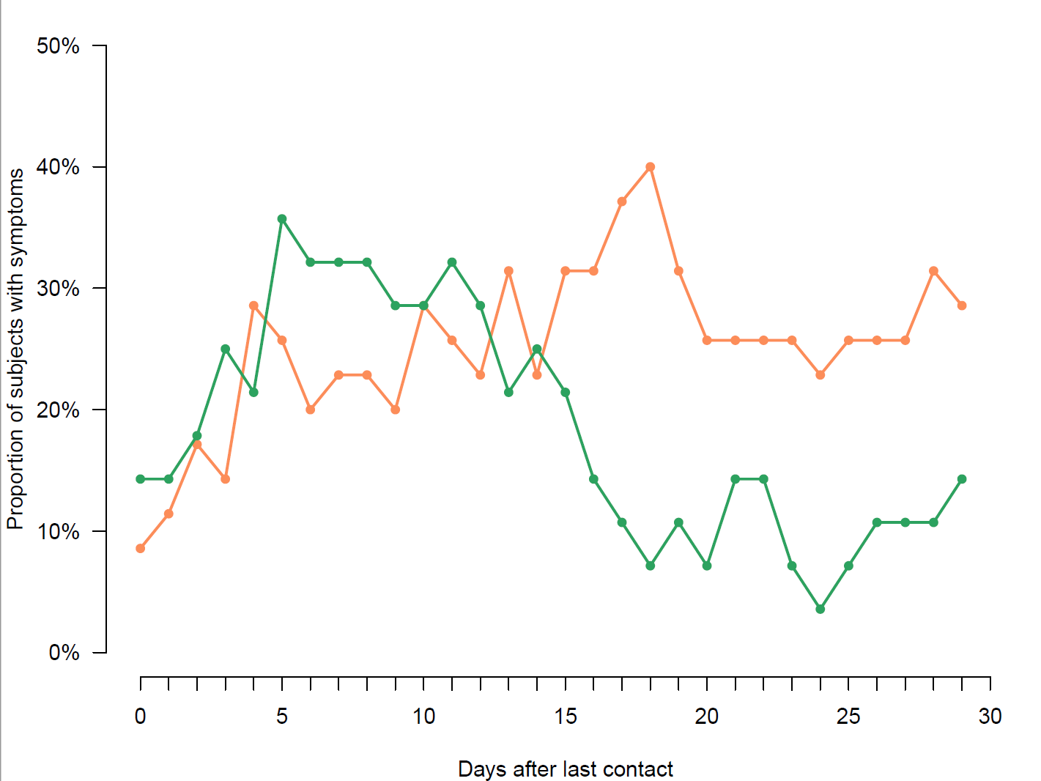

Table 1
Characteristics of the 146 contacts with high-risk exposure to SARS-CoV-2 included in the CoV-CONTACT cohort, according to the infection status at D30.
Variable | All contacts (N=146) | Contacts with  SARS-CoV-2 infection (N=63) | Contacts with no  SARS-CoV-2 infection (N=83) | OR [95%CI] | P-value | aOR [95%CI] | P-value
Contact characteristics
Age (year) | 35 [29;46] (N=146) | 35 [28.5;45.5] (N=63) | 35 [30;47] (N=83) | 0.99 [0.96;1.02] | 0.46
Male gender | 35/146 (24%) | 11/63 (17.5%) | 24/83 (28.9%) | 0.52 [0.23;1.14] | 0.11
HW functions
Medical doctor / Resident / Midwife | 49/146 (33.6%) | 14/63 (22.2%) | 35/83 (42.2%) | 1 (ref) | - | 1 (ref) | -
Registered nurse / Certified nurse assistant /Physiotherapists / Hospital Students | 74/146 (50.7%) | 36/63 (57.1%) | 38/83 (45.8%) | 2.37 [1.11;5.22] | 0.028 | 1.76  [0.78;4.03] | 0.18
Non-caregiver HWs | 23/146 (15.8%) | 13/63 (20.6%) | 10/83 (12%) | 3.25 [1.17;9.36] | 0.025 | 4.06 [1.42;12.18] | 0.010
Coexisting conditions
Obesity (BMI>30Kg/m²) | 27/146 (18.5%) | 13/63 (20.6%) | 14/83 (16.9%) | 1.28 [0.55;2.98] | 0.56
Tobacco use | 36/146 (24.7%) | 17/63 (27%) | 19/83 (22.9%) | 1.24 [0.58;2.66] | 0.57
Cardiopathy | 8/146 (5.5%) | 5/63 (7.9%) | 3/83 (3.6%) | 2.3 [0.54;11.57] | 0.27
Chronic respiratory disease | 21/146 (14.4%) | 7/63 (11.1%) | 14/83 (16.9%) | 0.62 [0.22;1.59] | 0.33
Chronic kidney disease | 2/146 (1.4%) | 2/63 (3.2%) | 0/83 (0%) | NE | 0.99
Diabete | 1/146 (0.7%) | 0/63 (0%) | 1/83 (1.2%) | NE | 0.99
Immusuppressive therapy | 7/146 (4.8%) | 4/63 (6.3%) | 3/83 (3.6%) | 1.81 [0.38;9.47] | 0.45
Current pregnancy | 1/111 (0.9%) | 0/52 (0%) | 1/59 (1.7%) | NE | 0.99
Type of exposition
Contact with > 1 index | 26/146 (17.8%) | 13/63 (20.6%) | 13/83 (15.7%) | 1.4 [0.59 ;3.3] | 0.44
Types of index subject
Contacts with infected HW(s) only | 80/146 (54.8%) | 27/63 (42.9%) | 53/83 (63.9%) | 1 (ref) | - | 1 (ref) | -
Contacts with infected patient | 66/146 (45.2%) | 36/63 (57.1%) | 30/83 (36.1%) | 2.36 [1.21;4.65] | 0.01 | 2.62 [1.24;5.71] | 0.013
Maximal SARS-CoV-2 viral load in the index subject | 9.3 [7.5;10.8] (N=145) | 10 [7.6;10.8] (N=62) | 8.7 [7.5;10.8] (N=83) | 1.1 [0.93;1.31] | 0.25
Cumulated length of exposure > 30 min | 98/143 (68.5%) | 38/61 (62.3%) | 60/82 (73.2%) | 0.61 [0.3;1.23] | 0.17
Exposure to infected patient (N=66)
Care during an aerosol-generating procedure | 6/66 (9.1%) | 3/36 (8.3%) | 3/30 (10%) | 0.82 [0.14;4.73] | 0.81
Care without aerosol-generating procedure | 55/66 (83.3%) | 30/36 (83.3%) | 25/30 (83.3%) | 1 [0.26;3.7] | 1
Presence in the patient's room during an aerosol-generating procedure | 22/66 (33.3%) | 13/36 (36.1%) | 9/30 (30%) | 1.32 [0.47;3.8] | 0.6
Other type of contact | 12/66 (18.2%) | 10/36 (27.8%) | 2/30 (6.7%) | 5.38 [1.27;37.23] | 0.04
Exposure to a SARS-CoV-2-infected HCW (N=92)
Face-to-Face discussion | 86/92 (93.5%) | 31/34 (91.2%) | 55/58 (94.8%) | 0.56 [0.1;3.2] | 0.5
Participation in a joint meeting | 25/92 (27.2%) | 9/34 (26.5%) | 16/58 (27.6%) | 0.95 [0.35;2.43] | 0.91
Lunch sharing | 20/92 (21.7%) | 6/34 (17.6%) | 14/58 (24.1%) | 0.67 [0.22;1.89] | 0.47
Other type of contact | 9/92 (9.8%) | 3/34 (8.8%) | 6/58 (10.3%) | 0.84 [0.17;3.42] | 0.81

