Clinical Outcomes Associated with Left Atrial Appendage Occlusion vs Direct Oral Anticoagulation in Atrial Fibrillation

Jens Erik Nielsen-Kudskª, MD, DMSc; Kasper Korsholmª, MD, PhD; Dorte Damgaard^{b}, MD, PhD, Jan Brink Valentin^{c}; Hans-Christoph Diener^{d}, MD, PhD; Alan John Camm^{e}, MD, PhD; Soren Paaske Johnsen^{c}, MD, PhD.

- Department of Cardiology, Aarhus University Hospital, Aarhus, Denmark
- Department of Neurology, Aarhus University Hospital, Aarhus, Denmark
- Danish Center for Clinical Health Services Research, Department of Clinical Medicine, Aalborg University, Aalborg, Denmark
- Institute for Medical Informatics, Biometry and Epidemiology, Medical Faculty of the University Duisburg-Essen, Essen Germany
- Cardiology Clinical Academic Group Molecular & Clinical Sciences institute, St. George´s University of London, UK

Running title: LAAO vs DOAC

Disclosures: JEN-K: Proctor and investigator for Abbott and Boston Scientific; H-CD: Honoraria for participation in clinical trials, contribution to advisory boards or oral presentations from: Abbott, Bayer Vital, BMS, Boehringer Ingelheim, Daiichi-Sankyo, Medtronic, Pfizer, Portola, Sanofi-Aventis and WebMD Global. Financial support for research projects was provided by Boehringer Ingelheim. Research grants from the German Research Council (DFG), German Ministry of Education and Research (BMBF), European Union, NIH, Bertelsmann Foundation and Heinz-Nixdorf Foundation. AJC: Institutional fees and personal fees from Bayer Boehringer Ingelheim, BMS-Pfizer and Daiichi Sankyo and personal fees from Abbott and Boston Scientific. KK, DD, JBV and SPV: Nothing to declare.

Funding: This study was supported by the Novo Nordic Research Foundation (NNF17OC0024868; NNF17OC0029510) and an unrestricted research grant from Abbott.

Corresponding author:
Jens Erik Nielsen-Kudsk, Professor, MD, DMSc (@Nielsen_Kudsk)
Department of Cardiology, Aarhus University Hospital
Palle Juul-Jensens Boulevard 99, DK-8200 Aarhus N, Denmark
E-mail: je.nielsen.kudsk@gmail.com
Tel: +45 78452024

Manuscript word count: 4440
ABSTRACT
BACKGROUND Left atrial appendage occlusion (LAAO) has been shown non-inferior to warfarin for stroke prevention in atrial fibrillation (AF). However, anticoagulation with direct oral anticoagulants (DOACs) is now preferred over warfarin as thromboprophylaxis in AF.

OBJECTIVES To investigate clinical outcomes associated with LAAO vs DOAC in patients with high-risk AF.

METHODS Patients with AF enrolled in the Amulet Observational Registry (n=1088) who had successful LAAO with the Amplatzer Amulet device (n=1078) were compared to a propensity score matched control cohort of incident AF patients (n=1184) treated by DOAC identified from Danish national patient registries. Propensity score matching was based on the covariates of the CHA₂DS₂-VASc and HAS-BLED scores for predicting stroke and bleeding. The primary outcome was a composite of ischemic stroke, major bleeding (BARC$≥$3) or all-cause mortality and follow-up was 2 years.

RESULTS AF patients treated with LAAO had a significantly lower risk of the primary composite outcome as compared to patients treated with DOAC, HR 0.57 (95% CI: 0.49-0.67). Total events and event rates/100 patient years were (LAAO vs. DOAC): 256 vs. 461 and 14.5 vs. 25.7, respectively.
The risk of ischemic stroke was comparable between groups, HR 1.11 (95% CI: 0.71-1.75), while risk of major bleeding, HR 0.62 (95% CI: 0.49-0.79) and all-cause mortality, HR 0.53 (95% CI: 0.43-0.64) were significantly lower in patients treated with LAAO.

CONCLUSIONS Among high-risk AF patients, LAAO in comparison with DOAC may have similar stroke prevention efficacy but lower risk of major bleeding and mortality.

KEY WORDS
Left atrial appendage occlusion, atrial fibrillation, stroke prevention

CONDENSED ABSTRACT
Clinical outcomes associated with LAAO vs DOAC were investigated in AF patients with a high risk of stroke and major bleeding (n=2255). Patients enrolled and treated by LAAO in the Amulet Observational Study were compared with a control cohort of AF patients treated by DOAC sampled from Danish national patient registries using propensity score matching. Patients were matched so they had similar risk of stroke and bleeding at baseline. After follow-up for 2 years, LAAO showed similar stroke prevention efficacy, but lower risk of major bleeding and mortality than DOAC.

Proposal for tweet (@Nielsen_Kudsk):
Left atrial appendage occlusion vs DOACs improved clinical outcomes in a propensity score match study including 2255 high-risk AF patients.

ABBREVIATIONS
AF: Atrial fibrillation
BARC: Bleeding Academic Research Consortium
CI: Confidence intervals
DOAC: Direct oral anticoagulation
LAAO: Left atrial appendage occlusion
VKA: Vitamin K antagonist

INTRODUCTION
Atrial fibrillation (AF) is a major health care challenge with an increasing prevalence and a projected number of 12.1 million patients by 2030 in US (1). AF increases the risk of stroke 5-fold and about 25% of all ischemic strokes are associated with AF (2, 3). The pathophysiology is embolization of thrombotic material mostly formed in the left atrial appendage (LAA) to the brain(4). Stroke prevention by anticoagulation is the mainstay therapy and direct oral anticoagulants (DOACs) are now preferred over warfarin, primarily due to a lower risk of intracerebral bleeding (5). However, bleeding remains an inherent problem with DOACs as displayed by annual bleeding rates of 2-3.6% in the randomised clinical trials (5). Other important challenges are drug compliance (6), underdosing and undertreatment (7, 8).
Transcatheter occlusion of the LAA (LAAO) is a non-pharmacological stroke prevention technology by which the LAA is closed and isolated from the heart and circulation (9). LAAO has been shown non-inferior to warfarin in two randomised clinical trials (10, 11). The main advantage of LAAO is a reduced bleeding risk by avoiding long-term anticoagulation while still providing a continuous protection from stroke. The two most widely used LAA occluders are the Watchman device and the Amplatzer Amulet (9). The global Amulet Observational Study prospectively enrolled a real-world population of AF patients undergoing LAAO with the Amulet device (n=1088). These patients had a high risk of stroke and bleeding. Implant success rate was 99%, peri-procedural complications 4% and device related thrombosis 1.6%. After 2 years follow-up there was a low ischemic stroke rate of 2.2%/yr (12, 13).
Data comparing LAAO with DOAC are sparse (14). This study sought to investigate clinical outcomes among AF patients having LAAO after enrolment in the Amulet Observational Study (n=1078) vs propensity score matched AF patients treated by DOAC.

METHODS
STUDY DESIGN. A cohort study of AF patients having stroke prevention by LAAO in the Amulet Observational Study compared to a propensity score matched control cohort of AF patients treated by DOAC.

STUDY POPULATION. LAAO cohort: Patients with paroxysmal, persistent or permanent non-valvular AF enrolled in the Amulet Observational Study (n=1088) having successful LAAO with the Amplatzer Amulet device (n=1078). Enrolment was prospectively performed at 61 cardiac centres in 17 countries from June 2015 to September 2016. The majority of patients were included from European centres including Aarhus University Hospital, Denmark. Patients had a high risk of stroke (CHA₂DS₂-VASc 4.2±1.6) and bleeding (HAS-BLED 3.3±1.1).
DOAC cohort: Patients (n=1184) selected by propensity score matching among all Danish patients with new-onset paroxysmal, persistent or permanent non-valvular AF diagnosed between 2013-2015 and initiated on DOAC (n=18570). All patients were identified from the Danish National Patient Registry and the Danish National Prescription Registry. Incident AF patients were chosen to exclude prevalent patients treated with anticoagulation before study inclusion.
Selection of the study population is shown in the Central Illustration. The Danish registries collect patient-level information on all hospital admissions, reimbursed prescriptions and vital status tracked through each citizens unique social security number assigned at birth. They provide high-quality data on mortality, anticoagulation use, stroke, bleeding and comorbidity relevant for matching the two groups (15-17).
The study complied with the ethical standard of the Declaration of Helsinki and patients provided informed consent. The Danish Data Protection Agency approved the study.

FOLLOW-UP. LAAO cohort: Clinical event reporting started at the time of LAAO with continued assessment at planned study visits (discharge, 1-3 months, 6 months, 1 and 2 year after the procedure). Patients were censored at time of first event or at the end of follow-up 2 years after LAAO.
DOAC cohort: Follow-up started from time of DOAC initiation (first redeemed prescription after AF diagnosis) with clinical outcomes collected from the Danish National Patient Registry (stroke and bleeding), the Danish Civil Registration System (mortality), and the Danish Cause of Death Registry.
Patients were censored at time of first event or at end of follow-up 2 years after initiation of DOAC.

CLINICAL OUTCOMES. Primary outcome: A composite of ischemic stroke, major bleeding (BARC ≥3)(18) or all-cause mortality.
Secondary outcomes: Each individual outcome of the primary composite outcome along with cardiovascular mortality, hemorrhagic stroke and discontinuation of DOAC. Definition of outcomes were in accordance with the Munich Consensus document on definitions, endpoints and data collection requirements for clinical LAAO studies (19). Major bleeding events in the DOAC cohort were captured as acute hospital admissions with a bleeding diagnosis. See Supplemental Table 1 for ICD-10 diagnosis codes used for outcomes in the DOAC cohort. Discontinuation of DOAC was defined as more than 60 days without drug.

COVARIATES. Baseline characteristics and comorbidities were collected at enrolment in the Amulet Observational Study or time at diagnosis of AF (DOAC cohort). Age, gender, previous stroke, congestive heart failure, hypertension, diabetes mellitus, vascular disease, abnormal renal function, abnormal liver function, prior major bleeding and drugs predisposing to bleeding were registered enabling calculation of CHA₂DS₂-VASc (20) and HAS-BLED (21) prediction scores.

DATA ANALYSIS AND STATISTICS. A propensity score matching (1:2; greedy 5-1 digit matching with replacement) was performed to reduce confounding in the comparison of LAAO vs DOAC and to include as many patients as possible in the LAAO cohort. The propensity score was calculated for each patient based on CHA₂DS₂-VASc, HAS-BLED and each separate covariate of the prediction scores as stated above. A weight was assigned to each of the patients in the DOAC group according to the number of matches and to ensure sum of weights equal to number of subjects. Balance was assessed using visual inspection of the weighted centiles of the propensity scores as well as the weighted distributions of the applied confounders. Supplemental Fig. 1 depicts the distribution of propensity scores in the LAAO and DOAC cohorts before and after matching.
For the primary outcome, a Cox proportional hazards regression compared LAAO vs DOAC with administrative censoring at two years follow-up. The cumulative incidence of both groups was estimated using the Kaplan-Meier estimator as well as number of events and annualized event rates. Hazard rate ratios (HR) were calculated from Cox regression. Secondary outcomes were analyzed similarly, but using the Aalen-Johansen estimator for the cumulative incidence of ischemic stroke, major bleeding and cardiovascular death. For ischemic stroke and major bleeding, all-cause death was considered a competing event, while for cardiovascular death, other causes of death were treated as competing events. In all analyses, subjects were weighted according to the matching procedure. Event rates, cumulative incidences and HRs were presented with 95% confidence intervals (CI). Moreover, a time to discontinuation of DOAC analysis was conducted for the DOAC population using the Aalen-Johansen estimator with death, LAAO and major bleeding as competing events. Data analysis was performed using Stata 16 (StataCorp. 2019. Stata Statistical Software: Release 16. College Station, TX: StataCorp LLC.).

SENSITIVITY ANALYSES. Having an early bleeding event after initiation of DOAC therapy might identify a group of AF patients with particularly high bleeding risk during long-term DOAC. In this study, events were counted immediately after redemption of the first DOAC prescription, which could potentially represent negative confounding on bleeding data for this cohort. As a first sensitivity analysis, we performed an additional propensity score match evaluation identifying a DOAC cohort in which all AF patients were adherent to DOAC treatment for the first two months as a minimum, and without bleeding events during this period.
Another confounder, especially on mortality, could be cancer if distributed unevenly among the LAAO and DOAC cohorts. A predominance of cancer in the DOAC cohort could theoretically make a negative impact on outcomes. As a second sensitivity analysis, we propensity score matched the LAAO cohort to a DOAC cohort in which all AF patients with a history of cancer at baseline were excluded. This approach was chosen since no data on cancer history were available for the LAAO group at baseline.
In the two sensitivity analyses, clinical outcomes and co-variates used were the same as in the main propensity score match analysis.

RESULTS
PATIENT CHARACTERISTICS. A total of 1078 AF patients had successful LAAO in the Amulet Observational Study. We propensity score matched 1071 LAAO patients with 1184 AF patients treated by DOAC (Central Illustration). Patient characteristics for the LAAO and DOAC cohorts after matching are shown in Table 1.
Mean age was 75.1 years and matching resulted in very similar CHA₂DS₂-VASc (4.2 vs 4.3) and HAS-BLED (3.3 vs 3.4) scores among the two cohorts (LAAO vs DOAC). The prediction scores indicated a study population at high risk of stroke and bleeding. About 30% of patients had a prior stroke and about 75% a prior bleeding event. Revascularisation for coronary artery and carotid artery disease were more common in the LAAO cohort, whereas chronic obstructive pulmonary disease was more prevalent in the DOAC cohort.

PRIMARY CLINICAL OUTCOME. The primary outcome (ischemic stroke, major bleeding or all-cause mortality) occurred in 256 events in the LAAO cohort vs 461 in the DOAC cohort. Median duration of follow-up (Q1-Q3) was for LAAO: 732 days (649-732) and for DOAC: 732 days (411.5-732). The annualized event rate was significantly lower for LAAO (14.5, 95% CI 12.8-16.5) than DOAC (25.7, 95% CI 22.1-30.0)(Table 2). Kaplan-Meier time-to-event curves for the primary outcome are shown in the Central Illustration and Hazard Ratios derived by Cox proportional hazards regression are stated in Table 2. The primary outcome time-to-event curves started to separate after about 1 week and showed progressive separation in favor of LAAO during the follow-up period of 2 years. The hazard ratio (LAAO vs DOAC) was significantly reduced to 0.57 (95% CI 0.49-0.67) corresponding to a relative 43% reduction in risk.

SECONDARY CLINICAL OUTCOMES. Number of events and event rates for each parameter in the primary outcome along with cardiovascular mortality are given in Table 2. Corresponding time-to-event curves (Aalen-Johansen estimates) are shown in Fig. 1 and hazard ratios are stated in Table 2. Ischemic stroke outcome did not differ significantly between LAAO and DOAC (HR 1.11, 95% CI 0.71-1.75), whereas LAAO was associated with a significantly lower risk of major bleeding, all-cause mortality and cardiovascular mortality. Time-to-event curves for all-cause mortality and cardiovascular mortality began to separate just after start of follow-up and showed sustained spreading with time after LAAO. Time-to-event curves for major bleeding started to separate at about 3 months after LAAO and demonstrated progressive separation over time in favor of LAAO vs DOAC. Few hemorrhagic strokes occurred, 10 in the LAAO cohort and 8 in the DOAC cohort.
A total of 155/1071 patients (14.5%) died in the LAAC cohort, 54/155 (35%) with a cardiovascular cause, 68/155 (44%) with a non-cardiovascular cause and 34/155 (22%) with an unknown cause (adjudicated by a clinical event committee). In the DOAC group, a total of 308/1184 patients died (26.0%) with 111/308 (36%) from a cardiovascular cause, 29/308 (9.5%) from vascular disease, 14/308 (4.5%) from stroke and 197/308 (64%) from non-cardiovascular causes according to the Danish Cause of Death Registry.

PROCEDURAL COMPLICATIONS AND ANTITHROMBOTIC TREATMENT IN THE LAAO COHORT.
Serious adverse events (death, stroke, major bleeding, device embolization, major vascular complications) occurred in 4% within the first 7 days after the procedure.(13) These events were included in the primary outcome analysis, except for 2/1078 device embolizations and 9/1078 vascular complications not meeting the criteria of major bleeding (eg. fistulas and pseudoaneurysms). Only stroke, major bleeding or death were included as periprocedural events in primary outcome analysis in the LAAO cohort.
The predominate antithrombotic therapy after LAAO with the Amplatzer Amulet device is dual antiplatelet therapy (DAPT) with aspirin and clopidogrel for 1-3 months and then single antiplatelet therapy (SAPT) with aspirin for 6-12 months. At 1-3 months follow-up in the Amulet Observational Study antithrombotic treatment was: DAPT 318/1018 (31.3%), SAPT 532/1018 (52.2%), DOAC 39/1018 (3.8%), OAC 24/1018 (2.2%) and no antithrombotic therapy 76/1018 (7.5%). At 12 months follow-up treatment was: DAPT 79/950 (8.3%), SAPT 614/950 (64.6%), DOAC 38/950 (4.0%), OAC 18/950 (1.9%) and no antithrombotic therapy 182/950 (19.2%). At 2 years, treatment was DAPT 66/865 (7.6%), SAPT 543/865 (62.8%), DOAC 41/865 (4.7 %), OAC 16/865 (1.8%) or no antithrombotic therapy 186/865 (21.5%). A few patients were on injectable anticoagulants (13/865, 1.5% at 2 year). (13, 22)

DISCONTINUATION OF DOAC
Fig. 2 shows the proportion of AF patients being without DOACs for more than 60 days, with death, LAAO or major bleeding treated as competing risk. After 3 months, 20% of patients in the DOAC cohort were without DOAC treatment. After 2 years of follow-up about 58% of patients had discontinued DOAC treatment.
Among those who discontinued DOAC, 684/806 (85%) did it for unknown reasons and 122/806 (15%) due to major bleeding. Of those with an unknown reason, 71 (10.4%) were switched to treatment by a VKA anticoagulant. Only 283 AF patients (23.9%) continued DOAC treatment for the full period of follow-up of 2 years.

SENSITIVITY ANALYSES. As a first sensitivity analysis, we propensity score matched 1067 LAAO patients with 1141 patients adherent to DOAC for the first 2 months. The primary clinical outcome (ischemic stroke, major bleeding or mortality) occurred by 254 events in the LAAO cohort and 344 events in the DOAC cohort. The annualized event rate was lower for LAAO (14.4, 95% CI 12.7-16.1) than DOAC (18.1, 95% CI 15.1-18.1). The hazard ratio (LAAO/DOAC) was significantly reduced to 0.80 (95% CI 0.68-0.94). The favorable primary outcome for LAAO was primarily driven by a difference in mortality (HR 0.66, 95% CI 0.54-0.81).
In a second sensitivity analysis, we propensity score matched 1067 LAAO patients with 1124 AF patients treated by DOAC and without any history of cancer at baseline. The primary clinical outcome (ischemic stroke, major bleeding or mortality) occurred by 254 events in the LAAO cohort and 409 events in the DOAC cohort. The annualized event rate was lower for LAAO (14.4, 95% CI 12.7-16.4) than DOAC (23.8, 95% CI 20.0-28.3). The hazard ratio (LAAO/DOAC) was significantly reduced to 0.62 (95% CI 0.53-0.72. The favorable primary outcome for LAAO was driven by a difference in major bleeding (HR 0.62, 95% 0.48-0.78) and mortality (HR 0.60, 95% 0.49-0.74).

DISCUSSION
The main finding from this study is that AF patients enrolled in the prospective global real-life Amulet Observational Study and treated by LAAO had a significantly lower risk of the composite clinical outcome of ischemic stroke, major bleeding or mortality compared with AF patients treated by DOAC. Patients in the two cohorts were propensity score matched to ensure similar baseline risk of stroke and bleeding. The studied AF population had a high risk of stroke and major bleeding as indicated by the CHA₂DS₂-VASc and HAS-BLED scores(20, 21) The favorable primary composite clinical outcome for LAAO was driven by a lower risk of major bleeding and all-cause mortality, whereas the risk of ischemic stroke did not differ between LAAO and DOAC.
Two sensitivity analyses supported the main finding. The primary outcome for LAAO vs DOAC was still favorable when the propensity score matched control cohort was restricted to AF patients who adhered to DOAC for at least 2 months after initiation and similar when the control cohort excluded DOAC patients with a history of cancer at baseline. The criterion of drug adherence to DOAC likely excluded AF patients having early bleeding after initiation of DOAC and patients showing intolerance to DOAC. The results of comparing LAAO with a DOAC cohort having no history of malignant disease likely rules out cancer as a significant confounder.
The observed rate of ischemic stroke was low in both the LAAO cohort 2.1%/year and DOAC cohort 1.9%/year and did not differ significantly. These data suggest that both strategies of stroke prevention are effective. For the LAAO cohort this result was achieved with >90% of patients being without any anticoagulation after 1-3 months (13).
The rate of major bleeding was significantly lower in the LAAO vs DOAC cohort. Bleeding rates were similar over the first 3 months due to inclusion of initial procedural bleeds in the LAAO cohort, but over time bleeding was more progressively seen for DAOC compared with LAAO (Fig. 2). These results suggest LAAO as a stroke prevention strategy associated with a lower long-term bleeding risk than DOAC. As patients age the burden of comorbidities increase and thereby the risk of bleeding. It might be speculated that follow-up for longer time than 2 years would show an even more pronounced difference in the rate of bleedings between LAAO and DOAC. However, more long-term follow-up data are needed to confirm or refute this hypothesis.

Transcatheter LAAO was associated with a significantly lower risk of both all-cause mortality (HR 0.53) and cardiovascular mortality (HR 0.51). Major bleeding, occurring at a considerably higher event rate in the DOAC cohort, could theoretically be an important contributor to the excess mortality in the DOAC group. However, it might be difficult to proof this hypothesis because it is often difficult to evaluate the causality between bleeding and death and major bleeding is likely underreported in the Danish Cause of Death Registry. In theory, cancer could possibly be more prevalent in the DOAC than in the LAAO cohort leading to higher mortality and excess bleeding as found for the DOAC cohort. Gastrointestinal bleeding can be triggered by DOAC therapy in patients having gastrointestinal cancer. However, we found that the risk for major bleeding and mortality was still much lower for LAAO than DOAC in a cohort of DOAC treated AF patients without any history of cancer.
In the DOAC cohort we observed a high drug discontinuation rate of about 20% at 3 months, 50% at 1 year and 58% at 2 years (Fig. 2). In the majority, the underlying cause was unknown and only 10.3% of cases could be ascribed to major bleeding. A minority of patients (6%) were switched to VKA following DOAC discontinuation. The high DOAC discontinuation rate should in theory add to an increased risk of ischemic stroke, but the ischemic stroke rate did not differ significantly between the two cohorts. Other large registry based studies have shown high DOAC discontinuation rates with bleeding as one of the underlying causes (6, 7, 23).
The randomized landmark Protect-AF trial evaluated LAAO (Watchman) vs warfarin and showed a non-inferiority result of the composite clinical endpoint of stroke, systemic embolism or cardiovascular mortality after 2 years (10). Superiority criteria were met after 4 years (24). Ischemic stroke rates did not differ significantly and the primary composite endpoint result favoring LAAO was driven by lower rates of mortality and non-procedure-related major bleeding. The effect profile of LAAO compared with DOAC as seen in the present study is very similar to that seen in the Protect-AF trial. This is also compatible with warfarin showing similar stroke prevention efficacy as DOAC (5).
Other data directly comparing LAAO with DOAC are very limited. A network analysis of randomized clinical trials suggested that LAAO was less effective than DOAC in stroke prevention but associated with a lower rate of bleeding (25) whereas a systematic review of observational studies suggested that LAAO was consistently associated with a lower rate of both thromboembolic and hemorrhagic events.(25) In a recent single center propensity score match study, LAAO (n=96) was non-inferior to DOAC (n=96) in terms of thromboembolic and major bleeding events (26). The Praque-17 study (14), a randomized clinical trial of LAAO vs DOAC in AF patients with a high risk of stroke and bleeding showed non-inferiority of LAAO vs DOAC, but it had a relatively low number of patients (n=402) and total events. Several randomized clinical trials comparing LAAO with DOAC have now been commenced, OPTION, OCCLUSION-AF, CLOSURE-AF, CATALYST and CHAMPION-AF, but results will not be available until 2024 at the earliest.

STRENGTHS AND LIMITATIONS. To our knowledge, this is so far the largest comparative study of LAAO vs DOAC. The LAAO cohort was based on a global real-life registry for LAAO and all clinical events were adjudicated by an independent clinical event committee. The DOAC cohort was based on validated nation-wide Danish registries providing reliable data on all clinical events, survival and drug prescriptions. Confounding was reduced by propensity score matching and a sensitivity analysis supported the main study findings. The study was limited by the observational design and potential unaccounted confounders may still be present. There is a risk of selection bias for the LAAO cohort with patients being referred for intervention having a health status and expected longevity better than average. On the other hand, patients selected for LAAO might also be characterized by a declined health status, multiple bleedings, frequent hospitalizations and significant comorbidity. Moreover, the study is limited by the comparison of two different datasets: a prevalent vs. an incident AF cohort, several countries vs. a single country, events captured by clinical visits vs. a national registry, adjudication of events vs. no adjudication and missing information about DOAC dosing. Only a single LAAO device, the Amplatzer Amulet, was evaluated and the results may not be applicable to other LAAO devices. Patients in the LAAO and matched DOAC cohort were at high risk of bleeding and the study findings cannot be extrapolated to a lower-risk AF population. However, the efficacy profile for LAAO found in this study mimicked that of the Protect-AF trial targeting an AF population with a lower risk of stroke and bleeding.

CONCLUSIONS. Among AF patients at high risk of stroke and bleeding, transcatheter LAAO compared with DOAC was associated with a lower risk of a combined clinical outcome of ischemic stroke, major bleeding or mortality. LAAO was associated with a lower risk of the individual outcome of major bleeding, all-cause mortality and cardiovascular mortality, whereas the risk of ischemic stroke was similar. Interpretation of the study is limited by the observational design and the results need confirmation in randomized clinical trials.

PERSPECTIVES
WHAT IS KNOWN? LAAO was shown non-inferior to warfarin as stroke prevention in AF, but data on LAAO vs DOAC are sparse.
WHAT IS NEW? In this study comparing high-risk AF patients having LAAO in the Amulet Observational Study with AF patients treated by DOAC using propensity score matching (n=2550), LAAO had similar stroke prevention efficacy, but lower risk of major bleeding and mortality than DOAC.
WHAT IS NEXT? Larger randomized clinical trials should be performed to further evaluate LAAO against DOACs.

REFERENCES

1. Colilla S, Crow A, Petkun W, et al. Estimates of current and future incidence and prevalence of atrial fibrillation in the U.S. adult population. Am J Cardiol. 2013;112:1142–1147.
2. Hart RG, Sherman DG, Easton JD, Cairns JA. Prevention of stroke in patients with nonvalvular atrial fibrillation. Neurology 1998;51:674–681.
3. Marini C, De Santis F, Sacco S, et al. Contribution of atrial fibrillation to incidence and outcome of ischemic stroke: results from a population-based study. Stroke 2005;36:1115–1119.
4. Cresti A, García-Fernández MA, Sievert H, et al. Prevalence of extra-appendage thrombosis in non-valvular atrial fibrillation and atrial flutter in patients undergoing cardioversion: a large transoesophageal echo study. Eurointervention Journal 2019;15:e225–e230.
5. Ruff CT, Giugliano RP, Braunwald E, et al. Comparison of the efficacy and safety of new oral anticoagulants with warfarin in patients with atrial fibrillation: a meta-analysis of randomised trials. Lancet 2014;383:955–962.
6. Paquette M, Franca LR, Teutsch C, et al. Dabigatran Persistence and Outcomes Following Discontinuation in Atrial Fibrillation Patients from the GLORIA-AF Registry. Am J Cardiol 2020;125:383–391.
7. Hellfritzsch M, Grove EL, Husted SE, et al. Clinical events preceding switching and discontinuation of oral anticoagulant treatment in patients with atrial fibrillation. Europace 2017;19:1091–1095.
8. Gadsbøll K, Staerk L, Fosbøl EL, et al. Increased use of oral anticoagulants in patients with atrial fibrillation: temporal trends from 2005 to 2015 in Denmark. Eur Heart J 2017;1:ehw658–8.
9. Glikson M, Wolff R, Hindricks G, et al. EHRA/EAPCI expert consensus statement on catheter-based left atrial appendage occlusion – an update. EuroIntervention 2020;15:1133–1180.
10. Holmes DR, Reddy VY, Turi ZG, et al. Percutaneous closure of the left atrial appendage versus warfarin therapy for prevention of stroke in patients with atrial fibrillation: a randomised non-inferiority trial. Lancet 2009;374:534–542.
11. Reddy VY, Doshi SK, Kar S, et al. 5-Year Outcomes After Left Atrial Appendage Closure. J Am Coll Cardiol 2017;70:2964–2975.
12. Landmesser U, Schmidt B, Nielsen-Kudsk JE, et al. Left atrial appendage occlusion with the AMPLATZER Amulet device: periprocedural and early clinical/echocardiographic data from a global prospective observational study. EuroIntervention 2017;13:867–876.
13. Hildick-Smith D, Landmesser U, Camm AJ, et al. Left atrial appendage occlusion with the Amplatzer™ Amulet™ device: full results of the prospective global observational study. Eur Heart J 2020;34:2746–8.
14. Osmancik P, Herman D, Neuzil P et al. Left Atrial Appendage Closure Versus Direct Oral Anticoagulants in High-Risk Patients With Atrial Fibrillation. J Am Coll Cardiol 2020;75:3122–3135.
15. Schmidt M, Pedersen L, Sørensen HT. The Danish Civil Registration System as a tool in epidemiology. Eur J Epidemiol 2014;29:541–549.
16. Wildenschild C, Mehnert Frank, W Thomsen R, et al. Registration of acute stroke: validity in the Danish Stroke Registry and the Danish National Registry of Patients. Clin Epidemiol 2013:27–10.
17. Vest-Hansen B, Riis, Christiansen C. Registration of acute medical hospital admissions in the Danish National Patient Registry: a validation study. Clin Epidemiol 2013:129–5.
18. Mehran R, Rao SV, Bhatt DL, et al. Standardized Bleeding Definitions for Cardiovascular Clinical Trials. Circulation 2011;123:2736–2747.
19. Tzikas A, Holmes DR Jr, Gafoor S, et al. Percutaneous left atrial appendage occlusion: the Munich consensus document on definitions, endpoints, and data collection requirements for clinical studies. Europace 2016;10:euw141–12.
20. Friberg L, Rosenqvist M, Lip GYH. Evaluation of risk stratification schemes for ischaemic stroke and bleeding in 182 678 patients with atrial fibrillation: the Swedish Atrial Fibrillation cohort study. Eur Heart J 2012;33:1500–1510.
21. Lip GYH, Frison L, Halperin JL, Lane DA. Comparative Validation of a Novel Risk Score for Predicting Bleeding Risk in Anticoagulated Patients With Atrial Fibrillation. J Am Coll Cardiol 2011;57:173–180.
22. Landmesser UU, Holmes DRD. Left atrial appendage closure: a percutaneous transcatheter approach for stroke prevention in atrial fibrillation. Eur Heart J 2012;33:698–704.
23. O'Brien EC, Holmes DN, Thomas L, et al. Therapeutic Strategies Following Major, Clinically Relevant Nonmajor, and Nuisance Bleeding in Atrial Fibrillation: Findings From ORBIT‐AF. J Am Heart Assoc 2018;7:527–12.
24. Reddy VY, Sievert H, Halperin J, et al. Percutaneous Left Atrial Appendage Closure vs Warfarin for Atrial Fibrillation. JAMA 2014;312:1988.
25. Li X, Wen S-N, Li S-N, et al. Over 1-year efficacy and safety of left atrial appendage occlusion versus novel oral anticoagulants for stroke prevention in atrial fibrillation. A systematic review and meta-analysis of randomized controlled trials and observational studies. Heart Rhythm 2016;13:1203–1214.
26. Godino C, Melillo F, Bellini B, et al. Percutaneous left atrial appendage closure versus non-vitamin K oral anticoagulants in patients with non-valvular atrial fibrillation and high bleeding risk. EuroIntervention 2020;15:1548–1554.

FIGURE TITLES AND LEGENDS

Central Illustration (title): Left atrial appendage occlusion vs DOAC, a propensity-score matched study.
Central Illustration (legend): Clinical outcomes associated with LAAO (Amulet device) vs DOAC in high-risk AF patients. Flow chart showing patient population and propensity-score matching. Kaplan-Meier curves showing the primary composite outcome: ischemic stroke, major bleeding or all-cause mortality. Hazards ratios with 95% CI given for the primary and secondary outcomes.

Fig. 2 (title): Primary clinical outcome
Fig. 2 (legend): Cumulative incidence of the primary clinical outcome (stroke, major bleeding or mortality) associated with LAAO vs DOAC in propensity score matched AF patients (Kaplan-Meier estimate). Number of AF patients at risk are given along the time axis.

Fig. 1 (title): Secondary clinical outcomes
Fig. 1 (legend): Cumulative incidence of ischemic stroke, major bleeding, all-cause mortality and cardiovascular mortality associated with LAAO vs DOAC in propensity score matched AF patients (Aalen-Johansen estimate). Number of AF patients at risk are given along the time axis.

Fig. 2 (title): DOAC discontinuation
Fig. 2 (legend): Cumulative incidence of DOAC discontinuation in the propensity score matched DOAC cohort (Aalen-Johansen estimate). Number of AF patients at risk are given along the time axis.

Table 1. Characteristics of propensity score matched AF patients treated by LAAO vs DOAC .

Patient characteristics | LAAO (n=1071) | DOAC (n=1184)
Age, mean (SD), y | 75.1 (8.5) | 75.1 (10.5)
Gender (male), n (%) | 687 (64.2) | 727 (61.4)
Congestive heart failure, n (%) | 178 (16.6) | 223 (18.9)
Hypertension, n (%) | 896 (83.7) | 1023 (86.5)
Diabetes mellitus, n (%) | 333 (31.1) | 424 (35.8)
Stroke, n (%) | 333 (31.1) | 376 (31.8)
Vascular disease, n (%) | 398 (37.2) | 445 (37.6)
Coronary artery disease, n (%) | 346 (32.3) | 402 (33.9)
Prior PCI or CABG, n (%) | 264 (25.6) | 180 (15.2)
Prior carotid intervention, n (%) | 28 (2.6) | 4 (0.3)
Chronic obstructive pulmonary disease, n (%) | 120 (11.2) | 265 (22.4)
Abnormal renal function, n (%) | 149 (13.9) | 169 (14.3)
Abnormal liver function, n (%) | 51 (4.8) | 77 (6.5)
Bleeding, n (%) | 794 (74.1) | 889 (75.0)
Drugs (antiplatelets, NSAID), n (%) | 321 (30.0) | 439 (37.1)
Alcohol, n (%) | 50 (4.7) | 60 (5.1)
CHA₂DS₂-VASc, mean (SD) | 4.2 (1.6) | 4.3 (1.7)
HAS-BLED, mean (SD) | 3.3. (1.0) | 3.4 (1.2)

Table 2. Number of clinical outcome events, event rates and hazard ratios in propensity score matched AF patients treated by LAAO vs DOAC

 | LAAO (n=1071) | DOAC (n=1184)
Primary outcome:
Ischemic stroke, major bleeding, mortality
Events, n | 256 | 461
Event rate pr. 100 patient years, 95% CI | 14.5 (12.8-16.5) | 25.7 (22.1-30.0)
Hazard ratio, 95% CI (LAAO vs DOAC) | 0.57 (0.49-0.67)
Ischemic stroke
Events, n | 39 | 37
Event rate pr. 100 patient years, 95% CI | 2.1 (1.5-2.9) | 1.9 (1.3-2.7)
Hazard ratio, 95% CI (LAAO vs DOAC) | 1.11 (0.71-1.75)
Major bleeding
Events | 108 | 183
Event rate pr. 100 patient years, 95% CI | 6.0 (4.9-7.3) | 10.0 (8.0-12.6)
Hazard ratio, 95% CI (LAAO vs DOAC) | 0.62 (0.49-0.79)
All-cause mortality
Events, n | 155 | 308
Event rate pr. 100 patient years, 95% CI | 8.0 (6.9-9.4) | 15.3 (12.6-18.6)
Hazard ratio, 95% CI (LAAO vs DOAC) | 0.53 (0.43-0.64)
Cardiovascular mortality
Events, n | 54 | 111
Event rate pr. 100 patient years, 95% CI | 2.8 (2.1-3.7) | 5.5 (4.0-7.8)
Hazard ratio, 95% CI (LAAO vs DOAC) | 0.51 (0.37-0.70)

Central Illustration

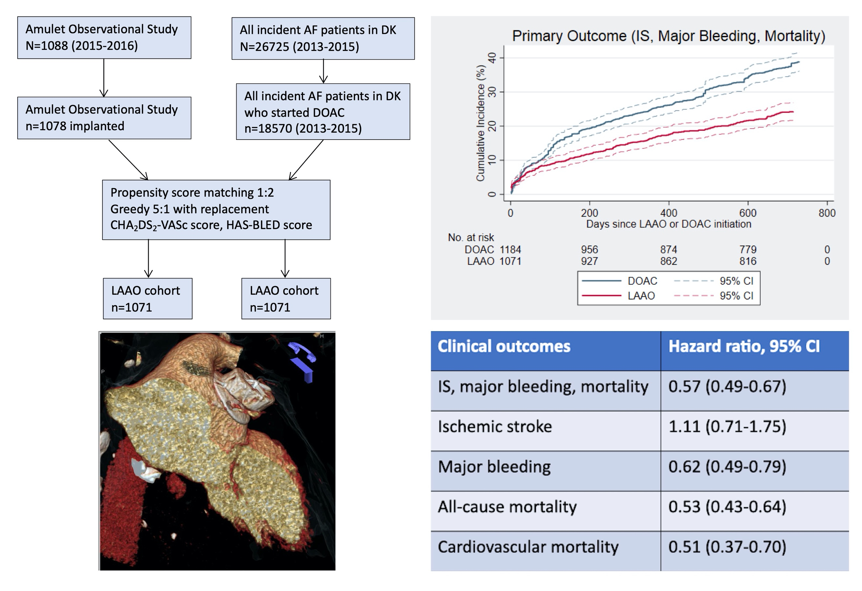

Fig. 1

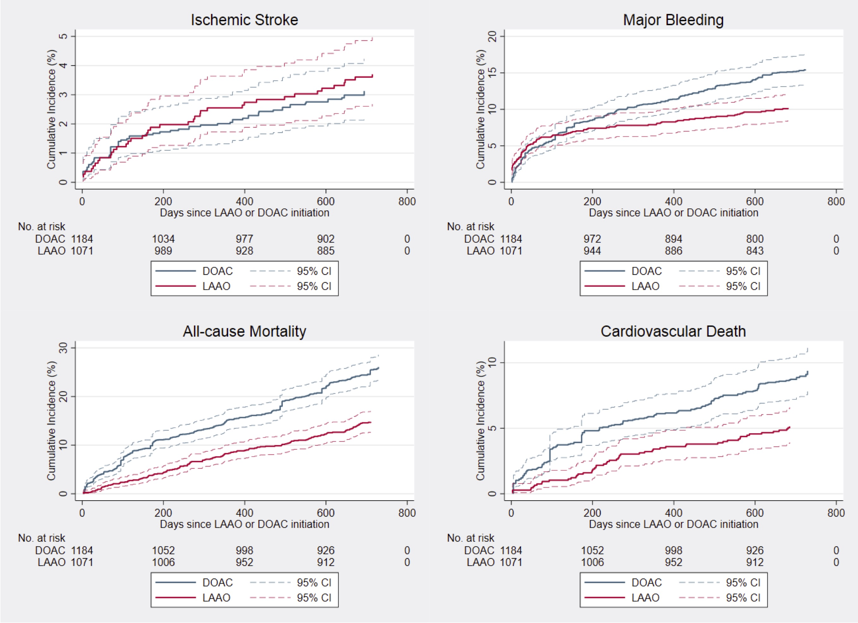

Fig. 2

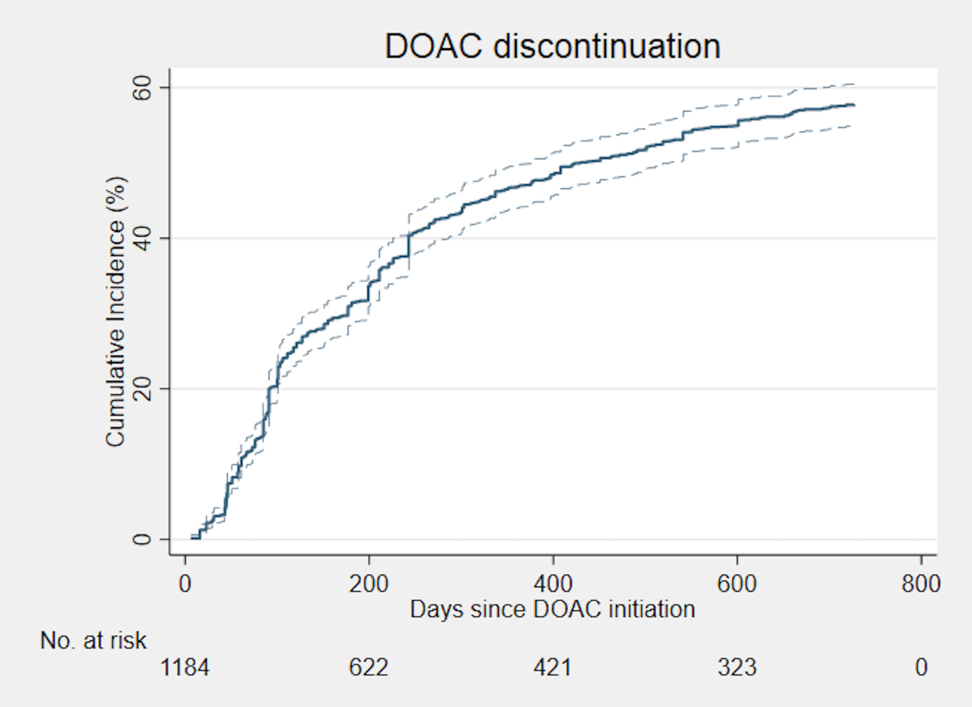

SUPPLEMENTAL MATERIALS

Supplemental Fig. 1 (title): Distribution of propensity scores
Supplemental Fig. 1 (legend): Distribution of propensity score among patients in the LAAO and DOAC cohorts before and after propensity score matching, respectively

Supplemental Table 1. ICD-10 diagnosis codes used to capture outcomes in the DOAC cohort

Outcome | ICD-10 codes
Stroke | I63*, I64
Major bleeding | D500, D62, I62, I850, I864A, K250, K252, K254, K256, K260, K262, K264, K266, K270, K272, K274, K276, K280, K282, K284, K286, K290, K299A, K625, K929, K921, K922, J942, R04, N02, R31, R58
Cardiovascular death | I00-28, I30-51, I60-99
Cancer | C00-C43, C45-C97

Supplemental Fig. 1

