Title: Imaging studies in a primary vaginal melanoma disguised as a sub-urethral cyst: A Case Report

Authors:
- Nicola Adanna Okeahialam
nicola.okeahialam@nhs.net

- Ranee Thakar
ranee.thakar@nhs.net

- Abdul H Sultan, MD, FRCOG
abdulsultan@nhs.net

Corresponding Author:
Mr Abdul H Sultan
abdulsultan@nhs.net

Keywords (3-5): Vaginal melanoma, Sub-urethral cyst, Pelvic Floor Ultrasound, Transperineal Ultrasound, Magnetic Resonance Imaging

Full Text: 1500/1500 words

Introduction:
Malignant melanoma is usually cutaneous in origin, however, mucosal surfaces, such as those lining the urogenital tract can also be affected.¹ In the urogenital tract, the most commonly affected sites include the vulva (77%), followed by the vagina(20%), with the least affected being the cervix (2%).² Malignant melanoma of the vagina accounts for 0.3% of all malignant melanomas and less than 3% of vaginal carcinomas.³ It is extremely rare and has been reported in epidemiological studies from the United States to affect approximately three women per 10 million women annually; mainly occurring in postmenopausal women in their sixth or seventh decade of life.^{2,4,5} Although magnetic resonance imaging (MRI) features of vaginal melanoma have been previously described, there is a paucity of literature describing pelvic floor ultrasound findings.^{6–10}

Patient Information:
A 70-year-old, multiparous, Caucasian woman presented to the Urogynecology clinic with a history of a painless vaginal lump for one month and one episode of vaginal bleeding on wiping. She had no concomitant urinary symptoms; including incontinence, dysuria, urinary frequency, post-micturition dribble or hematuria. She denied any change in appetite or unexplained weight loss.
Her past medical history was unremarkable, with no significant gynecological or obstetric history of note. She had a normal cervical screening history and did not report prior use of hormone replacement therapy. She had a BMI of 24, was a non-smoker and did not drink alcohol.
Clinical Findings:
On vaginal examination, a 3 cm cystic, smooth-walled, pigmented, sub-urethral mass with contact bleeding was identified, with a palpable small nodule posterolaterally. There was no associated pelvic organ prolapse. Figure 1 depicts the timeline of important interventions and outcomes of this case.

Diagnostic Assessment:
Initial investigations including a midstream urinalysis excluded urinary tract infection. MRI revealed a partially septated mass with intermediate signal intensity on T2-weighted sequencing. The mass measured 23 x 40 x 27 mm, and was positioned immediately posterior to the distal urethra, lying anterior to the vaginal introitus (Figure 2). Although MRI is believed to be the recommended modality of choice in the diagnosis of sub-urethral masses ¹¹, pelvic floor ultrasound has been shown to be equally as accurate.¹² Two-dimensional perineal pelvic floor ultrasound (2D pPFUS) was performed using the Flex Focus 500 ultrasound system (BK Medical, Herlev, Denmark) with a convex transducer (Type 8802; 4.3–6 MHz) applied to the perineum. This revealed a 36 x 24 x 26 mm loculated mass with mixed echogenicity. The mass lay posterior to the urethra in the anterior vaginal wall, with its most proximal border 5 mm above the level of the bladder neck. Color doppler sonography showed a diffuse hypervascular pattern (Figure 2). Three-dimensional endovaginal ultrasound was not performed due to contact bleeding from the cyst. Both MRI and 2D pPFUS confirmed there was no communicating tract present between the mass and the urethra; therefore, making a diagnosis of a urethral diverticulum less likely. Other potential differential diagnoses included vaginal leiomyoma, skene duct abscess or Gartner’s duct cyst.

Therapeutic Interventions:
Surgical excision of the sub-urethral mass was performed under general anesthetic. Prior to excision of the mass, due to the close proximity of the cyst to the bladder neck, rigid cystoscopy was performed; confirming a normal bladder urothelium, with normal ureteric orifices with no diverticula ostium seen. The urethra appeared normal. The vaginal mass was found to be cystic, hemorrhagic and pigmented. It measured 4 x 6 cm and was positioned 1.5 cm from the bladder neck (Figure 3). An inverted U-shaped incision over the anterior vaginal wall was performed followed by dissection and mobilization of the vascular mass. A two-layer closure (urethral fascia and vaginal skin) was performed using Vicryl 2-0. Three further masses were also identified including; a hemorrhagic 2cm cyst at the bladder neck, and two posterior vaginal wall cysts with a diameter of 1cm. The cervix appeared normal. Circumferential excision of these cysts was performed. Skin closure was completed with Vicryl 2-0. There was no urethral disruption; confirmed with the methylene blue dye test injected into the urethra with a syringe and quill. A Foley catheter was placed in the bladder for 12 hours. After a successful voiding trial without catheter she was discharged home the next day.

Histological examination of the surgical specimens revealed fragments of tissue lined by non-keratinized stratified squamous epithelium with focal ulceration; with no urothelium identified. Within the junctional component, nests and single enlarged atypical melanocytes were present. Pigment was noted within the cytoplasm of the atypical cells which exhibited brisk mitotic activity and focally, spindle cell morphology. No lymphovascular activity was noted histologically. Furthermore, immunohistochemistry showed that cell cytoplasm was positive for diagnostic antibody biomarkers including Melan A, S100 and HMB45. A diagnosis of malignant melanoma was made, with a Breslow thickness of 23 mm. Using the Tumor, Node and Metastasis (TNM) pathological staging, the tumor was classified as pT4b pNx. The mean survival rate for vaginal melanoma has been reported as 19 months (95% CI 16-22 months) with tumor extension and lymph node status being associated with survival outcome.¹³

Follow-up and Outcomes:
Referral to a large tertiary center for management was made and computerized Tomography (CT) scan was performed for disease staging; confirming there was no evidence of metastatic disease. However, examination under anesthesia performed two months later revealed a pigmented para-urethral and vaginal nodule measuring 0.5 x 1cm, consistent with residual disease. Adjuvant immunotherapy was commenced and was escalated to brachytherapy after four cycles due to further local disease recurrence confirmed on CT and MRI. MRI showed two separate masses; one distally in the left vaginal wall and one centered on the cervix with no parametrial involvement. A 44Gy course of brachytherapy was delivered in 4 fractions using multi-channel vaginal applicators. The patient unfortunately experienced symptoms of acute toxicity; diarrhea, weight loss and appetite reduction and local side effects including vaginal soreness. These were managed and resolved with the use of oral prednisolone, loperamide and a topical vaginal moisturizer. A follow up MRI has been arranged in 3-months to assess disease response.

Discussion:
Sub-urethral masses can be congenital or acquired in origin. The differential diagnoses include sub-urethral cysts, urethral diverticulum, urethral caruncle, Gartner duct cyst, Skene duct cyst and urethral leiomyoma.^{14–16} Disease is usually benign but malignant change should be considered in a mass that is hardened or irregular in shape, particularly in the presence of accompanying symptoms such as bleeding.^{17,18} Diagnosis can prove difficult as patients often present with non-specific signs and symptoms which may be complicated by infection, hemorrhage or rupture.¹⁶ Vaginal melanoma typically occurs in the distal third of the vagina, with most affecting the lateral (45%) followed by the anterior vaginal wall (39%). Common presenting symptoms include vaginal bleeding in 64% of cases, vaginal mass in 16% and discharge in 16%.¹⁹

Imaging modalities used to evaluate sub-urethral masses include MRI, ultrasound (transvaginal, transperineal and endovaginal), video cystourethrography (VCU) and cystourethroscopy.^{17,20,21} MRI is the gold standard investigation as it delineates urethral anatomy well due to good soft tissue contrast; particularly T2-weighted images which highlight fluid-filled sub-urethral masses, whose contents appear bright.^{17,20} However, ultrasound use is increasing in popularity.^{21,22} An electronic search of the literature was performed with no limit on publication date or language. Sources used included MEDLINE, EMCARE and a manual search of references. The search terms used were “vaginal melanoma”, “malignant melanoma” and/or “sub-urethral mass”. The search identified a total of 639 papers. After screening of title and abstract and removal of duplicates, seven relevant papers which discussed the MRI (six papers) or ultrasound (one paper) appearance of vaginal melanomas were highlighted.

The T2-weighted MRI appearance of vaginal melanoma has been discussed in 15 patients. In these patients, the tumor most commonly exhibited a hyperintense signal (66.7%) followed by intermediate signal (20%) and a low signal intensity (13.3%).
Signal intensities are associated with the percentage melanin pigment within the mass; the greater the concentration, the lower the signal intensity on T2 weighted images.²³

To our knowledge, appearance of vaginal melanomas on transperineal ultrasound has been documented in only one other paper.²⁴ Here, the vaginal melanoma was described as a hypoechoic, anterior vaginal wall mass which was highly vascular on color doppler.²⁴ Sonographic findings in our case are consistent with two of the features in the abovementioned paper.

Our case was limited by diagnostic uncertainty at presentation, meaning early referral to a gynecology oncology team/special interest dermatologist via the urgent cancer referral pathway was not initially made. However, despite this, prompt referral to a tertiary service for further management was made once histopathological confirmation was obtained. It is recommended that vaginal melanomas should initially be investigated with biopsy (punch or incisional). This should be supplemented with MRI, examination under anesthesia and cystoscopy if clinically indicated. It is then advised that they are treated with complete wide local excision, with a recommended microscopically clear resection margin of greater than 1mm.²⁵

MRI is mainly used to evaluate tumor size and extent including, relationship with local and regional anatomy, therefore assisting in surgical planning.^{4,6} In this case, pelvic floor ultrasound was also able to delineate tumor extent including distance from important local anatomical sites including the bladder neck. Vaginal melanoma can be associated with early dissemination and distant metastasis.^{2,4} Therefore, although imaging is important in the initial evaluation, given that vaginal melanoma is extremely rare, tissue biopsy of vaginal masses with diagnostic uncertainty is vital.

We used the CARE checklist when writing this report.²⁶

References:
1. Mihajlovic M, Vlajkovic S, Jovanovic P, et al. Primary mucosal melanomas: a comprehensive review. Int J Clin Exp Pathol 2012; 5: 739–753.
2. McLaughlin CC, Wu X-C, Jemal A, et al. Incidence of noncutaneous melanomas in the U.S. Cancer 2005; 103: 1000–1007.
3. Kalampokas E, Kalampokas T, Damaskos C. Primary Vaginal Melanoma, A Rare and Aggressive Entity. A Case Report and Review of the Literature. In Vivo 2017; 31: 133–140.
4. Leitao MM, Cheng X, Hamilton AL, et al. Gynecologic Cancer InterGroup (GCIG) Consensus Review for Vulvovaginal Melanomas. Int J Gynecol Cancer 2014; 24: S117–S122.
5. Kirschner AN, Kidd EA, DeWees T, et al. Treatment Approach and Outcomes of Vaginal Melanoma: Int J Gynecol Cancer 2013; 23: 1484–1489.
6. Liu Q-Y, Zeng Y-P, Lin X-F, et al. MRI findings in primary vaginal melanoma—a report of four cases. Clinical Imaging 2015; 39: 533–537.
7. Moon W-K, Kim S-H, Han M-C. MR findings of malignant melanoma of the vagina. Clinical Radiology 1993; 48: 326–328.
8. Tsuda K, Murakami T, Kurachi H, et al. MR imaging of non-squamous vaginal tumors. European Radiology 1999; 9: 1214–1218.
9. Fan SF, Gu WZ, Zhang JM. MR findings of malignant melanoma of the vagina. BJR 2001; 74: 445–447.
10. Takehara M, Saito T, Mizumoto H, et al. Imaging studies in patients with malignant melanoma in the female genital tract. Int J Gynecol Cancer 2002; 12: 506–509.
11. Abrams P, Cardozo L, Wagg A, et al. (eds). Imaging in urinary incontinence and pelvic floor dysfunction. In: Incontinence 6th Edition (2017). Bristol, UK: ICI-ICS.
12. Okeahialam NA, Taithongchai A, Sultan AH, et al. Transperineal and endovaginal ultrasound for evaluating sub-urethral masses: A comparison to magnetic resonance imaging. Ultrasound in Obstetrics & Gynecology; n/a. Epub ahead of print 16 September 2020. DOI: 10.1002/uog.23123.
13. Wohlmuth C, Wohlmuth-Wieser I, May T, et al. Malignant Melanoma of the Vulva and Vagina: A US Population-Based Study of 1863 Patients. Am J Clin Dermatol 2020; 21: 285–295.
14. Blaivas JG, Flisser AJ, Bleustein CB, et al. Periurethral Masses: Etiology and Diagnosis in a Large Series of Women: Obstet Gynecol 2004; 103: 842–847.
15. El-Nashar SA, Bacon MM, Kim-Fine S, et al. Incidence of female urethral diverticulum: a population-based analysis and literature review. Int Urogynecol J 2014; 25: 73–79.
16. Chaudhari VV, Patel MK, Douek M, et al. MR Imaging and US of Female Urethral and Periurethral Disease. RadioGraphics 2010; 30: 1857–1874.
17. Archer R, Blackman J, Stott M, et al. Urethral diverticulum. Obstet Gynecol 2015; 17: 125–129.
18. Thyavihally YB. Primary Carcinoma of the Female Urethra: Single Center Experience of 18 Cases. Jpn J Clin Oncol 2005; 35: 84–87.
19. Xia L, Han D, Yang W, et al. Primary Malignant Melanoma of the Vagina: A Retrospective Clinicopathologic Study of 44 Cases. Int J Gynecol Cancer 2014; 24: 149–155.
20. Greiman AK, Rolef J, Rovner ES. Urethral diverticulum: A systematic review. Arab Journal of Urology 2019; 17: 49–57.
21. Shobeiri SA, Rostaminia G, White D, et al. Evaluation of Vaginal Cysts and Masses by 3-Dimensional Endovaginal and Endoanal Sonography. Journal of Ultrasound in Medicine 2013; 32: 1499–1507.
22. Yang H, Gu J-J, Jiang L, et al. Ultrasonographic Imaging Features of Female Urethral and Peri-urethral Masses: A Retrospective Study of 95 Patients. Ultrasound in Medicine & Biology. Epub ahead of print 22 May 2020. DOI: 10.1016/j.ultrasmedbio.2020.03.024.
23. Woodruff WW, Djang WT, McLendon RE, et al. Intracerebral malignant melanoma: high-field-strength MR imaging. Radiology 1987; 165: 209–213.
24. Hamed ST, Mansour SM. Surface transperineal ultrasound and vaginal abnormalities: applications and strengths. Brit J Radiol 2017; 20170326.
25. Smith HG, Bagwan I, Board RE, et al. Ano-uro-genital mucosal melanoma UK national guidelines. Eur J Cancer 2020; 135: 22–30.
26. Gagnier JJ, Kienle G, Altman DG, et al. The CARE Guidelines: Consensus-based Clinical Case Reporting Guideline Development. Glob Adv Health Med 2013; 2: 38–43.

Figure 1: Timeline of interventions and outcome
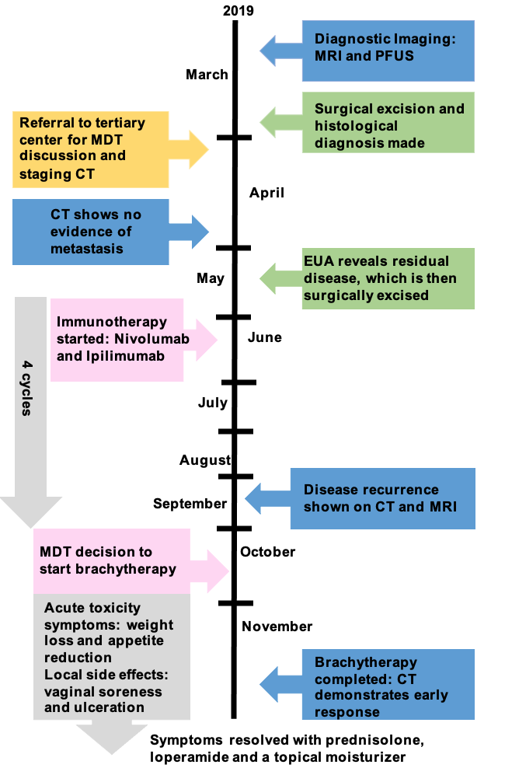

Figure 2 (A-F): T2-weighted MRI images of the sub-urethral mass measuring 23 x 40 x 27 mm in a sagittal (A) axial (B) and coronal view (C). Two-dimensional transperineal ultrasound image of the sub-urethral mass measuring 36 x 24 x 26 mm in a sagittal (D) and coronal view (E, F), showing the loculations (E) and increased vascularization on color doppler (F)
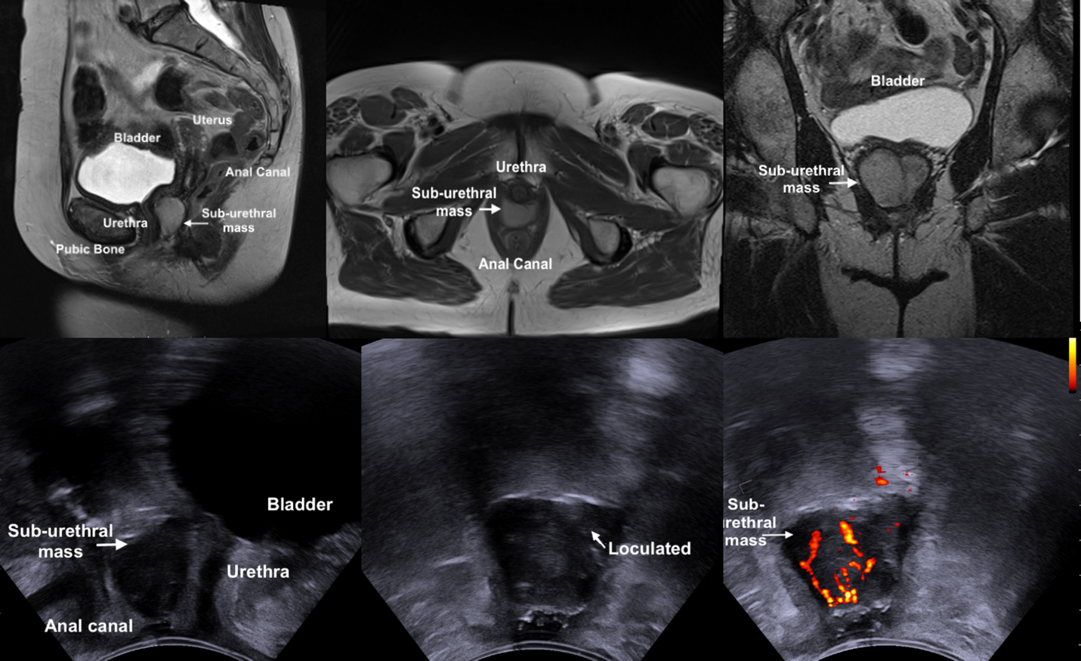

Figure 3 (A, B): Intraoperative appearance of the pigmented sub-urethral mass (A) exhibiting overlying vascularity with contact bleeding (B).

