DEEP BRAIN STIMULATION OF THE VENTRALIS ORALIS ANTERIOR THALAMIC NUCLEUS IS EFFECTIVE FOR DYSTONIC TREMOR

Mongardi L MD^{1*}, Rispoli V MD^{2*§}, Scerrati A MD¹, Giordano F MD, PhD³, Capone JG MD⁴, Vaudano AE MD, PhD², De Bonis P MD, PhD¹, Morgante F MD, PhD^{5,6}, Picillo M MD, PhD⁷, Cavallo MA MD¹, Sensi M MD, PhD⁴
¹Neurosurgery, S. Anna University Hospital, via Aldo Moro 8, Ferrara, Italy
²Neurology, Neuroscience Head Neck Department, University of Modena and Reggio Emilia, Italy
³Neurosurgery Department, Children's Hospital A. Meyer, University of Florence, viale Pieraccini 24, Florence, 50139, Italy.
⁴Neurology Department, S. Anna University Hospital, via Aldo Moro 8, Ferrara Italy
⁵Neurosciences Research Centre, Molecular and Clinical Sciences Research Institute, St George's University of London, London, United Kingdom;
⁶Department of Experimental and Clinical Medicine, University of Messina, Italy
⁷Center for Neurodegenerative Diseases (CEMAND), Department of Medicine, Surgery and Dentistry, University of Salerno, Italy
*both these authors contributed equally to this article.

§Corresponding author:
Vittorio Rispoli, MD.
Via Pietro Giardini, 1355, 41126 Baggiovara – Modena (MO)
Neurology, Neuroscience Head Neck Department, University of Modena and Reggio Emilia, Italy

Phone: 0039 059 3962220
E-mail: vit.rispoli@gmail.com

Manuscript type: Correspondence
Word count (text): 858
Word count (abstract): 50
Key words: dystonic tremor, VoA, dystonia, DBS, VTA.

Dear Editor,
Dystonic tremor (DT) is a phenomenological feature of dystonia which may occur in the body part affected by dystonia. Its management relies on oral medications, botulinum neurotoxin and deep brain stimulation (DBS).
To date, the most effective target to treat both dystonia and tremor in case of DT is still matter of debate. On the one hand, several experiences reported that Globus Pallidus Internus (GPi)-DBS did not ameliorate tremor to the same extent as dystonia[1–4]. In a case series the tremor reduction was 39.8% for GPi-DBS implanted patients compared to 84.7% in case of Ventralis Intermedius nucleus (VIM)-DBS[3], results confirmed by Tsuboi et al[1]. On the other hand, VIM-stimulation may induce dystonia[5]. Therefore, VIM is preferred when tremor is the most prominent feature compared to dystonia, but its efficacy in DT patients has been proved so far only at short-term[3,4] and the effect on dystonia are extremely variable[1,4]. So, the aforementioned evidence drove some authors to propose a combined VIM/GPi-DBS approach[1,3,4].

Few reports support Ventralis Oralis Anterior - Ventralis Oralis Posterior thalamic nuclei (VoA-VoP) complex as a potential target for functional surgery (see supplementary table 1).
Herein, we report the clinical outcome of three Ventralis Oralis Anterior thalamic nucleus (VoA) DBS implanted tremor-dominant dystonic patients, in whom correlation with volume of tissue activated (VTA) has been performed. Demographic characteristics, patient selection criteria, surgical procedure and neuroimaging processing are described in supporting information.

Case 1. A 17-year-old boy affected by post-traumatic left sided hemi-dystonia with disabling left upper and lower limbs action tremor was implanted in the right VoA (Medtronic 3389 electrode with Activa RC). At six and 24-month follow-up, his tremor showed a moderate reduction, whereas dystonia improved in craniocervical segment only. His Fahn Tolosa Marin Tremor Rating Scale (FTMRS) score dropped from 18/144 to 11/144 and Burke-Fahn-Marsden Dystonia Motor score (BFMRS-M) from 33,5/120 to 28/120. Post-operative neuroimaging processing showed that the lead was slightly anterior and lateral to the right VoA. The VTA produced by conventional ring-mode stimulation encompassed the anterolateral portion of VoA, and only marginally VoP, Zona Incerta (Zi) and Forel’s fields (Figure 1).

Case 2. A 63-year-old woman underwent bilateral VoA-DBS implant (Abbott directional DBS electrodes 6172 Infinity) because of medication resistant idiopathic cervical dystonia (retrocollis, left laterocollis and severe anterior-to-posterior head dystonic tremor). She experienced an early significant reduction of tremor and at 6- and 24-month follow-up tremor was further remarkably reduced, while cervical dystonic posture showed a moderate improvement (FTMRS at baseline 44/144 and at 24-months 4/144; BFMRS-M baseline 8/120 and 24-months 4/120). At 3D-rendering, left and right leads crossed the whole VoA, while the VTA seems to spread to the Zi, particularly on the left side (Figure 1).

Case 3. A 59-year-old man presented with right hand idiopathic upper limb dystonia and asymmetric (right>left) bilateral postural and action upper limb tremor. At baseline BFMRS-M was 4/120 and FTMRS 41/144. A directional DBS system (Boston Scientific Gevia) was implanted bilaterally. During the surgical procedure the patient experienced a nearly complete resolution of the upper limb tremor, which was maintained in long-term follow-up (12-month FTMRS: 15/144). Also, focal dystonia improved significantly (12-month BFMRS-M: 1/120). On neuroimaging, the trajectory of the electrodes was slightly posterior and medial to the VoA bilaterally with no involvement of other surrounding nuclei.
Video related to this article can be found in supplementary materials.

For the first time, in this series, considering the distinct phenotype of DT, the most anterior portion of the VoA-VoP complex, namely the VoA, was specifically targeted, as shown by the analysis of the VTA. VoA was preferred to GPi since tremor was the most prominent and disabling symptom, while it was chosen instead of VIM because of simultaneous dystonic features. Moreover, this target may overcome the doubles surgical risk of the suggested combined VIM/GPi implant, but it may offer the advantages of both these targets[1,3,4]. Indeed, VoA represents a crucial crossroad between the pallidothalamic and cerebellothalamic afferents[6]: ansa lenticularis connects the lateral part of GPi to the centromedian nucleus, ventral anterior nucleus and VIM, while the lenticular fasciculus, the superior segment of the medial part of the GPi to VoA and Ventralis Lateral thalamic nucleus[7]. The possible partial engagement of Zi was also a co-factor contributing in tremor improvement as previously reported[7].
Remarkably, even though the limited (up to 2 years) and variable follow-up, no significant adverse events related to implant or stimulation induced dystonia, neither habituation and/or re-emergence of tremor were documented compared to some VIM-DBS case series[8]. Indeed, the more anterior surgical approach of thalamic nuclei, avoiding a direct stimulation of the cerebello-thalamic tract[8], and the possible involvement of Zi could explain the absence of these long-term thalamic nuclei stimulation setbacks[7]. The reason for case 1’s smaller improvement may be twofold: (1) the lesion aetiology of dystonia and (2) a conventional stimulation paradigm with VTA not perfectly focused on the VoA. The advantages of VoA-DBS were more pronounced in case 2 and 3, as they benefited from novel DBS technology, namely directional leads and/or multiple independent current stimulation. In conclusion, we suggest VoA as the target of choice for dystonic tremor, especially when tremor is the most disabling feature.

DISCLOSURES

All authors have approved the final article.

CONFLICT OF INTERESTS
This study did not receive any industry funding.
Financial disclosure related to research covered in this article:Full financial disclosure for the previous 12 months:
- Mongardi Lorenzo: no disclosure to declare;
- Rispoli Vittorio: received travel grant from Abbvie and Merz;
- Scerrati Alba: no disclosure to declare;
- Giordano Flavio: no disclosure to declare;
- Capone Jay Guido: no disclosure to declare;
- Vaudano Anna Elisabetta: no disclosure to declare;
- Francesca Morgante: Travel grants from the International Parkinson’s disease and Movement Disorder Society; Advisory board fees from Merz; Consultancies fees from Merz and Bial; Research support from Boston Scientific, Merz and Global Kynetic; Royalties for the book “Disorders of Movement” from Springer; member of the editorial board of Movement Disorders, Movement Disorders Clinical Practice, European Journal of Neurology;
- Marina Picillo: received support from the Michael J Fox Foundation for Parkinson’s research
- Michele Alessandro Cavallo: no disclosure to declare;
- Mariachiara Sensi: Speaking honoraria from Abbvie, Zambon, Bial, Ucb. Advisory board fees from ABBvie, Bial.

DOCUMENTATION OF AUTHOR ROLES
ML initiated the project, collected clinical data, collected and reviewed the literature, and wrote the manuscript draft. RV wrote several manuscript chapters, generated images, and critically reviewed the manuscript. SA and GF supported project execution and critically reviewed the manuscript. CJG acquired data and critically reviewed the manuscript. VAE supported image generation and critically reviewed the manuscript. MF contributed in data acquisition, drafting the article and revising it critically for important intellectual content, final approval of the version to be submitted. PM contributed in data acquisition and revising it critically for important intellectual content, final approval of the version to be submitted. CAM conceived the project, supported clinical data collection, and critically reviewed the manuscript. SM conceived and initiated the project, supported clinical data collection, and critically reviewed the manuscript. All authors agreed on the final manuscript draft.

Figure
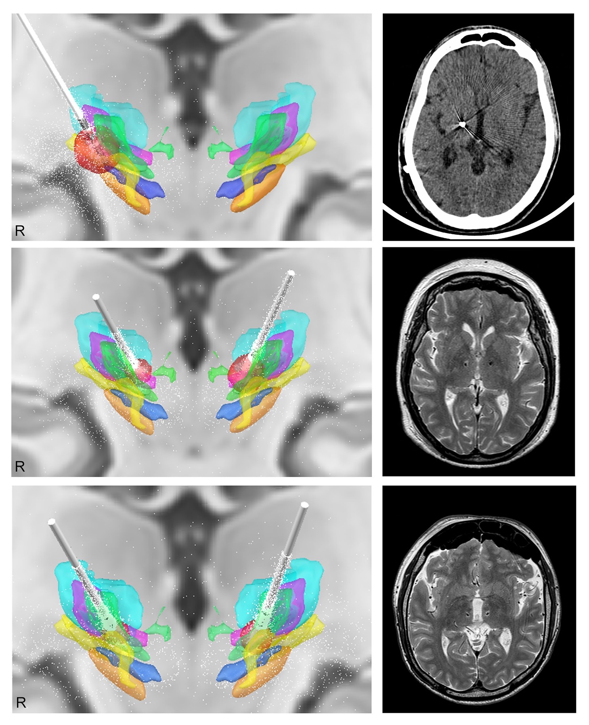

REFERENCES
[1] T. Tsuboi, Z. Jabarkheel, P.R. Zeilman, M.J. Barabas, K.D. Foote, M.S. Okun, A. Wagle Shukla, Longitudinal follow-up with VIM thalamic deep brain stimulation for dystonic or essential tremor, Neurology. 94 (2020) e1073–e1084. https://doi.org/10.1212/WNL.0000000000008875.
[2] T. Morishita, K.D. Foote, I.U. Haq, P. Zeilman, C.E. Jacobson, M.S. Okun, Should we consider vim thalamic deep brain stimulation for select cases of severe refractory dystonic tremor, Stereotact. Funct. Neurosurg. 88 (2010) 98–104. https://doi.org/10.1159/000289354.
[3] P. Hedera, F.T. Phibbs, R. Dolhun, P.D. Charles, P.E. Konrad, J.S. Neimat, T.L. Davis, Parkinsonism and Related Disorders Surgical targets for dystonic tremor : Considerations between the globus pallidus and ventral intermediate thalamic nucleus, PRD. 19 (2013) 684–686. https://doi.org/10.1016/j.parkreldis.2013.03.010.
[4] T. Tsuboi, K.L.K. Au, W. Deeb, L. Almeida, K.D. Foote, M.S. Okun, A. Ramirez-Zamora, Motor outcomes and adverse effects of deep brain stimulation for dystonic tremor: A systematic review, Parkinsonism Relat. Disord. 76 (2020) 32–41. https://doi.org/10.1016/j.parkreldis.2020.06.008.
[5] M. Picillo, V. Paramanandam, F. Morgante, M. Algarni, D.A. Olszewska, R.P. Munhoz, T. Aziz, E. Pereira, M. Hodaie, S.K. Kalia, A.M. Lozano, T. Lynch, A. Fasano, Dystonia as complication of thalamic neurosurgery, Parkinsonism Relat. Disord. 66 (2019) 232–236. https://doi.org/10.1016/j.parkreldis.2019.08.008.
[6] G. Macchi, E.G. Jones, Toward an agreement on terminology of nuclear and subnuclear divisions of the motor thalamus, J. Neurosurg. 86 (1997) 670–685. https://doi.org/10.3171/jns.1997.86.4.0670.
[7] K.A.M. Pauls, S. Hammesfahr, E. Moro, A.P. Moore, E. Binder, F. El Majdoub, G.R. Fink, V. Sturm, J.K. Krauss, M. Maarouf, L. Timmermann, Deep brain stimulation in the ventrolateral thalamus/subthalamic area in dystonia with head tremor, Mov. Disord. 29 (2014) 953–959. https://doi.org/10.1002/mds.25884.
[8] J. Becker, T. Thies, J.N. Petry-Schmelzer, T.A. Dembek, P. Reker, D. Mücke, M. Grice, V. Visser-Vandewalle, G.R. Fink, M.T. Barbe, The effects of thalamic and posterior subthalamic deep brain stimulation on speech in patients with essential tremor – A prospective, randomized, doubleblind crossover study, Brain Lang. 202 (2020) 104724. https://doi.org/10.1016/j.bandl.2019.104724.

Figure 1 - Leads and VTAs in 3D rendering (left column) and post-operative (right column) CT in case 1 (superior row), post-operative T2 MRI for case 2 (middle row) and case 3 (inferior row). VTA was estimated according to the most effective and stable stimulation program at 6-month follow-up. VTA: red. VoA: green. VoP: purple. VIM: light blue. Forel’s Field: blu. Zona Incerta: yellow. STN: orange.

Supporting materials

Supplementary material – Methods

Supplementary table 1

Supplementary table 2

Video 1: Case 2. Segment 1 shows head dystonic tremor during preoperative evaluation, while segment 2 the clinical improvement few days after surgery and at 6-month follow-up.
Video 2: Case 3. Segment 1 shows bilateral asymmetric upper limb tremor more prominent on the right at preoperative evaluation, whereas segment 2 the benefit at intraoperative macrostimulation trial.

