Derepression of glomerular filtration, renal blood flow and antioxidant defence in patients with type 2 diabetes at high-risk of cardiorenal disease

Running title: Antioxidant status and nephroprotection

¹Karima Zitouni PhD, ²Mia Steyn MRCP, ⁵Eliza Lyka MB BS, ³Frank J. Kelly PhD, ⁴Paul Cook MD, ¹Irina Chis Ster PhD and ^{2,5}Kenneth Anthony Earle MD

Affiliations:
¹St Georges University of London, Institute of Infection and Immunity, London, UK
²St Georges University Hospitals NHS Foundation Trust, Thomas Addison Unit, London, UK
³Kings College London, Analytical, Environmental and Forensic Sciences Department, London, UK
⁴University Hospital Southampton NHS Foundation Trust, Trace Element Unit, Southampton, UK
⁵St Georges University of London, Institute of Biomedical & Medical Education, London, UK

Contact Author:
Kenneth Anthony Earle
St Georges University Hospitals NHS Foundation Trust
Thomas Addison Unit
Blackshaw Rd
London SW17 0RE
United Kingdom

Word count: 3193

Abstract

Background
The role of antioxidant status on microvascular blood flow and glomerular filtration (eGFR) in patients with type 2 diabetes and hypertension whose risk of progressive renal disease varies by ethnicity is unknown.

Methods
Adult, non-Caucasian (n=101) and Caucasian (n=69) patients with type 2 diabetes, hypertension and/or microalbuminuria and an eGFR > 45 mL/min/1.73m² were randomised to 400 IU vitamin E and/or 20 ug selenium daily or matching placebo. eGFR (CKD-EPI) was measured at baseline, 3,6 and 12 months and renal blood flow by contrast-enhanced ultrasonography in a sub-group (n=9) at baseline and 3 months by assessing the area under the time intensity curve (TIC). Circulating glutathione peroxidase 3 (GPx-3) activity was measured as a biomarker of oxidative defence status.

Results
The time to change in eGFR was shortest with combined vitamin E and selenium than usual care (5.6 [4.0-7.0] vs 8.9 [6.8-10.9 months]; p=0.006). Area under the TIC was reduced compared to baseline (38.52 [22.41- 90.49] vs 123 [86.98- 367.03]dB.s; P≤0.05 and 347 [175.88- 654.92] vs 928.03 [448.45-1683]dB.s; P≤0.05, respectively] at 3 months suggesting an increase in rate of perfusion. The proportional change in eGFR at 12 months was greater in the group whose GPx-3 activity was above, compared with those below the cohort median (360 U/L) in the non-Caucasian and the Caucasian groups (19.1(12.5 to 25.7] % vs 6.5[-3.5 to 16.5] % and 12.8 [0.7 to 24] % vs 0.2 [-6.1 to 6.5] %). .

Conclusion
In these patients with type 2 diabetes and early CKD, antioxidant treatment derepresses renal blood flow and a rise in eGFR correlated directly with GPx-3 activity.

Significance
Diabetes mellitus is the world’s leading cause of end-stage renal disease which has a predilection for black and minor ethnic groups compared with Caucasians. The differences in risk despite the benefits of conventional care may be related to oxidative stress. We found that glomerular filtration and renal blood flow is suppressed when renal function is preserved in high-risk patients with type 2 diabetes. Conventional care supplemented with selenium - the co-factor for glutathione peroxidase-3 (GPx-3) - improves renal blood flow and glomerular filtration in sub-groups with lower host antioxidant defence determined by GPx-3 activity. Circulating GPx-3 activity warrants further investigation as a novel biomarker of reversible haemodynamic changes in early diabetic kidney disease to better enable targeting of renoprotective strategies.

Trial registration
ISRCTN 9735811
Funding
This research was supported by a grant from Dialysis Clinic Inc (C-3305) and the National Institutes of Health Research (UKCRN ID: 8432). Neither sponsor had a role in the preparation and presentation of this manuscript.

INTRODUCTION
Throughout the world, diabetes is the leading cause of chronic kidney disease (CKD) and the need for renal replacement therapy which is associated with premature cardiovascular death. The greatest disease burden resides in populations of low- and middle-income countries and groups of patients of non-Caucasian heritage living in developed countries [1,2]. The phenotype of diabetic kidney disease is heterogeneous. Classically, its development and progression are described as being heralded by an increased urinary albumin excretion. However, albuminuria does not occur in 1:3 cases of CKD and hence its value as a comprehensive biomarker is debatable [3]. Furthermore, although modulators of the renin-angiotensin system are effective and established as nephroprotective treatments a considerable, residual risk of CKD persists that could be associated with non-traditional factors linked to obesity and heritage [4,5].

A strong experimental evidence base implicates increased oxidative stress in the development of haemodynamic alterations and histological features of diabetic kidney disease [6,7]. In experimental studies, micronutrient supplementation reduces markers of oxidative stress, pro-inflammatory cytokines and mediators of renal fibrosis that is typical of human, diabetic kidney disease [8,9]. Clinical studies in patients without diabetes, have reported that vitamin E reduces blood pressure and the incidence of vascular events in select groups with genetically determined defects in antioxidant defence [10,11]. However, in patients with diabetes, a recent meta-analysis was unable to confirm an effect of micronutrient intervention(s) beyond improvement in biomarkers of renal injury [12].

Glutathione peroxidase-3 (GPx-3) is member of the family of selenium-dependent antioxidant enzymes and component of the endogenous antioxidant pathways. Neutralisation of reactive oxygen species (ROS) by these enzymes is associated with reduced glucose-dependent renal and vascular damage [13,14]. Moreover, GPx-3 activity appears to have an inverse relationship with the rate of decline in eGFR in patients with diabetes and advanced CKD [15]. A consequence of renal injury is a reduction in renal reserve which increases the risk of ESRD [16]. One therapeutic agent has been reported to increase eGFR in patients with diabetes and advanced CKD [17]. However, the role of redox status in the protection of renal function in patients with earlier stages of diabetic kidney disease is unknown. Here we examine the effect of the antioxidant vitamin E, selenium-the co-factor for GPx-3 with usual care on eGFR over time in relation to ethnicity and GPx-3 activity.

METHODS:
Trial Design
The PRospective EValuation of Early Nephropathy and its Treatment (PREVENT) study is a double-blind, randomized, placebo-controlled trial designed to assess whether changes in eGFR in the early stages of diabetic kidney disease are related to, or modified by, oxidative stress and host antioxidant defence mechanisms [18]. The trial was conducted at a single site in South West London, United Kingdom (UK) in collaboration with local general practices serving a population of 107,565.
The protocol was approved by the UK National Health Service (NHS) National Research and Ethics Committee and written informed consent was obtained from all trial participants prior to enrolment. The trial was conducted in the Clinical Research Facility at St George’s University Hospital NHS Foundation Trust, London, UK by trained nurses. Clinical data were captured in electronic proformas and externally audited through the Joint Research and Enterprise Office of St George’s University of London. All authors had access to the final trial results and have revised and approved this manuscript.

Patients, eligibility and treatments:
We screened the community diabetes registers for patients with Type 2 Diabetes of Caucasian and non-Caucasian heritage with hypertension and CKD stages 1 or 2. Type 2 Diabetes was diagnosed according to WHO criteria; hypertension was diagnosed if three consecutive sitting systolic/diastolic blood pressure readings were >140/90mmHg respectively without treatment or if treatment for known hypertension was prescribed. Hypertensive patients with microalbuminuria - urinary albumin: creatinine ratio >3 and < 300 mg/mmol - or without microalbuminuria and an eGFR < 90 and > 45 mL/min/1.73m² - determined using the Chronic Kidney Disease Epidemiology equation - were considered high risk of developing cardiovascular and progressive renal disease. Exclusion criteria were: a history of ischaemic heart disease (angina, myocardial infarction, coronary artery revascularization and/or heart failure), peripheral vascular disease (intermittent claudication or peripheral artery revascularization) or cerebrovascular disease (transient ischaemic episodes or stroke), malignancy, any other life threatening illness, current pregnancy, systolic blood pressure >200 mmHg, diastolic blood pressure >160 mmHg, haemoglobin A1c (HbA1c) > 86 mmol/mol (10 %), significant renal impairment (eGFR < 45 mL/min 1.73 m²) or albumin:creatinine ratio >300 mg/mmol.

Investigations
Anthropometric measures included height in metres, weight in kilogrammes, and waist circumference in centimetres. Body mass index was calculated from the weight in kilogrammes divided by the height in metres squared. Sitting blood pressure was measured by digital oscillometry (Omron 705IT, OMRON Healthcare Europe, The Netherlands).

The presence or absence of retinopathy was assessed by standardized, digital retinal fundal photography and reported according to NHS guidelines by retinal screeners who were unaware of the patient’s participation in the study. Peripheral vascular disease was assessed by the appreciation of the dorsalis pedis and posterior tibial artery pulsation by digital examination. The modified Rose questionnaire and resting, 12-lead electrocardiography (Seca CardioConcept 5.6, Seca UK) were used to screen for ischaemic heart disease [19]. Biochemical assessments included a fasting lipid profile, renal function and HbA1c. Oxidative, DNA damage was assessed by measuring urinary 8-hydroxydeoxyguanosine (8-OHdG) and endogenous, antioxidant status was measured according to activities of circulating plasma GPx-3 and superoxide dismutase (SOD) as previously described [18].

Randomisation
Eligible patients were block randomised (block sizes of 20) by ethnicity to receive either active selenium (200μg once daily) or its placebo and/or vitamin E (400 IU once daily) or its placebo in a 2x2 factorial design (Fig 1). The randomisation chart was prepared by an independent biostatistician and codes were generated using SPSS (Chicago IL, US) for each treatment allocation by heritage group which the research pharmacist used to administer the treatment. Patients, research investigators, and study staff were blinded to treatment allocation. Tablet return counts at three monthly intervals were used to assess compliance. Recruitment began in November 2012 and follow-up the study completed in July 2016.

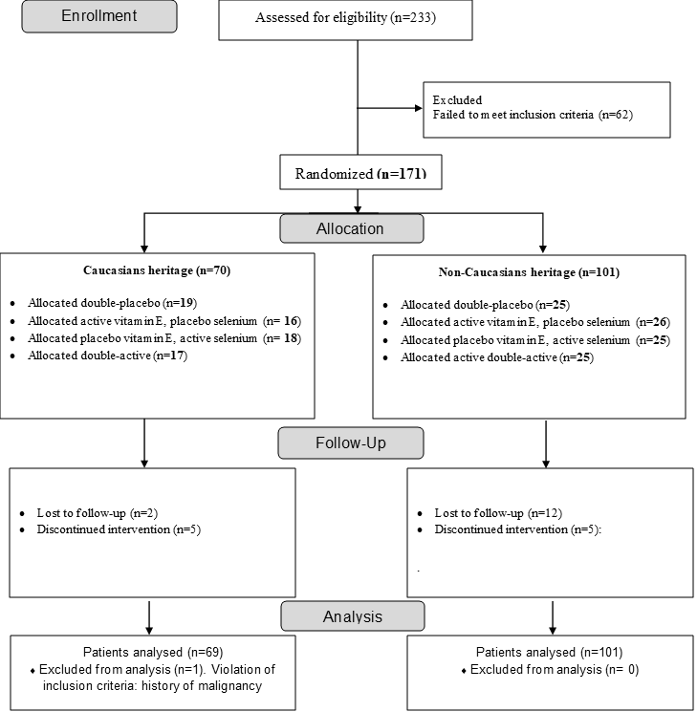

Fig 1. Flow diagram of patients with type 2 diabetes at increased risk of progressive cardiorenal disease recruited and block randomised to antioxidant therapy and usual care.
Contrast-enhanced ultrasonography (CEUS) measurement of renal blood flow
A sub-group of patients were randomly allocated for CEUS to investigate renal blood flow [20]. Scans were performed at baseline and after 3 months in patients who were either randomised to vitamin E and/ or selenium (n=6) or placebo (n=3) with usual care. A 1 ml intravenous bolus injection of SonoVue® - a mixture of stabilised, sodium hexafluoride (Bracco Imaging, Milan, Italy) with 5 ml saline. Dynamic image changes were continuously recorded using an Aplio™ 500 ultrasonographic device (Toshiba America Medical Systems Inc.). Renal perfusion images were analysed using Aplio’s CEUS analysis software for the TIC (time intensity curve) analysis. Time- intensity curves and quantitative indices for the derived peak intensity, the ascending slope, and the areas under the ascending (wash-in) and descending (wash-out) curves (AUC1 and AUC2) were calculated for the renal cortex [21]. The operator and data analyst (EL) were blinded to the treatment group allocation.

Statistical analyses
Mixed (or random coefficient) non-linear models were fit to the longitudinal outcome, eGFR, which was measured at baseline, three, six and 12 months after randomisation and the percentage change from baseline at one year of follow-up.

Mixed models of increasing complexity were fitted to the data, starting with assessing the treatment effect only on the absolute and percentage change in eGFR. Demographics factors (age and ethnicity) were added to the model as well as baseline levels of albuminuria and GPx-3 activity. The two groups whose slopes are compared over time are thought of as either, (a) Caucasian and non-Caucasian, or (b) High and Low levels of oxidative stress/inflammation according to GPx-3 activity dichotomized at its median value. Interactions between the explanatory variables were also considered. An unstructured variance-covariance matrix has been considered as the most general assumption on the random effects. Model comparisons (on similar number of observations selected by the most complex model) have been made using the likelihood ratio, Akaike information criterion and Bayesian information criterion.

The data were analysed on an intention-to-treat basis. Patterns in the missing data at the follow-up were carefully explored. Mixed models’ estimation used the maximum likelihood methods and assume that missing data are at random. Population average models using generalized estimation equations were also explored as they exhibit robustness with regards to the assumption on the correlation structure. The results from both approaches were similar, as expected for Gaussian outcomes but only the inference from mixed models is presented given the availability of formal methods for model comparison based on complete data. Marginal interpretation and predictions illustrate the effect of each explanatory on the outcomes. Effects resulting in P-values < 0.05 were considered statistically significant and the uncertainty was assessed by the corresponding 95% confidence intervals.

The effect sizes are conservative and are based on the estimated changes from baseline to 1 year [17]. The required sample sizes corresponding to various strengths of correlation among repeated measures for this proposal and various correlation structures and attrition rates were derived according to Hedeker et al [22]. Sample sizes of 73 subjects in each group divided according by heritage or the median value of GPx-3 provided 80% power using a 2-tailed alpha of 5% to detect an effect size of 0.5 standard deviation units which equates to detecting a biologically significant difference in eGFR.

Results
Two-hundred and thirty-three patients were screened in the research centre and of these 171 were enrolled and block-randomised as either Caucasian (n=70) or non-Caucasian (n=101) heritage in to one of four intervention groups (Placebo, Vitamin E/Placebo, Selenium/Placebo and double-active Vitamin E/Selenium). Data from one patient was evaluable due to a protocol violation.

There were no differences between the demographic, clinical and anthropometric characteristics of the treatment groups at baseline except in the smaller proportion of patients prescribed sulphonylureas in the Selenium/Placebo intervention group in comparison to the other groups (Table 1). The proportions of patients with hypertension that were treated with either angiotensin converting enzyme inhibitor (ACEi) or angiotensin 2 receptor blocking (ARB) agents was similar between the groups receiving double placebo, active selenium alone, active vitamin E alone or both active vitamin E and selenium (63.6 vs 58.5 vs 76.2 vs 61.9) respectively.

Compliance with treatment was generally good with between 0 and 10 tablets of allocated treatment returned every 3 months which was non-significantly higher in the non-Caucasian compared with the Caucasian heritage treatment groups. Twelve adverse events were reported (8 in the active - and 4 in the placebo group) that were judged to be unrelated to trial procedures or treatment (Appendix S1).

Table 1. Baseline demographic, anthropometric, clinical and biochemical characteristics of patients with type 2 diabetes allocated to antioxidant treatment and/or placebo.

 | Double Placebos  (n = 44) | Active vitamin E & placebo selenium  (n = 42) | Active selenium & placebo vitamin E  (n = 42) | Double Active  (n = 42)
Age (years) | 61.2 ± 7.3 | 60.6 ± 8.2 | 61.9 ± 8.0 | 59.1 ± 7.3
Gender: Male (%) | 48 | 41 | 49 | 64
Ethnicity: Caucasian (%) | 43 | 37 | 42 | 41
Diabetes duration (years) | 8.0 [4.0-12.5] | 8.0 [5.3-14.8] | 9.0 [4.0-17.5] | 9.0 [4.3-16.8]
Smoking: Yes/No/Ex- (%) | 9/62/29 | 8/59/33 | 5/59/36 | 12/55/33
Retinopathy (%)† | 53.6 | 32.4 | 35.1 | 48.6
Insulin (%) | 31.8 | 17.1 | 30.2 | 14.3
Sulphonylurea (%)§ | 15.9 | 26.8 | 4.7 | 28.6
Antihypertensive (%) | 75.0 | 68.3 | 76.2 | 76.2
Lipid lowering - statin (%) | 75.0 | 73.2 | 69.8 | 76.2
Body mass index (Kg/m²) | 31.1 ± 5.5 | 30.54 ± 7.8 | 30.28 ± 5.2 | 29.81 ± 5.3
Waist circumference (Cm) | 102.4 ± 13.2 | 102.0 ± 12.6 | 102.9 ± 13.0 | 101.0 ± 13.2
Systolic blood pressure (mmHg) | 141.8 ± 15.7 | 143.83 ± 17.5 | 137.6 ±18.8 | 137.7 ± 12.0
Diastolic blood pressure (mmHg) | 81.9 ± 7.6 | 83.8 ± 10.7 | 82.7 ± 9.2 | 80.3 ± 9.4
Haemoglobin A1c %  (mmol /mol) | 6.9[6.3-8.4]-52.0[45.0-68.0] | 6.7[6.3-7.9]-50.0[45.5-63.0] | 6.8[6.4-8.1]-51.0[46.5-64.5] | 7.1[6.5-8.1]-54.0[47.8-65.3]
Total Cholesterol (mmol/L) | 4.2 ± 0.8 | 4.0 ± 0.7 | 4.1 ± 0.9 | 4.1 ±0.9
Triglycerides (mmol/L) | 1.3[0.9-1.8] | 1.3[1.0-1.8] | 1.3[0.8-2.1] | 1.6[1.0-2.0]
HDL-cholesterol (mmol/L) | 1.3 ± 0.3 | 1.3 ± 0.3 | 1.2 ± 0.3 | 1.3 ± 0.4
LDL-cholesterol (mmol/L) | 2.2 ± 0.6 | 2.0 ±0.7 | 2.2 ± 0.9 | 2.2 ± 0.7
Estimated GFR (mL/min/1.73 m²) | 90.5  [77.8-101.0] | 95.0  [80.5-99.0] | 91.0  [75.0-100.0] | 97.5  [84.5-103.0]
Albumin: creatinine ratio (mg/mmol) | 0.9[0.0-5.0] | 0.6[0.0-2.2] | 0.9[0.0-3.1] | 0.9[0.0-5.0]
Vitamin E: total-cholesterol (µmol/mmol) | 8.2 ± 2.5 | 9.0 ± 2.8 | 9.4 ± 3.5 | 9.0 ± 2.2
Plasma Selenium (µmol/L) | 1.3 ± 0.3 | 1.2 ± 0.3 | 1.3 ± 0.2 | 1.3 ± 0.3
Glutathione peroxidase activity (U/L) | 366.4 ± 118.5 | 368.0 ± 123.7 | 359.2 ± 114.6 | 357.9 ± 114.5
Superoxide dismutase activity (U/L) | 59.6  [1.0-103.6] | 68.3  [15.2-97.9] | 60.5  [25.7113.8] | 61.4  [13.1-92.7]
8-OHdG (ng/mL) ‡ | 272.2  [104.4-377.5] | 227.4  [114.1-431.7] | 230.0  [159.4-626.6] | 296.7  [119.3-578.6]
8-OHdG:Creatinine ratio (ng/mg) ‡ | 27.8[12.3-61.3] | 33.7[16.7-63.3] | 28.7[17.4-78.1] | 38.7[20.3-64.4]
* Data expressed as mean ± SD or median [interquartile range] depending on variables distribution. † Retinopathy denotes the presence of background, pre-proliferative or proliferative retinopathy. ‡ 8-OHdG, 8 hydroxy 2’deoguanosine. § There was a significant between-group difference in the proportion of patients who were prescribed sulphonylurea (P=0.02). There were no significant differences in any other baseline characteristics between groups.

A rise in eGFR occurred for all the interventions in a non-linear, quadratic trend with time. The predicted mean [95% confidence interval] time to peak rise (TPR) in eGFR was shortest in the double-active treatment group compared with placebo (5.6 [4.0-7.0] vs 8.9 [6.8-10.9 months]; p=0.006), followed by vitamin E alone (6.82 [5.2-8.5] months) and was longest with selenium only (7.6 [5.7-9.4] months) and consistent between heritage groups (Figure 2).

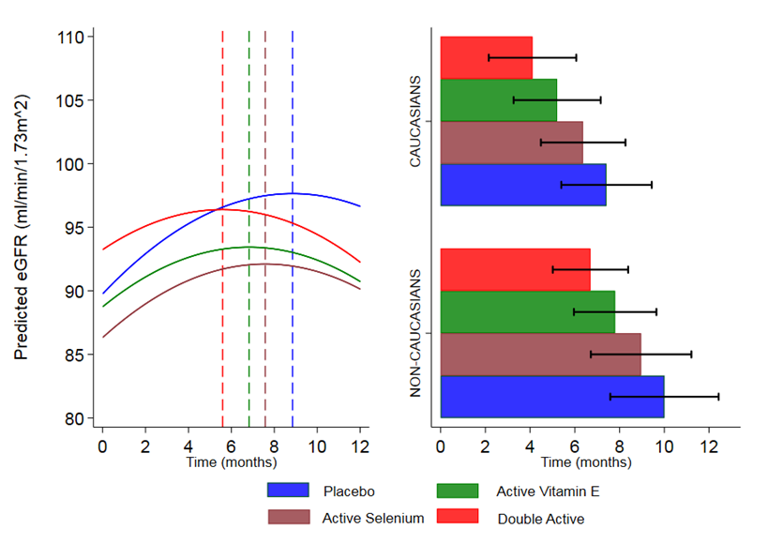
Figure 2. Time to peak rise (TPR) in eGFR (hashed vertical lines) as predicted by models of the absolute values accounting for the treatment effect only. The horizontal bars on the right depict the effect of ethnicity/heritage on the TPR which are prolonged in the non-Caucasians group.

Patients randomised to the CEUS sub-study in the control and antioxidant treatment groups had similar chronological age, BMI, haemoglobin A1c, systolic blood pressure and eGFR (58.67[10.6] vs 66.33[8.89] years; 31.83[2.8] vs 33.18[5.43]kg/m²; 64.0 [32.9] vs 60.50[20.2] mmol/mol; 144.67[7.3] vs 144.83[13.9] mmHg; and 96[17.4] vs 80.66[25.4]mL/min/1.73 m²) There were no differences in plasma GPx-3 activity and the levels of vitamin E and selenium.
Quantitative evaluation of the signal intensity allowed calculation of the AUC1 as evidence of maximum volume of wash-in and AUC2 as the parameter to evaluate the wash-out from the renal microvascular bed. Others have reported that patients with diabetes and CKD stages 1-2 have reduced perfusion when evaluated with CEUS compared with non-diabetic controls [23,24]. In this study, the 3-month follow-up scan with antioxidant treatment showed a decrease in time to peak intensity of contrast and a decrease in the AUC1 and AUC 2 in comparison to the baseline scans (38.52 [22.41- 90.49] vs 123 [86.98- 367.03]dB.s; P≤0.05 and 347 [175.88- 654.92] vs 928.03 [448.45- 1683]dB.s; P≤0.05, respectively) reflecting more rapid perfusion and clearance of contrast (Figure 3). No changes were observed in AUCs between the 3-month follow–up and baseline scans in the placebo group.

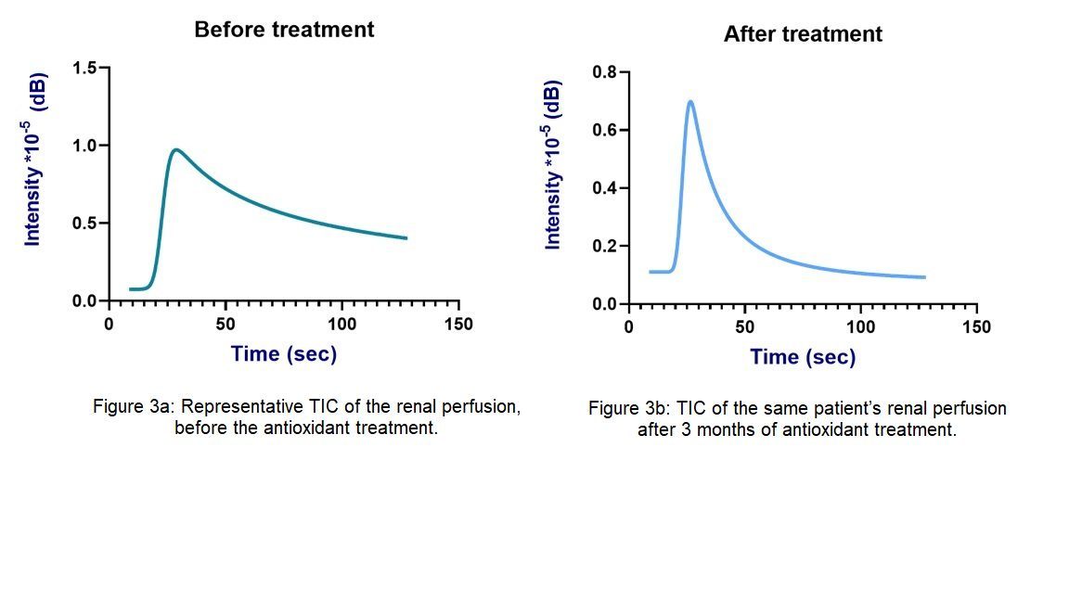Fig 3. Changes in perfusion. Representative example of a time intensity curve (TIC) of cortical renal perfusion after antioxidant treatment in a patient showing peak intensity is reached sooner with increased rates of wash-in and wash-out of contrast compared to baseline.

After 12 months follow-up, the rise in eGFR was greater in patients classified as having high vs low GPx-3 activity in both the non-Caucasian and the Caucasian patients (19.1(12.5 to 25.7] % vs 6.5[-3.5 to 16.5] % and 12.8 [0.7 to 24] % vs 0.2 [-6.1 to 6.5] %). Selenium alone was associated with a significant rise in eGFR over baseline in patients of non-Caucasian heritage with high and low GPx-3 activity (9.1 [-0.9 to 19.2] and 9.4 [2.3 to 16.6] %) compared with usual care (Fig 4). We found no effect over time of either the albumin:creatinine ratio (β -0.138 96% CI [-0.296 to 0.021] p=0.09) or antihypertensive treatment with ACEI or ARB (β -2.560 95%CI [-6.427 to 1.308] p=0.20) on the change in eGFR with the antioxidant interventions.

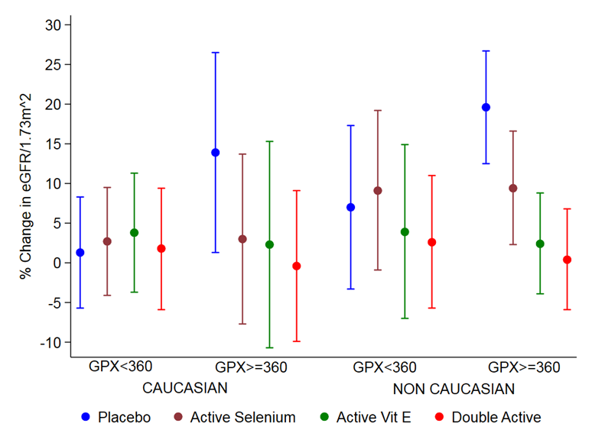

Figure 4. Change in mean percentage [95% confidence interval] eGFR at 12 months follow-up in patients with type 2 diabetes at high risk of cardiorenal disease stratified by ethnic group, GPx-3 status and treatment allocation. Increases in eGFR above baseline were sustained in patients with high GPx-3 activity independent of antioxidant treatment intervention.

Discussion

In this study of patients with type 2 diabetes at high risk of progressive CKD who were supplemented with vitamin E and/or selenium, eGFR significantly increased in the short-term with evidence of an increase in renal perfusion. After 12 months of follow-up, only patients receiving usual care with high activity of GPx-3 retained a sustained increase in renal function. In these patients with early CKD, derepression of renal blood flow with antioxidant treatment is associated with improvement in eGFR and sustained by activation of antioxidant defences.

A reserve of renal function is considered evident when glomerular filtration increases in response to physiological or pathological stimuli [25]. It may be absent when basal function remains normal - even with significant nephron loss, and is associated with progressive CKD [26,27]. Subjects with reduced renal reserve have a higher rate of decline in renal function compared with matched controls with normal reserve [28]. Prospective, longitudinal studies suggest that a 5% rise in eGFR over 12 months is biologically relevant and associated with a reduced risk of ESRD [29,30]. Therefore, the rise in eGFR as a measure of reserve could be a surrogate marker for the future risk of CKD and its measurement in select, high-risk groups could potentially have a role in the development of preventative strategies.

The mechanism(s) of a stimulated rise in eGFR in patients with type 2 diabetes are not clearly understood. Studies have shown that renal function can improve as determined by ⁵¹Cr-EDTA clearance, at any stage of CKD in patients with non-diabetic nephropathies. In these so-called ‘improvers’ who achieve more treatment goals it is not clear what changes occur within the kidney compared to their ‘non-responder’ counterparts [31]. Perfusion is a parameter of tissue viability and functionality and its measurement is of value in characterizing pathological changes in ischemia and inflammation. Using CEUS, we like others have shown that this technique has utility is demonstrating impairment of tissue blood flow and changes with treatment in inflammatory conditions [32]. The baseline renal cortical perfusion characteristics we found were similar to that reported in patients with early CKD (24). We have shown for the first time that antioxidant supplementation may reverse the impedance to renal blood flow in patients with type 2 diabetes and early CKD and is a response that could be of pathological significance in the rate of disease progression.

Our data suggest activation of the endogenous antioxidant pathways was necessary to preserve eGFR. The attenuation of inflammatory and oxidative stress increases glomerular filtration. A sustained improvement in eGFR with an antioxidant modulator, Bardoxolone that increases redox signalling through the Keap1-Nrf2 pathway has been previously reported in patients with type 2 diabetes and CKD stage 3 [17]. The reported early rise in eGFR was thought related to a haemodynamic mechanism which is supported by our work. However, structural changes - which similar compounds produce in an experimental, murine diabetes model - are also considered likely to explain the sustained response in eGFR after 12 months [33].
The difference in rate of change in eGFR between patients of Caucasian and non-Caucasian ethnicity was notable and may be relevant to susceptibility to CKD progression [34]. The non-Caucasian patients appear to have a slower response to the interventions which we consider could be related to reduced/altered vascular reactivity [35]. We previously reported that patients of African origin with type 2 diabetes have a lower renal reserve compared with Caucasian patients in relation to a reduced bioavailability of the systemic vasodilator nitric oxide [36,37]. The higher antioxidant enzyme activity of GPx-3 and SOD observed in the non-Caucasian compared with Caucasian patients could be a response to higher oxidative stress. Increased oxidative stress neutralises nitric oxide which occurs in advanced stages CKD and hypertension and has been recently recognised as a feature of early diabetic kidney disease [38].

We found that the sustained improvement in renal function with usual care to which both heritage groups were equally compliant in the study was modulated by the activity of GPx-3. The GPx family of antioxidant enzymes are ubiquitously expressed and involved in the early response to increased systemic oxidative stress, neutralising reactive hydrogen peroxide oxygen species to water [39]. In experimental studies of tissue injury, the expression of GPx-3 is permissively cytoprotective and its downregulation associated with cell death [40,41]. Therefore an increase in endogenous antioxidant activity could augment the action of cardio- and nephroprotective treatments (angiotensin converting enzyme inhibitors, angiotensin 2 receptor blockers and aldosterone antagonists) in current treatment strategies, which act to limit the pro-inflammatory and vasoconstrictive effects of angiotensin-2 mediated by ROS [42,43].

Disruptions to endogenous antioxidant defence mechanisms are linked to the development of kidney disease. Patients with type 1 diabetes in the GENEDIAB cohort study carrying the minor T-allele of rs3448 of the GPx-1 gene reportedly had higher circulating levels of isoprostane, a marker of oxidative stress and after 5-9 years of follow-up had a 3-fold higher incidence of ESRD [44]. Recently, patients with type 2 diabetes and advanced stages of CKD have been recognised to have a reduction in thiols which provide the capacity to reduce oxidative species [45]. Also, Neves et al reported that reversing suppressed redox signalling caused by adipokines in a murine model of diabetes, prevented the development and progression kidney disease [46]. Finally, suppression of the endogenous antioxidant response by an exogenous antioxidant, N-acetyl cysteine can promote the development of CKD [47]. Together, these observations support a hypothesis that endogenous antioxidant defence is permissive in preserving kidney function in patients with diabetes.

Our findings of a treatment effect that was dependent on GPx-3 enzyme activity was striking. We used multiple estimates of eGFR over time from a single laboratory which allowed us to describe and predict the pattern of change with some confidence. Our sub-study was limited in power and caution is required in generalising these findings due to limitations in the length of follow-up and variety of ethnicities in the heritage classification. Longer-term studies are required to assess GPx-3 activity as a novel biomarker of treatment response to improving renal perfusion and protecting glomerular filtration in high-risk patients with type 2 diabetes with early stage CKD.

Author contribution
KAE and KZ conceived and designed the study. MS, FJK and PC provided methodological support. KAE secured funding for the project. KAE provided clinical leadership, while KZ managed the study. EL contributed to the sub-study and to the analysis of the results. ICS drafted the statistical analysis plan and holds responsibility for all the data analyses. All authors contributed to data interpretation. KAE wrote the first draft of the paper. All authors reviewed and critically revised the manuscript and approved it before submission.

Acknowledgements
I would like to thank Dr John Pepe of Richmond University, New York and Professor John Godbold of Mount Sinai School of Medicine, New York for supporting the development of this research Dr James Pilcher from St Georges University Hospitals NH Foundation Trust for facilitating the radiological investigations and Dr Joanna Lewis of the Institute of Child Health, London for her valuable overview of the analysis and presentation.

Disclosures
There are no financial conflicts of interest to disclose

References
- Stanifer JW, Jing B, Tolan S, et al. The epidemiology of chronic kidney disease in sub-Saharan Africa: a systematic review and meta-analysis. Lancet Glob Health 2014; 2(3):e174-81.
- Regunathan-Shenk R, Hussain FN, Ganda A. Chronic kidney disease and end-stage renal disease in disadvantaged communities of North America: an investigational challenge to limit disease progression and cardiovascular risk. Clin Nephrol 2016 Supplement 1; 86 (13):37-40.
- MacIsaac RJ, Ekinci EI, Jerums G. 'Progressive diabetic nephropathy. How useful is microalbuminuria: contra'. Kidney Int 2014; 86(1):50-57.
- Whaley-Connell A, Sowers JR. Obesity and kidney disease: from population to basic science and the search for new therapeutic targets. Kidney Int 2017; 92(2):313-323.
- Babayev R, Whaley-Connell A, Kshirsagar A, et al. Association of race and body mass index with ESRD and mortality in CKD stages 3-4: results from the Kidney Early Evaluation Program (KEEP). Am J Kidney Dis 2013; 61(3):404-412.
- Jha JC, Banal C, Chow BS, Cooper ME, Jandeleit-Dahm K. Diabetes and Kidney Disease: Role of Oxidative Stress. Antioxid Redox Signal 2016; 25(12):657-684.
- Forbes JM, Coughlan MT, Cooper ME. Oxidative stress as a major culprit in kidney disease in diabetes. Diabetes 2008; 57(6):1446-1454.
- Clarke C, Baghdadi H, Howie AF, Mason JI, Walker SW, Beckett GJ. Selenium supplementation attenuates procollagen-1 and interleukin-8 production in fat-loaded human C3A hepatoblastoma cells treated with TGFbeta1. Biochim Biophys Acta 2010; 1800(6):611-618.
- Farid N, Inbal D, Nakhoul N, et al. Vitamin E and diabetic nephropathy in mice model and humans. World J Nephrol 2013; 2 (4):111-124.
- Tesoriere L, D'Arpa D, Butera D, et al. Oral supplements of vitamin E improve measures of oxidative stress in plasma and reduce oxidative damage to LDL and erythrocytes in beta-thalassemia intermedia patients. Free Radic Res 2001; 34(5):529-540.
- Rodrigo R, Prat H, Passalacqua W, Araya J, Bachler JP. Decrease in oxidative stress through supplementation of vitamins C and E is associated with a reduction in blood pressure in patients with essential hypertension. Clin Sci (Lond) 2008; 114(10):625-634.
- Bolignano D, Cernaro V, Gembillo G, et al. Antioxidant agents for delaying diabetic kidney disease progression: A systematic review and meta-analysis. PLoS One 2017; 12(6):e0178699.
- Lewis P, Stefanovic N, Pete J, et al. Lack of the antioxidant enzyme glutathione peroxidase-1 accelerates atherosclerosis in diabetic apolipoprotein E-deficient mice. Circulation 2007; 115(16):2178-2187.
- Blankenberg S, Rupprecht HJ, Bickel C, et al. Glutathione peroxidase 1 activity and cardiovascular events in patients with coronary artery disease. N Engl J Med. 2003; 349 (17):1605-13
- Zitouni K, Nourooz-Zadeh J, Harry D, et al. Race-specific differences in antioxidant enzyme activity in patients with type 2 diabetes: a potential association with the risk of developing nephropathy. Diabetes Care 2005; 28(7):1698-1703.
- Barai S, Gambhir S, Prasad N, Sharma RK, Ora M. Functional renal reserve capacity in different stages of chronic kidney disease. Nephrology (Carlton) 2010; 15(3):350-353.
- Pergola PE, Raskin P, Toto RD, et al. Bardoxolone methyl and kidney function in CKD with type 2 diabetes. N Engl J Med 2011; 365(4):327-336.
- Earle KA, Zitouni K, Pepe J, Karaflou M, Godbold J Jr. Modulation of endogenous antioxidant defence and the progression of kidney disease in multi-heritage groups of patients with type 2 diabetes: PRospective EValuation of Early Nephropathy and its Treatment (PREVENT). J Transl Med 2016; 14(1):234-016-0975-9
- Cook DG, Shaper AG, MacFarlane PW. Using the WHO (Rose) angina questionnaire in cardiovascular epidemiology. Int J Epidemiol 1989; 18(3):607-613.

- Cokkinos DD, Antypa EG, Skilakaki M, Kriketou D, Tavernaraki E, Piperopoulos PN. Contrast enhanced ultrasound of the kidneys: what is it capable of? Biomed Res Int. 2013;2013:595873.
- Dong Y, Wang WP, Cao J, Fan P, Lin X. Early assessment of chronic kidney dysfunction using contrast-enhanced ultrasound: a pilot study. Br J Radiol. 2014;87(1042):20140350.

- Hedeker D, Gibbons RD, and Waternaux C. Sample size estimation for longitudinal designs with attrition: comparing time-related contrasts between two groups. Journal of Educational and Behavioral Statistics 1999; 24: 70 – 93
- Ma F, Cang Y, Zhao B, et al. Contrast-enhanced ultrasound with SonoVue could accurately assess the renal microvascular perfusion in diabetic kidney damage. Nephrol Dial Transplant. 2012;27(7):2891–2898.
- Dong Y, Wang WP, Cao J, Fan P, Lin X. Early assessment of chronic kidney dysfunction using contrast-enhanced ultrasound: a pilot study. Br J Radiol. 2014;87(1042):20140350. doi:10.1259/bjr.20140350
- Gabbai FB. The role of renal response to amino acid infusion and oral protein load in normal kidneys and kidney with acute and chronic disease. Curr Opin Nephrol Hypertens 2018 Jan;27(1):23-29.
- Hodgin JB, Bitzer M, Wickman L, Afshinnia F, Wang SQ, O'Connor C, et al. Glomerular Aging and Focal Global Glomerulosclerosis: A Podometric Perspective. J Am Soc Nephrol 2015;26(12):3162-3178.
- Barai S, Gambhir S, Prasad N, Sharma RK, Ora M. Functional renal reserve capacity in different stages of chronic kidney disease. Nephrology (Carlton) 2010;15(3):350-353.
- Livi R, Guiducci S, Perfetto F, Ciuti G, Gri- foni E, Conforti L, Galluccio F, Moggi Pi- gnone A, Matucci Cerinic M: Lack of activation of renal functional reserve predicts the risk of significant renal involvement in systemic sclerosis. Ann Rheum Dis 2011;70: 1963–1967.
- Christensen PK, Gall M-A, Parving H-H. Course of Glomerular Filtration Rate in Albuminuric Type 2 Diabetic Patients With or Without Diabetic Glomerulopathy. Diabetes Care 2000; 23 (Suppl.2):B14-B20.
- (20) Tsai C-W, Ting I-W, Yeh H-C, Kuo C-C. Longitudinal change in estimated GFR among CKD patients: A 10-year follow-up study of an integrated kidney disease care program in Taiwan. Shimosawa T, ed. PLoS ONE. 2017;12(4):e0173843. doi:10.1371/journal.pone.0173843.
- Weis L, Metzger M, Haymann J-P, Thervet E, Flamant M, Vrtovsnik F, et al. Renal Function Can Improve at Any Stage of Chronic Kidney Disease. PLoS ONE 2013; 8(12): e81835.
- Quaia E, Sozzi M, Angileri R, Gennari AG, Assunta Cova M. Time-Intensity Curves Obtained after Microbubble Injection Can Be Used to Differentiate Responders from Nonresponders among Patients with Clinically Active Crohn Disease after 6 Weeks of Pharmacologic Treatment. Radiology 2016 281:2, 606-616
- Wu P, Yan Y, Ma LL, Hou BY, He YY, Zhang L, et al. Effects of the Nrf2 Protein Modulator Salvianolic Acid A Alone or Combined with Metformin on Diabetes-associated Macrovascular and Renal Injury. J Biol Chem 2016 ;291(42):22288-22301.
- Udayaraj U, Pruthi R, Casula A, Roderick P. UK Renal Registry 16th annual report: chapter 6 demographics and outcomes of patients from different ethnic groups on renal replacement therapy in the UK. Nephron Clin Pract 2013;125(1-4):111-125
- Morris AA, Patel RS, Binongo JN, Poole J, Al Mheid I, Ahmed Y, et al. Racial differences in arterial stiffness and microcirculatory function between Black and White Americans. J Am Heart Assoc 2013 Apr 8;2(2):e002154.
- Earle KA, Mehrotra S, Dalton RN, Denver E, Swaminathan R. Defective nitric oxide production and functional renal reserve in patients with type 2 diabetes who have microalbuminuria of African and Asian compared with white origin. J Am Soc Nephrol 2001;12(10):2125-2130.
- Earle KA, Harry D, Madhavi M, Zitouni K, Barron J. Nitric oxide bioavailability and its potential relevance to the variation in susceptibility to the renal and vascular complications in patients with type 2 diabetes. Diabetes Care 2009;32(1):138-140.
- Gluhovschi C, Gluhovschi G, Petrica L, Timar R, Velciov S, Ionita I, et al. Urinary Biomarkers in the Assessment of Early Diabetic Nephropathy. J Diabetes Res 2016;4626125.
- Zhan CD, Sindhu RK, Pang J, Ehdaie A, Vaziri ND. Superoxide dismutase, catalase and glutathione peroxidase in the spontaneously hypertensive rat kidney: effect of antioxidant-rich diet. J Hypertens 2004 Oct;22(10):2025-2033.
- Kanno SI, Tomizawa A, Yomogida S, Hara A. Glutathione peroxidase 3 is a protective factor against acetaminophen induced hepatotoxicity in vivo and in vitro. Int J Mol Med 2017;40(3):748-754
- An BC, Choi Y-D, Oh I-J, Kim JH, Park J-I, Lee S-w GPx3-mediated redox signaling arrests the cell cycle and acts as a tumor suppressor in lung cancer cell lines. PLoS ONE 2018; 13(9): e0204170.
- Briet M, Schiffrin EL. Aldosterone:effects on the kidney and cardiovascular system. Nat Rev Nephrol 2010;6(5): 261-273
- Wen H, Gwathmey JK, Xie LH. Oxidative stress-mediated effects of angiotensin II in the cardiovascular system. World J Hypertens. 2012 Aug 23;2(4):34-44.
- Mohammedi K, Patente TA, Bellili-Munoz N, Driss F, Le Nagard H, Fumeron F, et al. Glutathione peroxidase-1 gene (GPX1) variants, oxidative stress and risk of kidney complications in people with type 1 diabetes. Metabolism 2016;65(2):12-19.
- Eren MA, Koyuncu I, İncebıyık H, Karakaş H, Erel Ö and Tevfik S. The evaluation of thiol/disulphide homeostasis in diabetic nephropathy, Diabetes Research and Clinical Practice, 2019; 148 : 249-253
- Neves KB, Montezano AC, Alves-Lopes R, et al. Upregulation of Nrf2 and Decreased Redox Signaling Contribute to Renoprotective Effects of Chemerin Receptor Blockade in Diabetic Mice. Int J Mol Sci. 2018;19(8):2454.
- Small DM, Sanchez WY, Roy SF, Morais C, Brooks HL, Coombes JS, et al. N-acetyl cysteine increases cellular dysfunction in progressive chronic kidney damage after acute kidney injury by dampening endogenous antioxidant responses. Am J Physiol Renal Physiol 2018;314(5):F956-F968.

Figure Legends
Figure 1.
Flow diagram
Figure 2.
Time to peak rise (TPR) in eGFR (hashed vertical lines) as predicted by models of the absolute values accounting for the treatment effect only. The horizontal bars on the right depict the effect of ethnicity on the TPR which are significantly prolonged in the non-Caucasians patient groups.

Figure 3.
Representative TIC graph before and after the antioxidant treatment. Intensity of enhancement of renal cortex after the bolus injection of contrast agent is continuously monitored until wash out is complete. AUC1 is defined as the area under the ascending slope and AUC2 is the area under the descending curve. After antioxidant treatment the peak intensity was reached in shorter time and AUCs reduced consistent with improved perfusion.

Figure 4.
Mean [95% confidence interval] percentage change in eGFR at 12 months follow-up of patients with type 2 diabetes after adjustment for age and albuminuria and stratified by ethnic group, GPx-3 status and allocated treatments.

