Assessment of WHO antibiotic consumption and access targets, 2000-2015: an analysis of pharmaceutical sales data from 76 countries

Eili Y. Klein, PhD,^{a,b, c*} Maja Milkowska-Shibata, MA, ª Katie K. Tseng, MS, ª Mike Sharland, MD,^{d} Sumanth Gandra, MD,ª Céline Pulcini, MD,^{e,f} and Ramanan Laxminarayan, PhD,^{a,g,h}
ª Center for Disease Dynamics, Economics & Policy, Washington, DC, USA
^{b} Department of Emergency Medicine, Johns Hopkins School of Medicine, Baltimore, MD, USA
^{c} Department of Epidemiology, Johns Hopkins Bloomberg School of Public Health, Baltimore, MD, USA
^{d} Paediatric Infectious Diseases Research Group, Institute for Infection and Immunity, St George’s University of London, London, UK
^{e} APEMAC, Université de Lorraine, Nancy, France
^{f} Infectious Diseases Department, Université de Lorraine, CHRU-Nancy, Nancy, France
^{g} Princeton Environmental Institute, Princeton University, Princeton, NJ, USA
^{h} Department of Global Health, University of Washington, Seattle, WA, USA

* Corresponding Author
Eili Y. Klein
Senior Fellow | Center for Disease Dynamics, Economics & Policy, Washington, DC
962 Wayne Ave, Suite 530, Silver Spring, MD 20910
klein@cddep.org | p: (202) 328-5197

Keywords: antimicrobial resistance | low-income countries | defined daily doses | antibiotic stewardship | antibiotics

Word count: 3188
Abstract
Background
The World Health Organization’s (WHO) antibiotic classification framework (AWaRe), aims to balance appropriate access to antibiotics and stewardship. We studied how patterns of antibiotic consumption in each of the AWaRe categories changed over time and across countries.

Methods
Antibiotic consumption was classified into Access, Watch, and Reserve categories for 76 countries between 2000 and 2015 using data from IQVIA. The WHO target of at least 60% Access antibiotics at the national level was measured for each country as was the ratio of Access to Watch antibiotics (Access-to-Watch Index).

Findings
Between 2000 and 2015, per capita consumption of Watch antibiotics rose by 90·9% (from 3·3 to 6·3 defined daily doses per 1,000 inhabitants per day [DIDs]) compared to 26·2% (from 8·4 to 10·6 DIDs) for Access antibiotics. The increase in Watch antibiotic consumption was greater in low- and middle-income countries (LMICs; 165·0%; from 2·0 to 5·3 DIDs), than in high-income countries (HICs; 27·9%; from 6·1 to 7·8 DIDs). The Access-to-Watch Index fell 34·6% over the study period globally (from 2·6 to 1·5); 46·7% in LMICs (from 3·0 to 1·6) and 16·7% in HICs (from 1·8 to 1·5), and nearly all LMICs had a decrease in their relative Access-to-Watch consumption. The proportion of countries in which Access antibiotics represented at least 60% of their total antibiotic consumption declined from 76% (50 of 66 countries) in 2000 to 55% in 2015 (42 of 76 countries).

Interpretation
Rapid increases in Watch antibiotic consumption, particularly in LMICs, reflect challenges in antibiotic stewardship. Without policy changes, the WHO country-level target of at least 60% of total antibiotic consumption being in the Access category by 2023 will likely be difficult to achieve. The AWaRe framework is an important indicator of effectiveness to combat antimicrobial resistance and to ensure equal access to effective antibiotics.

Funding
US Centers for Disease Control and Prevention (IPA 16IPA1609427).

Research in context

Evidence before this study
Given steadily increasing antibiotic consumption and the threat posed by emerging antimicrobial resistance, monitoring global antibiotic consumption is an important prerequisite for informing strategies geared towards optimizing antibiotic use. The World Health Organization’s (WHO) AWaRe classification of antibiotics, introduced as part of the updated 2017 Model List of Essential Medicines, was developed to measure and drive improvement in stewardship efforts on global, regional, and national levels. We searched PubMed for studies published up to November 2019 that documented antibiotic consumption based on AWaRe classification, using the following search strategy: “(“antibiotic”) AND (“consumption” OR “use”) AND (“AWaRe classification”). Relevant publications included four global (covering 56-75 countries) and three local studies (India, Pakistan, Germany), focusing on the years 2011-2016 and 2019. To our knowledge, no other study has attempted to assess global antibiotic consumption trends based on the AWaRe classification for an extended research timeframe, discussing both pediatric as well as adult antibiotic consumption.

Added value of this study
Here we report patterns of antibiotic consumption based on the AWaRe classification for 76 countries between 2000 and 2015 using data from a global database of antibiotic sales. We provide results in defined daily doses, as used by the WHO, to facilitate the assessment of antibiotic consumption over time and across countries. Focusing on Access and Watch antibiotics, we further describe country variability in use using two additional indices, the Access-to-Watch Index and the Amoxicillin Index, which were highly variable across the income spectrum. The analysis identified considerable differences regarding the desirable dynamic of Access-to-Watch antibiotic consumption over the study period: the growth in consumption of Watch antibiotics was nearly four times greater in comparison with Access antibiotics.

Implications of all the available evidence
Evaluating long-term changes in the consumption of Access and Watch antibiotics allows for a better understanding of local patterns of antibiotic use when establishing global consumption goals. The study findings highlight that the WHO target of 60% Access antibiotics being consumed at the country level will be challenging to achieve by 2023, especially in low- and middle-income countries, given the rapid increase in the consumption of Watch antibiotics in contrast with a more modest rise in Access antibiotics. The increasing consumption of Watch antibiotics compared to Access antibiotics is a challenge to global goals of improving appropriate antibiotic use. However the cause of rising consumption likely differs by country, and requires further investigation to ascertain the cause and potential solutions to meet Access-to-Watch targets.
INTRODUCTION
Global per capita antibiotic consumption increased by 39% between 2000 and 2015, primarily driven by increases in low- and middle-income countries (LMICs).¹ Despite rapid increases in antibiotic consumption, in the majority of LMICs per capita consumption is still considerably lower than rates in high-income countries (HICs), and there remains a significant unmet need for antibiotics. Thus, balancing access to antibiotics with appropriate use is a global challenge. In response, the World Health Organization (WHO) introduced the AWaRe classification of antibiotics as part of the 2017 Essential Medicines List (EML).² AWaRe categorizes antibiotics used to treat commonly occurring infections into three groups: Access, Watch, and Reserve. Access group antibiotics are typically used as first- or second-line therapies and should be widely available at an affordable cost and of high quality. Watch group antibiotics are recommended only for specific indications due to their higher resistance potential. Reserve group antibiotics include antibiotics of last resort, the use of which needs to be highly tailored and monitored. With the revision of the EML in 2019,² the category of Not Recommended antibiotics was added to the framework, encompassing inappropriate fixed dose combinations of antibiotics that may exacerbate antimicrobial resistance (AMR) and raise concerns about enhanced toxicity.

The AWaRe classification framework is designed to give an indirect indication of the appropriateness of antibiotic consumption at national and global levels. AWaRe categories have been used in previous studies to classify antibiotic consumption.^{3–7} However, these have been geographically limited or focused mainly on pediatric age groups. Thus, gaps remain in understanding global patterns of consumption of essential medicines, particularly with respect to the changes in the relative consumption of Access antibiotics as antibiotic consumption has increased globally,¹ and how this impacts the WHO’s target that Access antibiotics account for at least 60% of overall antibiotic consumption within a country by 2023. Here we report on the current patterns of antibiotic consumption and evaluate changes in global consumption of antibiotics by AWaRe categories in the years 2000-2015, based on the most recent revision of the EML.

METHODS
Antibiotic sales data for the years 2000-2015 were obtained from the IQVIA MIDAS database (IQVIA, Danbury, Connecticut, USA). IQVIA uses national sample surveys conducted periodically that are employed with the use of specifically developed algorithms to estimate total volumes of antibiotic sales. The data consisted of quarterly sales for all systemic antibiotic molecules, including combinations, sold in retail and hospital settings for 76 countries, including two regions with aggregated sales data: Central America (Costa Rica, El Salvador, Guatemala, Honduras, Nicaragua, and Panama) and French West Africa (Benin, Burkina Faso, Cameroon, Chad, Côte d’Ivoire, Republic of the Congo, Guinea, Mali, Niger, Senegal, and Togo). Data in kilograms were converted into defined daily doses (DDDs) using the 2019 WHO Anatomical Therapeutic Chemical Classification System (ATC/DDD) as previously described in Klein et al.¹ Though not all antibiotics sold are consumed, we calculated antibiotic consumption as the total of sales and expressed this as the number of DDDs per 1,000 inhabitants per day (DIDs), based on population estimates from the World Bank (data.worldbank.org). For inter-country comparisons, countries were grouped into HICs, lower-middle-income countries (LMIC-LMs, and upper-middle-income countries (LMIC-UMs) according to the World Bank income classification for the year 2007.

Antibiotics were classified into the four current AWaRe categories: Access, Watch, Reserve, and Not Recommended (www.adoptaware.org). Antibiotics not noted in the AWaRe classification were categorized into one of the four groups based on expert opinion. Antibiotics that could not be assigned to the AWaRe categories, were left unclassified (Supplementary Table 1). Following Hsia et al.,⁴ we calculated three metrics of antibiotic consumption at the country level:
- The percentage of Access, Watch, Reserve, and Not Recommended antibiotics: the DDDs of antibiotics in each group divided by the total DDDs, by country;
- The Access-to-Watch Index: the ratio of DIDs of Access to Watch antibiotics, by country;
- The Amoxicillin Index: the DIDs of amoxicillin and penicillin V divided by the total DIDs, by country.
We included the Amoxicillin Index because amoxicillin and penicillin V are narrow-spectrum drugs that are common effective treatments for respiratory tract infections,⁸ which are, in turn, the primary indication for antibiotic prescriptions globally.^{9,10}

Statistical Analysis
All data and derived consumption values were calculated using STATA version 14.1 (StataCorp, College Station, TX). Population consumption rates were calculated as the total DDDs divided by the population total multiplied by 1,000. Percentages and ratios of AWaRe antibiotics were calculated as the consumption per category divided by the total, or divided by the other category, respectively. Country level values were summed to generate aggregated values and compared in charts and tables. Means, standard deviations, medians, and interquartile ranges were calculated as appropriate. Confidence intervals for aggregated consumption values were calculated by applying a fixed percentage of 5% total variation. Where appropriate, the three countries with the highest or lowest values were noted in the text for context on the distribution around the mean or median value presented.

Role of the funding source
The funders of the study had no role in study design, data collection, data analysis, data interpretation, or writing of the study report. The corresponding author had full access to all the data in the study and had final responsibility for the decision to submit for publication.

RESULTS
Distribution of AWaRe categories
The median antibiotic consumption rate across countries in 2015 was 17·2 DIDs (IQR 12·3-24·3). Access group antibiotic consumption accounted for 60·6% of total antibiotic consumption (IQR 54·3-68·5), ranging from 83·7% (358·8 of 428·6 million DDDs) in Algeria to 13·9% (92·3 of 665·1 million DDDs) in Japan (Figure 1). In 2015, 42 out of 76 countries (55·3%) met the WHO target of at least 60% Access antibiotics to reduce AMR. The majority of non-Access antibiotic consumption was from Watch antibiotics, which accounted for 38·6% (IQR 31·1-45·6) of consumption. Relative consumption of Watch drugs was highest in Japan (84·0% [558·3 of 665·1 million DDDs]) and lowest in Algeria (16·3% [69·8 of 428·5 million DDDs]). Reserve group consumption was under one percent of total antibiotic consumption for all countries except Japan, where Reserve consumption accounted for 2·2% (14·3 of 665·1 million DDDs) of consumption. Twenty out of 76 countries (26·3%) reported consumption of Not Recommended antibiotics, though consumption was less than 3·0% of total antibiotic consumption except in Egypt, India, and Pakistan (9·6%, 7·5%, and 4·0%, respectively).

Per capita consumption of Access and Watch antibiotics
Between 2000 and 2015 the median per capita consumption of Access antibiotics increased 26·2% (from 8·4 to 10·6 DIDs). Consumption of Watch antibiotics increased 90·9% (from 3·3 to 6·3 DIDs). Overall, growth in the consumption of Access antibiotics was higher in low- and middle-income countries (LMICs; 45·3% [from 6·4 to 9·3 DIDs]) compared to HICs (14·8% [from 10·8 to 12·4 DIDs]) (Figure 2A and Table 1). However, the increase in consumption of Watch antibiotics was greater in both settings, increasing in LMICs by 165·0% (from 2·0 to 5·3 DIDs) and by 27·9% in HICs (from 6·1 to 7·8 DIDs) (Figure 2B). Countries with the greatest absolute increase between 2000 and 2015 in Access antibiotic consumption included Tunisia (20·1 DIDs), Algeria (14·2 DIDs), and Taiwan (11·5 DIDs), while the respective declines were greatest in Slovakia (7·7 DIDs), Lithuania (7·0 DIDs), and Hungary (6·3 DIDs) (Figure 3A). The highest growth in Watch antibiotic consumption occurred in Turkey (16·2 DIDs), Vietnam (10·6 DIDs), and the United Arab Emirates (9·9 DIDs) (Figure 3B). Despite an overall increase in Watch antibiotic consumption in HICs, absolute reductions in Watch antibiotic consumption were observed in several countries, with Japan, France, and the United States having the largest decreases at 10·0, 6·8, and 2·4 DIDs, respectively.

The proportion of countries in which Access antibiotics constituted at least 60% of their total antibiotic consumption declined over the study period from a high of 76% in 2000 (50 of 66 countries) to 55% in 2015 (42 of 76 countries) (Figure 4, Supplementary Table 2). All LMICs had declines in the relative consumption of Access antibiotics compared to Watch antibiotics, except in South Africa where relative consumption increased from 75·0% to 81·5%. The largest declines were in Slovakia (72·7% in 2000 to 41·4% in 2015), India (56·8% to 27·2%), and Russia (76·0% to 48·1%). Relative consumption of Access antibiotics in HICs were characterized by a flat U-shaped curve, in which there were small declines between 2000 and 2006, followed by an increase between 2011 and 2015. The largest increases were in France (51·1% to 67·7%), Kuwait (48·6% to 64·4%), and Spain (56·6% to 68·5%).

The declines in the relative consumption of Access antibiotics between 2000 and 2015 are reflected in the global Access-to-Watch Index (ratio of DIDs of Access to Watch antibiotics), which fell by 34·6%, from 2·6 to 1·5 (Figure 2C). The rate of decrease was considerably higher in LMICs, in which the Index declined by 46·7% (from 3·0 to 1·6) in comparison with a 16·7% reduction in HICs (from 1·8 to 1·5). The index increased the most between 2000 and 2015 in South Africa (1·5), Tunisia (1·3), and Australia (1·3), while Indonesia, Romania, and Colombia noted the largest decreases (4·3, 4·3, and 4·0, respectively).

Consumption of amoxicillin and penicillin V
The Amoxicillin Index, which measures the percent of amoxicillin and penicillin V of total antibiotic consumption, varied across income classes (Supplementary Figure). In 2015, the median value was 18·5% (IQR 12·7-25·6), with the highest consumption of amoxicillin and penicillin V in Tunisia (38·7%, 14·3 DIDs), Uruguay (38·5%, 5·8 DIDs), and Indonesia (35·8%, 2·5 DIDs), and the lowest in Kuwait (1·9%, 0·2 DIDs), India (3·3%, 0·4 DIDs), and Turkey (4·1%, 1·7 DIDs).

DISCUSSION
The rapid increase in antibiotic consumption over the last 15 years, which was driven by increases in LMICs,¹ has significant implications for controlling the spread of AMR. While for many people in LMICs, access to antibiotics remains limited, there are also significant stewardship challenges in these countries. The WHO’s AWaRe framework and target provides a mechanism for assessing countries’ stewardship of antibiotics. While we observed increased consumption of both Access and Watch antibiotics, the consumption of Watch antibiotics has increased much faster than Access antibiotics, particularly in LMICs. This has led to a significant decrease in the number of countries that meet the WHO’s target of at least 60% of Access antibiotics in total antibiotic consumption and suggests that the WHO target will likely be difficult to achieve without major policy changes.

Total global increases in consumption of Watch antibiotics were largely driven by India and China – which accounted for 43·5% of the overall Watch antibiotic consumption worldwide in 2015 (6·6 of 15·2 billion DDDs). Every LMIC, except South Africa, saw relatively large increases in Watch antibiotic consumption (and thus decreases in their Access-to-Watch Index). In the case of South Africa, the increase was due largely to purchases of sulfamethoxazole/trimethoprim by the government-run HIV prophylaxis program.¹¹ This one antibiotic accounted for 58·2% of all antibiotic sales in South Africa in 2015.

The increase in consumption of Watch antibiotics may have been driven by several factors. First, rapid economic growth in many LMICs¹ has permitted greater affordability of expensive broad-spectrum antibiotics, driving greater consumption. Second, the specificity of local pharmaceutical markets may also play a role. The example of Pakistan, characterized by a market saturated with Watch antibiotics (including numerous brand names of the same active ingredient), illustrates how the availability of certain drugs may influence prescribing practices based on market pressure.⁵ Similar practices of offering incentives by pharmaceutical companies for prescribing of more expensive broad-spectrum antibiotics have also been reported in China¹² and Ethiopia.¹³ Third, weak regulatory capacity has allowed greater over-the counter sales of antibiotics, which are often inappropriate. For instance, wide-scale consumption of invalidated fixed-dose combinations has been permitted in India,³ and in many countries weak enforcement of regulations has resulted in the wide availability of antibiotics from multiple sources without prescriptions.¹⁴ Fourth, diagnostic uncertainty concerning febrile illnesses¹⁵ leads to antibiotic overprescribing.¹⁶ Fifth, given the limited resources of many LMICs, halting the spread of drug-resistant bacteria is often a lower priority than addressing higher profile diseases or prevention measures such as sanitation and hygiene improvements and vaccination.¹⁷ Sixth, higher rates of resistant infections¹⁸ may lead to greater consumption of Watch medications.

Several LMIC countries (e.g., Algeria, Tunisia) have high relative consumption of Access antibiotics comparable to some of the best performing HICs in terms of antibiotic stewardship (e.g., Norway, Sweden, the Netherlands), suggesting that improvements are possible across the income spectrum. In HICs, lack of resources are not the driving factor in the consumption of more costly second- and third-generation Watch antibiotics. Rather, these consumption patterns reflects suboptimal stewardship efforts.^{6,19} For example, Japan, which has the highest percentage of Watch antibiotics (80·9%), has long had issues with misuse of antibiotics for minor infections and selective use of certain classes of antibiotics, resulting in a high prevalence of macrolide-resistant Mycoplasma pneumoniae in pediatric patients, clarithromycin-resistant Helicobacter pylori, and Escherichia coli strains resistant to third-generation cephalosporins and fluoroquinolones.²⁰ To alter these trends and improve national consumption of antibiotics, concerted efforts by governments are needed. For example, the relative consumption of Access antibiotics in France has risen in recent years, demonstrating the power of national stewardship initiatives.²¹

While poor stewardship is one factor driving the increase in Watch antibiotics as well as the observed country-level differences in amoxicillin consumption,²² the availability and affordability of the drug on the market also plays a significant role.²³ Limited availability of amoxicillin in the public and private sectors in some countries, such as China or Kazakhstan,²⁴ represents an evident access barrier. However, poor availability of the drug, especially in the public sector, can be also dictated by its low demand by prescribers. It is common for clinicians to resort to broad-spectrum antibiotics when confronted with patient pressure or the potential lack of follow up.²⁵ Low levels of amoxicillin consumption can also be a result of its higher costs, both in the public and private domains, as is the case in French West Africa and Peru.²⁴ Intellectual property issues play a role, but introduction of generic alternatives do not always lead to lower prices. For example, in India the cost of generic amoxicillin is sometimes greater than newer drugs.²⁴ Generally, countries characterized by high consumption of amoxicillin tend to have national guidelines for the treatment of respiratory tract infections supporting the use of the drug, including France. However, in some cases, high consumption of amoxicillin can be influenced by its easy access, as in the case of Iran, where the drug is commonly available without prescription. The use of the Amoxicillin Index can inform the development of initiatives concentrated on improving access to the medication, as well as help guide efforts to encourage its greater use also in countries characterized by relatively high percentages of Access antibiotic consumption, such as Australia, New Zealand, and South Africa.

As previously highlighted in the approach of the Global Action Plan on Antimicrobial Resistance,²⁶ among others, setting relevant global targets to tackle AMR poses a great challenge given the differences in surveillance of antimicrobial consumption between countries. The WHO target of at least 60% Access antibiotics to combat AMR established based on the AWaRe framework remains an important indicator of the effectiveness of global activities. However, country-specific goals need to account for the complexity of the problem. For instance, targets for reducing total antibiotic prescription rates, inappropriate prescribing, or consumption of specific groups of antibiotics have been implemented in countries such as Belgium, France, the Netherlands, Norway, Slovenia, and the United States.^{27,28} Yet, while the experience gained from implementation of these national strategies can be useful in defining and setting global AMR goals, harmonization of methodologies used to quantify and improve accuracy of antibiotic consumption will be necessary for implementation. For example, currently there is only one source of antibiotic consumption for many countries, and there is a lack of transparency in methods used and variability in the quality of the data. In addition, consumption alone does not reflect the appropriateness of use. As rates of resistance can affect the choice of drug, global assessments and targets for consumption should take into consideration local resistance rates.

While our assessment of global antibiotic use has important policy implications, the data have important limitations that should be considered when interpreting our results. First, certain low-income regions, such as Sub-Saharan Africa, were largely excluded from the analysis due to lack of data. Second, data was only available through 2015, limiting analysis of more recent trends. Third, for some countries, data was not available for all the years under study. In such instances, when comparing differences in antibiotic consumption, the estimations were done based on available data timeframes (Supplementary Table 3). Fourth, given that for some countries data were available only from the public or private sector, they may not fully represent the exact consumption volumes relevant on a local scale. Fifth, antibiotic sales data aggregated by IQVIA may not reliably reflect consumption. Though data from Europe were comparable to other sources for data on antibiotic consumption,¹ we were unable to validate these data outside of Europe. However, while potential inaccuracies may exist for consumption estimates in LMICs, even large difference from actual consumption data are unlikely to change the qualitative results regarding changes in Watch antibiotic consumption compared to HICs. Sixth, while conversion of the data from kilograms to 2019 DDDs permits better comparison to other sources of antibiotic consumption, DDDs are not a perfect measure of antibiotic prescribing, particularly in children or for penicillins where the DDD is typically lower than the actual prescribed dose,^{29,30} thereby overestimating antibiotic consumption. Seventh, despite continuing revisions of the AWaRe classification of antibiotics, 54 antibiotics included in the IQVIA database (23·3%) are currently not included in the grouping. We employed expert consultations to classify these medicines, but some antibiotics remained unclassified (Supplementary Table 4). Two antibiotics, fosfomycin and minocycline, were assigned different AWaRe categories based on their most common routes of administration in a given setting. These groupings may not always accurately reflect the most common route of administration in all countries; however, these antibiotics only accounted for 0.7% of total use and thus these differences are unlikely to qualitatively alter the results. Lastly, the appropriateness of antibiotic consumption cannot be solely studied by analyzing consumption patterns. Future studies could benefit from taking into account other factors related to antibiotic use, including national antimicrobial resistance levels, as well as indicators that more accurately reflect the quality of care.

The AWaRe antibiotic classification provides a useful framework for exploring antibiotic consumption patterns. Revisions made over time allow for more accurate estimation of antibiotic consumption as classifications are expanded to include antibiotics previously not covered. Large variations in the Access-to-Watch Index between countries suggests that national antibiotic surveillance systems and policies should be reassessed to meet the WHO AMR target of at least 60% Access antibiotics. In addition, further research is needed to improve evidence on the modifiable factors driving differences in Access/Watch antibiotic consumption between countries as well as changes over time. Greater investment in infrastructure, regulations, and leadership is also needed to promote improvements in antibiotic prescribing, ensure equal access to effective essential antibiotics, and limit the spread of AMR.

Funding:

Ramanan Laxminarayan is supported by IPA 16IPA1609427 from the US Centers for Disease Control and Prevention to Princeton University.

Conflicts of interest
We declare that we have no conflicts of interest.
References
1 Klein EY, Van Boeckel TP, Martinez EM, et al. Global increase and geographic convergence in antibiotic consumption between 2000 and 2015. Proceedings of the National Academy of Sciences 2018; 115: E3463–70.
2 Organization WH. World Health Organization model list of essential medicines: 21st list 2019. World Health Organization, 2019.
3 McGettigan P, Roderick P, Kadam A, Pollock AM. Access, Watch, and Reserve antibiotics in India: challenges for WHO stewardship. The Lancet Global Health 2017; 5: e1075–6.
4 Hsia Y, Sharland M, Jackson C, Wong ICK, Magrini N, Bielicki JA. Consumption of oral antibiotic formulations for young children according to the WHO Access, Watch, Reserve (AWaRe) antibiotic groups: an analysis of sales data from 70 middle-income and high-income countries. The Lancet Infectious Diseases 2019; 19: 67–75.
5 Malik F, Figueras A. Analysis of the Antimicrobial Market in Pakistan: Is It Really Necessary Such a Vast Offering of “Watch” Antimicrobials? Antibiotics 2019; 8: 189.
6 Schweickert B, Feig M, Schneider M, et al. Antibiotic consumption in Germany: first data of a newly implemented web-based tool for local and national surveillance. Journal of Antimicrobial Chemotherapy 2018; published online Sept 17. DOI:10.1093/jac/dky345.
7 Hsia Y, Lee BR, Versporten A, et al. Use of the WHO Access, Watch, and Reserve classification to define patterns of hospital antibiotic use (AWaRe): an analysis of paediatric survey data from 56 countries. The Lancet Global Health 2019; 7: e861–71.
8 Skarpeid P, Høye S. Phenoxymethylpenicillin Versus Amoxicillin for Infections in Ambulatory Care: A Systematic Review. Antibiotics 2018; 7: 81.
9 Shapiro DJ, Hicks LA, Pavia AT, Hersh AL. Antibiotic prescribing for adults in ambulatory care in the USA, 2007–09. Journal of Antimicrobial Chemotherapy 2014; 69: 234–40.
10 Zoorob R, Sidani MA, Fremont RD, Kihlberg C. Antibiotic use in acute upper respiratory tract infections. Am Fam Physician 2012; 86: 817–22.
11 South Africa National Department of Health. Surveillance for antimicrobial resistance and consumption of antibiotics in South Africa. 2018 http://www.health.gov.za/index.php/antimicrobial-resistance?download=3374:surveillance-for-antimicrobial-resistance-and-consumption-of-antibiotics-in-south-africa.
12 Dong H, Bogg L, Rehnberg C, Diwan V. Health financing policies. Providers’ opinions and prescribing behavior in rural China. Int J Technol Assess Health Care 1999; 15: 686–98.
13 Gebretekle GB, Haile Mariam D, Abebe W, et al. Opportunities and barriers to implementing antibiotic stewardship in low and middle-income countries: Lessons from a mixed-methods study in a tertiary care hospital in Ethiopia. PLoS ONE 2018; 13: e0208447.
14 Dooling K, Kandeel A, Hicks L, et al. Understanding Antibiotic Use in Minya District, Egypt: Physician and Pharmacist Prescribing and the Factors Influencing Their Practices. Antibiotics 2014; 3: 233–43.
15 Mendelson M, Røttingen J-A, Gopinathan U, et al. Maximising access to achieve appropriate human antimicrobial use in low-income and middle-income countries. The Lancet 2016; 387: 188–98.
16 Adrizain R, Setiabudi D, Chairulfatah A. The inappropriate use of antibiotics in hospitalized dengue virus-infected children with presumed concurrent bacterial infection in teaching and private hospitals in Bandung, Indonesia. PLoS Negl Trop Dis 2019; 13: e0007438.
17 Ayukekbong JA, Ntemgwa M, Atabe AN. The threat of antimicrobial resistance in developing countries: causes and control strategies. Antimicrob Resist Infect Control 2017; 6: 47.
18 Klein EY, Tseng KK, Pant S, Laxminarayan R. Tracking global trends in the effectiveness of antibiotic therapy using the Drug Resistance Index. BMJ Glob Health 2019; 4: e001315.
19 Goossens H, Ferech M, Coenen S, Stephens P, European Surveillance of Antimicrobial Consumption Project Group. Comparison of Outpatient Systemic Antibacterial Use in 2004 in the United States and 27 European Countries. Clinical Infectious Diseases 2007; 44: 1091–5.
20 Muraki Y, Yagi T, Tsuji Y, et al. Japanese antimicrobial consumption surveillance: First report on oral and parenteral antimicrobial consumption in Japan (2009–2013). Journal of Global Antimicrobial Resistance 2016; 7: 19–23.
21 Trinh NTH, Bruckner TA, Lemaitre M, et al. Association between National Treatment Guidelines for Upper Respiratory Tract Infections and Outpatient Pediatric Antibiotic Use in France: An Interrupted Time–Series Analysis. The Journal of Pediatrics 2019; published online Oct 11. DOI:10.1016/j.jpeds.2019.09.017.
22 Tebano G, Li G, Beovic B, et al. Essential and forgotten antibiotics: An inventory in low- and middle-income countries. International Journal of Antimicrobial Agents 2019; 54: 273–82.
23 Isabel Frost, Jessica Craig, Jyoti Joshi, Kim Faure, Ramanan Laxminarayan. Access Barriers to Antibiotics. Washington, DC: Center for Disease Dynamics, Economics & Policy, 2019.
24 Health Action International. Medicine Prices, Availability, Affordability & Price Components Database. 2011. https://haiweb.org/what-we-do/price-availability-affordability/price-availability-data/ (accessed Nov 11, 2019).
25 Kotwani A, Joshi P, Jhamb U, Holloway K. Prescriber and dispenser perceptions about antibiotic use in acute uncomplicated childhood diarrhea and upper respiratory tract infection in New Delhi: Qualitative study. Indian J Pharmacol 2017; 49: 419.
26 World Health Organization. Monitoring and evaluation of the global action plan on antimicrobial resistance: framework and recommended indicators. 2019.
27 D’Atri F, Arthur J, Blix HS, et al. Targets for the reduction of antibiotic use in humans in the Transatlantic Taskforce on Antimicrobial Resistance (TATFAR) partner countries. Eurosurveillance 2019; 24. DOI:10.2807/1560-7917.ES.2019.24.28.1800339.
28 Howard P, Huttner B, Beovic B, et al. ESGAP inventory of target indicators assessing antibiotic prescriptions: a cross-sectional survey. Journal of Antimicrobial Chemotherapy 2017; 72: 2910–4.
29 Versporten A, Bolokhovets G, Ghazaryan L, et al. Antibiotic use in Eastern Europe: a cross-national database study in coordination with the WHO Regional Office for Europe. The Lancet Infectious Diseases 2014; 14: 381–7.
30 Bruyndonckx R, Hens N, Aerts M, Goossens H, Molenberghs G, Coenen S. Measuring trends of outpatient antibiotic use in Europe: jointly modelling longitudinal data in defined daily doses and packages. Journal of Antimicrobial Chemotherapy 2014; 69: 1981–6.

Table 1. Volumes of Access and Watch antibiotics, and Access-to-Watch Index by country income level; 2000, 2015
Access antibiotic volume (DID)
Country income | 2000 |  |  |  |  | 2015
 | Median | IQR | Range | 95% Lower CIª | 95% Upper CIª | Median | IQR | Range | 95% Lower CIª | 95% Upper CIª
HIC | 10·8 | 5·9 | 19·4 | 10·5 | 11·1 | 12·4 | 4·9 | 21·27 | 12·1 | 12·7
LMIC-UM | 7·4 | 6·8 | 16·8 | 7·2 | 7·6 | 10·9 | 6·3 | 22·16 | 10·6 | 11·2
LMIC-LM | 5·2 | 4·9 | 7·6 | 5·0 | 5·3 | 5·6 | 6·7 | 25·90 | 5·5 | 5·7
Watch antibiotic volume (DID)
Country income | 2000 |  |  |  |  | 2015
 | Median | IQR | Range | 95% Lower CIª | 95% Upper CIª | Median | IQR | Range | 95% Lower CIª | 95% Upper CIª
HIC | 6·1 | 5·5 | 20·6 | 5·9 | 6·2 | 7·8 | 6·0 | 18·7 | 7·6 | 8·0
LMIC-UM | 2·6 | 1·4 | 6·0 | 2·6 | 2·7 | 6·2 | 4·9 | 20·8 | 6·0 | 6·4
LMIC-LM | 1·3 | 1·2 | 3·9 | 1·2 | 1·3 | 5·2 | 3·7 | 12·0 | 5·0 | 5·3
Access-to-Watch Index
Country income | 2000 |  |  |  |  | 2015
 | Median | IQR | Range | 95% Lower CIª | 95% Upper CIª | Median | IQR | Range | 95% Lower CIª | 95% Upper CIª
HIC | 1·8 | 1·4 | 4·3 | 1·7 | 1·8 | 1·5 | 1·0 | 3·9 | 1·5 | 1·6
LMIC-UM | 2·7 | 1·1 | 4·4 | 2·6 | 2·8 | 1·7 | 0·4 | 4·3 | 1·6 | 1·7
LMIC-LM | 3·8 | 2·9 | 5·3 | 3·7 | 3·9 | 1·4 | 1·1 | 2·9 | 1·4 | 1·5
ª Confidence interval calculated as 5% total increase in variation of consumption

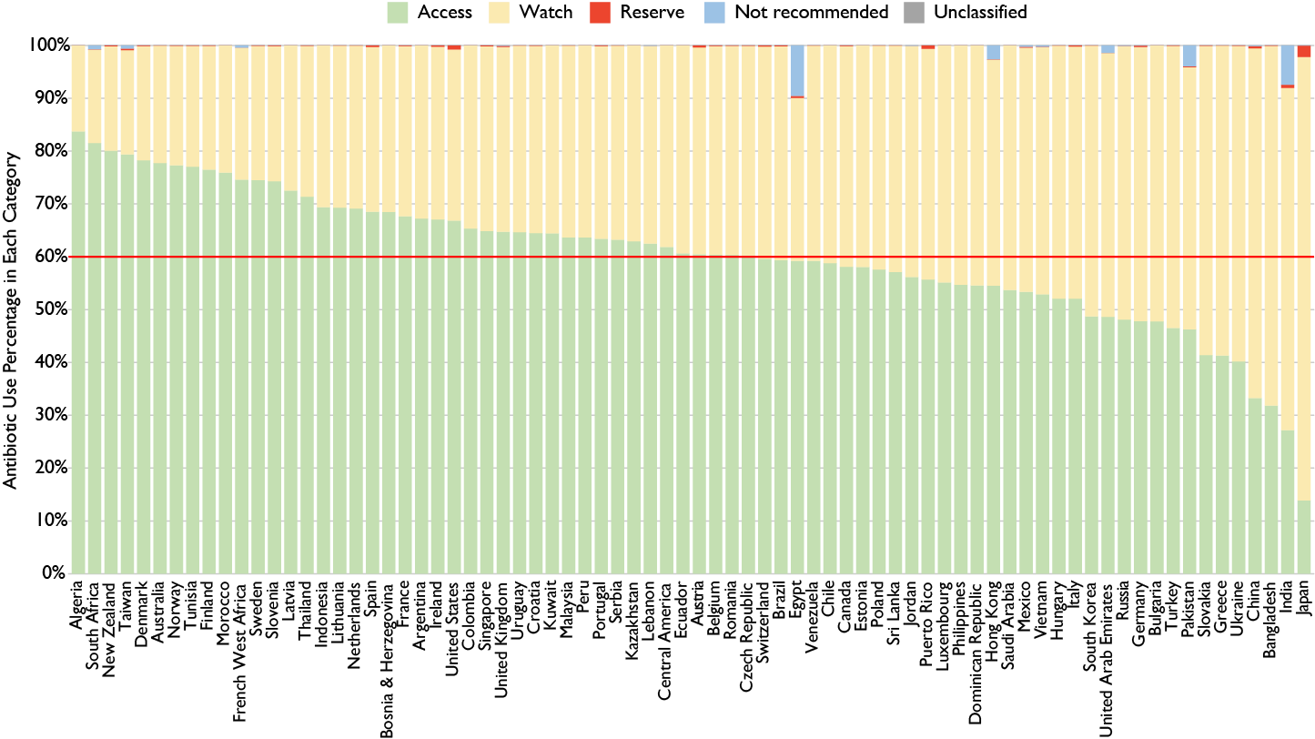

Figure 1. Percentage antibiotic consumption according to WHO AWaRe grouping, 2015
Based on total national antibiotic consumption measured in defined daily doses (DDDs) with considerable inter-country variation in the proportions of Access and Watch antibiotic consumption. The red line marks the WHO target of at least 60% Access antibiotics to combat antibiotic resistance. Source: IQVIA MIDAS, 2000–2015, IQVIA Inc. All rights reserved.

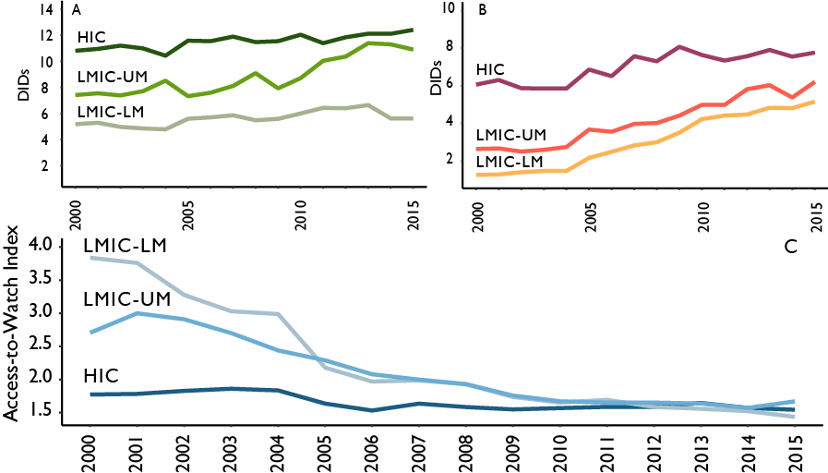

Figure 2. Relative and absolute consumption of Access and Watch antibiotics, 2000-2015
Median consumption in high-income countries (HICs), upper-middle low- and middle-income countries (LMIC-UM), and lower-middle low- and middle-income countries (LMIC-LM) expressed in defined daily doses (DDDs) per 1,000 inhabitants per day (DIDs) for (A) Access and (B) Watch antibiotics. The Access-to-Watch Index (C), which measures the ratio of DIDs of Access to Watch antibiotics, saw large declines in both LMIC-UM and LMIC-LM, which reflects the relatively larger increase in use of Watch antibiotics compared to Access antibiotics. Source: IQVIA MIDAS, 2000–2015, IQVIA Inc. All rights reserved.

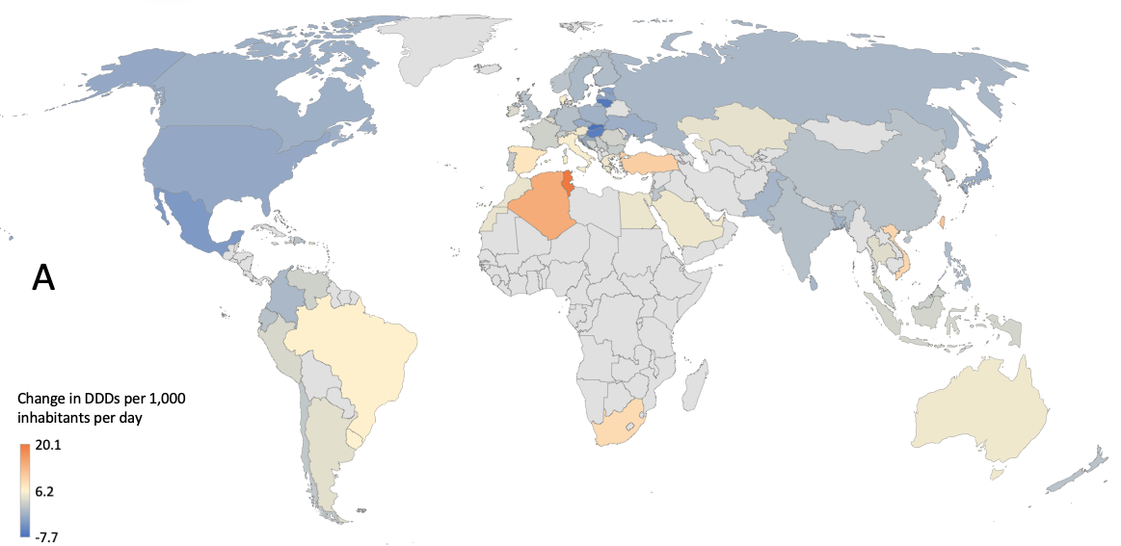

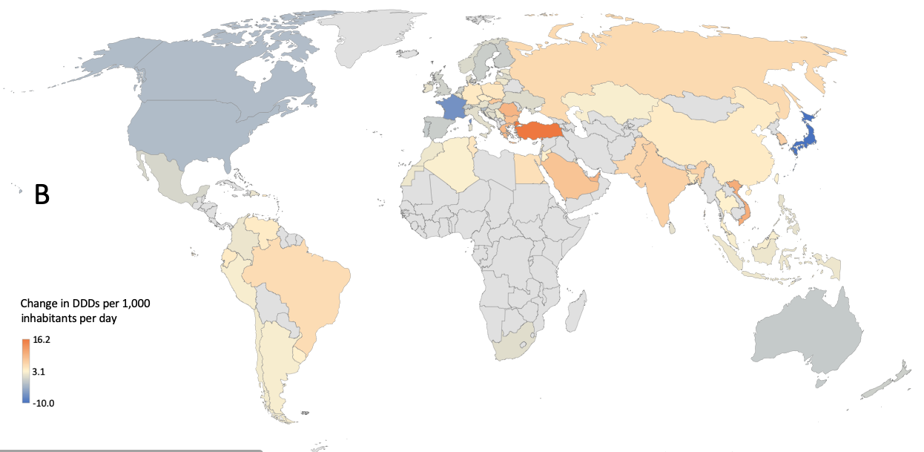

Figure 3. Change in the national consumption of Access and Watch antibiotics, 2000-2015
Country-level change in (A) Access and (B) Watch antibiotics expressed in defined daily doses (DDDs) per 1,000 inhabitants per day (DIDs) between 2000 and 2015. Due to availability of data, change in consumption was calculated from 2002 for Algeria, from 2005 for Bangladesh, Croatia, Kazakhstan, Netherlands, and Vietnam, from 2007 for Sri Lanka, from 2010 for Ukraine, and from 2011 for Bosnia and Herzegovina, and Serbia. Source: IQVIA MIDAS, 2000–2015, IQVIA Inc. All rights reserved.

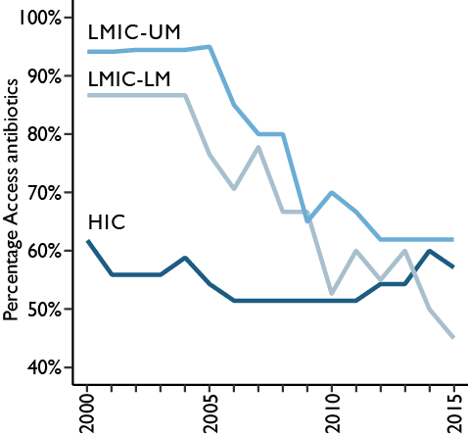

Figure 4. Countries that met the WHO target of at least 60% Access antibiotics, 2000-2015
Percentage of countries that achieved the WHO target of at least 60% Access antibiotics to combat antibiotic resistance by country income classification from 2000 to 2015. The percentage of high-income countries (HICs) with at least 60% of Access antibiotics in total national antibiotic consumption fell only slightly, while the percentage of low- and middle-income countries (LMICs; e.g., lower-middle income countries [LM] and upper-middle income countries [UM]) meeting that target fell significantly. Source: IQVIA MIDAS, 2000–2015, IQVIA Inc. All rights reserved.

