GARFIELD-AF (Global Anticoagulant Registry in the FIELD – Atrial Fibrillation), a worldwide prospective registry of patients with atrial fibrillation at risk of stroke

Jean-Pierre Bassand,^{1,2} Patricia N. Apenteng,³ Dan Atar,^{4,5} A. John Camm,⁶ Frank Cools,⁷ Ramon Corbalan,⁸ David A. Fitzmaurice,³ Keith A.A. Fox,⁹ Shinya Goto,¹⁰ Sylvia Haas,¹¹ Werner Hacke,¹² Carlos Jerjes-Sanchez,¹³ Yukihiro Koretsune,¹⁴ Jean-Yves Le Heuzey,¹⁵ Jitendra P.S. Sawhney,¹⁶ Seil Oh,¹⁷ Janina Stępińska,¹⁸ Vincent ten Cate,¹⁹ Freek W.A. Verheugt,²⁰ Gloria Kayani,² Karen S. Pieper,² Ajay K. Kakkar;^{2,21} for the GARFIELD-AF Investigators
¹University of Besançon, Besançon, France
²Thrombosis Research Institute, London, UK
³ Warwick Medical School, University of Warwick, Coventry, UK.
⁴ Department of Cardiology, Oslo University Hospital Ullevaal, Oslo, Norway
⁵University of Oslo, Oslo, Norway
⁶Molecular and Clinical Sciences Research Institute, St George's University of London, London, UK
⁷AZ Klina, Brasschaat, Belgium
⁸Catholic University, Santiago, Chile
⁹University of Edinburgh, Edinburgh, UK
¹⁰Tokai University School of Medicine, Kanagawa, Japan
¹¹Formerly Technical University of Munich, Munich, Germany
¹²University of Heidelberg, Heidelberg, Germany
¹³Instituto de Cardiologia y Medicina Vascular, Tec Salud, Garza Garcia, Mexico
¹⁴Osaka National Hospital, Osaka, Japan
¹⁵European Hospital Georges Pompidou, René Descartes University, Paris, France
¹⁶Sir Ganga Ram Hospital, New Delhi, India
¹⁷Seoul National University College of Medicine, Seoul, South Korea
¹⁸Institute of Cardiology, Warsaw, Poland
¹⁹Cardiovascular Research Institute Maastricht, Maastricht, the Netherlands
²⁰Onze Lieve Vrouwe Gasthuis, Amsterdam, the Netherlands
²¹University College London, London, UK

Clinical Trial Registration—URL: http://www.clinicaltrials.gov, unique identifier: NCT01090362.

Corresponding author
Jean-Pierre Bassand
University Hospital Jean-Minjoz, Boulevard Fleming, 25000 Besançon, France
- jpbassand@tri-london.ac.uk

Page Break
Acknowledgements
The authors thank the physicians, nurses, and patients involved in GARFIELD-AF as well as statisticians and programmers at Thrombosis Research Institute (TRI), London, UK. Alex Kahney of TRI provided editorial support.

Sources of funding
The GARFIELD-AF registry is sponsored by TRI and supported by an unrestricted research grant from Bayer AG, Berlin, Germany. The sponsor had no involvement in the collection, analysis or interpretation of the data.

Conflicts of Interests:
J.-P.B. reports personal fees from Thrombosis Research Institute, during the conduct of the study. DA has received personal fees from Bayer Healthcare, BMS/Pfizer, Boehringer-Ingelheim, and MSD. AJC has received institutional grants and personal fees from Bayer, Boehringer Ingelheim, Pfizer/BMS and Daiichi Sankyo. FC reports personal fees from Bayer, personal fees from BMS, personal fees from Boehringer-Ingelheim, outside the submitted work. D.A.F. reports personal fees from Bayer outside the submitted work. K.A.A. Fox has received grants and personal fees from Bayer/Janssen and AstraZeneca and personal fees from Sanofi/Regeneron and Verseon outside the submitted work. S.G. has received personal fees from the Thrombosis Research Institute, Harvard University, the American Heart Association, and grants from the Vehicle Racing Commemorative Foundation, Nikitina Foundation for Advancement of Measuring Technologies in Biomedical Engineering, Bristol-Myers Squibb, Sanofi, Ono, and Pfizer. S.H. has received personal fees from Aspen, Bayer Healthcare, BMS/Pfizer, Daiichi-Sankyo, Portola and Sanofi. WH reports that he was on the steering committee of RROCKET AF and was reimbursed for travel and time by Bayer until 2013.He is also member of the steering committee of GARFIELD AF and received travel reimbursement. YK reports research grant from Daiichi Sankyo and Boehringer Ingelheim. Paid lecture: Daiichi Sankyo, Boehringer Ingelheim, Bayer, Bristol Meyers and Pfizer. J-YLH reports fees (modests) for participating to advisory boards: Bayer, Boehringer Ingelheim, BMS/Pfizer and Daiichi-Sankyo. JPSS reports personal fee from Pfizer, Astra Zeneca, Novartis, Sanofi & BMS. SO has received consultant/advisory board payments for Bayer Pharma AG, Bristol-Myers Squibb Korea, Boehringer-Ingelheim Korea, Pfizer Korea, Sanofi-Aventis, and St Jude Medical, outside the submitted work. JS has received grants from Bayer; personal fees from Bayer, Boehringer Ingelheim, BMS/Pfizer, Novartis, and Servier; has served as an expert witness for Boehringer Ingelheim; has served as a consultant or on an advisory board for Amgen, Boehringer Ingelheim, Novartis, and Sanofi. FWAV has received grants from Bayer Healthcare; personal fees from Bayer Healthcare, BMS/Pfizer, Daiichi-Sankyo, and Boehringer-Ingelheim. A.K.K. has received research support from Bayer AG; personal fees from Bayer AG, Janssen Pharma, Sanofi S.A, Pfizer and Verseon. All other authors have reported that they have no relationships relevant to the contents of this paper to disclose.

Abstract
The Global Anticoagulant Registry in the FIELD (GARFIELD)-AF examined real-world practice in a total of 57,149 (5069 retrospective, 52,080 prospective) patients with newly diagnosed atrial fibrillation (AF) at risk of stroke/systemic embolism (SE), enrolled at over 1000 centres in 35 countries. It aimed to capture data on AF burden, patients' clinical profile, patterns of clinical practice and antithrombotic management, focusing on stroke/SE prevention, uptake of new oral anticoagulants (NOACs), impact on death, and bleeding. GARFIELD-AF set new standards for quality of data collection and analysis. Thirty-six peer-reviewed articles were already published, and 73 abstracts presented at international congresses, covering treatment strategies, geographical variations in baseline risk and therapies, adverse outcomes, and common comorbidities such as heart failure. A risk prediction tool as well as innovative observational studies and artificial intelligence (AI) methodologies are currently being developed by GARFIELD-AF researchers.

Key words: atrial fibrillation (AF), GARFIELD-AF, observational study, non-vitamin K oral anticoagulant (NOAC), artificial intelligence (AI)

The problem of atrial fibrillation
Atrial fibrillation (AF) is the commonest sustained cardiac arrhythmia, mainly affecting older adults. Because the ageing population is expected to expand the worldwide prevalence of AF is projected to increase markedly [1-7]. AF is still often considered as a benign condition, even though AF patients are at increased risk of adverse clinical outcomes particularly death, stroke, systemic embolism (SE), dementia, and bleeding. AF can also worsen pre-existing cardiac or non-cardiac conditions such as heart failure and respiratory insufficiency. The rate of hospital visits and readmissions is high in patients with AF, incurring substantial financial costs on healthcare [7].
Left atrial (LA) remodelling due to AF itself and mechanical burden such as structural heart disease and hypertension results in electrical dissociation between muscle bundles and in chaotic activation of the atrial myocardium, mechanical inefficiency, and blood stasis in the atria and left atrial appendage (LAA) and this may lead to thrombus formation and SE[8].
Vitamin K antagonists (VKAs) have been shown to reduce the risk of stroke by 66% and death by 26%, at the cost of a substantial risk of bleeding[9]. Wide variations in VKA control are commonly observed, with fluctuations in prothrombin time international normalised ratio (PT-INR) that expose the patient to elevated risk of stroke/SE and bleeding[10, 11]. In addition, other vitamin K-associated biological processes interacting with kidney function and bone mineralisation are also inhibited [12, 13]. Assessment of the risk-to-benefit balance of VKA therapy is essential. Tools have been developed to assess the risk of stroke/SE and of bleeding [14, 15]. The commonplace stroke/SE risk score CHA₂DS₂-VASc was developed in 1084 non-anticoagulated patients followed for 1 year, of whom 9.2% were at low, 15.1% intermediate, and 75.7% high risk. The predictive ability for risk of embolic events was modest (C statistics in the range 0.6). The bleeding risk calculator HAS-BLED was developed in a cohort of 3456 patients followed for 1 year, of whom two thirds were anticoagulated. It was derived in patients during the non-VKA oral anticoagulant (NOAC) era and, indeed, includes 1 point for "labile INR," which is largely irrelevant today [15]. No widely available tool can simultaneously predict the risk of stroke/SE, bleeding, and death in a single readout.
Aspirin was not shown to have any significantly meaningful impact on stroke prevention, and its use is associated with an increased risk of bleeding [16, 17]; however, this drug remains widely prescribed in spite of its limitations. NOACs including factor Xa and direct thrombin inhibitors have been introduced in clinical use during the past decade. They are easier to use than VKAs since they do not require anticoagulation status checks due to limited drug-drug and food-drug interactions. In RCTs NOACs were at least as efficacious as VKA in preventing stroke and conferred lower risk of bleeding, particularly intracranial haemorrhage [18-22]. Whether results achieved with NOACs in RCTs would translate into equivalent findings in unselected patients treated in routine daily practice provided the main rationale for large patient registries such as GARFIELD-AF.

The GARFIELD-AF Registry main objectives were to assess real-life treatment patterns in various countries and regions of the world, uptake of new anticoagulants, efficacy and safety of various anticoagulation regimens, impact on outcomes of guideline-recommended and of non-recommended antithrombotic therapies such as aspirin, impact of bleeding on outcomes, therapy persistence, management and impact of comorbidities on outcomes, resources utilisation, and development of new risk stratification schemes more accurately to assess the risk-to-benefit balance of treatments and thereby identify low- to very low-risk patients.

GARFIELD-AF Mission Statement was (1) to enhance understanding of the burden of AF- related thromboembolic stroke and identify opportunities for the incorporation of innovations designed to improve safety, outcomes, and utilisation of healthcare resources, (2) to provide representative, real-world insights, and clarify AF treatments and outcomes for patients, clinicians, and healthcare providers as they evolve over time, and (3) to generate, disseminate, and communicate research findings according to the highest academic and ethical standards.
Methods

Structure of GARFIELD-AF Registry
GARFIELD-AF is run under the auspices of the Thrombosis Research Institute in London, UK (https://www.tri-london.ac.uk). It was conceived by Professor Ajay K. Kakkar, the Thrombosis Research Institute chairman. The governing structure of the registry consists of the Steering Committee chaired by Ajay K. Kakkar and including 15 members with interest in the thromboprophylaxis and AF, the Audit Committee comprising 2 members, the Publication Committee comprising 8 members and the National Coordinator Council including 38 members (full details in the Appendix). The Steering Committee, supported by the National Coordinator Council, provides global leadership for this programme and engagement with diverse healthcare settings and disciplines, including cardiology, haematology, neurology, primary care, and health economics. Independent Ethics Committee and hospital-based institutional review boards approved the registry protocol in each participating country (list at https://af.garfieldregistry.org/).

GARFIELD-AF Design
GARFIELD-AF is a worldwide observational study of stroke prevention in patients with newly diagnosed AF. The GARFIELD-AF Registry is a pioneering, independent academic research initiative, funded by an unrestricted research grant from Bayer AG [23, 24]. Starting in December 2009, a total of 52,080 adult patients with de novo AF diagnosed within 6 weeks of study entry, on average 2 weeks after diagnosis of AF, and at least one investigator-defined risk factor for stroke were recruited in five independent, sequential, prospective cohorts at more than 1000 centres in 35 countries. An additional retrospective validation cohort of 5069 patients with established AF diagnosed 6–24 months before study start was recruited in parallel to the first prospective cohort to allow comparison of prospective and retrospective data. Data were collected on electronic case report forms (eCRFs) at 4-monthly intervals up to 24 months or until death or loss to follow-up. GARFIELD-AF structure was adapted from the GRACE Registry CRF[25]. Patients were not required to attend 4-monthly clinic visits. The aim was to capture all planned and unplanned visits, interruptions to treatment, and clinical events through electronic records.
As the value of data collected in registries depends critically on robust quality standards including source data verification (SDV) and personnel training, GARFIELD-AF set new standards for quality of data collection and analysis. These included a combination of remote and onsite data quality monitoring to ensure completeness and accuracy of records and by design. For stringent quality control 20% eCRFs were monitored against source data documentation. Four performance measures were introduced for rating study sites according to their data quality, with those obtaining lower rankings designated for closer monitoring. The quality standards set by GARFIELD-AF are considered as high as those governing RCTs and have the potential to become reference point for future registries [26].
The registry was conducted in accordance with the Declaration of Helsinki, local regulatory requirements, and Good Pharmacoepidemiologic and Clinical Practice guidelines. All patients provided written informed consent to participate.
Regions were classified according to the definitions of the United Nations. Patients were recruited from: Europe (Finland, Norway, Sweden, Denmark, United Kingdom, Netherlands, Belgium, Germany, Switzerland, France, Spain, Italy, Austria, Hungary, Russia, Poland, Czech Republic, Ukraine and Turkey), Asia (Singapore, China, Japan, South Korea, Thailand and India), North America (USA and Canada), Latin America (Mexico, Brazil, Argentina and Chile) and other countries including Egypt, United Arab Emirates, South Africa and Australia.
Investigator sites have been selected randomly and represent the different care settings in each participating country (office-based practice; hospital departments – neurology, cardiology, geriatrics, internal medicine, and emergency; anticoagulation clinics; and general or family practice. Investigators had to include consecutively patients with newly diagnosed atrial fibrillation (AF diagnosed within 6 weeks of study entry).
Baseline characteristics and data on antithrombotic treatment (VKAs, NOACs, antiplatelets [AP]), and cardiovascular drugs were collected at study entry. The risk profiles for stroke/SE and bleeding were assessed retrospectively by CHA₂DS₂-VASc and HAS-BLED scores. Standardized definitions for clinical adverse events were used[23, 24]; however, clinical adverse events reported by the investigators were not centrally adjudicated by an independent committee as in other registries[27].

GARFIELD-AF Achievements

The main objectives of the GARFIELD-AF Registry were to assess real-life treatment patterns in various countries and regions of the world, use of OACs including uptake of NOACs, efficacy and safety of the various anticoagulation regimens, impact on outcomes of guideline-recommended and of non-recommended therapies such as aspirin, impact of bleeding on outcomes, therapy persistence, management and impact of comorbidities on outcomes, use of healthcare resources, and development of new risk stratification schemes.
GARFIELD-AF recruitment was completed with the last patient enrolled in August 2016. End of follow-up for the fifth and final cohort occurred with the last patient's 24-month follow-up visit in August 2018 (Figure 1). The GARFIELD-AF database was locked end of June 2019. Out of 52,080 patients recruited in all 5 prospective GARFIELD-AF cohorts, 2155 (4.1%) patients were lost to follow-up. Thereafter, nearly 29,000 patients consented to enter the long-term extension (LTE) study and will provide important information on chronic treatment and outcomes.
During the registry, multiple analyses were carried out. In addition, the retrospective validation cohort was analysed and compared with the first prospective cohort. Every year since 2011, findings from GARFIELD-AF have been presented at major symposia including European Society of Cardiology (ESC), American College of Cardiology (ACC), American Heart Association (AHA), International Society on Thrombosis and Haemostasis (ISTH), and European Stroke Organization (ESO). At each ESC congress GARFIELD-AF holds a satellite symposium featuring a range of stimulating presentations by a panel of esteemed cardiologists and haematologists. To date, lessons from GARFIELD-AF have been promulgated in the form of 73 abstracts presented at international scientific conferences and 36 published articles in major peer-reviewed medical journals.

GARFIELD-AF: New Standards in Quality Assurance
Evidence generated from RCTs is recognized as the "gold standard" for comparing treatment options. RCTs have restrictive inclusion/exclusion criteria, so that some populations such as elderly individuals or patients with comorbidities are typically not well represented. RCTs are complemented by robust observational studies that provide evidence on the application of therapies in clinical practice. Appropriately designed registries have the potential to capture the burden of disease and to describe patient characteristics and outcomes in large-scale populations employing wide inclusion criteria that are more closely reflective of "real world" clinical practice [28].
Registries differ in their design, recruitment strategies, care settings, geographic representation, and duration of follow-up as well as in the endpoint characterisation and quality assurance methods. In addition, depending on their retrospective or prospective design, they may yield different outcomes [28]. GARFIELD-AF has demonstrated the impact of inclusion bias and survivorship bias in retrospective cohorts, not seen in prospectively recruited patients [28]. In two cohorts of approximatively 5000 patients recruited retrospectively and prospectively in GARFIELD-AF there were differences in treatment strategies and outcomes with significantly higher rates of OAC prescription and lower rate of death in retrospective cohort despite similar baseline characteristics [28]. Patients who die in the retrospective period prior to study initiation are clearly excluded and retrospective designs cannot take the higher rates of outcome events shortly after AF diagnosis into account. For these reasons, a prospective study design with successive cohorts was selected for GARFIELD-AF as the most reliable way of capturing the burden of disease from an unselected population shortly after the diagnosis of AF^{25,}[28]. Not all registries have included the standards defined in GARFIRLD-AF.

Evolving Practice Patterns in Antithrombotic Therapy
Population profile, gender differences, and use of antithrombotic therapy
Baseline characteristics and initial treatment of GARFIELD-AF patients were first evaluated in 10,614 individuals registered in cohort 1 (mean age, 70.2 years, 43.2% women). At diagnosis, 55.8% of patients overall were given a VKA for stroke prevention, 45.2% (n = 4,797) a VKA alone and 10.6% (n = 1,128) a combination of VKA and antiplatelet drug (AP). A minority of patients (4.5%, n = 475) received a NOAC. Over one-quarter (25.3%, n = 2,681) of the patients received AP alone and 14.4% (n = 1,533) had no antithrombotic therapy at all. Overall, 38.0% of patients with an indication for OAC (moderate-to-high stroke/SE risk) did not receive any anticoagulation whereas 42.5% of those without an indication for OAC (low risk for stroke/SE) received anticoagulant therapy [23]. As opposed to common beliefs GARFIELD-AF also showed that anticoagulant use for stroke/SE prevention was not different in men and women [29]. Hence coming to the end of the VKA era, these drugs were paradoxically underused in patients at higher risk and overused in those at lower risk [23], in women and men alike [29].

Evolving patterns of anticoagulation therapy--anno 2009–16: the NOACs revolution
Antithrombotic treatment strategies were analysed in 4947 patients retrospectively enrolled during 2009-11 and 51,354 patients prospectively enrolled in cohorts 1–5 during 2010–16. Baseline characteristics were similar across all cohorts. From the first to fifth prospective cohort, OAC use rose by 24% from 57.5% to 71.1%. Treatment with VKA alone or in combination with AP drugs declined markedly (from 53.3% to 28.1%) whereas prescription of NOACs with or without AP simultaneously increased (from 4.2% to 43.1%). Similar trend was observed between the retrospective and prospective cohorts. More patients with AF at risk of stroke/SE received guideline-recommended therapy, predominantly due to an increased use of NOACs and reduced use of VKA alone or in combination with AP and of AP alone[30] (Figure 2).

Indeed, GARFIELD-AF documented the major change in anticoagulation practice after NOACs became available for stroke/SE prevention in AF. The key factors determining choice between NOACs and VKAs were explored in a population of 24,137 patients initiated on OAC w/wo AP (NOAC 51.4%; VKA 48.6%) between April 2013 and August 2016. The most significant predictors of OAC therapy were country, enrolment year, care setting at diagnosis, AF type, concomitant AP, and kidney disease. Patients enrolled in emergency care or in the outpatient setting were more likely to receive a NOAC than those enrolled in hospital (OR, 1.16 [95% CI, 1.04 to 1.30]; OR, 1.15 [95% CI, 1.05 to 1.25], respectively). NOAC prescription was favoured in lower-risk groups, namely, patients with paroxysmal AF and normotensive patients but also the elderly and patients with acute coronary syndrome. By contrast, VKAs were preferentially used in higher-risk groups, such as patients with permanent AF, moderate to severe kidney disease, heart failure, vascular disease, and diabetes (Figure 3)[31].
The changes in prescription practice depended on the availability of NOACs in each country. As an example, in the UK, the changes were evaluated in 186 primary care practices participating in GARFIELD-AF. A total of 3482 participants were prospectively enrolled between September 2011 and July 2016. Their mean age was 74.5 years, 42.7% were women, and their median CHA2DS2-VASc score was 3 and HAS-BLED score 2. There was a statistically significant increase in the use of OAC therapy over time, from 54.7% to 73.9%. Use of VKA±AP drugs decreased from 53.3% to 30.6%, while that of NOACs±AP increased from 1.3% to 43.3% over the study period. In the meantime, use of AP as only antithrombotic agent decreased from 36.4% to 10.5%, as did the combination therapy of VKA+AP from 13.6% to 5.8%. The progressive increase in the proportion of patients newly diagnosed with AF receiving guideline-recommended therapy in the UK was driven by the availability of NOACs[32].

Are vitamin K antagonists here to stay?
VKAs remain widely prescribed for stroke/SE prevention in nonvalvular AF, particularly but not only in low-to-middle income countries. These medications are also useful in patients in whom NOACs are contraindicated including those with severe renal disease. In the last two GARFIELD-AF cohorts, VKAs were used in over 30% of patients. Treatment with VKA poses some inconvenience in that dosing should be individually titrated to maintain a target range of PT-INR 2.0-3.0 as recommended by most international guidelines. However, in Asian countries VKA control is monitored according to a lower target range compared with other regions of the world (ORW). In GARFIELD-AF patients receiving VKA during 2010–13, PT-INR values were compared between 1356 Asian patients and 7081 ORW patients. VKA-treated patients in Asia compared with those in ORW were younger (mean 67.1 vs 71.3 years) and had lower CHA₂DS₂-VASc score (3.0 vs 3.5) but a similar HAS-BLED score (1.3 vs 1.4). Mean PT-INR was lower in Asia than in ORW (2.0 vs 2.4). Only 31.1% Asian patients met the international target PT-INR (2.0-3.0) compared with 54.1% of ORW patients. In Asia and ORW, PT-INR <2.0 was noted in 59.3% and 28.2% and PT-INR >3.0 in 9.6% and 17.7%, respectively. The difference in the distribution of PT-INRs in patients from Asia versus other regions is mostly related to the lower recommended target PT-INR in Asia than in ORW [33]. Whether targeting lower PT-INR in Asian countries would result in different outcomes remains moot.
The time in therapeutic range (TTR) of VKA-treated patients is a measure of the quality of anticoagulation control. Using the recommended PT-INR target range 2.0-3.0, a TTR over 65% is associated with better outcomes[34]. The effect of TTR on adverse outcomes was assessed in 9934 GARFIELD-AF patients using 136,082 PT-INR measurements during 1-year follow-up. The mean TTR was 55.0%, 58.9% patients had TTR <65%. In particular, TTR <65% was observed in 87.3% of Asian patients. After adjusting for potential confounders, TTR <65% was associated with 2.4-fold higher risk for all-cause mortality, 2.6-fold increase for stroke/SE, and 1.5-fold higher risk for major bleeding compared with TTR ≥65%. Whether improving VKA control would substantially reduce the incidence of adverse outcomes in all AF patients worldwide remains unknown [35].
Further to these observations, agreement between two PT-INR audit parameters was evaluated, namely frequency in range (FIR) and time in therapeutic range (TTR). FIR is the proportion of INRs in the therapeutic range and number of tests in range. TTR is the proportion of time in the therapeutic INR range[36]. Whether FIR and TTR are equivalent PT-INR audit parameters was assessed in 8445 GARFIELD-AF patients who received VKA therapy at enrolment, of whom 5066 had ≥3 PT-INR readings, giving a total of 70,905 PT-INR readings over 1-year follow-up. TTR values were higher than FIR values (mean, 56.0% vs 49.8%; median, 59.7% vs 50.0%), with high correlation between FIR and TTR values. However, at patient level there were high disagreement and variability (Lin's concordance coefficient, 0.829 [95% CI, 0.821 to 0.837]) that explained 17.4% of the total variability of measurements between FIR and TTR. Thus, although FIR and TTR correlate, they are not concordant and should not be used interchangeably [37].

Antiplatelet therapy remains widely used
Despite guideline-recommended practice against the use of AP for the prevention of stroke/SE in AF, AP use remains widespread despite its inherent limitations—mostly as aspirin monotherapy, predominantly in many countries in transition. Among a total of 51,270 patients enrolled in GARFIELD-AF cohorts 1–5 one fifth (20.7%) received AP monotherapy. Compared with patients on OAC monotherapy those given AP monotherapy were more likely Chinese (vs. Caucasian: hazard ratio [HR], 2.73) and to have persistent AF (HR, 1.32), coronary artery disease (CAD; HR, 2.41), vascular disease (HR, 2.41), or prior bleed (HR, 2.11). Although use of AP alone declined over the course of the study, even at study end half patients treated with this regimen had no regulatory body-approved indication for AP, for example intercurrent CAD[38].
In a recent analysis, patients with concomitant prescription of OAC and AP compared to patients with OAC monotherapy had greater prevalence of cardiovascular indications for AP, namely coronary artery, or carotid disease, but that about a third of these patients had no indication for concomitant AP therapy. Over 1 year, patients treated with OAC plus AP had significantly higher incidence rates of stroke and of any bleeding than patients with OAC monotherapy. There was no difference in all-cause mortality, in the risk of acute coronary syndrome in patients with OAC+AP therapy compared to patients with OAC monotherapy. The practice of co-prescribing OAC and AP should be avoided unless there is a clear indication of adding AP to OAC [39].

New Insights on Major Outcomes
Two-year outcomes
GARFIELD-AF showed that patients with newly diagnosed AF were at very high risk of death as well as considerable risk of stroke/SE and bleeding. In 17,162 patients prospectively enrolled in the first two cohorts of GARFIELD-AF and followed over 2 years, all-cause death was the most frequent adverse event followed by stroke/SE and major bleeding (incidence rate, 3.83 [95% CI, 3.62 to 4.05], 1.25 [95% CI, 1.13 to 1.38], and 0.70 [95% CI, 0.62 to 0.81] per 100 person-years, respectively). Congestive heart failure, acute coronary syndromes, sudden/unwitnessed death, malignancy, respiratory failure, and infection/sepsis accounted for 65% of deaths; stroke accounted for only 5.1% cases. Anticoagulation therapy was associated with a 35% reduced risk of death. Because stroke was not a major cause of death, this suggests a holistic approach to the management of AF is needed to reduce mortality, namely interventions targeting modifiable, cause-specific risk factors, particularly heart failure, diabetes, CKD, hypertension, and coronary artery disease[40]. The observation that anticoagulation reduced risk of death to a greater extent than might be expected from stroke reduction remains unexplained.

Predictors of outcomes
Predictors of outcomes were explored using data on 28,628 patients enrolled in the first three GARFIELD-AF cohorts. At 2-year follow-up, the rates of death, stroke/SE, and major bleeding were 3.84 (95% CI, 3.68 to 4.02), 1.27 (95% CI, 1.18 to 1.38), and 0.71 (95% CI, 0.64 to 0.79) per 100 person-years, respectively. Several variables were associated with the risk of one or more outcomes, confirming that they share similar risk factors. OAC therapy was associated with 30% lower risk of death and 28% reduction of stroke/SE compared with no OAC (Figure 4). Prescription of guideline-recommended drugs for CHF, vascular disease, and CKD was suboptimal, highlighting that more vigilance is required in patients with these comorbidities [41].

Very early hazards
In patients with newly diagnosed AF GARFIELD-AF showed that the risk of death, stroke/SE, and major bleeding was significantly higher during the first 1 month than the subsequent 11 months of follow-up. Over 12 months, among 52,014 patients, a total of 2140 patients died (incidence rate, 4.3 [95% CI, 4.2 to 4.5] per 100 person-years). Of these, 288 (13.5%) died in the first 1 month (rate, 6.8 [95% CI, 6.1 to 7.6]). This higher mortality rate observed during the first month was mostly attributable to cardiovascular causes: in particular, heart failure, sudden death, and acute coronary syndromes (1.0 [95% CI, 0.8 to 1.4], 0.6 [95% CI, 0.4 to 0.8], and 0.5 [95% CI, 0.3 to 0.8] per 100 person-years, respectively). Independent predictors of death were older age, heart failure, prior stroke, history of cirrhosis, vascular disease, moderate-to-severe CKD, and diabetes mellitus whereas OAC and living in Europe or Asia were independent predictors of a lower risk of early death[42] (Figure 5).

Influence of atrial fibrillation type
The influence of type of AF on outcomes remains uncertain, with many researchers suggesting that paroxysmal AF carries a lower risk of stroke/SE than persistent/permanent AF. In 29,181 GARFIELD-AF patients enrolled between 2010 and 2015 14,344 (49.2%) were diagnosed with paroxysmal AF, 8064 (27.6%) persistent, and 6773 (23.2%) permanent-type AF. Patients with paroxysmal AF were least likely to receive OAC and most likely to receive AP alone or no anticoagulation. Over 2 years, persistent/permanent AF patients who were not anticoagulated had higher risk of stroke/SE, new/worsening HF, and death than those with paroxysmal AF. In anticoagulated patients, however, the risk of adverse events was similar across all types of AF. These data suggest that AF pattern has no prognostic value for the risk of stroke/SE in patients who receive anticoagulation therapy[43].

Impact of Comorbidities on Outcomes
Heart failure
Congestive heart failure (CHF) is the commonest comorbidity of atrial fibrillation, affecting treatment strategies and outcomes. CHF may result from ischemic heart disease or from non-ischemic aetiologies. We aimed at comparing the baseline characteristics, management strategies and outcomes of patients with ischemic cardiomyopathy (ICM) and without non-ischemic cardiomyopathy (NICM). Among the entire GARFIELD-AF cohort, 11,738 patients with CHF were stratified by presence of underlying ICM (n = 4717) or non-ischemic cardiomyopathy (NICM; n = 7021). For stroke prophylaxis, patients with ICM were less likely to receive OAC and more likely to receive AP alone than those with NICM. Moreover, ICM patients received angiotensin-converting enzyme inhibitors/angiotensin receptor blockers more often than patients with NICM (Figure 6). Over 1 year, ICM patients had greater risk of death by any cause and major bleeds. This real-world observation study suggests that patients with AF and ICM are at especially high risk and merit comprehensive disease management [44].

Acute coronary syndromes
Limited data are available on long-term outcomes in AF patients with intercurrent acute coronary syndrome (ACS). Among 39,679 patients enrolled in GARFIELD-AF between 2010 and 2015, history of ACS was noted in 4152 individuals (10.5%). Over 2-year follow-up, patients with versus without ACS had a higher risk of all-cause death (HR, 1.34 [95% CI, 1.21 to 1.49]), CV death (HR, 1.85 [95% CI, 1.51 to 2.26]), stroke/SE (HR, 1.39 [95% CI, 1.08 to 1.78]), major bleeding (HR, 1.30 [95% CI, 0.95 to 1.79]), recurrent ACS (HR, 3.42 [95% CI, 2.62 to 4.45]), and new or worsening HF (HR, 1.39 [95% CI, 1.12 to 1.71]). Despite these greater risks, AF patients with prior ACS were less likely to receive OAC than their counterparts who had not experienced ACS. Greater use of OACs, particularly NOACs could improve their prognosis [45].

Chronic kidney disease
Kidney function data were available in 33,024 patients enrolled in GARFIELD-AF, including 9491 patients from Asia (China, India, Japan, Singapore, South Korea, and Thailand). Moderate-to-severe CKD was documented in 3613 (10.9%), mild CKD in 5595 (16.9%), and no CKD in 23,816 individuals (72.1%). In them, use of OAC was driven by stroke/SE risk regardless of kidney function, and quality of anticoagulant control using VKAs was unaffected by CKD stage. After adjusting for baseline characteristics and antithrombotic medications, the presence of mild-to-severe CKD was independently associated with higher all-cause mortality compared with normal kidney function. The impact of moderate-to-severe CKD on mortality was significantly worse in Asian patients than in patients from the rest of the world. The differential impact on all-cause death between Asians and non-Asians remains unexplained. Moderate-to-severe CKD was also independently associated with higher risk of stroke/SE and major bleeding [46].
Impact of Transient Ischemic Attack on Future Stroke Risk
In most AF risk scoring schemes including CHA₂DS₂-VASc prior TIA is included as an influencing factor. However, it is questionable whether previous TIA has the same significance as documented stroke for the risk of stroke recurrence. Indeed, it is difficult retrospectively to ascertain whether symptoms of TIA represent an actual cerebrovascular event. We assessed baseline characteristics and outcomes of 5617 patients with a history of stroke or TIA, based on physicians' assessment. Prior stroke/TIA was associated with significantly higher risk for all-cause mortality (HR, 1.26[95% CI, 1.12 to 1.42]), cardiovascular death (HR, 1.22[95% CI, 1.01 to 1.48]), non-cardiovascular death (HR, 1.39 [95% CI, 1.15 to 1.68]), and stroke/SE (HR, 2.17 [95% CI, 1.80 to 2.63]) than in patients without history of stroke/TIA. However, whereas history of stroke was associated with higher risk of all-cause mortality (HR, 1.29 [95% CI, 1.11 to 1.50]), non-cardiovascular death (HR, 1.39 [95% CI, 1.10 to 1.77]), and stroke/SE (HR, 2.29 [95% CI, 1.83 to 2.86]) no significantly higher risk of adverse events was seen for patients with history of TIA. These findings suggest that history of TIA without evidence of stroke may not prognosticate future risk of stroke in patients with newly diagnosed AF due to low reliability of ascertaining TIA retrospectively[47]. Notably, the GARFIELD-AF risk calculator does not include history of TIA in its assessment scheme [48].
The GARFIELD-AF Risk Score
An important output of GARFIELD-AF is the development of a new tool facilitating decisions on the potential benefits/risks of anticoagulation. It was developed, and externally validated, for all GARFIELD-AF patients then applied to lower- or higher-risk patients stratified by use or non-use of anticoagulation. External validation was carried out in an independent dataset, Outcome Registry for Better Informed Treatment of Atrial Fibrillation (ORBIT-AF). The discriminatory value of the GARFIELD-AF risk model was superior to CHA₂DS₂-VASc for patients with or without anticoagulation including in very low- to low-risk patients (CHA₂DS₂-VASc 0 or 1 in men; 1 or 2 in women; Table 1). The GARFIELD-AF risk tool could accurately predict all-cause mortality using a full and simplified model, and any stroke/SE over 1 year (Table 2). The GARFIELD-AF risk calculator unlike other currently available risk scoring systems can simultaneously calculate risk of death, stroke/SE, and major bleeding dependent on treatment selected (VKA, OAC, or no OAC) in a single readout. The tool is currently updated with 2-year follow-up data. The newest tool is available on the GARFIELD-AF website (https://af.garfieldregistry.org/garfield-af-risk-calculator) and QX-MD[49]. It can be accessed on any mobile device or computer or incorporated automatically in electronic medical records [48] (Figure 7).
GARFIELD-AF: Regional and National Reports
So far, national and regional manuscripts from Belgium, France, India, Japan, Latin America, Netherlands, Nordic countries (in press), Poland, Turkey, and UK have been published. They all explored baseline characteristics of patients included nationally or regionally as well as anticoagulation patterns, uptake of NOACs, and in some cases outcomes at 1-year follow-up. Wide variations were observed in baseline characteristics and antithrombotic patterns with a trend to younger populations in countries in transition as opposed to developed countries [32, 50-57].
Ongoing Publications
Several ongoing publications are due soon. The publications listed in this section have all been reported as poster or oral presentations in numerous international meeting such as ESC, ACC, AHA, ISTH, and ESO. Manuscripts are in preparation for each of these topics, which explore multiple aspects of AF and its management.
Large variations have been observed in prescription patterns of OAC worldwide. In countries in transition, AP and VKA are still widely prescribed. In high-income countries, uptake of NOACs has gradually increased. These differences result in different outcomes as regards death, stroke/SE, and bleeding.
Bleeding remains a major concern in patients treated with OAC, particularly intracranial haemorrhage (ICH). GARFIELD-AF confirmed that use of NOAC led to a significantly lower risk of all-type bleeding driven by lower risk of major bleedings. The risk of ICH was assessed in a pooled analysis of GARFIELD-AF and ORBIT registries so as better to define predictors of ICH.
Discontinuation of OAC for 7 days or more is associated with worse rates of death and stroke/SE. Discontinuation may be mandatory in critical situations such as internal bleeding, but in many instances, discontinuation of OAC was not based on strong reasons.
Impact of guidelines implementation on outcomes, differences between various guidelines and their impact on outcomes, appropriateness of NOAC dosing, and comparative effectiveness of different OAC will be reported soon.

Clinical Implications
Considering our observations and those of others, a whole new approach to AF management seems imminent. AF should not be considered simply a localized cardiac arrhythmia. GARFIELD-AF confirms that AF is a systemic disease having complex interactions with risk factors and associated comorbidities. The diagnosis of AF should be a warning signal for clinicians alerting them to its associated risks and engaging them in a holistic approach to disease management. Stroke attributable risk of death accounts for only 5% of AF-related deaths, over 90% AF mortality is due to cardiovascular and non-cardiovascular causes. OAC therapy is mandatory in high-risk patients, as well as appropriate management of risk factors and comorbidities.
Limitations
Though based on prospective data representative of real-world practice collected worldwide with high standard quality control, this registry has some limitations. In the section about CHF, we cannot provide detailed information about the type of heart failure, with depressed or preserved ejection fraction, as these features were not collected. Similarly, we cannot provide information on the rate of tachycardia-induced heart failure. Major events, death, stroke/SE and bleeding were documented by the investigators but not independently adjudicated.
Future Research Directions
Exciting times lie ahead for GARFIELD-AF, with several new research directions in the pipeline. Increasingly, regulators and medical product developers are turning to real-world evidence (RWE) to support data from RCTs, especially in the areas of drug safety and expansion into new indications. Many efforts are being considered to reduce the long duration and huge cost of RCTs. Postmarketing surveillance (PMS) has always been a condition of new drug approval. One important development for observational studies, however, is the hybrid or pragmatic trial, distinct from a conventional RCT. A pragmatic trial uses the RWE design motif of non-interventional observation of a population undergoing any treatment for a defined disease condition. Randomisation within a large clinical registry allows all-comers to be treated and followed according to clinical practice except for the randomised treatment allocation. The aim of pragmatism is to minimize differences in treatment and follow-up between participants recruited to an RCT and patients managed with usual care. GARFIELD-AF intends to branch into innovative trial methodologies such as observational studies looking at comparative effectiveness and pragmatic studies providing real-world practice-based RCTs[58].
Because it is widely believed that the increasing future burden of chronic diseases will eventually reach unsustainable levels, major priorities of 21st century healthcare systems will be focused on personalized disease prevention. There will be enormous demand for high-quality data on healthcare practice and research—and new technologies are already being applied to enable innovative approaches to generating and interrogating health data.
The era of artificial intelligence (AI) and personalized medicine will go beyond traditional clinical sources of data, bringing together economic reports from inventory and claims, treatment and outcomes from electronic health records, registries, patient-generated data from mobile devices and wearables, and multi-omics from biobanks. AI uses analytical algorithms iteratively to learn from patterns and improve from experiences, known as machine learning, and deep learning using multilayer neural networks. AI-based pattern recognition can identify previously unknown risk factors from a vast range of patient characteristics, and deep learning has been shown to match or exceed expert performance in areas such as imaging classification [59] .
GARFIELD-AF has begun to use the above techniques of AI and machine learning in analysing patient data to predict risk [60]. With ongoing and future successful collaborations, the large GARFIELD-AF datasets have substantial potential for advanced analyses.
Conclusions
The GARFIELD-AF registry was designed to probe some of the deepest problems in the worldwide aetiology, diagnosis, and management of AF and its associated comorbidities that often arise in largely elderly populations. Its objectives were to observe the prevalence of AF and to capture a timeline of clinical practice patterns for prevention of stroke/SE, death, and bleeding in those affected. In all, well over 50,000 patients were recruited in five independent, sequential cohorts and observed for 2 years or longer, with a long-term extension study now completed. GARFIELD-AF findings have been reported extensively in a wide range of publications in major journals and expert-led presentations at international conferences and customized satellite symposia. GARFIELD-AF has witnessed and reported the evolution of treatment as NOACs steadily increased in popularity and ease of use over VKAs. The extensive GARFIELD-AF dataset was applied, along with new and sophisticated statistical modelling techniques, to create the GARFIELD-AF outcomes prediction tool, a freely available online risk calculator to help clinicians make treatment decisions. Future cohorts using new observational study designs are set to revamp the conduct of clinical trials. And GARFIELD-AF researchers are heavily involved in the fields of AI and machine learning to reduce the future burden and improve prognoses of AF patients well into the coming decades.
Executive summary
- GARFIELD-AF Design. GARFIELD-AF is the largest worldwide prospective registry involving 35 countries and over 1000 randomly selected sites representing all care settings and real-world practice
- New Standards in Quality Assurance. Garfield-AF set new standards in quality assurance with strict monitoring and stringent quality control
- Evolving Practice Patterns in Antithrombotic Therapy. GARFIELD-AF followed the historical changes in treatment practice after NOACs were introduced in routine clinical care and their impact on major outcome measures, death, stroke/SE, and major bleeding
New Insights on Major Outcomes. GARFIELD-AF showed that death was the most frequent major events occurring in patients with newly diagnosed AF at a rate threefold as high as stroke/SE and major bleeding. The rate of stroke-related death did not exceed 5% of all-cause death. OAC therapy was associated with a 30% lower risk of death, far a greater than might be expected from the reduction of stroke-related risk of death. This suggests that other mechanisms than stroke/SE risk reduction may affect the risk of death.

- Impact of Comorbidities on Outcomes. GARFIELD-AF showed that heart failure, prior coronary artery disease/acute coronary syndrome, and chronic kidney disease were the three commonest comorbidities in patients with newly diagnosed AF, and that each of them affecting treatment strategies and outcomes.
- The GARFIELD-AF Risk Score. GARFIELD-AF made it possible to develop a new risk calculator that provides estimates of risk of all three major clinical outcomes such as death, stroke, and major bleeding and assesses the impact of different anticoagulation strategies in a single reading
- Clinical Implications. GARFIELD-AF showed that AF should not be considered simply as a localized cardiac arrhythmia but rather a systemic disease requiring comprehensive management of risk factors and comorbidities.
- Future Research Directions. GARFIELD-AF set the foundation for innovative trial methodologies such as observational studies looking at comparative effectiveness and pragmatic studies providing real-world reference arms for RCTs. It innovated in techniques of AI and machine learning to analyse patient data and predict risk

References
1. Go AS, Hylek EM, Phillips KA et al. Prevalence of diagnosed atrial fibrillation in adults: national implications for rhythm management and stroke prevention: the AnTicoagulation and Risk Factors in Atrial Fibrillation (ATRIA) Study. JAMA 285(18), 2370-2375 (2001).
2. Heeringa J, Van Der Kuip DA, Hofman A et al. Prevalence, incidence and lifetime risk of atrial fibrillation: the Rotterdam study. Eur Heart J 27(8), 949-953 (2006).
3. Miyasaka Y, Barnes ME, Gersh BJ et al. Secular trends in incidence of atrial fibrillation in Olmsted County, Minnesota, 1980 to 2000, and implications on the projections for future prevalence. Circulation 114(2), 119-125 (2006).
4. Naccarelli GV, Varker H, Lin J, Schulman KL. Increasing prevalence of atrial fibrillation and flutter in the United States. Am J Cardiol 104(11), 1534-1539 (2009).
5. Stewart S, Hart CL, Hole DJ, Mcmurray JJ. Population prevalence, incidence, and predictors of atrial fibrillation in the Renfrew/Paisley study. Heart 86(5), 516-521 (2001).
6. Stewart S, Hart CL, Hole DJ, Mcmurray JJ. A population-based study of the long-term risks associated with atrial fibrillation: 20-year follow-up of the Renfrew/Paisley study. Am J Med 113(5), 359-364 (2002).
7. Thrall G, Lane D, Carroll D, Lip GY. Quality of life in patients with atrial fibrillation: a systematic review. Am J Med 119(5), 448 e441-419 (2006).
8. Kirchhof P, Benussi S, Kotecha D et al. 2016 ESC Guidelines for the management of atrial fibrillation developed in collaboration with EACTS: The Task Force for the management of atrial fibrillation of the European Society of Cardiology (ESC)Developed with the special contribution of the European Heart Rhythm Association (EHRA) of the ESCEndorsed by the European Stroke Organisation (ESO). Eur Heart J doi:10.1093/eurheartj/ehw210 (2016).
9. Hart RG, Pearce LA, Aguilar MI. Meta-analysis: antithrombotic therapy to prevent stroke in patients who have nonvalvular atrial fibrillation. Annals of internal medicine 146(12), 857-867 (2007).
10. Holbrook AM, Pereira JA, Labiris R et al. Systematic overview of warfarin and its drug and food interactions. Arch Intern Med 165(10), 1095-1106 (2005).
11. Nieuwlaat R, Capucci A, Lip GY et al. Antithrombotic treatment in real-life atrial fibrillation patients: a report from the Euro Heart Survey on Atrial Fibrillation. Eur Heart J 27(24), 3018-3026 (2006).
12. Popov Aleksandrov A, Mirkov I, Ninkov M et al. Effects of warfarin on biological processes other than haemostasis: A review. Food Chem Toxicol 113 19-32 (2018).
13. Yanagita M. The role of the vitamin K-dependent growth factor Gas6 in glomerular pathophysiology. Curr Opin Nephrol Hypertens 13(4), 465-470 (2004).
14. Lip GY, Nieuwlaat R, Pisters R, Lane DA, Crijns HJ. Refining clinical risk stratification for predicting stroke and thromboembolism in atrial fibrillation using a novel risk factor-based approach: the euro heart survey on atrial fibrillation. Chest 137(2), 263-272 (2010).
15. Pisters R, Lane DA, Nieuwlaat R, De Vos CB, Crijns HJ, Lip GY. A novel user-friendly score (HAS-BLED) to assess 1-year risk of major bleeding in patients with atrial fibrillation: the Euro Heart Survey. Chest 138(5), 1093-1100 (2010).
16. Connolly S, Pogue J, Hart R et al. Clopidogrel plus aspirin versus oral anticoagulation for atrial fibrillation in the Atrial fibrillation Clopidogrel Trial with Irbesartan for prevention of Vascular Events (ACTIVE W): a randomised controlled trial. Lancet (London, England) 367(9526), 1903-1912 (2006).
17. Lip GY, Hart RG, Conway DS. Antithrombotic therapy for atrial fibrillation. BMJ 325(7371), 1022-1025 (2002).
18. Connolly SJ, Ezekowitz MD, Yusuf S et al. Dabigatran versus warfarin in patients with atrial fibrillation. The New England journal of medicine 361(12), 1139-1151 (2009).
19. Giugliano RP, Ruff CT, Braunwald E et al. Edoxaban versus warfarin in patients with atrial fibrillation. N Engl J Med 369(22), 2093-2104 (2013).
20. Granger CB, Alexander JH, Mcmurray JJ et al. Apixaban versus warfarin in patients with atrial fibrillation. The New England journal of medicine 365(11), 981-992 (2011).
21. Patel MR, Mahaffey KW, Garg J et al. Rivaroxaban versus warfarin in nonvalvular atrial fibrillation. The New England journal of medicine 365(10), 883-891 (2011).
22. Ruff CT, Giugliano RP, Braunwald E et al. Comparison of the efficacy and safety of new oral anticoagulants with warfarin in patients with atrial fibrillation: a meta-analysis of randomised trials. Lancet (London, England) 383(9921), 955-962 (2014).
23. Kakkar AK, Mueller I, Bassand JP et al. Risk profiles and antithrombotic treatment of patients newly diagnosed with atrial fibrillation at risk of stroke: perspectives from the international, observational, prospective GARFIELD registry. PLoS One 8(5), e63479 (2013).
24. Kakkar AK, Mueller I, Bassand JP et al. International longitudinal registry of patients with atrial fibrillation at risk of stroke: Global Anticoagulant Registry in the FIELD (GARFIELD). Am Heart J 163(1), 13-19 e11 (2012).
25. Rationale and design of the GRACE (Global Registry of Acute Coronary Events) Project: a multinational registry of patients hospitalized with acute coronary syndromes. Am Heart J 141(2), 190-199 (2001).
26. Fox KaA, Gersh BJ, Traore S et al. Evolving quality standards for large-scale registries: the GARFIELD-AF experience. Eur Heart J Qual Care Clin Outcomes 3(2), 114-122 (2017).
27. Beyer-Westendorf J, Camm AJ, Coleman CI, Tamayo S. Rivaroxaban real-world evidence: Validating safety and effectiveness in clinical practice. Thrombosis and haemostasis 116(Suppl. 2), S13-s23 (2016).
28. Fox KaA, Accetta G, Pieper KS et al. Why are outcomes different for registry patients enrolled prospectively and retrospectively? Insights from the global anticoagulant registry in the FIELD-Atrial Fibrillation (GARFIELD-AF). Eur Heart J Qual Care Clin Outcomes 4(1), 27-35 (2018).
29. Lip GY, Rushton-Smith SK, Goldhaber SZ et al. Does sex affect anticoagulant use for stroke prevention in nonvalvular atrial fibrillation? The prospective global anticoagulant registry in the FIELD-Atrial Fibrillation. Circ Cardiovasc Qual Outcomes 8(2 Suppl 1), S12-20 (2015).
30. Camm AJ, Accetta G, Ambrosio G et al. Evolving antithrombotic treatment patterns for patients with newly diagnosed atrial fibrillation. Heart 103(4), 307-314 (2017).
31. Haas S, Camm AJ, Bassand JP et al. Predictors of NOAC versus VKA use for stroke prevention in patients with newly diagnosed atrial fibrillation: Results from GARFIELD-AF. American heart journal 213 35-46 (2019).
32. Apenteng PN, Gao H, Hobbs FR, Fitzmaurice DA. Temporal trends in antithrombotic treatment of real-world UK patients with newly diagnosed atrial fibrillation: findings from the GARFIELD-AF registry. BMJ open 8(1), e018905 (2018).
33. Oh S, Goto S, Accetta G et al. Vitamin K antagonist control in patients with atrial fibrillation in Asia compared with other regions of the world: Real-world data from the GARFIELD-AF registry. Int J Cardiol 223 543-547 (2016).
34. Wan Y, Heneghan C, Perera R et al. Anticoagulation control and prediction of adverse events in patients with atrial fibrillation: a systematic review. Circulation. Cardiovascular quality and outcomes 1(2), 84-91 (2008).
35. Haas S, Ten Cate H, Accetta G et al. Quality of Vitamin K Antagonist Control and 1-Year Outcomes in Patients with Atrial Fibrillation: A Global Perspective from the GARFIELD-AF Registry. PLoS One 11(10), e0164076 (2016).
36. Rosendaal FR, Cannegieter SC, Van Der Meer FJ, Briet E. A method to determine the optimal intensity of oral anticoagulant therapy. Thrombosis and haemostasis 69(3), 236-239 (1993).
37. Fitzmaurice DA, Accetta G, Haas S et al. Comparison of international normalized ratio audit parameters in patients enrolled in GARFIELD-AF and treated with vitamin K antagonists. British journal of haematology 174(4), 610-623 (2016).
38. Verheugt FWA, Gao H, Al Mahmeed W et al. Characteristics of patients with atrial fibrillation prescribed antiplatelet monotherapy compared with those on anticoagulants: insights from the GARFIELD-AF registry. Eur Heart J 39(6), 464-473 (2018).
39. Fox KaA, Velentgas P, Camm AJ et al. Outcomes Associated With Oral Anticoagulants Plus Antiplatelets in Patients With Newly Diagnosed Atrial Fibrillation. JAMA Netw Open 3(2), e200107 (2020).
40. Bassand JP, Accetta G, Camm AJ et al. Two-year outcomes of patients with newly diagnosed atrial fibrillation: results from GARFIELD-AF. Eur Heart J 37(38), 2882-2889 (2016).
41. Bassand JP, Accetta G, Al Mahmeed W et al. Risk factors for death, stroke, and bleeding in 28,628 patients from the GARFIELD-AF registry: Rationale for comprehensive management of atrial fibrillation. PLoS One 13(1), e0191592 (2018).
42. Bassand JP, Virdone S, Goldhaber SZ et al. Early Risks of Death, Stroke/Systemic Embolism, and Major Bleeding in Patients With Newly Diagnosed Atrial Fibrillation. Circulation 139(6), 787-798 (2019).
43. Atar D BE, Le Heuzey Jy, Virdone S, Camm Aj, Steffel J, Gibbs H, Goldhaber Sz, Goto S, Kayani G, Misselwitz F, Stepinska J, Turpie Agg, Jean-Pierre Bassand Jp, Kakkar Ak for the Garfield-Af Investigators. The association between patterns of atrial fibrillation, anticoagulation, and cardiovascular events. Europace (2019) 0, 1–10 doi:10.1093/europace/euz29 (2019).
44. Corbalan R, Bassand JP, Illingworth L et al. Analysis of Outcomes in Ischemic vs Nonischemic Cardiomyopathy in Patients With Atrial Fibrillation: A Report From the GARFIELD-AF Registry. JAMA Cardiol 4(6), 526-548 (2019).
45. Verheugt FW, Ambrosio G, Atar D et al. Outcomes in newly diagnosed atrial fibrillation and history of acute coronary syndromes: insights from GARFIELD-AF. Am J Med xxx xxx-xxx (2019).
46. Goto S, Angchaisuksiri P, Bassand JP et al. Management and 1-Year Outcomes of Patients With Newly Diagnosed Atrial Fibrillation and Chronic Kidney Disease: Results From the Prospective GARFIELD - AF Registry. J Am Heart Assoc 8(3), e010510 (2019).
47. Hacke W BJ, Virdone S, Camm Aj, Fitzmaurice Da, Fox Kaa, Goldhaber Sz, Goto S, Haas S, Kayani G, Mantovani Lg, Misselwitz F, Pieper Ks, Turpie Agg, Van Eickels M, Verheugt Fwa? Kakkar Ak for the Garfield-Af Investigators. Prior stroke and transient ischemic attack as risk factors for subsequent stroke in atrial fibrillation patients: A report from the GARFIELD-AF registry. International Journal of Stroke doi:10.1177/1747493019891516 (2019).
48. Fox KaA, Lucas JE, Pieper KS et al. Improved risk stratification of patients with atrial fibrillation: an integrated GARFIELD-AF tool for the prediction of mortality, stroke and bleed in patients with and without anticoagulation. BMJ open 7(12), e017157 (2017).
49. Garfield-Af. GARFIELD-AF risk calculator. https://af.garfieldregistry.org/garfield-af-risk-calculator (2019).
50. Cools F, Wollaert B, Vervoort G et al. Treatment patterns in anticoagulant therapy in patients with newly diagnosed atrial fibrillation in Belgium: results from the GARFIELD-AF registry. Acta Cardiol 74(4), 309-318 (2019).
51. Jerjes-Sanchez C, Corbalan R, Barretto ACP et al. Stroke prevention in patients from Latin American countries with non-valvular atrial fibrillation: Insights from the GARFIELD-AF registry. Clin Cardiol 42(5), 553-560 (2019).
52. Koretsune Y, Etoh T, Katsuda Y et al. Risk Profile and 1-Year Outcome of Newly Diagnosed Atrial Fibrillation in Japan- Insights From GARFIELD-AF. Circ J 83(1), 67-74 (2018).
53. Le Heuzey JY, Bassand JP, Berneau JB et al. Stroke prevention, 1-year clinical outcomes and healthcare resource utilization in patients with atrial fibrillation in France: Data from the GARFIELD-AF registry. Arch Cardiovasc Dis 111(12), 749-757 (2018).
54. Sawhney JP, Kothiwale VA, Bisne V et al. Risk profiles and one-year outcomes of patients with newly diagnosed atrial fibrillation in India: Insights from the GARFIELD-AF Registry. Indian Heart J 70(6), 828-835 (2018).
55. Stepinska J, Kremis E, Konopka A et al. Stroke prevention in atrial fibrillation patients in Poland and other European countries: insights from the GARFIELD-AF registry. Kardiologia polska 74(4), 362-371 (2016).
56. Ten Cate V, Ten Cate H, Verheugt FW. The Global Anticoagulant Registry in the FIELD-Atrial Fibrillation (GARFIELD-AF) : Exploring the changes in anticoagulant practice in patients with non-valvular atrial fibrillation in the Netherlands. Netherlands heart journal : monthly journal of the Netherlands Society of Cardiology and the Netherlands Heart Foundation 24(10), 574-580 (2016).
57. Sayin B, Okutucu S, Yilmaz MB et al. Antithrombotic treatment patterns and stroke prevention in patients with atrial fibrillation in TURKEY: inferences from GARFIELD-AF registry. Anatol J Cardiol 21(5), 272-280 (2019).
58. Ford I, Norrie J. Pragmatic Trials. The New England journal of medicine 375(5), 454-463 (2016).
59. De Fauw J, Ledsam JR, Romera-Paredes B et al. Clinically applicable deep learning for diagnosis and referral in retinal disease. Nat Med 24(9), 1342-1350 (2018).
60. Goto S, Goto S, Pieper KS et al. New AI Prediction Model Using Serial PT-INR Measurements in AF Patients on VKAs: GARFIELD-AF. Eur Heart J Cardiovasc Pharmacother doi:10.1093/ehjcvp/pvz076 (2019).

Figure legends:
Figure 1. Recruitment of five successive cohorts of AF patients in GARFIELD-AF. Patient enrolment began in December 2009 and was wrapped up August 2016. On completion of 2-year follow-up, patients from later cohorts 3–5 were invited to participate in a long-term extension (LTE) study for a further 2 years; approximately two thirds eligible patients consented to enter LTE study.
Reproduced with permission from Stephen Mulvey, Thrombosis Research Institute, London, UK. https://af.garfieldregistry.org/about/garfield-af
Figure 2. Timeline: trends in antithrombotic therapeutic strategies adopted at baseline in GARFIELD-AF sequential cohorts 1–5 recruited during 2010–16.
Figure 3. Predictors of selecting NOAC vs. VKA: relations between patient characteristics and choice of treatment. Patients with paroxysmal vs. other-type AF, older individuals, and those with history of ACS were significantly more likely to receive NOACs than VKA therapy. On the other hand, patients with comorbid complications were more likely to receive VKA.
Reproduced with permission from Haas et al; Predictors of NOAC versus VKA use for stroke prevention in patients with newly diagnosed atrial fibrillation: Results from GARFIELD-AF Am Heart J. 2019;213:35-46.
https://www.sciencedirect.com/science/article/pii/S0002870319300791?via%3Dihub
Figure 4 - Predictors of death (A), stroke/SE (B), and major bleeding (C) in GARFIELD-AF cohorts 1–3.
Reproduced with permission from Bassand et al; Risk factors for death, stroke, and bleeding in 28,628 patients from the GARFIELD-AF registry: Rationale for comprehensive
management of atrial fibrillation PLoS ONE. 2018:13;e0191592
https://journals.plos.org/plosone/article?id=10.1371/journal.pone.0191592
Figure 5. Mortality rate (per 100 person-years) according to cause of death assessed at different intervals during follow-up. GARFIELD-AF cohorts 1–5.
Reproduced with permission from Bassand et al; Early Risks of Death, Stroke/Systemic Embolism, and Major Bleeding in Patients With Newly Diagnosed Atrial Fibrillation Circulation. 2019:139;787-798.
https://www.ahajournals.org/doi/full/10.1161/CIRCULATIONAHA.118.035012

Figure 6. Anticoagulation (OAC) strategies in AF patients (n = 11,738) with ischemic or nonischemic cardiomyopathy (ICM or NICM) or no heart failure (HF) followed over 1 year. Patients with ICM were less likely to receive OAC and more likely to receive AP alone than those with NICM HF.

Figure 7. The GARFIELD-AF online risk tool. After entering a patient's clinical variables on the simple user interface (above), the tool displays his or her risk of treatment choice-related adverse outcome events over time calculated up to 2 years (below).
Reproduced with permission from Stephen Mulvey, Thrombosis Research Institute, London, UK. (https://af.garfieldregistry.org/garfield-af-risk-calculator)

Table 1 - GARFIELD-AF risk calculator development
Events | C-index |  | p-value of test for one risk model over the other
 | GARFIELD-AF risk model | CHA2DS2-VASc (HAS-BLED for bleeding) * | GARFIELD-AF risk model | CHA2DS2-VASc (HAS-BLED for bleeding)*
All patients
All-cause mortality | 0.77 (0.76–0.78) | 0.66 (0.64–0.67) | <0.001 | 0.165
Anticoagulant treated | 0.75 (0.73–0.77) | 0.65 (0.63–0.66) | <0.001 | 0.186
Anticoagulant untreated | 0.78 (0.77–0.80) | 0.68 (0.66–0.70) | <0.001 | 0.507
Ischaemic stroke/systemic embolism | 0.69 (0.67–0.71) | 0.64 (0.61–0.66) | <0.001 | 0.006
Anticoagulant treated | 0.67 (0.64–0.71) | 0.64 (0.60–0.67) | <0.001 | 0.02
Anticoagulant untreated | 0.69 (0.65–0.72) | 0.65 (0.61–0.68) | <0.001 | 0.047
Major bleed (anticoagulant treated) | 0.66 (0.62–0.69) | 0.64 (0.61–0.68)* | <0.001 | 0.001*
Very low to low risk patients
CHA2DS2-VASc score of 0 or 1 (men) and 1 or 2 (women); HAS-BLED 0 for bleeding
All-cause mortality | 0.69 (0.64–0.75) | 0.50 (0.45–0.55) | <0.001 | 0.383
Ischaemic stroke/systemic embolism | 0.65 (0.56–0.73) | 0.59 (0.50–0.67) | 0.004 | 0.108
Major bleed (anticoagulant treated) | 0.60 (0.47–0.73) | 0.55 (0.53–0.56)* | 0.299 | 0.403*
Low to intermediate or higher risk patients (sensitivity analysis)
CHA2DS2-VASc score 0, 1 or 2 (men) and 1, 2 or 3 (women); HAS-BLED score 0 or 1 for bleeding
All-cause mortality | 0.72 (0.70–0.75) | 0.56 (0.54–0.59) | <0.001 | 0.377
Ischaemic stroke/systemic embolism | 0.67 (0.63–0.72) | 0.58 (0.54–0.62) | <0.001 | 0.087
Major bleed (anticoagulant treated) | 0.64 (0.58–0.71) | 0.62 (0.58–0.65)* | 0.001 | 1.000*
GARFIELD-AF, Global Anticoagulant Registry in the FIELD-Atrial Fibrillation.

Adapted from Fox, K. A. Aet al (2017). "Improved risk stratification of patients with atrial fibrillation: an integrated GARFIELD-AF tool for the prediction of mortality, stroke and bleed in patients with and without anticoagulation." BMJ Open 7(12): e017157.

Table 2 - GARFIELD-AF risk calculator: evaluation of performance
 | GARFIELD-AF full risk model | GARFIELD-AF simplified risk model
1-year mortality | 0.75 (0.73 to 0.77) | 0.75 (0.73 to 0.77)
Anticoagulant treated | 0.74 (0.72 to 0.77) | 0.74 (0.71 to 0.76)
Anticoagulant untreated | 0.77 (0.73 to 0.80) | 0.76 (0.72 to 0.79)
3-year mortality | 0.74 (0.73 to 0.76) | 0.74 (0.73 to 0.75)
Anticoagulant treated | 0.73 (0.72 to 0.75) | 0.73 (0.71 to 0.75)
Anticoagulant untreated | 0.76 (0.73 to 0.78) | 0.76 (0.74 to 0.78)

Adapted from Fox, K. A. Aet al (2017). "Improved risk stratification of patients with atrial fibrillation: an integrated GARFIELD-AF tool for the prediction of mortality, stroke and bleed in patients with and without anticoagulation." BMJ Open 7(12): e017157.

Figure 1. Recruitment of five successive cohorts of AF patients in GARFIELD-AF. Patient enrolment began in December 2009 and was wrapped up August 2016. On completion of 2-year follow-up, patients from later cohorts 3–5 were invited to participate in a long-term extension (LTE) study for a further 2 years; approximately two thirds eligible patients consented to enter LTE study.

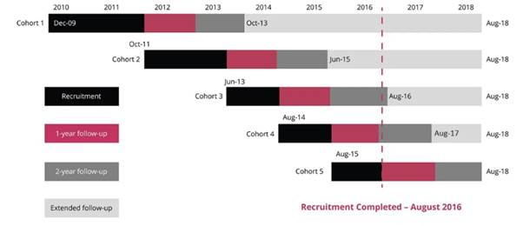

Figure 2. Timeline: trends in antithrombotic therapeutic strategies adopted at baseline in GARFIELD-AF sequential cohorts 1–5 recruited during 2010–16.
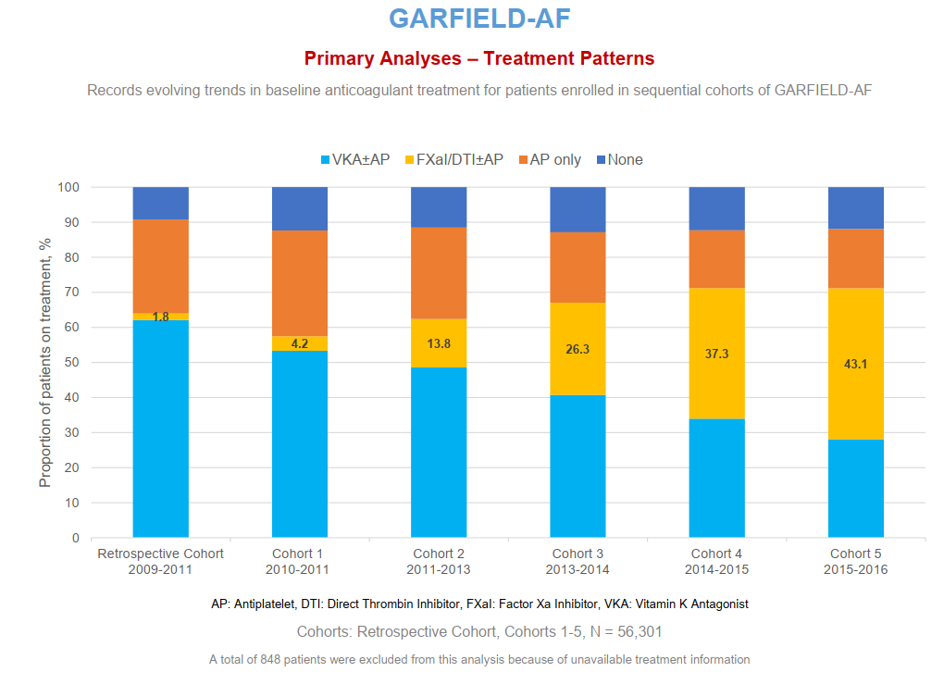

Figure 3. Predictors of selecting NOAC vs. VKA: relations between patient characteristics and choice of treatment. Patients with paroxysmal vs. other-type AF, older individuals, and those with history of ACS were significantly more likely to receive NOACs than VKA therapy. On the other hand, patients with comorbid complications were more likely to receive VKA.

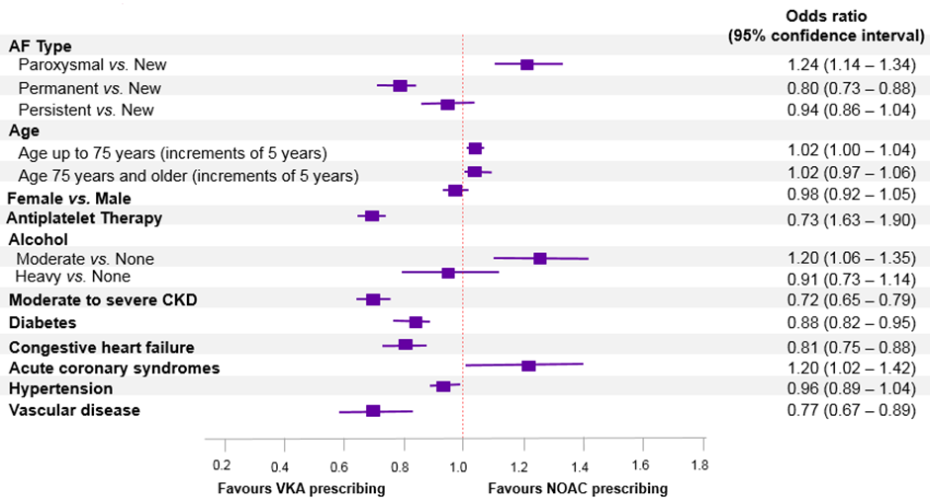

Figure 4 - Predictors of death (A), stroke/SE (B), and major bleeding (C) in GARFIELD-AF cohorts 1–3.
A
B.
C

Figure 5. Mortality rate (per 100 person-years) according to cause of death assessed at different intervals during follow-up. GARFIELD-AF cohorts 1–5.
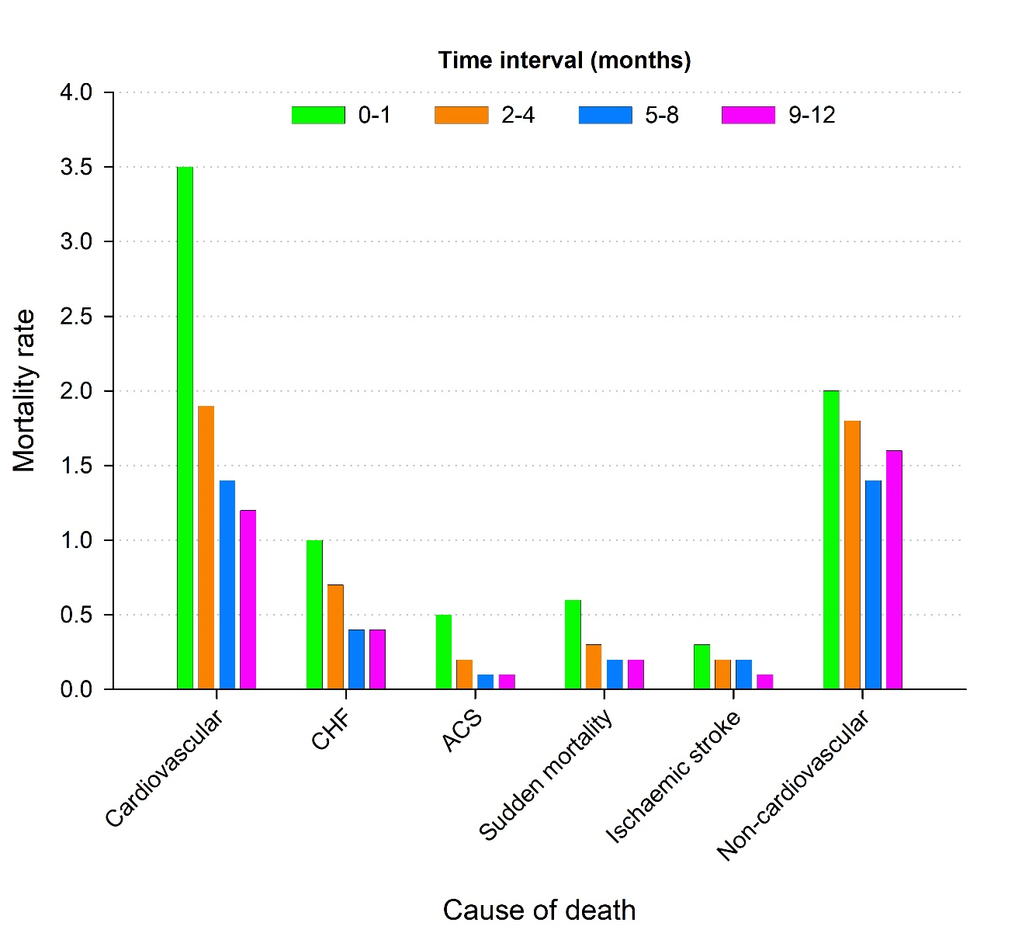

Figure 6. Anticoagulation (OAC) strategies in AF patients (n = 11,738) with ischemic or nonischemic cardiomyopathy (ICM or NICM) or no heart failure (HF) followed over 1 year. Patients with ICM were less likely to receive OAC and more likely to receive AP alone than those with NICM HF.
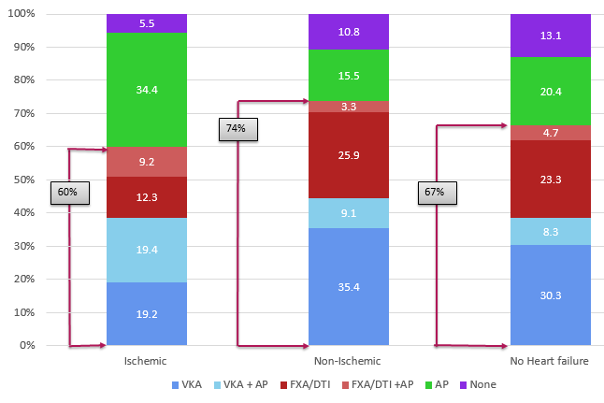

Figure 7. The GARFIELD-AF online risk tool. After entering a patient's clinical variables on the simple user interface (above), the tool displays his or her risk of treatment choice-related adverse outcome events over time calculated up to 2 years (below).
