A case for reduced frequency of CD4 count monitoring for children on combination antiretroviral therapy with consistently undetectable HIV viral load

Shortened title: Reduced CD4 monitoring in children with undetectable VL
SM Johnson¹, J Standing², N Klein^{1,2}, A Irwin³, D Shingadia¹, D Lonsdale⁴, K Gilmour¹ J Flynn¹ C Manns¹ M Clapson¹ and A Bamford^{1,2}
¹Paediatric Infectious Diseases & Immunology, Great Ormond Street Hospital for Children NHS Foundation Trust, London, UK
²Infection, Immunology, Inflammation & Physiological Medicine, Institute of Child Health, London, UK
³University of Queensland Centre for Clinical Research, Queensland, Australia
⁴Institute of Infection and Immunity, St George’s University and St George’s Hospital, London, UK

Correspondence address: Dr Alasdair Bamford, Department of Paediatric Infectious Diseases, Great Ormond Street Hospital for Children, Great Ormond Street, London, WC1N 3JH. Tel: 02078138594. Fax: 02078138552. Email: alasdair.bamford@gosh.nhs.uk

Key words: HIV, CD4 count, paediatric, viral suppression

Dear Editor

PENTA guidelines currently recommend monitoring CD4 T cell counts every 3-4 months in all children and young people with HIV [1]. The clinical utility of monitoring CD4 this frequently in the context of fully suppressed HIV viral load (VL) has been questioned [2-4]. When available, VL is the most useful correlate of adherence and/or combination antiretroviral therapy failure (CART). Two published paediatric studies in South Africa and Asia suggest there is a low risk of CD4 decline in virally suppressed children [2,3]. Whilst transient drops in CD4 count do occur in virally suppressed patients, they rarely contribute to clinical decision making [4,5].

Great Ormond Street Hospital in London, UK has one of the largest cohorts of HIV positive children and young people in the U.K. We were therefore well placed to assess the safety of reduced CD4 count monitoring in children with fully suppressed VL. To that end, we carried out a retrospective analysis of this single-centre cohort using electronic notes and results of all current HIV patients in 2017. Patients were included if they had any period of >12 months of sustained undetectable HIV VL (<50copies/ml). Periods of viral rebound (VL>50 copies/ml) were not included. The primary outcomes were persistent CD4 decline below the PENTA-defined cut-off for urgent CART (<3 years <1000 cells/mcl, 3-5 years <750 cells/mcl, >5 years <350 cells/mcl). Secondary endpoints included: transient falls in CD4 counts and cotrimoxazole prescriptions.

Fifty six out of 75 patients were included (53% male). The majority (96%) had perinatally acquired HIV. The median age was 9 years and 2 months. A total of 1377 paired measurements were obtained (equating to 402 patient years). No patients had progressive CD4 decline or required cotrimoxazole during periods of viral suppression. Cox proportional hazards regression (R software) showed initial baseline CD4 Z-score to be predictive of a low CD4 count (p<0.001). After excluding the first 12 months of data this effect disappeared, therefore indicating that CD4 counts recovered, then remained stable after the first twelve months of viral suppression. After this period of count recovery, only 4% of 1125 paired measurements showed a transient CD4 drop- 100% of which showed spontaneous recovery (Fig. 1). During full VL suppression on CART, no clinically significant fall in CD4 count occurred. Neither opportunistic infections or disease progression were observed.

Our results indicate that it is safe to reduce the frequency of CD4 count monitoring while on suppressive CART, after a 12 month period of CD4 count recovery, to once per year (and during times of detectable viraemia).

We suggest that the future PENTA guidelines take this data into account and recommend less frequent CD4 monitoring in virally suppressed children and young people.

References
1. Bamford A, Turkova A, Lyall H, Foster C, Klein N, Bastiaans D et al. Paediatric European Network for Treatment of AIDS (PENTA) guidelines for treatment of paediatric HIV-1 infection 2015: optimizing health in preparation for adult life. HIV Med 2015; 19(1): e1-e42.

2. Davies M, Ford N, Rabie H, Fatti G, Stinson K, Giddy J et al. Reducing CD4 Monitoring in Children on Antiretroviral Therapy With Virologic Suppression. Pediatr Infect Dis J 2015; 34(12): 1361-1364.

3. Kosalaraksa P, Boettiger D, Bunupuradah T, Hansudewechakul R, Saramony S, Do V et al. Low Risk of CD4 Decline After Immune Recovery in Human Immunodeficiency Virus-Infected Children With Viral Suppression. J Pediatric Infect Dis Soc 2017; 6: 173-177.

4 Ford N, Stinson K, Gale H, Mills E, Stevens W, González M et al. CD4 changes among virologically suppressed patients on antiretroviral therapy: a systematic review and meta-analysis. J Int AIDS Soc 2015; 18(1): 20061.

5 Chow E, Read T, Chen M, Fehler G, Bradshaw C, Fairley C. Routine CD4 cell count monitoring seldom contributes to clinical decision-making on antiretroviral therapy in virologically suppressed HIV-infected patients. HIV Med 2014; 16(3): 196-200.

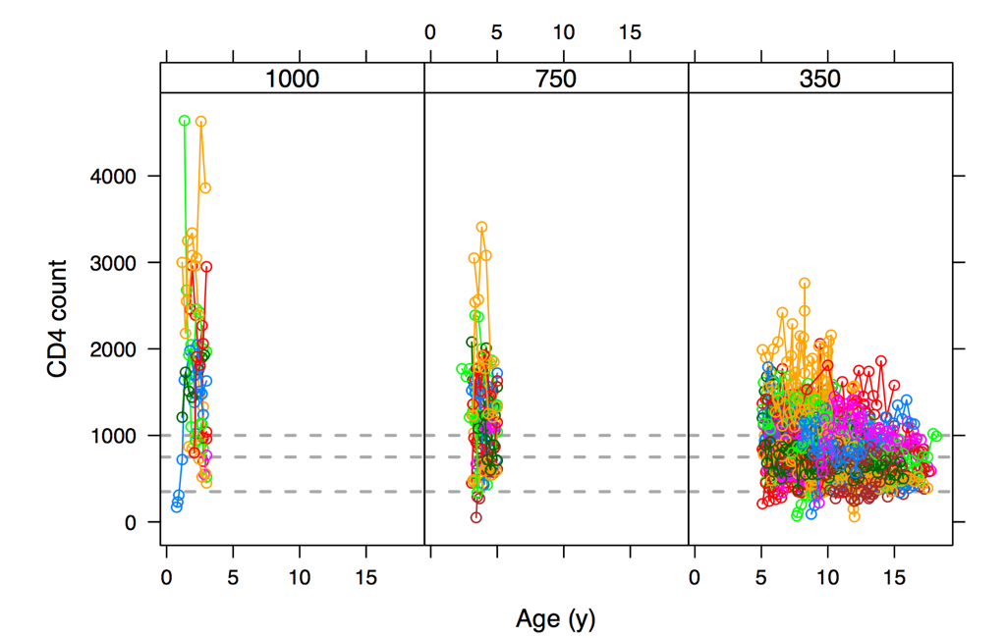

Fig.1. Summary of all CD4 counts over time. Each patient is indicated by a coloured line, with grey horizontal lines indicating the three age-dependent study defined cut-offs for low CD4. Period of ‘CD4 count recovery’ illustrated by upward trend of individual patients.

