Interventional Radiology and Stroke Thrombectomy in Europe: An Online Survey by the Cardiovascular and Interventional Radiological Society in Europe

Morgan RA, Brountzos E, Binkert C, Pereira P, Waigl D, Slijepcevic B, Gangi A.

Letter to the editor”: word limit 800, max. images 3, max. references: 5

Dear Sir,

A growing body of clinical evidence underlines the potential of stroke thrombectomy (ST) to significantly improve the recovery of stroke patients, when performed swiftly by skilled clinicians. Interventional radiologists (IRs) offer a unique skillset and knowledge in endovascular interventions to quickly learn new treatment techniques such as ST, and would be perfectly placed to meet the increasing demand for ST. Interventional radiology has thus the potential to become a valuable part of local stroke management systems across Europe.

Current challenges for IRs becoming key players in European stroke management were identified by the leadership of the Cardiovascular and Interventional Radiological Society of Europe (CIRSE). These include the absence of an established training structure for interventional radiologists performing ST, a strong dependence on local conditions, limited 24/7 coverage as well as varying opinions on the desired involvement of IR in ST. To assess the level of interest and involvement by IRs in ST across Europe, CIRSE conducted a survey on the current situation of stroke thrombectomy practice among European interventional radiologists.

An anonymous online survey was made available to all European CIRSE members to assess their current involvement in stroke therapies, the situation at their hospital including training in ST, and cooperation with other specialities as well as expectations for the future development of stroke thrombectomy.

A total of 601 valid responses were collated, which represents a very high response rate (11.5%) for a CIRSE member survey. The sample was considered to be representative of CIRSE’s European membership in terms of geographical spread, centre type and level of experience of the submitting IRs (Figure 1).

The survey confirmed that there is a very high interest in the topic among interventional radiologists. Stroke thrombectomy was performed in 74.5% of the respondent’s centres, with an expected predominance in university hospitals, tertiary care hospitals and private hospitals, although ST was also performed in 52.5% of general hospitals. There was also an increasing tendency for ST to be performed with increasing size of hospitals.

In centres where ST is performed, this was most frequently delivered by IRs in 70.1% and by neuroradiologists (NR) in 48%. ST was provided by both IRs and NRs in 21% of centres (Figure 2 and Figure 3). In a few centres, ST was also delivered by other specialties such as neurologists or neurosurgeons. Collaboration with other specialties appeared to be good throughout the obtained sample, as IRs perform stroke thrombectomies in collaboration with other medical specialties in almost 90% of centres.

In terms of geographic spread there was a predominance of IRs performing ST in
some countries, and this was particularly marked in Poland, Romania, Slovakia, Finland, the Netherlands, Belgium, Serbia and Austria. Interventional Radiologists were also prominent in ST in Turkey, Czech Republic, Norway and Hungary. Interventional radiologists are less involved in ST in Ireland, Denmark France and the UK.
There was a broad consensus among the respondents that a significant growth in the demand for stroke thrombectomy was expected due to factors such as improved infrastructure and service availability, increased awareness of this treatment option among referrers, better clinical evidence and broader inclusion criteria.

Training for ST by IRs was either provided by a NR at the same centre (47.7%) or was obtained by IRs independently (46.2%). However, opportunities for training in ST are relatively limited for IRs especially where there was reluctance by NRs to involve IRs in the stroke thrombectomy service and almost a quarter of respondents who perform stroke thrombectomies indicated that they were “trained in another way”, indicating a large variety in training modes and options and reconfirming the need for more standardised training pathways and dedicated courses for IR. This finding, together with the stated interest of the overwhelming majority of IRs who have not yet received ST training to do so, seems to mandate further European-wide initiatives in this field.

Finally, a vast majority of respondents expected a growth in procedure numbers in the future, regardless of whether they perform the procedure themselves or not.

In summary, the CIRSE survey on Stroke Thrombectomy confirmed a strong interest in this topic among the European CIRSE membership. The high response rate and representative sample further strengthen this observation. The survey further confirmed the high and growing involvement of IRs in the delivery of ST; with 88.9% of IRs who work in centres that offer this therapy being actively involved in the delivery of the service. The survey highlighted challenges in delivering training in ST for IRs, which emphasises the need for improved ease of access for IRs to train in stroke thrombectomy.

References:

- Van Overhagen H, van Zwam WH, Krajina A, Fiehler J, Reekers JA, Cekirge S, Thornton J, Binkert C, Brountzos, Gangi A, Morgan RA. CIRSE Position Statement: Interventional Radiologists and Intra-arterial Stroke Therapy. Cardiovasc Intervent Radiol 2018;41:1460-1462.

- Sacks D, van Overhagen H, van Zwam WH, Radvany MG, Marx MV, Morgan RA, Vrazas JI, Goh GS. The Role of Interventional Radiologists in Acute Ischemic Stroke Interventions: A Joint Position Statement from the Society of Interventional Radiology, the Cardiovascular and Interventional Radiology Society of Europe, and the Interventional Radiology Society of Australasia. J Vasc Intervent Radiol 2019;30:131-133.

Figures:

Fig. 1 Number of responses collected per country (n=601)

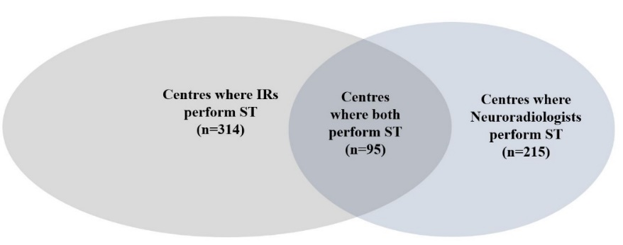
Fig. 2 Centres performing stroke thrombectomy (n = 448)

Fig. 3 Delivery of stroke therapy/thrombectomy services by discipline (n = 566, multiple answers possible)

