Supplementary Material: Cell Senescence and Cerebral Small Vessel Disease in the Brains of Older People, Aged 80+

Emma J Norton BSc¹, Leslie R Bridges MD FRCPath^{1,2}, Lawrence C Kenyon MD PhD³, Margaret M Esiri DM FRCPath^{4,5}, Dorothy C Bennett PhD¹, Atticus H Hainsworth PhD^{1,6}

¹Molecular and Clinical Sciences Research Institute, St George’s, University of London, Cranmer Terrace, London, UK, SW17 0RE. ²Department of Cellular Pathology, St George’s University Hospitals NHS Foundation Trust, Blackshaw Road, London, UK, SW17 0QT. ³Department of Pathology, Anatomy & Cell Biology, Thomas Jefferson University Hospital, 132 S. 10th St. Philadelphia, PA, USA, 19107. ⁴Department of Neuropathology, Oxford-Radcliffe NHS Trust, Oxford, UK. ⁵Department of Clinical Neurology, Oxford University, John Radcliffe Hospital, Oxford, UK. ⁶Department of Neurology, St George’s University Hospitals NHS Foundation Trust, Blackshaw Road, London, UK, SW17 0QT.

Correspondence: Dr Atticus H Hainsworth PhD, Clinical Neurosciences Mailpoint J-0B, St George’s, University of London, Cranmer Terrace, London, SW17 0RE, United Kingdom.
Tel: +44 208 725 5586 Fax: +44 208 725 2950 email: ahainsworth@sgul.ac.uk

Morphometric Protocol: percentage of SAHF-positive nuclei nuclear inclusion criteria
To calculate the percentage of SAHF-positive nuclei, nuclear counts were conducted for the nuclei visible within the vessel wall visible after staining with anti-H3K9me3. From this, a percentage of SAHF-positive to total observed nuclei was calculated for each vessel.
Criteria for “SAHF-positive”: confident identification of punctate dots or “stipples” across the whole nucleus. This is based on the documented appearance of SAHFs: 30-50 distinct, dense foci distinguishable from chromatin in non-senescent cells.
Criteria for non-senescent: distinct stipples not seen within the nucleus; uniform dark staining across the whole nucleus or staining exclusively around the nuclear membrane.
Criteria for exclusion: nuclei of endothelial cells (judged by shape and position within the vessel wall, Figure S1), those obviously within the lumen of the vessel or outside the vessel wall.
Figure S1 Immunohistochemistry of Endothelial Cells in Cerebral Small Arteries
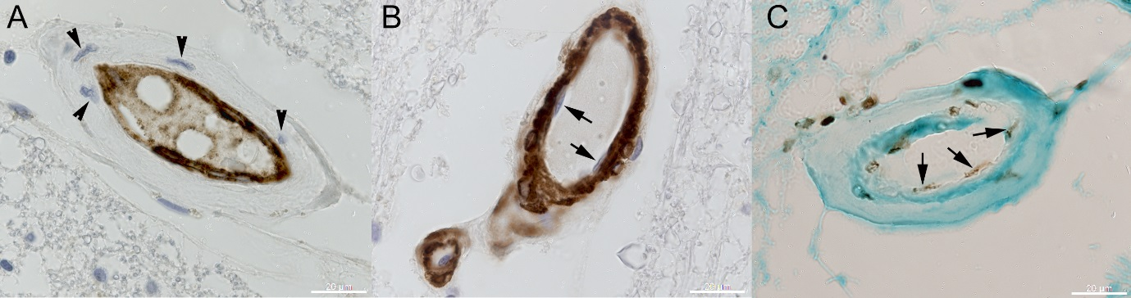
Example of immunolabelling of small arteries in neighbouring sections with an endothelial-specific marker (CD34, panel A) or a myocyte-specific marker (SMA, panel B) or the senescence marker H3K9me3 (panel C). Immunolabelling is visualised by DAB chromogen (brown in A, B, black in C). Panels A and B are counterstained with the chromatin stain hematoxylin, while C is counterstained with the cytoplasmic stain Light Green. In panel A, endothelia lining the vessel lumen are clearly immunolabelled while myocytes (arrowheads) are negative. In B, endothelial cells (arrows) are negative. In C, examples of nuclei assumed to be endothelia are marked (arrows). Scale bars 20 µm.

Morphometric Protocol: calculation of the area fraction of SAHF-positive nuclei (AF%)
The area fraction of SAHF-positive nuclei within the vessel wall (AF%) was calculated using the software ImageJ (available in the public domain). First, a colour deconvolution macro (Methyl Green DAB) was used to separate the green, brown and red components of the photograph into three separate images (Figure S2A-D). Using the brown image, a threshold (Maximum Entropy) was applied to select only the nuclei (figure S2E). The freeform tool allowed the outer circumference of the vessel to be traced (figure S2F). Within this, of the areas selected by the threshold, areas between 1-500 square pixels were analysed and a percentage area taken (figure S2G). The size restriction excluded uniformly dark, non-senescent appearing nuclei. This allowed the calculated value to represent the area fraction of the vessel wall containing SAHF-positive, stippled nuclei. The computer-generated results were evaluated to assess for outliers, for example caused by histology or image artefact.
Figure S2 Schematic of methodology used to calculate the SAHF-positive area fraction.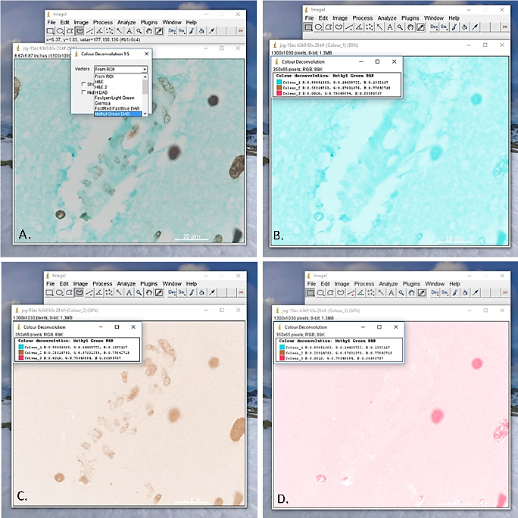
(A) Photograph imported into ImageJ (from a non-cSVD case, 84-year-old male). (B) Colour 1 image (green), created using colour deconvolution macro. (C) Colour 2 image (brown), created using colour deconvolution macro - used in subsequent analysis. (D) Colour 3 image (red), created using colour deconvolution macro.

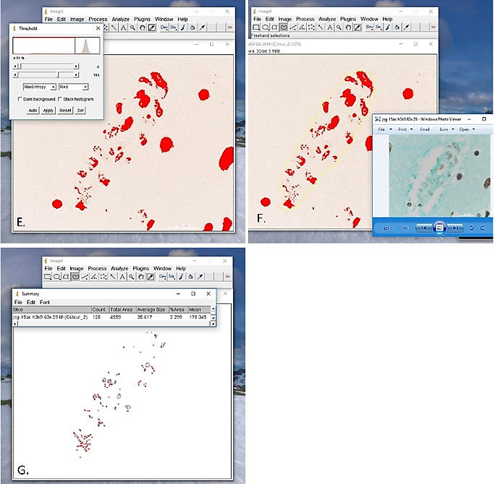
Figure S2 continued. (E) Photograph after application of Maximum Entropy threshold to select nuclei. (F) Photograph showing freeform outline (yellow line) of the outer circumference of the vessel. (G) Photograph showing areas analysed to create the area fraction of SAHF-positive nuclei (large, homogenously stained nuclei shown to be excluded).

