S1 – Flow chart
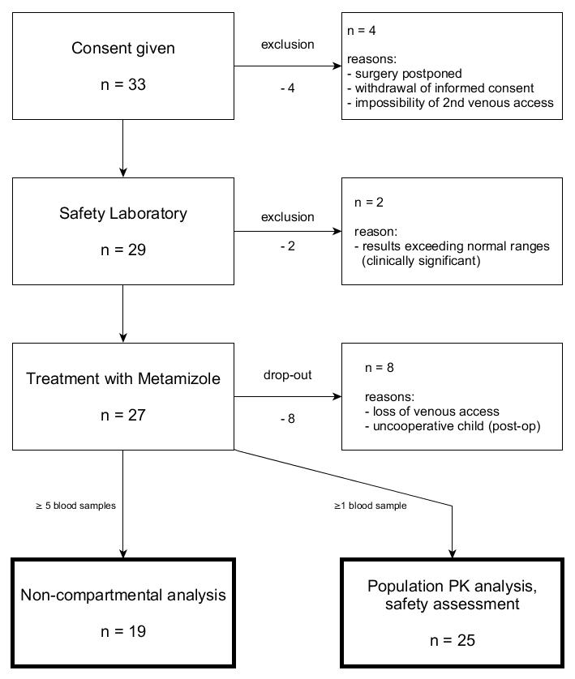
Figure S1: Recruitment flow chart.

S2 Sample preparation and laboratory analysis
Immediately after collection, samples were centrifuged at 1’500 g for 10 min at 4°C and plasma was stored frozen at -80°C until analysis.
The samples were analyzed as described before with some adaptions (Bachmann et al., 2019). In brief, MAA, AA, FAA, and AAA were analysed on a Shimadzu HPLC (Kyoto, Japan) which was connected to a triple quadrupole mass spectrometer (API 4000 Qtrap, AB Sciex, Ontario, Canada). All analytes were quantified by multiple reaction monitoring in the positive mode using electro spray ionization.
Chromatographic separation was conducted on a luna pentafluorophenyl column (50 mm x 2 mm, Phenomenex, Torrance, CA, USA) at a flow rate of 0.7 mL/min and a temperature of 43°C. Mobile phase were water (A) and methanol (B) both supplemented with 0.1% formic acid. The following gradient program was applied: 0-0.5 min, 5% B; 0.5-1.8 min, 5-40% B; 1.9-2.2 min, 40-95% B; 2.2-3.0 min, 95% B; 3.0-3.5 min, 5% B. The injected sample (2 µL) was mixed with mobile phase A during the first 0.5 min of each run using a third pump (pump C). Therefore, a T-union was installed ahead of the analytical column. Thereby, the total flow of pump A and B was increased linearly from 0.1 to 0.7 mL/min, while the pump C flow was reduced simultaneously from 0.6 to 0 mL/min. Analyst software 1.6.2 (AB Sciex) was used to operate the instruments and to analyze the data.
Study samples were kept at -80°C. On the day of the analysis, samples were thawed at room temperature. 20 µL of plasma was precipitated with 400 µL methanol containing the internal standards (4-MAA-d3: 20 ng/mL, 4-AA-d3: 30 ng/mL, 4-AAA-d3: 60 ng/mL). Samples were vortex-mixed for 1 minute and centrifuged at 3220g for 30 minutes at 10 °C. The supernatant was injected into the LC-MS/MS system. Samples above the upper limit of quantification were diluted with blank plasma and reanalyzed. Overall, the inter-day accuracy was between 90.6% to 109.5%, while maximal inter-day imprecision was ≤11.6%

S3 – Safety Laboratory
Table S3: Safety laboratory of the patients who had ≥5 samples at baseline (T0) and 6 hours after metamizole administration (T6) (compared by Mann Whitney test).
Parameter | unit | n | Median | [IQR] | n | Median | [IQR] | p
Hematology |  | T0 |  |  | T6
Erythrocytes | 10E¹²/l | 19 | 4.34 | (4.2; 4.6) | 18 | 4.08 | (4; 4.4) | 0.033
Hemoglobin | g/l | 19 | 117 | (115.5; 121.5) | 18 | 110 | (108.2; 115) | 0.022
Thrombocytes | 10E⁹/l | 19 | 353 | (317; 382) | 18 | 299 | (247.8; 361.8) | 0.078
Leucocytes | 10E⁹/l | 19 | 8.08 | (7.6; 10.2) | 18 | 14.04 | (10.9; 15.4) | <0.001
Neutrophils | 10E⁹/l | 19 | 3.06 | (2.6; 4) | 18 | 10.72 | (7.1; 11.8) | <0.001
Biochemistry |  | T0 |  |  | T6
Urea | mmol/l | 19 | 4.5 | (3.4; 5.3) | 18 | 3.9 | (3.2; 4.4) | 0.125
Creatinine | µmol/l | 19 | 31 | (23; 34) | 18 | 27.5 | (25; 31) | 0.401
eGFR Schwartz | ml/min | 9 | 44.62 | (36.6; 63.9) | 9 | 62.33 | (46; 70.1) | 0.31
eGFR FAS | ml/min | 18 | 49.89 | (41.5; 66.5) | 17 | 63.76 | (45.5; 74.1) | 0.228
ALAT | U/l | 19 | 17 | (11; 20) | 18 | 16.5 | (13; 21.8) | 0.761
ASAT | U/l | 19 | 33 | (29.5; 34) | 18 | 36.5 | (33; 40) | 0.017
Total bilirubin | µmol/l | 19 | 4 | (3; 4.5) | 18 | 4 | (3; 5) | 0.545
Total albumine | g/l | 19 | 34 | (31.5; 36) | 18 | 33 | (32; 34.8) | 0.305
Abbreviations: IQR interquartile range; GFR Glomerular filtration rate;

S4 – Population pharmacokinetic model evaluation

A: Sensitivity analyses
Methods: The following sensitivity analyses were performed: applying two- versus one-compartmental distribution models for MAA or all metabolites, treating concentrations below LLOQ as censored variables (LAPLACE estimation method) versus fixing concentrations below LLOQ to LLOQ/2, inclusion of MAA concentration data considered as not physiological in the initial analysis (defined as MAA concentrations increasing >50% from its previous value), and use of varying k_{H} All analyses were performed using subroutine ADVAN6 (differential equation solver), and first-order conditional estimation method with interaction unless otherwise stated.
Results: Using two-compartmental distribution kinetics for MAA or more metabolites improved the general model fit (lower AIC, lower residual error for AA, AAA and FAA), but lead to increased bias in residual diagnostics for the main metabolite MAA and larger residual error. CL_{MAArest} was not identifiable in the two-compartment model, but total MAA clearance did not significantly differ (<8%) from one-compartmental analysis, hence the simpler one-compartment distribution model was considered for the final analysis.
Treating concentrations below LLOQ as censored variables (LAPLACE estimation method with interaction), reduced the residual error for MAA to approximately half, but did not impact total MAA clearance (<3% difference), while increasing model instability and estimation time. Use of a mixed error model also approximately halved the residual proportional error, and was therefore used in the final analysis.
Inclusion of MAA concentration data considered as unphysiological in the initial analysis, largely increased BSV (from ≈50% to 90%) and uncertainty (RSE increase from ≈15% to 37%) in CL_{MAAother,} and increased the residual error of MAA by 20%. Total MAA clearance did not however significantly change (<4% difference).
The hydrolysis of metamizole could not be estimated (estimate → infinity), using slower kH than 20/h worsened the model fit, hence the fixed value of 20/h was also used for the final analysis.
Summary: Sensitivity analyses did not alter MAA clearance estimates or improve the MAA kinetic description.

B: Supplemental figures
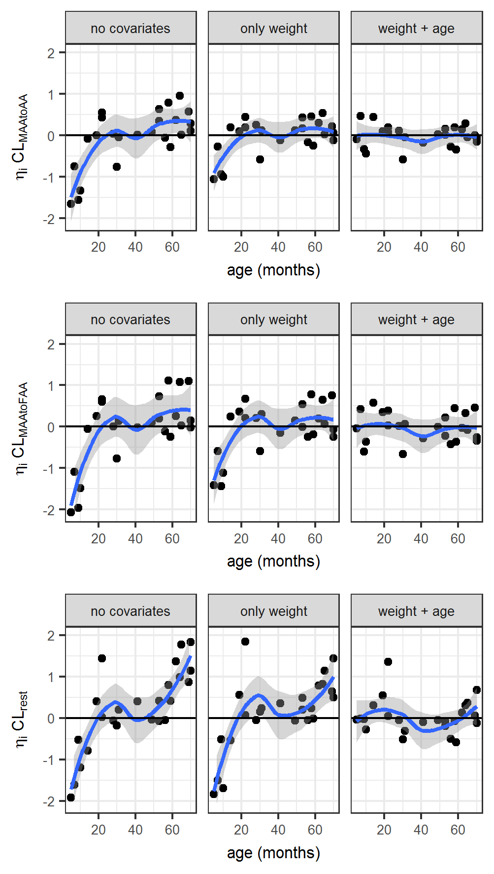
Figure S4.1: Bias in distribution of individual random effects (ηi) related to MAA clearance (CL) over age, with and without inclusion of age and weight as covariates (shrinkage: < 10-20%).
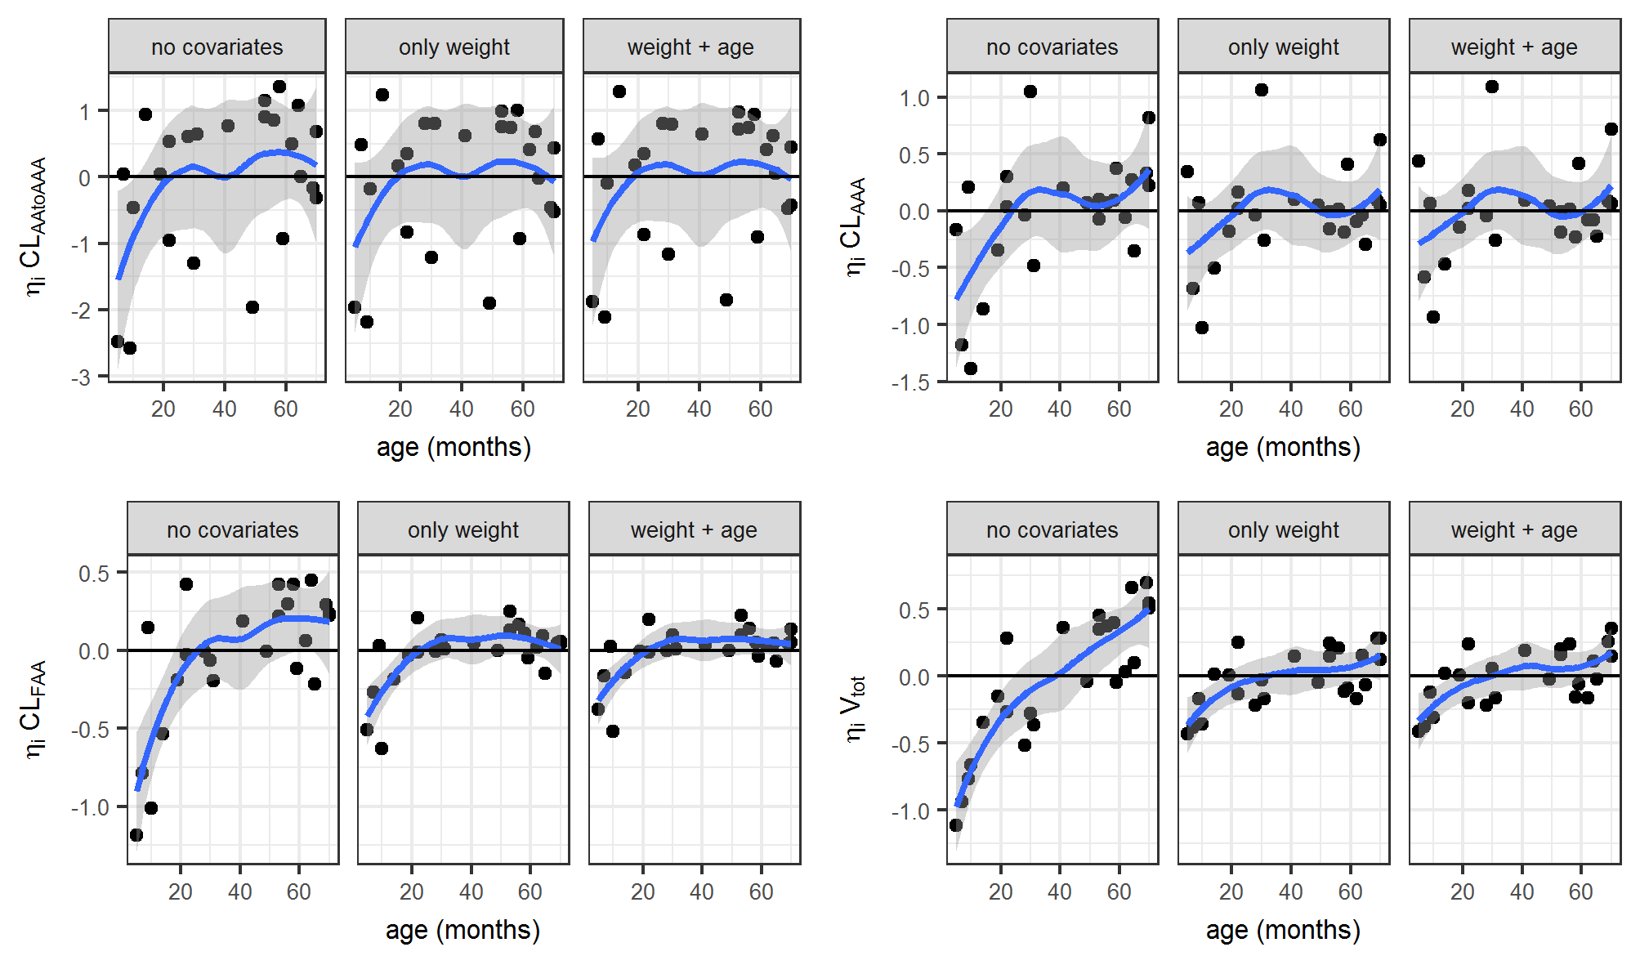
Figure S4.2: Distribution of individual random effects related to the other metabolite’s clearance (CL) and volume of distribution (V_{tot}) over age, with and without inclusion of age and weight as covariates on MAA clearance (shrinkage: <10-30%).

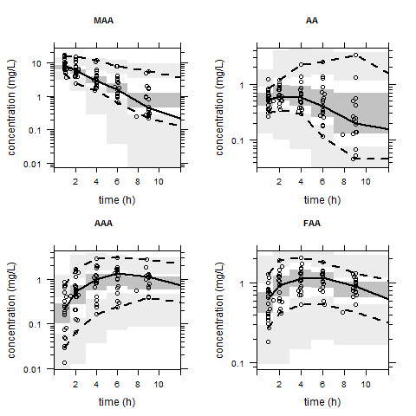
Figure S4.3: Visual predictive check. Model evaluation: comparison of observed and model-based predicted percentiles (semi-logarithmic scale). Black dots: observed concentrations. solid line: empirical median, dashed lines: empirical 2.5th and 97.5th percentiles (limiting the 95% prediction interval).

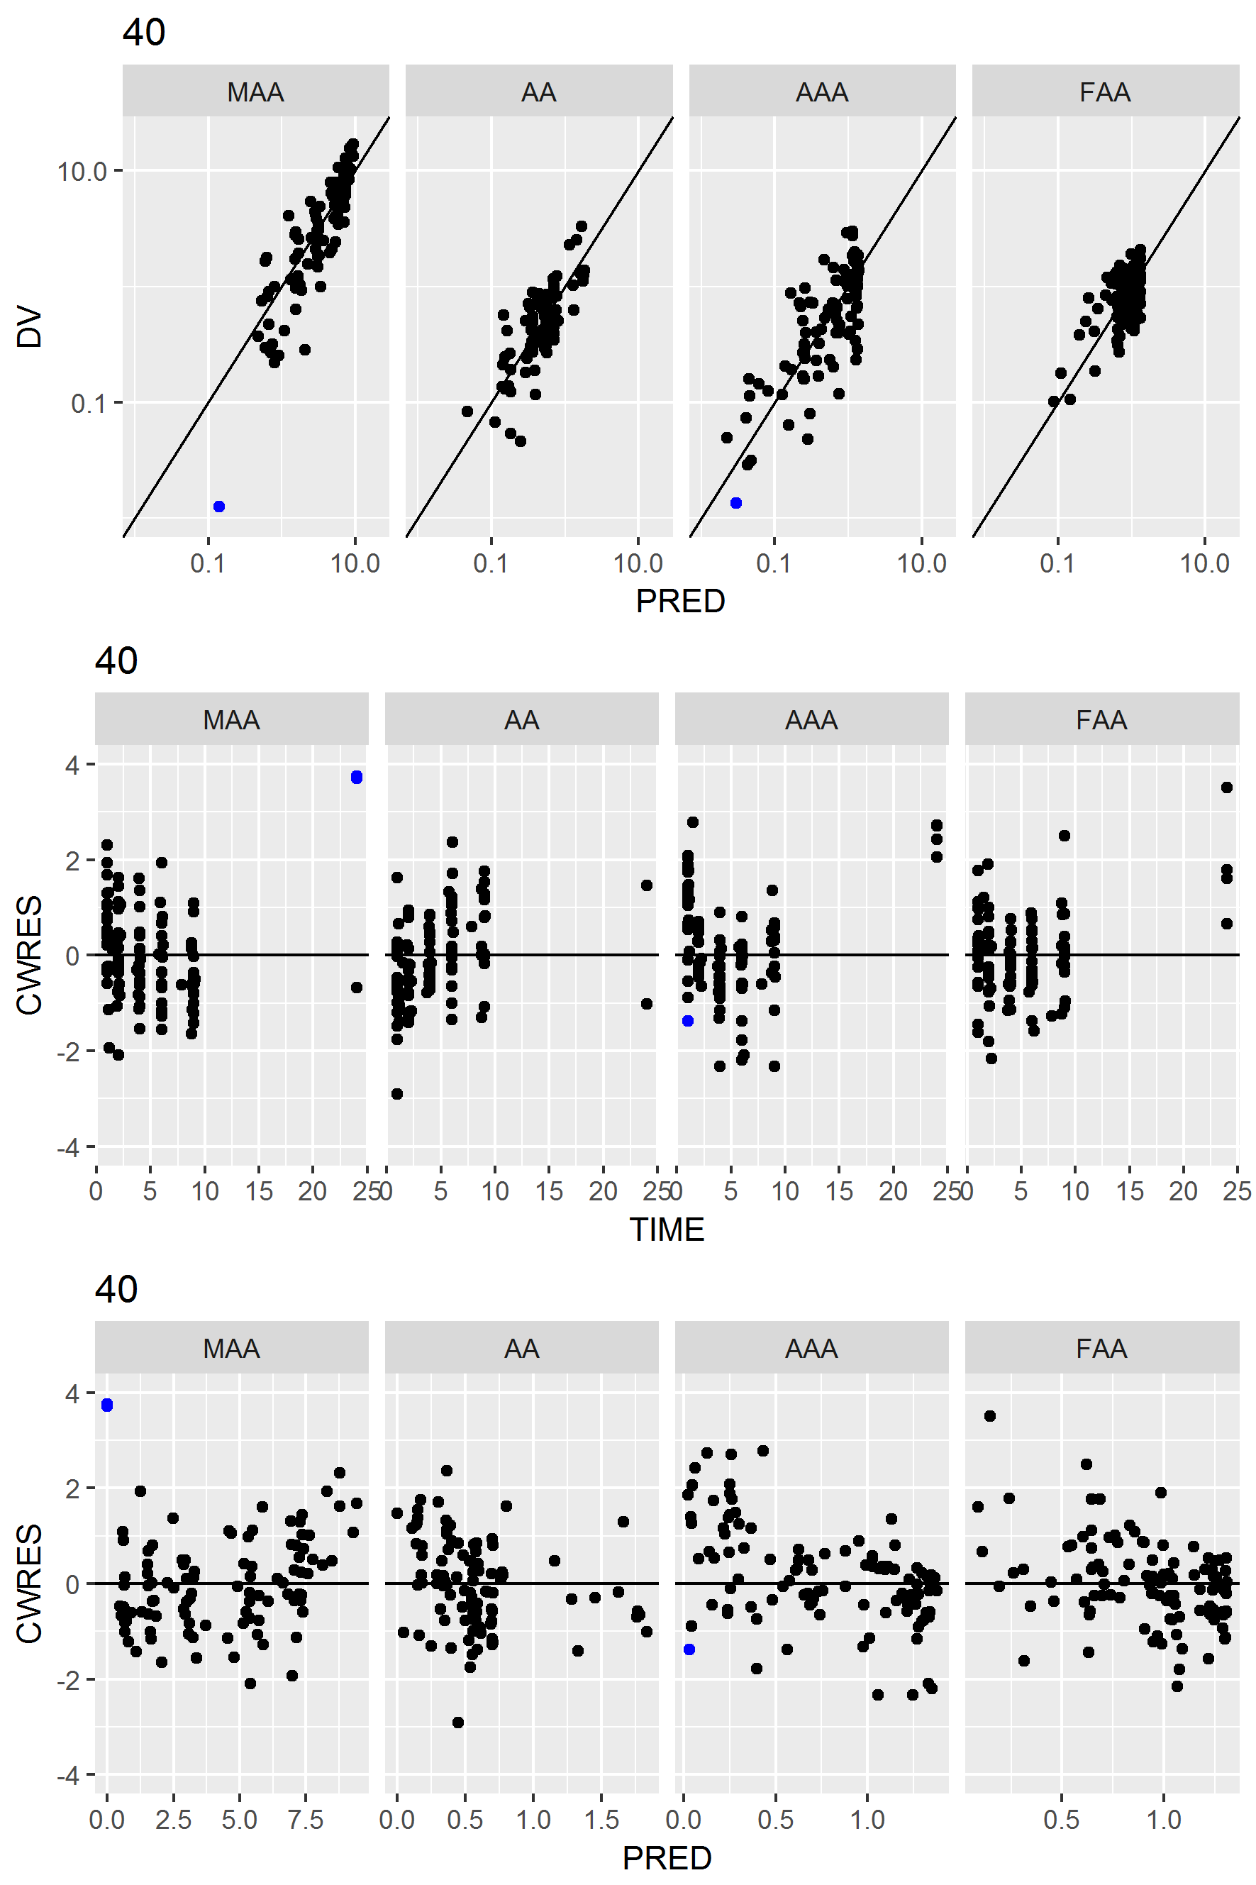
Figure S4.4: Goodness-of fit plots. Observed versus population predicted concentrations (DV vs PRED) and residual plots (conditional weighted residuals, CWRES) over time (TIME) and population predictions (PRED). Blue dots: concentrations below lower limit of quantification.

S5 – Dose evaluation
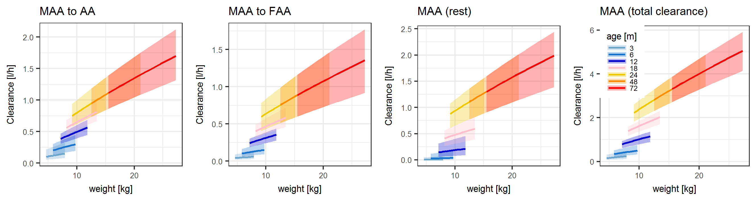
Figure S5.1: Illustration of model-predicted typical clearance for patients of different age and weight with 95% confidence intervals (shaded areas). Weight for age bands was simulated according to WHO percentiles curves.

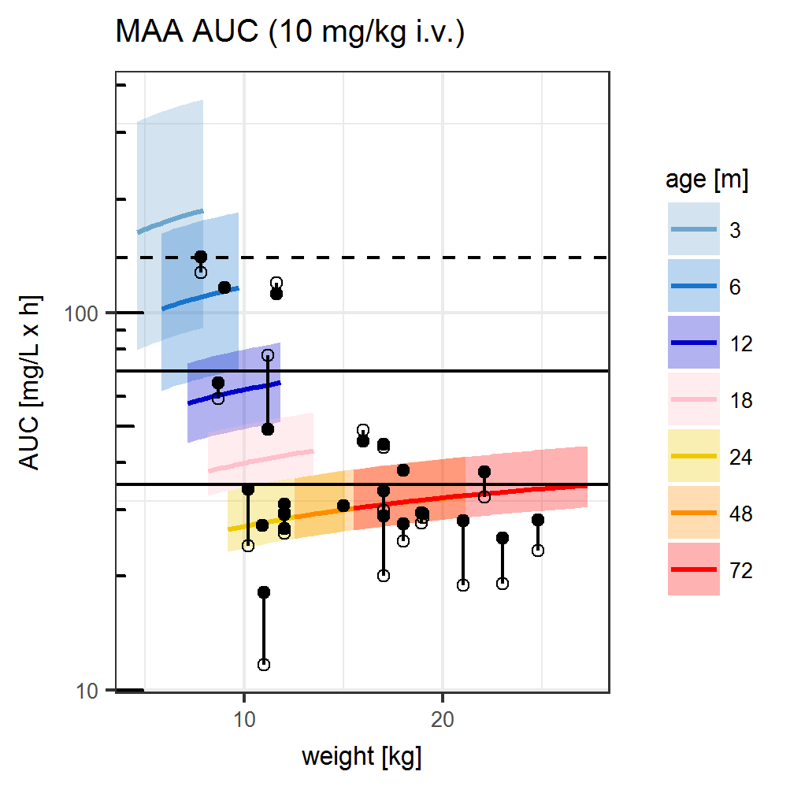
Figure S5.2: Comparison of model-based AUC predictions (typical value with 95%CI) with individual AUC estimates from model-based (black dots) and non-compartmental analysis (open circles). Weight for age bands were simulated according to WHO percentiles curves. Black horizontal lines: reference AUC in healthy volunteers receiving a dose of 500 mg or 1000 mg metamizole (AUC₅₀₀, AUC₁₀₀₀). Dashed horizontal line: 2-fold increase in AUC₁₀₀₀).

