Table 1. Percentage composition of N-glycan populations on the heavy chains of different VRC01 glycovariants. Structures and abbreviations of N-glycans which constitute less than 5% of the total population have been shaded). Unglyc. – unglycosylated heavy chain. Abbreviations according to the ProGlycAn nomenclature (http://www.proglycan.com/protein-glycosylation-analysis/nomenclature).
VRC01 HEK |  |  | VRC01 WT |  |  | VRC01 ∆XF |  |  | VRC01 Gal
GnGnF⁶ | 70.5% |  | GnGnXF³ | 54.1% |  | GnGn | 74.6% |  | unglyc. | 29.4%
GnAF⁶ | 17.2% |  | unglyc. | 35.9% |  | unglyc. | 21.1% |  | MA + Man4Gn | 28.7%
unglyc. | 3.1% |  | MGnXF³ | 3.7% |  | MGn | 4.3% |  | Man4A + Man5Gn | 10.8%
MGnF⁶ | 2.7% |  | MMXF³ | 2.5% |  |  |  |  | Man5A | 9.9%
GnAF⁶bi | 2.4% |  | Man8 | 1.2% |  |  |  |  | MGn | 9.3%
AAF⁶ | 1.9% |  | Man9 | 1.0% |  |  |  |  | AA | 7.8%
Man5 | 1.2% |  | Man7 | 0.7% |  |  |  |  | GnGn | 3.3%
UGnF⁶ | 0.9% |  | Man5 | 0.7% |  |  |  |  | MM | 0.9%
 |  |  | Man6 | 0.4%

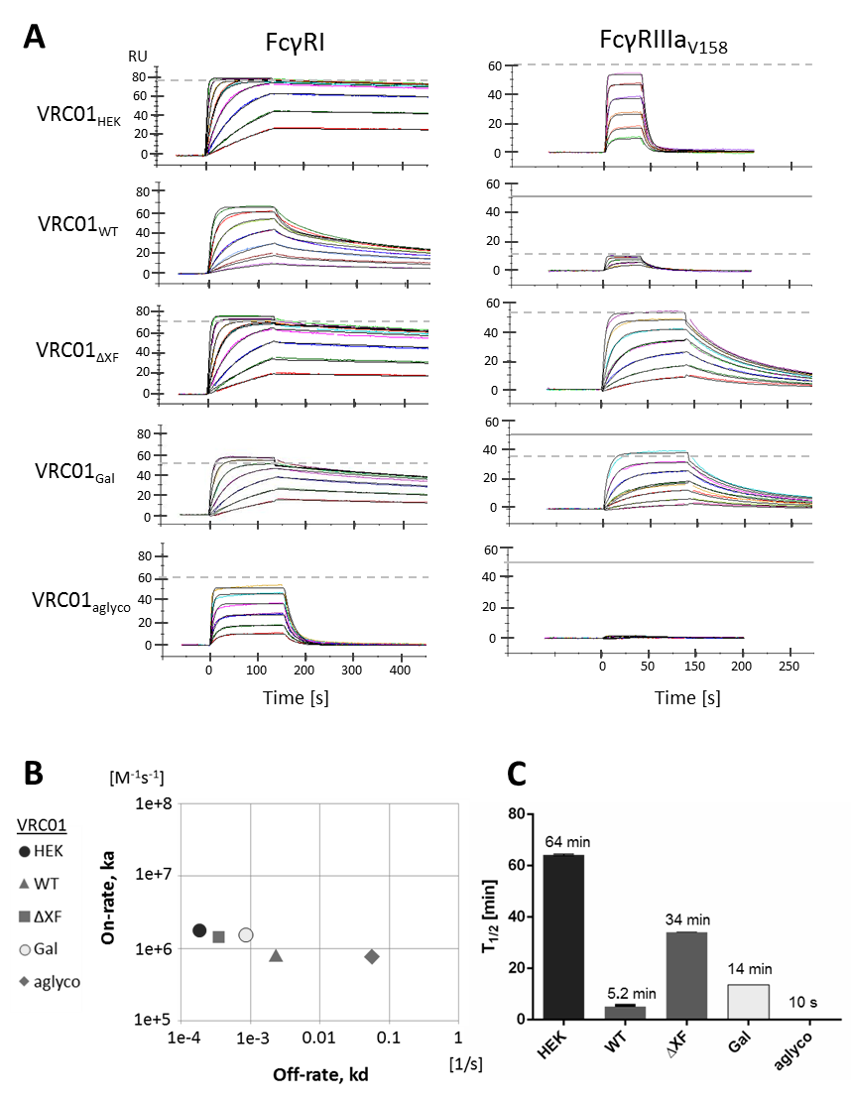
Figure 1. Interaction of VRC01 glycovariants with recombinant human FcγRI and FcγRIIIa. A. SPR sensorgrams illustrate binding and dissociation of antibody-receptor complexes. Data were analysed with a 1:1 binding interaction model for FcγRI (except VRC01_{WT} , see text for details) and a two-state reaction interaction model for FcγRIIIa. Dashed line denotes maximum response upon saturation. Theoretical saturation level is displayed separately as a solid line if it differs or could not be extrapolated from the data. Receptor concentrations used: FcγRI at 2-240 nM (15-480 nM for VRC01_{aglyco}), FcγRIIIa at 125-4000 nM for fucosylated antibodies and 12-800 nM for afucosylated ones. B. Kinetic map for the interaction of antibodies with FcγRI based on association rate (on-rate) and dissociation rate (off-rate) constants. For VRC01_{WT}, the kinetics parameters of the glycosylated portion were used. C. Half-life of the antibody–FcγRI complexes as calculated from the dissociation rate constants.

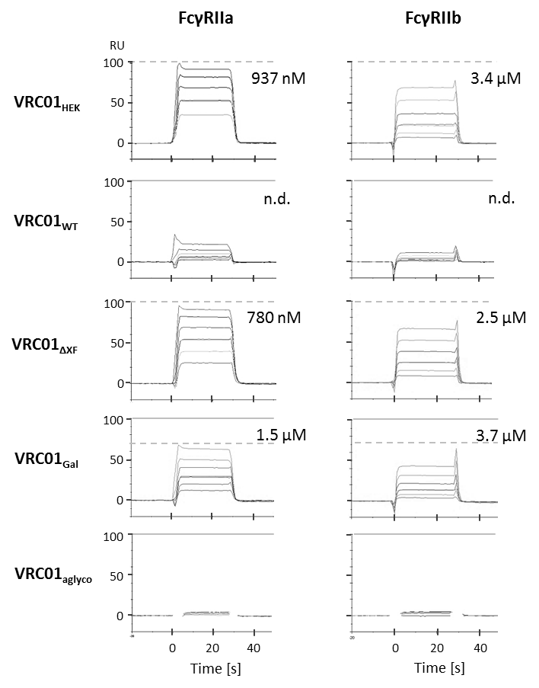
Figure 2. Affinity of VRC01 glycovariants to the human FcγRIIa and FcγRIIb. SPR sensorgrams show binding responses at the injection of different receptor concentrations (0.5-8 μM) over the Protein A-captured antibodies. Dissociation constants are calculated from steady-state responses at a dynamic equilibrium of complex formation. Maximum response at the saturation level is marked with dashed horizontal lines. When the experimentally-measured response at saturation does not overlap with expected response, theoretical saturation levels are indicated with solid horizontal lines.

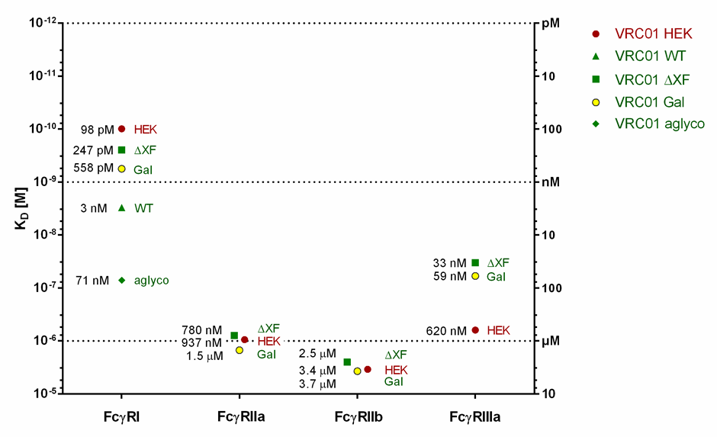

Figure 3. Affinity of VRC01 glycovariants to human FcγRs. The graph summarises the affinity values (K_{D}) for the interaction of different glycovariants with human FcγRI, FcγRIIa, FcγRIIb and FcγRIIIa.

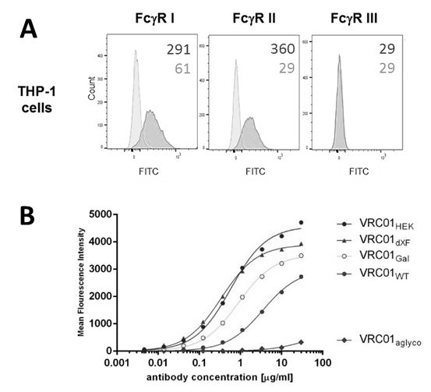
C

Figure 4. Binding of monomeric VRC01 glycovariants to cell surface Fc receptors on THP-1 monocytes. A. Flow cytometric analysis with FITC-conjugated antibodies specific to FcγRI, FcγRII or FcγRIII on the surface of THP-1 cells (red histograms) as compared to the isotype controls (blue histograms). The numbers indicate mean fluorescent intensity (MFI) of the populations. B. Binding of serially-diluted VRC01 antibodies to THP-1 cells was detected with a FITC-labelled F(ab’)2 fragment against human antibodies using flow cytometry. MFI responses were corrected by subtracting background response levels from cells incubated with the FITC-labelled F(ab’)2 fragment only (no VRC01). Nonlinear regression curve fit was applied. The results represent one of two biological repeats. C. FcγRIIIa activation by VRC01_{WT}, VRC01_{ΔXF} and VRC01_{HEK} was demonstrated by luciferase activity of ADCC Bioassay Reporter cells. Antibodies were pre-incubated with HIV-1 UG37 gp140 before effector cells (Jurkat NFAT-luc) were added. Luciferase activity was the average result of 3 independent experimental repeats. Error bars equals ±SD and PBS was used as negative control. * VRC01_{ΔXF} at 10ug/mL was omitted because the readings exceeded the range of the assay.

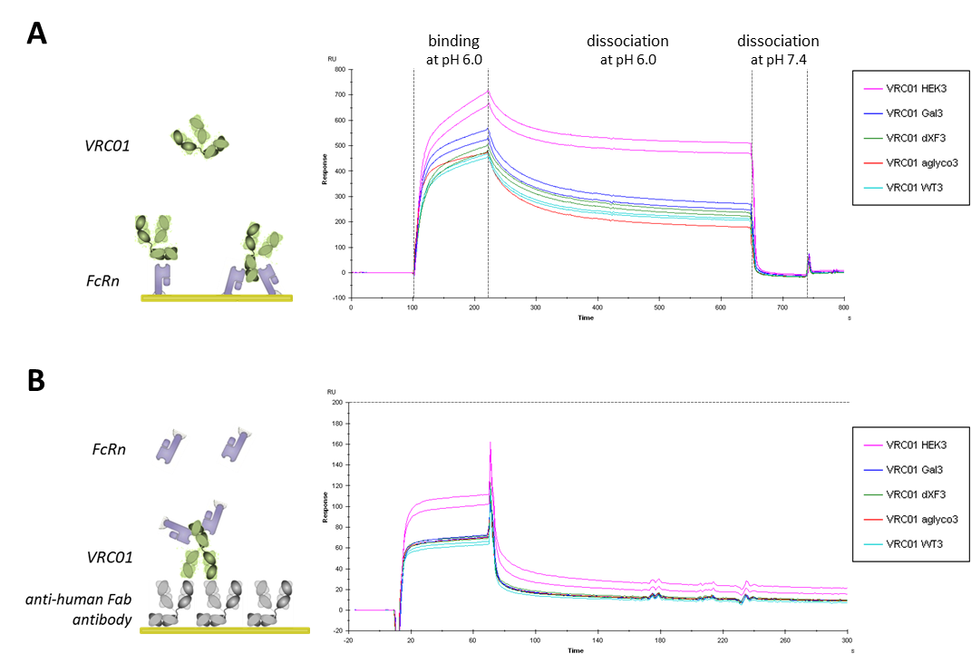

Figure 5. Binding analysis of VRC01 glycovariants to FcRn. A. Human recombinant FcRn ectodomains were covalently immobilised on the CM5 sensor chip surface and different VRC01 glycovariants were injected at 200 nM concentration in duplicates. Binding and dissociation of different antibodies was observed at pH 6.0 and the FcRn surface was regenerated with PBS pH 7.4. B. Each VRC01 glycovariant was captured onto the anti-human Fab surface to the same level and tested for binding to 200 nM FcRn. Sensorgrams represent binding and dissociation at pH 6.0 for two independent repeats. Maximum binding level is marked with a dashed horizontal line.

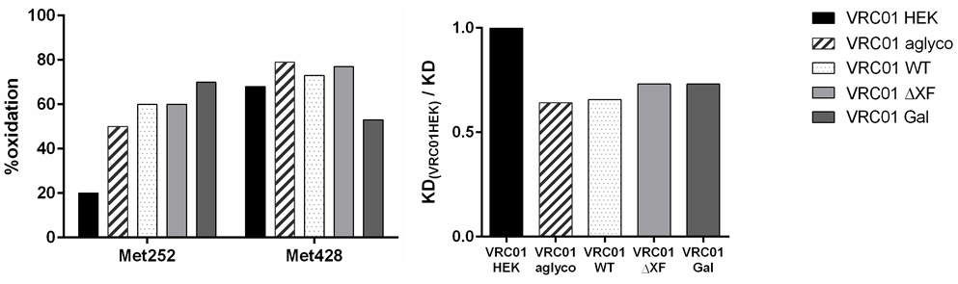

Figure 6. Methionine oxidation of VRC01 glycovariants. A. Percentage oxidation of Met252 and Met428 on antibody heavy chains, as determined by mass spectrometry. All plant-made VRC01 glycovariants were produced at the same time under the same conditions and stored in non-oxidising atmosphere. B. Relative affinity of plant-made VRC01 glycovariants to FcRn compared to VRC01_{HEK}. Values obtained from SPR analysis.

