# Implantable Cardioverter-Defibrillators in Previously Undiagnosed Patients with Catecholaminergic Polymorphic Ventricular Tachycardia Resuscitated from Sudden Cardiac Arrest

Christian van der Werf1, *, †, Krystien V. Lieve1, *, †, J. Martijn Bos2, Conor M. Lane2, Isabelle Denjoy3, †, Ferran Roses-Noguer4, Takeshi Aiba5, Yuko Wada6, Jodie Ingles7, Ida S. Leren8, Boris Rudic9, Peter J. Schwartz10, †, Alice Maltret11, Frederic Sacherl2, Jonathan R. Skinner13, Andrew D. Krahn14, Thomas M. Roston14, 15, Jacob Tfelt-Hansen16, Heikki Swan17, Tomas Robyns18, †, Seiko Ohno6, 19, Jason D. Roberts20, Maarten P. van den Berg21, Janneke A. Kammeraad22, Vincent Probst23, †, Prince J. Kannankeril24, Nico A. Blom25, Elijah R. Behr26, †, Martin Borggrefe9, Kristina H. Haugaa8, Christopher Semsarian7, Minoru Horie6, Wataru Shimizu5, 27, Janice A. Till4, Antoine Leenhardt3, †, Michael J. Ackerman2, ‡ and Arthur A. Wilde1, 28, †, ‡

*Drs Van der Werf and Lieve are co-first authors.

†European Reference Network ‘ERN GUARD-heart’

‡Drs. Ackerman and Wilde are co-senior authors. 1Amsterdam UMC, University of Amsterdam, Heart Centre; Department of Clinical and Experimental Cardiology, Amsterdam Cardiovascular Sciences, Amsterdam, the Netherlands

2Departments of Cardiovascular Medicine (Division of Heart Rhythm Services), Pediatric and Adolescent Medicine (Division of Pediatric Cardiology), and Molecular Pharmacology & Experimental Therapeutics (Windland Smith Rice Sudden Death Genomics Laboratory), Mayo Clinic, Rochester, MN, United States

3Service de Cardiologie et CNMR Maladies Cardiaques Héréditaires Rares, Hôpital Bichat, Paris, France

4Department of Cardiology, Royal Brompton Hospital, London, United Kingdom

5Division of Arrhythmia and Electrophysiology, Department of Cardiovascular Medicine, National Cerebral and Cardiovascular Centre, Suita, Osaka, Japan

6Department of Cardiovascular Medicine, Shiga University of Medical Science, Otsu, Japan

7Agnes Ginges Centre for Molecular Cardiology, Centenary Institute, Sydney, New South Wales, Australia; Sydney Medical School, University of Sydney, Sydney, New South Wales, Australia; Department of Cardiology, Royal Prince Alfred Hospital, Sydney, New South Wales, Australia

8Department of Cardiology, Centre for Cardiological Innovation, Oslo University Hospital, Rikshospitalet, and University of Oslo, Oslo, Norway

9Department of Cardiology, University Medical Centre Mannheim, Mannheim, Germany; German Centre for Cardiovascular Research (DZHK), Partner Site Heidelberg/Mannheim, Mannheim, Germany

10Istituto Auxologico Italiano, IRCCS, Center for Cardiac Arrhythmias of Genetic Origin, Milan, Italy

11Cardiologie Pédiatrique, Hôpital Necker-Enfants-Malades, Paris, France

12LIRYC Institute, Bordeaux University Hospital, Bordeaux University, Bordeaux, France

13Cardiac Inherited Disease Group New Zealand, Green Lane Paediatric and Congenital Cardiac Services, Starship Children's Hospital, Auckland New Zealand; The University of Auckland, Department of Paediatrics Child and Youth Health, Auckland, New Zealand

14Heart Rhythm Services, Division of Cardiology, University of British Columbia, Vancouver, BC, Canada

15BC Children's Hospital and Department of Pediatrics, University of British Columbia, Vancouver, British Columbia, Canada

16Department of Cardiology, Rigshospitalet, Copenhagen, Denmark

17Heart and Lung Centre, Helsinki University Hospital and Helsinki University, Helsinki, Finland

18Department of Cardiovascular Diseases, University Hospitals Leuven, Leuven, Belgium

19Department of Bioscience and Genetics, National Cerebral and Cardiovascular Centre, Suita, Osaka

20Section of Cardiac Electrophysiology, Division of Cardiology, Department of Medicine, Western University, London, Ontario, Canada

21Department of Cardiology, University of Groningen, University Medical Centre Groningen, Groningen, the Netherlands

22Department of Pediatric Cardiology, Sophia Children’s Hospital, Erasmus University Medical Centre, Rotterdam, the Netherlands

23Service de Cardiologie du CHU de Nantes, Hopital Nord, Bd Jacques Monod 44093, Nantes Cedex, France

24Department of Pediatrics, Monroe Carell Jr. Children's Hospital at Vanderbilt and Vanderbilt University Medical Centre, Nashville, TN, USA

25Department of Pediatric Cardiology, Emma Children's Hospital, Academic Medical Centre, Amsterdam, The Netherlands; Department of Pediatric Cardiology, Willem-Alexander Children's Hospital, University Medical Centre, Leiden, The Netherlands

26Molecular and Clinical Sciences Research Institute, St. George's, University of London, London, United Kingdom; Cardiology Clinical Academic Group, St. George’s University Hospitals NHS Foundation Trust, London, United Kingdom

27Department of Cardiovascular Medicine, Nippon Medical School, Tokyo, Japan

28Princess Al-Jawhara Al-Brahim Centre of Excellence in Research of Hereditary Disorders, Jeddah, Kingdom of Saudi Arabia

**Corresponding Author**

Christian van der Werf, MD, PhD

Amsterdam UMC, University of Amsterdam

Heart Centre; department of Clinical and Experimental Cardiology, Amsterdam Cardiovascular Sciences

Meibergdreef 9

1105 AZ Amsterdam

The Netherlands

Telephone: +31205662904

Fax: +31206971385

E-mail: c.vanderwerf@amc.uva.nl

# Abstract

## Aims

In patients with catecholaminergic polymorphic ventricular tachycardia (CPVT), implantable cardioverter-defibrillator (ICD) shocks are sometimes ineffective and may even trigger fatal electrical storms. We assessed the efficacy and complications of ICDs placed in patients with CPVT who presented with a sentinel event of sudden cardiac arrest (SCA) while undiagnosed and therefore untreated.

## Methods and Results

We analyzed 136 patients who presented with SCA and in whom CPVT was diagnosed subsequently, leading to the initiation of guideline-directed therapy, including β-blockers, flecainide, and/or left cardiac sympathetic denervation. An ICD was implanted in 79 patients (58.1%). The primary outcome of the study was SCD. The secondary outcomes were composite outcomes of SCD, SCA, appropriate ICD shocks, and syncope. After a median follow-up of 4.8 years, SCD had occurred in 3 patients (3.8%) with an ICD and none of the patients without an ICD (*P* = 0.1). SCD, SCA, or appropriate ICD shocks occurred in 37 patients (46.8%) with an ICD and 9 patients (15.8%) without an ICD (*P* < 0.0001). Inappropriate ICD shocks occurred in 19 patients (24.7%) and other device-related complications in 22 patients (28.9%).

## Conclusion

In previously undiagnosed patients with CPVT who presented with SCA, an ICD was not associated with improved survival. Instead, the ICD was associated with both a high rate of appropriate ICD shocks and inappropriate ICD shocks along with other device-related complications. Strict adherence to guideline-directed therapy without an ICD may provide adequate protection in these patients without all the potential disadvantages of an ICD.

## Keywords

Catecholaminergic polymorphic ventricular tachycardia – implantable cardioverter-defibrillator – secondary prevention – sudden cardiac arrest – sudden cardiac death

# Introduction

Survivors of sudden cardiac arrest (SCA) due to non-reversible cardiac diseases are at increased risk of recurrent and potentially fatal arrhythmic events. Accordingly, implantable cardioverter-defibrillators (ICDs) are generally a class I indication in these patients to reduce the risk of sudden cardiac death (SCD).1-2

In patients with catecholaminergic polymorphic ventricular tachycardia (CPVT) however, this may be different. This inherited arrhythmia syndrome is characterized by adrenergically-mediated ventricular arrhythmias, including bidirectional or polymorphic ventricular tachycardia (VT) and ventricular fibrillation (VF) in individuals with a normal resting ECG and no structural heart disease.3 In the current North American and European guidelines, an ICD is a class 1 recommendation for CPVT patients presenting with SCA,1, 2, 4 even when CPVT had not been diagnosed previously and the patient was therefore untreated. However, in patients with CPVT, ICD shocks are sometimes ineffective and potentially proarrhythmic.5-8 Fatal electrical storms, initiated by both appropriate and, more disturbingly, following inappropriate ICD shocks, have been reported.9-11 Therefore, the risk-benefit of ICD therapy in patients with CPVT requires further evaluation.

Here, we studied patients with previously undiagnosed and untreated CPVT who presented with SCA as their sentinel event, with an emphasis on the efficacy and complications of ICDs during follow-up.

# Methods

## Study population

The study population comprised 136 patients from the International CPVT Registry, a multicentre retrospective observational registry established in 2014. In all centres, institutional review board approval was obtained for this type of study.

All patients included in the International CPVT Registry met current phenotypic and/or genotypic diagnostic criteria for CPVT.4 CPVT was diagnosed based on phenotype in the presence of a structurally normal heart, normal resting ECG, and unexplained exercise- or catecholamine-induced bidirectional VT, polymorphic ventricular premature beats or VT. In patients >40 years of age, coronary artery disease had to be ruled out. CPVT was diagnosed based on genotype in the presence of a pathogenic variant in the CPVT-associated genes, in particular *RYR2* (heterozygous) and *CASQ2* (homozygous or compound heterozygous). When eligibility for inclusion was uncertain, cases were reviewed by members of the core team of investigators at the Amsterdam UMC, Amsterdam, the Netherlands, to reach consensus.

In this study, we included all patients who presented with a sentinel event of SCA (definition detailed in the **Supplementary Methods**), were diagnosed with CPVT based on the aforementioned phenotypic and/or genotypic diagnostic criteria, and survived to hospital discharge with preserved neurologic function. Patients had to be treatment naïve and guideline-directed therapy, including β-blockers, flecainide, left cardiac sympathetic denervation (LCSD), and/or an ICD,1, 2, 4 had to have been initiated after the sentinel SCA. The study population included (mainly historical) cases in which CPVT was not diagnosed initially, but at least one of the aforementioned guideline-directed therapies was initiated after the sentinel SCA, and CPVT was later diagnosed during follow-up. All patients had to have a follow-up period of at least 6 months after the SCA (unless an outcome event occurred within 6 months).

Standardized forms in a custom online database were used to collect patient data, including baseline characteristics, results of cardiac and genetic evaluation, therapy, and arrhythmic events during follow-up (see the **Supplementary Methods**).

## Outcomes

The primary outcome was SCD in patients with versus without an ICD. The secondary outcomes included i) a composite outcome of SCD, SCA, and appropriate ICD shocks, and ii) a composite outcome of SCD, SCA, appropriate ICD shocks, and syncope in CPVT patients with an ICD versus without an ICD. SCD, SCA, appropriate ICD shock, and syncope were defined according to current recommendations (see the **Supplementary Methods**).1, 2, 12

Follow-up time for the primary analyses was calculated for each patient as the date of their sentinel SCA to the date of an outcome event, date of ICD implant in patients in whom no ICD was implanted at baseline, date of ICD explant in patients in whom an ICD was implanted at baseline, or date of last contact, whichever occurred first.

## Statistical analysis

Continuous variables were compared with the use of the Wilcoxon rank sum test and are reported as median with interquartile ranges (IQR). Categorical variables were compared with the use of Fisher’s exact test and Pearson’s chi-square test and are reported as frequencies and percentages. Incidence rates were computed by dividing the number of patients experiencing the primary and secondary outcomes by the total number of person-years. We used the Kaplan–Meier method to provide survival estimates with 95% confidence intervals (CIs), which were assessed with a log-rank test. Relative risks or risk differences at 4-year follow-up were calculated by dichotomizing all patients with a minimal follow-up of 4 years by whether or not an event had occurred within this follow-up period. In addition, hazard ratios with 95% CIs and *P* values from univariable and multivariable (corrected for age at baseline) Cox regression analyses and from corresponding Wald statistics have been provided. An interaction term was added to the Cox proportional hazards model to investigate the interaction between age as a continuous variable and the presence of an ICD. *P* values of less than 0.05 were considered to indicate statistical significance. All analyses were performed with the use of SPSS Statistics software, version 24 (IBM Corporation, Armonk, New York). All graphs were compiled with the use of R version 3.4.3 (R Project for Statistical Computing, Vienna, Austria).

# Results

## Characteristics of the patients

A total of 136 patients with a sentinel event of SCA between 1983 and June 2017, who were subsequently diagnosed with and treated for CPVT, were included in the study (**Figure 1** and **Table 1**). Median age at time of the SCA was 14.0 years (IQR: 9.0-20.8) and 112 patients (82.4%) presented in or after the year 2000.

One-hundred and twenty-nine patients (94.9%) were treated with β-blockers. Thirty-nine patients (28.7%) were treated with flecainide and ten patients (7.4%) underwent LCSD at baseline or during follow-up.

An ICD was implanted immediately after the SCA in 79 patients (58.1%). Fifty-seven patients (41.9%) did not receive an ICD, mainly because these patients were considered well protected with medication only and due to concerns regarding the possible proarrhythmic effects of the ICD (**Table S1** in the **Supplementary Appendix**).

Patients in whom an ICD was implanted were older (age 16.0 years [IQR: 12.0-26.0]) than patients in whom no ICD was implanted (age 11.0 years [IQR: 7.5-14.0]) (*P* < 0.001). ICDs were relatively more often implanted in patients from North America (21/28 patients; 75.0%) and Oceania (Australia and New Zealand; 9/9 patients; 100%) than in patients from Europe (45/79 patients; 57.0%) and Asia (4/20 patients, 20.0%).

Patients with an ICD were more often treated with metoprolol and bisoprolol, whereas nadolol and propranolol were more often initiated in patients without an ICD (**Table 1**). There were no significant differences in the proportion of patients treated with flecainide or LCSD.

## Follow-up and outcomes

After a median follow-up of 4.8 years (IQR: 2.5-10.5), SCD had occurred in 3 patients (3.8%) with an ICD (0.6 events per 100 person-years) and in none of the patients without an ICD (0; *P* = 0.1 by the log-rank test; **Figure 2A** and **Table 2**). At 4 years, SCD event rates were 1.3% (95% CI 0.0-4.0%) in patients with an ICD and 0% in patients without an ICD. The risk difference at 4 years was 2.0%. A detailed description of the three patients with an ICD who died during follow-up is provided in the **Supplementary Results**. None of the patients died due to other causes.

The composite outcome of either SCD, SCA, or appropriate ICD shocks occurred in 37 patients (46.8%) with an ICD (9.7 events per 100 person-years) compared to 9 patients (15.8%) without an ICD (2.3 events per 100 person-years; *P* < 0.0001 by the log-rank test; **Figure 2B** and **Table 2**). Four-year event rates were 39.0% (95% CI 26.3-49.4%) in patients with an ICD and 6.2% (95% CI 0.0-12.8%) in patients without an ICD, and the relative risk at 4 years was 5.0 (95% CI 1.7-15.4). The hazard ratio for SCD, SCA, or appropriate ICD shocks in patients with an ICD, as compared to patients without an ICD, was 5.89 (95% CI: 2.66-13.04; *P* < 0.0001 by multivariable Cox regression).

Regarding those 9/57 patients (15.2%) without an ICD who experienced at least one recurrent SCA after diagnosis and treatment, two of the events occurred in the 1980s. In addition, 3 events were associated with definite or probable medication non-adherence. Among the 6 adherent patients, 4 events occurred in patients on β-blocker monotherapy (metoprolol 0.7 mg/kg/day, propranolol 3 mg/kg/day; and nadolol 160 mg/day and atenolol 50 mg/day patients with unknown body weight), 1 event in a patient treated with low dose bisoprolol (0.1 mg/kg/day) combined with flecainide (6 mg/kg/day), and 1 event in a possible non-adherent patient treated with nadolol (2.6 mg/kg/day) combined with flecainide (3.3 mg/kg/day).

Appropriate ICD shocks occurred in 36 patients (45.6%) with an ICD. Of these, 5 patients did not have drug therapy and 4 events were associated with definite or probable medication non-adherence. The type and programming of ICDs did not differ between patients who did and did not receive appropriate ICD shocks (**Table S2** in the **Supplementary Appendix**).

Syncope occurred as the first or only recurrent event during follow-up in 1 patient (1.3%) with an ICD and in 8 patients (14.0%) without an ICD. The composite outcome of SCD, SCA, appropriate ICD shocks, or syncope occurred in 38 patients (48.1%) with an ICD (10.1 events per 100 person-years) and 17 patients (29.8%) without an ICD (4.7 events per 100 person-years, *P* = 0.014 by the log-rank test, **Figure 2C** and **Table 2**). At 4 years, this endpoint had occurred in 41.9% (95% CI 29.0-52.5%) of patients with an ICD and in 14.1% (95% CI 3.7-23.3%) of patients without an ICD. The relative risk at 4 years was 2.5 (95% CI 1.3-5.2). The hazard ratio for SCD, SCA, or syncope in patients with an ICD, as compared to patients without an ICD, was 2.99 (95% CI: 1.59-5.64; *P* = 0.001 by multivariable Cox regression).

## Subgroup analysis

We hypothesized that the risk of SCD or SCA might be different between young children and adolescents or adults, because younger age at diagnosis has been associated with an increased risk of arrhythmic events in symptomatic and asymptomatic patients with CPVT, and medication non-adherence may be more prevalent among young children. Indeed, the hazard ratio for SCD or SCA in patients with an ICD, as compared to patients without an ICD, was 12.75 (95% CI: 3.53-46.08; *P* < 0.0001 by Cox regression) in children < 14 years of age (*n* = 64, including 25 with an ICD), and 3.93 (95% CI: 0.92-16.82; *P* = 0.065 by Cox regression) in patients ≥ 14 years of age (*n* = 72, including 54 with an ICD). There was no interaction between age and the presence of an ICD.

## Recurrent outcome events

Among the 36 patients with an ICD who received an appropriate shock, 16 (44.4%) received ≥ 1 recurrent appropriate shocks during an additional follow-up of 2.9 years (IQR: 0.8-6.7) after the first shock. Of these, 7 patients received one additional shock, 6 patients received two to four additional shocks, and 3 patients received eight to fourteen additional shocks. Two of these patients died.

In the 9 patients without an ICD who experienced an SCA during follow-up, an ICD was implanted and no medication change was made in 4 patients, the flecainide dose was increased and metoprolol was added in 1 patient, the propranolol dose was increased and flecainide was added in 1 patient, propranolol was changed to nadolol and LCSD was performed in 1 patient, an ICD was implanted and flecainide was added in 1 patient, and an ICD was implanted and LCSD was performed in 1 patient. During an additional follow-up of 5.3 years (IQR: 1.4-21.3), 3 patients with an ICD received appropriate shocks, whereas no other events occurred in the other 6 patients.

## Safety

Inappropriate ICD shocks occurred in 19 of 77 patients (24.7%; 95% CI 16.4-35.4%; unknown in 2 patients). In 7 patients inappropriate shocks occurred due to supraventricular tachycardia, in 3 patients due to electrical noise, in 3 patients due to lead fracture, in 2 patients due to ICD malfunction, in 2 patients due to malsensing, and in 2 patients the reasons for inappropriate shocks were unknown.

Other device-related complications occurred in 22 of 76 patients (29.0%; 95% CI 20.0-40.0%; unknown in 3 patients), including 3 patients with 2 complications. These complications included lead malfunction or dislodgement in 12 patients, infection in 5 patients, cardiac perforation in 2 patients, failed sensing not leading to inappropriate shocks in 2 patients, Twiddler syndrome in 1 patient, migration of the pulse generator in 1 patient, depression due to multiple ICD shocks in 1 patient, and inappropriate antitachycardia pacing leading to VF which was terminated by an ICD shock in 1 patient.

## ICD implantation and explantation during follow-up

In 22 of 57 patients (38.6%) in whom no ICD was implanted after the initial SCA, an ICD was implanted after a median follow-up of 4.6 (IQR: 1.6-12.4) years without an ICD. Indications for subsequent ICD implantation were mainly SCA or syncope during follow-up (**Table S3**). Between their sentinel event of SCA and their eventual ICD implantation, all 22 patients were treated with β-blockers (including atenolol in 6 patients, propranolol in 6 patients, nadolol in 7 patients, metoprolol in 2 patients, and sotalol in 1 patient), 3 patients with flecainide, and 1 patient with LCSD. Eighteen of these 22 patients were followed for an additional 7.2 years (IQR: 4.0-11.2). Nine patients (45.0%) received at least 1 appropriate shock and none of the patients died.

During follow-up, the ICD was explanted in 3 of 79 patients (3.8%). In 2 patients, the ICD was explanted when the initial diagnosis was revised to CPVT during follow-up and the ICD was considered potentially proarrhythmic, including the patient who suffered from depression after multiple shocks. In 1 patient, a subcutaneous ICD was explanted twice because of severe infections and it was decided not to implant a transvenous ICD.

# Discussion

In this largest observational study of previously undiagnosed and untreated patients with CPVT who had presented with a sentinel event of SCA to date, implantation of an ICD was not associated with a reduction of SCD as compared with patients who did not receive an ICD despite the global guidelines-based class 1 recommendation for its use.1, 2, 4 Instead, the ICD was associated with a high rate of i) appropriate ICD shocks, which were not associated with a survival benefit, ii) inappropriate ICD shocks, and iii) numerous other device-related complications. The incidence of appropriate ICD shocks was significantly higher than the combined incidence of both SCA and syncope in patients without an ICD, suggesting that a significant number of ventricular tachyarrhythmia episodes that led to appropriate ICD shocks would not have resulted in either SCD or SCA requiring external defibrillation or even a syncope in the absence of an ICD.

SCA occurred in 9 patients without an ICD. Three events were associated with definite or probable medication non-adherence, which is a well-known contributor to arrhythmic events in CPVT8 and underscores the importance of encouraging medication adherence. Three events occurred in patients who were treated with monotherapy with a β-blocker other than nadolol, which is thought to be most effective β-blocker in patients with CPVT.13-15 Some of these events could possibly have been prevented by medication adherence and nadolol combined with flecainide16, 17 and/or LCSD18, 19. Indeed, further escalation of these recommended therapies was associated with a favorable long-term prognosis in these patients.

Forty-five percent of the patients with an ICD received at least one appropriate shock, but this was not associated with a reduction of SCD as compared with patients without an ICD. Previous studies have shown a moderate efficacy of appropriate ICD shocks in patients with CPVT.5-8 Roses-Noguer et al. studied 13 CPVT patients with an ICD and found that only 20 of 63 appropriate ICD shocks (32%) were effective in terminating the ventricular tachyarrhythmia.5 Shocks delivered to VF were effective in 83% of episodes, whereas shocks delivered to VT were effective in only 3% of episodes. Miyake et al. reported on 24 CPVT patients with an ICD.6 Ten of these patients experienced a total of 75 appropriate shocks, of which 43 (57%) demonstrated successful primary termination. All successful appropriate shocks were for VF. In both studies, none of the patients died. In a large series of children with CPVT, an ICD was implanted in 121 children, of whom 67 (55%) had a history of SCA.8 Among the patients with an ICD, electrical storm occurred in 18 patients (18.2%) and death occurred in 3 patients (2%), including 1 fatality due to electrical storm.

Collectively, these data suggest that CPVT patients may have recurrent VTs which cannot successfully be terminated by ICD shocks, but do not degenerate into VF and therefore do not impact on survival. On the other hand, appropriate or inappropriate shocks may trigger or maintain electrical storm, which may be fatal,8-11 as was probably the case in at least 2 patients in our study. In other words, this class I recommended intervention (the ICD) conferred no demonstrable survival benefit but only device-related comorbidities including death where the ICD itself could be concluded to be the direct and proximate cause of the patient’s death.

The other non-lethal side effects associated with an ICD in our study were substantial. Inappropriate ICD shocks occurred in 24.7% of the patients and other device-related complications in 28.9%. This is consistent with a meta-analysis on the harm of ICDs in patients with inherited cardiac diseases, in which the number of inappropriate shocks and other device-related complications was highest in patients with CPVT.20 In three patients, the ICD was explanted, including one in whom recurrent shocks led to device-related distress and anxiety. In a recent study on psychosocial implications of living with CPVT, young patients with an ICD reported significantly worse device-related distress and shock anxiety than older patients with an ICD.21

Supraventricular arrhythmias have previously been reported in 5-26% of patients with CPVT.22, 23 In CPVT patients with an ICD, aggressive treatment of supraventricular arrhythmias with medication or catheter ablation is very important to reduce the risk of inappropriate ICD shocks which can trigger an electrical storm.10 Indeed, in 7 patients an inappropriate ICD shock was caused by a supraventricular arrhythmia. In addition, all 3 patients who died were known to have either atrial fibrillation or atrial flutter and this triggered the fatal electrical storm in at least one of them. One may consider an even more stringent policy as to ICD implantation in patients with documented supraventricular arrhythmias.

This was a non-randomized, retrospective, observational study. A prospective randomized trial on this topic will be difficult to execute, because CPVT is a rare condition, only a minority of the patients with CPVT present with SCA (~13% of the patients in the International CPVT Registry), and the incidence of SCD, which would be the most appropriate primary endpoint, is low. ~~The vast majority of international centres who have published on patients with CPVT contributed to this study, so it is unlikely that another study will be able to address this topic in the coming years.~~

Our study presented some limitations inherent to this kind of clinical retrospective research, including retrospective data extraction. Some potentially important data were unknown in a substantial number of patients. In addition, some differences existed between the patients with and without an ICD. Most importantly, patients who did not receive an ICD were significantly younger. Younger age at diagnosis has been associated with an increased risk of arrhythmic events in symptomatic and asymptomatic patients with CPVT,13 indicating a possible elevated risk of outcome events in the patients in whom no ICD was implanted. Indeed, the increased incidences of SCD and SCA in patients with an ICD as compared with those without an ICD were most pronounced in children <14 years of age. Finally, we cannot rule out that some ICD shocks were wrongfully classified as appropriate in the patients with a single chamber ICD.

In conclusion, among patients who presented with SCA prior to diagnosis of and treatment for CPVT, the ICD did not confer a survival benefit but only ICD-associated co-morbidities including device-attributable death. In patients in whom an ICD was implanted directly after the SCA, we observed three cases of SCD, including two due to electrical storm, as well as high rates of appropriate and inappropriate ICD shocks and other ICD-related complications. Strict adherence to guideline-based therapy including β-blockers, flecainide, and LCSD without an ICD may provide adequate protection for secondary prevention of SCD without exposing the patient to the potential harm of ICDs in patients with CPVT. This option as well as the utmost importance of medication adherence should be discussed with these young patients and/or their parents. Contrary to the current guidelines that stipulate an ICD as a class I recommendation for patients with CPVT who experienced SCA, it may be as reasonable to forego an ICD and instead proceed with triple therapy comprised of nadolol, flecainide, and LCSD.

# Acknowledgements

The authors thank Drs Alban-Elouen Baruteau, Henning Bundgaard, Shuhei Fujita, Yvonne Hoedemaekers, Kenji Hoshino, Gaku Izumi, Camilla Jespersen, Kimie Okubo, Shubhayan Sanatani, Tadakatsu Yamada, and Yoko Yoshida for data collection and/or review of the manuscript. The data collection and management for this paper was performed using the OpenClinica open source software, version 3.6. Copyright © OpenClinica LLC and collaborators, Waltham, MA, USA, www.OpenClinica.com.

# Funding

This work was supported by ZonMW Priority Medicines for Rare Diseases and Orphan Drugs (grant 113304045 to Dr Van der Werf), the National Health and Medical Research Council (NHMRC Practitioner Fellowship 1059156 to Dr Semsarian), the Mayo Clinic Windland Smith Rice Comprehensive Sudden Cardiac Death Program (to Dr Ackerman), the Netherlands Federation of University Medical Centres, the Netherlands Organisation for Health Research and Development and the Royal Netherlands Academy of Sciences (CVON 2012-10 PREDICT to Dr Wilde), and E-Rare Joint Transnational Call for Proposals 2015 "Improving Diagnosis and Treatment of Catecholaminergic Polymorphic Ventricular Tachycardia: Integrating Clinical and Basic Science” (to Drs Leenhardt and Wilde).

# Conflicts of interest

Dr Ackerman is a consultant for Audentes Therapeutics, Boston Scientific, Gilead Sciences, Invitae, Medtronic, MyoKardia, and St. Jude Medical. MJA and Mayo Clinic have an equity/royalty agreement with AliveCor, Blue Ox Health, and StemoniX without remuneration thus far. Dr Wilde serves on the scientific advisory board of Audentes Therapeutics. However, none of these entities have been involved in this study in any way. The other authors report no conflicts.

# References

1. Al-Khatib SM, Stevenson WG, Ackerman MJ, Bryant WJ, Callans DJ, Curtis AB, Deal BJ, Dickfeld T, Field ME, Fonarow GC, Gillis AM, Granger CB, Hammill SC, Hlatky MA, Joglar JA, Kay GN, Matlock DD, Myerburg RJ, Page RL. 2017 AHA/ACC/HRS Guideline for Management of Patients With Ventricular Arrhythmias and the Prevention of Sudden Cardiac Death: A Report of the American College of Cardiology/American Heart Association Task Force on Clinical Practice Guidelines and the Heart Rhythm Society. Hear. Rhythm 2018;72:1677-1749.

2. Priori SG, Blomström-Lundqvist C, Mazzanti A, Blom N, Borggrefe M, Camm J, Elliott PM, Fitzsimons D, Hatala R, Hindricks G, Kirchhof P, Kjeldsen K, Kuck KH, Hernandez-Madrid A, Nikolaou N, Norekvål TM, Spaulding C, Van Veldhuisen DJ. 2015 ESC Guidelines for the management of patients with ventricular arrhythmias and the prevention of sudden cardiac death: The Task Force for the Management of Patients with Ventricular Arrhythmias and the Prevention of Sudden Cardiac Death of the Europe. Eur Heart J 2015;36:2793-2867.

3. Leenhardt A, Lucet V, Denjoy I, Grau F, Ngoc DD, Coumel P. Catecholaminergic polymorphic ventricular tachycardia in children. A 7-year follow-up of 21 patients. Circulation 1995;91:1512–19.

4. Priori SG, Wilde AA, Horie M, Cho Y, Behr ER, Berul C, Blom N, Brugada J, Chiang CE, Huikuri H, Kannankeril P, Krahn A, Leenhardt A, Moss A, Schwartz PJ, Shimizu W, Tomaselli G, Tracy C. HRS/EHRA/APHRS expert consensus statement on the diagnosis and management of patients with inherited primary arrhythmia syndromes: document endorsed by HRS, EHRA, and APHRS in May 2013 and by ACCF, AHA, PACES, and AEPC in June 2013. Heart Rhythm 2013;10:1932–1963.

5. Roses-Noguer F, Jarman JWE, Clague JR, Till J. Outcomes of defibrillator therapy in catecholaminergic polymorphic ventricular tachycardia. Heart Rhythm 2014;11:58–66.

6. Miyake CY, Webster G, Czosek RJ, Kantoch MJ, Dubin AM, Avasarala K, Atallah J. Efficacy of implantable cardioverter defibrillators in young patients with catecholaminergic polymorphic ventricular tachycardia: success depends on substrate. Circ Arrhythm Electrophysiol 2013;6:579–587.

7. Marai I, Khoury A, Suleiman M, Gepstein L, Blich M, Lorber A, Boulos M. Importance of ventricular tachycardia storms not terminated by implantable cardioverter defibrillators shocks in patients with CASQ2 associated catecholaminergic polymorphic ventricular tachycardia. Am J Cardiol 2012;110:72–76.

8. Roston TM, Vinocur JM, Maginot KR, Mohammed S, Salerno JC, Etheridge SP, Cohen M, Hamilton RM, Pflaumer A, Kanter RJ, Potts JE, LaPage MJ, Collins KK, Gebauer RA, Temple JD, Batra AS, Erickson C, Miszczak-Knecht M, Kubuš P, Bar-Cohen Y, Kantoch M, Thomas VC, Hessling G, Anderson C, Young ML, Cabrera Ortega M, Lau YR, Johnsrude CL, Fournier A, Kannankeril PJ, Sanatani S. Catecholaminergic polymorphic ventricular tachycardia in children: analysis of therapeutic strategies and outcomes from an international multicenter registry. Circ Arrhythm Electrophysiol 2015;8:633–642.

9. Mohamed U, Gollob MH, Gow RM, Krahn AD. Sudden cardiac death despite an implantable cardioverter-defibrillator in a young female with catecholaminergic ventricular tachycardia. Heart Rhythm 2006;3:1486–1489.

10. Pizzale S, Gollob MH, Gow R, Birnie DH. Sudden death in a young man with catecholaminergic polymorphic ventricular tachycardia and paroxysmal atrial fibrillation. J Cardiovasc Electrophysiol 2008;19:1319–1321.

11. Palanca V, Quesada A, Trigo A, Jiménez J. Arrhythmic storm induced by AICD discharge in a patient with catecholaminergic polymorphic ventricular tachycardia. Rev Esp Cardiol 2006;59:1079–1080.

12. Brignole M, Moya A, de Lange FJ, Deharo JC, Elliott PM, Fanciulli A, Fedorowski A, Furlan R, Kenny RA, Martín A, Probst V, Reed MJ, Rice CP, Sutton R, Ungar A, van Dijk JG; ESC Scientific Document Group. 2018 ESC Guidelines for the diagnosis and management of syncope. Eur Heart J 2018;39:1883-1948.

13. Hayashi M, Denjoy I, Extramiana F, Maltret A, Buisson NR, Lupoglazoff JM, Klug D, Hayashi M, Takatsuki S, Villain E, Kamblock J, Messali A, Guicheney P, Lunardi J, Leenhardt A. Incidence and risk factors of arrhythmic events in catecholaminergic polymorphic ventricular tachycardia. Circulation 2009;119:2426–2434.

14. Leren IS, Saberniak J, Majid E, Haland TF, Edvardsen T, Haugaa KH. Nadolol decreases the incidence and severity of ventricular arrhythmias during exercise stress testing compared with β1-selective β-blockers in patients with catecholaminergic polymorphic ventricular tachycardia. Heart Rhythm 2016;13:433–440.

15. Ackerman MJ, Priori SG, Dubin AM, Kowey P, Linker NJ, Slotwiner D, Triedman J, Van Hare GF, Gold MR. Beta-blocker therapy for long QT syndrome and catecholaminergic polymorphic ventricular tachycardia: Are all beta-blockers equivalent? Heart Rhythm 2017;14:e41-44.

16. van der Werf C, Kannankeril PJ, Sacher F, Krahn AD, Viskin S, Leenhardt A, Shimizu W, Sumitomo N, Fish FA, Bhuiyan ZA, Willems AR, van der Veen MJ, Watanabe H, Laborderie J, Haïssaguerre M, Knollmann BC, Wilde AA. Flecainide therapy reduces exercise-induced ventricular arrhythmias in patients with catecholaminergic polymorphic ventricular tachycardia. J Am Coll Cardiol 2011;57:2244–2254.

17. Watanabe H, van der Werf C, Roses-Noguer F, Adler A, Sumitomo N, Veltmann C, Rosso R, Bhuiyan ZA, Bikker H, Kannankeril PJ, Horie M, Minamino T, Viskin S, Knollmann BC, Till J, Wilde AA. Effects of flecainide on exercise-induced ventricular arrhythmias and recurrences in genotype-negative patients with catecholaminergic polymorphic ventricular tachycardia. Heart Rhythm 2013;10:542–547.

18. Wilde AA, Bhuiyan ZA, Crotti L, Facchini M, De Ferrari GM, Paul T, Ferrandi C, Koolbergen DR, Odero A, Schwartz PJ. Left cardiac sympathetic denervation for catecholaminergic polymorphic ventricular tachycardia. N Engl J Med 2008;358:2024-2029.

19. De Ferrari GM, Dusi V, Spazzolini C, Bos JM, Abrams DJ, Berul CI, Crotti L, Davis AM, Eldar M, Kharlap M, Khoury A, Krahn AD, Leenhardt A, Moir CR, Odero A, Olde Nordkamp L, Paul T, Rosés I Noguer F, Shkolnikova M, Till J, Wilde AA, Ackerman MJ, Schwartz PJ. Clinical management of catecholaminergic polymorphic ventricular tachycardia: the role of left cardiac sympathetic denervation. Circulation 2015;131:2185–2193.

20. Olde Nordkamp LR, Postema PG, Knops RE, van Dijk N, Limpens J, Wilde AA, de Groot JR. et al. Implantable cardioverter-defibrillator harm in young patients with inherited arrhythmia syndromes: A systematic review and meta-analysis of inappropriate shocks and complications. Heart Rhythm 2016;13:443–454.

21. Richardson E, Spinks C, Davis A, Turner C, Atherton J, McGaughran J, Semsarian C, Ingles J. Psychosocial implications of living with catecholaminergic polymorphic ventricular tachycardia in adulthood. J Genet Couns 2018;27:549-557.

22. van der Werf C, Nederend I, Hofman N, van Geloven N, Ebink C, Frohn-Mulder IM, Alinga AM, Bosker HA, Bracke FA, van den Heuvel F, Waalewijn RA, Bikker H, van Tintelen JP, Bhuiyan ZA, van den Berg MP, Wilde AA. Familial evaluation in catecholaminergic polymorphic ventricular tachycardia: disease penetrance and expression in cardiac ryanodine receptor mutation-carrying relatives. Circ Arrhythm Electrophysiol 2012;5:748–756.

23. Sy R, Gollob MH, Klein GJ, Yee R, Skanes AC, Gula LJ, Leong-Sit P, Gow RM,

Green MS, Birnie DH, Krahn AD. Arrhythmia characterization and long-term outcomes in

catecholaminergic polymorphic ventricular tachycardia. Heart Rhythm 2011;8:864–871.

# Figure legends

**Figure 1. Flowchart of included and excluded patients and outcome events.**

ICD, implantable-cardioverter defibrillator; SCA, sudden cardiac arrest; SCD, sudden cardiac death.

aOne patient received appropriate ICD shocks 3 years before he died due to electrical storm (see **Supplementary results**).

bEighteen of these 22 patients (81.8%) were followed for an additional 7.2 years (IQR: 4.0-11.2).

**Figure 2. Time-to-event curves for SCD and for combinations of SCD, SCA, appropriate ICD shocks, and syncope.**

Kaplan–Meier survival curves and corresponding 95% confidence intervals in patients with an ICD (green) and without an ICD (red).

SCA, sudden cardiac arrest; SCD, sudden cardiac death.

**Take-home figure. Time-to-event curve for SCD.**

In previously undiagnosed patients with CPVT who presented with SCA, an ICD was not associated with improved survival.

# Tables

**Table 1. Clinical Characteristics**

|  |  |  |  |  |  |  |  |  |
| --- | --- | --- | --- | --- | --- | --- | --- | --- |
|  | **Whole Cohort**  **(*n* = 136)** | | | **ICD**  **(*n* = 79)** | | **No ICD**  **(*n* = 57)** | | ***P-*value** |
| Age at SCA (years) | 14.0 (9.0-20.8) | | | 16.0 (12.0-26.0) | | 11.0 (7.5-14.0) | | <0.0001 |
| 0-10 years | 44 | | (32.4) | 16 | (20.3) | 28 | (49.1) | <0.0001 |
| 11-20 years | 58 | | (42.6) | 33 | (41.8) | 25 | (43.9) |  |
| 21-30 years | 20 | | (14.7) | 17 | (21.5) | 3 | (5.3) |  |
| 31-40 years | 7 | | (5.1) | 6 | (7.6) | 1 | (1.8) |  |
| >40 years | 7 | | (5.1) | 7 | (8.9) | 0 | (0.0) |  |
| Female | 75 | | (55.1) | 46 | (58.2) | 29 | (50.9) | 0.485 |
| Proband | 123 | | (90.4) | 73 | (92.4) | 50 | (87.7) | 0.389 |
| Family history of SCD in first-degree relative < 40 yearsa | 9/123 | | (7.5) | 5/71 | (7.0) | 4/49 | (8.2) | 1.000 |
| Previous syncope | 61 | | (44.9) | 30 | (38.0) | 31 | (54.4) | 0.080 |
| Genotype |  | |  |  |  |  |  |  |
| *RYR2* variant | 105/128 | | (82.0) | 59/76 | (77.6) | 46/52 | (88.5) | 0.160 |
| *CASQ2* variant | 4/58 | | (6.9) | 4/27 | (12.9) | 0/27 | (0.0) | 0.116 |
| Therapy |  | |  |  |  |  |  |  |
| β-blocker | 129 | | (94.9) | 74 | (93.7) | 55 | (96.5) | 0.699 |
| First β-blocker type |  | |  |  |  |  |  | 0.038 |
| Nadolol | 40/127 | | (31.5) | 18/73 | (24.7) | 22/54 | (40.7) |  |
| Metoprolol | 24/127 | | (18.9) | 18/73 | (24.7) | 6/54 | (11.1) |  |
| Propranolol | 25/127 | | (19.7) | 12/73 | (16.4) | 13/54 | (24.1) |  |
| Atenolol | 23/127 | | (18.1) | 14/73 | (19.2) | 9/54 | (16.7) |  |
| Bisoprolol | 12/127 | | (9.4) | 10/73 | (13.7) | 2/54 | (3.7) |  |
| Otherb | 3/127 | | (2.4) | 1/73 | (1.4) | 2/54 | (3.7) |  |
| Flecainide | 39 | (28.7) | | 20 | (25.3) | 19 | (33.3) | 0.340 |
| LCSD | 10 | (7.4) | | 4 | (5.1) | 6 | (10.5) | 0.320 |

Values are median (interquartile range) or *n* (%). Total numbers are included when they differ from those in the overall study group.

ICD, implantable-cardioverter defibrillator; LCSD, left cardiac sympathetic denervation; SCA, sudden cardiac arrest; SCD, sudden cardiac death.

aOnly applicable in probands (data missing in 3 patients).

bOther β-blockers included sotalol (*n* = 2) and carvedilol (*n* = 1).

**Table 2. Primary and Secondary Outcomes**

|  |  |  |  |  |  |  |  |  |
| --- | --- | --- | --- | --- | --- | --- | --- | --- |
|  |  | |  | | **Univariable Analysis** | | **Multivariable Analysisa** | |
|  | **ICD**  **(*n* = 79)** | | **No ICD**  **(*n* = 57)** | | **Hazard Ratio**  **(95% CI)** | ***P*-value** | **Hazard Ratio**  **(95% CI)** | ***P-*value** |
| SCD | 3 | (3.8) | - | | NAb | NAb | NAb | NAb |
| SCD, SCA, or appropriate ICD shock | 37 | (46.8) | 9 | (15.8) | 3.91 (1.87-8.15) | <0.0001 | 5.89 (2.66-13.04) | <0.001 |
| SCD, SCA, appropriate ICD shock, or syncope | 38 | (48.1) | 17 | (29.8) | 2.03 (1.14-3.61) | 0.003 | 2.99 (1.59-5.64) | 0.001 |

Values are *n* (%) unless otherwise indicated.

NA, not applicable.

aCorrected for age at baseline.

bCox regression model could not be constructed, because no SCD events occurred in patients without an ICD.

# Figures

**Figure 1. Flowchart of included and excluded patients and outcome events.**



**Figure 2. Time-to-event curves for SCD and for combinations of SCD, SCA, appropriate ICD shocks, and syncope.**

1. **Sudden Cardiac Death**

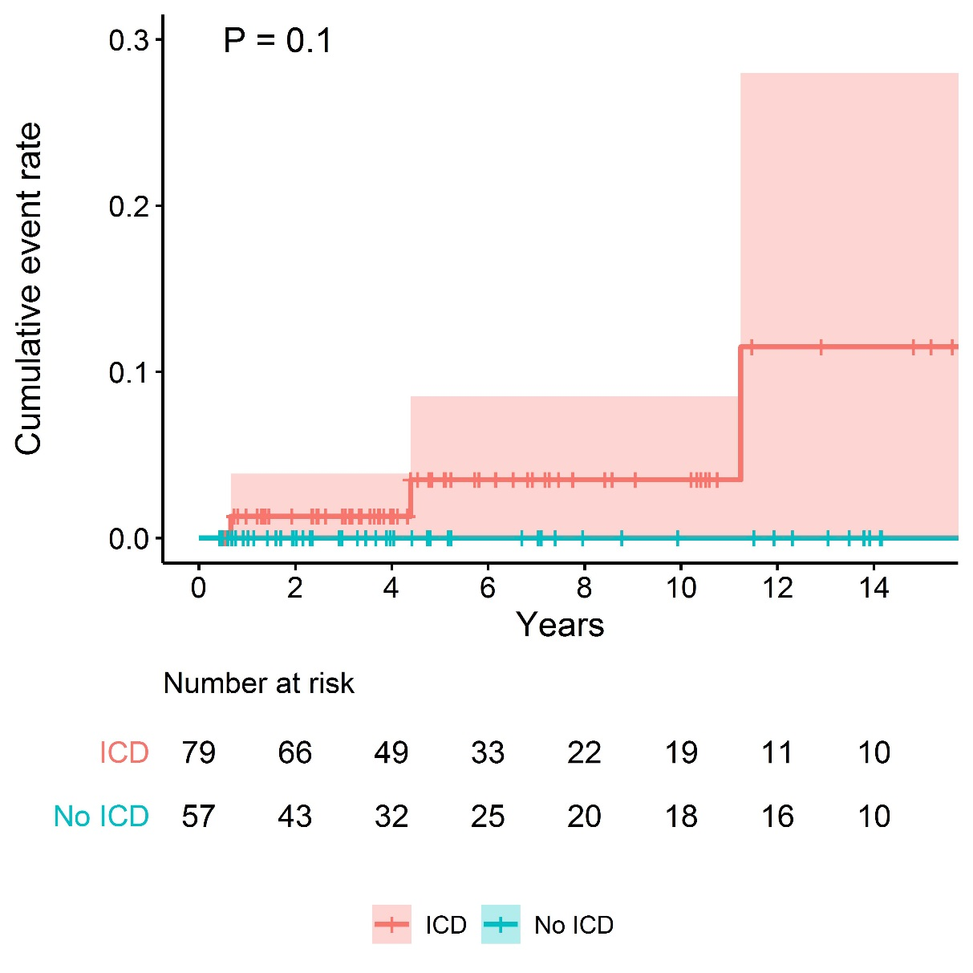

1. **Sudden Cardiac Death, Sudden Cardiac Arrest, and Appropriate ICD Shock**

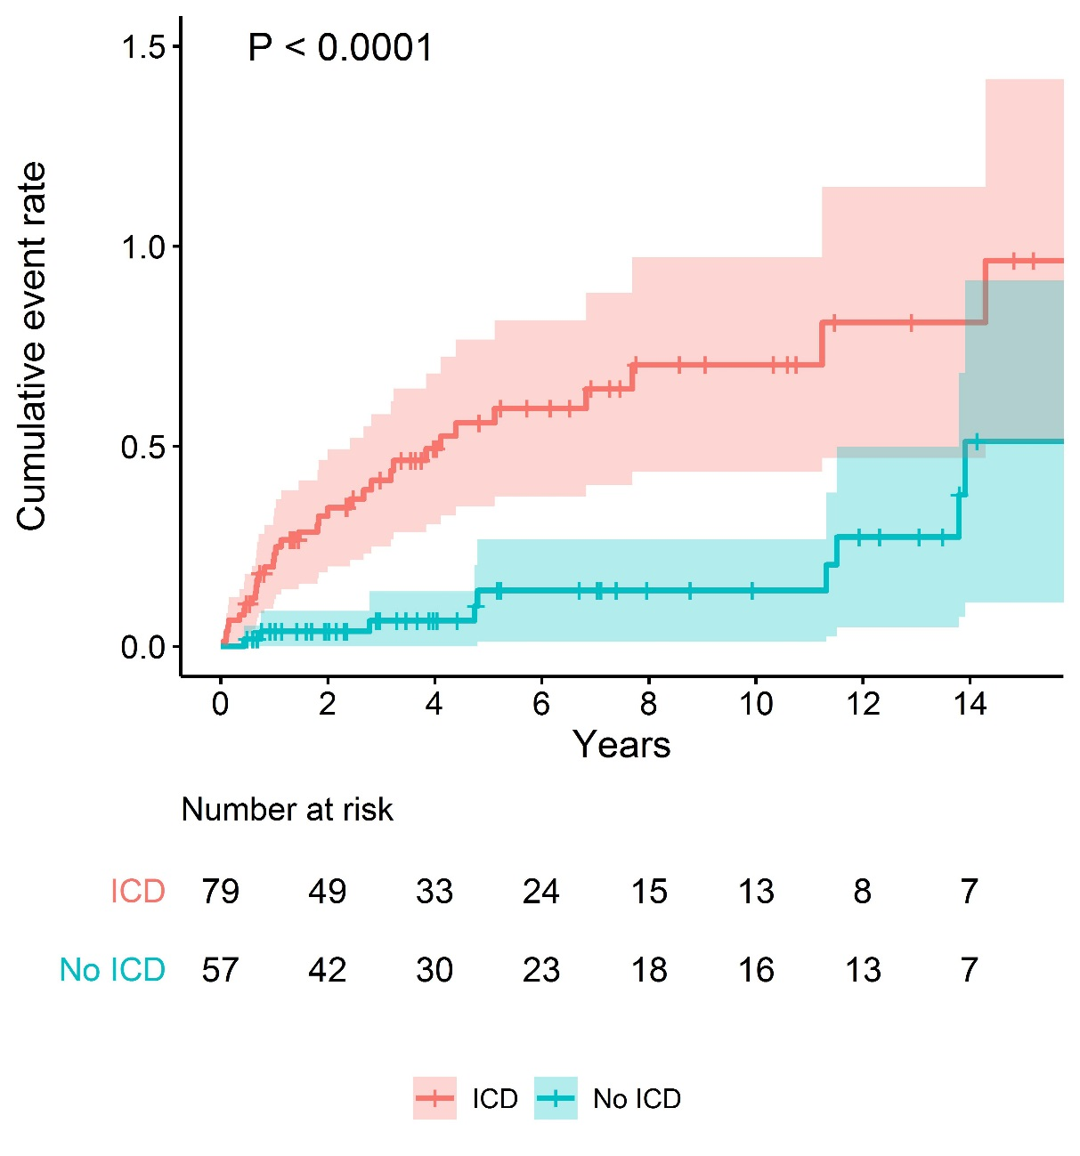

1. **Sudden Cardiac Death, Sudden Cardiac Arrest, Appropriate ICD Shock, and Syncope**

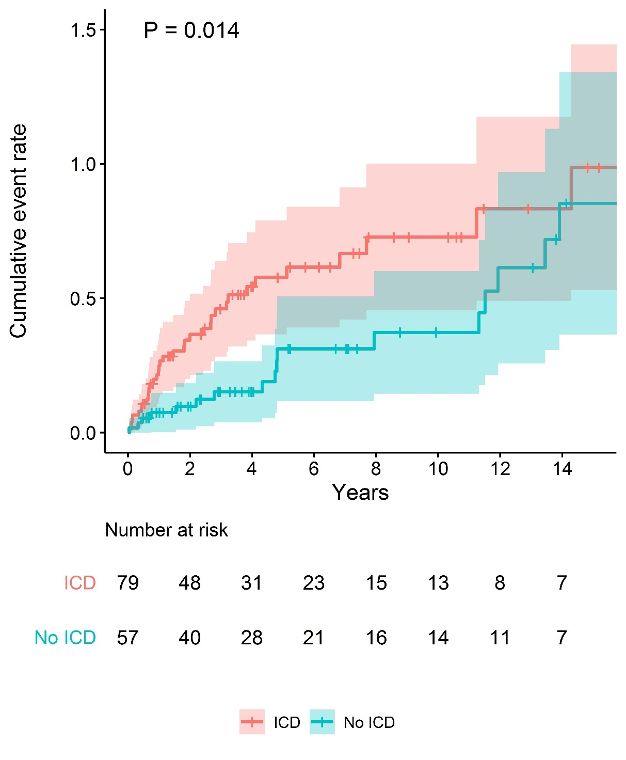

**Take-home figure. Time-to-event curve for SCD.**



# Supplementary Appendix

## Supplementary Methods

**Therapy**

We collected data on the types and maximal daily doses (after up-titration) of the initial and current or last known β-blocker and flecainide that were prescribed to the patients and on the performance of LCSD at baseline or during follow-up. In patients with an ICD, dates of implant and explant, and data on programming and the number, dates and electrograms of appropriate and inappropriate shocks, when applicable and available, were collected.

**Outcomes**

*Sudden cardiac death*

SCD was defined as non-traumatic, unexpected fatal event occurring within 1 hour of the onset of symptoms in an apparently healthy subject. If death is not witnessed, the definition applies when the victim was in good health 24 hours before the event.

*Sudden cardiac arrest*

SCA was defined as unexpected circulatory arrest, occurring within 1 hour of onset of acute symptoms, which was reversed by successful resuscitation maneuvers (e.g. defibrillation).

*Appropriate ICD shock*

ICD shocks were considered to be appropriate if the triggering rhythm was determined to be ventricular fibrillation or ventricular tachycardia. When electrograms were available (*n* = 8), adjudication of appropriateness of ICD shocks was performed by members of the core team of investigators at the Academic Medical Center in Amsterdam, the Netherlands. In the other cases, adjudication of appropriateness of ICD shocks was performed by the local investigators who submitted the patient data. When a patient received multiple appropriate ICD shocks within one ventricular tachyarrhythmia episode or repeated ventricular tachyarrhythmia episodes within 24 hours, this was counted as one outcome event. Data on the loss of consciousness and clinical signs of SCA in patients who received an appropriate ICD shock were available in approximately half of the events.

*Syncope*

Syncope was defined as transient loss of consciousness due to transient global cerebral hypoperfusion

characterized by rapid onset, short duration, and spontaneous complete recovery. Only suspected arrhythmic syncopal events were included, which were defined as syncope likely to be caused by a ventricular arrhythmia but without documentation of this arrhythmia. This diagnosis was made particularly when syncope occurred during exercise, with sudden onset without prodrome, and without typical triggers for reflex or situational syncope.

**Previously published patients**

A total of 76 patients (55.9%) have been published previously in other studies on CPVT, but none of these studies focused on patients presenting with a sentinel SCA specifically.1-26

## Supplementary Results

**Deceased patients**

The first deceased patient experienced a sudden cardiac arrest (SCA) at the age of 18. CPVT secondary to Q4936K-RyR2 was diagnosed and he was treated with bisoprolol (0.0.05 mg/kg/day), flecainide (2 mg/kg/day) and a transvenous single chamber ICD was implanted. After 1 year, he experienced 6 ICD shocks on one day, of which 3 shocks were considered appropriate. Three years later, he died due to electrical storm, which was initiated by an inappropriate ICD shock caused by atrial fibrillation with a rapid ventricular response. There was no information on medication.

One 16-year-old male with an ICD, with CPVT secondary to L4720F-RyR2, died eight months after his SCA. He also had developmental delay and paroxysmal atrial fibrillation for which he underwent catheter ablation.He was treated with low-dose bisoprolol (0.25 mg/kg/day) due to sinus bradycardia, verapamil (6 mg/kg/day), flecainide (5 mg/kg/day), and amiodarone (200 mg/day), and a transvenous single chamber ICD was implanted. During follow-up, he received appropriate ICD shocks (no more information available). The fatal event was initiated by emotion-induced VT and VF, leading to repetitive successful appropriate ICD shocks, which were followed by a slow VT, wide complex bradycardia, asystole, and death. There were no indications of medication non-adherence, and it is unknown whether the initiation of amiodarone increased the defibrillation threshold.

The third deceased patient with an ICD had a history of atrial flutter and a transient ischemic attack, and suffered an SCA at the age of 43 years. She was treated with atenolol (0.4 mg/kg/day), a transvenous dual chamber ICD was implanted, and CPVT secondary to E1646D-RyR2 was established. She was found dead at home at the age of 58 years after being seen alive and apparently well several days earlier. No autopsy was performed and the ICD was not interrogated.

## Supplementary References

1. Roses-Noguer F, Jarman JWE, Clague JR, Till J. Outcomes of defibrillator therapy in catecholaminergic polymorphic ventricular tachycardia. Heart Rhythm 2014;11:58–66.

2. Roston TM, Vinocur JM, Maginot KR, Mohammed S, Salerno JC, Etheridge SP, Cohen M, Hamilton RM, Pflaumer A, Kanter RJ, Potts JE, LaPage MJ, Collins KK, Gebauer RA, Temple JD, Batra AS, Erickson C, Miszczak-Knecht M, Kubuš P, Bar-Cohen Y, Kantoch M, Thomas VC, Hessling G, Anderson C, Young ML, Cabrera Ortega M, Lau YR, Johnsrude CL, Fournier A, Kannankeril PJ, Sanatani S. Catecholaminergic polymorphic ventricular tachycardia in children: analysis of therapeutic strategies and outcomes from an international multicenter registry. Circ Arrhythm Electrophysiol 2015;8:633–642.

3. Hayashi M, Denjoy I, Extramiana F, Maltret A, Buisson NR, Lupoglazoff JM, Klug D, Hayashi M, Takatsuki S, Villain E, Kamblock J, Messali A, Guicheney P, Lunardi J, Leenhardt A. Incidence and risk factors of arrhythmic events in catecholaminergic polymorphic ventricular tachycardia. Circulation 2009;119:2426–2434.

4. van der Werf C, Kannankeril PJ, Sacher F, Krahn AD, Viskin S, Leenhardt A, Shimizu W, Sumitomo N, Fish FA, Bhuiyan ZA, Willems AR, van der Veen MJ, Watanabe H, Laborderie J, Haïssaguerre M, Knollmann BC, Wilde AA. Flecainide therapy reduces exercise-induced ventricular arrhythmias in patients with catecholaminergic polymorphic ventricular tachycardia. J Am Coll Cardiol 2011;57:2244–2254.

5. Watanabe H, van der Werf C, Roses-Noguer F, Adler A, Sumitomo N, Veltmann C, Rosso R, Bhuiyan ZA, Bikker H, Kannankeril PJ, Horie M, Minamino T, Viskin S, Knollmann BC, Till J, Wilde AA. Effects of flecainide on exercise-induced ventricular arrhythmias and recurrences in genotype-negative patients with catecholaminergic polymorphic ventricular tachycardia. Heart Rhythm 2013;10:542–547.

6. De Ferrari GM, Dusi V, Spazzolini C, Bos JM, Abrams DJ, Berul CI, Crotti L, Davis AM, Eldar M, Kharlap M, Khoury A, Krahn AD, Leenhardt A, Moir CR, Odero A, Olde Nordkamp L, Paul T, Rosés I Noguer F, Shkolnikova M, Till J, Wilde AA, Ackerman MJ, Schwartz PJ. Clinical management of catecholaminergic polymorphic ventricular tachycardia: the role of left cardiac sympathetic denervation. Circulation 2015;131:2185–2193.

7. van der Werf C, Nederend I, Hofman N, van Geloven N, Ebink C, Frohn-Mulder IM, Alinga AM, Bosker HA, Bracke FA, van den Heuvel F, Waalewijn RA, Bikker H, van Tintelen JP, Bhuiyan ZA, van den Berg MP, Wilde AA. Familial evaluation in catecholaminergic polymorphic ventricular tachycardia: disease penetrance and expression in cardiac ryanodine receptor mutation-carrying relatives. Circ Arrhythm Electrophysiol 2012;5:748–756.

8. Kawata H, Ohno S, Aiba T, Sakaguchi H, Miyazaki A, Sumitomo N, Kamakura T, Nakajima I, Inoue YY, Miyamoto K, Okamura H, Noda T, Kusano K, Kamakura S, Miyamoto Y, Shiraishi I, Horie M, Shimizu W. Catecholaminergic polymorphic ventricular tachycardia (CPVT) associated with ryanodine receptor (RyR2) gene mutations - long-term prognosis after initiation of medical treatment. Circ J 2016;80:1907-1915.

9. Ohno S, Hasegawa K, Horie M. Gender differences in the inheritance mode of RYR2 mutations in catecholaminergic polymorphic ventricular tachycardia patients. PLoS One 2015;26;10:e0131517.

10. Ozawa J, Ohno S, Fujii Y, Makiyama T, Suzuki H, Saitoh A, Horie M. Differential diagnosis between catecholaminergic polymorphic ventricular tachycardia and long QT syndrome type 1 - modified Schwartz score. Circ J 2018;82:2269-2276.

11. Kawamura M, Ohno S, Naiki N, Nagaoka I, Dochi K, Wang Q, Hasegawa K, Kimura H, Miyamoto A, Mizusawa Y, Itoh H, Makiyama T, Sumitomo N, Ushinohama H, Oyama K, Murakoshi N, Aonuma K, Horigome H, Honda T, Yoshinaga M, Ito M, Horie M. Genetic background of catecholaminergic polymorphic ventricular tachycardia in Japan. Circ J 2013;77:1705-13.

12. Bellamy D, Nuthall G, Dalziel S, Skinner JR. Pediatr Crit Care Med 2019;20:262-268.

13. Roston TM, Guo W, Krahn AD, Wang R, Van Petegem F, Sanatani S, Chen SR, Lehman A. A novel RYR2 loss-of-function mutation (I4855M) is associated with left ventricular non-compaction and atypical catecholaminergic polymorphic ventricular tachycardia. J Electrocardiol 2017;50:227-233.

14. Roston TM, AlAhmari L, Krahn AD, Sherwin E, Sanatani S. Choking-induced cardiac arrest unmasks a diagnosis of catecholaminergic polymorphic ventricular tachycardia. HeartRhythm Case Rep 2015;1:494-497.

15. Padfield GJ, AlAhmari L, Lieve KV, AlAhmari T, Roston TM, Wilde AA, Krahn AD, Sanatani S. Flecainide monotherapy is an option for selected patients with catecholaminergic polymorphic ventricular tachycardia intolerant of β-blockade. Heart Rhythm 2016;13:609-613.

16. Cheung CC, Lieve KV, Roston TM, van der Ree MH, Deyell MW, Andrade JG, Laksman ZW, Nannenberg EA, Tadros R, Pang B, Rutberg J, Green M4, Conacher S, Seifer CM, Roberts JD, Steinberg C, Sanatani S, Wilde AA, Krahn AD. Pregnancy in catecholaminergic polymorphic ventricular tachycardia. JACC Clin Electrophysiol 2019;5:387-394.

17. Broendberg AK, Nielsen JC, Bjerre J, Pedersen LN, Kristensen J, Henriksen FL, Bundgaard H, Jensen HK. Nationwide experience of catecholaminergic polymorphic ventricular tachycardia caused by RyR2 mutations. Heart 2017;103:901-909.

18. Sy RW, Gollob MH, Klein GJ, Yee R, Skanes AC, Gula LJ, Leong-Sit P, Gow RM, Green MS, Birnie DH, Krahn AD. Arrhythmia characterization and long-term outcomes in catecholaminergic polymorphic ventricular tachycardia. Heart Rhythm 2011;8:864-871.

19. Tülümen E, Schulze-Bahr E, Zumhagen S, Stallmeyer B, Seebohm G, Beckmann BM, Kääb S, Rudic B, Liebe V, Wolpert C, Herrera-Siklody C, Veltmann C, Schimpf R, Borggrefe M. Early repolarization pattern: a marker of increased risk in patients with catecholaminergic polymorphic ventricular tachycardia. Europace 2016;18:1587-1592.

20. Haugaa KH, Leren IS, Berge KE, Bathen J, Loennechen JP, Anfinsen OG, Früh A, Edvardsen T, Kongsgård E, Leren TP, Amlie JP. Europace 2010;12:417-423.

21. Leren IS, Saberniak J, Majid E, Haland TF, Edvardsen T, Haugaa KH. Nadolol decreases the incidence and severity of ventricular arrhythmias during exercise stress testing compared with β1-selective β-blockers in patients with catecholaminergic polymorphic ventricular tachycardia. Heart Rhythm 2016;13:433–440.

22. Lieve KV, Verhagen JM, Wei J, Bos JM, van der Werf C, Rosés I Noguer F, Mancini GM, Guo W, Wang R, van den Heuvel F, Frohn-Mulder IM, Shimizu W, Nogami A, Horigome H, Roberts JD, Leenhardt A, Crijns HJ, Blank AC, Aiba T, Wiesfeld AC, Blom NA, Sumitomo N, Till J, Ackerman MJ, Chen SR, van de Laar IM, Wilde AA. Linking the heart and the brain: Neurodevelopmental disorders in patients with catecholaminergic polymorphic ventricular tachycardia. Heart Rhythm 2019;16:220-228.

23. Kozlovski J, Ingles J, Connell V, Hunt L, McGaughran J, Turner C, Davis A, Sy R, Semsarian C. Delay to diagnosis amongst patients with catecholaminergic polymorphic ventricular tachycardia. Int J Cardiol 2014;176:1402-1404.

24. Loar RW, Bos JM, Cannon BC, Ackerman MJ. Sudden cardiac arrest during sex in patients with either catecholaminergic polymorphic ventricular tachycardia or long-QT syndrome: a rare but shocking experience. J Cardiovasc Electrophysiol 2015;26:300-304.

25. Coleman MA, Bos JM, Johnson JN, Owen HJ, Deschamps C, Moir C, Ackerman MJ. Videoscopic left cardiac sympathetic denervation for patients with recurrent ventricular fibrillation/malignant ventricular arrhythmia syndromes besides congenital long-QT syndrome. Circ Arrhythm Electrophysiol 2012;5:782-788.

26. Ostby SA, Bos JM, Owen HJ, Wackel PL, Cannon BC, Ackerman MJ. Competitive sports participation in patients with catecholaminergic polymorphic ventricular tachycardia: a single center's early experience. JACC Clin Electrophysiol 2016;2:253-262.

Supplementary Tables

**Table S1. Indications for not implanting an implantable cardioverter-defibrillator after the sentinel sudden cardiac arrest**

|  |  |  |
| --- | --- | --- |
|  | ***n* = 37** | |
| Considered well protected with medication | 16 | (43.2) |
| Concerns regarding possible proarrhythmic effects of ICD | 11 | (33.3) |
| Erroneously diagnosed with another condition in which ICD was not considered indicated | 3 | (9.1) |
| Historical case (ICDs not available) | 3 | (8.8) |
| ICD explanted almost quickly because of complications | 1 | (2.9) |
| Very young age | 1 | (2.9) |
| Uncertainties about diagnosis | 1 | (2.9) |
| Patient refusal | 1 | (2.9) |

Values are *n* (%). Unknown in 20 patients (35.1%).

ICD, implantable-cardioverter defibrillator.

**Table S2. Details on implantable cardioverter-defibrillator types and programming**

|  |  |  |  |  |  |  |  |
| --- | --- | --- | --- | --- | --- | --- | --- |
|  | **Whole Cohort**  **(*n* = 79)** | | **Patients with Appropriate Shock**  **(*n* = 36)** | | **Patients without Appropriate Shock**  **(*n* = 43)** | | ***P*-value** |
| ICD type |  |  |  |  |  |  | 0.329 |
| Single chamber ICD | 42/73 | (57.5) | 22/34 | (64.7) | 20/39 | (51.3) |  |
| Dual chamber ICD | 24/73 | (32.9) | 8/34 | (23.5) | 16/39 | (41.0) |  |
| Subcutaneous ICD | 6/73 | (8.2) | 3/34 | (8.8) | 3/39 | (7.7) |  |
| CRT-D | 1/73 | (1.4) | 1/34 | (2.9) | - | |  |
| ICD programming |  |  |  |  |  |  |  |
| Number of therapy zones |  |  |  |  |  |  | 0.791 |
| 1 | 40/61 | (65.6) | 19/30 | (63.3) | 21/31 | (67.7) |  |
| 2 | 21/61 | (34.4) | 11/30 | (36.7) | 10/31 | (32.3) |  |
| Heart rate cut-off  therapy zone (bpm)a | 214 (200-222) | | 221 (200-222) | | 207 (200-220) | | 0.298 |
| Antitachycardia pacingb | 28/56 | (50.0) | 16/28 | (57.1) | 12/28 | (42.9) | 0.423 |

Values are median (interquartile range) or n (%). Total numbers are included when they differ from those in the overall study group.

Bpm, beats per minute; CRT-D, cardiac resynchronization therapy-defibrillator; ICD, implantable-cardioverter defibrillator.

aIn patients who received an appropriate ICD shock, heart rate cut-off of VT/VF detection at time of the event, when available, was analyzed. Data available in 61 patients (77.2%).

bNot applicable in patients with a subcutaneous ICD.

**Table S3. Indications for implanting an implantable cardioverter-defibrillator during follow-up**

|  |  |  |
| --- | --- | --- |
|  | ***n* = 20** | |
| Sudden cardiac arrest | 9 | (45.0) |
| Syncope | 6 | (30.0) |
| Pacemaker indication | 2 | (10.0) |
| Ventricular premature beats during exercise testing | 1 | (5.0) |
| Inducible ventricular fibrillation during electrophysiology study | 1 | (5.0) |
| Considered indicated based on the sentinel SCA | 1 | (5.0) |

Values are *n* (%). Unknown in 2 patients (9.1%).

ICD, implantable-cardioverter defibrillator; SCA, sudden cardiac arrest.