For: Methods in Molecular Medicine. Allergy Methods & Protocols.
Jones & Lympany. Humana Press.

Novel Method for the Purification of House Dust Mite Allergen Der p 1 and its Use in Structure-Based Chemical Design of Novel Inhibitors

Jihui Zhang^{a,b} and Clive Robinson^{b}
ªState Key Laboratory of Microbial Resources, Institute of Microbiology, Chinese Academy of Sciences, Beijing, P.R. China and ^{b}Institute for Infection & Immunity, St George’s, University of London, London, UK.

Correspondence:
c.robinson@sgul.ac.uk
Abstract
House dust mites are globally significant triggers of allergic disease. Notable among their extensive repertoire of allergens are the Group 1 cysteine peptidase allergens which function as digestive enzymes in house dust mites. Compelling evidence suggests that the proteolytic activity of these molecules plays key roles in the development and maintenance of allergic diseases through the activation of innate immune mechanisms which exploit genetic predispositions to allergy. Growing interest in this area creates a requirement for high quality purified protein, whether natural or recombinantly expressed. It has also identified these allergens as therapeutic targets for a novel approach to allergy treatment through modulation of innate immune responses. The purpose of this chapter is to describe a new method for the purification of Der p 1 and use of the protein produced in a screening assay designed for the discovery of novel inhibitors of Group 1 house dust mite allergens.

Key words: House dust mite; Der p 1 purification; allergen delivery inhibitors; innate immunity; protease inhibitor screening; structure-based drug design; protein purification; protease assay
1. Introduction
In 1921 the American physician Richard Kern postulated that house dust was a cause of allergic disease because many patients with asthma or rhinitis had positive skin responses to extracts of dust from their dwellings. This concept was developed further by Willem Storm van Leeuwen whose work led him to believe that house dust mites (HDM) were key components of this house dust allergy. However, formal proof of this idea was elusive and it was not until the work of Voorhorst and Spieksma in 1967 that the involvement of HDM was eventually acknowledged by most allergists. Under environmental conditions which enable HDM to thrive, they elicit the production of allergen-specific IgE and form a notable allergen source strongly associated with asthma. Many species of mite are found in house dust, with the Pyroglyphid family (eg Dermatophagoides pteronyssinus, D. farinae, and Euroglyphus maynei) dominating in most parts of the world. The unusually extensive allergen repertoire of HDM includes proteins of several classes ¹. Of these, the Group 1 allergens have attracted particular scrutiny because of their strong association with sensitization and disease. In studying Group 1 HDM allergens, Der p 1 has frequently been used as a meaningful archetype for Group 1 allergens from other mite species. This approach is reasonable because Group 1 allergens from different HDM species show a high degree of sequence identity, giving encouragement that their immunological, and other, behavior should be similar if not the same.

In HDM, Group 1 allergens function as digestive enzymes belonging to the cysteine protease family. In fact, they represent a novel sub-family of 25 kDa cysteine proteases based on the length, structure and behavior of the propiece which regulates latency of these enzymes ². The recognition that Group 1 allergens were cysteine proteases prompted interest into the possible relevance of this bioactivity to the mechanisms of allergy, in particular fundamental questions surrounding the molecular basis of allergenicity ¹. It is clear from exploration of this topic that proteolytic activity of Group 1 HDM allergens is significant for the development of sensitization to themselves, other mite allergens and allergens from unrelated sources. Proteolytic activity acts as a means of facilitating allergen delivery to antigen presenting cells, as an adjuvant to stimulate a vigorous immune response which exhibits Th2 polarization, and contributes to mechanisms which have chronic pathophysiological consequences ³. These biophysical and innate immune mechanisms are summarized in Table 1. A recent, and unexpected, finding was the discovery that Der p 1 is a prothrombinase capable of triggering interstitial thrombin formation in the absence of coagulation pathway activation ⁴. This triggering of thrombin formation initiates a complex signaling cycle in which the intracellular generation of ROS eventuates, and whose operation forms a nexus with inflammatory signaling from Toll-like receptors 3 and 7 which act as sensors for viral RNA ^{4, 5}.

The realization that these events are relevant to allergic sensitization and, significantly, exert a collateral priming effect for the sensitization to other allergens has prompted interest in Group 1 HDM allergens as novel therapeutic targets for asthma and other allergic conditions. Conveniently, amino acid sequence similarities between Group 1 allergens from different species of HDM mean that they represent a single target for drug design purposes. This is pleasingly helpful compared to their epitopes which, although showing many similarities, are sufficiently different to be immunologically distinguishable.

Provisioning a drug discovery campaign requires a supply of purified target protein for screening, and generally, recombinantly-expressed protein is used for this purpose. However, in the case of Der p 1 inhibitor design this was not an immediately available option. Although recombinant Der p 1 had been expressed prior to drug discovery work, this was produced by prokaryotic expression and lacked catalytic competence due to the absence of correct protein folding. Purified protein is also the basis of structure-based drug discovery approaches because the availability of high resolution target structures facilitates rational decision making in chemical design. In the initial absence of definitive structural data for Der p 1 itself, we generated its likely structure by homology modelling using high quality crystallographic data for the cysteine peptidases cathepsin K, papain and actinidin. Subsequently, high-resolution crystal structures became available for Der p 1 and Der f 1 from D. farinae and, with only few notable differences, these are generally consistent with our homology models ^{6, 7}. In its monomeric form, Der p 1 comprises a pair of globular domains between which is located a substrate binding groove whose composition, as predicted by empirical examinations of substrate and inhibitor kinetics, is highly conserved at both the isoallergen and homologous species levels. This substrate binding groove contains the Cys, His and Asn catalytic triad typical of the C1 family of CA clan cysteine peptidases. The availability of high-quality structural data, together with information gathered during screening using highly-purified Der p 1, corrects an erroneous report that Der p 1 (and by implication other Group 1 HDM allergens) are mechanistically bifunctional enzymes with both cysteine and serine protease activity ⁸. No credible evidence exists to support this suggestion, which most likely originates from inadequacies in protein purification based on immunoaffinity chromatography which has been a commonly employed method of obtaining Der p 1 for research studies. Der p 1 prepared as described herein will not degrade N-succinyl-Ala-Ala-Pro-Phe-p-nitroanilide, which is an effective substrate for chymotrypsin, and while trypsin and Der p 1 are both able to utilize N-Bz-Phe-Val-Arg-p-nitroanilide as substrate, the latter enzyme’s behavior is not affected by the broad spectrum serine peptidase inhibitor 4-(2-aminoethyl)benzene sulfonyl fluoride (AEBSF), whereas it is blocked by the thiol-reactive Der p 1 inhibitor ADZ 50,000 ³. Indeed, structural inspection of Der p 1 reveals that none of the serine residues it contains are located in a proximity to His or Asp residues for the creation of a catalytic triad.

Examination of protease substrate specificity provides an efficient means of identifying target motifs which may be useful as scaffolds in structure-based drug design. Screening a library of fluorescence resonance energy transfer (FRET) substrates of general formula Abz-B-C-D-E-Tyr(NO₂)-Asp-NH₂ revealed preferences as follows. B: Val>Ala, Gln, Leu, Phe; C: Ala>>Gln or Lys; D: Leu, Nle or Ala>Ser; E: Ser. This information was employed in the elaboration of substrates into inhibitors such as acyloxymethyl ketones based around the scaffold Val-Ala-Nle-Ser (Figure 1).

An unfortunate corollary of this otherwise valuable approach is that while initial inhibitor ‘hits’ may exhibit exquisite potency, they lack significant drug-likeness ^{3, 9}. Thus, progress towards developable candidate drugs requires careful optimization of necessary credentials (potency, selectivity, pharmacokinetic properties, physical form etc). An additional concern in the case of the acyloxymethyl ketone derivatives is that their mechanism of Der p 1 inhibition is irreversible, creating the potential for hapten generation. This negates the optimization of this particular series for the intended therapeutic indications where the intended patient population has a genetic predisposition to allergy. However, considerable success was achieved in optimization of a lead series based around a pyruvamide motif ⁹. These inhibitors have a reversible mechanism on the target enzyme and through a structure-based design campaign around this series we obtained a range of developable compounds with the required combination of properties for delivery by inhalation in dry powder form ⁹. Arrival at this position required iterative rounds of screening and counter-screening of compounds in which structure variations at key positions in the basic pyruvamide scaffold were introduced systematically. An illustration of one small aspect of this, made using the screening method described herein for Der p 1 purified as described, is shown in Table 2. Comprehensive details of structure-activity relationships for the Der p 1 target are available elsewhere ⁹. We call this new class of drugs ‘Allergen Delivery Inhibitors’ (ADIs) because of their ability to inhibit the transepithelial delivery of allergens to sub-epithelial dendritic antigen presenting cells. However, their efficacy profile extends considerably beyond this action given the wide-ranging effects of the target’s proteolytic activity on innate immune responses.
2. Materials
2.1 Reagents for Der p 1 extraction and purification
- House dust mites (Dermatophagoides pteronyssinus) are maintained in continuous solid phase culture with controlled temperature and relative humidity (25 °C, 75 %) in a custom-built containment system. Mite growth medium comprises 50 % (w/w) of Brewer’s Yeast (Saccharomyces cerevisiae) and 50 % desiccated liver that has been ground in a Waring blender and hot-air sterilized at 80 °C for 3-4 hours in a Stericell oven. Cultures grown for 1.5-3 months provide a suitable feedstock for Der p 1 purification.
- Dulbecco’s phosphate-buffered saline, without calcium chloride and magnesium chloride (D-PBS).
- Ethylenediaminetetraacetic acid disodium salt (EDTA) 100 mM in H₂O: Dissolve 18.6 g EDTA into 500 mL de-ionized water to make up 100 mM EDTA solution.
- Elution buffer for Sephacryl S200 column (EB)
- Add 98 mL 0.2 M Na₂HPO₄, 10 mL 100 mM EDTA and 890 mL double de-ionized water into a 1000 mL beaker.
- Weigh out 29.22 g NaCl and dissolve in the above solution.
- Carefully adjust the pH to 7.4 with 0.2 M NaH₂PO₄ .
- Add double de-ionized water to total volume 1000 mL.
- Vacuum filter through 0.2 μm porosity membrane. The filter device can be of any type having a suitable pore size. For routine batch preparations a filter device of 500 mL volume is adequate.
- Buffer A (20 mM Tris-HCl buffer, pH 8.0)
- Dissolve 60.5 g Trizma base in 900 mL de-ionized water, and adjust to pH 8.0 using 50 % (v/v) HCl.
- Add de-ionized water to total volume 1000 mL to produce 0.5 M Tris-HCl buffer, pH 8.0.
- Add 20 mL 0.5 M Tris-HCl buffer, pH 8.0 to 480 mL de-ionized water to yield buffer A.
- Buffer B (20 mM Tris-HCl buffer, pH 8.0 containing 2 M NaCl): dissolve 58.4 g NaCl into 500 mL buffer A.
- 0.1 M Glycine-HCl buffer, pH 2.8 (GB)
- Dissolve 7.5 g glycine in 995 mL de-ionized water, and adjust the pH to 2.8 using 50 % (v/v) HCl.
- Adjust volume to 1000 mL using de-ionized water.

2.2 Reagents for SBTI (Trypsin Inhibitor from soybean) affinity column:
- SBTI (from Sigma-Aldrich, UK)
- CNBr-activated Sepharose 4 Fast Flow (from Sigma-Aldrich, UK)
- 0.1 M NaHCO₃ pH 8.3 containing 0.5 M NaCl
- 1 mM HCl
- 0.5 M Tris-HCl, pH 8.0 buffer: dissolve 60.5 g Trizma base in 900 mL de-ionized water, and adjust to pH 8.0 with 50 % (v/v) HCl. Then adjust to a final volume of 1000 mL with deionized water to produce 0.5 M Tris-HCl, pH 8.0. Add 100 mL of this solution to 400 mL de-ionized water to produce 0.1 M Tris-HCl buffer, pH 8.0
- 0.1 M acetate buffer pH 3-4 containing 0.5 M NaCl: Dissolve 8.2 g sodium acetate in 500 mL deionized water to produce a 0.2 M solution. Mix 10 mL glacial acetic acid with 865 mL deionized to produce a 0.2 M solution. Take 410 mL of the acetic acid solution and adjust to pH 4.0 using 0.2 M sodium acetate (requires about 90 mL). Dilute two-fold with deionized water to produce 0.1 M acetate buffer and dissolve 14.6 g NaCl into 500 mL of this.
- 0.1 M Tris-HCl buffer pH 8–9 containing 0.5 M NaCl
- Binding buffer: EB

2.3 Reagents for Der p1 identification by Matrix-Assisted Laser Desorption/Ionization Time of Flight (MALDI-TOF) mass spectrometry
- 50 mM ammonium bicarbonate solution
- Ammonium bicarbonate, 40 mM, pH 8.9, containing 9 % v:v acetonitrile
- 50 % v:v acetonitrile
- 1 mM hydrochloric acid (HCl): Add 1 mL concentrated HCl to 11 mL de-ionized water yielding 1 M HCl which should then be diluted 1000-fold with de-ionized water to provide, finally, 1 mM HCI.
- Trypsin solution: 20 μg trypsin (Sigma Aldrich, UK) is supplied lyophilized in vials. Reconstitute the lyophilized trypsin in 100 μL 1 mM HCl and mix the vial briefly until completely dissolved. Add 900 μL, ammonium bicarbonate, 40 mM, pH 8.9, containing 9 % v:v acetonitrile to the vial and mix. The final concentration of trypsin is 20 μg/mL. Aliquot and store at -20 °C (4.1).
- Matrix: α-cyano-4-hydroxycinnamic acid (CHCA) for peptides with molecular weight <10 kDa. Weigh out 10 mg CHCA and add 700 μL acetonitrile and 300 μL, 0.1 % v:v trifluoroacetic acid (TFA) in de-ionized water. Vortex mix to dissolve completely.

2.4 Reagents for Der p 1 activity test with or without ADZ 50,000
- 50 mM potassium phosphate buffer containing 1 mM EDTA, pH 8.29 (PPE) (Note 4.2)
- Mix 97.4 mL, 0.5 M K₂HPO₄ with 10 mL, 100 mM EDTA, and 890 mL de-ionized water.
- Adjust pH to 8.29 with 0.5 M KH₂PO₄ (about 2.6 mL).
- Adjust to 1000 mL using de-ionized water.
- Substrate solution (125 µM substrate in buffer PPE, reagent I): Weigh out 10 mg Der p 1 substrate ((3S,6S,9S,12S,15S,18S)-1-(2-aminophenyl)-9-butyl-18-carbamoyl-15-(4-hydroxy-3 -nitrobenzyl)-12-(hydroxymethyl) -3-isopropyl-6-methyl- 1,4,7,10,13,16-hexaoxo-2,5,8,11,14,17-hexaazaicosan-20-oic acid), and dissolve in dry dimethyl sulfoxide (DMSO) to make a 10 mM stock solution. Aliquot as 50 µL/vial and store frozen at 4 °C or lower. Before use, add 987.5 µL buffer PPE into 12.5 µL 10 mM substrate solution. Vortex mix immediately and thoroughly.
- 10 mM DL-dithiothreitol (DTT) (reagent II):
- 1 M DTT stock solution: dissolve 1.55 g DTT in 8 mL water and adjust the final volume to 10 mL. Aliquot as 50 µL/vial and store frozen at -20°C.
- Make up 10 mM DTT from the stock solution by adding 10 µL, 1M DTT stock solution into 990 µL buffer PPE.
    - 9 mM DTT (reagent II*): Make up 9 mM DTT by adding 9 µL, 1 M DTT stock solution into 991 µL buffer PPE.
- Reagent III (2.5 µg/mL Der p 1 in PPE): Add 7.5 µL, 1 mg/mL Der p 1 into 2992.5 µL PPE. Mix well. For pre-activation: Add Der p 1 (7.5 µL x 1 mg/mL) to 2989.5 µL PPE and 3 µL 1 M DTT. Mix well and leave at room temperature for 5 min (Note 4.3).
- Inhibitor preparation: Dissolve inhibitors in dry DMSO to make 100 mM stock solutions if they can be dissolved, otherwise the stock solutions could be 50 mM or 10 mM (the default inhibitor stock concentration). Prior to use, dilute the stock solution to 10 mM with DMSO.

2. 5 Apparatus and columns
- Amicon Stirred Cell 50 mL (Merck Millipore, UK)
- Ultracel membrane with 10 kDa cutoff (Merck Millipore, UK)
- Cylinder of oxygen-free, compressed nitrogen (or nitrogen line from an infrastructure ‘boil off’ supply).
- Magnetic stirrer
- Balances, analytical and general laboratory
- pH meter
- pH paper
- Sephacryl S-200 column, Hiprep, 16/60. (GE Healthcare, UK)
- Resource Q column, 1mL (GE Healthcare, UK)
- Refrigerated centrifuges with fixed angle rotors. The g force needs to be 23,500 x g or above for 30 mL tubes and 10, 000 x g for 15mL microcentrifuge tubes.
- Microplate reader equipped with fluorescence reading modes and heated plate carrier
- ÄKTA Purifier or similar equipment for protein chromatography
- MALDI-TOF mass spectrometer

3 Methods
All Der p 1 purification steps are carried out at 4 °C. This may be achieved by working in a cold room or, more comfortably, in a suitably-equipped laboratory cold cabinet.

3.1 Preparation of the SBTI affinity column
- Dissolve 400 mg SBTI in 40 mL coupling buffer (0.1 M NaHCO₃, pH 8.3, containing 0.5 M NaCl) to make up 10 mg/mL SBTI as coupling solution.
- Add 20 mL of cold 1 mM HCl to 2 g dried CNBr-activated Sepharose 4 Fast Flow. Wait until all the powder is wet, then pack the matrix into a 25 mL syringe and wash with 10–15 column volumes of cold 1 mM HCl.
- Cycle load 40 mL of 10 mg/mL SBTI in coupling buffer and allow to react for 4 h (or overnight) at 4 °C. (Note 4.4).
- Wash away excess ligand with at least 5 column volumes of coupling buffer.
- After coupling, non-reacted groups on the matrix should be blocked. To do this, run 100 mL 0.1 M Tris-HCl pH 8.0 buffer through the column and allow to stand for at least 2 h. (Note 4.5)
- Wash the coupled matrix using alternate low and high pH buffers. Recommended buffers are 0.1 M acetate buffer pH 3-4 containing 0.5 M NaCl and 0.1 M Tris-HCl buffer pH 8–9 containing 0.5 M NaCl. A suitable procedure is 3 column volumes of Tris-HCl buffer followed by 3 column volumes of acetate buffer. Repeat this cycle 3–6 times.
- The coupled matrix is now ready for use. To prevent microbial growth, store in 20 % v:v ethanol.
- Equilibrate the column with binding buffer before applying samples.

3.2 Preparation of PBS extracts and 50% ammonium sulphate fraction
- Der p 1 PBS extracts from house dust mite medium
  - Add 200 mL D-PBS to 50 g spent medium from house dust mite cultures in a 500 mL beaker.
  - Cover with parafilm and stir at 4 °C for 4 h to overnight. Ensure the stirrer is operating satisfactorily in order to achieve efficient extraction.
  - Transfer the mixture into suitable centrifuge tubes (eg 30 mL for a Sorvall RC-5B centrifuge). Weigh the tubes to make sure that each pair of tubes has the same weight so that the rotor can be balanced.
  - Put a pre-cooled fixed angle rotor in the centrifuge, and ensure it is in correctly located on the spindle.
  - Put the tubes into the rotor in a balanced (symmetrical) position.
  - Centrifuge at 23,500 x g and 4 °C for 30 minutes.
  - Remove the tubes gently to avoid disturbing the pellets and carefully transfer the supernatants to a 250 mL measuring cylinder to measure the volume. Then transfer the combined supernatants to a 500 mL beaker. This combined supernatant is called the PBS extract (PBSE).
  - Clean the rotor with water and wipe dry with tissues. Return the rotor to cool storage.
2. 50 % ammonium sulphate precipitates
- Add 100 mM EDTA (stock solution in H₂O) to PBSE so the final concentration for EDTA is 1 mM.
- Calculate the amount of solid ammonium sulfate (Ammonium sulfate (grams) = (supernatant volume / 100) x 30) required for the supernatant to make up 50 % saturation.
- Add the required solid ammonium sulfate to PBSE gradually, and stir at 4 °C for 4 h or overnight.
- Centrifuge at 23,500 x g and 4°C for 30 minutes.
- Discard the supernatants. Gently raise the pellets with D-PBS to remove excess ammonium sulfate (Note 4.6).
- Add 3 mL D-PBS to each tube, and re-dissolve the precipitates.
- Centrifuge again, as above, and collect the supernatants.
- Transfer the supernatants carefully to an Amicon filtration cell equipped with a 10 kDa cut-off membrane for concentration with stirring at 4 °C under compressed nitrogen (Note 4.7).
- After concentration, wash the 50 % ammonium sulfate fraction into 1 - 3mL Sephacryl S200 EB buffer (Note 4.7)
- Centrifuge at 23,500 x g and 4°C for 10 minutes and transfer the supernatant into a clean vial for chromatography. This supernatant is called the concentrated 50 % ammonium sulfate fraction.

3.3 Isolation of Der p 1 by chromatography
- Equilibrate a Sephacryl S-200 column (16/60, Hiprep) on an ÄKTA Purifier system using 3 column volumes (CV) of buffer EB.
- Apply 2-3 mL (Note 4.8) of the concentrated 50 % ammonium sulfate fraction to the column and elute with EB. Collect the fraction with a retention volume of 90 – 120 mL (RT90) (Figure 2).
- Equilibrate the SBTI affinity column with EB before applying samples.
- Load the sample RT90 on the SBTI affinity column by cycle loading for 4 h to overnight using a flow rate of 0.1 mL/min.
- Collect the flow-through solution and concentrate it under pressurized nitrogen in an Amicon cell equipped with 10 kDa cut-off ultrafiltration membrane.
- After each run, regenerate the SBTI affinity column by washing it with 5 CV 0.1 M glycine-HCl buffer, pH 2.8, and re-equilibrate it with 5 CV of EB for the next run.
- Add elution buffer for Sephacryl S200 chromatograph, and transfer the concentrated sample into 1.5 ml vials, then centrifuge at 13,400 x g, for 10 min at 4°C to get rid of any insoluble precipitates. Then repeat steps 2 -5 (Figure 2).
- Concentrate and desalt the samples obtained from step 7 (Note 4.9) and then re-dissolve them in 20 mM Tris-HCl, pH 8.0 buffer, followed by centrifugation at 23,400 x g, for 10 min at 4°C with fixed anglehead rotor. Collect the supernatant for Resource Q chromatography.

3.4 Chromatography on Resource Q
- Equilibrate a Resource Q column with 5 CV of pH 8.0 20 mM Tris-HCl buffer before use. Then load the samples.
- Gradient elution from 0.05 – 0.5 M NaCl is done with buffer A and buffer B (Figure 2c) (Note 4.10). It is possible to modify the gradient to improve the resolution if samples show complex behavior. Table 3 illustrates one possible alternative.
- Collect each peak and concentrate and desalt them using an Amicon cell as above. Then transfer into D-PBS for quality assurance.
- Determine the concentration of the fractions from the Resource Q column by measuring A₂₈₀ in a quartz cell or microplate. The concentration of Der p 1 is calculated using the equation (Der p 1 concentration (mg/mL) = absorption A_{280nm}/1.8).
- Run the Der p 1 activity assay with or without inhibitor ADZ 50,000 to confirm the purity from a proteolytic class activity perspective.
- Determine the purity of purified Der p 1 by 15 % sodium dodecyl sulfate polyacrylamide gel electrophoresis (SDS-PAGE) (ref. Molecular Cloning: A Laboratory Manual, by Sambrook, Fritsch and Maniatis) (Note 4.11)
- Identify Der p 1 in each eluted fraction by MALDI-TOF mass spectrometry.
- Combine the Der p 1 fractions which combine high purity on SDS-PAGE with good proteolytic activity (Note 4.12).
- Re-determine the concentration of the combined Der p 1 sample and its activity.
- Aliquot and store at -20 °C or lower.

In a typical run, about 0.4 mg (measured by A_{280nm}) purified Der p 1 is obtained from 50 g spent house dust mite culture medium (Note 4.13). The purity of Der p 1 is ≥90% on SDS-PAGE by Coomassie blue staining (Figure 3). Fractions eluted from Resource Q column were characterized by mass spectrometry, and combined for activity testing. The enzymatic activity of purified Der p 1 was confirmed by assay with the specific substrate which incorporates a FRET fluorescor-quencher pair.

3.5 Der p 1 confirmation by MALDI-TOF mass spectrometry
- Carefully excise the band of interest from the SDS-PAGE gel and transfer to a 1.5 mL microcentrifuge vial.
- Cut the excised band into smaller pieces and wash with 50 mM ammonium bicarbonate followed by 50 % acetonitrile in water (500 μL). Then dehydrate the gel with 100% acetonitrile.
- Remove acetonitrile and cover the vial with pierced parafilm. Vacuum dry the gel for 20 min in a freeze dryer.
- Add 20 μL (0.4 μg of trypsin) of the trypsin solution prepared for in-gel digests to the sample and rehydrate for 15 min.
- Add sufficient 9 % v:v acetonitrile in 40 mM ammonium bicarbonate to cover the gel and incubate for 4 hours to overnight at room temperature.
- After incubation, pipette 1 μL solution onto a MALDI-TOF target and mix with 1 μL matrixα-cyano-4-hydroxycinnamic acid. Air dry the samples before running.
  - MALDI-TOF mass spectrometry can be performed using any suitable instrument. Details are given here for work performed using a Kratos Axima instrument operated in positive reflectron mode at an accelerating voltage of 100 kV. The calibrant contained peptides with m/z⁺ from 700-2000.
  - The ions obtained by MALDI-TOF mass spectrometry of trypsin-digested Der p 1 (m/z⁺: 622.49, 647.51, 741.66, 1830.83, 1734, 1759, 2056.57, 2585.88, 3214.87) can be observed on the sample mass spectrum (Figure 4) and match to the calculated data of the Der p 1 sequence (Note 4.14). Among them, m/z⁺ 1830.83 is the variant of fragment ²⁰⁹FGISNYCQIYPPNVNK, in which V²²² was changed to A²²² FGISNYCQIYPPNANK, as reported in UniProtKB/Swiss-Prot.

3.6 Der p 1 proteolytic activity measurement with or without ADZ 50,000
The purpose of this assay is to measure the enzymatic activity of Der p 1 and to provide assurance that the measured activity is free from serine peptidase contamination. This is achieved using a potent and selective inhibitor, ADZ 50,000. The proteolytic activity assay is performed on a black 96-well plate (Optiplate, Perkin Elmer, Buckinghamshire, UK) by adding reagent I (10 µL), PPE (70 µL) and reagent II (10 µL) into each well, then adding 10 µl reagent III to initiate the reaction. The plate is read in a kinetic assay mode for 33 minutes at 30°C using excitation/emission at 330/420 nm immediately after adding reagent III. Our preference has been to perform these assays using Perkin Elmer Fusion or Envision microplate readers, but recognized alternatives are available. The ADZ 50,000 inhibition component of the assay is performed as described above except for the addition of 10 μL/well of ADZ 50,000 at a range of concentrations into wells before adding substrate. To accommodate this, the volume of PPE is reduced to 60 μL in these wells. This modification is also used in the screening of inhibitors eg in the evaluation of novel compounds synthesized in a drug discovery campaign directed against the enzymatic activity of Group I house dust mite allergens (see description below). Example progress curves for Der p 1 activity assays are shown in Figure 5.

3.7 K_{obs}/[I ] measurement of irreversible inhibitors
The assay is set up on a 96-well plate containing different concentration of inhibitors according to the format shown in Table 4. Examples of progress curves for determining inhibitor constant K_{obs}/[I] are presented in Figure 6. [I] is the inhibitor concentration. The reproducibility was measured by determining K_{obs}/[I] of ADZ50, 000 on Der p 1. K_{obs} is calculated as shown below:
[P]_{t} = V_{z}/K_{obs} (1-e^{-Kobs.t}).
In this equation, [P]_{t} is the product concentration at time t (RFU in this case);
V_{z} is the velocity of uninhibited reaction (mRFU/min);
K_{obs} is a pseudo first order rate constant;
K_{obs} / [I] unit is sec⁻¹ .M⁻¹ and calculated with Sigmaplot (Note 4.13).
The inter-daily standard deviation and within-daily standard deviation of K_{obs} /[I] is below 0.3 (Table 5), suggesting the assays display good reproducibility and reliability.

3.8 Measurement of IC₅₀ for reversible inhibitors
For reversible inhibitors, the screening assays are constructed similarly, except a 20 min pre-incubation is required prior to initiating the reaction by substrate addition. Inhibitory activity is analyzed from progress curves of reactions in the presence of a range of inhibitor concentrations. Initial reaction velocities are calculated by computational non -linear regression and the degree of inhibition produced by compounds determined, from which the concentration required to inhibit the reaction by 50 % (IC₅₀) is calculated according to the scheme below:

Initial velocity in each well is converted to fractional activity by Equation 1:

Equation 1:

Fractional activity = (V_{t}/V₀) x 100
where:
V_{t}: Initial rate at inhibitor concentration [X]
V₀: Initial rate at inhibitor concentration zero
Then, IC₅₀ is determined by fitting the data of fractional activity and inhibitor concentration to a 4 parameter logistic curve, using Equation 2:

Equation 2:

V = V_{min} + [ V_{max} - V_{min} ] / [ 1 + ( X / IC₅₀ ) ^{Hillslope} ]

where:
V is the fractional activity of the enzyme in the presence of inhibitor at concentration [X];
[X] is the inhibitor concentration;
V_{min} is the minimum of Y observed at high inhibitor concentration;
V_{max} is the maximum of Y observed at zero inhibitor concentration; and
Hillslope is the slope of the dose-response (inhibition) curve.

    - Notes
  - Trypsin solution can be stored at -20°C. Minimize the aliquot volumes so it can be used with little wastage because the activity will drop significantly if the enzyme is refrozen and thawed.
  - The pH will drop slightly after adding DTT, so the working pH would be very close to 8.25. If >2.6mL NaH₂PO₄ is required to adjust the pH to 8.29, the total volume will be slightly over 1000 mL, but the buffer can still be used as normal.
  - Der p 1 is a cysteine peptidase and the active site contains reduced cysteine residues. When the catalytic cysteine is oxidized, the activity of Der p 1 drops. During purification, the cysteine residues in Der p 1 might have been oxidized, so preactivation of Der p 1 prior to use is very necessary. Therefore, reducing reagents such as DTT need to be added in the reaction to ensure maximal activation of the enzyme. Activation of Der p 1 by DTT is fast so this step should be done immediately prior to use. Der p 1 should not be stored in DTT to minimize the risk of autolysis.
  - The coupling process can be done as cycle loading to increase the coupling efficiency.
  - For good blocking efficiency, more blocking buffer can be used and the blocking time of non-reacted groups on the medium can be longer up to overnight.
  - When raising the pellets with D-PBS, be quick and gentle to avoid D-PBS dissolving the pellets.
  - Make sure the membrane is intact. An Ultracel membrane with 10 kDa cutoff is used. Carefully pipette EB buffer into the cell and try to dissolve all materials in the cell, and divide the mixture into 2 x 1.5 mL Eppendorf vials for centrifugation. To avoid damaging the filtration membrane, do not touch it with pipette tips. The membrane can be reused after washing thoroughly with buffer and stored in water at 4 °C.
  - For the first chromatography on Sephacryl S200 the sample volume can be up to 5 mL.
  - For concentration of step 7 samples using Amicon cell ultrafiltration, try to filter all liquid through the membrane to remove salt as much as possible. Residual salt may affect the binding efficiency of samples on Resource Q columns.
  - For the elution gradient on Resource Q, the gradient change from 0.05 to 0.5 M NaCl can be adjusted according to different purposes. For example, to polish samples the gradient could be set as a linear change from 0.05 – 0.5 M. For complex samples, the gradient can be finely tuned using a lower NaCl concentration in buffer B (eg 1 M can be used instead of 2 M to achieve a small gradient change). Table 3 is an example of this application.
  - On SDS-PAGE, there will be more than one fraction containing Der p 1 eluted by the NaCl gradient. This is due to different isoforms of Der p 1 in the mite medium. Although these contain Der p 1 they may also contain significant impurities and therefore should not be used for experimental purposes where purity is paramount. Der p 1 appearing in different fractions of Resource Q column indicates the different forms of Der p 1.
  - In activity tests, Der p 1 in different eluted peaks displays different activities due to autolysis and/or Der p 1 isoforms. The fractions with significantly lower activity should not be combined in the purification work-up.
  - The yield of purified Der p 1 is highly dependent on the initial production in the mite medium and this should be borne in mind when comparing different batches purely according to gross yield.
  - SigmaPlot is our preferred data processing software, but suitable alternatives are available (eg Prism or WorkOut).
Figure Captions
Figure 1. Exemplification of acyloxymethyl ketone inhibitors of the proteolytic activity of Group 1 HDM allergens. Inhibitory activity is expressed as second order inhibitor rate constant for each compound when evaluated against Der p 1. These compounds were identified by making systematic variations to a peptide sequence identified from peptide library screening.

Figure 2. Purification of Der p 1. a Initial chromatography of HDM allergen extract on Sephacryl S200 with monitoring of absorbance at 280 nm. b Rechromatography of HDM allergen extract on Sephacryl S200. c Resource Q chromatography of Der p 1 monitored by absorbance at 280 nm. The peak pattern is dependent on sample purity, and indicates various forms of Der p 1 caused by different degree of glycosylation, autolysis or cleavage of the propiece from pro-Der p 1 at different cleavage sites. More than one peak containing Der p 1 is not unusual at this stage. The dotted line shows the gradient profile.

Figure 3. SDS-PAGE of purified Der p 1.

Figure 4. MALDI-TOF mass spectrum of Der p 1 following trypsin digestion as described in these methods.

Figure 5. Measurement of Der p 1 enzymatic activity by FRET assay performed as described herein using (3S,6S,9S,12S,15S,18S)-1-(2-aminophenyl)-9-butyl-18-carbamoyl-15-(4-hydroxy-3 -nitrobenzyl)-12-(hydroxymethyl) -3-isopropyl-6-methyl- 1,4,7,10,13,16-hexaoxo-2,5,8,11,14,17-hexaazaicosan-20-oic acid as substrate. Triangles show activity in the absence of any inhibitor. Circles depict reaction progress in the presence of 25 nM of the acyloxymethyl ketone derivative ADZ 50,000.

Figure 6. Annotated screen shot of sample progress curves showing the activity of Der p 1 in the absence or presence of various experimental inhibitors from an experiment to determine inhibition constants.

Biosignature | Notes
Cleavage of tight junction adhesion molecules/ allergen delivery | Demonstrated for Der p 1. Molecular targets are occludin and claudins. Reversible increase in epithelial permeability eventuates. Prevented by ADI drugs.
Prothrombinase activity | Intrinsic property of Der p 1. Prevented by ADIs.
Activation of protease activated receptor (PAR) 1 & 4 | Due to formation of thrombin by prothrombinase action. Prevented by ADIs.
Activation of protease activated receptor 2 | Direct cleavage of receptor by Der p 1
Breakdown of immune tolerance – development of allergic sensitization | Der p 1 promotes sensitization to itself and unrelated allergens. Prevented by ADIs.
Cleavage of low affinity IgE receptor (CD23) | Regulates IgE biosynthesis in B cells.
Cleavage of DC-SIGN/R | Regulate recruitment of dendritic antigen presenting cells.
Cleavage of IL-2R (CD25) | Promotes Th2 polarization of immune responses.
Inactivation of surfactant proteins A and D | Demonstrated for Der p 1 and Der f 1. Predicted to promote allergy development.
Inactivation of airway antiproteases eg α₁-antitrypsin | Der p 1 impairs natural defence against other proteases.
IgE-independent mast cell stimulation | Demonstrated for Der p 1.
Cytokine and chemokine release (eg IL-6, IL-8, GM-CSF, CCL-5, CCL-11 from epithelial cells | Demonstrated for Der p 1. Possibly mediated through PAR activation.
Activation of epidermal growth factor receptor (EGFR) signaling | Dependent on Der p 1. Thought to be cross-talk from PAR activation. Requires activation of a disintegrin and metalloprotease (ADAM) 17. Prevented by ADIs.
Pannexon gating in airway epithelial cells | ATP release and signaling through P₂X₇ receptors eventuates. Dependent on Der p 1 and thought to be downstream of EGFR signaling. Prevented by ADIs.
Activation of ADAM 10 | Downstream signaling consequence of ATP release by Der p 1. Exerts significant control over IgE biosynthesis (as a CD23 sheddase) and involved in stem cell factor-dependent recruitment of mast cells. Prevented by ADIs.
Thrombin formation | Endogenously formed from prothrombin by ADAM 10-dependent mechanism activated as above. Prevented by ADIs.
Intracellular reactive oxidant formation in airway epithelial cells | Downstream consequence of Der p 1. Mechanism involves PAR, EGFR signaling, ATP and ADAM 10 components as described above. Provides fundamental redox-dependent transcriptional control of cytokine expression. Prevented by ADIs.
Inflammatory cell recruitment in vivo | Innate mechanisms activated by Der p 1 and prevented by ADIs.
Table 1. Actions of Der p 1 mediated through pathways central to innate immunity.

Table 2. Structure-activity relationships for simple modifications to a pyruvamide scaffold and their effects on the ability to inhibit the proteolytic activity of Der p 1 and cathepsin B.
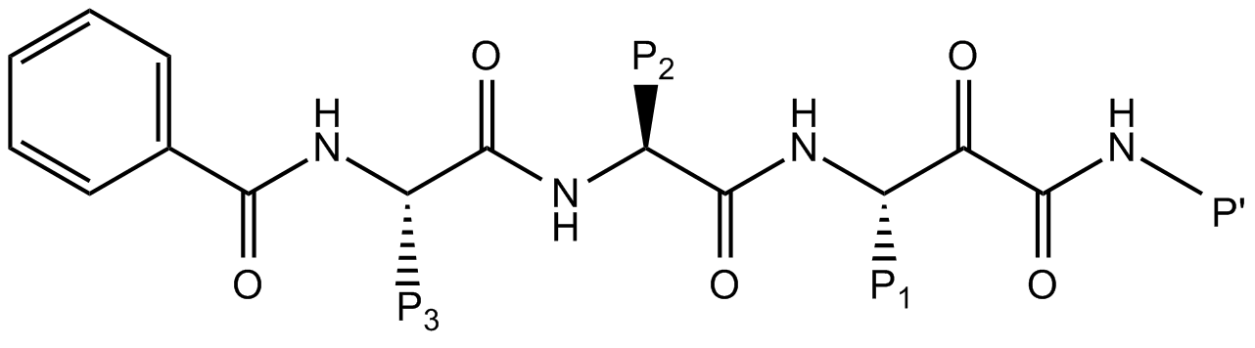

P₁ | P₂ | P₃ | P’ | Der p 1  IC₅₀ (nM) | Cathepsin B IC₅₀ (nM)
n-Bu | Me | benzyl | cyclohexyl | 8 ± 1 | 17 ± 2
i-Pr | Me | benzyl | cyclohexyl | 18 ± 2 | 52 ± 5
i-Pr | Me | benzyl | benzyl | 12 ± 2 | 50 ± 5
t-Bu | Me | benzyl | cyclohexyl | 9167 ± 880 | Not Determined
i-Pr | Me | t-Bu | cyclohexyl | 14 ± 3 | 378 ± 27
i-Pr | Me | C(Me)₂Ph | benzyl | 42 ± 6 | 446 ± 11
i-Pr | n-Pr | benzyl | cyclohexyl | 164 ± 24 | 67 ± 1

Cathepsin B inhibition was measured using enzyme from human liver preactivated by 2.5 mM 1,4 dithioerythritol at 37 °C for 10 min. Substrate was ABz-Gly-Ile-Val-Arg-Ala-Lys-DNP-OH. Progress curves were measured at 30 °C by detection of fluorescence (excitation/emission 320/420 nm).

Table 3. Fine gradient elution programme for Resource Q chromatography using an ÄKTA Purifier system with Buffer A and Buffer B containing 1 M NaCl.

Start_Conc_B | Start_ConcB {%B} | 0
Column_Equilibration | Equilibrate_with {CV} | 1
Sample_Injection | Empty_loop_with {ml} | 5
Wash_Out_Unbound_Sample | Wash_column_with {CV} | 2
Gradient_Segment_1 | Target_ConcB_1 {%B} | 5
 | Length_of_Gradient_1 {CV} | 0
Gradient_Segment_2 | Target_ConcB_2 {%B} | 5
 | Length_of_Gradient_2 {CV} | 5
Gradient_Segment_3 | Target_ConcB_3 {%B} | 10
 | Length_of_Gradient_3 {CV} | 5
Gradient_Segment_4 | Target_ConcB_4 {%B} | 10
 | Length_of_Gradient_4 {CV} | 5
Gradient_Segment_5 | Target_ConcB_5 {%B} | 17.5
 | Length_of_Gradient_5 {CV} | 20
Gradient_Segment_6 | Target_ConcB_6 {%B} | 20
 | Length_of_Gradient_6 {CV} | 10
Gradient_Segment_7 | Target_ConcB_7 {%B} | 50
 | Length_of_Gradient_7 {CV} | 5
Gradient_Segment_8 | Target_ConcB_8 {%B} | 50
 | Length_of_Gradient_8 {CV} | 5
Gradient_Segment_9 | Target_ConcB_9 {%B} | 100
 | Length_of_Gradient_9 {CV} | 5
Gradient_Delay | Gradient_Delay {ml} | 5
Clean_after_Elution | Clean_with {CV} | 10
Length_of_Reequilibration | Reequilibrate_with {CV} | 10

Table 4. Map for screening Der p 1 inhibitors using a 96-well format.

C1 | 50 | 25 | 12.5 | 6.25 | 3.125 | 1.56 | 0.78 | 0.39 | 0.195 | 0.0975 | 0.0488 | NC
C1 | 50 | 25 | 12.5 | 6.25 | 3.125 | 1.56 | 0.78 | 0.39 | 0.195 | 0.0975 | 0.0488 | NC
C2 | 50 | 25 | 12.5 | 6.25 | 3.125 | 1.56 | 0.78 | 0.39 | 0.195 | 0.0975 | 0.0488 | NC
C2 | 50 | 25 | 12.5 | 6.25 | 3.125 | 1.56 | 0.78 | 0.39 | 0.195 | 0.0975 | 0.0488 | NC
C3 | 50 | 25 | 12.5 | 6.25 | 3.125 | 1.56 | 0.78 | 0.39 | 0.195 | 0.0975 | 0.0488 | PC
C3 | 50 | 25 | 12.5 | 6.25 | 3.125 | 1.56 | 0.78 | 0.39 | 0.195 | 0.0975 | 0.0488 | PC
C4 | 50 | 25 | 12.5 | 6.25 | 3.125 | 1.56 | 0.78 | 0.39 | 0.195 | 0.0975 | 0.0488 | PC
C4 | 50 | 25 | 12.5 | 6.25 | 3.125 | 1.56 | 0.78 | 0.39 | 0.195 | 0.0975 | 0.0488 | PC

C1- C4: Compound identifier
The unit of concentration for the inhibitors is μM
PC: Positive control (Der p 1 without inhibitors)
NC: Blank without Der p 1
Table 5. Second order rate determinations for acyloxymethyl ketone derivative ADZ 50,000 versus Der p 1 showing example assay standard deviation (SD).

K_{obs}/I (x 10⁸ M⁻¹ s⁻¹) | Assay 1 | Assay 2 | Assay 3 | Assay 4 | SD inter-daily
Plate 1a | 1.42 | 1.74 | 1.48 | 1.33 | 0.1761
Plate 1b | 1.52 | 1.33 | 1.15 | 1.35 | 0.1513
Plate 2a | 0.97 | 1.0 | 0.93# | 0.83# | 0.0741
Plate 2b | 1.18 | 1.29 | 0.95# | 0.99# | 0.1603
Within-day SD | 0.2470 | 0.3045 | 0.2551 | 0.2568 | /

K_{obs}/I was measured in 5 replicates except where indicated # when n=4.
Figure 1

Figure 2
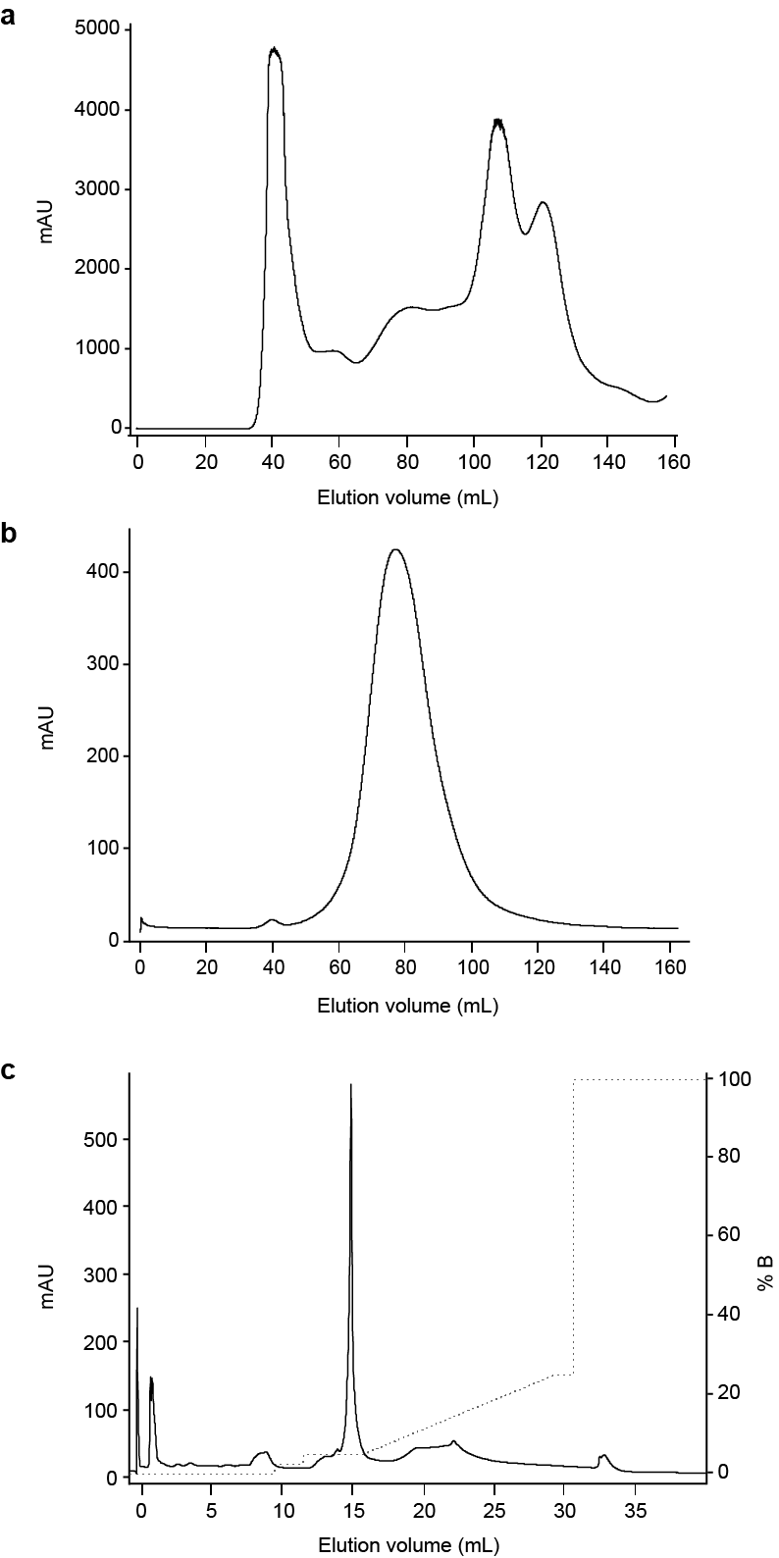
Figure 3
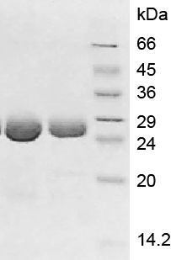
Figure 4
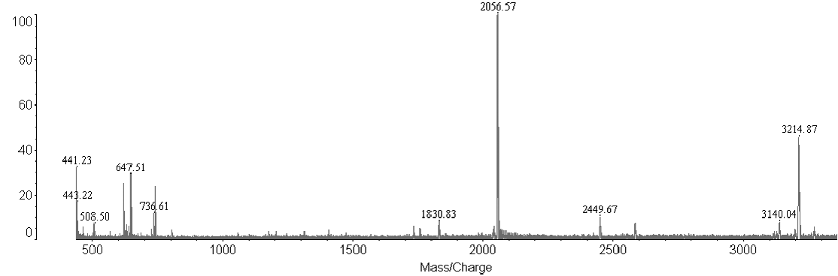
Figure 5
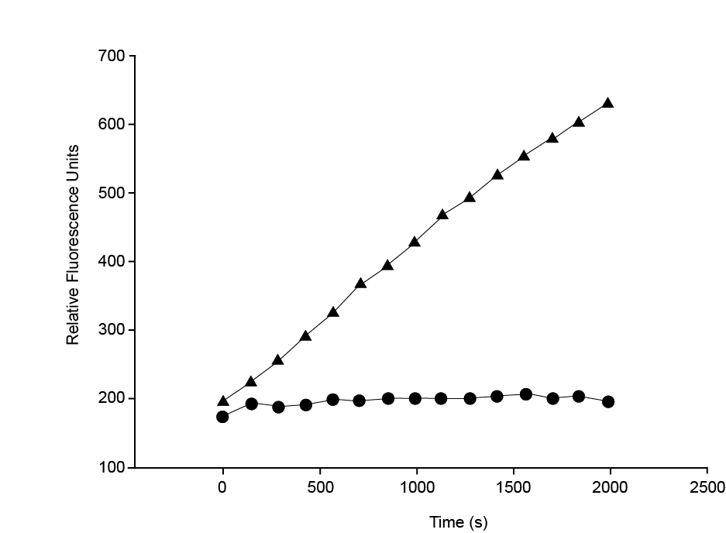

Figure 6

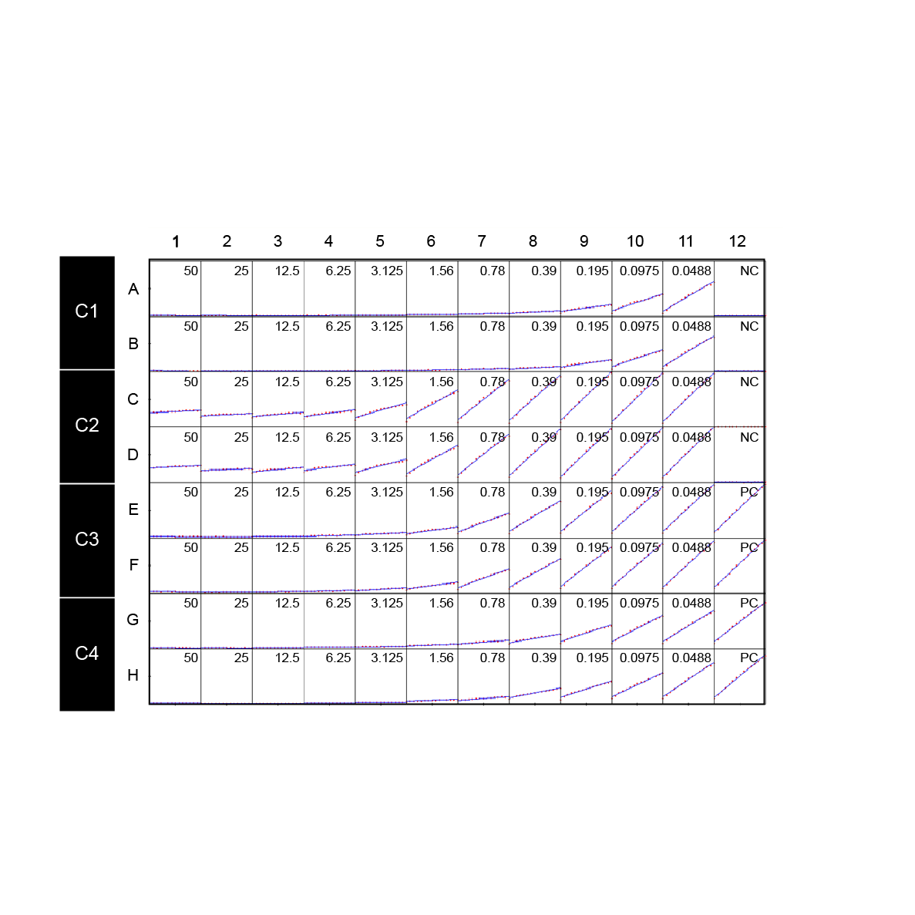

References

1. Stewart GA, Richardson JP, Zhang J, Robinson C. The structure and function of allergens. In: Adkinson NF, Bochner BS, Burks AW, Busse WW, Holgate ST, Lemanske RF, et al., editors. Middleton's Allergy - Principles and Practice. Philadelphia Elsevier Saunders; 2014. p. 398-429.
2. Zhang J, Hamilton JM, Garrod DR, Robinson C. Interactions between mature Der p 1 and its free prodomain indicate membership of a new family of C1 peptidases. Allergy 2007; 62:1302-9.
3. Robinson C, Zhang J, Newton GK, Perrior TR. Nonhuman targets in allergic lung conditions. Future.Med Chem. 2013; 5:147-61.
4. Zhang J, Chen J, Allen-Philbey K, Perera Baruhupolage C, Tachie-Menson T, Mangat SC, et al. Innate generation of thrombin and intracellular oxidants in airway epithelium by allergen Der p 1. J Allergy Clin Immunol 2016; 138:1224-7.
5. Chen J, Zhang J, Tachie-Menson T, Shukla N, Garrod DR, Robinson C. Allergen-dependent oxidant formation requires purinoceptor activation of ADAM 10 and prothrombin. J Allergy Clin Immunol 2017; 139:2023-6 e9.
6. Meno K, Thorsted PB, Ipsen H, Kristensen O, Larsen JN, Spangfort MD, et al. The Crystal Structure of Recombinant proDer p 1, a Major House Dust Mite Proteolytic Allergen. The Journal of Immunology 2005; 175:3835-45.
7. de Halleux S, Stura E, VanderElst L, Carlier V, Jacquemin M, Saint-Remy JM. Three-dimensional structure and IgE-binding properties of mature fully active Der p 1, a clinically relevant major allergen. J Allergy Clin Immunol 2006; 117:571-6.
8. Hewitt CR, Horton H, Jones RM, Pritchard DI. Heterogeneous proteolytic specificity and activity of the house dust mite proteinase allergen Der p I. Clin Exp Allergy 1997; 27:201-7.
9. Newton GK, Perrior TR, Jenkins K, Major MR, Key RE, Stewart MR, et al. The discovery of potent, selective, and reversible inhibitors of the house dust mite peptidase allergen Der p 1: an innovative approach to the treatment of allergic asthma. J Med Chem 2014; 57:9447-62.

