UCL The UCL Lancet Commission on Migration and Health: The health of a world on the move
Prof Ibrahim Abubakar*¹ FRCP, Robert W Aldridge*² PhD, Delan Devakumar*¹ PhD, Miriam Orcutt*¹ MBBS, Rachel Burns¹ MSc, Prof Mauricio L Barreto³ MD, Poonam Dhavan⁴ MPH, Fouad M Fouad⁵ MD, Prof Nora Groce⁶ PhD, Prof Yan Guo⁷PhD, Sally Hargreaves^{8,9} FRCPE, Michael Knipper¹⁰ MD, Prof J Jaime Miranda¹¹ MD, Prof Nyovani Madise¹² PhD, Prof Bernadette Kumar¹³ Dr.Philos, Davide Mosca^{4 ‡} MD, Prof Terry McGovern¹⁴ JD, Leonard Rubenstein¹⁵ LLM, Prof Peter Sammonds¹⁶ PhD, Prof Susan M Sawyer¹⁷ MD, Kabir Sheikh^{18,19} PhD, Prof Stephen Tollman²⁰ PhD, Prof Paul Spiegel²¹ MD, Prof Cathy Zimmerman*²² PhD, on behalf of the Migration and Health Commission#
- UCL Institute for Global Health, London, WC1N 1EH, UK
- UCL Institute for Health Informatics, London, UK
- Centre for Data and Knowledge Integration for Health (CIDACS), Fundação Oswaldo Cruz, Salvador-Bahia, Brazil
- International Organisation for Migration, Geneva, Switzerland
- Faculty of Health Sciences, American University of Beirut, Beirut, Lebanon
- Leonard Cheshire Centre, UCL Institute of Epidemiology and Healthcare, London, UK
- School of Public Health, Peking University, Beijing, China
- Institute of Infection and Immunity, St George’s, University of London, UK
- International Health Unit, Section of Infectious Diseases and Immunity, Imperial College London, London, UK.
- Institute for the History of Medicine, Justus Liebig University Giessen, Giessen, Germany
- CRONICAS Center of Excellence in Chronic Diseases, Universidad Peruana Cayetano Heredia, Lima, Peru
- Centre for Global Health, Population, Poverty and Policy, University of Southampton, Southampton, UK
- Norwegian Centre for Minority Health Research and Department of Community Medicine and Global Health, Institute of Health and Society, Faculty of Medicine, University of Oslo, Oslo, Norway
- Program on Global Health Justice and Governance, Mailman School of Public Health, Columbia University, New York, NY, USA
- Center for Public Health and Human Rights, Johns Hopkins Bloomberg School of Public Health, Baltimore, MD 21205, USA and Berman Institute of Bioethics, Johns Hopkins University, Baltimore, MD 21205, USA
- UCL Institute for Risk and Disaster Reduction, London, UK
- Department of Paediatrics, University of Melbourne and Centre for Adolescent Health, Royal Children's Hospital, and Murdoch Childrens Research Institute, Parkville, VIC, Australia
- Public Health Foundation of India, Institutional Area Gurgaon 122002, India
- Nossal Institute of Global Health, University of Melbourne, Melbourne, Victoria 3010, Australia
- MRC/Wits Rural Public Health and Health Transitions Research Unit, School of Public Health, Faculty of Health Sciences, University of the Witwatersrand, Johannesburg, South Africa
- Johns Hopkins Center for Humanitarian Health, Johns Hopkins University, Baltimore, MD, USA and Department of International Health, Johns Hopkins Bloomberg School of Public Health, Johns Hopkins University, Baltimore, MD, USA
- Gender, Violence and Health Centre, London School of Hygiene & Tropical Medicine, London, UK
‡Retired; # Full list of authors at the end of the report; *writing group;

Executive summary

With one billion people on the move or having moved in 2018, migration is a global reality —and has also become a political lightning rod. Although estimates indicate that the majority of global migration occurs within low- and middle-income countries (LMICs), the most prominent dialogue focuses almost exclusively on migration from LMICs to high-income countries. Today, populist discourse demonises the very same individuals who uphold economies, bolster social services and contribute to health services in both origin and destination locations. Those in positions of political and economic power continue to restrict or publicly condemn migration to promote their own interests. Meanwhile nationalist movements assert “cultural sovereignty” by delineating an ‘us’ and ‘them’ rhetoric which has created a moral emergency.
In response to these issues, the UCL-Lancet Commission on Migration and Health was convened to articulate evidence-based approaches to inform public discourse and policy, undertaking a wide consultation of diverse international expertise spanning sociology, politics, public health, law, humanitarianism, and anthropology. The result of this work is a report that aims to be a call to action for civil society, health leaders, academics, and policy-makers to maximise the benefits and reduce the costs of migration on health locally and globally. The outputs of our work relate to five overarching goals that we thread throughout the report.
First, we provide the latest evidence on migration and health outcomes to challenge common myths and highlight the diversity, dynamics, and benefits of modern migration as they relate to population and individual health. Migrants generally contribute more to the wealth of host societies than they cost. Our report shows that international migrants have, on average, lower mortality rates than the host country population. However, increased morbidity was found amongst several subgroups of migrants, for example increased rates of mental ill health in victims of trafficking and people fleeing conflict. Currently, the full range of migrants’ health needs are difficult to assess due to poor quality data. We know very little, for example, about the health of undocumented migrants, disabled people or LGBTI who migrate or who are unable to move.
Second, we examine multi-sector determinants of health and consider the implication of current sector-siloed approaches. The health of people who migrate depends greatly on structural and political factors that determine the impetus for migration, the conditions of their journey and their destination. Discrimination, gender inequalities and exclusion from health and social services repeatedly emerge as negative health influences that require cross-sector responses.
Third, we critically review key challenges to healthy migration. Population mobility provides economic, social and cultural dividends for those who migrate and their host communities. Furthermore, the right to the highest attainable standard of health, regardless of location or migration status, is enshrined in numerous human rights instruments. However, national sovereignty concerns overshadow these benefits and legal norms. Attention to migration focuses largely on security concerns and where there is conjoining of the words ‘health’ and ‘migration’ it is either limited to small subsets of society and policy, or negatively construed. International agreements, such as the UN Global Compacts on Migration and on Refugees, represent an opportunity to ensure that international solidarity, unity of intent and our shared humanity triumphs over nationalist and exclusionary policies, leading to concrete actions to protect the health of migrants.
Fourth, we examine equity in access to health and health services and offer evidence-based solutions to improve the health of migrants. Migrants must be explicitly included in universal health coverage commitments. Ultimately, the cost of failing to be health-inclusive may be more expensive to national economies, health security and global health than the modest investments required.

Finally, we look ahead to outline how our evidence can contribute to synergistic, equitable health, social and economic policies and feasible strategies to inform and inspire action by migrants, policy makers and civil society. We conclude that migration must be treated as a central feature of 21st century health and development. Commitments to health of migrating populations should be considered across all Sustainable Development Goals (SDGs) and in the implementation of the Global Migration and Refugee Compacts.The Commission offers recommendations that view population mobility as an asset to global health by demonstrating the meaning and reality of ‘good health for all’. We present four key messages that provide a focus for future action.

Key messages
- We call on nation states, multilateral agencies, non-governmental organisations and civil society to positively and effectively address the health of migrants by improving leadership and accountability. First, we urge the United Nations to appoint a Special Envoy on Migration and Health and national governments to have a country-level focal point for migration and health to ensure much needed coordination and that migrants are included in all decisions about their health. Second, we propose that a Global Migration and Health Observatory is established to develop evidence-based migration and health indicators to ensure better reporting, monitoring, transparency and accountability on the implementation of the migration and refugee Global Compacts.
- International and regional bodies and states should re-balance policy-making in migration to give greater prominence to health by inviting health representatives to high-level migration policy-making fora. Health leaders and practitioners must fully engage in dialogues on the macro-economic forces that affect population mobility and participate in multi-sector budgeting and programme planning for migrants.
- Racism and prejudice must be confronted with a zero tolerance approach. Public leaders and elected officials have a political, social and legal responsibility to oppose xenophobia and racism that fuels prejudice and exclusion of migrant populations. Health professionals’ and organisations awareness of racism and prejudice should be strengthened by regulatory and training bodies including through accreditation, educational courses and continuous professional development. Civil society organisations should hold leaders to account to ensure the implementation of these obligations.
- Universal and equitable access to health services and to all determinants of the highest
attainable standard of health need to be provided to migrant populations, regardless of age, gender or legal status by governments. Solutions must include input from migrants and be specific to the diverse migrant populations. For those exposed to disaster and/or conflict, mobility models and disaster risk reduction systems should be integrated. Targeted interventions to improve the rights of migrant workers’ and their knowledge of workplace health and safety and entitlement to healthcare are needed.

Introduction
Nearly one seventh of the world’s population is now living in a location different from the one in which they were born.¹ A migrant is someone who has moved across an international border or within her or his own country away from their habitual place of residence. Migration is not a new phenomenon. People have migrated throughout human history and population mobility continues to benefit many individuals and communities and contribute to social and economic advancement globally.
Despite the long history of human migration, international dialogue has recently become more prominent, although relatively limited attention has been paid to migration as a core determinant of health. When individuals migrate, they enter new environments that have different health risks and protection mechanisms.² Studies indicate that morbidity patterns among migrants are diverse and dynamic because of numerous interacting influences, such as: an individual’s pre-departure health,socio-economic and environmental conditions, local disease patterns and risk behaviours, cultural norms and practices, and access to preventive or curative therapies throughout the migration process.³
Health outcomes in migrants are heterogeneous, but evidence consistently shows the disproportionate health, social and economic burdens of forced migration.⁴ Yet, despite widespread recognition of the numerous migration-related health risks, mobile populations—even forced migrants who are fleeing for their lives—are often met with punitive border policies, arbitrary detention, abuse and extortion and commonly denied access to care. Governments that institute immigration policies that legalise exclusion and rights abuses frequently cite ‘national security’ concerns to justify migration controls that extend beyond their own borders. These policies can go as far as criminalising migrant status, and detering asylum seekers by detaining them; even separating children from their parents, as recently seen in US government immigration policies.⁵ All too often, government policies prioritise the politics of xenophobia and racism over their responsibilities to act forcefully to counter them.
Our current political economy is driven by Western industrial powers that draw on natural and human resources in low- and middle-income countries (LMICs). Moreover, laws and regulations that encourage relatively unrestricted trade in goods, services and capital are simultaneously being used to control labour mobility to further the political and economic interests of the wealthy while often leaving poor communities behind. For example, global trade and pro-business policies in lower-income countries have drained natural resources, contributed to environmental degradation and pushed people into hazardous, exploitative work to meet consumer demands for cheap goods such as ‘fast fashion’.⁶
International conventions are in place to guide policy to support safer and more inclusive migration and can be used to counter some of these negative forces. Migrants, as all human beings, are equally entitled to universal human rights without discrimination. All migrants thus have the right to the “highest attainable standard of health”, according to international law.⁷ All migrants are entitled to equal access to preventive, curative and palliative health care.⁸ They also have rights to the underlying social, political, economic, cultural determinants of physical and mental health, such as clean water and air and non-discriminatory treatment.⁸ Human rights treaties also entitle migrants to due process of law in border practices and freedom from arbitrary detention and restrictions on movement. These rights do not simply impose legal obligations on governments but are essential preconditions for social and economic integration, prosperity, and social cohesion in any society and ”human well-being in the modern world.”⁹ The substantial gap between the international legal requirements guaranteeing the human rights of migrants and the implementation of these laws by states provides important context for this Commission report.
In 2016, at the UN General Assembly, the Global Compact for ‘safe, orderly and regular migration’ and a further Compact to respond to acute and chronic refugee situations were initiated in line with the 2030 Agenda for Sustainable Development target 10.7 (to ‘facilitate safe, orderly and responsible migration’).^{10,11} Yet, these critical multi-lateral processes appear to be heading in a precarious direction, as exemplified by the US Government’s withdrawal from the Compact on safe, orderly and regular migration in 2017,¹² potential internment camps titled ‘migrant centres’¹³ and the reticence of European Union countries in accepting an equitable redistribution of migrants.

Our Commission’s Journey
Worldwide mobility is our future—regardless of laws and walls, and our Commission was developed in light of the opportunity to achieve the SDG commitments “to leave no one behind” and “to reach first those who are furthest behind,”¹⁴ and in the context of States’ guarantees to protect the human rights of migrants. Initially we brought together 20 Commissioners ensuring gender and geographical representation to generate transdisciplinary evidence, contemporary thought and global expertise that draws on multiple scientific perspectives. To achieve this aim Commissioners were drawn from a range of scientific backgrounds including public health, sociological, policy, legal, anthropological and humanitarian.
We initially structured our work around the key themes of Health systems; Labour migration; Forced migration; Vulnerabilities; Law, human rights and politics; Socio-cultural factors and identity; and Data and health outcomes. We undertook a series of rapid systematic reviews to identify key literature in each area and building upon these, as well as two formal systematic reviews and meta-analyses that informed the Commission and are published in detail alongside the report. Our work was conducted over a two year period with a week long in-person review of the first draft of the Commission at the Rockefeller Foundation, Italy, in November 2017.
The principles that underpin our report are those of equity and healthy inclusion. The Commission settled upon five goals to examine in-depth which provide a focus throughout the four sections of the final report. First, we review current evidence on migration and health, challenge common myths and describe the composition and characteristics of population mobility and assess uses and limitations of migrant categories. Second, we examine multi-sector determinants of health and consider the implication of current sector-siloed approaches, such as the dichotomous goals of the health versus the security sectors. Third, we critically review key challenges to healthy migration by analysing health and migration in relation to: culture and identity, rights, legal issues, and the environment and climate change. Fourth, we examine equity in access to health and health services and offer evidence-based solutions to improve the health of migrants. Fifth, we look ahead to consider how our evidence can contribute to synergistic, ethical policies and feasible strategies to inform and inspire action by governments, international agencies and health professionals to promote health amidst global mobility.
To tackle this complex subject, we developed a ‘Migration and Health Determinants Framework’ to consider the interactions between migration and the health of individuals, populations and global health (See supplementary appendix, Figure 1). The Framework highlights key factors influencing the health of mobile populations including: legal, social, health structures and systems; service access and support; exposures and behaviours particular to migrants; and the epidemiological changes (positive and negative) related to population mobility. These health influences are generally relevant for each stage of a migration process. Our report thus offers evidence on how various factors might benefit or be detrimental to individual and population health throughout a journey—including at origin, transit, destination and return.
Migration and health is a diverse topic with an extensive existing literature. While we consciously start with a broad and ambitious remit, it is not possible to cover all aspects of migration and health, nor give an overview of all groups of migrants and the conditions they experience. There are many other facets of migration and health that were beyond the specific remit or bounds of the five main goals of this Commission but we plan to do more in the post-Commission phase in collaboration with others across sectors who are working in this space. Recognising the recent Lancet series on Conflict and Health, and the Syria Lancet Commission, we have not presented substantive amounts of reference to policy documents or examples of best practice, or deeper analysis in the field of refugee studies. We feel these areas and wider collaboration on forced migration will be key for the post-Commission phase in achieving further research, policy and operational impact. Whilst we cite cases of operational practice, we were unable to systematically explore grey literature or repositories of migration and health operational and interventional practice.

Section 1: The Case for Action – What do we know about migration and health

Migration is a dynamic process
Migration seldom involves a single long journey from one place to settle in another. The diversity and complexity of migration patterns include people traveling long and short distances, within and across borders, for temporary or permanent residency and often undertaking the journeys multiple times. A clear delineation or rigid categorisation of different types of migration is rarely possible. The categorising process attempts to classify a large, heterogeneous population according to limited criteria, which are not generally suited to capture the complex social dynamics of human mobility or necessarily the perspectives or needs of the people who are moving. Terms such as “voluntary” or “forced” migration and categories such as “refugees”, “asylum seekers”, “international” and “internal” migrants can partially help to understand migration dynamics. These same terms can also be used to “other” and discriminate against migrants, as well as being generally administrative definitions used to classify migrants for protection, assistance or research—rather than a true representation of individual circumstances. For example, legal categories are instrumental for migration control and management by states and international agencies providing support but may not fully explain an individual’s circumstances. However, for the purposes of the evidence presented in this report, we often use existing definitions (See supplementary appendix, Table 1), which enable us to draw on current migration literature and data sources. At the same time, throughout the report we will highlight the complex drivers of migration, and the difficulties and potential dangers of assigning singular or narrow definitions. Migrant categories are not necessarily objective or neutral; distinctions frequently reflect particular assumptions, values, goals and interests of the parties who assign these labels.
It is also difficult to categorise people in relation to their reasons for migrating. There are a myriad of negative drivers and positive aspirations (‘push’ or ‘pull’ factors) that motivate people to migrate. Individuals, families and groups often have mixed motives for migrating, and their reasons can change over the course of a single journey. For instance, people seeking safety from conflict may be classified as refugees, asylum-seekers, undocumented or internally displaced persons, but before and during transit—especially in protracted conflicts where aid resources are insufficient—migration decisions may also relate to livelihoods and employment. ‘Distress migration’ or migration due to entrenched poverty, food insecurity and household economic shock (e.g., illness, debt), is common worldwide. Distress migration is linked to local unemployment, household financial crises, poor crop production and in some instances, forced evictions, for example, linked to rising real estate prices, large development projects and land confiscation.
Regardless of migration motives, economic contributions, or people’s rights, amidst populist rhetoric, the amorphous labelling of people who move as ‘migrants’ has seemed to become a condemnatory marker for populations who have fewer resources, such as refugees, asylum-seekers, undocumented migrants and low-wage workers. Moreover, in an era of xenophobic politics, the catch-all term ‘migrants’ obscures the net social, political and economic benefits of migration for destination communities, and contributions to places of origin, that support families and supplement development aid, which, in sum, promise greater global health.

Health throughout the migration process
Migration trajectories involve various phases, (figure 1) including: pre-departure circumstances at places of origin; short or long-term transit, which may involve interception by authorities, non-governmental groups or criminal gangs; destination situations of long- or short-term stay; and return to places of origin for re-settlement or for temporary visits before re-migration.³ In each phase of a person’s journey there are potential health risks and possible protective factors that can have a short or long-term impact on their well-being. As previously noted, the journeys are often diverse and rarely singular. For example, it is especially common for labour migrants to undertake circular migration, transiting back and forth between their place of origin and destination or re-migrating to a new destination. When people are transiting between locations, their health and safety depend on the forms of transport (air travel, on foot across deserts, hidden in lorries) and the pathogenic or environmental exposures (malaria, tuberculosis, heat exhaustion, dehydration) along the transit routes.¹⁵ Return migration also poses both health risks and benefits. For instance, communities of origin may benefit from new skills or improved health behaviours gained by returning migrants,¹⁶ but conversely, individuals who are injured or disabled during their journey may return to locations with few services or support mechanisms. Importantly, policies to protect migrants’ and public health will be most effective if they take advantages of opportunities to address people’s health needs at the multiple phases of the migratory process.³ Maintaining the mental health and wellbeing of migrants and the families they may leave behind is particularly important. Even in ideal conditions, migration is stressful, and most people move in ways that are far from ideal; which coupled with the causes of migration, can lead to mental ill health.

Migration, gender and health
Both population mobility and the health implications of migration are highly gendered. That is, women, men and sexual minorities are likely to encounter different health risks and protection opportunities at each phase of a migration journey - a journey they may have undertaken to flee gender-based violence. The risks begin before departure, where women and children may be at risk of violence and discrimination. Amongst those who are forcibly displaced, there is a particular risk of sexual violence, coercion and sexual exploitation, such as recent accounts of widespread rape of Rohingya women and girls,¹⁷ or when moving along irregular and dangerous routing ending in official and unofficial detention centres such as the case of Libya.¹⁸ Even when reaching zones of apparent safety, women and children have been exploited by humanitarian workers, a problem that remains widespread suggesting that some protectors need to be protected against.¹⁹ A systematic review of women and girls in conflict-affected settings indicated their extraordinary vulnerability to various forms of human trafficking and sexual exploitation, frequently occurring as early or forced marriage and forced combatant sexual exploitation.²⁰ Women and children are especially at risk when they migrate without the protection of family or social networks. Unaccompanied girls and boys who move in ways that are not readily detected by potential support mechanisms are particularly vulnerable to neglect, trafficking, abuse and sexual exploitation, such as survival sex among Afghan refugee boys who shelter in parks and makeshift camps in Greece.²¹ Child marriages appear to increase among displaced populations,²² as parents are often forced to make impossible choices about their daughters based on their fear of sexual violence by armed forces or combatants and economic hardship.²³ Sexual minorities might be among the most neglected and at-risk populations in circumstances of migration. The stigma associated with being lesbian, bi-sexual, gay, transsexual, or intersex (LGBTI) can subject individuals to bullying and abuse or force them to remain invisible. There appears to be little training for health and humanitarian aid professionals currently to meet the health needs of sexual minorities.

Challenging myths
In our current political climate, the term ‘migrant’ raises a litany of myths and inaccurate stereotypes. While often used for cynical political gain, stigmatising falsehoods about migrants frequently become publicly accepted. We will respond to common myths by offering data-driven facts.

Are high-income nations being overwhelmed by migrants? Dialogue on migrants often centres around absolute numbers of migrants crossing international borders into high-income countries (HIC). This rhetoric rarely acknowledges that there has been little change in the proportion of the world’s international migrants, which has only risen from 2.0% to 3.3% from 1975 to 2015 globally (figure 2A). And, while HICs have seen a greater rise, from 4.3% to 13.3% (1960 to 2015), it is important to note that the proportion of the total population that were individuals who have been displaced and are currently living in HICs is considerably smaller than in LMICs. Furthermore, the figures in high income settings include, for instance, students²⁴ who pay for their education and often return to their countries of origin and labour migrants who are net positive contributors to the economy. Previous waves of migration as a proportion of the global population (e.g. Europeans colonising the Americas & Australasia) have been vastly greater than these recent trends. Similarly, the proportion of the world’s population that were refugees was relatively stable between 1960 and 2015 but HICs saw a slight decrease and it was low income countries (LICs) that experienced fluctuations from 0.1% to 1.3% (figure 2B). These data illustrate that despite popular discourse to the contrary, changes in migration are more complex than the simple narrative of a rise in numbers. Overall, mobility patterns are highly regional and context specific with less wealthy nations bearing a disproportionate burden of hosting vulnerable displaced populations.
Are migrants a burden on services? Macro-economic analysis on the impact of asylum seekers in Europe concluded that they have a positive impact on host countries’ economies.²⁵ Today, rather than burdening systems, migrants in HICs are more likely to bolster services by providing medical care, teaching children, caring for grandparents and undergirding understaffed services. Migration provides much-needed high and low-skilled workers into economies. The way healthcare markets are constructed – from both supply and demand side – is inextricably connected with human mobility. Hospitals, residential homes, childcare centres, domestic and professional cleaning services are often staffed by migrants. Migrants comprise a substantial portion of the health workforce in many HICs and contribute to a significant “brain gain” in net-migrant receiving countries.²⁶ For example, 36% of doctors in the UK gained their medical qualification in another country.²⁷ Healthcare workforce migration from poorer to wealthier countries has been the subject of extensive academic literature. Health professionals migrate because of low remuneration, poor working conditions, work overload, and poor opportunities for professional advancement in their home countries.²⁸ Higher income countries reap the benefits. It is LMICs such as Syria and Turkey, who host a higher proportion of vulnerable migrants, where services are challenging to deliver for the poorest members of society. While many migrants are able to access the labour markets, there are also many who may not have this same access with immediate and long-term consequences on livelihoods, social security, education and health. Our systematic review and meta-analysis of global patterns of mortality however, provides strong evidence that international migrants - particularly those who are more likely to have actively chosen to migrate such as economic, student, and family reunion migrants - have a mortality advantage compared to host populations across the majority of ICD10 disease categories.
Are fertility rates among migrants higher than among host populations? Despite populist rhetoric that migrants have many more children than host populations, the growth and decline of migrant populations in a country are affected by birth and death rates and inward and outward migration from a country. Using large-scale longitudinal data from six countries (Germany, Sweden, United Kingdom, France, Spain and Switzerland), researchers found that migrants have lower first-birth rates than non-migrants with the exception of migrant Turkish women.²⁹ Moreover, birth rates among migrants are barely at the level of population replacement (a total fertility rate below 2.1 births per woman) and often falling. Access to contraception also influences differences in fertility rates. Poor access to contraception among migrants is often related to inconsistent policies, guidelines and provision of services, such as in the EU, where migrants appear to have inadequate access to sexual and reproductive health care, including family planning services.³⁰
Evidence about fertility and its relation with internal migration in LMICs is limited. Using Demographic and Health Survey (DHS) data on the use of modern contraception by individuals’ migration category in five LMICs (Ethiopia, India, Kenya, Malawi and Tanzania) we showed that, in each country, internal migrants used modern contraception methods more often than non-migrants (figure 3). These results may be explained, in significant part, by people’s educational and socio-economic status, supporting evidence that migrants have lower first-birth rates than non-migrants—and dispelling populist views about fertility among migrants. However, these data may not represent patterns among more marginalised groups such as undocumented migrants, refugees, asylum seekers or displaced populations in humanitarian crisis situations—where rape is common and there is even greater need for readily accessible sexual and reproductive health care.³¹
Are migrants damaging economies? There is overwhelming consensus on the positive economic benefits of migration which is insufficiently acknowledged. In settings that offer universal access to minimum economic benefits, there has been much debate whether migrants receive more in social assistance than they contribute in taxes. The evidence examining this issue generally suggests that migrants make greater overall contributions, except in countries with a high proportion of older migrants. In advanced economies, each one percent increase of migrants in the adult population increases the GDP per person by up to two percent.³² Migrants increase income per person and living standards through greater contribution to taxes than the social benefits they receive.³³ Furthermore, in Europe free movement has been demonstrated to address imbalances in the labour market³⁴ by serving as an equilibrating force through the provision of labour where and when needed. These benefits are not just accrued by the wealthiest in society, as evidence also supports the increase in average income per person at the bottom and the top of income scales. Moreover, the World Bank Group estimated that migrants sent a total sum of US$613 billion to their families at origin in 2017. Approximately three quarters of these remittances were sent to LMICs -an amount that is more than three times larger than official development assistance - and these remittance flows have been growing steadily since 1990.³⁵ In countries such as Liberia, Nepal and Tajikistan, up to one-third of the gross domestic product comes from international remittances. Globally these sums of money are large and transformatory for the lives of non-migrants. (See supplementary appendix, Figure 2).
Are migrants disease-carriers that pose risks to resident populations? Suspicion against migrants to be “carriers of disease” is probably the most pervasive and powerful myth related to migration and health throughout history.³⁶ Although there are historical examples of the introduction of disease into new settings through human mobility (e.g., the spread of infection from European colonial settlers), the risk of transmission from migrating populations to host populations is generally low. For example, studies on tuberculosis, suggest that the risk of transmission is elevated within migrant households and migrant communities, but not in host populations.^{37,38} Nonetheless, several HICs screen migrants for tuberculosis as part of pre-migration visa application checks.³⁹ While tuberculosis screening systems may benefit individuals through early detection, screening is often stigmatising and can spur xenophobic media messages,⁴⁰ despite the negligible risk of transmission in countries with functioning public and universal health systems.³⁷ Migrant populations may come from countries with a high burden of disease⁴¹ and it is not uncommon for disease outbreaks to be found in situations of conflict, which dismantle already weak public health systems. Illness and infections may also be acquired or spread via transit routes and transport means. For example, air travel can facilitate rapid geographic spread of infections. However, even risk of air travel-related outbreaks is low to modest if the destination setting has strong surveillance and inclusive public health services,⁴² which are also crucial to prevent pandemics, whether associated with population movement or not.⁴³ Epidemiological patterns and related risks are readily addressed by assessing the infectious disease burden among populations and using data to design targeted interventions to contain outbreaks and prevent new infections through immunisation. Because of the prejudice and unfounded fear that can be generated by misuse of surveillance data, caution is required when releasing potentially stigmatising disease prevalence figures for public consumption. We revisit this issue throughout the report and discuss the misuse of data in panel 5.

Composition of mobile populations
Understanding the health of people on the move requires clarity about who is moving, why and where, and the potential positive and negative effects. In this section, we offer an overview of: international migrants; internal migrants; labour migrants; refugees; asylum-seekers; internally displaced persons (IDP) and climate refugees - an emerging group that is likely to increase. Data will be presented using the most widely applied migration categories, despite our previously stated reservations about their weaknesses, reviewing numbers and their associated limitations, geographical distribution, age and sex characteristics and key issues for each group.

International Migration: In 2017, there were an estimated 258 million international migrants—which accounted for 3.4% of the world’s population.⁴⁴ Notably, most data on international migration between 1960 and 2015 did not classify migrants by subgroup. Recent estimates by the International Labour Organization indicate that labour migrants comprised 61% of all international migrants in 2015 —however this figure is based on limited data and this was the first year for which data were available (figure 4a). Figure 4b outlines the number of international migrants by age, sex and region in 2015. Europe has the largest number of international migrants (76 million), closely followed by Asia (75 million) and North America (55 million). Globally, the largest number of international migrants were in the 30-34 age group and 48% were female. To date, data come primarily from population censuses, population registers and nationally representative surveys, often using place of birth to determine international migrant status. For 47 countries, place of birth is not available, so country of citizenship is used instead potentially leading to overestimation of international migrant numbers, but conversely, these data can also underestimate by inappropriately excluding people born abroad with local citizenship. Data collection on international migration would benefit from better information on subgroups and categories of migrants that are currently not adequately counted so that vulnerable groups are not omitted from needs assessments and budget allocations for responses.

Internal Migration: While international migration receives the most political and public attention, the majority of movement globally is internal migration. In 2009 the number of people who moved across the major zonal demarcations within their countries was nearly four times larger (763 million) than those who moved internationally. ⁴⁵ Approximately 40% of urban growth in Asia, Africa and Latin America results from internal migration from rural to urban areas.⁴⁶ In many LMICs, rural to rural internal migration to work in the agriculture sector still accounts for the largest number of people on the move.⁴⁷ In the past, evidence suggests that internal migration was dominated by single men, however, recent trends show increases in women moving for work and to seek freedom from discriminatory social and cultural norms.⁴⁸ From 2014 to 2050, the proportion of people living in urban areas, largely due to migration from rural areas, in Asia and Africa are expected to increase from 48% to 64%, and 40% to 56% respectively.⁴⁶ Producing global estimates on internal migrants is methodologically challenging and routine data are rare.⁴⁹
There are considerably more internally displaced persons due to conflict and natural disasters than asylum seekers and refugees globally. However, they also receive substantially less attention than the latter, primarily due to the importance attached to national borders, citizenship and the availability of better data collection for refugees. In 2016, there were 31.1 million newly internally displaced people, with a total of 40.3 million people internally displaced globally.⁵⁰ Asia was the region with the highest number of IDPs. Between 2009 and 2016, the number of individuals displaced due to conflict were fewer than those resulting from disaster (figure 5).

Labour Migration: The International Labour Organization (ILO) estimates suggest that in 2013 there were 150.3 million international migrant workers in the world. While official figures indicate that the largest proportion of international labour migrants is in North America and Northern, Southern and Western Europe, this is perhaps misleading. Regional labour migration among LMICs often goes uncounted due to regional and bilateral labour and trade agreements and undocumented or irregular border-crossing.^{51,52} LMICs are estimated to host roughly 13.6% (20.4/150.3) of total labour migrants globally.^{51,53} Moreover, it is important to note that these figures will be under-estimates as they exclude undocumented international migration between neighbouring countries and workers in the informal economy. Among labour migrants globally, recent figures indicate that there are more male migrant workers (55.7%) than female (44.3%).⁵¹ Women more commonly work in service jobs (74%) and less often in manufacturing and construction work (15%).^{51,53} Increases in female migration may be due in part to shifts in gender, social and migration norms, and in other part by remittances,⁵⁴ which create greater opportunity for women to migrate. Adolescent girls also migrate for work, driven by financial incentives,^{55,56} and hopes for greater freedom and empowerment. However, there is growing recognition of the number of young women who end up in exploitative work.⁵⁷ There is extraordinarily limited comparative national data on the patterns and prevalence of internal labour migration, especially for harder to monitor forms, such as seasonal and often circular migration.

Forced Migration: Two billion people currently live in countries affected by civil unrest, violence or ongoing conflict.⁵⁸ Using data on historical refugee numbers which fall under UNHCR’s mandate, the proportion of international migrants who were refugees has remained below 10% following a peak in 1985 at 9% (figure 4a). Consistent with the trend in proportions, the number of refugees declined from 17.8 million to a low of 8.7 million from 1992 to 2005, followed by an increase to 19.9 million in 2017 (figure 6). Africa had the highest percentage of refugees under 18 in terms of the countries of origin and countries of asylum application in 2015 (See supplementary appendix, Figure 3). Further details on the regional variation in the number of refugees are provided in the See supplementary appendix, Figure 4 and Figure 5. Previously most forcibly displaced people were from LICs and lived in camp-like settings, however, current refugees are more likely to live out of camps. Most refugees reside in LICs and recent wars and forced displacement, in the Middle East in particular, have caused millions of refugees to reside in urban and peri-urban settings, often with undocumented status. For example, less than a fifth of refugees in Jordan live in camps.⁵⁹
There were an estimated 1.9 million claims for asylum in 2017 and total 3.1 million asylum seekers whose refugee status was yet to be determined.⁶⁰ There is enormous variation in the total number of asylum seekers by country of origin (See supplementary appendix, Figure 6) reflecting proximity to source countries, and the proportion successfully securing refugee status. The numbers in other categories of forced migrants who are undocumented, and often the most vulnerable, are not available as these individuals are often not in contact with authorities.
Resettlement is a considerable challenge. Refugees with acute health and medical needs are among the top priorities for consideration for resettlement referral by UNHCR, and some resettlement countries expedite consideration of refugees facing acute health risks. In 2018 UNHCR determined that about 1.2 million refugees around the world needed resettlement.⁶¹

Human trafficking and modern slavery: Human trafficking, forced labour and forced marriage, now referred to collectively as ‘Modern Slavery’, is estimated to affect 40.3 million people globally, according to recent estimates from the ILO.⁶² These new figures indicate there were 25 million people in forced labour and highlight that there are also 15 million in forced marriage. This equates to 5.4 victims for every 1000 people in the world.⁶³ Regionally, Asia appears to have the largest number of trafficking victims, with 62% of all trafficked persons, followed by Africa (23%). Women and girls are disproportionately affected, accounting for 71% of these victims, as are children, with one in four victims under the age of 18. Females are commonly trafficked for sex work, domestic service and as brides. Men and adolescent boys are more likely to be recruited—often deceptively—for various forms of strenuous manual labour, including commercial fishing and construction.⁶⁴ Sexual minorities who are trafficked are often subjected to forced sex work.

Climate Change Refugees: Global climate change, driven by anthropogenic atmospheric and oceanic warming, and its global impact on rising sea levels, shrinking cryosphere and ocean acidification, has the potential to affect and disrupt well-known drivers and mechanisms of migration in the future on an unknown but potentially dramatic scale. The Lancet Commission on Health and Climate Change: policy responses to protect public health,⁶⁵ discusses the potential effects on migrants including impact on urban health, extremes of heat, and the social impact of population redistribution due to people who cannot move. A recent study suggests that by 2070 deadly heatwaves due to the combined impacts of climate change and the vast expansion of irrigated agriculture could make large parts of northern China, with a population of 400 million, uninhabitable.⁶⁶ Climate change will also increase the frequency and intensity of hydrometeorological hazards.⁶⁷
According to a recent report by the World Bank, climate change has the potential to force more than 143 million people to move within their country by 2050.⁶⁸ The messages are that internal climate migration may be a reality but not necessarily a crisis and that migration can be a sensible climate change adaptation strategy if managed carefully and supported by good development policies and targeted investments. There is large uncertainty in the impacts of climate change on migration because migration is driven by complex multi-causal processes which also include social, economic, political and demographic dimensions which impact on each other and can be driven by the effects of climate change. The uncertainty is compounded by the fact that refugees from conflict, war or persecution are protected by the 1951 Convention relating to the Status of Refugees and its 1967 Protocol, but in contrast no international law recognises climate refugees, who are mostly seen as searching for better economic conditions. The World Bank report is limited to internal displacement, which limits its scope. For Bangladesh, a country usually considered to be in the front line for climate change impacts, the World Bank projects that by 2050 there will be 13.3 million climate migrants (surpassing the number of other internal migrants).⁶⁸ In Panel 1, this projection is tested, using detailed census data over the period is 2001-11. Migration attributed to hydrometeorological hazard risks from all causes are projected up to 2050 and exceeds the World Bank figure of 13.3 million internal climate migrants. So as with northern China, the combination of global climate change and local anthropogenically-driven environmental degradation may trigger dramatic increases in migration. For Bangladesh, there has been no automatic assumption that climate change will cause mass migration in our analysis, but rather that mass migration is occurring now and will increase, projected from current trends based on large-scale census data.

Political, cultural, environmental and structural determinants of migration and health

Political determinants of health
Migration has become highly politicised, especially as certain politicians try to curry electoral favour by migrant-blaming and undermining the welfare state. Stigmatising rhetoric has meant that the rights of migrants are under attack by the same structures and processes that are supposed to protect them, both in their country of origin -potentially leading some to move- and during their migration journey. The views, words and actions by those in power both instigate discrimination and restrict access to education, work, justice and health. The term “fake news” has recently been created to describe inaccurate information deliberately created or used to mislead. In a world of social media and populist discourse, fake news is used against migrants to undermine trust and divide communities. A previous Lancet Commission on Global Governance, outlined the major influences and governance deficits which affect health and the power disparities that govern health inequity.⁶⁹ This previous Commission highlighted how the goals of the health sector, which are inclusive towards better health for all, commonly come into policy conflict with the interests of influential global actors who prioritise national security, sovereignty, and economic goals. When considering the health of migrants in light of the Global Governance report, the convergence of health and migration is situated at the heart of these opposing governance goals. For example, the Global Governance commission highlighted current democratic deficits—or the insufficient participation of civil society, health experts, and marginalised groups - in the decision-making processes. Migrants often suffer from exclusion, and despite their participation as workers, parents, consumers and investors in the economy, they are frequently left out of democratic processes. The previous Commission report also indicated that these democratic deficits are compounded by weak or absent government or public ‘accountability mechanisms’ to fix the failings in this exclusionary system. Moreover, the authors point out there is a leadership vacuum on health and this is particularly true for migrant health. For instance, in the UN system, these global concerns cross thinly through many UN mandates with no clear leadership or coordination with all relevant external actors. With these profound governance gaps, voices are few and far between to combat the current highly-charged political rhetoric that demonises migrants.

Culture, ethnicity and identity
Understanding issues of culture, ethnicity and identity is crucial for achieving equity in health.⁷⁰ Past and present migration dynamics have contributed significantly to the cultural and ethnic diversity of many societies, highlighting the importance of the cultural dimensions of health and medical care. Although culture is difficult to define it may be outlined as: a linked group of customs, practices and beliefs jointly held by individuals, social networks and groups, that help define who they are, where they stand in relation to those within and beyond the group, and that give meaning and order to life. A central feature of culture are “the shared, overt and covert understandings that constitute conventions and practices, and the ideas, symbols, and concrete artifacts that sustain conventions and practices, and make them meaningful.”⁷⁰ Anthropologists describe culture as “a process through which ordinary activities and conditions take on an emotional tone and a moral meaning for participants”⁷¹; this includes perceptions, beliefs, and practices related to health, suffering and disease. Culture is thus never static but evolves in relation to a range of social, economic and political factors and experiences of individuals and groups. At the individual level, cultural beliefs, habits and values can be manifested differently among members of the same culturally defined group.
Both migration and culture are processes that define an individual’s identity and are both dynamic in nature. Migration and “living as a migrant” in a transit or host community entails multiple occasions and stimuli for cultural adaptation and change, on individual and collective levels. Identity can initially be based on one’s place of origin (e.g. ethnicity, nationality). As a migrant, aspects of oneself are regularly re-shaped as new identities emerge and new labels are imposed (e.g. “migrant”, “foreigner”, “undocumented”). New locations raise challenges and individuals develop strategies to respond to opportunities or constraints, including how they care for their own health and that of their family, and how they interact with health systems. For individuals who migrate, their past combines with migration-related experiences to shape how they perceive their health, wellbeing, risk and disease, and their health seeking behaviour. On arrival at a destination, assimilation and acculturation may alter their risk profile to mirror patterns of local residents or their fellow migrants. Independent of specific ethnicity or country of origin, this may mean higher morbidity due to the deleterious interaction of multiple adverse structural factors, including marginalisation, poverty, the impact of immigration laws and legal status, and poor access to care.⁷² Analysing the dominant discourse in host countries around migrants helps us to understand how these populations tend to be ‘othered’. For example, questioning the “derservingness” of certain groups of migrants for healthcare, that eventually supported actual practices and structures of exclusion.⁷³ Such measures are both fuelled by and contribute to the anti-migration environments, which make individuals feel uncertain about their future, their safety and the security of their family.
At all stages of the migration process, individuals and groups may be affected by the toxic consequences of social exclusion and discrimination on the grounds of ethnicity, race, nationality or migrant status. For some migrants, ethnic discrimination or persecution is already their reason to leave. In transit or in receiving countries, migrants are often subject to pejorative discourses fed by cultural stereotypes and racism. The creation of group identity though distinct cultural artefacts, language, and an assumed common origin or history is an essential feature of culture. However, this diversity can be utilised as a tool for discrimination which can be created or increased by those who seek to divide communities. Its detrimental consequences, including the impact of raising unfounded fears of increased infectious diseases, violence and demands on health resources within the host group, are well-known from past and recent history. Migrants’ burden of discrimination is often doubled as they carry group characteristics that may be associated with additional prejudice and exclusion, for example related to intersectionality with gender or disabilities.
Discrimination towards migrants is commonplace and often conflated with racism. Anti-migrant discrimination and racism overlap, sharing features of prejudice against the ‘other’, and are forms of xenophobia, but are distinct entities. Racism is based on the belief that one race or ethnicity is superior, justifying discriminatory actions. Anti-migrant discrimination is directed against migrants and tends to be a combination of prejudice against the other with fear over the loss of something to the migrant (e.g. a job, a service). Crucially, discrimination against migrants is usually racism, that is, it is directed towards people who appear physically or culturally different and can occur between migrant and host community but can also occur by one migrant group against another.^{74,75} Why is this distinction important? In political discourse, racism is usually socially prohibited and sometimes illegal. Discrimination against migrants however is ‘acceptable’ for many and is commonly used in populist rhetoric. Anti-migrant language is a tool that provides the opportunity to divide populations on ethnic grounds to advance the majority view and to mobilise fear and hatred. For example, Victor Orban, Prime Minister of Hungary when speaking about migrants in 2018 stated, “we do not want our own colour, traditions and national culture to be mixed with those of others”.⁷⁶ In the United States for example, anti-immigrant policies were associated with higher levels of perceived discrimination in migrant and non-migrant Latino groups, providing a basis for the unequal treatment of both migrant and ethnic minority groups.⁷⁷ A further study from the United States showed the health impact; areas with higher anti-immigrant prejudice were associated with increased mortality generally amongst minority ethnic groups, but in this study the migrants themselves had lower mortality.⁷⁸ This may also have intergenerational consequences. A prominent raid against Latino migrants was associated with subsequent poorer perinatal outcomes (increased risk of low birthweight) amongst members of the Latino community.⁷⁹ Another example from the UK was the ‘hostile environment’ towards migrants created by the Conservative government leading to migrants and British citizens being denied healthcare. This was recently highlighted in the ‘Windrush scandal’ in 2018, where British citizens who came to the UK from the Caribbean more than 45 years ago were deported and denied rights and benefits.
The socio-political context that leads to inequalities in health creates an accumulation of disadvantage throughout the lifecycle—and potentially over generations- and migrant-related discrimination is a profound determinant of health, especially mental health and social well-being. Studies have shown the substantial mental health implications of living in a state of persistent unpredictability and uncontrollability over one’s future.⁸⁰ Fear of deportation, discrimination and targeted condemnation can influence willingness to seek care and maintain follow-up appointments, including to receive medical test results and follow treatment regimens. Studies indicate that the wider consequences of discrimination are substantial. For example, it is estimated that, on average, Australia loses up to 3.02% of GDP ($37.9 billion) annually as a result of individuals being exposed to some form of racial discrimination.⁸¹
A number of countries have implemented interventions to address discrimination. For example, Canadian schools have implemented cross-cultural youth leadership programmes and anti-racism education curricula to equip students and staff to deal more effectively with racism.⁸² In South Africa, the Roll Back Xenophobia programme used community radio to help combat negative stereotypes of migrants and promote social inclusivity.⁸³ However, efforts to raise awareness of and support the needs of particularly at-risk migrant communities fight an uphill battle against nationalist forces, exclusionary systems, parsimonious resourcing and service-level biases.

Environmental influences and hazards
Extreme environmental events and ensuing disasters can cause displacement of populations. These may be naturally occurring hazards, such as tsunamis, floods, earthquakes, volcanic eruptions; pandemics of infectious diseases; or conflict and disaster; all of which form a complex driver of both internal and international migration. Importantly, the most significant components of risk in a disaster are the vulnerability and exposure, rather than the environmental hazard itself.⁸⁴ In this context, vulnerability refers to the susceptibility of an individual or population to the adverse impact of the hazard, the components of which are physical, social, economic or environmental. While disasters may result in an increase in vulnerability, they are also a consequence of the underlying vulnerability of communities, infrastructure and processes due to poor preparation and mitigation.
For example, the increase in extreme weather events has been linked to anthropogenic climate change^{65,85}, but there has been a reduction in global disaster deaths as a proportion of the population, which is attributed to progress in Disaster Risk Reduction (DRR) actions⁸⁶ reducing the vulnerability of communities, infrastructure and healthcare systems, and through the establishment of early warning systems. Reactive policies to a crisis which fail to address vulnerability amplify the social, economic and environmental drivers that turn natural hazards into large-scale disasters.⁸⁷ The majority of disaster deaths occur in fragile and conflict-affected states where DRR is almost absent.⁸⁸ DRR aims to increase resilience and reduce the risk of disasters.
Large disasters typically cost between 0.2 and 10% of annual GDP depressing the economy⁸⁹ and these costs may be considerably higher for the lowest income countries, such as the case of the 2010 Haiti earthquake where economic losses equalled GDP.⁹⁰ They may exacerbate economically-driven migration trends, in the medium to longer term from rural to urban areas⁹¹ and sometimes internationally.⁹² But for localised disasters, where effective aid equals disaster losses, there may be no net migration.⁹³ Evidence from a longitudinal study over 15 years in Indonesia showed that permanent migration mostly did not occur in response to disasters, with the exception of landslides.⁹⁴ However, there is contrasting evidence from both Caribbean islands, which experienced significant post-disaster international migration, and tsunami-affected Japan where large numbers of local working-age people and families from the Tohoku coast have permanently relocated to Tokyo and other large cities.⁹⁵ Rising sea levels are likely to cause permanent migration of coastal populations in developing countries with the lowest likelihood of protection, however the people living in these settings also have strong abilities and desires to make their own mobility decisions.⁹⁶ There is also evidence of migration into disaster areas in response to government programmes creating jobs or economic migrants filling jobs of displaced people. These inward migrants have heightened vulnerability owing to lower social capital and disaster awareness.
Slow-onset changes in land use and availability due to sea level rise, coastal erosion, precipitation or agricultural degradation and sector loss, will influence the pre-existing economic drivers of permanent migration.⁹⁷ These changes may be man-made, for example overuse of land or deforestation that renders it infertile. Drought is a common cause of migration. For example, the drought in Orissa, India in 2001 resulted in 60,000 people migrating, mostly to the adjoining state of Andhra Pradesh in search of employment.⁹⁸ Migration involves substantial costs and those with fewest resources have the least capacity to move away, and so are the most vulnerable to harm. Furthermore, environmental change has the potential to even further diminish people’s resources, exacerbating the vulnerability of a population, resulting in a sub-section, with the least ability to move, who may become ‘trapped.’⁹⁹ This ‘non-migration influenced by environmental change’ is of great humanitarian concern.
It is essential for areas at a high risk of natural disasters to develop strong DRR actions to mitigate future potential hazards and minimise life loss. An example of where this is important are the Rohingya settlements in Bangladesh. The Rohingya are the world’s largest stateless population, stripped of citizenship in 1982 by the government of Myanmar. In late August 2017, renewed violence by the military of Myanmar spurred a rapid mass exodus of Rohingya (655,000 people in three months) to the south eastern region of Bangladesh.¹⁰⁰ These locations, such as Cox’s Bazar and Bandarban, are extremely susceptible to cyclones, flash flooding, and rainfall-induced landslides and, coupled with the temporary, makeshift shelters often created by cutting into mud hillsides, render the Rohingya extremely vulnerable. There is an urgent need to conduct multi-hazard vulnerability mapping of the refugee camp and surrounding areas, conduct mapping of human mobility patterns, improve drainage capacities of refugee settlement areas, develop evacuation and relocation processes, examine resilience of existing healthcare centres to potential hazards, and generate a post-disaster plan.¹⁰¹ Reactive policies to a crisis which fail to address vulnerability amplify the social, economic and environmental drivers that turn natural hazards into large-scale disasters.¹⁰²

Education for migrant children and adolescents
Education is essential for children and adolescents and is a determinant of future health and well-being. Education includes formal schooling, and acquisition of cognitive, social and other soft skills that foster intellectual and social growth. Migration disrupts a child’s formal education, including difficulties accessing school— with the potential for lost generations of educated adults, particularly for irregular child migrants and unaccompanied children. For example, in a study of access to public schools in 28 developed and developing countries across the world, 40% of the developed and 50% of the developing countries did not allow immediate access to irregular migrant children.¹⁰³ Migrant children may also be excluded from school in some countries because they have not undergone health screening,¹⁰⁴ or they may miss school days because of their limited access to services to treat even simple illnesses. Migrant children in school may suffer poor educational attainment or decide to drop out because of language barriers, unsuitable materials or teachers who are inadequately trained to support student integration. For those with disabilities, obtaining an education can be especially challenging because few countries will prioritise adapting education, school structures or providing the necessary staff to ensure children with disabilities can obtain a good education.¹⁰⁵ Migrant students are more likely than natives to be placed in groups with lower curricular standards and lower average performance levels.¹⁰⁶ An analysis of Demographic and Health Surveillance data from Ethiopia, India, Kenya, Malawi and Tanzania on the association between mean number of years of education and internal migration status indicates that, on average, migrants have more years of education than non-migrants, with the exception of rural to rural migrants (figure 7). It is also notable that there are differences between females and males educational attainment among all groups, with males more likely to stay in school longer—especially among urban residents.
Internal migration in China is subjected to the ‘Hukou’ system, which is a household registration system that determines service entitlements by internal divisions based on residency.¹⁰⁷ These regulations may mean that internal Chinese migrants, do not have access to their own public education system—or other services—because the child is not registered in the region they live.¹⁰⁸
However, where migration is managed well, children can integrate relatively quickly into a new system, with younger children assimilating particularly well. All children and adolescents, regardless of their status, should have access to education. According to the Convention of the Rights of the Child, states are responsible to make primary and secondary education available and accessible to all children, regardless of migration status. Primary education must be free and compulsory and states must take progressive steps to make secondary education free as well. The Convention on the Rights of Persons with Disabilities also requires that governments ensure equal access to basic services including education for people with disabilities. A practical example of the inclusion of child migrants is the Reaching All Children with Education programme in Lebanon, which sought to integrate large numbers of migrant Syrian children into its public school system, while simultaneously improving access for Lebanese children. The programme increased the number of school places, waived fees and provided education grants, with encouraging results emerging.¹⁰⁹

Health and safety of labour migrants
Migrant workers’ earnings can sustain households and influence entire economies. For some labour migrants, primarily highly-skilled individuals with sufficient education, employment, financial, or citizenship credentials, migration poses few risks. In these circumstances, migration is generally advantageous for livelihoods, health and well-being. However, the majority of labour migrants are less well-situated, often originating from LMICs and seeking work in response to financial or safety needs.
Distress or economic migration puts migrant workers at particular risk of unsafe transit and pressures—or coercion—to engage in unsafe work conditions. Low wage labour migration is closely linked to globalization and supply and demand, especially for cheap labour. Migrant workers in these jobs are often amongst the most invisible of migrant populations. Not only are they likely to work in informal or even illegal sectors, but they are also less likely to take part in the formal economy, engage with the local community or use official resources. Their safety is also often hindered by limited social, economic or legal status to assert their rights.
Labour migrants rarely migrate on their own without the assistance of labour intermediaries, both formal agencies and informal migrant networks. Labour brokers play a fundamental role to link individuals to jobs, however it is not unusual for recruiters to charge exorbitant fees, causing migrants to incur substantial debt. Recruitment agents, including a migrant’s own social network, often facilitate third-party contractual arrangements, day labour, piecework, and similar precarious employment and pay arrangements that lead to long hours, exhaustion and serious health hazards. For example, Bolivian migrant workers in Argentina explained that their social networks had led them to jobs in harsh working conditions in textile workshops.¹¹⁰
Although labour migration has served to advance global markets and offer greater livelihood opportunities, there is growing recognition of the often exploitative and hazardous nature of many low-skill work sectors and their adverse effects on health and well-being, particularly in emerging economies. The health and well-being of migrant workers are directly related to their working and living conditions and influenced by broader social conditions (table 1). Harmful labour situations are not uncommon for many migrants, especially those in low-wage sectors, as employment destinations frequently involve hazardous working arrangements, dangerous tasks and unsafe and/or unhygienic living conditions. For example, commercial fishing is considered to have some of the most hazardous work conditions—especially in situations of exploitation or ‘sea slavery’. A study among trafficking survivors in the Thai fishing industry reported higher injury rates (46.6%) than injuries amongst non-trafficked fishermen (20.6%). Additionally, 53.8% of trafficked fishermen were subjected to severe violence, whereas 10.1% of non-trafficked fishermen were beaten.¹¹¹
As for all migrants, health protections such as health entitlements or health insurance, occupational safety and health (OSH) regulations and reliable social support are often not easily accessible, particularly for low-wage sectors and irregular work. In addition to the common barriers to care experienced by migrants, migrant workers worry about missing work time to seek medical care. Especially when workers are paid by piecework or are struggling to pay off debts, missing work is extremely difficult. Moreover, if the medical recommendation for injuries or illness is rest and time off, day-wage workers are unlikely to heed this advice. In locations where there are regional accords for cross-border labour migration, it is still not unusual for workers to avoid seeking medical care for fear of being dismissed for injury or illness or for missing work. Migrant workers may be covered by insurance in certain instances. However, even those who are insured may not understand that they are insured or that they have the right to seek care without paying. For example, in a study of Bangladeshi domestic workers in Singapore,¹¹² 72% did not know if they had received information about company-paid insurance, and of those that had received information, 68% did not receive it in their native language.
A diverse groups of labour migrants experience major health risks which are often related to employment policies inadequate to ensure worker health and safety. Most low-wage sectors are poorly regulated or inspected for protections against occupational hazards and stressors, including fair wages, financial insecurity, poor psychosocial work environments, exploitation, and verbal or physical abuse.^{113,114}
Recognising the important contribution of migrant workers, migrant health has been included in the SDGs, and highlighted in key international frameworks, for example the WHO Model for Action to support healthy workplaces, the WHO Global Plan of Action on Worker’s Health 2008-2017, and the Global Framework for Healthy Workplaces.¹¹⁵ However, migrants often don’t qualify for medical subsidies and are frequently not covered by the healthcare financing schemes that protect citizens.¹¹⁶ Where such entitlements do exist, work to date suggests that interventions should be directed towards improving migrant workers’ knowledge of workplace health and safety and about their healthcare entitlements in order to improve their uptake. There have also been questions about whether the welfare state is a driver of migration, but research in the US found little evidence for welfare generosity linked to internal migration across states.¹¹⁷
Migrant workers’ human rights to health are often severely restricted. Three UN agencies jointly found that “Migrant workers are among the most vulnerable workers in the world, often subject to exploitation, discrimination and abuse, lacking access to mechanisms for remedy and redress and in constant fear of deportation.”¹¹⁸ Only a minority of migrant workers globally who suffer occupational injuries receive medical treatment.¹¹⁹ A report on the ten most significant human rights violations affecting global business included: recruitment of migrants and refugees into forced labour; a lack of information on labour practices deep within the supply chain; and inadequate oversight of suppliers.¹²⁰ From a human rights standpoint, the right to health requires states to ensure occupational health and safe working conditions in accordance with the ILO occupational health conventions 155 and 161 and regardless of immigration status. SDG 8, on decent work and economic growth, calls on governments to “protect labour rights and promote safe and secure working environments for all workers, including migrant workers...”¹²¹ and the UN General Assembly has called for adequate workplace health and safety and protection against violence and exploitation of migrant workers.¹²² Nonetheless, states with significant numbers of migrant workers often obstruct migrant worker freedoms and safety. For example, in the Gulf Cooperation Council (GCC) states, the kafala or sponsorship system restricts workers’ ability to change or leave their job without their employer’s permission, or challenge any unfair treatment by the employer (See access to health systems section and see supplementary appendix, Table 2).¹²³ These restrictions have allowed private sector employers to pay usurious wages, engage in unprotected hazardous work and force workers to live in crowded, squalid, and unhygienic living quarters.

Section 2: Achieving Safe and Healthy Migration
There is a strong case for action on migration and health and current evidence indicates that safeguarding the health of migrants will have positive effects for global wealth and population health. Countries have a moral and legal obligation to respect the human rights of migrants, although these obligations are not always respected by states. Over the last century, multilateral agencies and nation states have moved the migration and health agenda forward through various notable instruments and events (figure 8). One of the key challenges in progress on advancing the migrant health agenda is the cross-cutting nature of the migration health topic that demands sustained multi-sectoral and inter-sectoral partnerships and policies for meaningful action. Recent policy developments at global, regional and national levels demonstrate evidence-based practices on how to overcome such challenges. There have been successes through whole-of-government and whole-of-society approaches, for example, in national migration health policy development by countries such as Sri Lanka and Chile; multi-stakeholder coordination platforms including civil society and academia, for example, the Joint UN Initiative on Migration and Health in Asia and the Joint Initiative on the Health of Migrants and their families in Mexico and Central America, and implementation of comprehensive refugee responses, for example, Uganda where provision of comprehensive health care to refugees is integrated within health facilities also serving host communities.
Most of these instruments include important principles supporting health of migrants and propose several measures for consideration by member states and stakeholders to achieve “health for all” migrants. It is time for the health community to strongly advocate for all those who migrate to ensure safety and access to health for all and to hold governments accountable to the migration policy instruments and conventions.
In the first half of this section we review these policy instruments and conventions and the mechanisms by which states can be held accountable for a migrants’ right to health. In the second half we explore how, in addition to these conventions, health services in particular can be developed to protect and improve the health of migrants.

Strengthening respect for migrants’ rights

Migrants’ right to health
The right to the highest attainable health extends to all individuals who migrate, regardless of their circumstances of migration or their legal status. International human rights treaties, most notably the International Covenant on Economic, Social and Cultural Rights, guarantee “the right of everyone to the enjoyment of the highest attainable standard of physical and mental health”.^{7,8}
States are obligated to: respect the right to health by not interfering in its realisation, such as through policies that exclude certain persons from health programmes; protect the right to health by ensuring that third parties do not interfere with the right, such as by discriminating against migrants; and fulfil the right by ensuring the provision of health services that meet essential elements of availability (economic, physical and geographical, non-discriminatory accessibility; cultural and other forms of acceptability) and adequate quality (AAAQ). But these rights do not necessarily translate into entitlements and often states are implicit in this discrimination.¹²⁴
For refugees, the Convention Relating to the Status of Refugees and its Protocol guarantees the right to “the same treatment with respect to public relief and assistance as is accorded their nationals” (Article 23 ), which has been interpreted to mean access to health services equivalent to the host population.¹²⁵ However healthcare for refugees is often limited because of inadequate resource allocation by front-line refugee-hosting countries and because states with large numbers of refugees, such as Jordan and Lebanon, are not signatories to this treaty. Difficulties can also arise for refugees resettling in non-signatory states where the law does not guarantee their right to access healthcare, social services, education or employment.
For internally displaced persons and irregular migrants, access to healthcare is often severely constrained. Many states grant irregular migrants access only to emergency care, a practice that is both overtly discriminatory and is inconsistent with good public health practice for the host population and for migrants. In Europe, some states have demonstrated that a humane response to migrant health is possible¹²⁶ and expanded access to health services for migrants, especially for asylum seekers and children without regular status, but there remain major disparities in entitlements to access based on legal status. (See supplementary appendix, Table 3.)

Ensuring limits to health-related restrictions on entry
According to UNAIDS, as of June 2015, 35 countries imposed some form of travel restriction of people living with HIV.¹²⁷ Of these, five countries completely bar the entry of HIV-positive people, four countries require proof of HIV negative status even for short-term stays, and 17 countries deport people who are found to be HIV positive (See supplementary appendix, Table 4). States impose other health-related restrictions on entry based on infectious disease, communicable disease, drug dependence, mental illness, pregnancy of migrant workers,¹²⁸ or cost of care, and/or permit deportation on these grounds (See supplementary appendix, Table 5).
These restrictions on entry or deportation for diseases with low risk of casual transmission, such as HIV/AIDS, leprosy, and hepatitis C, are impermissible on both public health and human rights grounds.^{129,130} The policies violate migrants’ right to health and the ability of migrants with disabilities to enjoy the right to freedom of movement, choice of residence, and nationality on an equal basis with others.^{131,132} Linking health status to migration enforcement reinforces distrust of the health system and limits migrants’ ability to access healthcare on a non-discriminatory basis.^{8,133}
In practice, health-related enforcement regimes can pressure health workers to act as immigration control agents—violating their professional ethical requirements as practitioners - an issue that has been taken up by civil society organisations like Docs Not Cops. Deportation can interrupt treatment, and deportation on the grounds of pregnancy also violates women migrant workers’ rights to privacy, bodily autonomy and reproductive choice and their right to equal treatment, equal employment rights, and freedom of movement.^{8,7,131,134} Protection of the public is often invoked as a basis for these policies. But if public health is invoked as a basis for denial of entry or deportation, the Siracusa Principles relating to limitations on civil and political rights demand that the policy be necessary to protect public health, be based on evidence, be the least restrictive means available to accomplish the public health objective, and be applied without discrimination.^{8,135} Further, screening for highly contagious diseases must be conducted voluntarily and with informed consent, pre- and post-test counselling, and protection of confidentiality.¹³⁶ Mass screening at entry for conditions such as HIV, pregnancy and disability is never permissible.¹³⁶ Care must be taken that where pre-entry screening programmes operate, they do not represent a barrier to individuals seeking to migrate.
Several HICs impose residence restrictions based on claims of high treatment costs, especially for migrants with certain chronic diseases or disabilities. For example, Australia’s Migration Act and Regulations grant the Minister for Immigration and Border Protection the discretion to reject permanent residency applications if an applicant has a health condition whose treatment is ‘likely to result in significant health care and community service costs to the Australian community,’ although applicants on certain visas (including certain humanitarian, family and skilled work visas) can apply for a waiver of the requirement.^{137,138} The five most common reasons for failing this criterion are intellectual impairment, functional impairment, HIV, cancer and renal disease.¹³⁹ These restrictions, however, violate the rights of persons with disabilities to liberty of movement and to freedom to choose their residence on an equal basis with others.¹³² As such, the implementation of the law must be reasonable and proportionate to achieve a legitimate end. All too often, cost-based restrictions are applied across the board without individualised determinations and in an arbitrary manner. They also often do not adequately consider the potential economic, social and cultural contributions that migrants with disabilities make to their host communities and countries, instead considering them only in terms of cost to the state.¹⁴⁰

Protection of refugees and asylum seekers
The Refugee Convention and Protocol provides specific protections to refugees. Its centrepiece is Article 33, prohibiting non-refoulement, or the return of a refugee to a country where his or her life or freedom would be threatened on account of race, religion, nationality, membership in a particular social group, or political opinion. The Convention and Protocol also prohibit states from penalising refugees seeking protection for unauthorised entry or presence, whether through criminal prosecutions, arbitrary detention or the imposition of other penalties, so long as they present themselves to authorities and show good cause for entry.¹⁴¹ States may not discriminate against refugees on account of race, religion or country of origin. Equivalent protections apply to internally displaced persons, including freedom of movement and the right to leave country and seek asylum elsewhere. Although 43 states have neither signed nor ratified the Convention and Protocol, including countries such as Lebanon, Jordan, and Bangladesh that host important refugee populations, these states are indirectly obligated to respect the principle of non-refoulement and other rights of asylum seekers and refugees through other relevant international instruments like the International Covenant on Civil and Political Rights.
Among other rights guaranteed by the Convention, Article 17 requires receiving states to provide refugees with the same right to wage-earning employment as nationals of a foreign state in the same circumstances, and the non-discrimination provisions of human rights law do not permit distinctions in work based on nationality or migrant status. Yet only half of the signatories to the Convention and Protocol grant refugees the right to work.¹⁴² As a result, refugees must work unlawfully if at all and, as a result, often suffer other rights violations and are at increased risks of trafficking.
Gaining adherence to the requirements of the Refugee Convention and Protocol has been challenging, as they do not include a mechanism for reviewing state compliance, so accountability is lacking. Further, to avoid their duties to refugees and asylum-seekers under the Convention, states often erect barriers to asylum seekers crossing into the country. These include providing incentives to contiguous states to prevent asylum seekers traveling through those states from reaching the border, detaining asylum seekers for long periods of time, and criminalising unauthorised entry. Another strategy, adopted by the EU, is the return of refugees fleeing conflict in Syria to Turkey on the grounds that it is a safe third country. Yet Turkey does not recognise their rights under the Convention. These barriers to entry often increase the health risks facing asylum seekers, leave them in difficult and dangerous situations, and push them to turn to irregular travel. The proposed Global Compact on Refugees would address some of these concerns by strengthening support for immediate and ongoing refugee needs and offer incentives for good practice through assistance to national and local institutions and communities receiving refugees, though it does not strengthen enforcement or accountability.

Human rights of children in forced migration
Migration enforcement policies directed at adults, including detention and deportation, inevitably impact children.¹⁴³ Children of parents who have been deported experience increased emotional and psychological symptoms.¹⁴⁴ The UN Convention on the Rights of the Child guarantees civil, political, economic, social, and cultural rights to all children, irrespective of migration status or citizenship. The Convention requires that states act in the “best interests of the child.” Determining the best interests of the child requires a comprehensive review of the child’s circumstances and ability to exercise basic rights, such as to education, health, and family unity. Children’s rights to life, survival, and development (article 6) provide a framework for migrant and refugee children’s rights in host countries. States must ensure equal opportunity, access to services, and the chance for all children to thrive and reach their potential.¹⁴⁵ As in other dimensions of international migration, however, national laws affecting child migrants often do not adhere to human rights requirements, treating children and adolescents as foreigners first and often prioritising immigration enforcement policies over children’s rights.¹⁴⁶

Immigration detention, human rights and health
States are increasingly treating unauthorised border crossing as a criminal offense and detaining immigrants, regardless of circumstances. For example, in 2018 the United States announced a “zero tolerance” policy for unauthorised border crossings, announcing that it would prosecute 100% of such crossings as crimes, regardless of whether the migrants included family groups with children. As a result, migrants have been arrested and jailed, and children, including very young children, were separated from their parents.¹⁴⁷
Evidence repeatedly demonstrates the range of negative health consequences associated with detention, especially for children and adolescents. We systematically reviewed 38 peer-reviewed studies on the effects of immigration detention on health outcomes, and found that a majority of the studies concerned male adults originating from Middle-Eastern countries and detained in Australia (38%) or the UK (22%). All studies showed negative health outcomes attributable to detention, especially mental health disorders although these studies are often limited by methodological constraints.
Detention poses clear violations of one of the most important international agreements: the International Convention on Civil and Political Rights, which confirms that “Everyone has the right to liberty and security of person. No one shall be subjected to arbitrary arrest or detention”¹³¹. The Refugee Convention and Protocol establish protections prohibiting penalising refugees due to their entry without documented permission or presence and restrictions on movement other than those that are necessary, such as to verify identity or protect national security.¹⁴⁸ Detention is only warranted when persuasive evidence exists that the individual poses a danger to the community or is likely to flee to avoid further immigration proceedings, and must be of short duration.¹⁴⁹ For children, the Convention on the Rights of the Child permits states to use detention “only as a measure of last resort and for the shortest appropriate period of time”¹⁴⁵. The UN Committee on the Rights of the Child found that immigration detention of children is never in the best interests of the child.¹⁵⁰
Yet throughout the world, detention of irregular migrants, including asylum-seekers, is often used routinely, arbitrarily, and for an indefinite period.¹⁵¹ Conditions in detention facilities are often substandard failing to meet needs for adequate food, clean water, healthcare, light, space, safety, health and sanitation with consequences for health.^{152,153} Detainees, especially children, are commonly subjected to violent victimisation, including abuse and rape.¹⁵⁴ Detention also impairs immigrants’ other human rights that can have profound and long-lasting effects on health, such as obtaining housing, education, employment and pursuit of claims for asylum. Numerous human rights and health experts have called for gradual abolition of immigration detention because of its arbitrariness, detrimental impact on health and flimsy justification.¹⁵⁵

Gender, law and health
As noted, health and migration are both highly gendered, affecting women, men and sexual minorities differently. Discriminatory laws frequently sustain or foster health inequalities by gender rather than protecting individuals - especially women and girls and sexual minorities. For example, host countries are often governed by plural legal systems that severely limit women’s and girls’ rights to access contraception and abortion, avoid early marriage, and escape violence. In addition, in humanitarian aid settings, implementing agencies often apply host country laws rather than international standards to determine the scope of access and rights of migrant women and girls. Examples of discriminatory laws in countries with very high numbers of displaced persons are described in Panel 2.
Some promising programmes and interventions exist to enhance gender justice for forcibly displaced persons. For instance, the UN Development Program, the UN Population Fund and local partners recently launched a project to protect female migrants inhabiting in refugee settlements in Iraq from exploitation, human trafficking, forced and underage marriages, and sexual and gender based violence.¹⁵⁶ This project offers novel opportunities for female Syrian refugees to receive free and long-term legal assistance in addition to counselling and psychosocial support.¹⁵⁶ The work of the Rights in Exile Programme, formerly known as the Fahamu Refugee Programme, is also notable for consolidating resources to support migrant legal aid advisors and advocates¹⁵⁷ and has gathered resources for legal advisors providing support to LGBTI migrants.¹⁵⁸ ‘Gender responsiveness’, that focuses on respecting human rights, is referred to in 12 of the 23 objectives in the Global Compact on Migration.

Access to Justice
Poor access to justice may lead to adverse health outcomes. People who migrate, for whatever reason, have the same rights to access to justice as all other people under the International Covenant on Civil and Political Rights.^{131,159} Yet, migrants encounter numerous obstacles to justice systems, for example, for violations of workplace rights and fair adjudication of asylum claims. Access to justice is frequently stymied by poor information, employer intimidation, lack of access to legal counsel, language barriers and unfamiliarity with procedures. Individual in refugee camps or settlements face particular difficulties accessing justice ¹⁶⁰ because these are often located in remote areas where courts are absent, legal representation is scarce, and judicial systems may be weakened by civil unrest and war. Frequently, people are also unfamiliar with formal legal systems and further hindered by poor education, language barriers and previous reliance on informal, local justice systems.¹⁶¹

Health services for mobile populations

Universal and equitable access to healthcare before, during and after migration
One of the most promising measures to address health inequalities is access to healthcare through Universal Health Coverage (UHC). As stated throughout the report, migrants have the right to health and UHC is a key strategy for the realisation of that right. UHC is a structural intervention under which ‘all people and communities can use the promotive, preventive, curative, rehabilitative and palliative health services they need, of sufficient quality to be effective, while also ensuring that the use of these services does not expose the user to financial hardship’.¹⁶² Making UHC truly ‘universal’, will promote SDG 3.8: “financial risk protection, access to quality essential health-care services and access to safe, effective, quality and affordable essential medicines and vaccines for all”. Creating UHC systems that integrate migrant populations will benefit entire communities with better health access for all, with positive gains for local populations and should be championed by politicians and healthcare leaders. To examine the potential role of UHC to improve health considering global migration, we focus first on the health system and access for migrants, building on published work¹⁶³ on transforming health systems towards SDG 3 targets and our conceptual model (See supplementary appendix, Figure 7) to ensure healthy lives and promote wellbeing for all at all ages. We build on established health system analytic frameworks by addressing governance, health financing policy, health information systems and health workforce with a focus on migration.

Equitable access to health systems
A health system is the collection of people, institutions and resources that aim to improve, protect, maintain, and restore health.¹⁶⁴ How health systems are conceptualised and structured is primarily linked to nation states and their constituent units. Migration can create challenges for health systems due to people crossing between system boundaries. That is, health systems are generally delimited by geo-political borders, which has made it difficult to assess how they might be strengthened to become migrant-inclusive. This is particularly true in situations of conflict that result in the spatial reorganisation of health systems within and across borders. These transformations can complicate displaced populations inclusion into health systems.¹⁶⁵ Considerations for a health system that aims to be inclusive are: addressing heterogeneity in service delivery; ensuring cross-jurisdictional networking and interoperability; and protecting the rights of individuals and communities to health services. Indeed, analysing health systems requires people-centred frameworks that are sensitive to individual and population care needs rather than determined by jurisdiction.
Levels of access varies globally with published data providing some examples of good practice (See supplementary appendix, Table 3). We performed a secondary analysis of data from the Migrant Integration Policy Index (See supplementary appendix, Panel 1) which complemented our analysis of access to healthcare in European countries (Law and human rights Section). In our MIPEX analysis, Italy received the highest rating of all countries and has had a notably inclusive system that provides for asylum seekers and legal migrants under the same system as nationals. In Italy undocumented migrants have access to wide health coverage that is specified in the country's law. Countries that scored poorly required migrants to pay for specific insurance when the national population was not required to, did not provide any exemptions for migrants, and detained undocumented migrants identified by healthcare systems.
Drawing on the patient centred access framework by Levesque et al,¹⁶⁶ we developed a new people-centred health systems framework for migrants’ access to health and social protection (see figure 9). Our framework is underpinned by concepts of equity to emphasise human rights and equal access to health care regardless of status. The framework explicitly defines health and social protection by highlighting both the “supply side”, or accessibility of services and determinants of health, such as water, nutrition and sanitation, and the “demand side”, or the ability to access services. Both the demand and supply side are influenced by geographical, economic, and institutional factors (including law). These supply- and demand-side factors exist within the broader context of how governance institutions define and protect the rights of people (including migrants and other marginalised groups equitably) to access and use health services and determinants.¹⁶⁷ Guided by this framework we have reviewed the health system accessibility and population’s ability barriers as they relate to migration.

Overcoming barriers to health services
National regulations, private employer’s provision of health or legal status coverage all interact with accessibility and create barrier to health services. Some countries, such as Kenya, have national specific treaties or constitutions that assert the right to healthcare for each person, but despite such legal protections, and compared to Kenyan patients, migrants often continue to experience specific barriers including harassment, cost differentials, administrative and language.¹⁶⁸ Differences between¹⁶⁹ and even within¹⁷⁰ countries in the rights of access to health services are marked.
Unaffordable cost of health services remains a significant barrier for many migrants, for example, among Syrian refugees in Jordan where cessation of free access to health care is taking a negative toll on the health of refugees.¹⁷¹
Fear of deportation is of particular importance to undocumented migrants or failed asylum seekers, especially in locations where public health workers have a ‘duty to report’ undocumented migrants. These mandates contradict the fundamental ethics of health workers to do no harm, can hinder individual and public health, and result in further criminalisation of migration. Data from Doctors of the World’s European clinics suggest that the contradictions between health and immigration goals are considerable and growing across Europe.¹⁷² As a result, individuals with irregular status or who are displaced without a regular residence often avoid making themselves known to formal services.
Logistical challenges to provision of health services compound these hindrances, including transportation, job commitments, waiting time or poor knowledge of how to navigate the medical system.¹⁷³ Migrant workers who are paid by piecework or by the hour can rarely afford to sacrifice the time and income to seek medical care until urgent. To overcome these issues, health and social services may need to be taken closer to people to achieve good levels of access. As a result, a number of services have come to understand that medical care and health promotion campaigns need to be mobile to reach vulnerable migrant populations who are at greatest risk of harm. Panel 3 outlines examples from the US of mobile health services and other examples include mobile clinics such as the Caravana de Vida, which reaches artisanal gold-miners in Madre de Dios, Peru.¹⁷⁴
There is an emerging understanding of the ways health needs in conflict-affected settings can be supported by telemedicine using digital health technology, such as cellular technology or cloud-based solutions.¹⁷⁵ However, these technologies require rigorous evaluation and monitoring during roll out with particular attention paid to possible intervention induced inequalities. Implementation should be undertaken using evidence based models, but if successful, such systems may help achieve SDG 3 indicators and foster better data collection among populations that are especially likely to be left behind.

Governance and leadership of universal healthcare systems
Governance and leadership in the development of universal healthcare systems that facilitate safe and successful migration processes have been absent until now. The current focus on provision of universal healthcare is therefore an exciting opportunity for this leadership vacuum to be filled. Such leadership commitment as shown by the new WHO Director General, need to be followed by concrete action and be inclusive of migrants, in all countries and globally through better coordinated leadership across the UN system.
The importance of migrant health was emphasised by the World Health Assembly (resolutions 61.17 in 2008 and 70.15 in 2017). WHO Europe has then created a “Strategy and action plan for refugee and migrant health in the WHO European Region”¹⁷⁶. This document sets out a number of actions that should strengthen health systems for migration and we specifically call for member states to take positive actions. These actions include identifying an authoritative focal point that can engage multiple sectors, supportive legislation for health provision, underpinned by a needs assessment and evidence based guidelines, well resourced, and providing inclusive health and social care ideally co-developed with migrants.
These calls to action and strategic frameworks have not been implemented by many countries and more work urgently needs to be done to ensure existing policies and guidelines around migration and health are fully implemented. One exception to the lack of progress is the example of how Switzerland have demonstrated leadership in the provision of open health systems for all migrants, and countries such as China (case study; Panel 4) have made substantial progress in improving access for internal migrants.

Financing universal health coverage for all stages in a migration journey
Where a universal system does not exist, migrants are often unable to access even basic levels of healthcare provision for several reasons, one of the most important of which is cost. Well-designed health financing systems can prevent any individual or family from experiencing catastrophic costs as a result of ill health but this is unfortunately not the case in many countries at present. In order to address such issues, the World Health Assembly resolution 58.33 from 2005 set out a series of statements with regards to sustainable health financing, universal coverage and social health insurance and urged member states to: “ensure that health-financing systems include a method for prepayment of financial contributions for healthcare, with a view to sharing risk among the population and avoiding catastrophic health-care expenditure and impoverishment of individuals as a result of seeking care”.¹⁷⁷ If implemented, policies such as those recommended by resolution 58.33 would ensure that no migrant is subject to financial hardship. However, prepayments are particularly challenging for migrants, particularly if they become unexpectedly unwell shortly after, or during the migration process - a point at which any prepayment is unlikely to be sufficient to cover costs.
Several countries have managed to achieve impressive changes in coverage and financing of their health systems, including pro-poor pathways towards universal health coverage and specific coverage for labour migrants.¹⁷⁸ These examples demonstrate how countries have managed to provide coverage using limited budgets, whilst being inclusive of migrants, but tend to focus on labour and other forms of documented migration. A systematic review identified six ways to improve coverage including adjusting eligibility criteria; improving awareness; reducing insurance costs to make them more affordable; improving enrolment processes; strengthening delivery of healthcare; and improving the organisational delivery of insurance schemes.¹⁷⁹
Health insurance schemes exist in many countries but do not cover migrants. A study of access to health services among migrants (including labour migrants) in the Greater Mekong Region (Cambodia, Lao, Myanmar, Thailand, Vietnam)¹⁸⁰ identified significant diversity in the capacity of health systems to address the needs of migrant populations. Thailand, for example, has sought to improve migrant health coverage. This has included developing migrant health programmes, migrant worker agreements, and the implementation of migrant health insurance schemes. In Vietnam, health coverage is provided to migrant workers. However, in the Greater Mekong Region overall access to high quality healthcare remains very limited, particularly for migrant workers and especially those with insecure legal status.
In addition to health insurance and general taxation mechanisms to fund UHC for documented migrants, innovative ways of financing may be particularly helpful for those who are undocumented and individuals temporarily transiting through a country. Several examples of such mechanisms exist. Foreign exchange transaction taxes have considerable potential for fundraising and also are a way of migrants indirectly financing the coverage themselves given their likelihood of using such services. A new intergovernmental bond scheme administered either through a newly created global organisation similar to the Global Fund for Malaria, HIV and Tuberculosis or a regional entity should also be explored. Such mechanisms can also be administered through existing regional bodies where they exist such as the European Union or African Union. Such a fund will allow nation states to provide care to settled and transient populations and pool risks by drawing on funding from a variety of sources including governmental donors, charitable sources and taxation of/contributions from beneficiaries where they are able to work or wish to purchase additional cover. These forms of regional and global support and solidarity are necessary to enable less wealthy countries to make progress that will be to the benefit host and destination populations.

Ensuring the provision of migration-appropriate health information systems
Health information systems are the cornerstone of efficient and effective healthcare provision and are used for assessing needs, delivering care, assessing quality of services and accounting and financing. At present, the majority of health information systems do not collect routine information about the migratory status of individuals.¹⁸¹ There are risks of collecting this information (see case study in Panel 5) although these are often outweighed by the wider overall benefits once mitigated. Health information systems that do not collect data on migration, are unable to provide useful data to monitor differences in risk factors, morbidity and mortality between migrant and non-migrant populations, an essential step in monitoring and improving equity of service provision to this group. When health information systems are misused, civil society, academia and healthcare workers - including through the creation of “sanctuary hospitals” and “sanctuary doctoring”¹⁸² - can play an important and vital role in standing up against the misuse. Human rights law can reduce the risk as it requires respect for confidentiality and other protections against misuse of information. Finally, information governance and encryption procedures can be built into health information systems so that whilst data can be produced on migrants, it remains impossible to identify them.
Many refugees’ healthcare providers have developed bespoke information systems on the basis of such a system's ability to disaggregate populations by refugee status, enabling the monitoring of services, and humanitarian standards. It was therefore proposed that these systems remained separate and specific to the situation but would feed into the national infrastructure.¹⁸³ Despite the advantages of such an approach, there are risks associated with developing a completely separate system for refugees and other migrants. Separate systems make comparisons between the host population much more challenging as the data collection processes and outcomes typically vary. Instead, national health information systems should be adapted, with only minor additions, to collect information on migrants that will provide public health and policy makers better data. A truly universal health coverage system requires joined up and universal health information systems. For these reasons we argue that wherever possible, national health information systems should be adapted to include data on migration, rather than separate systems being used.

Cultural competence
The health sector cannot fully assess and support health needs, including health promotion, surveillance and service provision, without understanding the users’ backgrounds and perspectives, as well as the mechanisms for exclusion. Approaches to tackle such challenges, however, need to be rooted in an understanding of the cultural context and its intersection with the environment. Yet too often, assumptions about health risks and behaviors faced by individuals from cultural or ethnic communities stem from misunderstandings or stereotypes. This can obfuscate relevant individual, social, structural, economic or political factors.⁷¹
Healthcare provision must be culturally appropriate and sensitive to the individual’s understanding of health.¹⁸⁴ The “acceptability“ of health services for migrants depends on the ability and preparedness of health professionals to provide “culturally informed care”,⁷¹ which includes an understanding of “culture” and the sensitivity and reflexivity subsumed under the notion of “cultural humility”.¹⁸⁵ For balancing the awareness for culture with the need to address other relevant factors, and to avoid cultural stereotypes, “structural competence” is also needed.¹⁸⁶ This is reflected in an anthropological study of irregular Mexican farm workers in the US which showed that in contrast to the physician’s assumptions, the migrants’ culture was not the primary barrier to health access.¹⁸⁷ Instead a range of structural issues, including farm schedules, economic pressure, lack of insurance coverage and the mobility of farm workers determined utilization of local health resources.
Cultural competence is thus not just a technical skill that can be acquired in specific courses or trainings – although such training is an important starting point; it must be an ongoing commitment to “awareness of the cultural factors that influence another’s views and attitudes” regarding health and disease.⁷⁰ It supports the healthcare provider in approaching the patients’ understanding of the illness, how she or he “understands, feels, perceives, and responds to it”.⁷¹ This includes notions and practices commonly identified as “traditional medicine”, that for multiple reasons may be of great importance for the patient and his or her peers. Systematic reflection of the health providers’ own assumptions, beliefs, conventional understandings and values regarding medicine, health, and their own culture or ethnic heritage is also essential. Understanding organisational ‘culture’ - how medical institutions, professional groups function in particular settings (e.g. NGO providing humanitarian assistance) - are also important factors to consider in providing effective health care for migrant populations.⁷⁰
An additional domain when considering migrant health, is the provision of adequate translation services and culturally appropriate health-related support services to migrants to increase their understanding of health and how to access services.¹⁸⁸ High quality interpretation and cultural mediation are among the most important factors in best practice delivery of health services to migrants.¹⁸⁹ The deployment of family members as translators when a professional interpreter is not available is, in contrast, highly problematic, for issues of confidentiality, quality of the translation, problems related to discussing sensitive topics, and the psychological burden for example for children when translating serious health issues for their parents. Moreover, it is important to consider that interpreters and individuals providing support services from the same country of origin or ethnicity may belong to socially and politically different parts of society, which may lead to associated challenges to effective provision of care.

Section 3: Burden of Disease and Migration
For many years, researchers pursued the theory of a “healthy migrant effect”, which has been described as: “an empirically observed mortality advantage of migrants from certain countries of origin, relative to the majority population in the host countries, usually in the industrialised world”.¹⁹⁰ However, not surprisingly, this theory has proven to be reductionist because it neglects the diversity and complexity of migration-related factors that influence people’s health and how these affect individuals at different stages of the lifecourse¹⁹¹ and also that the health benefits of being a migrant tend to reduce over time. To ensure the Commission is informed by the latest and most relevant burden of disease evidence, we present the results of a new systematic review and meta-analysis of mortality outcomes in international migrants, examine mortality internal migrants and then explore in depth migration and morbidity across the lifecourse.

International migration and mortality
To complement the Commission’s work, a systematic review and meta-analysis on mortality outcomes in migrants was undertaken.[cross reference review] A total of 96 studies were included and 5498 mortality data points were extracted and meta-analysed using a random effects model. Findings provide strong empirical evidence of the mortality advantage of international migrants (figure 10). Published evidence on all-cause mortality in international migrants was lower (0·70 (95% CI:0·65–0·76) than for non-migrants, although there were high levels of underlying heterogeneity between studies. Infectious disease and external causes were the only two ICD-10 category for which there was increased mortality (2·4 [1·8–3·2]; I²=98·5% and 1·3 [1·1–1·5]; I²=98·3% respectively).
Our review highlighted the heterogeneity of SMRs by country of origin¹⁹², which is consistent with other studies. Moreover, other evidence indicates the importance of age at migration, type of migrant, year of migration, social class and policies towards promoting health in the receiving country.¹⁹³ We compared all-cause SMRs across migrant groups and geographical region of destination to examine underlying heterogeneity (See supplementary appendix, Figure 8) in the supplementary appendix). All-cause SMRs in migrants compared to non-migrants in the host countries were lower for Europe, Americas and Asia, but the statistical evidence of reduction for international migrants to Asia was weak (0·98 [0·92–1·05]; I²=99·3%). Data on refugees and asylum seekers were very limited precluding firm conclusions; based on two studies, there was lower mortality in refugees (0.50; 95% CI: 0.46, 0.56) and only four data points and no relative mortality difference found in among asylum seekers. No SMR data were available for labour migrants or internal migrants.
The limitations to this review, detailed in the full manuscript, were that only SMR and absolute measures of mortality were included and we were unable to examine whether the mortality advantage changed over time since migration, or whether voluntary versus forced migration, socio-economic status, levels of acculturation) were associated with mortality rates. We also did not explore multi-generational effect. Our results point to the need for improved data collection and reporting in migrant health research.

Internal Migration and Mortality
To explore internal migration and mortality, we conducted a case study using novel analysis of Health and Demographic Surveillance System data from Sub Saharan Africa (Panel 6). Findings indicate that in half of the study sites, migrants' mortality was 50% higher than among non-migrants. These findings are strengthened by results from a study of internal migration and AIDS/tuberculosis and non-communicable disease (NCD) mortality in 4 HDSSs in South Africa and Kenya, which showed that in-migrants, and return migrants even more so, had higher mortality risk attributed to both non-communicable and infectious disease.¹⁹⁴

Migration and morbidity across the lifecourse
In this section, we describe the health effects of migration on selected morbidity outcomes to illustrate varying impact through the life course and in different migrant groups and, where available, we summarise evidence of effective interventions. Health in different periods of life, vary in important ways in comparison to non-migrants, and may lead to longer term or intergenerational effects. There is paucity of evidence comparing migrant groups with the population in the location of origin and, unless otherwise stated, the studies relate to international migrants, with the comparison group being the host population. This makes it difficult to ascertain whether migration itself improves or worsens health. The reality is that it would improve and worsen different risk factors for health at an individual and population level. The health risk profiles of migrants are determined by their pre-migration status and is a complex combination of biological and socioeconomic factors developed over their lives. Moving to a new location will change someone’s risk profile, with some determinants of health improving and others worsening. As people usually move to better their lives, risk factors for health will generally improve, resulting in better overall health than the counterfactual in their previous location. Comparing to the population in the destination location may make it appear that the morbidity in migrants is higher.

Perinatal health
An umbrella review (including 19 systematic reviews) of perinatal outcomes amongst migrants and refugee women generally found worse outcomes amongst migrants for maternal mortality, maternal mental health, preterm birth and congenital anomalies.¹⁹⁵ A meta-analysis of 18 million pregnancies in Europe showed that migrant populations had an increased risk of perinatal mortality (OR 1.50; 95% CI 1.47, 1.53), preterm birth (OR 1.24; 95% CI 1.22, 1.26), low birthweight (OR 1.43; 95% CI 1.42, 1.44), and congenital malformations (OR 1.61; 95% CI 1.57, 1.65). Importantly, these risks were found to be significantly lower in countries with policies promoting social participation and active integration with the host population (Belgium, Denmark, the Netherlands, Norway, Sweden).¹⁹⁶ Conversely a further large meta-analysis including >20 million pregnant women moving to western industrialised countries, found that children of migrants generally fared better. For subgroups of migrants from Asia and Africa, there were increased rates of preterm birth and mortality but Latin American migrants were at a lower risk of preterm birth.¹⁹⁷ The reasons for adverse birth outcomes included underlying conditions in the mother which could be exacerbated by migration, such as heart disease or HIV, poor access to and interaction with the health service, communication problems, socioeconomic deprivation and the stress of migration.
Migration is also commonly associated with stressors that can have substantial effects on maternal mental health and postpartum depression. In a meta-analysis of perinatal mental disorders among women from LMICs in HICs, 31% had symptoms of any depressive disorder and 17% for major depressive disorder.¹⁹⁸ Estimates suggest that within the first year after childbirth, the risk of postpartum depression is 1.5-2 times higher in immigrant versus non-immigrant women.¹⁹⁹ Risk factors included a shorter period of residence, lower levels of social support, difficulties adjusting to the new country and perceived insufficient household income.¹⁹⁵

Children and adolescent health
Children and adolescents who migrate generally do well, as they adapt and integrate quickly into new environments, especially when supported by families and engaged in quality education with access to health services. The risk factors for health in the location of origin can be profound, for example huge health benefits result from escaping trauma or conflict settings. Healthy development in infants, children and adolescents occurs in the context of stable and caring relationships. The extent to which migration can alter these social determinants of health is immense and migration during sensitive developmental phases, especially when exposed to stressors, can determine later health outcomes and the health of the next generation. Migration can break up and alter family units and loss of parents and carers can lead to emotional and psychological harm but it may also bring families together and new family and social networks form over time. Maintenance of secure family structures and functions during the migration journey can help protect children and adolescents from some of the most adverse influences, while continued access to learning environments is critical for all children and adolescents. Migration can also disrupt the provision of healthcare, for example immunisation schedules, threaten early childhood development and access to schooling.²⁰⁰
Overall there is far less evidence on adolescents compared to young children, despite them constituting a larger proportion of migrants (figure 4b). As children mature through adolescence (10-24 years) they become more directly exposed to social determinants of health beyond the family (e.g. education, gender norms, racism). During puberty, brain maturation results in increased sensitivity to real and perceived differences related to migration. Beyond simply feeling “different”, the experience of stigma and social exclusion by bullying can contribute to emotional distress, anxiety and depression, and self-harm, including suicide.²⁰¹ Some of these impacts can be intergenerational. For example, migration of the mother as an adolescent or young adult was found to be associated with lower sociability and problem-solving skills in her children at four years of age compared to children born in the country or mothers who migrated when younger.²⁰²
Mental Health: A systematic review of mental health outcomes in economic migrants found equivocal results, varying by migrant group and host country.²⁰³ A meta-analysis of internal migration in China showed that migrant children have a greater risk of internalising and externalising problems in public schools, but not in migrant-specific schools.²⁰⁴ Amongst forcibly displaced children in HICs, higher rates of psychological morbidity have been recorded. Only a small number of studies have looked at the migration itself with inconclusive results, but the evidence shows that pre-migration factors, such as exposure to violence were predictors of mental illness. Comparison studies with children left-behind are lacking. Factors, such as support from families and friends and a positive school experience, can be protective. There is also evidence of increased mental illness²⁰⁵ and autism²⁰⁶ in second generation migrants, potentially mediated via epigenetic mechanisms and by their parents’ reactions to trauma.
Nutrition: Rapid transitions associated with migration can lead to substantial changes in diet, exercise and infectious disease exposure, all of which can affect nutritional status. Improving the access to quality food by migrating would improve health but changes in lifestyles, shrinking social networks and the adoption of taste changes to high fat, high sugar or processed foods may lead to obesity.²⁰⁷ Poor nutrition, particularly during fetal life and infancy, coupled with rapid weight gain in a new environment can lead to an increased long-term risk of NCDs. As well as undernutrition, migration can lead to rapid weight gain, with evidence that timing of migration alters obesity rates.²⁰⁸ Children affected by migration may experience both undernutrition and overweight. For example, a Swedish study found an association between maternal migration and lower BMI in children <5 years old but higher BMI in older children.²⁰⁹ Apart from promoting breastfeeding, most other nutrition interventions vary according to the context and health outcome.²¹⁰
Unaccompanied minors: Unaccompanied minors, typically 15-18 year olds who are ‘separated from both parents and other relatives and are not being cared for by an adult who, by law or custom, is responsible for doing so’.²¹¹ They are particularly vulnerable, both from the circumstances that have rendered them unaccompanied (e.g. war, parental death) and the risks that can arise when less protected by close family. The group is diverse and includes victims of trafficking or modern slavery, those reuniting with family, and those seeking a better life or reuniting with family. Less experienced than older adults, and generally impoverished, they are at great risk of exploitation. Unaccompanied minors can be subject to dispute over age (see Panel 7). While the younger the age, the greater the risks, unaccompanied young adults are also likely to be at greater risk than those protected by their immediate family. Health risks results from exposure to substances and unsafe sexual behaviours, and greater risk of early school completion and unsafe employment. Unaccompanied girls are particularly vulnerable to sexual violence and unwanted pregnancy.²¹² The accumulation of risks can result in complex health needs, especially mental health problems, which can then be compounded by issues around residency status.²¹³
Left-behind children: Children may be ‘left behind’ when parents migrate usually for work. Though there are no global estimates for the number of left-behind children, there are an estimated 61 million in China alone. The impacts of parental migration on the health of left-behind children are mixed. In some settings there is evidence of a beneficial effect, for example through receipt of remittances, while in others, children suffer adverse consequences. We undertook a comprehensive systematic review of the literature in any language, including in Chinese, across key areas of child and adolescent mental and physical health (see accompanying paper). We identified 111 observational studies with outcomes for mental health, nutrition, infectious diseases, injuries and key determinants of health. The majority of studies addressed children of internal migrants in China and showed no difference or worse outcomes in children or adolescents left-behind compared to those of non-migrant parents. The meta-analyses showed an increased risk of anxiety (RR 1.85; 95% CI 1.36, 2.53), depression (RR 1·52; 95% CI 1·27-1·82), substance use (RR 1.24; 95% CI 1.00, 1.52), suicidal ideation (RR 1·70; 95% CI 1·28-2·26), stunting (RR 1.12 (95% CI 1.00, 1.26), and wasting (RR 1.13; 95% CI 1.02, 1.24) among left-behind children and adolescents. No differences were found in the risk of being overweight/obese or experiencing abuse. In all the meta-analyses, heterogeneity was high, however the results were robust to sensitivity analyses removing low quality studies and subgroup analyses of internal and international migration, showed little difference. Parental absence and lack of supervision may lead to unhealthy risk behaviours in left-behind adolescents. Given the very large population of left-behind children globally, the increased risk of mental disorders, substance use and malnutrition represent a major concern.

Women, Men and Sexual Minority health
The health and morbidity patterns among adult migrants are associated with a combination of pre-existing factors, their new environment and lifestyles, and exposures during their journey. This results in a great deal of variation in morbidity. There are also commonly differences between certain health conditions among recent migrant populations versus long-term residents and in this section we review the latest evidence in these areas.

Mental health: In general, prevalence rates of mental illness vary widely. Among first generation international migrants, individuals tend to have higher prevalence rates of depression, anxiety and post-traumatic stress disorder compared to the host population, with an increased risk in asylum seekers and refugees.²¹⁴ Men appear to have a higher risk of mood disorders (RR 1.29; 95% CI 1.06, 1.56), but no difference in women.²⁰⁵ Psychosis and schizophrenia are consistently higher among migrants, approximately double the risk compared to the host population and these effects are carried over into the next generation.^{215,216} The reasons for the differences in mental health outcomes and the variation between individuals and groups is multi-faceted. They reflect real differences in precipitating risk factors, for example exposure to violence and traumatic events, time in new setting, and, importantly, methodological variation. Discrimination is also implicated across a range of mental health outcomes including depression, psychological distress, anxiety, and well-being.²¹⁷ Perceived discrimination has also been linked to specific types of physical health problems, like self-reported poor health and breast cancer, as well as potential risk factors for disease, such as obesity, hypertension, and substance use.²¹⁸
Mixed results were found in mental health status in Chinese rural to urban internal migrants compared to local urban migrants or no difference or worsening mental health status compared to rural migrants. Social and economic exclusion were both important determinants of mental illness.²¹⁹ Research on the mental health of migrants typically focuses on refugees, asylum-seekers and torture survivors. Systematic reviews and meta-analyses often indicate inter-survey variability. A review and meta-analysis of 181 surveys from 40 countries, comprising 81,866 refugees and torture and conflict-affected persons found the unadjusted weighted prevalence rate was 30.6% (range: 0-99%) for PTSD, and 30.8% (range: 0-86%) for depression.²²⁰ Compared to labour migrants, refugees experienced approximately double the prevalence of depression and anxiety.²²¹ Mental health interventions, including CBT²²² and trauma-focused therapy²²³ have some efficacy in treating PTSD, and community-based mental health services have been consistently shown to improve outcomes.²²⁴

Communicable diseases: Control measures for infectious diseases have long been established, including processes such as quarantine of visitors and animals at ports of entry. The true risk of transmission arising through migration is, however, a function of multiple factors and risk varies according to route of transmission of the pathogen, its transmissibility, the degree of mixing between the infectious and susceptible population and the available control measures in place to mitigate transmission risks. Outbreaks of infectious diseases may be sustained by population movement, for example during the West African Ebola outbreak, population movement within and between countries contributed to sustaining transmission.²²⁵ An important risk in relation to the spread of infections is the emergence and subsequent transmission of antimicrobial resistant strains that emerge in one part of the world and spread to other regions.²²⁶ However, the spread of such resistant pathogens is not due to migration but driven by international travel and tourism and the movement of livestock.²²⁶ The public health burden of infectious disease in migrant populations remains high in many settings. Strong preventive services, including immunisation and screening programmes, and curative services to ensure early detection and treatment of infections in migrants are needed. Where screening programmes are established, they need to be evidence-based and culturally acceptable. Ultimately, the enlightened self-interest approach is to strengthen global health security by supporting the establishment of sustainable health infrastructure and system in all countries.

Physical disability: For people of any age with a range of disabilities, such as those with mobility impairments, or visual, hearing, intellectual or mental health impairments, the process of leaving home and traveling elsewhere can be physically challenging, stressful and confusing especially in times of crisis. These difficulties also often lead to later departure in times of economic stress or humanitarian disaster, placing them at additional risk. Furthermore, migration can disrupt existing social and medical support networks. People with disabilities are frequently and incorrectly assumed to be less able or competent leading to inability to find work or find enough work in a new community to cover their expenses or contribute to their households. Although the UN Convention on the Rights of Persons with Disabilities guarantees equal access across borders to all, people with disabilities find themselves victims of discrimination during the immigration process, struggling to pass immigration tests, understand oaths of alliance or to meet minimum income requirements. People with disabilities in all societies are significantly more likely to be victims of violence.

Non-communicable diseases: Increasingly people are moving with established non-communicable diseases (NCDs); and often combined with a double burden of NCDs alongside communicable disease. The interruption of care during transit - due to barriers to health access, documentation, lack of healthcare providers or disrupted health systems - prevents the continuous treatment necessary for the effective management of many chronic health conditions.²²⁷ The absence of effective prevention, screening and continuity of care in migrant populations result in higher burdens of NCD morbidity and mortality. Evidence has shown that migrants undergo rapid changes in environmental risk factor profiles. When compared to the native Danish population, migrants from Africa, Asia and the Middle East had 2.5 times the incidence of diabetes.²²⁸ This difference could be due to various factors such as poor health literacy and language barriers leading to difficulties accessing services, shift in socioeconomic status, decreased rates of physical activity and changes in diet. A systematic review of 37 studies of ‘non-Western’ migrants in Europe found lower morbidity due to any malignancy in migrants compared to the host populations. For specific cancers some exceptions existed, for example liver cancer, and incidence varied by the region migrants moved from.²²⁹ Consequently, more effective integration of NCD care into health systems and humanitarian response is therefore essential.

Tobacco and alcohol use: While tobacco and alcohol in migrants has been shown to be heterogenous and context-dependent, a number of underlying risk factors were identified including unemployment, poor working conditions, language proficiency, level of integration, number of traumatic experiences and community cohesion. Studies suggest that migrant smoking prevalence rates are dependent upon the rates in the country of origin and the rates in the host country. For example, Ghanaian migrants in Europe were more likely to smoke than both rural and urban dwellers in Ghana but still smoked less than the host population.²³⁰ Several studies in HICs and internal migrants in China have shown that migrants are less likely to smoke than non-migrants,^{231,232} while male migrants from Europe, North Africa and the Middle-East in Australia were found to smoke more than Australian-born men.²³³ A study in Kazakhstan demonstrated that international labour migrants reported higher rates of hazardous alcohol consumption compared to internal migrants and the host population.²³⁴ Conversely, in Peru the prevalence and incidence of heavy drinking was the same for rural-to-urban internal migrants as their rural and urban counterparts.²³⁵

Occupational health outcomes in labour migrants: Rates of fatal and non-fatal injuries are higher in labour migrant populations compared to non-migrant populations. This is in part due to the type of employment, such as construction, fishing, and metallurgy, but even within these sectors, occupational morbidity and mortality is higher among migrants than native-born workers (Table 1).²³⁶ Occupational harms differ by sector and include injuries, exposure to weather/pesticides, respiratory conditions, depression and anxiety, infectious diseases. As part of a new analysis done for this Commission, we did a systematic review and meta-analysis focused on international labour migrants (originating from 24 LMICs) which found a reported prevalence of 47% documenting at least one morbidity (7260 migrants; 95% CI = 29-64%; I²= 99.7%)– including predominantly musculoskeletal pain and dermatological conditions – and a prevalence of reported injury and accidents of 22% (3890 migrants; 95% CI=7-37%; I²=99.4%).²³⁷
However, there are studies that have shown no difference for migrant and non-migrant health in certain sectors. In general, men are more likely to suffer workplace injuries, illness and fatalities.²³⁸ In fact, migrant workers, operating in many of the most hazardous work sectors may not be aware of or have access to occupational health and safety training or personal protective equipment.²³⁶
To date, there are few studies exploring the mental health of migrant workers. A review that compared labour migrants to refugees found that refugees had approximately double the prevalence rates of depression and anxiety. Importantly, the authors suggest that financial stress is a significant risk factor and that a higher Gross National Product in the country of immigration was related to lower symptom prevalence of depression and/or anxiety in labour migrants but not in refugees.²²¹

Sexual and reproductive health (SRH): Addressing SRH needs can be particularly challenging because of the risks of sexual abuse and exploitation,²³⁹ especially among children and adolescents, and because of cultural practices that increase health risk, such as early or forced marriage,²⁰ genital cutting, and historical and cultural norms, such as unfamiliarity with or restricted use of gynaecological and obstetric care.
Sexual violence or threat of abuse exacerbates reproductive health problems and can deter women and youth from seeking care. Importantly, it is not uncommon for sexual abuse among boys to be overlooked, nor is it unusual for professionals to be ill-equipped to detect and treat men and boys who have experienced sexual abuse. Traditional practices and beliefs can also be a point of contention, as new migrant populations call upon local health services and social support organisations. For example, female genital mutilation/cutting (FGM/C) is a human rights violation, with substantial health implications. At least 200 million girls and women have been subjected to genital cutting in 30 countries.²⁴⁰ Health systems in locations where FGM/C is uncommon need to be able to manage the resulting morbidity from this in migrant women and girls. Healthcare practitioners are well-positioned to detect and address the negative effects of FGM/C among pregnant women and to also help prevent FGM/C in girls in high risk families through provider training and guidelines on FGM/C, culturally appropriate information and engagement with self-help groups for the communities concerned.²⁴¹ Similarly, for migrant sexual minorities or LGBTI groups, appropriate and sensitive sexual services may be difficult to find. For example, in urban centres in China, approximately 70% of HIV/AIDS infections are among rural Chinese residents, of whom 80% are 16-29 year old men, a portion of whom are ‘money boys’ or those who engage in transactional same-gender sex.²⁴²
Forcibly displaced women and adolescent girls may have facilitated access to much-needed SRH services if they enter well-equipped humanitarian aid settings. Without targeted SRH services in place, migrant women and adolescent girls may be more vulnerable to poor SRH outcomes, including unwanted pregnancy, pregnancy complications, sexually transmitted infections, and unsafe termination options.^{243,244} Humanitarian aid agencies have established an agreed set of essential services to respond to reproductive health needs in humanitarian crises. The Minimal Initial Service Package (MISP) includes: preventing and managing the consequences of sexual violence; reducing HIV; and preventing maternal and newborn mortality and morbidity.²⁴⁵ Where these targeted services are not in place, women are at greater risk of unwanted pregnancy, pregnancy complications, sexually transmitted infections and unsafe termination options.²⁴⁶

Violence: Migration can be a movement away from physical or structural violence. For people fleeing from violence, whether by crossing an international border or moving within their own country, migration allows people to move away from circumstances in which their life and freedom were at risk.²⁴⁷ However, mobility and relocation can create substantial risk factors for various forms of gender-based violence (GBV), including rape, intimate partner violence, sexual exploitation and human trafficking. Systematic reviews on health and human trafficking indicate that trafficking survivors are exposed to multiple physical and psychological abuses, sexual violence, confinement, occupational hazards and poor living conditions.²⁴⁸ The physical, mental health, social and financial consequences of these extreme forms of exploitation are multiple, severe and often enduring, especially psychological consequences.²⁴⁸ Meta-analysis of studies in humanitarian settings suggested that 21% of refugees or displaced women in complex humanitarian emergencies experienced sexual violence—a likely underestimation.²⁴⁹ Despite the prevalence of GBV in refugee populations, there is limited evidence on the effectiveness of prevention programmes, interventions and strategies.²⁵⁰
Mobility may increase or decrease these health and safety risks among LGBTI migrants, depending on the comparative levels of discrimination and stigma in origin, transit and destination locations. Research with LGBTI migrants suggests that these individuals are especially likely to suffer from mental health disorders as a result of cultural or even state-sponsored persecution and violence. Many LGBTI migrants report emotional, physical and sexual violence committed by their families, leaving them without a familial support network and even more vulnerable upon migrating.²⁵¹ Service providers in Nairobi have shown that LGBTI services for refugees need to be accessible and highly confidential to prevent further harassment or violence.²⁵²
Migrants with disabilities are significantly more likely to be victims of violence and are less likely to be able to report such violence. This can be due to barriers such as not being believed or an inaccessibility of reporting mechanisms. Additionally, lack of employment options because of stigma, prejudice, lower access to education and job skills training result in many people with disabilities at increased risk of poverty and consequently increased risk of sexual violence and forced participation in prostitution and household slavery.²⁵³

Older persons
There is relatively little evidence on the health effects of migration on older people, particularly from LMICs. Older people may have additional health risks due to multimorbidity, for example from interruptions to the continuity of care that contribute to clinical decompensations and declines in their health status. Despite lower mortality, morbidity is thought to be higher amongst older migrants. Analysis of population data from Belgium, England and Wales, and the Netherlands of healthy life expectancy at age 50 (HLE₅₀; expected number of remaining years in good health) found higher life expectancy in migrants compared to non-migrants, but HLE₅₀ was lower. This was particularly so for ‘non-Western’ migrants, i.e. not from Europe, USA, Canada, Australia, New Zealand or Japan.²⁵⁴ Multi-country studies from across Europe show higher self-reported morbidity in older migrants compared to native borns.^{255,256} A study from Sweden found a 50 to 80% increased risk in cardiovascular determinants, such as physical activity, smoking and body mass index in elderly migrants.²⁵⁷
Studies of mental health in migrants across Europe found an increased risk of illness. Increased odds ratios of 1.6 (men)²⁵⁸ for depression were found in older migrants, despite lower rates of other chronic diseases. Research in forced migrants also points to an increase in depression but there is a dearth of evidence.²⁵⁹ The diagnosis and management of dementia is a particular concern amongst all migrants. With population ageing, dementia is becoming more common globally. Migrant or ethnic minority populations receive diagnoses later and have differences in their management, for example less medication and nursing home admission.²⁶⁰

Section 4: Knowledge to address future migration and health challenges
Work of the Commission argues for a step-change in research on migration and health, joined with a deliberate effort to enhance the instruments and infrastructures supporting this. Synergistic work is needed which links academia, policy and frontline health and humanitarian workers. Research in migration and health has traditionally proven difficult to conduct, partially explained by migrants’ high mobility.²⁶¹ In this section we outline how we can generate better knowledge to meet needs of people on the move through better data collection, research, research funding and ethics.

Meeting the health needs of a mobile world
Research undertaken in migration and health has to respond to the whole population need, not only the migrants themselves, but also the other groups affected by migration, such as families left in countries of origin and host communities. To enable this, and to further build capacity, the migrant population themselves should be viewed as an asset and a participatory approach encouraged, where migrants and local communities are included in all stages of the research process. Further, mixed methods and qualitative work, including anthropological and sociological work, is needed to understand socio-cultural factors of the migration experience, how to reduce barriers to healthcare and how the determinants of health might affect migrants differently, alongside systems level work to develop processes to mainstream and normalise migration.
We used data from our review on mortality, (see section International Migration and Mortality) to systematically examine which disease areas have been the focus of historical research. Our data suggest that despite being the only ICD-10 disease categories with evidence of increased mortality, infectious and parasitic diseases and external causes of mortality were the fifth and third most studied group respectively in international migrants (See supplementary appendix, Figure 9a). These data also suggested that labour migrants have also been understudied relative to size of this population globally (See supplementary appendix, Figure 9b).
These data can be used to inform future funding priorities, but this problem is compounded by the fact that migration has not been a priority amongst health funders. Review of the mission statements and strategies of the main global health funders (including the Global Fund, Gavi, the Vaccine Alliance, World Bank, Bill and Melinda Gates Foundation, European Commission, United States Agency for International Development, United Kingdom’s Department for International Development, Wellcome Trust, Ford Foundation, Rockefeller Foundation, Medical Research Council and National Institute for Health) suggest that only two, the Global Fund and the European Commission, prioritise migrant health. Some funding streams exist that focus on research in humanitarian settings²⁶², but generally opportunities in migration and health are limited and research funding agencies including national government entities, charitable foundations and multilateral funding organisations should prioritise specific calls to address these gaps.

Data collection, technology and innovation
Traditional cohort studies are important to understand the life-course and intergenerational effects of migration but these are expensive and can be inefficient when studying populations with high levels of loss to follow up. Existing studies have therefore had sub-national coverage on migrants who have already moved.²⁶³ One efficient way to produce health data for migrants is the use of electronic health records with national coverage.^{264,265} However, in most countries (with one or two exceptions such as Sweden), migrants are not identifiable within these datasets. ‘Big data’, such as that collected from wearable devices, mobile phones, the internet and electronic health records, has the potential to provide new sources of information on migration and health and improve uptake and follow-up rates as migrant populations.²⁶⁶ Progress in genomics, mapping and mathematical models, including mechanistic approaches that are driven by information from satellites, human behaviour data and pathogen characteristics will allow better elucidation of outbreaks and global mapping of infectious transmission.^{267,268}
A particular difficulty in migration research is understanding internal migration flows, where there are no border controls. A new method to map internal migrants is to use mobile phone data. Each time a mobile phone is used, the location of the individual is logged. Anonymised mobile phone call detail record (CDR) data can allow inferences about the movement patterns of individuals to be made, enabling the movement of populations to be tracked at scale, even in remote areas. For example, in 2016 a monsoon in Nepal caused severe flooding and triggered a series of landslides. Using mobile phone CDRs, researchers were able to demonstrate that the monsoon resulted in large movements of people, examine the number of people who spent time outside their home area, identify where these areas of movement were and those that were most heavily affected.²⁶⁹
These new techniques are not without risks and logistical problems: for example, if personal health records or mobile data can be used to track where people have been, migrants may be reluctant to use them. In the case of the Dublin Regulation in the European Union, this might mean that a migrant could be sent back to their first country of entry in Europe. The acceptability of mobile health records therefore needs to be assessed further and any implementation of these should have routine monitoring and impact evaluation conducted, to include qualitative perspectives. Health professionals must recognise the need to protect the data and safeguards, including firewalls to separate who can access the data. New technologies, such as the use of blockchains, can help to keep the data secure but may not be possible in low resource countries.

Intervention research
While this Commission found ample evidence on differences in physical and mental health morbidity between migrants and host populations, information on specific interventions to improve the delivery of services or how diagnosis and treatment should be altered to better cater for the needs of migrants was limited. To complement our understanding of health consequences, resources have to be directed to find the best ways to improve health, from clinical and behavioural to health systems studies. Evidence on interventions outside the health system and focused on improving social, political and economics determinants of health are also critical. Outside of the humanitarian setting and in populations who have previously moved, robust interventions to improve the health of migrants are uncommon, particularly for neglected groups, such as elderly people left when their families migrate or LGBTI migrants. Where evidence of effectiveness exists, for example talking-based therapies for PTSD in refugees, data are needed on how to scale up and evaluate them. There may also be scope for adaptation and evaluation of interventions that work in other marginalised groups.
Understanding the best treatment regimens and modifications in mobile populations to ensure continuity of care is urgently needed. Advances in digital technology allow diagnosis and monitoring of treatment for infections to be undertaken remotely. Removing the need for a clinic visit opens up the prospect of remote-, and self-, management for mobile populations.
In populations that have been traumatised by violence, either at the individual or community level, research on pathways to prevent or improve management of both physical and mental health are needed. For example, schools have been suggested as important sites for mental health intervention research for both children refugees and their families, although studies conducted have been relatively small and difficult to replicate.²⁷⁰ Moreover, intervention implementation should include routine monitoring and evaluation of programmes in order to strengthen migration health interventions long-term.

Health policy and systems research
Our analysis of health systems and migration concludes that current thinking on health systems may well have a “migration problem”, since mainstream views of a health system tend to be of a jurisdiction defined by geopolitical boundaries within which services are provided, rather than – more appropriately and justly – a societal response to people’s needs regardless of their official status. Contemporary advances in trans-disciplinary health policy and systems research (HPSR) can partly address this problem. HPSR is concerned with answering evaluative, explanatory and exploratory questions focused on bringing change in health systems and the policy processes that shape and underpin them.²⁷¹ Multiple disciplines, such as economics, political science, sociology, anthropology and public health, contribute towards this. Of late there has been a turn towards a people-centric approach to framing the field, with the recognition that changes in health systems are not unifocal but are driven by different people at different levels of the system, including service users and communities.²⁷² As such, HPSR has the potential to include migration in relation to health system research questions. Under the umbrella question of how we can make existing real-world health systems become more responsive to human mobility, thereby improving individual and population health outcomes, there is a range of valuable lines of enquiry. More qualitative research focusing on the experience of healthcare from the perspectives of migrant service users and providers can broaden and enrich our understanding of their needs in different settings. Finally, and critically, implementation research on existing migration-friendly initiatives can help to identify bottlenecks and enablers, and which approaches work in which contexts and for whom, and translate those insights to other contexts.

Research ethics
Migration should be an essential component of public health ethics, in particular in relation to social justice. Migration is a good example of where ethical issues related to health and determinants of health exist across state boundaries. Many important ethical issues exist - including the prioritisation of services, the detention and deportation of migrants, and the labelling of and discrimination against migrant groups- yet there is little literature on migration and public health ethics beyond issues of access to healthcare.
Compliance with standards of research ethics is essential and can be particularly challenging in vulnerable and mobile populations. The social, cultural, legal and political aspects of migration status are often associated with higher levels of vulnerability. Due to this inferior social position and the particular risks from suffering deprivation of rights and dignity, researchers have to be highly sensitive and responsive to unintended and possibly harmful consequences of their work. The particular vulnerability to abuse and discrimination of disadvantaged groups demands the inclusion of the social and historical contextualisation of research. Systematic reflection on ethical questions thus has to be a part of all steps in the research process. When defining the research question, it is crucial to reflect on whether the research is likely to produce valuable data to improve living and health conditions. Data collection may cause fear and distrust in populations with experiences of exclusion and persecution, and trigger traumatising events in case of victims and witnesses of torture, sexual and other types of violence. Communication of research results has to be sensitive to the risk of directly or indirectly sustaining or promote stereotypes and stigma. The principle of “first do no harm” thus applies to all steps of the research process, while issues of confidentiality and informed consent especially apply to data security and the risk of abuse of medical and personal data (e.g. migration routes reflected in the medical record) by migration authorities. Little is known about whether migrants are willing to share their data and the perspectives they may have on this. Research activities have to be sensitive to systematically include ethical reflection and accountability in the research process and be “responsive” to findings that encourage a reconsideration of research questions and methodological and moral challenges. Institutional Review Board approval is mandatory, yet not sufficient, as it lacks the required flexibility and responsiveness. A key process to ensure that the research is fit for purpose is to engage with the public on migration and health. This is in the design of the research, participatory methods in the conduct of the research and in the dissemination and discussion of the results.

Conclusions
Migration must be urgently treated as the central feature of the 21° century which is a core determinant of health and well-being, and addressed as a global health priority (further details in supplement). Migration and global health are each defining issues of our time. How the world addresses human mobility will determine public health and social cohesion for decades to come. Our work for this Commission aimed to provide robust evidence on migration and health and examine the structures and systems at the intersection of human mobility and individual and population health. By systematically presenting evidence on what is known about health and migration, it has been our intention to dispel populist myths about a ‘perceived other’ and to suggest promising strategies for a highly mobile world. Amidst current international dialogues about safer, healthier migration, substantial gains can be achieved towards multiple Sustainable Development Goals by resisting the turbulence of nationalist xenophobic discourse.
In summary, our findings highlight that modern migration is a diverse and dynamic phenomenon and the health of people who migrate generally reflects the circumstances of migration. Our evidence indicates that, with sufficient political will, the international community, states and local providers have the knowledge and resources necessary to ensure those who are most vulnerable to harm are not health-marginalised. But, at the same time, our findings suggest that attitudes, misperceptions and cynical political motivations can hinder rights-based approaches to global health for migrants—especially for those seeking safety and economic security for themselves and their family. We must ensure that migrant’s equal right to health is respected and implemented.
Our multiple analyses also contradict myths about who is migrating where and the health burden of migration on recipient locations. Data on migration tell us that more people from LMICs are migrating within their own countries and region than across high-income country borders—even if vocal political rhetoric implies otherwise. And, migrants are, on average, healthier, better educated and employed at higher levels than those in destination locations. However, many individuals who migrate are subjected to laws, restrictions and discrimination that put them at risk of ill-health. Certain mobile subgroups are especially likely to be exposed to migration-related harm and excluded from care, such as trafficking victims, irregular migrants, low-wage workers and asylum-seekers. These highly vulnerable migrant subgroups are also frequently individuals who have been forced to move because of global economic and political forces well-beyond their control. This also applies to the populations left-behind, when family members migrate for work or groups who are unable to flee from conflict areas or environmental dangers. The evidence indicates that through targeted rights-based laws, inclusive, migrant-friendly health systems and mobile medical services, it is possible to reduce migration-related risks and increase people’s access and use of health services. Migration-informed laws, services and public perceptions can increase determinants of good health, such as social inclusion, safe versus hazardous, low-wage employment, good nutrition, decent housing and hygiene, and universally accessible health systems that does not create catastrophic costs for families.
Moreover, there are multiple opportunities to intervene to address health throughout the phases of a migrant’s journey. We believe that now, as we have the evidence, tools and potential international political will via the Global Compacts on Migration and the Sustainable Development Goals, is the time to call on our humanity and to take advantage of worldwide mobility to secure global health—especially for migrant groups who are most at risk of exclusion.
In preparing this report, the Commissioners have reviewed a mass of data collected by researchers from around the world. These data describe the scale and nature of migration and the many threats to the health of those migrating. But it is impossible, on the pages of a scientific journal, to capture the entire distressing picture. That would require the many individual accounts of tragedy, of children drowning in parents’ arms or dying by the wayside, or of individual heroism among those who risk their own lives to rescue them. For those stark realities, we must look to those few journalists and humanitarian organisations who have recorded these accounts, such as the now iconic picture of the lifeless body of Aylan Kurdi being lifted from a Turkish beach. Anyone viewing those images must surely ask: Why has the international community done so little to live up to its commitments to advance the health of migrating populations, and especially those who have been forced to migrate? How can we explain this inertia?
There are no simple answers to this question, but one indisputable reality is that, in the discourse on migration, health is far down the list of priorities. International meetings on migration are instead dominated by other considerations, such as domestic politics, especially where populist politicians ruthlessly exploit migration for their own purposes, national security, international trade, and commerce. These almost always take precedence over the health needs of migrants. Indeed, if health is discussed at all, it is often framed, unjustifiably, as the migrant posing a threat to the population in the destination country, either as a vehicle for infections or a terrorist risk. Health and migration have competing, if not conflicting, policy goals: health goals are inclusive (better health for all, the Hippocratic oath) and international migration policy goals are exclusionary (secure borders, national trade). The other key challenges are: a) the money; and 2) the leadership.
Investing in health of populations and individuals is generally an expensive long-term commitment, such as providing medical services over lifetimes, whereas, for state budgets, protecting borders and arranging deportation can seem a lesser investment for greater political gain. Health leadership in the realm of migration policy-making often seems like the poor sister to other policy interests. Why are health leaders absent from the top table, engaging proactively in high level debates on migration. Instead, the health sector is often left to pick up the pieces of those migration policies that leave the lives of migrants in tatters. And, because the health sector will remain dedicated to these humanitarian ideals, policy makers can continue to prioritise security, exclusion and trade, while discriminatory rhetoric re-enforces the neglect and abuse of migrants. A second, much simpler, question is: why do some migrants have better health and health services than others? The answer is quite obviously related to the individual’s social and economic status and the power this wields. So, perhaps the greatest challenge to achieving health equity for disadvantaged migrating populations will be promoting rights and empowerment that enables individuals to assert their rights to health. The publication of the Global Compacts with numerous references to health in the context of migration and for refugees presents an unprecedented opportunity that should be leveraged for specific action. Investments should be shifted towards empowering migrants, through, for example, migrant worker insurance schemes or regional health and social accords.

Recommendations
The Commission makes the following recommendations that aim to maximise the health of people on the move and societies more broadly. We call for urgent action to raise migration and health on the political agenda in an objective manner, increase multi-stakeholder action and create robust accountability and monitoring mechanisms.
1. Dedicate political capital, financial and human resources to fulfil our global commitments to secure healthy migration and improve the security and well-being of mobile groups, especially the most vulnerable and marginalised.
a. States need to commit strong leadership to meet their commitments to the 2030 Sustainable Development Goals, and fulfil the health objectives of the Global Compacts on Migration and Refugees as well as other relevant global agreements. We advocate for clarity in leadership at the global level and for support to national actors, the public health workforce and civil society. We urge the Secretary General of the United Nations to appoint a Special Envoy on Migration and Health, regional bodies to appoint a regional representative, and national governments to have country-level focal points for migration and health.
b. International and regional bodies need to utilize existing agreements, such as the Global Compacts and the WHO Action Plan, to prioritise the health, rights and security of migrating populations. Decision-makers should allocate sufficient funding to create equitable health protection mechanisms for mobile groups, such as joint health insurance or social safety net schemes, mutual health accords and other mechanisms to integrate these groups into health systems.
c. Multilateral funding organizations should have clear mechanisms to include migrants into national and regional proposals. Ultimately the inclusion of migrants into existing health systems should improve such systems to benefit nationals and migrants.
d. States and the international community must urgently develop policy links that recognize the integral connections between environmental conditions and anthropogenic climate change, migration and health. Decision-makers should join forces to predict and respond to the effects of climate change on population mobility. Investments are needed in sustainable health infrastructure models that respond to migrants’ health protection needs, including disaster risk reduction mechanisms.
e. States must go beyond rhetoric to tackle modern slavery by recognizing the exploitation of migrant workers, especially in informal labour, and trafficking of individuals and families displaced by conflict, natural disasters and environmental degradation.
2. Re-balance policy-making in migration, trade and environment and foreign affairs to give greater prominence to health. Foster cross-sector, complementary decision-making that integrates health considerations across policies and services that determine the health of migrants.
a. International and regional bodies and states must create a prominent place for health representatives at high-level policy-making fora for migration-related sectors e.g. (immigration, trade, labour, environment, security, education). Health leaders must assert their rights to participate in these policy fora. Conversely, high-level representatives from other sectors must be encouraged to participate in similar health policy-making fora.
b. Health leaders and practitioners must fully engage in policy dialogues that affect migration, including the macro-economic forces that affect population mobility. They must participate in multi-sector budgeting and programme planning for migrants.
c. Migrants and their advocates must have a voice in strategies that affect their health and safety.
3. Confront urgently, vigorously and persistently divisive myths and discriminatory rhetoric about migrants.
a. Political leaders and elected officials must resoundingly and consistently condemn misinformation and disinformation about migrants, especially xenophobia proffered by divisive and populist voices. Fact-checking, promoting truth and vociferous objections should not be left to migrants and their advocates alone.
b. Governments, international agencies and civil society must stay ahead of developments in social media and digital technology to shut down anti-migrant abuse and promote fact-based portrayals of global migration, particularly the widespread reliance on migrants for economic development, health services, educational institutions and cultural richness.

4. Advocate for and improve the rights of migrants to ensure safe and healthy educational and working conditions that includes freedom of movement with no arbitrary arrest.
a. States, regional bodies and the international community must utilize policies, laws and resources to improve the rights of migrants, especially for labour migrants. States and businesses must ensure workplace health and safety measures, employment conditions and implement inspections and monitoring tools targeted to protect migrant workers. Migrants must be assured easy-to-access, equitable healthcare and worker compensation entitlements. Transparent reporting using an agreed upon framework should occur.
b. Policy-makers must guarantee migrants’ rights and inclusion across sectors that affect the health of migrants, including workers, internally displaced persons, asylum seekers, refugees, and empower migrants to assert their rights to the underlying social, political, economic, cultural, and determinants of physical and mental health.
c. Social and health sector leaders and educational institutions should offer training to promote cultural competency, cultural mediation and migrant-sensitive services, including outreach programmes for hard-to-reach individuals and groups.
d. States must abolish arbitrary arrest and the detention of all migrants, especially children and adolescents. They must remove health restrictions on entry, stay and residence as well as the deportation of individuals with certain health conditions. These measures should be codified in international agreements and included in national law.
5. There is an urgent need to ensure adequate monitoring, evaluation and research to support the implementation of the Global Compacts.
- States, coordinating with the global community and relevant local professionals (e.g. health, refugee services, labour, civil society), should put into place robust monitoring frameworks and independent reporting mechanisms to ensure accountability in the delivery of the Migration and Refugee Global Compacts. Strategies should include transparent and comparable monitoring frameworks and mechanisms to report how regions and countries are adhering to the policy principles and implementation components on migration and health. The Commission, therefore, recommends that a Global Migration and Health Observatory is established to develop evidence-based indicators and measurement methods, and to ensure improved reporting, transparency and accountability on the implementation of the Migration and Refugee Global Compacts.
- Specific recommendations for research are outlined in greater detail in Panel 9 and were reached through a consensus approach by Commissioners.

The post-Commission phase
The Commission plans to inspire action, building on the health and health determinant aspects of the Global Compacts on Migration and on Refugees, through a number of key initiatives. There is considerable momentum in the migration and health community to move from recommendations to action. We plan to engage at multiple levels of society to raise the profile of migration and health. This would be at the community level with the public, including migrants themselves and populations at all stages of the migration process. Secondly, we plan to support the establishment of an inclusive global mechanism that will bring together civil society with researchers, non-governmental bodies and charities, and multilateral organisations including the World Health Organization, the global Migration Agency (International Organization for Migration) and the UN Refugee Agency to establish a distributed observatory to develop agreed indicators and a monitoring framework which has local, regional and global reach. The governance, reporting and advocacy efforts will include the use of reports, media, and the arts to challenge elected officials and will support research to generate new evidence on implementation best practice. We expect the observatory to report annually and liaise with regional stakeholders for adapted versions of the report to allow local and inter-regional action.

# The Migration and Health Commission: In addition to the commissioners, authors include Mustafa Abbas, Eleanor Acer, Ayesha Ahmad, Bayes Ahmed, Seye Abimbola, Juan D. Beltrán, Karl Blanchet, Philippe Bocquier, Fiona Samuels, Olga Byrne, Sonia Haerizadeh, Rita Issa, Mark Collinson, Carren Ginsburg, Ilan Kelman, Alys McAlpine, Nicola Pocock, Barbara Olshansky, Dandara Ramos, Katerina Stavrianaki, Michael White, Suzanne Zhou.

Role of Funding Source
The funders of the commission had no role in design, information, collection, analysis, interpretation, writing of the report, or the decision to submit the paper for publication. All authors had full access to all the data in the report and had final responsibility for the decision to submit for publication.

Declaration of interests
IA, DD and RA undertook paid consultancy work in support of the Doctors of the World 2017 Observatory report - Falling through the cracks: The Failure of Universal Healthcare Coverage in Europe. MO reports personal fees from World Health Organisation, EURO, personal fees from World Health Organisation, EMRO, personal fees from Médecins Sans Frontières (MSF), Operational Centre Brussels, outside the submitted work; and Steering committee member for the Syria Public Health Network, which conducts research and policy work on public health issues in Syria and the region.

Author contributions
The UCL-Lancet Commission on Migration and Health has been an international collaboration spanning multiple continents. The Commission was chaired and led by IA, with support from the steering group (RA, RB, DD, MO, CZ). The Commission was coordinated by MO, with research assistance from RI for the first year and RB for the last year of the Commission work. The work for the Commission was undertaken in six subgroups and all commissioners met on three occasions in: London (2016), London (2017) and Bellagio (2017). The first draft of the report manuscript was written by RA and DD, the second draft was compiled by IA, DD, MO and CZ. Authors provided sections of the report in the following themes: law TM and LR; culture, society and racism MK, NG and BK; labour migration and trafficking AM and CZ, health systems KS, DM and PD; data ST, RA, environment PSa, human rights MK, disabilities NG. All authors read and critiqued the manuscript and approved the final version of the report.

Acknowledgments
We are grateful to the Wellcome Trust, Rockefeller Foundation, UK National Institute for Health Research, the UCL Grand Challenges in Global Health and the European Union’s Health Programme (E-DETECT TB (709624). Views expressed here are the authors only and is their sole responsibility; it cannot be considered to reflect the views of the European Commission and/or the Consumers, Health, Agriculture and Food Executive Agency or any other body of the EU or any of our other funders. We are also grateful to the following individuals for their contribution to various stages of the commission and meetings: Catherine Kyobutungi (Commissioner till Sept 2017), Valentina Parisi, Victoria Rodulson, Kanokporn Kaojaroen, Laura B Nellums. The INDEPTH collaboration acknowledges support from NIH for the Migration and Health Follow-up Study (MHFUS). IA acknowledges funding from NIHR (SRF-2011-04-001; NF-SI-0616-10037), Medical Research Council, UK Department of Health and the Wellcome Trust. DD received salary funding from NIHR. The views expressed are those of the authors and not necessarily those of the NHS, the NIHR or the Department of Health. RWA is supported by a Wellcome Trust Clinical Research Career Development Fellowship (206602/Z/17/Z).

Figures
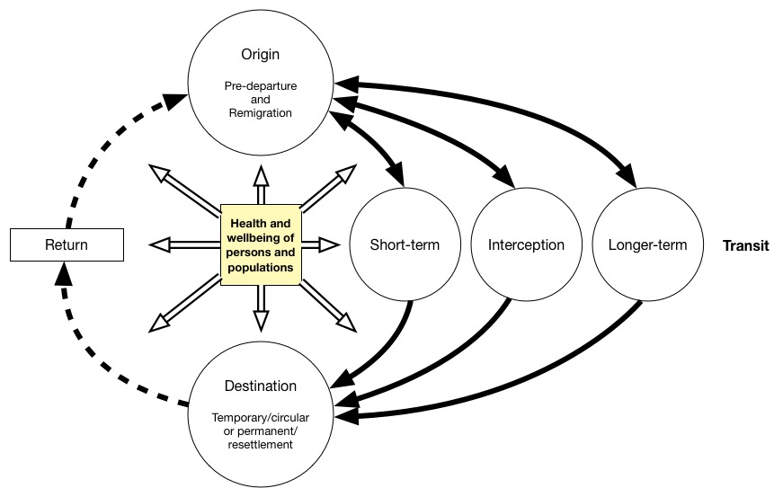

Figure 1: The Migration cycle
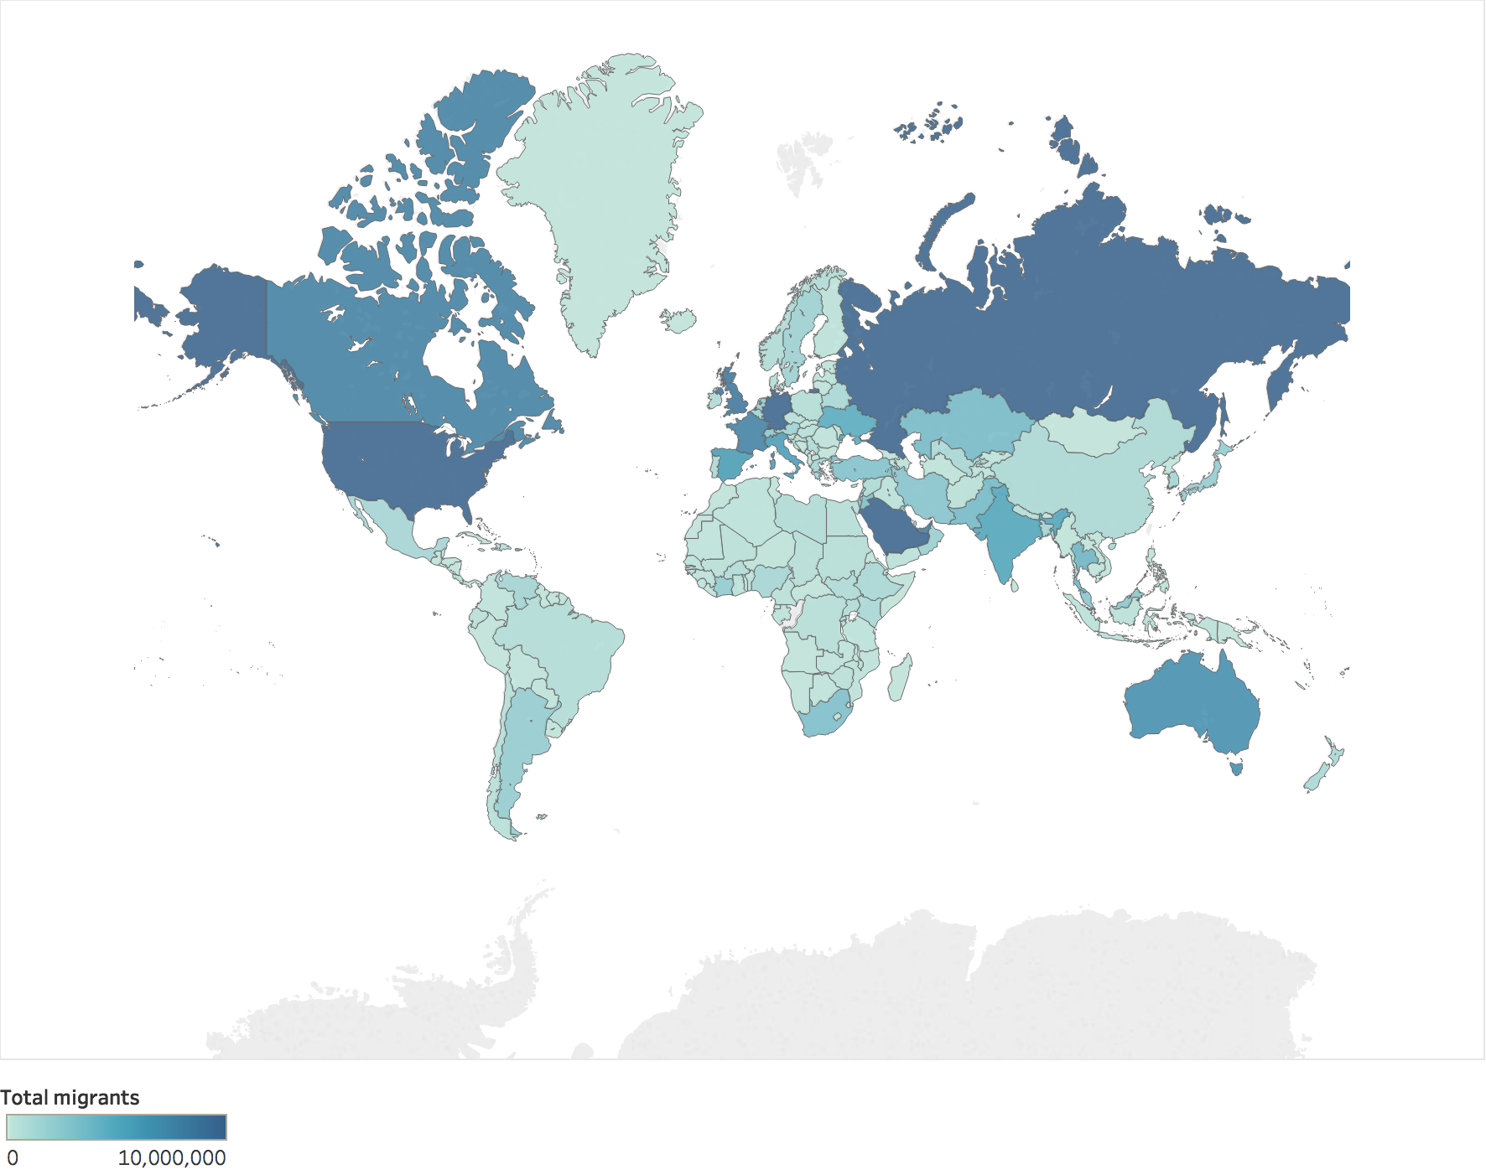 | 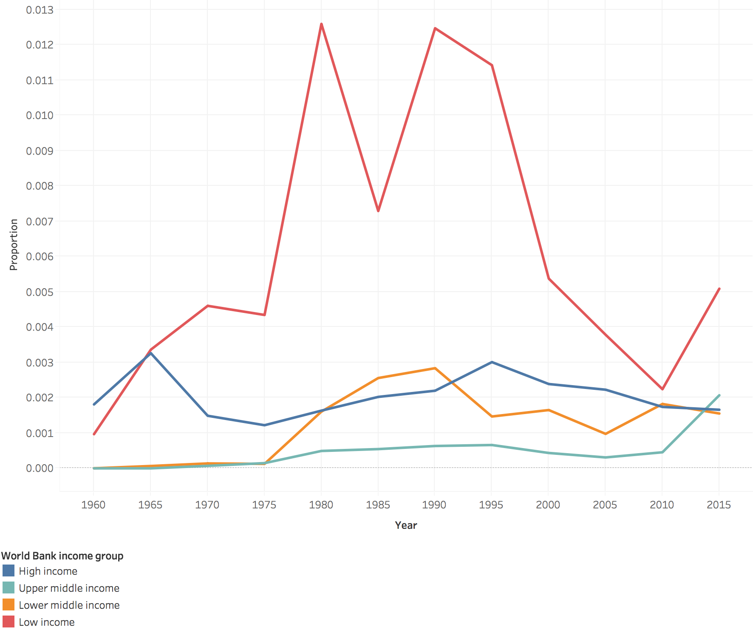
A | B
Figure 2 A. Global map of the total number of international migrants (2015); B. Proportion of population that were refugees by World Bank Income group (1960-2015). Analysis conducted using data from UN DESA, UNHCR and World Bank. Online interactive versions of figures 2A and 2B

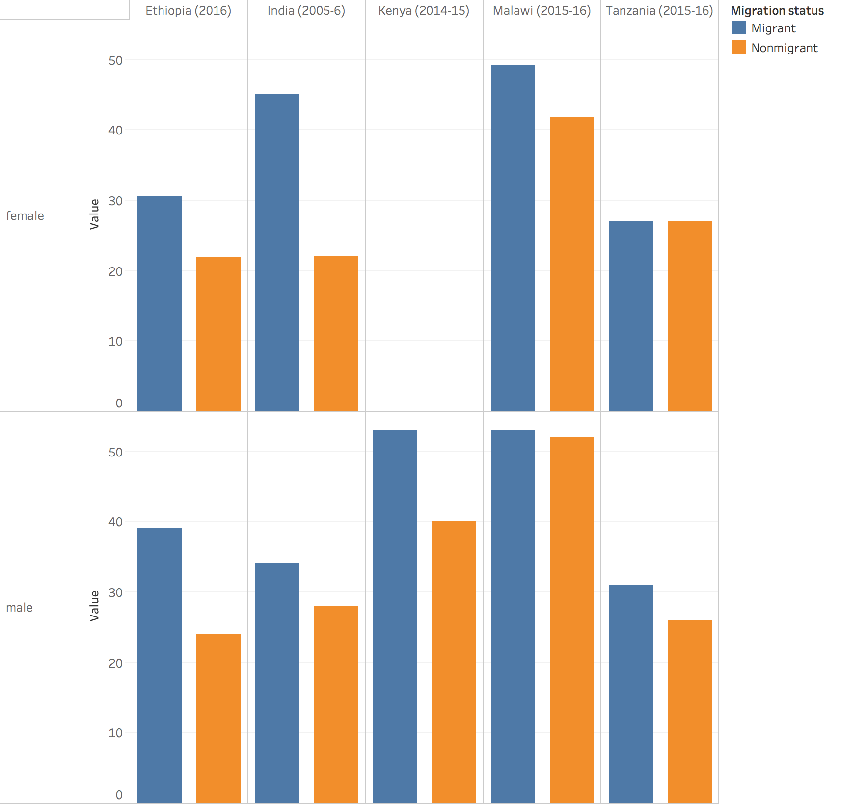

Figure 3. Weighted percentage of men and women using modern methods of contraception by migration status.

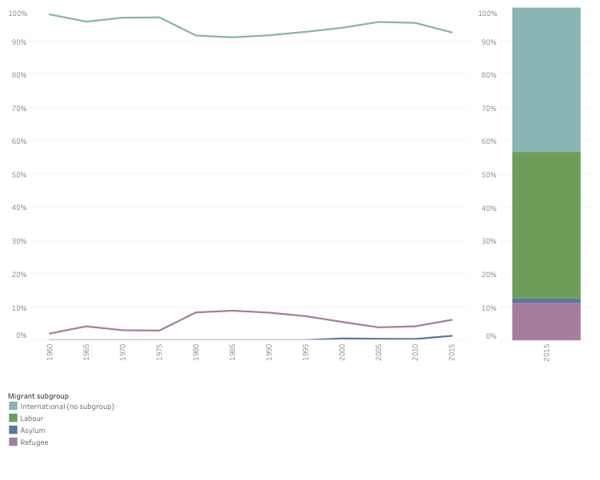
Figure 4a. Percentage of all international migrants that were refugees, asylum seekers and labour migrants, 1960-2015 Note: Labour migration data for 2013 used in estimates for 2015. No historical estimates for labour migration available.
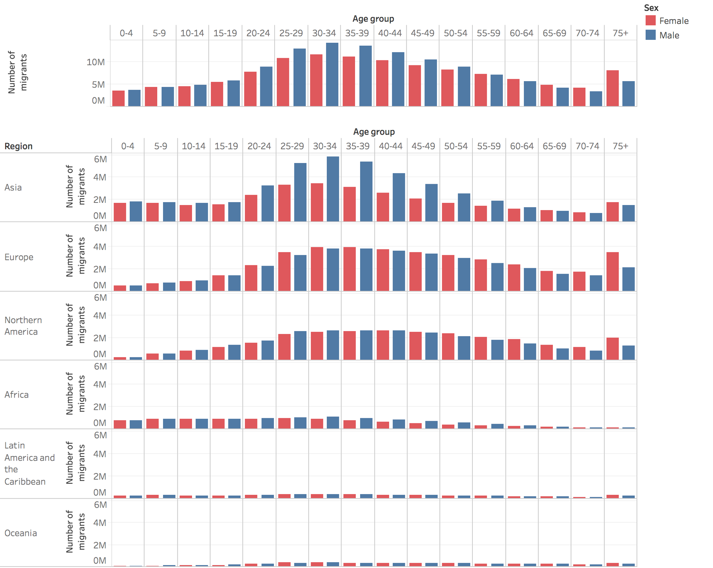
Figure 4b. International migrant numbers at mid-year by age, sex and region (2015)

Online interactive version of this figure

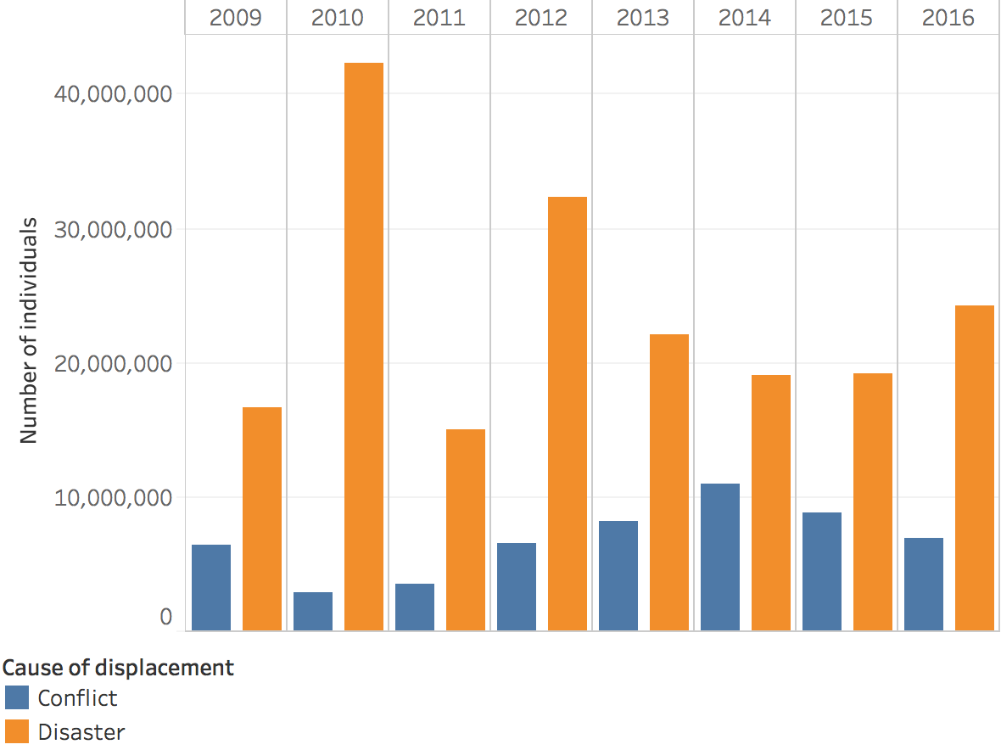
Figure 5. Total annual new displacements due to conflict and disasters
Online interactive version of figure

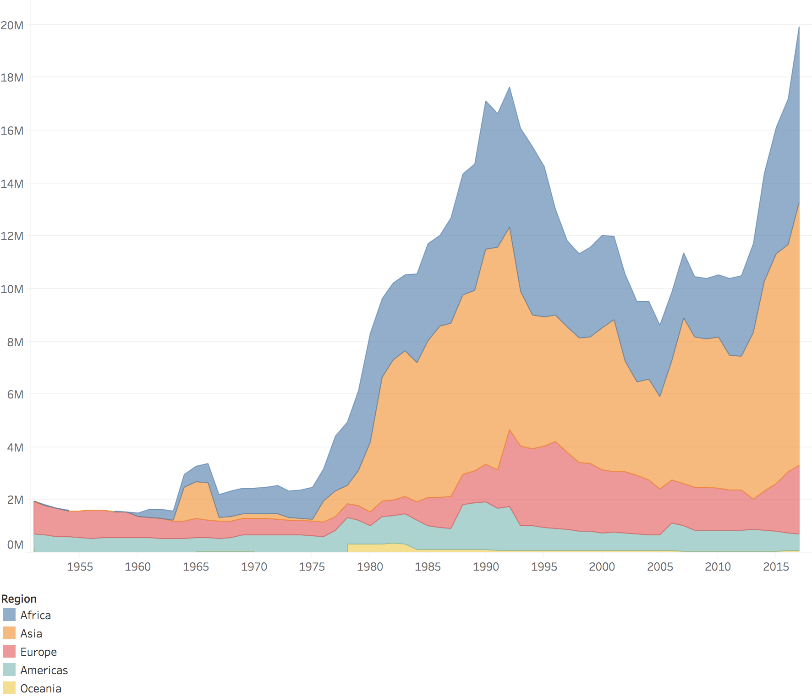

Figure 6. Estimated refugee numbers by region, 1990-2017.
Online interactive version of figure here

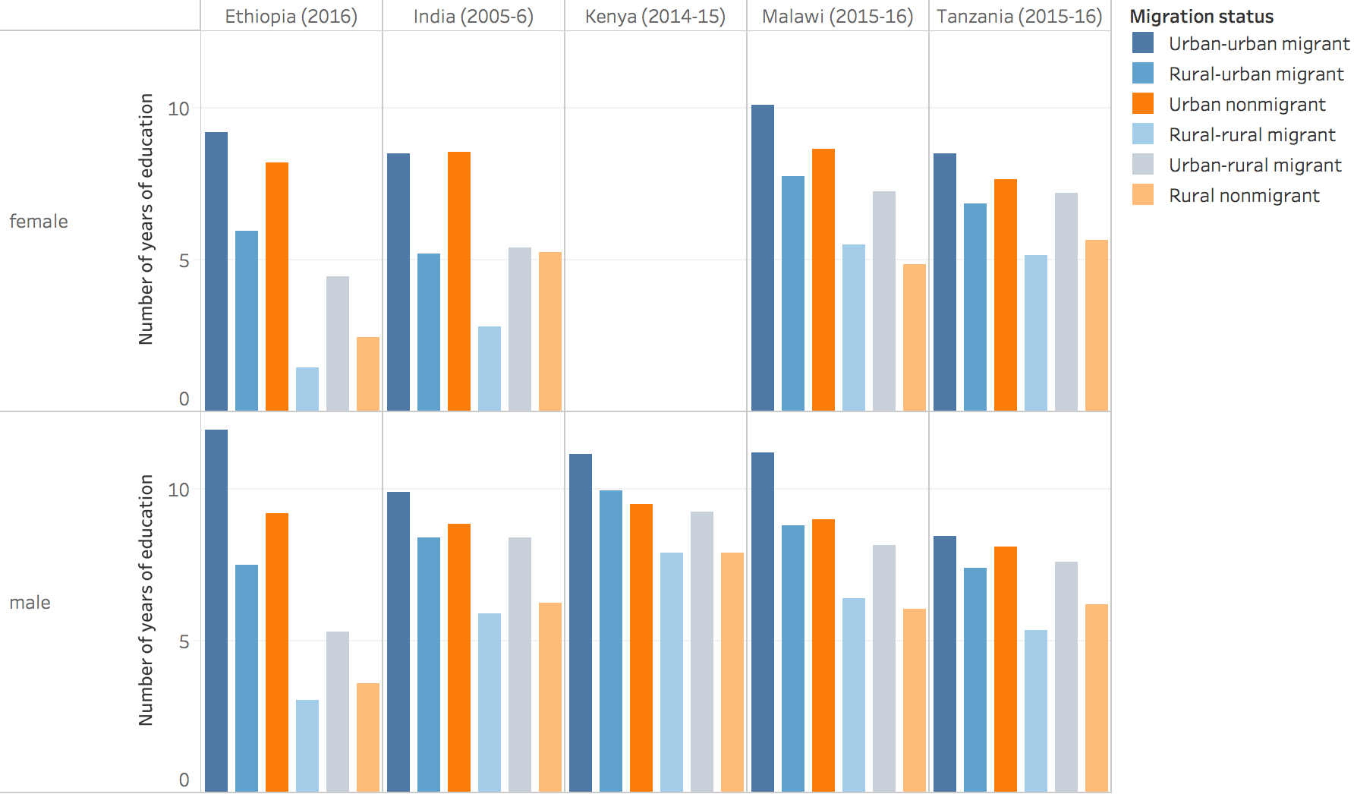
Figure 7. Weighted mean number of years of education by internal migration status (Source: DHS)

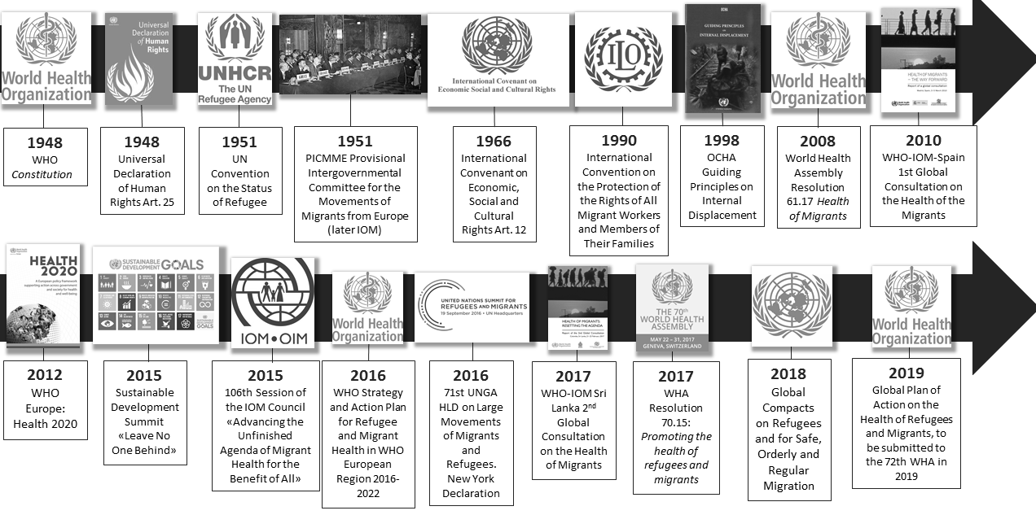
Figure 8. Historical Evolution of the Migration and Health Agenda: Selected International instruments and events

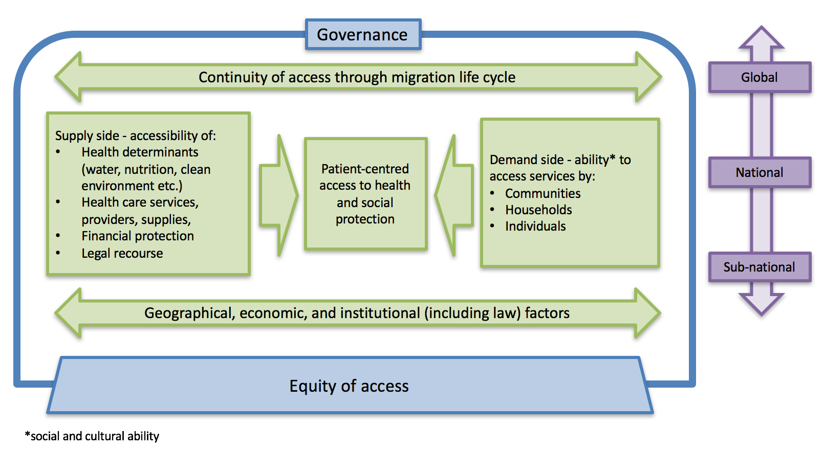

Figure 9. A health systems framework for migrants’ access to health and social protection Adapted from Levesque et al. 2013¹⁶⁶ Note: Factors on the supply side can affect demand and vice versa.

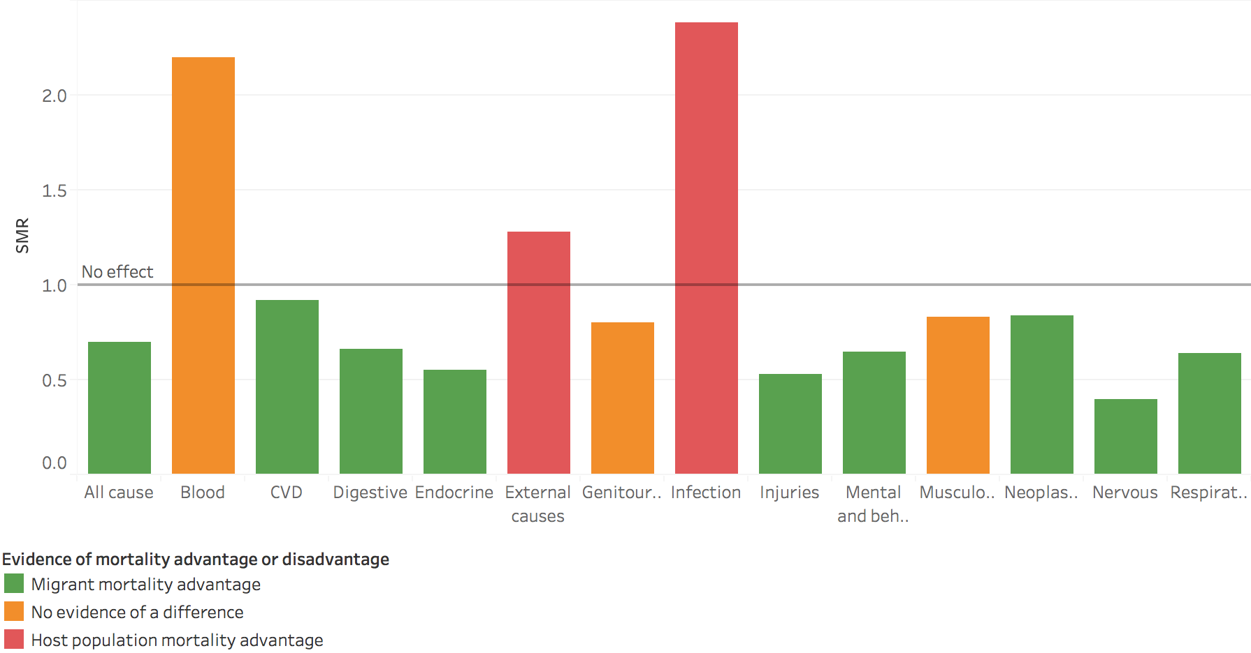
Figure 10. Summary of random effects meta-analysis of Standardised Mortality Ratios for international migrants by ICD-10 disease category. Online interactive version of figure:

Panels

Panel 1 Projection for internal migrant numbers for Bangladesh by 2050 driven by hydrometeorological hazard risks under certain assumptions of social and political developments
Three different scenarios based on the combination of two development pathways and two climate trajectories were modelled by the World Bank,⁶⁸ along with three environmental variables, water stress, crop failure and sea level rise, using a gravity model based on distance and attractiveness of the destination compared with the source area. The report defines climate migrants as people who have moved from their place of origin for at least 10 years and travelled over 14 kilometres within country because of climate change. The report aims to present a plausible range of outcomes rather than precise forecasts. It is based on a single model but has positive aspects such as the inclusion of socioeconomic factors, the choice of slow onset climate change parameters, the use of whole globe decadal changes and that downscaling can easily be achieved. The modelling was calibrated by the highest resolution population census data available at that time. The World Bank report projects that by 2050 there will be 13.3 million climate migrants in Bangladesh applying pessimistic-realistic reference scenario with high emissions and unequal development.
To test the World Bank projection, the 2011 population and housing census data were collected from the Bangladesh Bureau of Statistics. This database was prepared from household surveying in Bangladesh using a questionnaire that covered the respondents’ household characteristics, demography, migration details, economic activities etc. 50 districts out of 64 in Bangladesh were identified as vulnerable to hydrometeorological hazard risks: 1) flooding and river erosion (23 districts); 2) cyclones and storm surges (19 districts); 3) drought and groundwater depletion (8 districts). Some districts are affected by multiple hazards. Then in each district, the total number of life-time (greater than 10 years) and inter-district migrants (travelled more than 14 km away) were identified. The migrants constitute about 9%, 12% and 5% of district-wise total population categorised according to flooding and river erosion, cyclone and storm surge, and drought and groundwater depletion as reasons to migrate. They were then filtered by selecting only people migrating from rural areas, based on an assumption that the adaptive capacity to climate-change is lower in rural communities in Bangladesh due to lack of development and poverty. They constitute about 8%, 11%, and 4% respectively. After applying these filters it is possible to assess the number of internal migrants attributed to hydrometeorological hazard risks in Bangladesh and that this figure is compatible with the local context by analysing primary data collected through actual field surveying under the supervision of BBS.
4.07 million internal migrants were identified for the period of 2001-2011 migrating because of these hydrometeorological hazard risks. They represented about 4% of country’s total population and 41%, 42%, and 31% of total migrant population for the flooding, cyclone, and drought hit districts, respectively. Now, by considering Bangladesh's population growth rate (varying between 0.22-1%) and a similar scenario (without new climatic and development interventions) up to 2050, it can be assessed that the total number of internal migrants attributed to hydrometeorological hazard risks of 19.4 million will surpass the World Bank projection of 13.3 million internal climate migrants by 2050. However the projected increase in the frequency and intensity of hydrometeorological events with global warming cannot all be identified as being caused by climate change. However these hydrometeorological hazard risks (e.g. river erosion and groundwater depletion) cannot all be identified as being caused by climate change.⁶⁷ So while showing greater number of people potentially affected than the World Bank report projects, our analysis of primary data does not validate their projections for internal climate migrants.

Panel 2: Gender, law and health: a four country analysis
Rape, sexual servitude, child marriage, and sex trafficking lead to substantial risks of transmitted infections, poor maternal health outcomes, and enduring mental health problems. But, access to protections, medical treatment and legal recourse, especially for women, are often dictated by laws and customs. An in-depth legal analysis of four countries in which migrants form a substantial portion of the population, Chad (519,968), Jordan (3,112,026), and especially in Lebanon (1,997,776) and Turkey (2,964,916), demonstrates the highly gendered –and sometimes contradictory—nature of the laws and customs governing the rights and safety of women and girls (See supplementary appendix, Table 6 ). Among Syrian refugee communities especially, rates of child marriage are high.273 While many countries have established a legal minimum age of marriage, the practice of early and forced marriage prevails due to weak enforcement, cumbersome marriage registration laws and cultural norms. In Jordan, for example, the legal age of marriage is 18, yet children can be married with the approval of a Sharia court judge starting at age 15.274 Although Chad criminalises child marriage under age 18, the child marriage rate was 68%. between 2004-2017.
Although countries may sign conventions and draft legislation against gender-based violence, migrant women are often unable to access justice due to cultural norms, language barriers, and limited legal representation. Countries often have plural legal systems that provide complete defences or reduced sentences for honour crimes. In Chad for example, adultery is a criminal offence and murder committed because of adulterous behaviour is excusable. Women inhabiting migrant camps have faced months-long detention on grounds of adultery, while men rarely face punishment for rape and sexual assault.²⁷⁵ In both Jordan and Lebanon, perpetrators can avoid prosecution by marrying their victims²⁷⁶ as marital rape is not a crime in many host countries.
For unmarried and displaced adolescent girls, failing health systems, limited providers, and domestic legal frameworks are significant barriers to reproductive health service access. Individuals under the age of 18 must obtain parental consent prior to receiving or undergoing any sort of medical treatment,²⁷⁷ including contraceptives in Jordan, Lebanon, and Turkey and in Jordan, spousal consent is also required.²⁷⁸ Migrant women also have limited access to abortion in the four countries reviewed. In Chad, Jordan, and Lebanon, abortion is not legal in cases of rape.
Globally, intimate partner violence is reported to affect one in three women,²⁷⁹ and displacement appears to exacerbate conditions of abuse,^{279,280} triggered by destabilization of gender norms and roles, men’s substance use, women’s separation from family, and rapid remarriages and forced marriages. Laws are often limited to protect women from sexual abuse, for example, among the migrant-recipient countries analysed, only Turkey has legislation against marital rape and only Chad had legal termination to save the life of the mother—even in cases of rape. Countries are often reluctant to make commitments to protect women, for example, only Chad had signed and ratified without reservations the Convention on the Elimination of All Forms of Discrimination against Women and Convention on the Elimination of All Forms of Discrimination against Women Optional Protocols (CEDAW). While international instruments such as CEDAW and the UN Convention on the Rights of the Child (CRC) exist to protect women and children, implementation is often poor, especially during humanitarian crises. Dismantled or ineffective justice systems result in weak protections and responses for sexual and gender-based violence.²⁸¹ And, even where laws are in place, migrants who have tenuous legal status or are not aware of their rights, especially common among women, are much less likely to benefit from health protections and medical treatment.

Panel 3: Healthcare for migrant and seasonal farmworkers in the US - improving access and cultural competence
A high proportion of migrant and seasonal farmworkers in the US are uninsured or underinsured, due to both lack of eligibility and extremely low incomes. It is estimated that at least 75% of farmworkers, and up to 90% of their children do not have health insurance.²⁸² Many of these individuals do not qualify for government provided or subsidised insurance (e.g. Medicaid) because they are undocumented.
There are positive examples of programmes that have been established to address the health needs of these populations, however. At a national level, the Health Resources and Services Administration funds 137 migrant health centres and 955 community health centres across the US aimed at improving access to services for marginalised groups such as farm workers, including a voucher programme enabling farmworkers to obtain care from community centres, as well as funding non-profit organisations such as Migrant Health Promotion, and Farmworker Health Services.²⁸² However, there is a significant gap in the literature in terms of robust evaluations of the effectiveness or acceptability of such programmes. There are also numerous local programmes in the US focused on accessible culturally appropriate health assessments, or the use of mobile outreach clinics to migrants, for uninsured farmworkers who are considered to be working in a hazardous industry and are mostly foreign migrants. For example, there are clinics targeting farmworkers in the USA,²⁸³ and the Migrant Health Outreach program (federally funded) mobile clinic to farmworkers staffed by nurses, which seems to be a successful approach.²⁸⁴ Outreach services offer the benefit of going to the locations where migrants are working, living, going to school or to houses of worship,²⁸⁵ reducing many of the main access barriers. In the US, for example, there are an estimated 1500 mobile clinics, receiving 5 million or more annual visits nationwide, which are becoming an integral component of the healthcare system to serve vulnerable populations. Findings from a study on outreach to migrants and seasonal farmworkers in the US shows that workers and their families make very limited use of clinic-based services because of their mobility (constant residential changes), work hours, poor knowledge of the US health system (almost 40% of the population is new each year) with a majority preferring to seek care in Mexico—even those who have US health insurance, but that clinic outreach programmes are overcoming many of these barriers. Research suggests, however, that mobile clinics for migrants have been more often disease-focussed, to offer testing and treatment, for example, for HIV, especially for sex worker populations.^{285,286} Evening cluster clinics targeting migrant workers were considered by migrants themselves to be excellent or good.²⁸⁷ Six characteristics were believed contributed to the successful delivery of healthcare and education through cluster clinics, including: provision of both direct and referral services for this underserved population; comprehensive delivery of services in a single setting; collaborative delivery of services; access-driven delivery of services; delivery of culturally sensitive and linguistically appropriate services; and evidence-based service delivery. Free or mobile clinics and health and wellness programmes specially targeted for migrant workers are relatively rare.

Panel 4: Leadership in Migrant Population Accessibility and Affordability of Healthcare Services
China
Since the launch of the new round of medical reform in 2009, China has almost achieved full coverage of its medical insurance system for urban and rural residents, with a stable coverage rate of above 95% for the whole population. The medical insurance system mainly consists of three types of schemes, including urban employee basic medical insurance (UEBMI), urban resident basic medical insurance (URBMI) and new rural cooperative medical scheme (NCMS). Among them, the number of people participating in NCMS reached 670 million, with a coverage rate of 98.8%. However, despite the high coverage rate achieved, there is concrete difference among the coverage scope of those three medical insurance schemes, with a higher insurance level by UEBMI and URBMI than by NCMS. In addition, since the off-site medical expense settlement information system for NCMS has not been fully established, medical expenses of migrant populations cannot be directly deducted when they seek medical care in urban areas. Many of them still have to pay medical expenses first out of pocket and afterwards return to rural areas for reimbursement. Besides, the reimbursement review procedures are quite cumbersome and usually take a long period, resulting in a considerable number of the migrant population actually not being able to enjoy concrete insurance security.
Faced with the demand of nearly 200 million migrants, in 2016, the government promulgated a relevant document on off-site medical expense settlement under basic medical insurance schemes, which clarified the responsibility of all levels of governments in ensuring migrant population’s right to medical insurance and defined the unified management requirements for locations providing medical treatment. At the same time, the off-site medical expense settlement information system was established and improved. Using social security cards distributed, migrant population can equally enjoy the convenient services of medical expense settlement across provinces. Through those policies and measures, the accessibility and affordability of healthcare services for migrant population have been greatly enhanced. Meanwhile, in order to promote the health of migrant workers working outside, the Health and Family Planning Commission in migrant-sending areas also established a health education group on WeChat, sending them health education messages and keeping track of their health status for better health management.

Switzerland
“Similar to all other areas of corporate governance, diversity policies need assertiveness by the highest management level”, Peter Saladin says.²⁸⁸ The economist and former president of the H+ Swiss Hospital Association headed the Swiss “Migrant-Friendly-Hospitals”-project implemented in 2003–2007, as part of the Confederation’s strategy on migration and public health.²⁸⁹ According to the recent Migrant Integration Policy Index (MIPEX) Health Strand, and international comparative study health systems’ responsiveness to immigrants needs, the endeavour was successful: Switzerland scored second of 38 nations , and has established a “world-leading `Migration and Health’ programme”.²⁹⁰
On the political level, Switzerland chose to turn “health” into a priority area of its integration policy. Legal entitlements and access to coverage within the insurance based Swiss healthcare system is nearly identical for nationals, legal migrants, asylum-seekers and undocumented migrants. Health care providers are informed by the Federal Health Office or NGOs (like the Swiss Red Cross) about immigrant’s entitlements to health care and migrant patients are provided access to health relevant information in multiple languages.²⁹¹ Data collection and funding for migrant relevant health data is well developed, just as training of health professionals in transcultural competencies. The actual adaptation and responsiveness of health services, however, vary between regions (cantons) and institutions. The implementation of federal policies and provisions depend on political and institutional structures, priorities, and leadership on regional and local level. Interpreters and cultural mediators, for example, are available only at certain health centres, mainly large and university hospitals. As costs are charged on hospital budgets, a negative incentive for using interpreting services still exists. Specific services and support for undocumented migrants are also only available in a small number of cantons and political and administrative barriers to the actual realisation of formally granted rights are still prevalent.

Panel 5: Inappropriate health data sharing for immigration enforcement in the UK
On 1 January 2017 a memorandum of understanding (MOU) between the UK Home Office and National Health Service (NHS) Digital was signed.²⁹² The MOU formalised existing processes and data sharing that had occurred between NHS Digital and the Home Office.²⁹³ The MOU described how any data shared had to comply with the legal obligations under the Data Protection Act 1998 (DPA), the Human Rights Act 1998 (HRA) and the Health and Social Care Act 2012. Requests were used by the Home Office to track down migrants for the purposes of immigration enforcement.
Upon publication, the MOU generated significant media interest, particularly as it became apparent that there had been an increasing use of these requests since 2010. The report led to a request for clarification about the issue from the Health Select committee, which received several responses from NHS Digital, Home Office, The National Data Guardian, Public Health England and the UK General Medical Council.²⁹³ In their responses , NHS Digital and the Department of Health outlined the basis by which the MOU had been written and the impact and equity considerations that had been reviewed. NHS Digital confirmed that no privacy impact statement had been undertaken, but that instead a public interest test was carried out in each individual tracing request.
In their response to the Health Select committee, Public Health England (PHE) stated they were unable to find statistical evidence about the impact of knowledge of data sharing on deterring immigrants from accessing healthcare treatment and agreed to undertake a full review within two years. However, in their testimony, PHE experts working in the field of communicable diseases stated that “sharing of personal information by NHS commissioners or healthcare providers, which has been provided to them by patients on an understanding of absolute confidentiality, with other government departments, law enforcement agencies or immigration enforcement authorities risks undermining public confidence in the public health system and could have unintended and serious consequences affecting the health of individuals and the risk to the public health of the wider community”.
The General Medical Council (GMC), the governing body for UK doctors, only permits clinicians to share patient information ‘if failure to disclose may expose others to a risk of death or serious harm’. Suspected immigration offences do not fall under this category. In the GMC’s response to the committee, they stated that: “The memorandum of understanding sets out clearly the public interest in maintaining effective immigration controls. It does not however reflect the public interest in there being a confidential health system, or consider how those two public goods should be weighed against each other”.
The National Data Guardian, Dame Fiona Caldicott, also expressed her concerns about this issue: “any perception by the public that confidential data collected by the NHS is shared for a purpose that they had not anticipated or without appropriate controls may well lead to a loss of people’s trust” and that “trust would have been better maintained had there been more public debate about where the balance should be struck between the public interest in maintaining an effective immigration service and the public interest in a confidential health service before an agreement was made between NHS Digital, the Home Office and the Department of Health. This would have allowed more scrutiny of the reasoning and factors which led to the policy position which has been taken.”
During a parliamentary debate in May 2018 about new data protection regulations, a member of the UK parliament with the Conservative party and chair of Health Select committee committee, Dr Sarah Wollaston, tabled an amendment to end the data-sharing arrangement between NHS Digital and the Home Office. During the debate the Government announced a reversal of policy and accepted Dr Wollaston’s amendment which significantly narrowed the scope of the MOU in order that it only covered sharing in cases where a person was suspected of serious criminality.

Panel 6: Internal migration and mortality - an analysis of all-cause mortality in 25 Health and Demographic Surveillance System (HDSS) sites in sub-Saharan Africa
These data represent a mix of rural and urban settlement types, from the International Network for the Demographic Evaluation of Populations and Their Health (INDEPTH) iShare platform.²⁹⁴ The datasets include individual-level information on all movements into or out of a surveillance area for durations in excess of 6 months. From these data, we can identify in-migrants (new residents) and return-migrants (former residents returning) to an area. After 5 years of residence, a migrant is considered a permanent resident, since prior analyses of the effect of duration following migration show that the mortality experience of migrants converges with that of permanent residents (non-migrants) after this length of time.²⁹⁵ For each migration category (non-migrant, in-migrant, return-migrant) premature mortality is estimated using the probability of mortality before age 60 if a person is alive at age 15 (45q15). The percentage difference in 45q15 between migrants and non-migrants was estimated by sex for each of the 25 HDSSs from the year 2000.
The analysis reveals that in sub-Saharan Africa, the distribution of the difference in premature adult mortality between migrants and non-migrants is substantial, i.e. in half of the sites migrants' mortality was 50% higher than non-migrants' mortality.
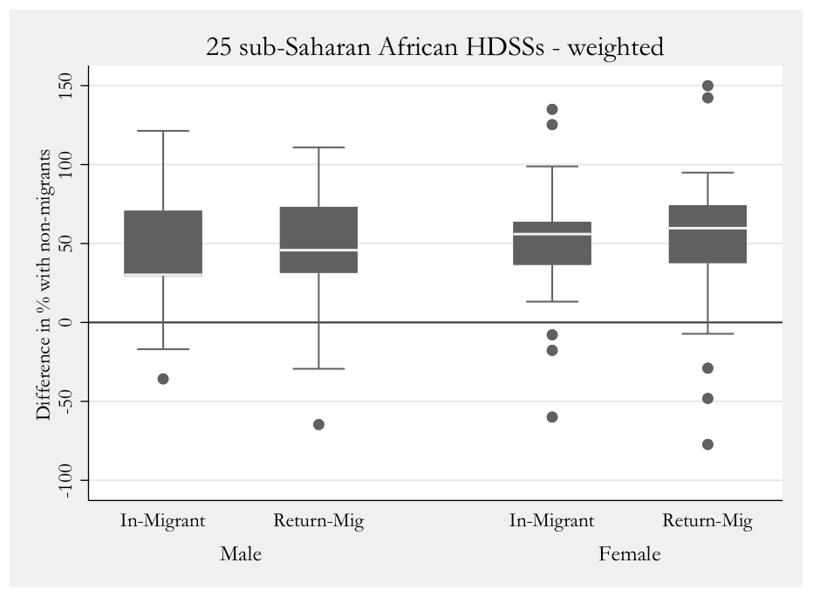
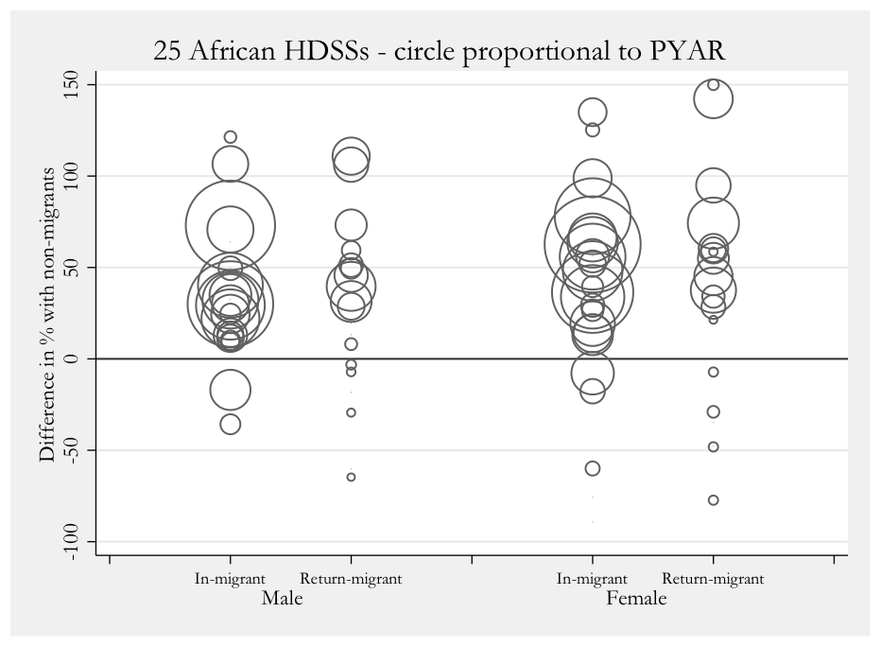

Figure 1: Difference in adult health probabilities (45q15) by migrant status in 25 African HDSSs
Box-and-whiskers plots or bubble plots (size of the bubble proportional to the person-years at risk) PYAR = person years at risk

These results suggest that internal migrants in the SSA sub-districts have a health disadvantage relative to the resident, non-migrant population. A study of internal migration and AIDS/tuberculosis and non-communicable disease mortality in 4 HDSSs in South Africa and Kenya affirmed these findings. In the Agincourt study population in rural South Africa, in-migrants and, even more so, return migrants had a health disadvantage in terms of mortality risk attributed to both non-communicable and infectious disease.²⁹⁶ These findings suggest that relative to non-migrant mortality, the experience of migrants is demonstrably worse in many sub-Saharan settings - with limited access to healthcare a likely determinant along with poor social integration or inadequate living conditions. Further research into the circumstances at migrant destinations is a priority going forward.
The same methodology was used to examine child mortality (the probability of death in under 5-year olds) by migrant status, where child migration status was considered independently of the migration status of their parents (Figure 2). The results present a striking contrast to those of adults. Both in-migrant and return-migrant children of both sexes have lower all-cause mortality on average than non-migrant children. These results present an important direction for further research and challenge assumptions that determinants operate in the same way and have the same outcomes for adults and children.

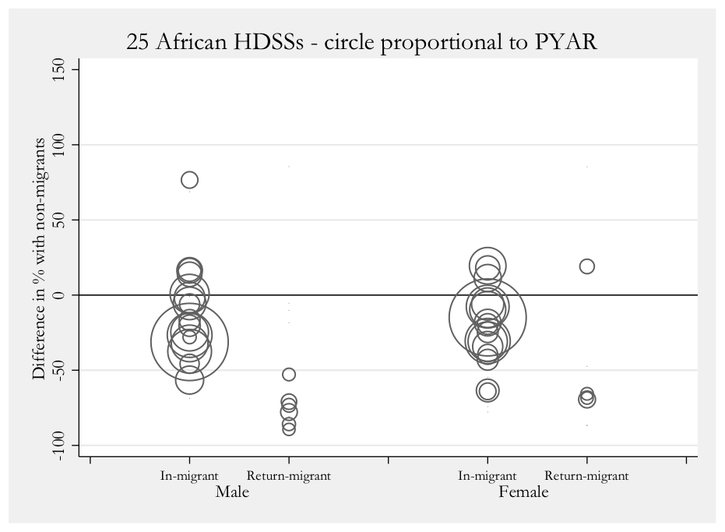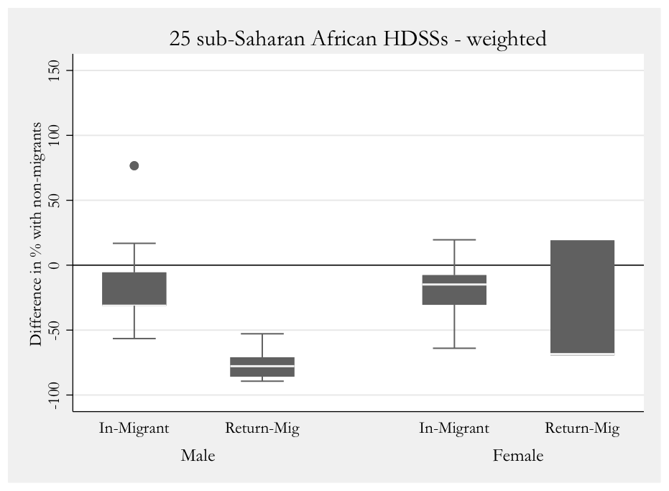
Figure 2: Difference in child health probabilities (45q15) by migrant status in 25 African HDSSs

Panel 7: Age assessment – an unresolved challenge for unaccompanied minors and refugee children
Though migration to Norway is not a new phenomenon, the number of refugees that came to Norway in 2015 was unprecedented. Over 30,000 sought asylum, of which 5000 were unaccompanied minors. This group is at increased risk of child trafficking, abuse and violence and requires guardianship and protection. However, instead of focusing on their rights and obligations to this group of children and adolescents, regrettably governments often seek to skirt these obligations.
Age determination has been a substantial challenge and source of debate amongst child rights groups and immigration officials. Though there are universally agreed definitions of a ‘child’ there are no agreed methods regarding the assessment to determine the age of a child. Unaccompanied minors often have no reliable information about their age or date of birth. Authorities deploy techniques and investigations that are, at best, approximations.²⁹⁷ But the consequences of these approximations can be devastating for this group of children. In Norway, if the age assessment shows that someone is less than 18 years of age, they will be cared for by the Norwegian Child Welfare Services. The Child Welfare Services statutory obligation is “to ensure that children and youth who live in conditions that may be detrimental to their health and development receive the necessary assistance and care at the right time”. In addition, non-resident minors are entitled to receive the same help from these services as any other Norwegian child. In contrast, if the assessments conclude that a person is over 18 years old, they will be treated as an ordinary adult asylum seeker, with few such rights.
Thus, it comes as no surprise that the techniques to determine the age of a child are controversial. In Norway, the measurement of age by x-rays of the hand (‘bone age’) and teeth are routinely used, despite long-standing dispute about these techniques. The x-rays assess ossification and presence of molar teeth and can be used to estimate age. However they are not an accurate method and unnecessarily expose the adolescent to radiation. In response to the gravity of concerns expressed by both the Norwegian Paediatric Society and the Ethical Committee in the Norwegian Medical Association in the context of critical significance of these procedures, the responsibility for conducting these was transferred from the private sector to the Oslo University Hospital from January 2017.
Age assessments, where necessary, should integrate the clinical history and physical assessment, taking into account the person’s development (physical, cognitive and emotional). A report on age assessments²⁹⁸ concluded that “There is evidence that radiography (X-rays) of bones and teeth, which is increasingly relied upon by immigration authorities, is imprecise, unethical and potentially unlawful, and should not be used for age assessment”. Despite this, x-rays are perpetuated as the gold standard. As this jeopardises the current and future situation of unaccompanied minors, many have no other alternative but to resort to other even more dangerous choices of living as undocumented minors on the streets of other European cities exposing and endangering them to further perils. Moreover, there is substantial evidence that even adolescents over the legal age for mandatory support services and guardianship, i.e., 16-24, have need of protection and support.²⁹⁹

Panel 8 Case study – Labour trafficked migrants, mental health and financial security.
A study among male, female and child trafficking survivors in the Greater Mekong Subregion found that 48% experienced physical or sexual violence, 43% reported symptoms of depression and 40% reported PTSD.³⁰⁰ Employment is highly correlated to mental health, with job insecurity and financial insecurity closely linked to anxiety and depression. Most data on employment and health come from high-income settings and studies on higher wage jobs, with very little research on migrant workers in LMICs. The Study on Trafficking, Exploitation and Abuse in the Mekong documented forms of labour exploitation and health outcomes among men, women and children using post-trafficking services in Thailand, Cambodia and Vietnam. Findings showed high symptom rates of depression and anxiety disorders, post-traumatic stress disorder (PTSD) and suicidal ideation associated with sexual and physical violence and threats during trafficking; poor living and working conditions; excessive overtime and restricted freedom.
Being deprived of wages was also a major stressor for formerly trafficked persons, many of whom experienced guilt and shame from failing to fulfil income expectations. In the STEAM study, most trafficked migrants (62.3%) reported being cheated of their wages. Among the few who were paid for their work, domestic workers ($0.40), agricultural workers ($0.70) and fishermen ($1.10) received the lowest daily wages. Unsurprisingly, domestic workers and fishermen more frequently expressed financial concerns (75.9% and 71.1% respectively). The majority (81.6%) of domestic workers reported depression, anxiety and/or PTSD symptoms, similar to individuals trafficked for construction work (79.0%). Individuals who had been cheated over their wages or had financial concerns had approximately one and a half times the odds of being symptomatic of a mental health disorder.
Studies often overlook the significance of income security to a migrants’ psychological well-being because research on migrants’ mental health frequently focuses primarily on past events versus current stressors. Especially for those who migrated to improve their family’s economic circumstances and failed, mental health support will need to include job training and placement or small business grants. Moreover, for individuals who were exploited, cheated of their wages or injured on the job, legal aid should be provided to help with wage recovery and compensation for abuses, and injuries, including long-term disability support.

Panel 9: Research recommendations and priority research questions
- To address the health needs of migrants, high-quality data collection for migration and health must:
  - Add migration-related questions to regularly administered surveys such as Demographic and Health Surveys, health and population surveillance systems and censuses.
  - Examine the multiple interactions between migrant populations and between migrant and non-migrant groups.
  - Include health outcomes of migrants that are more closely aligned with the drivers of migration and the geographical region of origin of migrants, internal migrants and the interaction with aging in order to better understand health needs.
  - In addition to comparisons with the host population, conduct research that, for example, compares to the population at origin to ascertain the consequences of moving on health, ideally using longitudinal data collection methods.
- To provide an evidence base for health-related drivers and outcomes of migration, it is essential to focus on the processes and implementation of migration and health research, through:
  - Engagement with the population using participatory approaches to ensure that migration and health research meets their needs and does not result in harm.
  - Undertaking research that responds to the population need, including through increased focus on the health effects and needs during the migrant life cycle.
  - Analysis of best treatment regimens and modifications to these treatments required by mobile populations.
  - Implementing evidence-based health interventions, with a focus on data collection, assessment of cost-effectiveness and analysis of intervention impact and effectiveness.
  - Increasing the evidence base describing the consequences of discrimination against migrants and racism, and ways to prevent this.
  - Considering the health of migrant groups in all areas of research.
- To provide and use better data to reduce inequities, changes in the migrant health research process and methods are needed, through:
  - Use of globally accepted definitions to guide comparable data collection and disaggregation, with a recognition that the categories used in human mobility and health are not static, but fluid.
  - Viewing the migrant population themselves as an asset and encouraging a participatory approach, where migrants and local communities are included in research prioritisation, policy making and decision process.
  - Including qualitative, adaptive and context sensitive approaches in order to understand socio-cultural factors of migration, the barriers to healthcare and how the determinants of health might affect migrants differently.
- To provide evidence for health policy and systems research, the following questions should be considered:
  - What financing models are most effective in extending access equitably to migrants?
  - How can prevailing jurisdiction-based health governance and citizen participation approaches be made more sensitive to the needs of migrants?
  - How can healthcare providers be equipped with necessary multicultural competencies for migrant care?
  - How can information systems be made more portable and interoperable while still preserving patient rights and privacy?
- To produce ethical research, there should be incorporation of ethics, data protection, monitoring and evaluation into all stages of the research process. The following questions should be considered:
  - Does the research meet the particular needs and priorities of the research population, as well as goals like equity, integration, health protection and/or universal health coverage?
  - When defining the sample and the distinguishing categories of “migrants”, what are the sources of information that this relies on and how do these categories resonate with the individual’s self-perception?
  - Does the research deal with the challenge to understand social boundaries by providing scientific evidence of “differences” between and “homogeneity” within social groups and/or populations?
  - To what extent does the research reflect social, structural and political determinants of health and their implications on social gradients, historical power relations, and probably stigma?
- To provide adequate funding and appropriate research, health funders should:
  - Make migration and health a priority research area.
  - Ensure that funded research always endeavours to include migrants within it.
  - Support capacity development among migration and health researchers and institutions in the global south through specific funding initiatives and support of research networks.

Tables

Industry | Examples of occupational hazards and harm | Migrant health studies
Sex work | - Weak condom negotiation ⇒ STIs, unwanted pregnancy  - Sexual violence, confinement ⇒ anxiety disorders, depression | Migrant female sex workers in Africa (Benin, Kenya, Ethiopia) are at greater risk of HIV than non-migrant sex workers and higher risk of acute STIs in all settings.
Construction | - Work at heights ⇒ fatal falls, disabilities  - Heavy lifting ⇒ musculoskeletal problems  - Poor personal protective equipment (PPE) ⇒ respiratory disease, dermatitis, eye injury. | In the USA, Latino construction workers were nearly twice (1.84, 95% CI 1.60,2.10) as likely to die from occupational injuries as their non-Latino counterparts.
Manufacturing (e.g., textile) | - Repeated bending & fixed postures ⇒ musculoskeletal damage, pain  - Sharp instruments, ⇒ puncture wounds  - Dust particles ⇒ silicosis | In Malaysia, 64.4% of migrant workers experienced musculoskeletal pain caused or worsened by work compared to 28% of Malaysian manufacturing workers.
Commercial fishing | - Environmental exposures (sun, cold, rain) ⇒ skin cancer, dehydration, frostbite  - Long hours, weeks with no break ⇒ exhaustion, pneumonia  - Unstable fishing vessels, inadequate life vests ⇒ drowning  - Fishing net and knife hazards ⇒ deep cuts, lost limbs | Trafficking survivors of the Thai fishing industry reported higher injury rates (46.6%) than non-trafficked fishermen (20.6%). 53.8% of trafficked fishermen experienced severe violence versus 10.1% of non-trafficked fishermen.
Agriculture | - Pesticide exposure ⇒ toxicity  - Environmental exposures (heat, cold, mosquitoes) ⇒ dehydration, kidney failure, headaches, malaria.  - Heavy lifting, bending ⇒ repetitive injury syndromes | 95% of the greenhouse workers in Oman were migrants. Poor practices related to pesticide use resulted numerous health problems, such as skin irritation (70.3%), headaches (39.2%), and vomiting (29.7%).
Domestic work | - Physical, sexual, verbal abuse, social isolation ⇒ depression, anxiety, suicide  - Extensive working hours, food deprivation ⇒ exhaustion  - Repeated lifting, bending and reaching ⇒ musculoskeletal strain  - Chemical cleaning agents, cooking, ironing, knives ⇒ skin damage, burns | A two-year study in Kuwait found that hospitalisation for domestic workers (93% from Sri Lanka, India and Philippines) was 1.86 times higher than for Kuwaiti women. Stress-related disorders were more common (49.2 vs. 22.3%) in housemaids than the Kuwaiti female patients.
Mining, quarrying | Mercury extraction, lead exposure, mineral dust ⇒ mercury poisoning (gold-mining), neurotoxic disorders, pneumoconiosis  Heavy lifting, falls, falling rocks ⇒ fatalities, traumatic injuries, disabilities  Heavy equipment, extensive hours, repetitive lifting ⇒ noise-induced hearing loss, chronic fatigue, musculoskeletal injuries  Remote locations malaria ⇒ venomous snake bites. | China’s Ministry of Health reports that 87% of occupational disease is pneumoconiosis (black lung disease), with a mortality rate higher than 20%. Pneumoconiosis is a chronic lung disease that often affects miners, sandblasters and metal grinders, occupations undertaken primarily by internal migrant workers.
Forestry | - Environmental exposures (heat, cold, mosquitos) ⇒ dehydration, malaria, parasites  - Falls, sharp tools, machinery ⇒ fatalities, broken bones, lacerations  - Repetitive motions, long hours ⇒ body pain, strains, chronic fatigue | A study of Burmese migrants found 87 of 105 (82.9%) rubber plantation workers had a suspected case of malaria in the past year. Workers had limited access to care due to their working hours and limited transportation.
Leather and tanning | - Chemical exposure (i.e., chromium, benzene dyes, formaldehyde) ⇒ respiratory illness, ocular damage, cancer, ulcers, toxicity, dermatological diseases (rashes), chronic / allergic bronchitis pulmonary tuberculosis | Higher morbidity was found in tannery worker (40.1%) than the control group (19.6%) in northern India.
Brick kilns | - Unsanitary environment, air pollution ⇒ bronchitis, asthma, silicosis, respiratory toxicity  - Extremely high heat ⇒, burns, fatalities  - High rates of child labour ⇒ Developmental problems | Migrant brick kiln workers in South India had higher prevalence of chest symptoms (9.4%) versus general population rates (4.9%) related to occupational hazards and poor healthcare access.
PPE= personal protective equipment; STI= sexually transmitted infection

Table 1: Low-wage labour sectors and associated occupational hazards among migrant workers (see appendix for full list of references)

References
1 International Organization for Migration. World Migration Report 2018. https://www.iom.int/wmr/world-migration-report-2018 (accessed June 25, 2018).
2 Urquia ML, Gagnon AJ. Glossary: migration and health. - PubMed - NCBI. https://www.ncbi.nlm.nih.gov/pubmed/21282138 (accessed Jan 15, 2018).
3 Zimmerman C, Kiss L, Hossain M. Migration and health: a framework for 21st century policy-making. PLoS Med 2011; 8: e1001034.
4 The Oxford Handbook of Stigma, Discrimination, and Health. Google Books. https://books.google.com/books/about/The_Oxford_Handbook_of_Stigma_Discrimina.html?id=aOw9DwAAQBAJ (accessed June 14, 2018).
5 Elliott P, Hennigan WJ. Exclusive: Navy Document Shows Plan to Erect ‘Austere’ Tent Cities for Immigrants. Time. http://time.com/5319334/navy-detainment-centers-zerol-tolerance-immigration-family-separation-policy/ (accessed July 1, 2018).
6 McNeill L, Moore R. Sustainable fashion consumption and the fast fashion conundrum: fashionable consumers and attitudes to sustainability in clothing choice. Int J Consum Stud 2015; 39: 212–22.
7 United Nations, Treaty Series. International Covenant on Economic, Social and Cultural Rights. OHCHR. 1976; 993: 3.
8 UN Committee on Economic, Social and Cultural Rights. General Comment 14, The right to the highest attainable standard of health. 2000 http://www.refworld.org/pdfid/4538838d0.pdf (accessed Jan 15, 2018).
9 Mann JM, Gostin L, Gruskin S, Brennan T, Lazzarini Z, Fineberg HV. Health and human rights. Health Hum Rights 1994; 1: 6–23.
10 Compact for Migration. UN Refugees and Migrants. http://refugeesmigrants.un.org/migration-compact (accessed Jan 12, 2018).
11 New York Declaration for Refugees and Migrants New York Declaration for Refugees and Migrants : resolution / adopted by the General Assembly, 3 October 2016, A/RES/71/1. United Nations General Assembly. 2016. http://www.un.org/en/ga/search/view_doc.asp?symbol=A/RES/71/1 (accessed Jan 15, 2018).
12 U.S. Ends Participation in the Global Compact on Migration. U.S. Department of State. 2017; published online Dec 3. http://www.state.gov/secretary/remarks/2017/12/276190.htm (accessed Jan 12, 2018).
13 Henley J. EU’s migrant centres could breach human rights, say campaigners. the Guardian. 2018; published online June 29. http://www.theguardian.com/world/2018/jun/29/eus-migrant-centres-could-breach-human-rights-say-campaigners (accessed July 1, 2018).
14 The Sustainable Development Goals Report 2016: Leaving no one behind. UN Stats Division. https://unstats.un.org/sdgs/report/2016/leaving-no-one-behind (accessed Jan 15, 2018).
15 Lynch C, Roper C. The Transit Phase of Migration: Circulation of Malaria and Its Multidrug-Resistant Forms in Africa. PLoS Med 2011; 8: e1001040.
16 Davies AA, Borland RM, Blake C, West HE. The Dynamics of Health and Return Migration. PLoS Med 2011; 8: e1001046.
17 Pocock NS, Mahmood SS, Zimmerman C, Orcutt M. Imminent health crises among the Rohingya people of Myanmar. BMJ 2017; 359: j5210.
18 United Nations Human Rights Office of the High Commission. Detained and dehumanised” report on human rights abuses against migrants in Libya. https://www.ohchr.org/Documents/Countries/LY/DetainedAndDehumanised_en.pdf (accessed June 28, 2018).
19 Quarterly Update: sexual exploitation and abuse within the UN. United Nations. 2018; published online July 30. https://www.un.org/preventing-sexual-exploitation-and-abuse/content/quarterly-updates (accessed Sept 8, 2018).
20 McAlpine A, Hossain M, Zimmerman C. Sex trafficking and sexual exploitation in settings affected by armed conflicts in Africa, Asia and the Middle East: systematic review. BMC Int Health Hum Rights 2016; 16: 34.
21 Freccero J, Biswas D, Whiting A, Alrabe K, Seelinger KT. Sexual exploitation of unaccompanied migrant and refugee boys in Greece: Approaches to prevention. PLoS Med 2017; 14: e1002438.
22 Whitson A. ‘To protect her honour’: Child marriage in emergencies – the fatal confusion between protecting girls and sexual violence. CARE http://insights.careinternational.org.uk/publications/to-protect-her-honour-child-marriage-in-emergencies-the-fatal-confusion-between-protecting-girls-and-sexual-violence (accessed Jan 17, 2018).
23 Brides GN. Untying the knot: exploring early marriage in fragile states. World Vision, 2013 https://www.girlsnotbrides.org/resource-centre/untying-the-knot-exploring-early-marriage-in-fragile-states/ (accessed Jan 17, 2018).
24 Immigration by Category: Workers, Students, Family Members, Asylum Applicants - Migration Observatory. Migration Observatory. http://www.migrationobservatory.ox.ac.uk/resources/briefings/immigration-by-category-workers-students-family-members-asylum-applicants/ (accessed June 14, 2018).
25 d’Albis H, Boubtane E, Coulibaly D. Macroeconomic evidence suggests that asylum seekers are not a ‘burden’ for Western European countries. Science Advances 2018; 4: eaaq0883.
26 Siyam A, Dal poz MR, editors. Migration of Health Workers: WHO Code of Practice and the Global Economic Crisis. WHO , 2014 http://www.who.int/hrh/migration/14075_MigrationofHealth_Workers.pdf (accessed Jan 17, 2018).
27 Baker C. NHS staff from overseas: statistics. House of Commons Library Briefing paper Number 7783 , 2017 http://researchbriefings.parliament.uk/ResearchBriefing/Summary/CBP-7783 (accessed Jan 17, 2018).
28 Okeke EN. Brain drain: Do economic conditions ‘push’ doctors out of developing countries? Soc Sci Med 2013; 98: 169–78.
29 Kulu H, Hannemann T, Krapf S, Wolf K, Andersson G, Persson L. Country-specific case studies on fertility among the descendants of immigrants: Part 1. Families and Societies , 2015 http://www.familiesandsocieties.eu/wp-content/uploads/2015/09/WP39HillEtAl2015Part1.pdf (accessed Jan 15, 2018).
30 Madise NJ, Onyango B. Protecting female migrants from forced sex and HIV infection. Lancet Public Health 2018; 3: e2–3.
31 Chynoweth SK. Advancing reproductive health on the humanitarian agenda: the 2012-2014 global review. Confl Health 2015; 9: I1.
32 IMFBlog. Migrants Bring Economic Benefits for Advanced Economies. IMF Blog. 2016; published online Oct 24. https://blogs.imf.org/2016/10/24/migrants-bring-economic-benefits-for-advanced-economies/ (accessed Dec 17, 2017).
33 Migration Policy Debates: Is migration good for the economy? Organisation for Economic Co-operation and Development. 2014; published online May. https://www.oecd.org/migration/OECD%20Migration%20Policy%20Debates%20Numero%202.pdf (accessed Dec 17, 2017).
34 Jauer J, Liebig T, Martin JP, Puhani P. Migration as an Adjustment Mechanism in the Crisis? A Comparison of Europe and the United States. OECD Social, Employment and Migration Working Papers. 2014. DOI:10.1787/5jzb8p51gvhl-en.
35 Migration and development brief 29, Migration and Remittances: Recent Developments and Outlook Special Topic: Transit Migration. KNOMAD. 2018; published online April. http://www.knomad.org/publication/migration-and-development-brief-29 (accessed June 25, 2018).
36 Marks L, Worboys M, editors. Migrants, Minorities and Health. Historical and contemporary studies. London/New York. Routledge, 1999.
37 Aldridge RW, Zenner D, White PJ, et al. Tuberculosis in migrants moving from high-incidence to low-incidence countries: a population-based cohort study of 519 955 migrants screened before entry to England, Wales, and Northern Ireland. Lancet 2016; 388: 2510–8.
38 Dahle UR, Eldholm V, Winje BA, Mannsåker T, Heldal E. Impact of immigration on the molecular epidemiology of Mycobacterium tuberculosis in a low-incidence country. Am J Respir Crit Care Med 2007; 176: 930–5.
39 Aldridge RW, Yates TA, Zenner D, White PJ, Abubakar I, Hayward AC. Pre-entry screening programmes for tuberculosis in migrants to low-incidence countries: a systematic review and meta-analysis. Lancet Infect Dis 2014; 14: 1240–9.
40 Khan MS, Osei-Kofi A, Omar A, et al. Pathogens, prejudice, and politics: the role of the global health community in the European refugee crisis. Lancet Infect Dis 2016; 16: e173–7.
41 Aldridge R, Devakumar D, Abubakar I. Doctors of the World: Vulnerable people should not fear arrest when seeking healthcare. The BMJ Opinion. 2017; published online Nov 8. http://blogs.bmj.com/bmj/2017/11/08/doctors-of-the-world-vulnerable-people-should-not-fear-arrest-when-seeking-healthcare/ (accessed Jan 16, 2018).
42 Mass gatherings health--creating a public health legacy. Lancet 2012; 380: 1.
43 Ihekweazu C, Abubakar I. Tackling viral haemorrhagic fever in Africa. Lancet 2017; 390: 2612–4.
44 United Nations, Department of Economic and Social Affairs, Population Division. International Migration Report 2017 Highlights (ST/ESA/SER.A/404). http://www.un.org/en/development/desa/population/migration/publications/migrationreport/docs/MigrationReport2017_Highlights.pdf (accessed July 4, 2018).
45 UNDP. Human Development Report 2009: Overcoming Barriers - Human Mobility and Development. 2009 DOI:10.18356/9d335cec-en.
46 United Nations. World Urbanization Prospects [highlights]. Department of Economic and Social Affairs, 2014 https://esa.un.org/unpd/wup/publications/files/wup2014-highlights.pdf (accessed Jan 15, 2018).
47 Deshingkar P, Grimm S. Internal Migration and Development: A Global Perspective. Overseas Development Institute, 2005 https://www.odi.org/resources/docs/68.pdf (accessed Dec 18, 2017).
48 de Haan A. Migrants, livelihoods and rights: the relevance of migration in development policies. Social Development Department, University of Sussex, 2000 https://books.google.com/books/about/Migrants_livelihoods_and_rights.html?hl=&id=ulhEAAAAYAAJ (accessed Dec 17, 2017).
49 Division P. Cross-national comparisons of internal migration: An update on global patterns and trends, Technical Paper No. 2013/1,. United Nations Department of Economic and Social Affairs , 2013 http://www.un.org/en/development/desa/population/publications/pdf/technical/TP2013-1.pdf. (accessed Dec 18, 2017).
50 Centre IDM, Norwegian Refugee Council. Global Report on Internal Displacement. 2017 http://www.internal-displacement.org/global-report/grid2017/pdfs/2017-GRID.pdf (accessed Jan 16, 2018).
51 (ilo) ILO. ILO global estimates on migrant workers: Results and methodology. 2015.
52 Battistella G. Labour Migration in Asia and the Role of Bilateral Migration Agreements. In: The Palgrave Handbook of International Labour Migration. Palgrave Macmillan, London, 2015: 299–324.
53 Key Migration Terms. International Organization for Migration. 2015; published online Jan 14. https://www.iom.int/key-migration-terms (accessed Jan 15, 2018).
54 Hennebry J, Grass W, Mclaughlin J. Women Migrant Workers’ Journey through the margins: Labour, migration, and trafficking. UN Women, 2016 http://www.unwomen.org/-/media/headquarters/attachments/sections/library/publications/2017/women-migrant-workers-journey.pdf?la=en&vs=4009 (accessed Jan 15, 2018).
55 Temin M, Montgomery MR, Engebretsen S, Barker KM. Girls on the Move: Adolescent Girls & Migration in the Developing World. Population Council , 2013 http://www.popcouncil.org/research/girls-on-the-move-adolescent-girls-migration-in-the-developing-world (accessed Jan 15, 2018).
56 Migrant children in child labour: A vulnerable group in need of attention. 2013; published online April 26. http://www.ilo.org/ipecinfo/product/download.do?type=document&id=23755">http://www.ilo.org/ipecinfo/product/download.do?type=document&id=23755 (accessed Nov 10, 2017).
57 Report IV: Addressing governance challenges in a changing labour migration landscape. International Labour Organization, 2017. http://www.ilo.org/ilc/ILCSessions/106/reports/reports-to-the-conference/WCMS_550269/lang--en/index.htm (accessed Jan 15, 2018).
58 Fragility, Conflict and Violence. The World Bank. http://www.worldbank.org/en/topic/fragilityconflictviolence/overview (accessed Jan 15, 2018).
59 In Search of Work - Creating Jobs for Syrian Refugees: A Case Study of the Jordan Compact. International Rescue Committee (IRC). 2017; published online Feb 3. https://www.rescue-uk.org/report/search-work-creating-jobs-syrian-refugees-case-study-jordan-compact (accessed Jan 18, 2018).
60 United Nations High Commissioner for Refugees. UNHCR Global Trends - Forced Displacement in 2017. UNHCR. http://www.unhcr.org/statistics/unhcrstats/5b27be547/unhcr-global-trends-2017.html (accessed July 4, 2018).
61 United Nations High Commissioner for Refugees. UNHCR Projected Global Resettlement Needs 2018. UNHCR. http://www.unhcr.org/en-us/protection/resettlement/593a88f27/unhcr-projected-global-resettlement-needs-2018.html (accessed Jan 17, 2018).
62 2017 Global Estimates of Modern Slavery and Child Labour. 2017 Global Estimates of Modern Slavery and Child Labour. http://www.alliance87.org/2017ge/modernslavery (accessed Jan 16, 2018).
63 Global Estimates of Modern Slavery: Forced Labour and Forced Marriage. Alliance 87, 2017 http://www.alliance87.org/global_estimates_of_modern_slavery-forced_labour_and_forced_marriage.pdf (accessed Jan 16, 2018).
64 Zimmerman C, Kiss L. Human trafficking and exploitation: A global health concern. PLoS Med 2017; 14: e1002437.
65 Watts N, Adger WN, Agnolucci P, et al. Health and climate change: policy responses to protect public health. Lancet 2015; 386: 1861–914.
66 Kang S, Eltahir EAB. North China Plain threatened by deadly heatwaves due to climate change and irrigation. Nat Commun 2018; 9: 2894.
67 Intergovernmental Panel on Climate Change. Climate Change 2014: Synthesis Report (Longer Report). 2014.
68 Rigaud KK, de Sherbinin A, Jones B, et al. Groundswell. 2018.
69 Ottersen OP, Dasgupta J, Blouin C, et al. The political origins of health inequity: prospects for change. Lancet 2014; 383: 630–67.
70 Napier AD, Ancarno C, Butler B, et al. Culture and health. Lancet 2014; 384: 1607–39.
71 Kleinman A, Benson P. Anthropology in the Clinic: The Problem of Cultural Competency and How to Fix It. PLoS Med 2006; 3: e294.
72 Willen SS, Knipper M, Abadía-Barrero CE, Davidovitch N. Syndemic vulnerability and the right to health. Lancet 2017; 389: 964–77.
73 Willen SS. How is health-related ‘deservingness’ reckoned? Perspectives from unauthorized im/migrants in Tel Aviv. Soc Sci Med 2012; 74: 812–21.
74 Bhopal R. Glossary of terms relating to ethnicity and race: for reflection and debate. Journal of Epidemiology & Community Health 2004; 58: 441–5.
75 Fox JE, Mogilnicka M. Pathological integration, or, how East Europeans use racism to become British. Br J Sociol 2017; published online Nov 30. DOI:10.1111/1468-4446.12337.
76 Prime Minister Viktor Orbán’s speech at the annual general meeting of the Association of Cities with County Rights. Government. http://www.kormany.hu/en/the-prime-minister/the-prime-minister-s-speeches/prime-minister-viktor-orban-s-speech-at-the-annual-general-meeting-of-the-association-of-cities-with-county-rights (accessed June 27, 2018).
77 Almeida J, Biello KB, Pedraza F, Wintner S, Viruell-Fuentes E. The association between anti-immigrant policies and perceived discrimination among Latinos in the US: A multilevel analysis. SSM - Population Health 2016; 2: 897–903.
78 Morey BN, Gee GC, Muennig P, Hatzenbuehler ML. Community-level prejudice and mortality among immigrant groups. Soc Sci Med 2018; 199: 56–66.
79 Novak NL, Geronimus AT, Martinez-Cardoso AM. Change in birth outcomes among infants born to Latina mothers after a major immigration raid. Int J Epidemiol 2017; 46: 839–49.
80 Momartin S E al. A comparison of the mental health of refugees with temporary versus permanent protection visas. - PubMed - NCBI. https://www.ncbi.nlm.nih.gov/pubmed/?term=A+comparison+of+the+mental+health+of+refugees+with+temporary+versus+permanent+protection+visas (accessed June 14, 2018).
81 Elias A, Paradies Y. Estimating the mental health costs of racial discrimination. BMC Public Health 2016; 16: 1205.
82 Pauchulo AL. Anti-Racism Education in Canada: Best Practices – Centre for Race and Culture. Centre for Race and Culture, 2013 https://cfrac.com/publications/anti-racism-education-in-canada-best-practices/ (accessed May 14, 2018).
83 Muswede T. Approaches to ‘Xenophobia’ interventions in Africa: Common narratives through community radio in South Africa. The Journal for Transdisciplinary Research in Southern Africa 2015; 11: 220–31.
84 O’Keefe P, Westgate K, Wisner B. Taking the naturalness out of natural disasters. Nature 1976; 260: 566–7.
85 Watts N, Amann M, Ayeb-Karlsson S, et al. The Lancet Countdown on health and climate change: from 25 years of inaction to a global transformation for public health. Lancet 2017; published online Oct 30. DOI:10.1016/S0140-6736(17)32464-9.
86 Bahadur A, Simonet C. Reducing disaster risks, through increasing resilience of communities, infrastructure and process have reduced the impact of hazard events. Disaster mortality, ODI Briefing 2015.
87 Ingram JC, Franco G, Rio CR, Khazai B. Post-disaster recovery dilemmas: challenges in balancing short-term and long-term needs for vulnerability reduction. Environ Sci Policy 2006; 9: 607–13.
88 Katie P. The next frontier for disaster risk reduction: Tackling disasters in fragile and conflict-affected contexts. 2017. http://repo.floodalliance.net/jspui/handle/44111/2502.
89 Davis I, Alexander D. Recovery from Disaster. Routledge, 2015.
90 Asia Pacific Disaster Report 2010 - Protecting Development Gains. United Nations ESCAP, 2010 http://www.unescap.org/publications/asia-pacific-disaster-report-2010-protecting-development-gains (accessed Jan 17, 2018).
91 Beine M, Parsons C. Climatic factors as determinants of international migration. CESifo working paper: Energy and Climate Economics, 2012 https://www.econstor.eu/bitstream/10419/55879/1/687925916.pdf (accessed Jan 17, 2018).
92 Drabo A, Mbaye L. Climate Change, Natural Disasters and Migration: An Empirical Analysis in Developing Countries. Institute for the Study of Labor , 2011 http://ftp.iza.org/dp5927.pdf (accessed Jan 17, 2018).
93 Paul BK. Evidence against disaster-induced migration: the 2004 tornado in north-central Bangladesh. Disasters 2005; 29: 370–85.
94 Bohra-Mishra P, Oppenheimer M, Hsiang SM. Nonlinear permanent migration response to climatic variations but minimal response to disasters. Proc Natl Acad Sci U S A 2014; 111: 9780–5.
95 Kelman I. Islandness within climate change narratives of small island developing states (SIDS). Island Studies Journal 2018; published online May 15. http://discovery.ucl.ac.uk/1567002/ (accessed Jan 17, 2018).
96 www.istructe.org - EEFIT reports - The Earthquake Engineering Field Investigation Team - The Institution of Structural Engineers. www.istructe.org/resources-centre/technical-topic-areas/eefit/eefit-reports (accessed Aug 22, 2018).
97 Barbieri AF, Domingues E, Queiroz BL, et al. Climate change and population migration in Brazil’s Northeast: scenarios for 2025–2050. Popul Environ 2010; 31: 344–70.
98 Wandschneider T, Mishra P. The role of small rural towns in Bolangir District, India: a village-level perspective. University of Greenwich, Natural Resources Institute, 2003 http://gala.gre.ac.uk/11672/1/Doc-0289.pdf (accessed Jan 17, 2018).
99 Black R, Arnell NW, Adger WN, Thomas D, Geddes A. Migration, immobility and displacement outcomes following extreme events. Environ Sci Policy 2013; 27: S32–43.
100 ISCG Situation Update: Rohingya Refugee Crisis, Cox’s Bazar | 21 December 2017. ReliefWeb. https://reliefweb.int/report/bangladesh/iscg-situation-update-rohingya-refugee-crisis-cox-s-bazar-21-december-2017 (accessed Dec 21, 2017).
101 Ahmed B, Orcutt M, Sammonds P, et al. Humanitarian disaster for Rohingya refugees: impending natural hazards and worsening public health crises. Lancet Glob Health 2018; 6: e487–8.
102 Mahmood SS, Wroe E, Fuller A, Leaning J. The Rohingya people of Myanmar: health, human rights, and identity. Lancet 2017; 389: 1841–50.
103 Klugman J, Pereira IM. Assessment of national migration policies: Human Development Research Paper No. 48. United Nations Development Programme, Human Development Report Office, 2009 http://hdr.undp.org/en/content/assessment-national-migration-policies (accessed Jan 17, 2018).
104 Kalengayi FKN, Hurtig A-K, Nordstrand A, Ahlm C, Ahlberg BM. ‘It is a dilemma’: perspectives of nurse practitioners on health screening of newly arrived migrants. Glob Health Action 2015; 8: 27903.
105 UNESCO. The Right to Education for Persons with Disabilities. http://unesdoc.unesco.org/images/0023/002325/232592e.pdf (accessed June 14, 2018).
106 Bartlett L. Access and Quality of Education for International Migrant Children. Education for All Global Monitoring Report, 2015 http://unesdoc.unesco.org/images/0023/002324/232474e.pdf (accessed Jan 17, 2018).
107 Urbanisation and health in China. Lancet 2012; 379: 843–52.
108 Fong HF MJ. Migration and health. Lessons from China. In: Griffiths SM, Tang JL, Yeoh EK, eds. Routledge Handbook of Global Public Health in Asia. 2014.
109 Lebanon - Refugees Access to Education. UNICEF. 2017. https://weshare.unicef.org/Folder/2AMZIFIL5FQY (accessed Jan 17, 2018).
110 Buller AM, Stoklosa H, Zimmerman C, Vaca V, Borland R. Labour Exploitation, Trafficking and Migrant Health: Multi-country Findings on the Health Risks and Consequences of Migrant and Trafficked Workers. International Organization for Migration, 2015.
111 Chantavanich S, Laodumrongchai S, Harkins B, et al. Employment Practices and Working Conditions in Thailand’s Fishing Sector. ILO Regional Office for Asia and the Pacific, Bangkok, Thailand, 2013.
112 Ang JW, Chia C, Koh CJ, et al. Healthcare-seeking behaviour, barriers and mental health of non-domestic migrant workers in Singapore. BMJ Glob Health 2017; 2: e000213.
113 Malhotra R, Arambepola C, Tarun S, de Silva V, Kishore J, Østbye T. Health issues of female foreign domestic workers: a systematic review of the scientific and gray literature. Int J Occup Environ Health 2013; 19: 261–77.
114 Hansen E, Donohoe M. Health issues of migrant and seasonal farmworkers. J Health Care Poor Underserved 2003; 14: 153–64.
115 Healthy workplaces: a model for action For employers, workers, policy-makers and practitioners. WHO, 2010 http://www.who.int/occupational_health/publications/healthy_workplaces_model_action.pdf. (accessed Jan 17, 2018).
116 Guinto RLLR, Curran UZ, Suphanchaimat R, Pocock NS. Universal health coverage in ‘One ASEAN’: are migrants included? Glob Health Action 2015; 8: 25749.
117 Levine PB, Zimmerman DJ. An empirical analysis of the welfare magnet debate using the NLSY. J Popul Econ 1999; 12: 391–409.
118 International Organization for Migration, World Health Organization and Office of the High Commission for Human Rights. International migration, health and human rights. http://www.ohchr.org/Documents/Issues/Migration/WHO_IOM_UNOHCHRPublication.pdf (accessed June 22, 2018).
119 Benach J, Muntaner C, Delclos C, Menéndez M, Ronquillo C. Migration and ‘low-skilled’ workers in destination countries. PLoS Med 2011; 8: e1001043.
120 Maplecroft V. Human rights outlook. 2016. https://maplecroft.com/portfolio/new-analysis/2016/02/15/human-rights-outlook-2016/ (accessed June 22, 2018).
121 Sustainable development goals - United Nations. United Nations Sustainable Development. https://www.un.org/sustainabledevelopment/sustainable-development-goals/ (accessed June 22, 2018).
122 [No title]. http://www.un.org/en/development/desa/population/migration/generalassembly/docs/globalcompact/A_RES_70_147.pdf (accessed June 22, 2018).
123 Alhasan H. Gulf Research Center Cambridge (hereafter ‘GLMM’), ‘Irregular Migration in Bahrain: Legislation, Policies, and Practices,’ Chapter 6 in Skillful Survivals: Irregular Migration to the Gulf. 2017. http://gulfmigration.eu/ (accessed Aug 28, 2017).
124 El-Zein A, DeJong J, Fargues P, Salti N, Hanieh A, Lackner H. Who’s been left behind? Why sustainable development goals fail the Arab world. Lancet 2016; 388: 207–10.
125 Pace P, editor. Migration and the Right to Health: A Review of International Law. IOM: International Migration Law, 2009 http://publications.iom.int/system/files/pdf/iml_19.pdf (accessed Jan 15, 2018).
126 Legido-Quigley H, Pajin L, Fanjul G, Urdaneta E, McKee M. Spain shows that a humane response to migrant health is possible in Europe. Lancet Public Health 2018; 3: e358.
127 Lifting HIV-related restrictions on entry, stay and residence. UNAIDS. https://results.unaids.org/sites/default/files/documents/FINAL_TR_A3_press.pdf (accessed Jan 15, 2018).
128 Swept Under the Rug: Abuses against Domestic Workers Around the World: V. Migrant domestic workers. Human Rights Watch. https://www.hrw.org/reports/2006/wrd0706/5.htm#_Toc139175370 (accessed Jan 15, 2018).
129 Sönmez S, Apostopoulos Y, Tran D, Rentrope S. Human rights and health disparities for migrant workers in the UAE – Health and Human Rights Journal. Health and Human Rights 2011; 13. https://www.hhrjournal.org/2013/08/human-rights-and-health-disparities-for-migrant-workers-in-the-uae (accessed Jan 15, 2018).
130 Deporting HIV-Positive Migrants Threatens Lives, Global Goals: Need to Ensure Continuity of Treatment and Care Across Borders. Human Rights Watch. 2009; published online Sept 23. https://www.hrw.org/news/2009/09/23/deporting-hiv-positive-migrants-threatens-lives-global-goals (accessed Jan 15, 2018).
131 United Nations. International Covenant on Civil and Political Rights. United Nations, Treaty Series. 1966; 999: 171.
132 Article 18 – Liberty of movement and nationality. Convention on the Rights of Persons with Disabilities, Article 18(1). https://www.un.org/development/desa/disabilities/convention-on-the-rights-of-persons-with-disabilities/article-18-liberty-of-movement-and-nationality.html (accessed Jan 15, 2018).
133 International Organization for Migration. International Migration, Health and Human Rights. 2013.
134 Assembly UNG. Convention on the Elimination of All Forms of Discrimination against Women: CEDAW/C/TUN/3-4. 2000; published online Aug 2. http://www.un.org/womenwatch/daw/cedaw/cedaw27/tun3-4.pdf (accessed Jan 15, 2018).
135 Siracusa Principles on the Limitation and Derogation of Provisions in the International Covenant on Civil and Political Rights. 1984. http://icj.wpengine.netdna-cdn.com/wp-content/uploads/1984/07/Siracusa-principles-ICCPR-legal-submission-1985-eng.pdf (accessed Jan 16, 2018).
136 Office of the High Commission for Human Rights. Recommended Principles and Guidelines on Human Rights at International Borders. 2014 http://www.globalmigrationgroup.org/system/files/OHCHR_Principles_and_Guidelines_on_Human_Rights_at_International_Borders_CRPA69.pdf (accessed Jan 16, 2018).
137 Government A. Migration Act 1958, No. 62. 2013; published online Aug 23. https://www.legislation.gov.au/Details/C2013C00458 (accessed Jan 16, 2018).
138 Australia. Migration Regulations 1994, No. 268. https://www.legislation.gov.au/Details/F2016C01073/6d7be855-ba1a-4160-b359-a8d70b1ba871.
139 Significant costs and services in short supply. Australian Government Department of Immigration and Border Protection. https://www.border.gov.au/Trav/Visa/Heal/overview-of-the-health-requirement/significant-costs-and-services-in-short-supply (accessed Aug 23, 2017).
140 Kett M, Trani JF. Refugees with Disabilities: More vulnerable, more at risk. In: Refugees Worldwide: Refugee health. discovery.ucl.ac.uk, 2012.
141 United Nations, Treaty Series. Convention Relating to the Status of Refugees. United Nations High Commissioner for Refugees. 1951; 189: 137.
142 Zetter R, Ruaudel H. Refugees’ Right to Work and Access to Labor Markets – An Assessment. Knomad Study, 2016 http://www.knomad.org/sites/default/files/2017-03/KNOMAD%20Study%201%20Part%20I-%20Assessing%20Refugees%27%20Rights%20to%20Work_final.pdf (accessed Jan 16, 2018).
143 Sinha A. Slavery by Another Name: ‘Voluntary’ Immigrant Detainee Labor and the Thirteenth Amendment. Stanford Journal of Civil Rights and Civil Liberties 2015; XI. https://papers.ssrn.com/sol3/papers.cfm?abstract_id=2571569 (accessed Jan 16, 2018).
144 Zayas LH, Aguilar-Gaxiola S, Yoon H, Rey GN. The Distress of Citizen-Children with Detained and Deported Parents. J Child Fam Stud 2015; 24: 3213.
145 United Nations. Convention on the Rights of the Child. 1990; published online Sept 2. http://www.ohchr.org/Documents/ProfessionalInterest/crc.pdf (accessed Jan 16, 2018).
146 (unicef) UNCF. Judicial Implementation of Article 3 of the Convention on the Rights of the Child in Europe : The case of migrant children including unaccompanied children. 2012 http://www.refworld.org/docid/5135ae842.html (accessed Jan 16, 2018).
147 Attorney General Announces Zero-Tolerance Policy for Criminal Illegal Entry. https://www.justice.gov/opa/pr/attorney-general-announces-zero-tolerance-policy-criminal-illegal-entry (accessed June 14, 2018).
148 Detention of Refugees and Asylum-Seekers, No. 44 (XXXVII). UN High Commissioner for Refugees, 1986 http://www.unhcr.org/4aa764389.pdf (accessed Jan 16, 2018).
149 Special Rapporteur on the Rights of Migrants, Annual report of the United Nations High Commissioner for Human Rights and reports of the Office of the High Commissioner and the Secretary-General. A/71/285 2016. 2016 https://reliefweb.int/report/world/human-rights-migrants-report-special-rapporteur-human-rights-migrants-a71285-enar-0 (accessed Jan 16, 2018).
150 Committee on the Rights of the Child. The Rights of all Children in the Context of International Migration. 2012 http://www2.ohchr.org/english/bodies/crc/docs/discussion2012/2012CRC_DGD-Childrens_Rights_InternationalMigration.pdf (accessed Jan 16, 2018).
151 Assembly UNG. In safety and dignity: addressing large movements of refugees and migrants. Report of the Secretary-General A/70/59. 2016 http://www.un.org/ga/search/view_doc.asp?symbol=A/70/59 (accessed Jan 16, 2018).
152 Wales J, Rashid M. No longer a place of refuge: health consequences of mandatory detention for refugees. Can Fam Physician 2013; 59: 609–11.
153 United Nations High Commissioner for Refugees. UNHCR Detention Guidelines: Guidelines on the Applicable Criteria and Standards relating to the Detention of Asylum-Seekers and Alternatives to Detention. UNHCR. http://www.unhcr.org/publications/legal/505b10ee9/unhcr-detention-guidelines.html (accessed Jan 16, 2018).
154 Kalt A, Hossain M, Kiss L, Zimmerman C. Asylum seekers, violence and health: a systematic review of research in high-income host countries. Am J Public Health 2013; 103: e30–42.
155 Report of the Working Group on Arbitrary Detention. A/HRC/13/50. UN Human Rights Council, 2010 https://documents-dds-ny.un.org/doc/UNDOC/GEN/G10/108/72/PDF/G1010872.pdf?OpenElement (accessed Jan 16, 2018).
156 Iraq: Syrian women and girls struggle to survive in camps. UNDP Arab States. http://www.arabstates.undp.org/content/rbas/en/home/ourwork/crisis-response/successstories/alone-in-iraq--syrian-women-and-girls-struggle-to-survive-in-ref.html (accessed Jan 17, 2018).
157 Rights in Exile Programme | Refugee Legal Aid Information for Lawyers Representing Refugees Globally. http://www.refugeelegalaidinformation.org/ (accessed Jan 17, 2018).
158 Sexual orientation and gender identity and the protection of forced migrants. Forced Migration Review 2013; published online April. http://www.fmreview.org/sites/fmr/files/FMRdownloads/en/fmr42full.pdf (accessed Jan 17, 2018).
159 United Nations High Commissioner for Refugees. General comment no. 32, Article 14, Right to equality before courts and tribunals and to fair trial, CCPR/C/GC/32. Refworld. 2007. http://www.refworld.org/docid/478b2b2f2.html (accessed Jan 16, 2018).
160 Grove NJ, Zwi AB. Our health and theirs: forced migration, othering, and public health. Soc Sci Med 2006; 62: 1931–42.
161 Jacobs C, Flaam H, Fowlis M, Pangburn A. Justice needs, strategies, and mechanisms for the displaced: Reviewing the evidence. 2017. http://webarchive.ssrc.org/working-papers/CPPF_Justice%20Needs_WorkingPaper.pdf.
162 WHO | What is universal coverage? 2018; published online June 13. http://www.who.int/health_financing/universal_coverage_definition/en/ (accessed June 14, 2018).
163 Stenberg K, Hanssen O, Edejer TT-T, et al. Financing transformative health systems towards achievement of the health Sustainable Development Goals: a model for projected resource needs in 67 low-income and middle-income countries. Lancet Glob Health 2017; 5: e875–87.
164 The world health report 2000 - Health systems: improving performance. WHO, 2013 http://www.who.int/whr/2000/ (accessed Jan 17, 2018).
165 Dewachi O, Skelton M, Nguyen V-K, et al. Changing therapeutic geographies of the Iraqi and Syrian wars. Lancet 2014; 383: 449–57.
166 Levesque J-F, Harris MF, Russell G. Patient-centred access to health care: conceptualising access at the interface of health systems and populations. Int J Equity Health 2013; 12: 18.
167 Dixit A. Governance Institutions and Economic Activity. Am Econ Rev 2009; 99: 3–24.
168 Arnold C, Theede J, Gagnon A. A qualitative exploration of access to urban migrant healthcare in Nairobi, Kenya. Soc Sci Med 2014; 110: 1–9.
169 Cuadra CB. Right of access to health care for undocumented migrants in EU: a comparative study of national policies. Eur J Public Health 2012; 22: 267–71.
170 Miedema B, Hamilton R, Easley J. Climbing the walls: Structural barriers to accessing primary care for refugee newcomers in Canada. Can Fam Physician 2008; 54: 335–6, 338–9.
171 Doocy S, Lyles E, Akhu-Zaheya L, Burton A, Burnham G. Health service access and utilization among Syrian refugees in Jordan. Int J Equity Health 2016; 15: 108.
172 Aldridge RW, Miller AK, Jakubowski B, Pereira L, Fille F, Noret I. Falling through the Cracks: The Failure of Universal Healthcare Coverage in Europe, European Network to Reduce Vulnerabilities in Health Observatory Report. 2017 https://mdmeuroblog.files.wordpress.com/2014/01/observatory-report-2017-web-version.pdf (accessed Jan 17, 2018).
173 Tsai T-I, Lee S-YD. Health literacy as the missing link in the provision of immigrant health care: A qualitative study of Southeast Asian immigrant women in Taiwan. Int J Nurs Stud 2016; 54: 65–74.
174 ‘Caravan of Life’ Documentary Launched in Peru. International Organization for Migration. 2015; published online March 26. https://www.iom.int/news/caravan-life-documentary-launched-peru (accessed July 1, 2018).
175 The role of digital health in making progress toward Sustainable Development Goal (SDG) 3 in conflict-affected populations. Int J Med Inform 2018; 114: 114–20.
176 Strategy and action plan for refugee and migrant health in the WHO European Region. WHO Regional Office for Europe . http://www.euro.who.int/__data/assets/pdf_file/0004/314725/66wd08e_MigrantHealthStrategyActionPlan_160424.pdf?ua=1 (accessed Jan 17, 2018).
177 WHA58.33 Sustainable health financing, universal coverage and social health insurance. WHO, 2005 http://apps.who.int/medicinedocs/documents/s21475en/s21475en.pdf (accessed Jan 17, 2018).
178 Admasu K, Balcha T, Ghebreyesus TA. Pro-poor pathway towards universal health coverage: lessons from Ethiopia. J Glob Health 2016; 6: 010305.
179 Meng Q, Yuan B, Jia L, et al. Expanding health insurance coverage in vulnerable groups: a systematic review of options. Health Policy Plan 2011; 26: 93–104.
180 McMichael C, Healy J. Health equity and migrants in the Greater Mekong Subregion. Glob Health Action 2017; 10: 1271594.
181 Rechel B, Mladovsky P, Ingleby D, Mackenbach JP, McKee M. Migration and health in an increasingly diverse Europe. Lancet 2013; 381: 1235–45.
182 Saadi A, McKee M. Hospitals as places of sanctuary. BMJ 2018; 361: k2178.
183 Haskew C, Spiegel P, Tomczyk B, Cornier N, Hering H. A standardized health information system for refugee settings: rationale, challenges and the way forward. Bull World Health Organ 2010; 88: 792–4.
184 A human rights-based approach to health. WHO http://www.who.int/hhr/news/hrba_to_health2.pdf (accessed Jan 17, 2018).
185 Tervalon M, Murray-García J. Cultural Humility Versus Cultural Competence: A Critical Distinction in Defining Physician Training Outcomes in Multicultural Education. J Health Care Poor Underserved 1998; 9: 117–25.
186 Metzl JM, Hansen H. Structural competency: theorizing a new medical engagement with stigma and inequality. Soc Sci Med 2014; 103: 126–33.
187 Holmes SM. The clinical gaze in the practice of migrant health: Mexican migrants in the United States. Soc Sci Med 2012; 74: 873–81.
188 Simbiri KOA, Hausman A, Wadenya RO, Lidicker J. Access impediments to health care and social services between Anglophone and Francophone African immigrants living in Philadelphia with respect to HIV/AIDS. J Immigr Minor Health 2010; 12: 569–79.
189 Jensen NK, Nielsen SS, Krasnik A. Expert opinion on ‘best practices’ in the delivery of health care services to immigrants in Denmark. Dan Med Bull 2010; 57: A4170.
190 Kirch W. Encyclopedia of Public Health. 2 Vol. Springer Science & Business Media, 2008.
191 Spallek J, Zeeb H, Razum O. What do we have to know from migrants’ past exposures to understand their health status? a life course approach. Emerg Themes Epidemiol 2011; 8: 6.
192 Marmot MG, Adelstein AM, Bulusu L. Lessons from the study of immigrant mortality. Lancet 1984; 323: 1455–7.
193 Moullan Y, Jusot F. Why is the ‘healthy immigrant effect’ different between European countries? - PubMed - NCBI. European Journal Public Health 2014; 24: 80–6.
194 Ginsburg, C., Bocquier, P., Béguy, D., Afolabi, S., Kahn K., Obor, D., Tanser, F., Tomita, A., Wamukoya, M., Collinson, M.A. Association between internal migration and epidemic dynamics: An analysis of cause-specific mortality in Kenya and South Africa using Health and Demographic Surveillance Data. BMC Public Health 2018; In Press.
195 Heslehurst N, Brown H, Pemu A, Coleman H, Rankin J. Perinatal health outcomes and care among asylum seekers and refugees: a systematic review of systematic reviews. BMC Med 2018; 16: 89.
196 Bollini P, Pampallona S, Wanner P, Kupelnick B. Pregnancy outcome of migrant women and integration policy: a systematic review of the international literature. Soc Sci Med 2009; 68: 452–61.
197 Gagnon AJ, Zimbeck M, Zeitlin J. Migration to western industrialised countries and perinatal health: A systematic review. Soc Sci Med 2009; 69: 934–46.
198 Fellmeth G, Fazel M, Plugge E. Migration and perinatal mental health in women from low- and middle-income countries: a systematic review and meta-analysis. BJOG 2017; 124: 742–52.
199 Falah-Hassani K, Shiri R, Vigod S, Dennis C-L. Prevalence of postpartum depression among immigrant women: A systematic review and meta-analysis. J Psychiatr Res 2015; 70: 67–82.
200 Mipatrini D, Stefanelli P, Severoni S, Rezza G. Vaccinations in migrants and refugees: a challenge for European health systems. A systematic review of current scientific evidence. Pathog Glob Health 2017; 111: 59–68.
201 Patton GC, Sawyer SM, Santelli JS, et al. Our future: a Lancet commission on adolescent health and wellbeing. Lancet 2016; 387: 2423–78.
202 Glick JE, Hanish LD, Yabiku ST, Bradley RH. Migration timing and parenting practices: contributions to social development in preschoolers with foreign-born and native-born mothers. Child Dev 2012; 83: 1527–42.
203 Stevens GWJM, Vollebergh WAM. Mental health in migrant children. J Child Psychol Psychiatry 2008; 49: 276–94.
204 Sun X, Chen M, Chan KL. A meta-analysis of the impacts of internal migration on child health outcomes in China. BMC Public Health 2016; 16: 66.
205 Mindlis I, Boffetta P. Mood disorders in first- and second-generation immigrants: systematic review and meta-analysis. Br J Psychiatry 2017; 210: 182–9.
206 Crafa D, Warfa N. Maternal migration and autism risk: systematic analysis. Int Rev Psychiatry 2015; 27: 64–71.
207 Sanou D E al. Acculturation and nutritional health of immigrants in Canada: a scoping review. - PubMed - NCBI. https://www.ncbi.nlm.nih.gov/pubmed/23595263 (accessed Aug 18, 2018).
208 Dawson-Hahn E, Pak-Gorstein S, Matheson J, et al. Growth Trajectories of Refugee and Nonrefugee Children in the United States. Pediatrics 2016; 138. DOI:10.1542/peds.2016-0953.
209 Pour MB, Bergström A, Bottai M, et al. Body Mass Index Development from Birth to Early Adolescence; Effect of Perinatal Characteristics and Maternal Migration Background in a Swedish Cohort. PLoS One 2014; 9. DOI:10.1371/journal.pone.0109519.
210 Victora CG, Bahl R, Barros AJD, et al. Breastfeeding in the 21st century: epidemiology, mechanisms, and lifelong effect. Lancet 2016; 387: 475–90.
211 Inter-agency Working Group on Unaccompanied and Separated Children. Field handbook on unaccompanied and separated children. https://www.iom.int/sites/default/files/HANDBOOK-WEB-2017-0322.pdf (accessed June 26, 2018).
212 Weathering the Storm: Adolescent Girls and Climate Change. Plan International , 2011 https://plan-international.org/publications/weathering-storm (accessed Jan 15, 2018).
213 Fazel M, Reed RV, Panter-Brick C, Stein A. Mental health of displaced and refugee children resettled in high-income countries: risk and protective factors. Lancet 2012; 379: 266–82.
214 Close C, Kouvonen A, Bosqui T, Patel K, O’Reilly D, Donnelly M. The mental health and wellbeing of first generation migrants: a systematic-narrative review of reviews. Global Health 2016; 12: 47.
215 Bourque F, van der Ven E, Malla A. A meta-analysis of the risk for psychotic disorders among first- and second-generation immigrants. Psychol Med 2011; 41: 897–910.
216 Cantor-Graae E, Selten J-P. Schizophrenia and migration: a meta-analysis and review. Am J Psychiatry 2005; 162: 12–24.
217 Paradies Y, Ben J, Denson N, et al. Racism as a Determinant of Health: A Systematic Review and Meta-Analysis. PLoS One 2015; 10: e0138511.
218 Pascoe EA, L SR. Perceived discrimination and health: a meta-analytic review. - PubMed - NCBI. https://www.ncbi.nlm.nih.gov/pubmed/19586161 (accessed Aug 18, 2018).
219 Li J, Rose N. Urban social exclusion and mental health of China’s rural-urban migrants - A review and call for research. Health Place 2017; 48: 20–30.
220 Steel Z, Chey T, Silove D, Marnane C, Bryant RA, van Ommeren M. Association of torture and other potentially traumatic events with mental health outcomes among populations exposed to mass conflict and displacement: a systematic review and meta-analysis. JAMA 2009; 302: 537–49.
221 Lindert J, Ehrenstein OS von, Priebe S, Mielck A, Brähler E. Depression and anxiety in labor migrants and refugees--a systematic review and meta-analysis. Soc Sci Med 2009; 69: 246–57.
222 Palic S, Elklit A. Psychosocial treatment of posttraumatic stress disorder in adult refugees: a systematic review of prospective treatment outcome studies and a critique. J Affect Disord 2011; 131: 8–23.
223 Nickerson A, Bryant RA, Silove D, Steel Z. A critical review of psychological treatments of posttraumatic stress disorder in refugees. Clin Psychol Rev 2011; 31: 399–417.
224 Williams ME, Thompson SC. The use of community-based interventions in reducing morbidity from the psychological impact of conflict-related trauma among refugee populations: a systematic review of the literature. J Immigr Minor Health 2011; 13: 780–94.
225 Omoleke SA, Mohammed I, Saidu Y. Ebola Viral Disease in West Africa: A Threat to Global Health, Economy and Political Stability. J Public Health Africa 2016; 7: 534.
226 Holmes AH, Moore LSP, Sundsfjord A, et al. Understanding the mechanisms and drivers of antimicrobial resistance. Lancet 2016; 387: 176–87.
227 Migration and health: key issues. World Health Organization: Regional Office for Europe. http://www.euro.who.int/en/health-topics/health-determinants/migration-and-health/migrant-health-in-the-european-region/migration-and-health-key-issues (accessed Jan 16, 2018).
228 Andersen GS, Kamper-Jørgensen Z, Carstensen B, Norredam M, Bygbjerg IC, Jørgensen ME. Diabetes among migrants in Denmark: Incidence, mortality, and prevalence based on a longitudinal register study of the entire Danish population. Diabetes Res Clin Pract 2016; 122: 9–16.
229 Arnold M, Razum O, Coebergh J-W. Cancer risk diversity in non-western migrants to Europe: An overview of the literature. Eur J Cancer 2010; 46: 2647–59.
230 Brathwaite R, Addo J, Kunst AE, et al. Smoking prevalence differs by location of residence among Ghanaians in Africa and Europe: The RODAM study. PLoS One 2017; 12: e0177291.
231 Bosdriesz JR, Lichthart N, Witvliet MI, Busschers WB, Stronks K, Kunst AE. Smoking prevalence among migrants in the US compared to the US-born and the population in countries of origin. PLoS One 2013; 8: e58654.
232 Ji Y, Liu S, Zhao X, Jiang Y, Zeng Q, Chang C. Smoking and Its Determinants in Chinese Internal Migrants: Nationally Representative Cross-Sectional Data Analyses. Nicotine Tob Res 2016; 18: 1719–26.
233 Weber MF, Banks E, Sitas F. Smoking in migrants in New South Wales, Australia: report on data from over 100 000 participants in The 45 and Up Study. Drug Alcohol Rev 2011; 30: 597–605.
234 El-Bassel N, Marotta PL. Alcohol and Sexual Risk Behaviors Among Male Central Asian Labor Migrants and Non-migrants in Kazakhstan: Implications for HIV Prevention. AIDS Behav 2017; 21: 183–92.
235 Taype-Rondan A, Bernabe-Ortiz A, Alvarado GF, Gilman RH, Smeeth L, Miranda JJ. Smoking and heavy drinking patterns in rural, urban and rural-to-urban migrants: the PERU MIGRANT Study. BMC Public Health 2017; 17: 165.
236 Schenker MB. A global perspective of migration and occupational health. Am J Ind Med 2010; 53: 329–37.
237 Hargreaves S, Rustage K, Nellums L, et al. Occupational health outcomes among international labour migrants: a systematic review and meta-analysis. (In press) 2018.
238 Stergiou-Kita M, Mansfield E, Bezo R, et al. Danger zone: Men, masculinity and occupational health and safety in high risk occupations. Saf Sci 2015; 80: 213–20.
239 Structural violence and marginalisation. The sexual and reproductive health experiences of separated young people on the move. A rapid review with relevance to the European humanitarian crisis. Public Health 2018; 158: 156–62.
240 Female Genital Mutilation and Cutting - UNICEF DATA. UNICEF DATA: Monitoring the Situation of Children and Women. https://data.unicef.org/topic/child-protection/female-genital-mutilation-and-cutting/ (accessed Jan 15, 2018).
241 Thierfelder C, Tanner M, Bodiang CMK. Female genital mutilation in the context of migration: experience of African women with the Swiss health care system. Eur J Public Health 2005; 15: 86–90.
242 Wong FY, Huang ZJ, He N, et al. HIV risks among gay- and non-gay-identified migrant money boys in Shanghai, China. AIDS Care 2008; 20: 170–80.
243 Reproductive Health: A Right for Refugees and Internally Displaced Persons. Reprod Health Matters 2008; 16: 10–21.
244 Sexual violence and unwanted pregnancies in migrant women. The Lancet Global Health 2017; 5: e396–7.
245 The Minimum Initial Service Package for reproductive health in crisis situations. WHO and the Inter-Agency Working Group for Reproductive Health http://www.who.int/disasters/repo/7345.doc (accessed Jan 15, 2018).
246 Women, Migration, and Conflict - Breaking a Deadly Cycle | Susan Forbes Martin | Springer. https://www.springer.com/gb/book/9789048128242 (accessed Aug 18, 2018).
247 Bank A, Fröhlich C, Schneiker A. The Political Dynamics of Human Mobility: Migration out of, as and into Violence. Glob Policy 2017; 8: 12–8.
248 Ottisova L, Hemmings S, Howard LM, Zimmerman C, Oram S. Prevalence and risk of violence and the mental, physical and sexual health problems associated with human trafficking: an updated systematic review. Epidemiol Psychiatr Sci 2016; 25: 317–41.
249 Vu A, Adam A, Wirtz A, et al. The Prevalence of Sexual Violence among Female Refugees in Complex Humanitarian Emergencies: a Systematic Review and Meta-analysis. PLoS Curr 2014; 6. DOI:10.1371/currents.dis.835f10778fd80ae031aac12d3b533ca7.
250 Tappis H, Freeman J, Glass N, Doocy S. Effectiveness of Interventions, Programs and Strategies for Gender-based Violence Prevention in Refugee Populations: An Integrative Review. PLoS Curr 2016; 8. DOI:10.1371/currents.dis.3a465b66f9327676d61eb8120eaa5499.
251 Mental health challenges of LGBT forced migrants | Forced Migration Review. http://www.fmreview.org/sogi/shidlo-ahola.html?contrast=regular-contrast (accessed Aug 22, 2018).
252 Breen D, Millo Y. Protection in the city: some good practice in Nairobi. Forced Migr Rev 2013; 42: 55.
253 Groce N, Kett M, Lang R, Trani J-F. Disability and Poverty: the need for a more nuanced understanding of implications for development policy and practice. Third World Q 2011; 32: 1493–513.
254 Reus-Pons M, Kibele EUB, Janssen F. Differences in healthy life expectancy between older migrants and non-migrants in three European countries over time. Int J Public Health 2017; 62: 531–40.
255 Lanari D, Bussini O. International migration and health inequalities in later life. Ageing & Society 2012; 32: 935–62.
256 Solé‐Auró A, Crimmins EM. Health of immigrants in European countries. Int Migr Rev 2008. http://onlinelibrary.wiley.com/doi/10.1111/j.1747-7379.2008.00150.x/full.
257 Pudaric S, Sundquist J, Johansson SE. Major risk factors for cardiovascular disease in elderly migrants in Sweden. Ethn Health 2000; 5: 137–50.
258 Ladin K, Reinhold S. Mental health of aging immigrants and native-born men across 11 European countries. J Gerontol B Psychol Sci Soc Sci 2013; 68: 298–309.
259 Virgincar A, Doherty S, Siriwardhana C. The impact of forced migration on the mental health of the elderly: a scoping review. Int Psychogeriatr 2016; 28: 889–96.
260 Sagbakken M, Kumar B, editors. Dementia, Ethnic Minorities and Migrants. Norwegian Centre for Migration and Minority Health, 2017 http://www.nakmi.no/publikasjoner/dokumenter/sagbakken-kumar-dementia-ethnic-minorities-and-migrants-nakmi-rapport-2-2017.pdf.
261 Migration Statistics Quarterly Report: Dec 2016. Office for National Statistics, 2016 https://www.ons.gov.uk/peoplepopulationandcommunity/populationandmigration/internationalmigration/bulletins/migrationstatisticsquarterlyreport/dec2016 (accessed Jan 17, 2018).
262 Research for Health in Humanitarian Crises. Elrha. http://www.elrha.org/r2hc/home/ (accessed Aug 18, 2018).
263 Wright J, Small N, Raynor P, et al. Cohort Profile: the Born in Bradford multi-ethnic family cohort study. Int J Epidemiol 2013; 42: 978–91.
264 Bhaskaran K, Douglas I, Forbes H, dos-Santos-Silva I, Leon DA, Smeeth L. Body-mass index and risk of 22 specific cancers: a population-based cohort study of 5·24 million UK adults. Lancet 2014; 384: 755–65.
265 Pell J. Maximising the Value of UK Population Cohorts: MRC Strategic Review of the Largest UK Population Cohort Studies. MRC. 2014. http://www.mrc.ac.uk/news-events/publications/maximising-the-value-of-uk-population-cohorts/ (accessed Jan 26, 2017).
266 Mapping Refugee Media Journeys. The Open University. http://www.open.ac.uk/ccig/research/projects/mapping-refugee-media-journeys (accessed Jan 17, 2018).
267 Pigott DM, Deshpande A, Letourneau I, et al. Local, national, and regional viral haemorrhagic fever pandemic potential in Africa: a multistage analysis. Lancet 2017; 390: 2662–72.
268 Redding DW, Moses LM, Cunningham AA, Wood JL, Jones KE. Environmental-mechanistic modelling of the impact of global change on human zoonotic 2 disease emergence: A case study of Lassa fever. Redding et al Methods in Ecology and Evolution 2016; 7: 646–55.
269 Worldpop - Nepal. http://www.worldpop.org.uk/nepal/ (accessed Jan 17, 2018).
270 Fazel M, Betancourt TS. Preventive mental health interventions for refugee children and adolescents in high-income settings. The Lancet Child & Adolescent Health 2018; 2: 121–32.
271 Methodology Reader A. Health Policy and Systems Research. http://www.who.int/alliance-hpsr/alliancehpsr_reader.pdf.
272 Sheikh K, George A, Gilson L. People-centred science: strengthening the practice of health policy and systems research. Health Res Policy Syst 2014; 12: 19.
273 Ghazal M. Child marriage on the rise among Syrian refugees. The Jordan Times. 2016; published online June 11. http://www.jordantimes.com/news/local/child-marriage-rise-among-syrian-refugees (accessed Jan 17, 2018).
274 Jordan: NGO Report - On the implementation of the ICCPR. Amman Center for Human Rights , 2010 http://tbinternet.ohchr.org/Treaties/CCPR/Shared%20Documents/JOR/INT_CCPR_NGO_JOR_98_9263_E.pdf (accessed Jan 17, 2018).
275 Leaning J, Bartels S, Mowafi H. Sexual Violence during War and Forced Migration. In: Women, Migration, and Conflict. 2009: 173–99.
276 Husseini R. Debate continues as Article 308 on way to Lower House’s vote. The Jordan Times. 2017; published online May 31. http://www.jordantimes.com/news/local/debate-continues-article-308-way-lower-houses-vote (accessed Jan 17, 2018).
277 Gündüz RC, Halil H, Gürsoy C, et al. Refusal of medical treatment in the pediatric emergency service: analysis of reasons and aspects. Turk J Pediatr 2014; 56: 638–42.
278 Gharaibeh MK, Oweis A, Shakhatreh FMN, Froelicher ES. Factors Associated with Contraceptive Use among Jordanian Muslim Women: Implications for Health and Social Policy. Journal of International Women’s Studies 2011; 12. http://vc.bridgew.edu/cgi/viewcontent.cgi?article=1119&context=jiws (accessed Jan 17, 2018).
279 Devries KM, Mak JYT, García-Moreno C, et al. The Global Prevalence of Intimate Partner Violence Against Women. Science 2013; 340: 1527–8.
280 Wachter K, Horn R, Friis E, et al. Drivers of Intimate Partner Violence Against Women in Three Refugee Camps. Violence Against Women 2018; 24: 286–306.
281 Jacobs C, Flaam H, Fowlis M, Pangburn A. Justice Needs, Strategies, and Mechanisms for the Displaced: Reviewing the Evidence. Social Science Research Council 2017; : 15.
282 Arcury TA, Quandt SA. Delivery of health services to migrant and seasonal farmworkers. Annu Rev Public Health 2007; 28: 345–63.
283 Luque JS, Reyes-Ortiz C, Marella P, et al. Mobile farm clinic outreach to address health conditions among Latino migrant farmworkers in Georgia. J Agromedicine 2012; 17: 386–97.
284 Stein LM. Health care delivery to farmworkers in the Southwest: an innovative nursing clinic. J Am Acad Nurse Pract 1993; 5: 119–24.
285 [No title]. https://www.annualreviews.org/doi/full/10.1146/annurev.publhealth.27.021405.102106?amp%3Bsearc= (accessed July 1, 2018).
286 Conserve DF, Jennings L, Aguiar C, Shin G, Handler L, Maman S. Systematic review of mobile-health behavioral interventions to improve uptake of HIV testing for vulnerable and key populations. J Telemed Telecare 2017; 23: 347–59.
287 Heuer LJ, Hess C, Batson A. Cluster clinics for migrant Hispanic farmworkers with diabetes: perceptions, successes, and challenges. Rural Remote Health 2006; 6: 469.
288 Coors M, Grützmann T, Peters Tim /, et al. Der Umgang mit Fremdheit in Medizin und Pflege. Interkulturalität und Ethik 2017; published online May 22. http://www.edition-ruprecht.de/katalog/titel.php?id=399 (accessed Jan 17, 2018).
289 Saladin P, Bühlmann R, Switzerland Bundesamt für Gesundheit, H+ Swiss Hospital Association. Diversity and equality of opportunity : fundamentals for effective action in the microcosm of the health care institution. NLM Catalog http://www.ncbi.nlm.nih.gov/nlmcatalog/101485196 (accessed Jan 17, 2018).
290 MIPEX 2015: Switzerland. Migration Integration Policy Index. http://www.mipex.eu/switzerland (accessed Jan 17, 2018).
291 migesplus.ch – Portal für gesundheitliche Chancengleichheit. 2017; published online Nov 29. http://www.migesplus.ch/ (accessed Jan 17, 2018).
292 Information requests from the Home Office to NHS Digital: Memorandum of understanding (MOU) on processing information requests from the Home Office to NHS Digital for tracing immigration offenders. https://www.gov.uk/government/publications/information-requests-from-the-home-office-to-nhs-digital (accessed Jan 18, 2018).
293 Publications - Health Committee. UK Parliament. 2013; published online May 7. http://www.parliament.uk/business/committees/committees-a-z/commons-select/health-committee/publications/?type=37&session=28&sort=false&inquiry=all (accessed Jan 18, 2018).
294 iSHARE Repository. http://www.indepth-ishare.org/ (accessed Jan 15, 2018).
295 Ginsburg, C., Bocquier, P., Béguy, D., Afolabi, S., Augusto, O., Derra, K., Herbst. K., Lankoande, B., Odhiambo, F., Otiende, M., Soura, A., Wamukoya, M., Zabre, P., White, M.J., and Collinson, M.A. Healthy or unhealthy migrants? Identifying internal migration effects on mortality in Africa using health and demographic surveillance systems of the INDEPTH network. Soc Sci Med 2016; 164: 59–73.
296 Ginsburg C, Bocquier P, Beguy D, et al. A multi-centre analysis of internal migration and cause specific mortality in Kenya and South Africa using Health and Demographic Surveillance Data of the INDEPTH Network. Manuscript 2017. https://iussp.confex.com/iussp/ipc2017/meetingapp.cgi/Paper/2230 (accessed Jan 15, 2018).
297 Methods for assessing the age of migrant children must be improved. Commissioner for Human Rights. https://www.coe.int/en/web/commissioner/blog/-/asset_publisher/xZ32OPEoxOkq/content/methods-for-assessing-the-age-of-migrant-children-must-be-improv-1 (accessed June 14, 2018).
298 Aynsley-Green A, Cole TJ, Crawley H, Lessof N, Boag LR, Wallace RMM. Medical, statistical, ethical and human rights considerations in the assessment of age in children and young people subject to immigration control. Br Med Bull 2012; 102: 17–42.
299 Curry SR, Abrams LS. Housing and Social Support for Youth Aging Out of Foster Care: State of the Research Literature and Directions for Future Inquiry. Child Adolesc Social Work J 2015; 32: 143–53.
300 Kiss L, Pocock NS, Naisanguansri V, et al. Health of men, women, and children in post-trafficking services in Cambodia, Thailand, and Vietnam: an observational cross-sectional study. Lancet Glob Health 2015; 3: e154–61.

