Association of QRS-T angle and Heart Rate Variability with Major Cardiac Events and Mortality in Hemodialysis patients
by
Dimitrios Poulikakos, MDª, Katerina Hnatkova, PhD^{b} Debasish Banerjee, MD^{c} and Marek Malik, PhD, MD^{b}
- Salford Royal NHS Foundation Trust, Manchester, UK,
- National Heart and Lung Institute, Imperial College, London, UK
- Renal and Transplantation Unit, St. Georges University Hospital NHS Foundation Trust, Cardiology Clinical Academic Group , Molecular and Clinical Sciences Research Institute, St George’s. University of London, UK

Short title: QRS-T angle and HRV in Hemodialysis Patients

Address for correspondence
Dr Dimitrios Poulikakos,
Salford Royal NHS Foundation Trust,
Stott Ln, M6 8HD, UK,
Tel: +44 161 206 0138, Fax: +44 161 206 5713,
email: dimitrios.poulikakos@srft.nhs.uk
Abstract
Introduction: Mortality in hemodialysis (HD) patients is high with significant proportion attributed to fatal arrhythmias. In a pilot study we showed that intradialytic electrocardiographic (ECG) monitoring can stable profiles of selected repolarisation descriptors and heart rate variability (HRV) parameters. This study investigated the relationship of these ECG markers with major adverse cardiac events (MACE) and mortality.
Methods: Continuous ECGs were obtained during HD and repeated 5 times at 2-weeks intervals. The QRS-T angle calculated as Total Cosine R to T (TCRT) and T wave morphology dispersion (TMD) were calculated in overlapping 10 second ECG segments. High- (HF) and low (LF) frequency components and the LF/HF ratio of HRV were calculated every 5 minutes. These indices were averaged during the first hour of dialysis and subsequently over all recordings in each subject.
Results: All ECG parameters were available in 72 patients aged 61±15, 23 (31.9 %) females and 26 (36.1%) diabetics. After a median follow up of 54.8 months, 16 patients died, 20 were transplanted and 9 suffered MACE. TCRT (in degrees) was higher and LF/HF was lower in patients who died compared to survivors (112±30 vs 73±35, p= 0.000 and 0.401±0.274 vs 0.222±0.418, p=0.000, respectively) and in MACE positive compared to negative (117±40 and 0.991±0.0470 versus 77±34 and 0.401±0.274 vs 0.125±0.333 p=0.007 respectively). In multivariate Cox regression analysis of mortality risk adjusted for age, diabetes mellitus, and coronary artery disease, TCRT and LF/HF remained significant predictors (p<0.05).
Conclusion: QRS-T angle and HRV may serve risk assessment in future prospective studies in HD patients.

Keywords: Electrocardiogram, QRS-T angle, Arrhythmias, Heart Rate Variability, Sudden Cardiac Death, Mortality

Introduction
Patients on haemodialysis (HD) have higher mortality compared to Medicare populations with cancer (USRDS, 2017). Arrhythmia and sudden death comprise 40% of known deaths amongst these patients (USRDS, 2017). The underlying pathophysiology of cardiovascular disease in HD patients is related to unique mechanisms associated with advanced chronic kidney disease in addition to traditional risk factors that are commonly present in HD patients (Poulikakos, Banerjee, & Malik, 2013). It is postulated that uraemic cardiomyopathy and autonomic imbalance contribute decisively to the heightened cardiovascular risk. Currently, however, there are no effective risk stratification strategies despite the fact that HD patients attend medical facilities regularly 3 times weekly for a 4-hour HD treatment.
Research in non-invasive electrophysiology suggested tools for risk stratification purposes. These indices derived from the surface electrocardiogram (ECG) aimed at the characterisation of arrhythmogenic substrate (Zabel et al., 2000) and cardiac autonomic dysregulation (Sassi et al., 2015). We have previously conducted a pilot study using continuous ECGs during 5 dialysis treatments in each HD participant and showed that selected repolarisation descriptors (Poulikakos, Banerjee, & Malik, 2013) and spectral heart rate variability (HRV) parameters(Poulikakos, Malik, & Banerjee, 2014) exhibited sufficient intra-subject stability making them suitable for risk stratification purposes.
In this study we followed up the same cohort of patients for major cardiac events (MACE) and for total mortality in order to assess the predictive value of the selected ECG descriptors.

Methods

Patients and Follow up
The characteristics of the study population have been previously described (Poulikakos, Banerjee, & Malik, 2013). In brief, patients established on maintenance thrice weekly HD for a minimum of 3 months who presented in sinus rhythm were recruited from the hospital and satellite HD units at St George’s Healthcare NHS Trust. Patients were excluded if they had experienced a cardiovascular complication within the last year and/or if diagnosed with active malignancy or active infection. The study obtained ethical approval and all subjects provided informed written consent. Patients were followed up for total mortality and MACE defined as acute coronary syndrome, coronary revascularisation, admission due to heart failure or arrhythmia, or sudden cardiac death.

ECG acquisition
Continuous Holter electrocardiograms (ECG) 12-lead electrocardiograms recorded with the Mason-Likar electrode configuration were obtained using CardioMem® CM 3000-12 (Getemed, Teltow, Brandenburg Germany). The sampling rate for ECG digitization was 1024 Hz. The recordings started at the beginning and stopped at the end of the 4-hour HD session. The intradialytic ECGs were repeated every 2 weeks for altogether 5 times in each patient.

ECG analysis

Heart Rate Variability
The spectral analysis was performed by fast Fourier transformation with Hanning window using the software of the Holter analyzer (Getemed, CardioDay®, 2006) and corresponded to previously published standards ((Electrophysiology, 1996) . The RR interval tachogram was derived from the RR interval time series and sampled at 1024 Hz within individual 5-minute windows using linear interpolation. The low frequency (LF, 0.04 Hz to 0.15 Hz) and high frequency (HF, 0.15 Hz to 0.40 Hz) components were calculated from the derived spectrum. Average values of LF, HF and LF/HF over the first hour of the recording were used for the analysis after decadic logarithmic transformation to normalize the distribution of the data.

Repolarization Descriptors
All digital ECG files were automatically analyzed using custom written software package. The QRS-T angle calculated as Total Cosine R-to T (TCRT) and the so-called T wave morphology dispersion (TMD) were calculated every 5 seconds in representative QRS-T complexes of overlapping 10-second ECG segments using a custom written software package that implemented previously published methods (Acar, Yi, Hnatkova, & Malik, 1999). TCRT is a measure of the vectorial deviation between depolarization and repolarization waves and is calculated as average of cosines of the angles between the three-dimensional T wave and QRS loop vectors. The three dimensional vectorial representation of the electrical signal is accomplished with application of singular value decomposition to the eight independent surface ECG leads to produce a system of 3 independent orthogonal leads that contain 99% of the ECG energy. The TCRT technology has been shown to offer risk prediction advantages compared to other possibilities of QRS-T angle measurement (Hnatkova et al, 2017).
Mean values during the first hour and the last hour of the repeated recordings were used to confirm their intra-subject stability with repeated measures ANOVA (Poulikakos, Banerjee, & Malik, 2013). The average value over the first hour of all the repeated recordings for each patient was used for the outcome analysis for this study. The TCRT is an expression of spatial QRS-T angle and reflects global repolarization heterogeneity and TMD reflects the morphologic differences of the T-wave patterns between different ECG leads. For the purposes of this analysis TCRT was converted to degrees.

Statistical Analysis
The intra-subject stability of repolarization descriptors and spectral HRV parameters averaged during the first and last hour of recordings was previously tested with Repeated Measures Anova and confirmed reproducibility of all measured parameters (Poulikakos, Banerjee, & Malik, 2013, Poulikakos, Malik, & Banerjee, 2014). For the purposes of this analysis, the average values over the first hour were included in the outcome analysis. Two sided independent t test and Mann-Whitney U test were used where appropriate for comparisons between dead and alive and MACE positive and negative subjects; p<0.05 was considered statistically significant. Subsequently, every variable found statistically significantly different between the two groups was entered into univariate Cox regression analysis as categorical value dichotomized at the median to model its relationship with the timing of events for both mortality and MACE during follow up. Cox regression analysis for TCRT was also performed using 100 degrees as cut off value for dichotomization based on published data reporting a specificity of 85.0% to predict sudden cardiac death in the general population (Porthan et al., 2013) . Univariable Cox Regression analysis was also performed to assess mortality risk prediction based on age, presence of diabetes mellitus, and history of coronary artery disease. Multivariable Cox regression analysis was subsequently performed with the variables that were statistically significant in the univariate analysis for total mortality but not for MACE because of the small number of events. In view of the previously reported correlation between TCRT and HRV (Poulikakos, Banerjee, & Malik, 2015) they were considered auto correlated values and were not entered together in the multivariable analysis.
Kaplan Meier event probability curves were generated by dichotomizing the TCRT and LF/HF values at their population median as well as at 100 degrees of TCRT (Porthan et al., 2013) (10). The Kaplan-Meier event probability curves were computed together with their empirical inter-quartile ranges and 10-90% confidence intervals using bootstrap with 10,000 repetitions. Patients receiving kidney transplant were censored at the transplantation time. Statistical analysis was performed using IBM SPSS statistics 23.

Results
From a total of 81 recruited patients, 4 did not have available data for repolarisation descriptors and 5 developed atrial fibrillation and were excluded from the HRV analysis. There were 72 patients with available ECG data for both HRV and repolarisation descriptors. They were aged 61±15, 23 (31.9 %) were females, 26 (36.1%) were diabetics and 16 (22.2%) had a history of coronary artery disease. The median time on dialysis was 24 months (range 5-190 months). After a median follow up of 54.8 months (range 5.2 -72.1 months) 16 patients died, 20 were transplanted and 9 suffered MACE. TCRT expressed in degrees was higher and LF/HF was lower in dead and MACE positive patients compared to alive and MACE negative patients and TMD was higher in MACE positive patients compared MACE negative (59±25 vs 26±18 respectively, p=0.033) (Table 1). There was not difference in LF and HF between those who died and survived and between MACE positive and negative patients. Comparison between patient who received kidney transplantation and those who died showed that transplanted patients had lower TCRT and TMD (70±27 vs 110±31 p=0.000 and 16±11 vs 45±27, p=0.000 respectively) and higher LF/HF (0.489±0.22 vs 0.145±0.226 p=0.000) but there was no statistical difference for LF and HF (-5.21±0.42 vs -5.26±0.44, p=0.752 and -5.59±0.44 vs -5.34±0.49, p=0.127). On univariable Cox regression analysis for mortality TCRT and LF/HF dichotomised at their median values and TCRT dichotomised at 100 degrees.were statistically significant
Univariable Cox regression analysis for all-cause mortality including demographic and clinical data was statistically significant for age with relative risk (RR) 1.06 (confidence Interval, CI, 1.01-1.10, p=0.004), for diabetes with RR of 3.44 (CI 1.25-9.47, p=0.017) and for history of coronary artery disease with RR of 3.21 (CI 1.19-8.63, p=0.021). In multivariable Cox regression analysis for all cause mortality including age, presence of diabetes mellitus and coronary artery disease and TCRT dichotomised at median value, TCRT and age remained significant, (RR 4.71, CI 1.01-21.87,p=0.048 and HR 1.05, CI 1.00-1.10, p=0.22 respectively) . In multivariable Cox regression analysis for mortality including age, presence of diabetes mellitus and coronary artery disease and LF/HF dichotomised at median value, LF/HF and age remained significant (RR 0.205, CI 0.04-0.98, p=0.048 and RR 1.05 CI 1.00-1.10, p=0.029 respectively).
On univariable Cox regression analysis for MACE, TCRT was statistically significant when dichotomised at 100 degrees but was not significant when dichotomised at median value. On univariate Cox regression analysis, TMD and LF/HF dichotomised at median values were not statistically significant for MACE (Table 2).

Discussion
This follow-up of the stability pilot study shows that QRS-T angle calculated as TCRT and LF/HF from intradialytic ECG monitoring predicted risk of death and major cardiovascular events in our cohort of HD patients. The ECG recordings were performed during the regular dialysis treatment and did not require an additional hospital visit.
The predictive value of TCRT is in line with a previous retrospective study that calculated the QRS-T angle in 277 incident Caucasians HD patients and showed an association between abnormal QRS-T angle and mortality and sudden cardiac death (De Bie et al., 2012) and with a recent prospective study in 358 incident HD patients from US that showed an association between abnormal QRS-T angle and cardiovascular mortality and sudden cardiac death (Tereshchenko et al., 2016). In the first study (De Bie et al., 2012) the investigators applied software that used inverse Dower matrix to construct the vectorcardiogram from routinely collected snapshot digital ECGs, calculated the angle between the mean QRS and T vectors and defined abnormal spatial QRS-T angle as >116° for females and >130° in male subjects. In the second study (Tereshchenko et al., 2016), the investigators used unfiltered averaged xyz orthogonal ECG signal derived from standard x, y, and z orthogonally placed leads for the measurement of spatial QRS-T angle that was calculated as the angle between spatial mean QRS vector and spatial peak T vector and a cut off of 75° was determined based on Receiver operating characteristic curves. The difference in cut-off values can be explained by the different methods of calculation of the spatial QRS-T angle (Hnatkova et al., 2017). Our results confirm the predictive value of a cut off of approximately 100° (total cosine R to T –0.21=102.12°) derived from 5618 adults in general population with a predefined specificity of 85% (Porthan et al., 2013).
In this study only LF/HF was significantly associated with mortality and major cardiac event amongst the calculated spectral HRV parameters but we did not observe statistically significant differences in LF and HF. In a previous Japanese study of 333 HD patients that used 24 hour ambulatory ECG monitoring all spectral HRV parameters predicted mortality and cardiac death (Oikawa et al., 2009). In another study of 120 Japanese HD patients, only LF/HF amongst all spectral HRV parameters predicted death but not cardiovascular mortality (Fukuta, 2003). Finally, in another Japanese study involving 281 HD patients with 24-hour Holter ECG all conventional HRV parameters were different between dead and alive subjects (Suzuki et al., 2012). The differences in the predictive value of the HRV parameters we report may be explained by the small number of patients included in our study that may not have been sufficient to show differences in LF and HF in absolute values.
In our study, patients who received a kidney transplant (20) had lower QRS-T angle by TCRT and higher LF/HF compared to patients who died (16) indicating that transplanted patients had less aberrant ECG risk profiles. Our survival analysis was performed with censoring at time of transplantation thus removing from the survival data systematically fitter and younger patients who are likely to have better survival prospects compared with the remaining population. This approach can underestimate the survival differences in the total population, especially if the transplant rate is high, and should be taken into consideration when interpreting the survival analysis

Limitations

The main limitation is the small number of participants. This study was designed to assess reproducibility of selected ECG descriptors and was not powered to detect mortality differences. Secondly, although we aimed at assessing cardiac autonomic regulation from short term recordings, we did not include autonomic postural provocations that are likely to improve the predictive value of spectral HRV parameters (Wellens et al., 2014). Finally we did not include echocardiographic assessment and measurement of arterial stiffness.

Clinical Implications
QRS-T angle is a promising descriptor of uraemic (CKD) cardiomyopathy that can be calculated from a standard 12 lead ECG that is routinely collected in maintenance dialysis patients. Different groups have used different methods for its calculation and expectedly report different cut-off values. There is a need to standardize the measurement of QRS-T angle in order to increase our knowledge about its characteristics in large populations of HD patients, define normal and abnormal values and characterize longitudinal pattern changes that may be associated with increased cardiac risk. QRS-T angle has the potential to be included as a cardiac risk marker in clinical practice to guide to support the clinical evaluation and management of cardiovascular disease in HD patients.
HRV appears to measure cardiac autonomic dysregulation which is particularly relevant in HD patients. However, HRV measurements require meticulous environmental and methodological standardization and substantial post processing analysis to yield reliable results that so far pose challenges in incorporating HRV measurement particularly from long-term (e.g., 24 hr) ECG recordings in clinical practice. Future studies should focus on short term HRV measurements with standardized provocations around the dialysis treatment aiming at simplifying the process of signal analysis and optimizing the measurements.

Conclusion
QRS-T angle calculated asTCRT and HRV measurement from short term recordings may have a value in risk stratification in HD patients and should be prospectively assessed. Standardized autonomic provocations are likely to improve the predictive value of short term spectral HRV parameters. Future collaborative work in digital ECG databases may be useful to expand our knowledge on QRS-T angle and its calculation for risk stratification purposes in HD population.

Acknowledgements
Supported in part by the British Heart Foundation New Horizons Grant NH/16/2/32499.

References
Acar, B., Yi, G., Hnatkova, K., & Malik, M. (1999). Spatial, temporal and wavefront direction characteristics of 12-lead T-wave morphology. Medical & Biological Engineering & Computing, 37(5), 574-584. doi:10.1007/bf02513351
De Bie, M. K., Koopman, M. G., Gaasbeek, A., Dekker, F. W., Maan, A. C., Swenne, C. A., … Jukema, J. W. (2012). Incremental prognostic value of an abnormal baseline spatial QRS-T angle in chronic dialysis patients. EP Europace, 15(2), 290-296. doi:10.1093/europace/eus306
Electrophysiology, T. F. (1996). Heart Rate Variability : Standards of Measurement, Physiological Interpretation, and Clinical Use. Circulation, 93(5), 1043-1065. doi:10.1161/01.cir.93.5.1043
Fukuta, H. (2003). Prognostic value of heart rate variability in patients with end-stage renal disease on chronic haemodialysis. Nephrology Dialysis Transplantation, 18(2), 318-325. doi:10.1093/ndt/18.2.318
Getemed, CardioDay®. (2006). CardioDay®, holter ECG analysis software, user manual (REF 90270-US 0505S1-LAB-Rev-C-GA-CardioDay-2-0-ENG_US.doc 12/16/2006). Getemed Medizin- und Informationstechnik AG;.
Hnatkova, K., Seegers, J., Barthel, P., Novotny, T., Smetana, P., Zabel, M., … Malik, M. (2017). Clinical value of different QRS-T angle expressions. EP Europace. doi:10.1093/europace/eux246
Oikawa, K., Ishihara, R., Maeda, T., Yamaguchi, K., Koike, A., Kawaguchi, H., … Itoh, H. (2009). Prognostic value of heart rate variability in patients with renal failure on hemodialysis. International Journal of Cardiology, 131(3), 370-377. doi:10.1016/j.ijcard.2007.10.033
Porthan, K., Viitasalo, M., Toivonen, L., Havulinna, A. S., Jula, A., Tikkanen, J. T., … Oikarinen, L. (2013). Predictive Value of Electrocardiographic T-Wave Morphology Parameters and T-Wave Peak to T-Wave End Interval for Sudden Cardiac Death in the General Population. Circulation: Arrhythmia and Electrophysiology, 6(4), 690-696. doi:10.1161/circep.113.000356
Poulikakos, D., Banerjee, D., & Malik, M. (2013). T wave morphology changes during hemodialysis. Journal of Electrocardiology, 46(6), 492-496. doi:10.1016/j.jelectrocard.2013.07.006
Poulikakos, D., Banerjee, D., & Malik, M. (2013). Risk of Sudden Cardiac Death in Chronic Kidney Disease. Journal of Cardiovascular Electrophysiology, 25(2), 222-231. doi:10.1111/jce.12328
Poulikakos, D., Banerjee, D., & Malik, M. (2015). Repolarisation descriptors and heart rate variability in hemodialysed patients. Physiol Res, 64, 487-493.
Poulikakos, D., Malik, M., & Banerjee, D. (2014). Sex-Dependent Association between Heart Rate Variability and Pulse Pressure in Haemodialysis Patients. Nephron Clinical Practice, 128(3-4), 361-366. doi:10.1159/000368436
Sassi, R., Cerutti, S., Lombardi, F., Malik, M., Huikuri, H. V., & Peng, C. (2015). Advances in heart rate variability signal analysis: joint position statement by the e-Cardiology ESC Working Group and the European Heart Rhythm Association co-endorsed by the Asia Pacific Heart Rhythm Society. Europace, 17(9), 1341-1353. doi:10.1093/europace/euv015
Suzuki, M., Hiroshi, T., Aoyama, T., Tanaka, M., Ishii, H., Kisohara, M., … Hayano, J. (2012). Nonlinear Measures of Heart Rate Variability and Mortality Risk in Hemodialysis Patients. Clinical Journal of the American Society of Nephrology, 7(9), 1454-1460. doi:10.2215/cjn.09430911
Tereshchenko, L. G., Kim, E. D., Oehler, A., Meoni, L. A., Ghafoori, E., Rami, T., … Parekh, R. S. (2016). Electrophysiologic Substrate and Risk of Mortality in Incident Hemodialysis. Journal of the American Society of Nephrology, 27(11), 3413-3420. doi:10.1681/asn.2015080916
USRDS. (2017). Annual Data Report, US Renal Data System (Mortality, Chapter 5). Retrieved from Bethesda MD: National Institutes of Health, National Institute of Diabetes and Digestive and Kidney Diseases; 2017 website: https://www.usrds.org/2017/view/v2_05.aspx
Wellens, H. J., Schwartz, P. J., Lindemans, F. W., Buxton, A. E., Goldberger, J. J., Hohnloser, S. H., … Wilde, A. A. (2014). Risk stratification for sudden cardiac death: current status and challenges for the future. European Heart Journal, 35(25), 1642-1651. doi:10.1093/eurheartj/ehu176
Zabel, M., Acar, B., Klingenheben, T., Franz, M. R., Hohnloser, S. H., & Malik, M. (2000). Analysis of 12-Lead T-Wave Morphology for Risk Stratification After Myocardial Infarction. Circulation, 102(11), 1252-1257. doi:10.1161/01.cir.102.11.1252

Tables

Table 1 Comparisons of T wave morphology parameters and spectral indices of Heart Rate Variability between dead and alive patients and event positive and negative patients for major cardiac events.
ECG  variable | Mortality |  |  | Major Cardiac Events
 | Alive  (n=56) | Dead  (n=16) | P value | No  (n=63) | Yes  (n=9) | P value
TCRT | 73±35 | 112±30 | 0.000 | 77±34 | 117±40 | 0.017
TMD | 25±18 | 47±27 | 0.156 | 26±18 | 59±25 | 0.033
LF | -5.19±0.44 | -5.24±0.44 | 0.744 | -5.18±0.43 | -5.37±0.46 | 0.224
HF | -5.53±0.51 | -5.34±0.49 | 0.098 | -5.51±0.52 | -5.43±0.53 | 0.703
LF/HF | 0.4013±0.274 | 0.222±0.418 | 0.000 | 0.401±0.274 | 0.125±0.333 | 0.007

ECG= Electrocardiogram, HF=high frequency component (0.15 Hz to 0.40 Hz) of Heart Rate Variability (HRV) in absolute values, LF= low frequency component (0.04 Hz to 0.15 Hz) of HRV in absolute values, LF/HF= ratio between LF and HF, n=number of subjects, TCRT =Total Cosine of R to T, TMD= T wave Morphology Dispersion. LF, HF and LF/HF values are presented after decadic logarithmic transformation. All numerical data are expressed as mean± SD. Shaded areas highlight statistically significant differences.

Table 2 TCRT and LF/HF and risk for all-cause mortality and major cardiac events from Univariate Cox Regression Analysis.
ECG  Variable | Mortality |  | Major Cardiac Events
 | Relative Risk (95% CI) | P value | Relative Risk (95% CI) | P value
TCRT (median)ª | 7.68 (1.74-33.85) | 0.007 | 7.91 (0.97-64.45) | 0.053
TCRT (100°)^{b} | 4.60 (1.68-12.70) | 0.003 | 9.02(1.80-45.02) | 0.007
LF/HF^{c} | 0.110 (0.025-0.786) | 0.004 | 0.255 (0.051-1.265) | 0.94
TMD | N/A |  | 7.84 (0.96-63.78) | 0.54
CI=Confidence Interval, ECG= Electrocardiogram, HF=high frequency component (0.15 Hz to 0.40 Hz) of Heart Rate Variability (HRV) in absolute values, LF= low frequency component (0.04 Hz to 0.15 Hz) of HRV in absolute values, LF/HF= ratio between LF and HF, TCRT =Total Cosine of R to T, TMD= T wave Morphology Dispersion.
- TCRT dichotomized at median value
- TCRT dichotomized at 100°
- LF/HF dichotomised at median value

Figure Legends
Figure 1 Kaplan Meier survival curves for patients stratified by TCRT below (blue) and above (red) median value (p= 0.001 by Log Rank test). Darker bands are inter-quartile ranges, the lighter bands are the ranges between 10th and 90th percentile. These confidence intervals were calculated using bootstrap with 10,000 repetitions
Figure 2 Kaplan Meier survival curves for patients stratified by LF/HF above (blue) and below (red) median value (p= 0.000 by Log Rank test). ). Darker bands are inter-quartile ranges, the lighter bands are the ranges between 10th and 90th percentile. These confidence intervals were calculated using bootstrap with 10,000 repetitions.
Figure 3 Kaplan Meier event probability curves for Major Cardiac Event (MACE) for patients stratified by TCRT above (red) and below (blue) 100° (p= 0.001 by Log Rank test). Darker bands are inter-quartile ranges, the lighter bands are the ranges between 10th and 90th percentile. These confidence intervals were calculated using bootstrap with 10,000 repetitions.

Figure 1
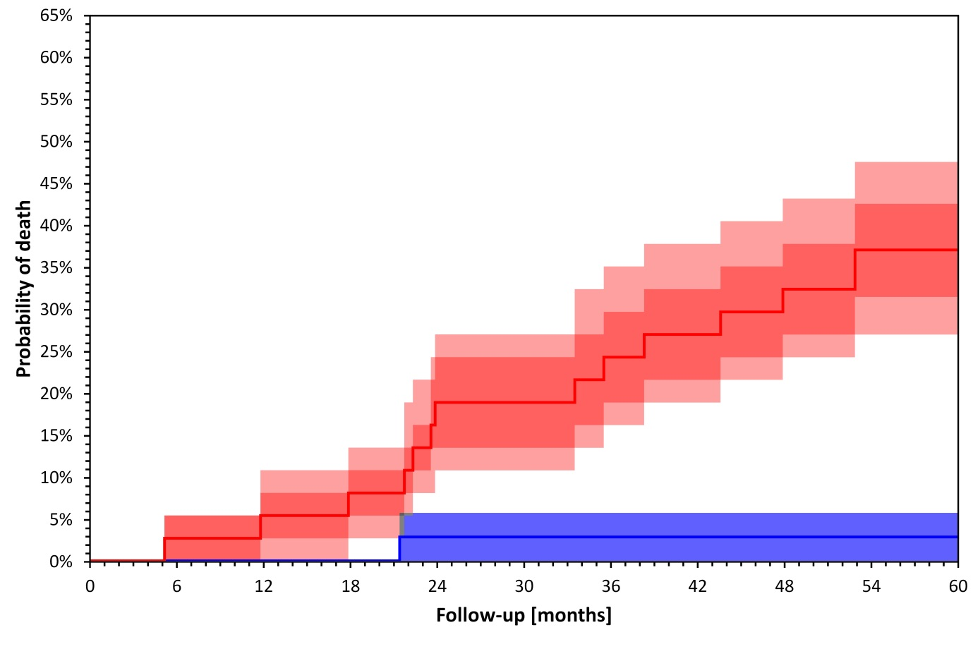
Figure 2
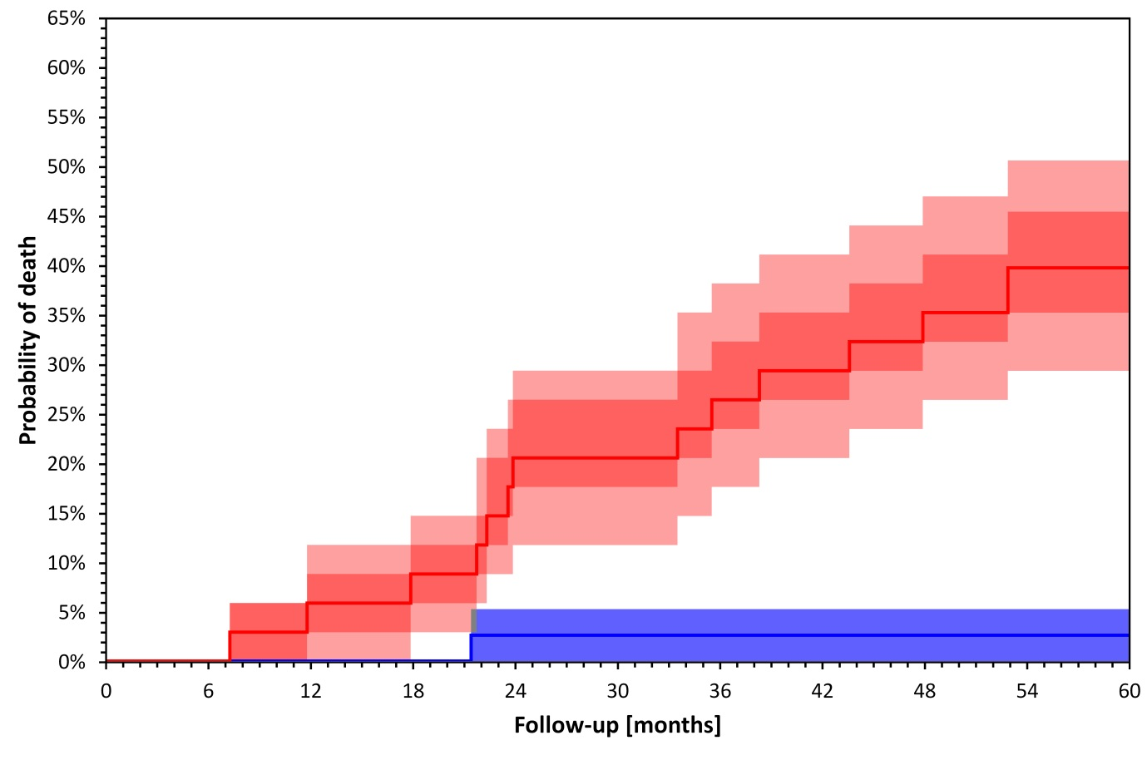
Figure 3
