Supplemental Figure S1: Overall Study Design
361 English GP practices
Mean HbA1c in each patient calculated
Follow-Up
N=104,617 patients aged 40-89 years on (QOF) diabetes register as of 1/1/2008 and registered for at least 1 year
N=96,630
Type 2 diabetes
N=141,768
matched controls¹
Infection rates in 2010-15 compared by mean HbA1c level during 2008-09
(i) within diabetes only, with HbA1c=6-7% as reference group
(ii) using matched controls as reference group

Excluded
no matched control (n=100)
N=5,863
Type 1 diabetes
N=3,342
matched controls¹
Infections during 2010-15 categorised by type and summarised as
(i) Any plus prescription
(Ii) Any as hospitalisation
(iii) Cause of death
N=4,496 Type 1
with HbA1c 2008-09
Excluded
During 2008-09: 13 practices leave CPRD (n=3,412), dies (n=6,636), de-registers (n=5,368), no HbA1c (n=2,393), control no longer eligible (n=1,496)
N=1,852 Type uncertain with HbA1c 2008-09
N=2,124
Type uncertain
N=78,964 Type 2 with HbA1c 2008-09
N=8,231
matched controls¹
Re-categorised from T1
has no insulin or has other anti-DM medication in 2008-09 (n=267)
1/1/2008
1/1/2010
31/12/2015
¹ – Age-sex practice matched controls were required to have no Read codes for diabetes in their record as of 1/1/2010, but could develop diabetes during follow-up

T1 code only
Type 1
N=5,139
Insulin
+ no ADM in 2007
Insulin only pre 2007
Insulin in 2007
+ no other ADM ever

Uncertain
N=93
T2 code only

Type 2
N=64
No Insulin ever

All others
Type 2
N=93,237
T1 & T2 codes or Non-specific only

Insulin in 2007
+ no other ADM ever
+ no gestational DM ever
Type 1
N=724
Uncertain
N=1,213
All others
Type 2
N=3,329
ADM = Anti-diabetic medicine
Insulin only pre 2007
+ no other ADM ever
Uncertain
N=47
Insulin
+ ADM in 2007
Uncertain
N=759
Any Insulin ever
+ no other ADM ever
+ gestational DM ever
Uncertain
N=12
All T1DM (1/1/2008)
N=5,863
All T2DM (1/1/2008)
N=96,630
What combination of DM OQF Read codes does the patient have by January 1st 2008?
All Uncertain (1/1/2008) N=2,124
All T1DM (1/1/2010)
N=4,496
All T2DM (1/1/2010)
N=78,964
All Uncertain (1/1/2008) N=1,852
See Figure S1 for derivation of how patients with diabetes on 1/1/2008 were followed up and re-classified by type as of 1/1/2010
Supplemental Figure S2: Derivation of diabetes type at beginning of study (1/1/2008)

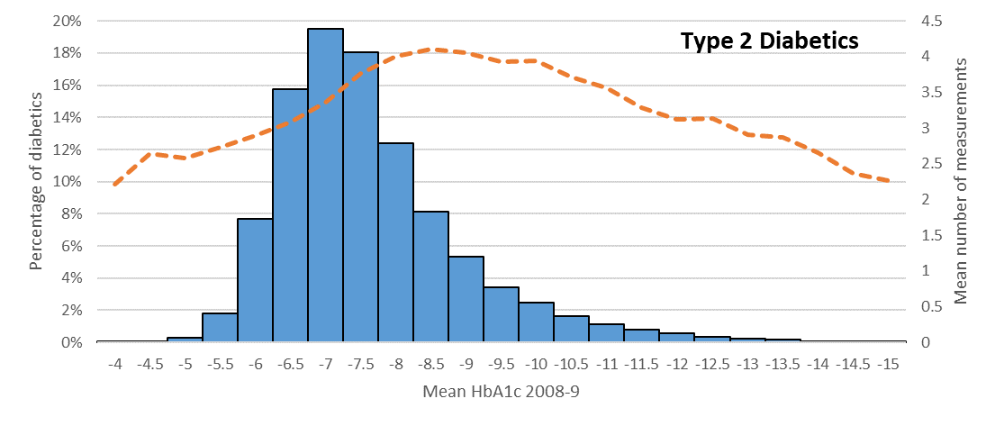
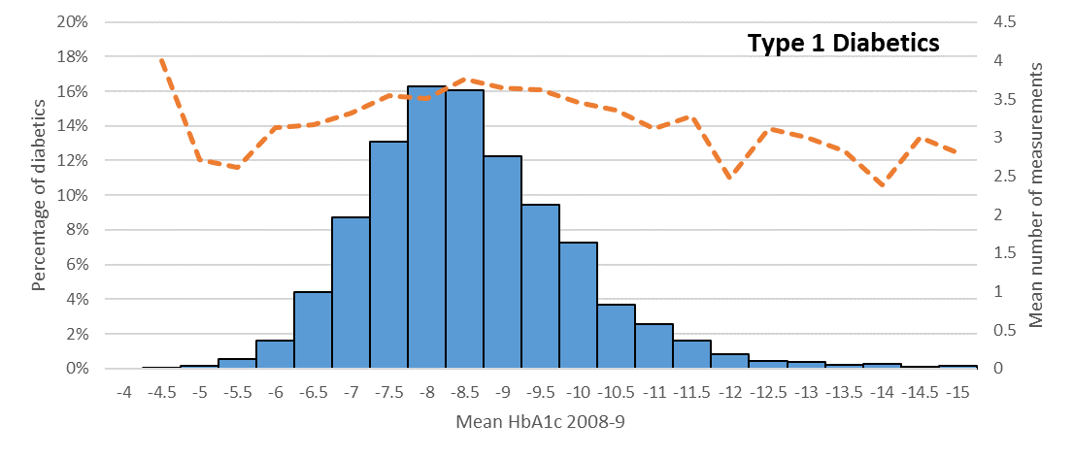
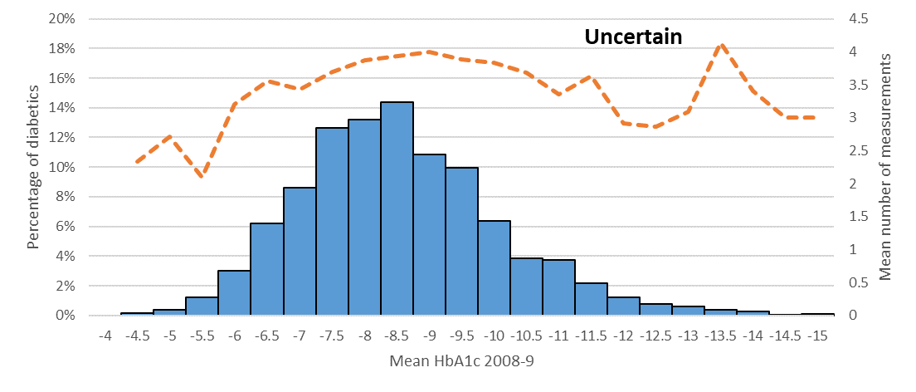
Supplemental Figure S3: Distribution of mean HbA1c during 2008-9 and number of eligible measurements by DM type
Note: Dotted lines represent mean number of HbA1c measurements per patient, with the scale represented on the secondary y-axis.
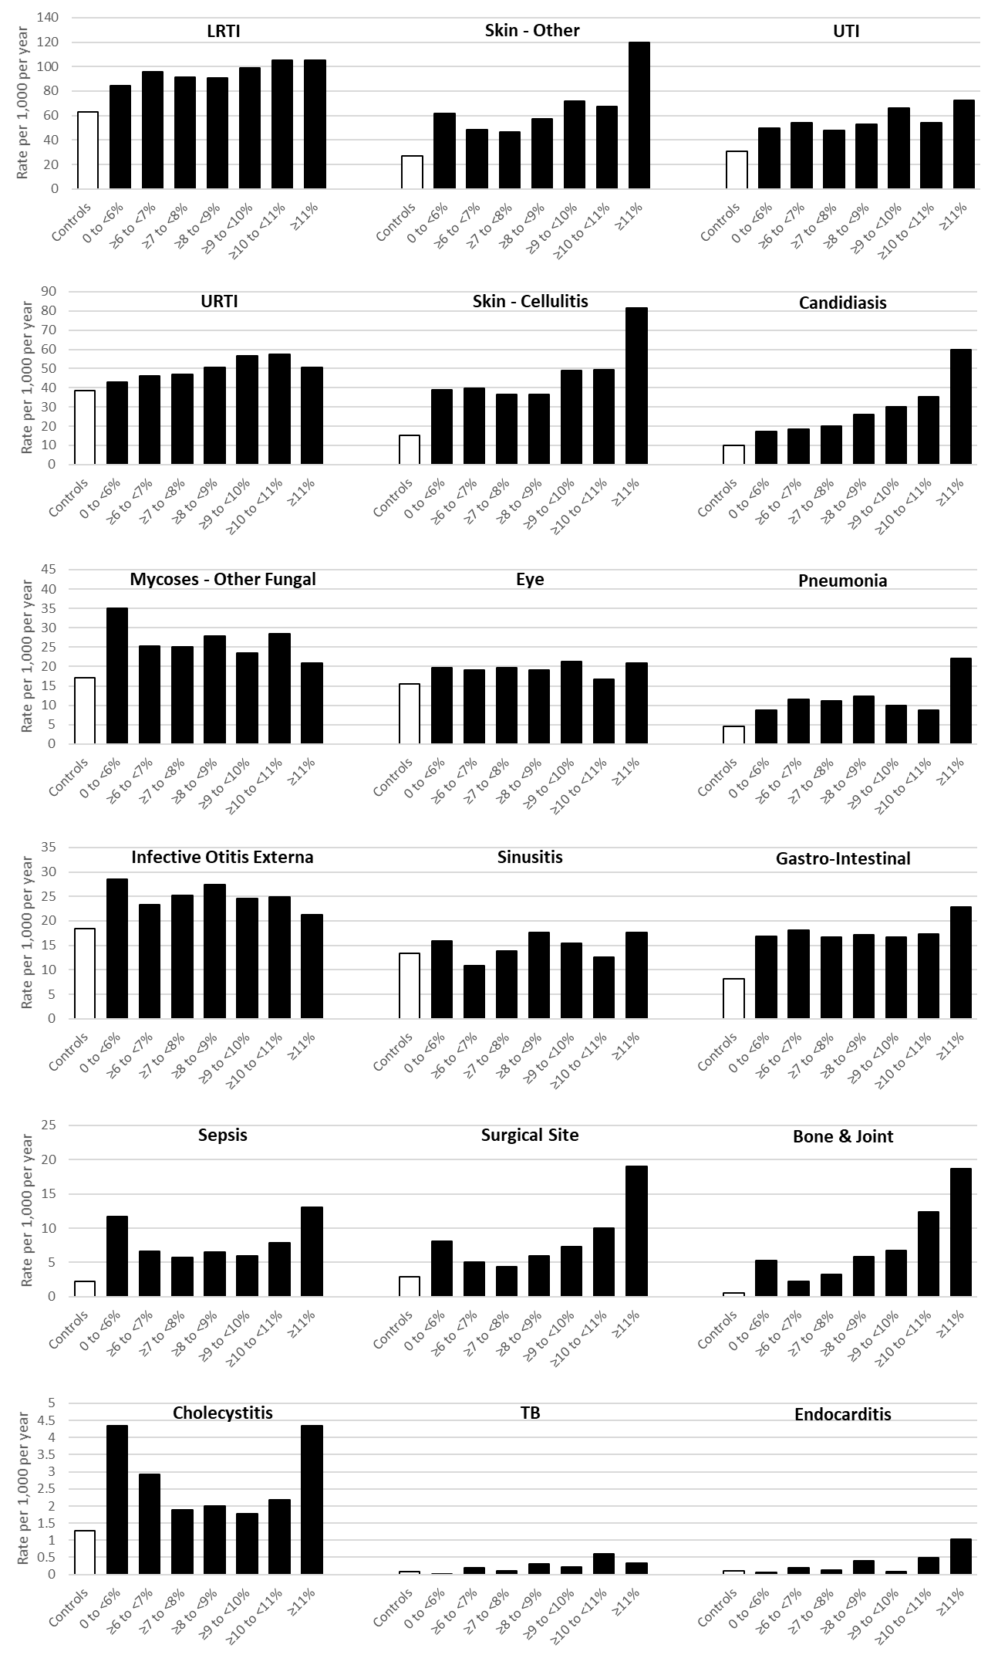
Supplemental Figure S4: Summary of Infection Rates during 2010-15 by mean HbA1c level during 2008-9, All diabetes (black) and matched controls (white)
Note: Infections are presented in descending frequency ordered, with different scales on each row.
Supplemental Table S1: ICD-10 and Read codes for Infections
Infection | ICD-10 | Read Codes
Bone & Joint Infections | M00, M86.0-M86.2 | N010*, N30..-N303z, N308*, N309*, N30y.-N30zz
(Acute) Cholecystitis | K80, K80.4, K81.0, K81.9 | J640*, J643*, J650*, J651z, J666.
Endocarditis | I01.1, I33, I33.0, I33.9, I38, I39, I39.8 | A3642, A7422, A932*, A98y3, AB2y0, AB414, G011., G14z., G51*, G54z., G54z3, G54z4, G54zz, Gyu5E
Eye Infection | H10, H10.0, H10.2, H10.3, H10.5, H16*, H44.0 | F400*, F4A*, F4C0.-F4C05, F4C0z, F4C2*, F4C33, F4D1.-F4D13, F4D1z, F4D4., F4D5.
Gastro-Intestinal | A00-A02.0, A02.2-A09.9 | A00..-A020., A022*, A02y.-A0z.., A3Ay2
Infective Otitis Externa | H60, H60.0-H60.4, H60.8-H60.9 | F501*, FyuN0, FyuN1, FyuN3-FyuN7
LRTI | J20-J22 | H06*, H07*
Mycoses - Candidiasis | B37* | AB2-AB2y., AB2y1-AB2z.
Mycoses - Other Fungal | B35-B36.9,B38-B49 | AB…-AB1z, AB3..-ABz..
Pneumonia | A48.1, J12-J18 | A3A4., H20..-H2C.., Hyu08-Hyu0H
Sepsis | A02.1, A20.7, A22.7, A26.7, A32.7, A40-A41.9, A48.3, O85 | A021., A023., A202., A270100, A271100, A2706, A362., A38*, A396., A3Ay100, A3C*, A545., A98yz12, Ayu3E00- Ayu3H00, Ayu3J00, H5y0100, K190600, L090y00, L090z00, L40..11, L293*, L403*, SP25400
(Acute) Sinusitis | J01* | H01*
Skin - Cellulitis | H60.1, K12.2, L03*, N73.0-N73.2 | F4D0.11, F4D14, H1y51, H1y71, J083.- J083z00, J0851, J54..11, J540.11, K2723, K2843, K403., K403100, K403z, K404., K4040, K405., K4051, K405z, M02..- M0200, M020z-M0210, M021z00, M02z.00, M03..00, M03..13, M030*, M031.00, M032-M034000, M034013- M03y000, M03z.00, M03z000, M03zz00, M08.., M080.00, M080.13- M086., M088.- M08y.
Skin - Other | A46, A49.0, J34.0, L00-L02.9, L04-L05.9, L08.1-L08.9, L30.3, L66.3, L66.4, L73.9, N73, N73.8-N73.9 | A35.., A3B1*, J54..00, J54..12, J540., K403000, K403111, K4041-K404z, K4050, M0...- M01z0, M0201-M0205, M0211-M0213, M021z11, M02z.11-M02z.14, M03..11, M03..12, M031.11, M034011, M034012, M03y011, M03z100, M03zz11, M04..- M061.00, M062.- M07..00, M072.- M07y100, M07yz- M07z.13, M07z0- M07z2, M080.11, M080.12, M087., M09*, M0y*, M0z*, M244.00, M2440- M244111, M2443- M244z
Surgical Site | T79.3, T80.2, T81.4, T82.6, T82,7, T83.5, T83.6, T84.5-T84.7, T85.7, T87.4, T88.0 | SP056, SP06.00, SP06.12- SP06A11, SP077, SP078, SP132, SP162, SP25.- SP253, SP255- SP25z, SP33*
Tuberculosis | A15-A19.9 | A1*, Ayu1.00, Ayu10, Ayu11, Ayu13- Ayu16, Ayu18, Ayu19, N304*, N305*, N306*
(Other) URTI | A37-A38, H65.0-H65.1, H66*, J02-J06.9, J36 | A33*, A34*, F510.00- F5103, F5200-F520z, F526.-F528., F52z.11, H02*, H03*, H04*, H05*, H15.., Hyu01- Hyu03
Urinary Tract Infection | N10-N12, N13.6, N15.1, N15.9, N30* | K103.12, K104.-K106., K10y.-K10z., K15*, K190*, Kyu10, Kyu1E
* - indicates a wild-card, so include all codes in hierarchy
Supplemental Table S2: Summary of mean HbA1c during 2008-9 among all diabetes patients (n=85,312)
Baseline characteristic |  | Mean HbA1c calculated during 2008-9
 |  | All Patients |  | <6% | ≥6 to <7% | ≥7 to <8% | ≥8 to <9% | ≥9 to <10% | ≥10 to <11% | ≥11%
 |  | n | mean (s.d.) | n (%) | n (%) | n (%) | n (%) | n (%) | n (%) | n (%)
All |  | 85,312 | 7.4 (1.4) | 8,013 (9.4) | 28,677 (33.6) | 25,848 (30.3) | 12,338 (14.5) | 5,738 (6.7) | 2,589 (3.0) | 2,109 (2.5)
Gender | Women | 38,043 | 7.4 (1.4) | 3,742 (9.8) | 13,325 (35.0) | 11,198 (29.4) | 5,203 (13.7) | 2,441 (6.4) | 1,139 (3.0) | 995 (2.6)
 | Men | 47,269 | 7.5 (1.4) | 4,271 (9.0) | 15,352 (32.5) | 14,650 (31.0) | 7,135 (15.1) | 3,297 (7.0) | 1,450 (3.1) | 1,114 (2.4)
Ageª | 40-49 | 8,309 | 8.2 (1.7) | 570 (6.9) | 1,591 (19.2) | 2,199 (26.5) | 1,698 (20.4) | 1,083 (13.0) | 595 (7.2) | 573 (6.9)
 | 50-59 | 15,959 | 7.8 (1.5) | 1,161 (7.3) | 4,129 (25.9) | 4,755 (29.8) | 2,914 (18.3) | 1,513 (9.5) | 794 (5.0) | 693 (4.3)
 | 60-69 | 24,441 | 7.4 (1.3) | 2,127 (8.7) | 8,097 (33.1) | 7,820 (32.0) | 3,702 (15.2) | 1,565 (6.4) | 641 (2.6) | 489 (2.0)
 | 70-79 | 25,196 | 7.2 (1.1) | 2,611 (10.4) | 10,004 (39.7) | 7,947 (31.5) | 2,887 (11.5) | 1,118 (4.4) | 386 (1.5) | 243 (1.0)
 | 80-89 | 11,407 | 7.0 (1.2) | 1,544 (13.5) | 4,856 (42.6) | 3,127 (27.4) | 1,137 (10.0) | 459 (4.0) | 173 (1.5) | 111 (1.0)
DM Type | T1DM | 4,496 | 8.3 (1.4) | 105 (2.3) | 592 (13.2) | 1,324 (29.5) | 1,269 (28.2) | 748 (16.6) | 279 (6.2) | 179 (4.0)
 | T2DM | 78,964 | 7.4 (1.3) | 7,820 (9.9) | 27,811 (35.2) | 24,046 (30.5) | 10,602 (13.4) | 4,688 (5.9) | 2,170 (2.8) | 1,827 (2.3)
 | Unclassified | 1,852 | 8.3 (1.6) | 88 (4.8) | 274 (14.8) | 478 (25.8) | 467 (25.2) | 302 (16.3) | 140 (7.6) | 103 (5.6)
Duration of | 0-5 years | 37,918 | 7.1 (1.2) | 4,832 (12.7) | 15,700 (41.4) | 10,737 (28.3) | 3,826 (10.1) | 1,546 (4.1) | 706 (1.9) | 571 (1.5)
diabetes | 5-15 years | 35,655 | 7.6 (1.4) | 2,655 (7.5) | 10,702 (30.0) | 11,391 (32.0) | 5,740 (16.1) | 2,711 (7.6) | 1,318 (3.7) | 1,138 (3.2)
 | >15 years | 11,739 | 8.0 (1.4) | 526 (4.5) | 2,275 (19.4) | 3,720 (31.7) | 2,772 (23.6) | 1,481 (12.6) | 565 (4.8) | 400 (3.4)
Deprivation | 1 – Least | 16,913 | 7.3 (1.3) | 1,715 (10.1) | 5,766 (34.1) | 5,303 (31.4) | 2,444 (14.5) | 1,040 (6.2) | 393 (2.3) | 252 (1.5)
quintile ^{b} | 2 | 19,921 | 7.4 (1.3) | 1,846 (9.3) | 6,860 (34.4) | 6,185 (31.1) | 2,810 (14.1) | 1,281 (6.4) | 539 (2.7) | 400 (2.0)
 | 3 | 17,707 | 7.4 (1.4) | 1,731 (9.8) | 5,913 (33.4) | 5,447 (30.8) | 2,584 (14.6) | 1,119 (6.3) | 493 (2.8) | 420 (2.4)
 | 4 | 17,848 | 7.5 (1.5) | 1,545 (8.7) | 5,796 (32.5) | 5,324 (29.8) | 2,653 (14.9) | 1,271 (7.1) | 675 (3.8) | 584 (3.3)
 | 5 – Most | 12,871 | 7.5 (1.5) | 1,170 (9.1) | 4,323 (33.6) | 3,577 (27.8) | 1,840 (14.3) | 1,022 (7.9) | 488 (3.8) | 451 (3.5)
Smoking | Never | 31,204 | 7.4 (1.4) | 2,827 (9.1) | 10,485 (33.6) | 9,624 (30.8) | 4,548 (14.6) | 2,016 (6.5) | 916 (2.9) | 788 (2.5)
Status | Ex | 43,148 | 7.4 (1.3) | 4,250 (9.9) | 14,855 (34.4) | 13,182 (30.6) | 6,109 (14.2) | 2,755 (6.4) | 1,165 (2.7) | 832 (1.9)
 | Current | 10,960 | 7.7 (1.6) | 936 (8.5) | 3,337 (30.5) | 3,042 (27.8) | 1,681 (15.3) | 967 (8.8) | 508 (4.6) | 489 (4.5)
BMI ^{b} | 10-20 | 1,458 | 7.2 (1.6) | 299 (20.5) | 525 (36.0) | 330 (22.6) | 156 (10.7) | 57 (3.9) | 39 (2.7) | 52 (3.6)
 | 20-25 | 13,551 | 7.3 (1.4) | 1,817 (13.4) | 4,976 (36.7) | 3,755 (27.7) | 1,617 (11.9) | 742 (5.5) | 318 (2.4) | 326 (2.4)
 | 25-30 | 30,084 | 7.4 (1.3) | 2,855 (9.5) | 10,522 (35.0) | 9,493 (31.6) | 4,087 (13.6) | 1,795 (6.0) | 766 (2.6) | 566 (1.9)
 | 30-40 | 33,437 | 7.5 (1.4) | 2,560 (7.7) | 10,651 (31.9) | 10,295 (30.8) | 5,320 (15.9) | 2,535 (7.6) | 1,162 (3.5) | 914 (2.7)
 | 40+ | 6,591 | 7.7 (1.5) | 445 (6.8) | 1,934 (29.3) | 1,938 (29.4) | 1,130 (17.1) | 599 (9.1) | 299 (4.5) | 246 (3.7)
ª Age calculated during baseline year (2008). ^{b} Patients with missing values for deprivation (IMD) (n=52) or BMI (n=191) are not shown in those categories
Supplemental Table S3: IRRs additionally adjusted for co-morbidity for summary infection groups during 2010-5 by mean HbA1c level during 2008-9
Outcome | Non-DM | DM vs. non-DMª | Mean HbA1c (2008-9) in DM patients^{b}
 |  |  | <6% | ≥6 to <7% | ≥7 to <8% | ≥8 to <9% | ≥9 to <10% | ≥10 to <11% | ≥11%
 | IRR^{c}, 95% CI | IRR^{c}, 95% CI | IRR^{c}, 95% CI | IRR^{c}, 95% CI | IRR^{c}, 95% CI | IRR^{c}, 95% CI | IRR^{c}, 95% CI | IRR^{c}, 95% CI | IRR^{c}, 95% CI
DM patients (n=85,312) vs. non-DM (n=153,341)
Any plus prescription | 1 (reference) | 1.26 (1.25-1.28) | 1.18 (1.14-1.24) | 1.15 (1.13-1.18) | 1.23 (1.20-1.25) | 1.35 (1.31-1.39) | 1.47 (1.42-1.52) | 1.54 (1.46-1.64) | 1.69 (1.60-1.79)
Any as hospitalisation | 1 (reference) | 1.58 (1.53-1.64) | 1.49 (1.40-1.59) | 1.29 (1.23-1.34) | 1.44 (1.38-1.50) | 1.77 (1.67-1.87) | 2.09 (1.94-2.26) | 3.02 (2.76-3.30) | 4.09 (3.68-4.54)
Death from infection | 1 (reference) | 2.03 (1.76-2.34) | 1.77 (1.50-2.10) | 1.45 (1.28-1.64) | 1.69 (1.48-1.92) | 1.87(1.56-2.24) | 1.94 (1.48-2.52) | 4.44 (3.28-6.02) | 4.64 (3.22-6.67)
DM patients only (n=85,312)
Any plus prescription | _ | _ | 1.02 (0.98-1.07) | 1 (reference) | 1.05 (1.02-1.07) | 1.13 (1.09-1.16) | 1.21  (1.16-1.26) | 1.25 (1.18-1.33) | 1.36 (1.29-1.44)
Any as hospitalisation | _ | _ | 1.16 (1.08-1.24) | 1 (reference) | 1.09 (1.03-1.14) | 1.28 (1.21-1.36) | 1.49 (1.37-1.61) | 2.09 (1.90-2.29) | 2.80 (2.52-3.10)
Death from infection | _ | _ | 1.24 (1.04-1.48) | 1 (reference) | 1.12 (0.98-1.30) | 1.19(0.98-1.45) | 1.22 (0.92-1.61) | 2.74 (2.02-3.73) | 2.87 (2.02-4.10)
ª - Poisson model conditioned on matchsets fits a term to compare DM vs. non-DM. ^{b} - Poisson model now fits HbA1c categories, with non-DM as reference category (top 3 rows) or HbA1c=6-7% as reference category (bottom 3 rows). ^{c} - Incidence Rate Ratios adjusted for age, sex, smoking, BMI, deprivation quintile and DM type as in Tables 1 and 2, and now additionally adjusted for chronic kidney disease, heart failure, hypertension, hypothyroidism, ischaemic heart disease, peripheral vascular disease, stroke & transient ischaemic attack and COPD.

Supplemental Table S4: Adjusted IRRs for summary infection groups during 2010-5 by updated 2-year mean HbA1c level among DM patients only, by different analysis type
Outcome | DM Type^{c} |  | Updated 2-year average mean HbA1c in DM patients^{b} |  |  |  |  |  |  | Attributable risk fractions
 | Type 1 | Type 2 | <6% | ≥6 to <7% | ≥7 to <8% | ≥8 to <9% | ≥9 to <10% | ≥10 to <11% | ≥11%
 | IRRª, 95% CI | IRRª, 95% CI | IRRª, 95% CI | IRRª, 95% CI | IRRª, 95% CI | IRRª, 95% CI | IRRª, 95% CI | IRRª, 95% CI | IRRª, 95% CI | AR^{d}
Any plus prescription | 1 (refer-ence) | 1.02 (0.98-1.07) | 1.04 (1.01-1.07) | 1 (refer-ence) | 1.04 (1.02-1.06) | 1.14 (1.11-1.16) | 1.19 (1.16-1.23) | 1.28 (1.23-1.33) | 1.26 (1.20-1.31) | 6.1
Any as hospitalisation | 1 (refer-ence) | 1.49 (1.35-1.65) | 1.29 (1.20-1.38) | 1 (refer-ence) | 1.02 (0.97-1.07) | 1.30 (1.22-1.37) | 1.58 (1.47-1.70) | 2.07 (1.89-2.26) | 2.53 (2.29-2.80) | 14.4
Death from infection | 1 (refer-ence) | 1.86 (1.37-2.53) | 1.51 (1.25-1.83) | 1 (refer-ence) | 1.10 (0.94-1.29) | 1.40 (1.15-1.69) | 1.50 (1.16-1.93) | 2.24 (1.63-3.10) | 2.72 (1.90-3.89) | 17.2
Note - Reference category in Poisson models are patients with DM and HbA1c between 6 to 7%.
ª- IRR from GEE Poisson model adjusted for age in year, sex, smoking, BMI, deprivation quintile and type of diabetes. ^{b} – Re-calculated every January 1st based on all HbA1c measurements in previous 2 years. Patients no longer registered or without measurements not included in later years. Analysis based on 372,850 patient x year observations. ^{c} – Type uncertain also fitted in model (estimates not shown). ^{d} - Attributable risk fractions for infections for a baseline scenario of HbA1c=6-7% among all patients with diabetes.

Supplemental Table S5: Bradford Hill Criteria(1) for hyperglycaemia and infection risk
Strength | Strong associations were observed, up to 3 times higher risk for patients with the most elevated levels of HbA1c compared with optimal control for both T1 and T2DM
Consistency | Almost all infection categories considered show an increased risk with higher HbA1c, as did our summary measures of infection (any episode requiring a prescription, any requiring hospitalisation, and infection-related mortality). Several other recent database studies have demonstrated similar, though more limited, findings(2, 3).
Specificity | The association with HbA1c is not specific to one infection or even limited to infections, but this would not be expected based on our understanding of the potential mechanisms. Lack of specificity should not therefore be regarded as an argument against the relationship being causal.
Temporality | In our cohort design, with frequent measurements of HbA1c, we are confident that the chronic hyperglycaemia arose before the infection episode. We were able to eliminate reverse causality by removing measurements of HbA1c close to or at the time on the infection episode.
Biological gradient | Very strong dose response relationships observed between HbA1c and infection risk, particularly for more serious infections. A rise in infection risk was seen across increasing categories of HbA1c. This remained after adjusting for type, duration, and key comorbidities.
Plausibility & Coherence | Plausible mechanisms are varied, but focus on relative immune function impairment in DM patients(4, 5). Laboratory evidence has seen adverse effects of glycaemia on macrophage function and T cell complement. Laboratory studies have also shown that metformin reduces the intracellular growth of Mycobacterium tuberculosis(6) and may limit Staphylococcus aureus growth(7).
Experiment | Very limited evidence exists. One trial (DCCT) demonstrated lower risks of some infections in the more intensively managed group (8), but there remains a major gap in the knowledge base.
Analogy | Randomised evidence supports an effect of glycaemia on microvascular(9), and to some extent macrovascular outcomes(10-13). Moreover microvascular disease is undoubtedly one of the mechanisms linking HbA1c to infection via neuropathies and amputations(14) (15). Macrovascular disease may also be important(16).

References to supplement
1. Fedak KM, Bernal A, Capshaw ZA, Gross S. Applying the Bradford Hill criteria in the 21st century: how data integration has changed causal inference in molecular epidemiology. Emerg Themes Epidemiol. 2015;12:14.
2. Hine JL, de Lusignan S, Burleigh D, Pathirannehelage S, McGovern A, Gatenby P, et al. Association between glycaemic control and common infections in people with Type 2 diabetes: a cohort study. Diabet Med. 2017 Apr;34(4):551-7.
3. Mor A, Dekkers OM, Nielsen JS, Beck-Nielsen H, Sorensen HT, Thomsen RW. Impact of Glycemic Control on Risk of Infections in Patients With Type 2 Diabetes: A Population-Based Cohort Study. Am J Epidemiol. 2017 Jul;186(2):227-36.
4. Pearson-Stuttard J, Blundell S, Harris T, Cook DG, Critchley J. Diabetes and infection: assessing the association with glycaemic control in population-based studies. Lancet Diabetes Endocrinol. 2016 Feb;4(2):148-58.
5. Casqueiro J, Casqueiro J, Alves C. Infections in patients with diabetes mellitus: A review of pathogenesis. Indian Journal of Endocrinology and Metabolism. 2012 2012-Mar;16 Suppl 1:S27-36.
6. Singhal A, Jie L, Kumar P, Hong GS, Leow MKS, Paleja B, et al. Metformin as adjunct antituberculosis therapy. Science Translational Medicine. 2014 Nov;6(263).
7. Garnett JP, Baker EH, Naik S, Lindsay JA, Knight GM, Gill S, et al. Metformin reduces airway glucose permeability and hyperglycaemia-induced Staphylococcus aureus load independently of effects on blood glucose. Thorax. 2013 Sep;68(9):835-45.
8. The Diabetes Control and Complications Trial Research Group. Adverse events and their association with treatment regimens in the diabetes control and complications trial. Diabetes Care 1995 Nov;18(11):1415-27.
9. Zoungas S, Arima H, Gerstein HC, Holman RR, Woodward M, Reaven P, et al. Effects of intensive glucose control on microvascular outcomes in patients with type 2 diabetes: a meta-analysis of individual participant data from randomised controlled trials. Lancet Diabetes Endocrinol. 2017 Jun;5(6):431-7.
10. Patel A, MacMahon S, Chalmers J, Neal B, Billot L, Woodward M, et al. Intensive blood glucose control and vascular outcomes in patients with type 2 diabetes. N Engl J Med. 2008 Jun;358(24):2560-72.
11. Gerstein HC, Miller ME, Byington RP, Goff DC, Bigger JT, Buse JB, et al. Effects of intensive glucose lowering in type 2 diabetes. N Engl J Med. 2008 Jun;358(24):2545-59.
12. Duckworth W, Abraira C, Moritz T, Reda D, Emanuele N, Reaven PD, et al. Glucose Control and Vascular Complications in Veterans with Type 2 Diabetes. N Engl J Med. 2009 Jan;360(2):129-U62.
13. Hemmingsen B, Lund SS, Gluud C, Vaag A, Almdal T, Hemmingsen C, et al. Intensive glycaemic control for patients with type 2 diabetes: systematic review with meta-analysis and trial sequential analysis of randomised clinical trials. Br Med J. 2011 Nov;343:20.
14. Simonsen JR, Harjutsalo V, Jarvinen A, Kirveskari J, Forsblom C, Groop PH, et al. Bacterial infections in patients with type 1 diabetes: a 14-year follow-up study. BMJ Open Diab Res Care. [Article]. 2015 Jan;3(1):9.
15. Mishra SC, Chhatbar KC, Kashikar A, Mehndiratta A. Diabetic foot. BMJ. 2017;359.
16. Bertoni AG, Saydah S, Brancati FL. Diabetes and the risk of infection-related mortality in the US. Diabetes Care. 2001 Jun;24(6):1044-9.

