TITLE
Continuous infusion of low dose Iohexol (CILDI) measures changing glomerular filtration rate in critically ill patients

AUTHORS
John J. Dixon M.Sc^{1,2,3}, Katie Lane MBBS^{1,2}, R. Neil Dalton PhD⁴, Charles Turner⁴, Iain A.M. MacPhee DPhil^{1,3}, Irina Chis Ster⁵, Barbara J. Philips MD^{1,2}
Institutions
- Institute of Medical and Biomedical Education, St. George’s, University of London, London, United Kingdom
- Department of Critical Care, St. George’s University Hospitals NHS Foundation Trust, London, United Kingdom
- Department of Renal and Transplantation Medicine, St. George’s University Hospitals NHS Foundation Trust, London, United Kingdom
- Wellchild Laboratory, King’s College, London, Evelina Children’s Hospital, London, United Kingdom
- Institute of Infection and Immunity, St. George’s, University of London, London, United Kingdom
CONFLICTS OF INTEREST
None declared
CORRESPONDENCE: Barbara J Philips
Institute of Medical and Biomedical Education, St. George’s, University of London, United Kingdom.
Email: bphilips@sgul.ac.uk

RUNNING TITLE: Iohexol infusion measures GFR in ICU
GRANTS AND FUNDING: 1) Intensive Care Foundation, Intensive Care Society, London, UK, 2) St. George’s Hospital Medical Research Charity, St. George’s Hospital, London, UK.

AUTHOR CONTRIBUTIONS: JD carried out the study, as part of a PhD project, and was responsible for all aspects of the research project, including writing the manuscript; CT and ND were involved in experimental design, sample analysis and statistical analysis of the laboratory samples; KL, IM and BP were involved in experimental design, and statistical analysis; ICS reviewed the study statistical methods and results and provided additional analyses; IM and BP provided final editorial changes prior to submission; and all authors approved the final version.

WORD COUNTS
Main body of text: 2687
Abstract: 246
Total word count: 2933

KEY WORDS
Acute kidney injury (AKI)
Glomerular Filtration Rate (GFR)
Iohexol

ABSTRACT
Objective: Measurement of changing glomerular filtration rate (GFR) in acute kidney injury (AKI) remains problematic. We have previously used a continuous infusion of low dose Iohexol (CILDI) to measure GFR in stable subjects and postulate that changes >10.3% in critically ill patients indicate AKI. Our objective is to explore the extent to which CILDI can be a measure of changing GFR during AKI.
Design: clinical observational exploratory study
Setting: adult intensive care unit.
Patients: Three patient groups were recruited: Nephrectomy group - predictable onset of AKI and outcome (n=10); Surgery group - predictable onset of AKI, unpredictable outcome (n=11); AKI group - unpredictable onset of AKI and outcome (n=13).
Interventions: CILDI was administered for 24-80h. Plasma (Cl_{P}) and renal (Cl_{R}) Iohexol clearances were measured at timed intervals.
Measurements and main results: Kidney Disease: Improved Global Outcomes (KDIGO) AKI criteria were fulfilled in 22 patients (Nephrectomy=5, Surgery=4, AKI=13); CILDI demonstrated AKI in 29 patients (Nephrectomy=10, Surgery=8, AKI=11). Dynamic changes in GFR were tracked in all patients. In Nephrectomy group, Cl_{R} decreased by an expected 50% (50.8±11.0%). Agreement between Cl_{P} and Cl_{R} improved with increasing duration of infusion: bias of Cl_{P} versus Cl_{R} at 48h was -0.1±3.6mL/min/1.73m² (Limits of agreement: -7.2 to 7.1mL/min/1.73m²). Co-efficient of variation of laboratory sample analysis was 2.4%.
Conclusions: CILDI is accurate and precise when measuring GFR and tracks changes in patients with differing risks of AKI. CILDI may provide a useful standard against which to test novel biomarkers for the diagnosis of AKI.

MAIN TEXT
INTRODUCTION
An improved method of measuring changing glomerular filtration rate (GFR) during acute kidney injury (AKI) would be of immense benefit. We need a method of properly evaluating biomarkers, which to date have been compared with flawed serum creatinine (SCr) measurements, and found to be wanting. Accurate assessment of AKI is required to facilitate dosing of renally-excreted drugs (1), to identify progression to renal replacement therapy (RRT) (2) and to predict those patients most vulnerable to the development of chronic kidney disease (CKD). In research, an improved measurement of GFR would help elucidate the temporal relationship between changing GFR during AKI and pathophysiological consequences.
AKI is defined by increased SCr concentration or reduced urine output (3). Both parameters have limitations in critically ill patients (4).
Theoretically, exogenous filtration markers have advantages over endogenous markers when measuring GFR during AKI. Measurements are not influenced by diet, metabolic processes or body habitus, and are independent of the time of the insult causing AKI. Single bolus injection (SBI) of Iohexol has been used to measure GFR in critically ill patients (5,6), but SBI has methodological limitations. Stable GFR is needed for accurate interpretation – the elimination constant changes during AKI. Multiple administrations are required to measure changing GFR, leading to larger administered volumes than with continuous infusions, increasing potential for toxicity. Prolonged washout periods are needed for complete elimination before the next dose is administered. Changes in volume of distribution (Vd) or non-renal clearance (Cl_{NON-RENAL}) in critically ill patients mean that a prolonged time is required before plasma clearance (Cl_{P}) is equivalent to renal clearance (Cl_{R}). Continuous infusions of Inulin (7) and EDTA (8) have been used to measure GFR in critically ill patients but only for less than 4 hours. This is too short for understanding the impact of changes in GFR and development of AKI.
We have previously developed a continuous infusion of low dose Iohexol (CILDI) as a measure of GFR in stable subjects over a range of GFR (28-128mL/min/1.73m²) (9). Accuracy of CILDI was confirmed with the SBI method. Mean intra-individual variation in Cl_{P} was <10.3±7.4%, and variation in Cl_{R} was <6.9±4.7% (9).
We hypothesise that variations in excess of these limits suggest AKI is present and that CILDI can accurately and precisely measure changing GFR during AKI. The aim of this study is to explore CILDI as a measure of changing GFR in patients with different risks of developing AKI.

METHODS
Detailed methods are outlined in supplementary online material
Study registration and ethical approval
The UK Clinical Research Network (http://public.ukcrn.org.uk/) adopted the study (Reference: 13391). Ethical approval was obtained from Queen’s Square research ethics committee (reference: 12/LO/1179). The Declaration of Helsinki (2008) (10) was adhered to throughout.

Patients
The study took place in an adult general intensive care unit. Three patient groups were selected: 1) Nephrectomy: Patients due an elective nephrectomy and thus a predictable reduction in GFR of approximately 50% (defined onset of injury; predictable outcome). 2) Surgery: Patients due elective major vascular surgery. These patients have a high risk of post-operative AKI (11) (defined onset of injury; unpredictable outcome). 3) AKI: Emergency patients admitted to ICU meeting Kidney Disease: Improved Global Outcomes (KDIGO) AKI criteria (3) (unpredictable onset of injury; unpredictable outcome).

Inclusions
- Patients over 18 years due an elective nephrectomy or major vascular surgery admitted to ICU post-operatively, or
- Patients meeting KDIGO-AKI criteria (urine output or SCr) in ICU (3).

Exclusions
See supplementary online material.

Iohexol administration and sampling
Iohexol was administered via a central venous catheter. A loading dose was administered over 2 minutes (9) and followed by a continuous infusion of Iohexol (Omnipaque 300®; 12) at 0.5mL/h (343.5mg/h) for up to 80h (13). Plasma samples (0.5mL) were taken for Cl_{P} at 30 mins, 1h, 2h and 4h on day 0, and at 08:00h, 10:00h, 18:00h and 20:00h on days 1-3 from an arterial catheter. Urine samples were taken for Cl_{R} between plasma samples on day 0 and between subsequent morning plasma samples and evening plasma samples. Time zero was considered to be the time of commencing the infusion. Infusions were commenced within 1h of surgery in Surgery and Nephrectomy groups.

Laboratory procedures and GFR calculation
Plasma and urine Iohexol concentration were measured by high performance liquid chromatography / electrospray tandem mass spectrometry (LC-MSMS) (Online supplementary material). Baseline eGFR was obtained from admission eGFR (14) for elective patients or from hospital notes, if within the last 6 months. The following formulae were used:
Cl_{P} (mL/min) = [Iohexol infusion rate (μmol/min)]/[plasma Iohexol concentration (μmol/mL)], adjusting for body surface area (BSA) (15).
Cl_{R} (mL/min) = [U x V] / P, where U =urine Iohexol concentration (μmol/L), V = volume of urine (mL) per unit time (min), and P = mid-time point plasma Iohexol concentration (μmol/L), adjusting for (BSA) (15).

Agreement with KDIGO and outcomes
Iohexol GFR measurements and KDIGO-AKI criteria were observed and classified according to whether subjects met KDIGO and CILDI criteria for AKI: KDIGO-positive (Kpos), KDIGO-negative (Kneg), CILDI-positive (Cpos), CILDI-negative (Cneg). Length of stay (LOS) in ICU and hospital, development of CKD within 1 year, need for renal replacement therapy (RRT), and death were recorded. CILDI defined AKI as GFR loss greater than 10.3% (9).

Statistical methods
The data have been graphically explored and summarized according to their nature. Cross sectional (one measurement per individual) have been summarized through means, medians, standard deviations and inter quartile ranges whilst categorical data have been summarized as proportions. Parametric or non-parametric tests have been tailored to variables’ nature. For hierarchical longitudinal data (multiple measurements per individual through time) nonlinear mixed models have been employed. Details are given in the supplementary material.
The analysis is not aiming at inferring differences between clinical groups. They differ by their default clinical definition. Rather, the statistical techniques used are exploratory, with the view of opening up novel methods or indicators which can contribute to the AKI definition.

RESULTS
Screening, enrolment, demographics.
Eleven subjects were enrolled into Nephrectomy and Surgery groups, and 13 into the AKI group (Table 1). One patient in the Nephrectomy group was excluded from analysis due to difficult venous access.

GFR.
Cl_{P} and Cl_{R} were calculated for each measurement taken on days 1-3. Measurements at 24h are shown in Table 2.

Agreement between Cl_{P} and Cl_{R}
Agreement (16) between Cl_{R} and Cl_{P} improved with increasing duration of the infusion (Figure 1).

Clinical and Laboratory Accuracy
Measured loss in GFR (Cl_{R}) at 24h in the Nephrectomy group was 50.8±17.6% as hypothesized from the loss of one kidney (Table 2, Supplementary Figure 3). For the laboratory analysis of samples, coefficient of variation (CV) for measuring Iohexol was 2.4%, (n=180 samples).

AKI misdiagnosis and outcomes
Iohexol Cl_{R} and Cl_{P} are compared with 1h- and 4hCrCl at 14h (Table 3). KDIGO-AKI criteria would have missed AKI in 9 patients (Nephrectomy group: 5, Surgery group: 4); three subjects meeting KDIGO-AKI criteria did not have AKI when measured by CILDI (Table 4). Patients who were Kneg/Cpos had higher proportion of CKD at 1 year than Kpos/Cneg.

DISCUSSION
Summary of results
We have used CILDI to measure GFR during AKI over the range encountered in critically ill patients, despite potential fluctuations in Vd and third space accumulation of fluids that may occur.
Demographics are shown in Table 1. The Surgery group had a reduced baseline eGFR reflecting the increased co-morbidities in this group. APACHE-II score was highest in the AKI group and lowest in Nephrectomy group. This was an expected observation related to the varying clinical presentations and complexity of disease.
There was no difference between Cl_{P} and Cl_{R} in all groups when GFR was measured at 24h (Table 2). Agreement between Cl_{R} and Cl_{P} improved at later stages of the infusion, suggesting a longer period is required for equilibration either caused by a change in Cl_{NON-RENAL} in critical illness or due to increased Vd.
Bland-Altman analysis (16) showed agreement between Cl_{P} and Cl_{R} improves with longer duration of infusion, with <1% bias and acceptable limits of agreement in later stages (Figure 1).
All nephrectomy patients underwent surgery for unilateral renal cell carcinomas and 10 had baseline eGFR >50mL/min/1.73m². One patient had an eGFR 39.7mL/min/1.73m² and we measured differential renal function. GFR was equal in both kidneys. The remaining patients had uncomplicated disease and we therefore expected a 50% reduction in GFR following nephrectomy. The observed 50.8% reduction at 24h (Fig 1 and Supplementary Figure 3) suggests that CILDI may provide an accurate measure of GFR.
Brenner’s theory suggests an immediate increase in single nephron GFR (SNGFR) following nephrectomy (17). Increases in blood flow and SNGFR have been observed in animal studies (18). Data are inconsistent in human studies: some confirm increased single kidney GFR several days post nephrectomy (19), others suggest it is delayed for up to 36 months (20). Increased blood flow to the remaining kidney has been reported post-nephrectomy (19) but there is a paucity of studies investigating GFR in the immediate post-operative period. We observed increasing GFR after 24h following nephrectomy, although numbers were too small for complete statistical analysis.
The 10.3% difference in Cl_{P} and 6.7% difference in Cl_{R} to define AKI is a significant contrast to KDIGO-AKI criteria where a rise in SCr >50% is required (3), resulting in a different proportion of patients meeting criteria for AKI. This is not unusual when different methods of defining AKI are compared (21). Using CILDI criteria, KDIGO-AKI criteria miss AKI in 5 patients in the Nephrectomy group, 4 in the Surgery group, and erroneously attribute AKI to 2 patients in the AKI group. All patients who were Kpos/Cneg (Table 4) had oliguria and raised SCr at 24h. Creatinine kinetics studies estimate a GFR reduction of 50% must occur to increase SCr by 100% (22), (i.e. stage 2 KDIGO-AKI (3)). To further evaluate our method, we looked at the rate of AKI if defined by a 10.3 % reduction in GFR and also if defined by a 50% reduction in GFR measured by CILDI to define AKI. In both situations, CILDI would detect more AKI than stage 1 KDIGO criteria (Table 4). We chose not to enrol a “control” group of ICU patients without KDIGO-criteria AKI because we would miss false negatives of KDIGO. Using KDIGO-negative AKI patients to define the limits of precision for CILDI-AKI would inevitably show no difference to KDIGO, and would thus render our method susceptible to the flaws of using creatinine-based definitions as comparators.
SCr is a poor marker of GFR in critically ill patients and may not increase as predicted by creatinine kinetic modelling (22). Its formation may be reduced and its secretion increased in critical illness (23) and sepsis (24) and fluid resuscitation may dilute SCr. This combination of factors and the ensuing dynamic changes may result in AKI being under-diagnosed or even over-diagnosed. Other endogenous markers have not yet proven to be sensitive and specific enough in a heterogeneous group of patients or when onset of the insult causing AKI is unknown. However, they have only been tested against SCr.
Studies have suggested 4hCrCl is a useful surrogate for changing GFR during AKI (25) and we have used it previously to evaluate the use of calculated GFR in AKI (26). Our data suggest it lacks sufficient precision to be useful clinically (Table 3). 1hCrCl may be a better choice than 4hCrCl when assessed against Cl_{R} of Iohexol.
Our data are too few to investigate outcomes fully, but 8 of 9 patients who were Kneg/Cpos developed CKD, whereas none of the 3 patients who were Kpos/Cneg developed CKD within 1 year.
Exogenous filtration markers have previously been used in ICU. Erley and colleagues used the SBI technique (5), but this method cannot be used for monitoring changing GFR during AKI. Salmon-Gandonneire and colleagues (6) observed a close correlation between a single Cl_{P} after SBI, measured over 12h, and mean Cl_{R} estimated on 4 separate occasions over the subsequent 24h. These findings are inconsistent with our data: we have demonstrated that a prolonged duration of infusion is required before a close agreement between Cl_{P} and Cl_{R} is observed (Figure 1). Caution needs to be applied when interpreting GFR measurements in AKI that are solely based upon Cl_{P} or SBI methods.
Inulin (7) and EDTA (8) infusions have been used for 4h (7), however, inulin is in short supply with increased manufacturing costs (27) and EDTA has risks associated with radiation exposure. Neither have been tested with prolonged infusions.
Iohexol has many properties of an “ideal marker” of filtration (28): it undergoes minimal protein-binding, almost all is filtered at the glomerulus, it undergoes no renal tubular reabsorption or secretion, it diffuses rapidly into extracellular spaces, and has an excellent safety profile (29). Highly reproducible laboratory results with low inter- and intra-patient CV are observed when Iohexol is measured by LC-MSMS (30). LC-MSMS measurements of Iohexol concentration are more accurate than routine laboratory SCr measurements (30). Iohexol is widely available and is 5-10% the cost of Inulin and 15% the cost of measuring GFR with Inulin.
Limitations
The CKD-EPI equation was used to estimate baseline GFR, rather than measured GFR. Measuring GFR in elective patients was not possible due to the logistics of being a specialist centre and the distances patients have to travel. However, CKD-EPI is an established method in stable patients (14).
Wider differences between Cl_{P} and Cl_{R} were observed when measured at lower GFR. This may suggest an increased role for Cl_{NON-RENAL} or that these were sicker patients with greater changes in Vd. Agreement between Cl_{R} and Cl_{P} improved at later stages of infusion, suggesting a longer time is needed for redistribution between extracellular spaces in critically unwell patients than in our previously studied patients with stable GFR (9). Despite this, a good agreement between Cl_{R} and Cl_{P} was observed, particularly in later stages of the study.
Continuous infusions are too cumbersome for daily clinical practice but could be a useful research tool. CILDI offers a method of measuring changing GFR in AKI in clinical trials (e.g. comparing biomarkers with accurately measured GFR, measuring the effects of AKI on pathophysiological processes (31)).
Older radio-contrast agents have been associated with AKI (32), although this relationship may not be causative (33-37). AKI occurring after contrast administration is likely to be multi-factorial and may be more attributable to the underlying illness than radio-contrast. A threshold ratio of radio-contrast volume to weight and baseline eGFR has been suggested before contrast-associated AKI develops (38). By keeping the infused volume low this risk is minimised. In our method, infusion for > 6 days would be required before this threshold was exceeded in an anuric 40Kg patent. Alternatively, SBI methods (5,6) would require repeated administration of larger volumes of Iohexol and the threshold for toxicity would be exceeded sooner. The debate surrounding contrast-associated AKI remains unresolved; a delayed nephrogram may be considered in patients with known low, or rapidly-declining, GFR.
Next stages:
The method was developed primarily for research purposes but it does provide opportunity to describe AKI more accurately and to assess more clinically-applicable methods. This, in turn, will allow clinicians to understand AKI in more detail. Biomarkers may be assessed more precisely and a definition of AKI better formulated: some biomarkers may be better than we realise. Improving AKI definitions will allow treatments to be tested accurately and could provide guidance on when to commence RRT. Early initiation of RRT may have survival advantages (39). In research, CILDI could improve investigation of biomarkers, of pathophysiology (31), and mechanisms of AKI.
Although CILDI defines AKI as GFR reduction of >10.3%, it is unclear whether symptoms manifest at this level of change, whether the rate of reduction in GFR is responsible for associated effects, or if a critical reduced GFR must be reached. Further research in this area is required, however, CILDI allows tracking of AKI and can help answer these questions. Furthermore, greater numbers are needed to determine whether small changes in GFR measured by CILDI have measurable differences in outcomes when compared with SCr.

ACKNOWLEDGEMENTS
We thank: study volunteers; Vascular and Urology departments, General ICU at St. George’s Hospital, London; SpotOn Diagnostics, London, for sample analysis; Intensive Care Foundation and St. George’s Hospital Medical Research Charity for funding.

REFERENCES
- Eyler RF, Mueller BA: Antibiotic dosing in critically ill patients with acute kidney injury. Nature reviews Nephrology 2011, 7(4): 226-235.
- Bagshaw SM, Wald R, Barton J et al: Clinical factors associated with initiation of renal replacement therapy in critically ill patients with acute kidney injury – a prospective multicentre observational study. J Crit Care 2012, 27(3): 268-275.
- Kidney Disease Improving Global Outcomes work group. KDIGO Clinical Practice Guidelines for Acute Kidney Injury. Kidney Int Suppl 2012, 2(1): 1-138.
- Ostermann M, Chang RW: Challenges of defining acute kidney injury. QJM 2011, 104(3): 237-243.
- Erley CM, Bader BD, Berger ED et al: Plasma clearance of iodine contrast media as a measure of glomerular filtration rate in critically ill patients. Crit Care Med 2001, 29(8): 1544-1550.
- Salmon-Gandonniere C, Benz-de Bretagne I, Mercier E et al: Iohexol clearance in unstable critically ill patients: a tool to assess glomerular filtration rate. Clim Chem Lab Med 2016.
- Robert S, Zarowitz BJ, Peterson EL et al: Predictability of creatinine clearance estimates in critically ill patients. Crit Care Med 1993, 21(10): 1487-1495.
- Bragadottir G, Redfors B, Ricksten SE: Assessing glomerular filtration rate (GFR) in critically ill patients with acute kidney injury – true GFR versus urinary creatinine clearance and estimating equations. Crit Care 2013, 17(3): R108.
- Dixon JJ, Lane K, Dalton RN et al: Validation of a continuous infusion of low dose Iohexol to measure glomerular filtration rate: randomised clinical trial. J Transl Med 2015, 13: 58.
- World Medical Association Declaration of Helsinki. Ethical Principles for Medical Research Involving Human Subjects. In: 59th WMA General Assembly. Seoul; 2008
- Ryckwaert F, Alric P, Picot MC et al: Incidence and circumstances of serum creatinine increase after abdominal aortic surgery. Intensive Care Med 2003, 29(10):1821-1824
- GE Healthcare Inc. OMNIPAQUE (Iohexol): Summary of product characteristics. In.; 2009.
- Product information for Agila MC Injectomat pump (http://www.fresanius-kabi.com/).
- Levey AS, Stevens LA, Schmid CH et al: A new equation to estimate glomerular filtration rate. Ann Intern Med 2009, 150(9): 604-612.
- Mostellor RD: Simplified calculation of body surface area. N Engl J Med 1987, 317(17): 1098.
- BlandJM, Altman DG: Measuring agreement in method comparison studies. Stat Methods Med Res 1999, 8(2): 135-160.
- Brenner BM, Lawler VL, MacKenzie HS. The hyperfiltration theory: A paradigm shift in nephrology. Kidney Int. 1996; 49: 1774-1777
- Shirley DG, Walter SJ. Acute and chronic changes in renal function following unilateral nephrectomy. Kidney Int 1991; 40:62-68
- Funahashi Y, Hattori R, Yamamoto T, et al. Renal parenchymal volume increases after contralateral nephrectomy: assessment using three-dimentional ultrasonography. Int J Urol 2011; 18: 857-860.
- Kasiske BL, Anderson-Haag T, Israni AK, et al. A prospective controlled study of living kidney donors: three-year follow-up. Am J Kidney Dis. 2015: 66(1): 114-124
- Joannidis M, Metnitz B, Bauer P, et al. Acute kidney injury in critically ill patients classified by AKIN versus RIFLE using the SAPS 3 database. Intensive Care Med. 2009;35(10):1692-702.
- Waiker SS, Bonventre JV: Creatinine kinetics and the definition of acute kidney injury. J Am Soc Nephrol 2009, 20(3): 672-679.
- Wilson FP, Sheehan JM, Mariani LH et al: Creatinine generation is reduced in patients requiring continuous venovenous haemodialysis and independently predicts mortality. Nephrol Dial Transplant 2012, 27(11): 4088-4094.
- Doi K, Yuen PS, Eisner C et al: Reduced production of creatinine limits its use as a marker of kidney injury in sepsis. J Am Soc Nephrol 2009, 20(6): 1217-1221.
- Pickering J0W, Frampton CM, Walker RJ et al: Four hour creatinine clearance is better than plasma creatinine for monitoring renal function in critically ill patients. Crit Care 2012, 16(3): R107.
- Kirwan CJ, Philips BJ, MacPhee IA: Estimated glomerular filtration rate correlates poorly with four-hour creatinine clearance in critically ill patients with acute kidney injury. Crit Care Res Pract 2013, 2013: 406075.
- Kays AJ: Economics. In: Biology and Chemistry of Jerusalem Artichoke: Helicanthus tuberosus. Edn. Edited by Nottingham SF: Taylor and Francis Group LLC; 2008: 407-421.
- Olsson B, Aulie A, Sveen K et al: Human pharmacokinetics of Iohexol. A new non-ionic contrast medium. Invest Radiol 1983, 18(2): 177-182.
- Lunqvist S, Holmberg G, Jacobsson G et al: Assessment of possible nephrotoxicity from Iohexol in patients with normal and impaired renal function. Acta Radiol 1998, 39(4): 362-367.
- Cavalier E, Rozet E, Dubois N et al: Performance of iohexol determination in serum and urine by HPLC: validation, risk and uncertainty assessment. Clin Chim Acta 2008, 396(1-2): 80-85.
- Kirwan CJ: The effect of Acute Kidney Injury on hepatic drug metabolism in critically ill patients.: St. George’s, University of London; 2010.
- Barret BJ, Carlisle EJ: Metaanalysis of the relative nephrotoxicity of high- and low-osmolality iodinated contrast media. Radiology 1993, 188(1): 171-178.
- McDonald RJ, McDonald JS, Bida JP et al: Intravenous contrast material-induced nephropathy: causal or coincident phenomenon? Radiology 2013, 267(1): 106-118.
- McDonald JS, McDonald RJ, Comin J et al: Frequency of acute kidney injury following intravenous contrast medium administration: a systematic review and meta-analysis. Radiology 2013, 267(1): 119-128.
- Hinson JS, Ehmann MR, Fine DM, et al. Risk of acute kidney injury after intravenous contrast media administration. Ann Emerg Med 2017, 69(5): 577-586
- Wilhelm-Leen J, Muntez-Rath ME, Chertow G. Estimating the risk of radiocontrast-associated nephropathy. J Am Soc Nephrol 2017, 28(2): 653-659
- Ehrmann S, Quartin A, Hobbs BP, et al. Contrast-associated acute kidney injury in the critically ill: systematic review and Bayesian meta-analysis. Int Care Med 2017, 43(7): 785-794
- Brown JR, Robb JF, Block CA et al: Does safe dosing of iodinated contrast prevent contrast-induced acute kidney injury? Circ Cardiovasc Interv 2010, 3(4): 346-350.
- Villa G, Ricci Z, Ronco C: Renal Replacement Therapy. Crit Care Clin 2015, 31(4): 839-848.

TABLE AND FIGURES
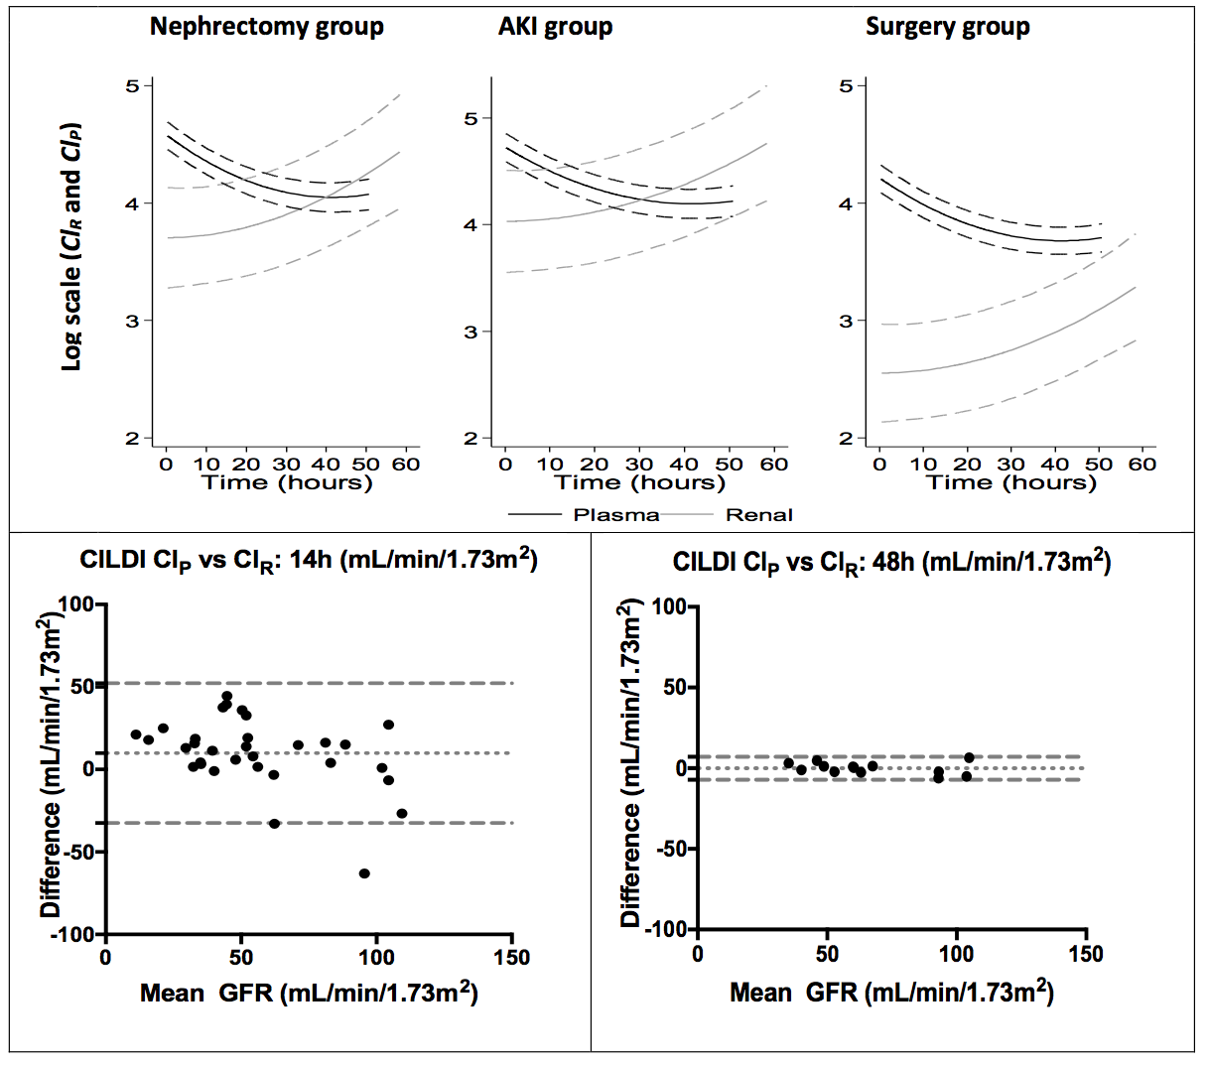
Figure 1. Change in plasma (Cl_{P}) and renal clearance (Cl_{R}) of Iohexol throughout the duration of the study. The top graph shows Cl_{P} and Cl_{R} as described by non-linear models, adjusted for baseline creatinine (SCr) and baseline eGFR by clinical group. The descriptions are made for an average baseline SCr of 72µmol/L and baseline eGFR of 82mL/min/1.73m² within the first 60h of the infusion. The bottom row shows Bland Altman agreement of plasma and renal clearance of CILDI at 14h and 48h of the study. The difference reduces with increasing infusion duration. At 14h bias of Cl_{P} is 9.9±21.6/min/1.73m², with 95% Limits of agreement (LoA) -32.5 to 52.3mL/min/1.73m²; this improves to -0.1±3.6 mL/min/1.73m², LoA -7.2 to 7.1mL/min/1.73m² at 48h.

Subjects | Age (years) |  | Sex |  | BSA  (m²) |  | Baseline eGFR  (mL/min/1.73m²) |  |  | APACHE-II
Nephrectomy group (n = 10)
MEDIAN  (IQR) |  | 70  (54-77) |  | 8M 2F |  | 1.90  (1.81-2.12) |  | 88.3  (67.6-97.4) | 10.5  (7.5-15.0)
Surgery group (n = 11)
MEDIAN  (IQR) |  | 73  (61-79) |  | 8M 3F |  | 1.86  (1.72-2.01) |  | 69.1  (50.6-86.0) | 13.0  (13.0-14.0)
KDIGO AKI criteria group (n = 13)
MEDIAN  (IQR) |  | 71  (54-83) |  | 8M 5F |  | 1.98  (1.82-2.00) |  | 96.7  (71.8-109.8) | 16.0  (14.5-23.0)

Table 1: Demographic features of study subjects. Variables expressed as median and interquartile range (IQR). eGFR = estimated glomerular filtration rate (CKD-EPI equation); BSA = body surface area (15); APACHE = acute physiology and chronic health evaluation 2 score. This table is expanded further in the Supplementary Tables 1 and 2.

Values | Nephrectomy Group | Surgery Group | AKI Group
Baseline Values
Mean SCr ±SD (µmol/L) | 83.0±29.9 | 93.3±24.0 | 65.5±22.7
Mean eGFR ±SD [mL/min/1.73m²] | [84.4±27.1] | [69.1±20.6] | [92.2±23.3]
Values at 24 hours
Mean PCr ±SD (µmol/L)  [%baseline]  (mean = +/- SD) | 108.8±38.5  [132.7±17.5] | 123.0±91.1  [122.3±59.3] | 149.8±71.0  [221.0±68.8]
AKI stage (KDIGO)  (0)  (1)  (2)  (3) | 5  5  0  0 | 7  3  1  0 | 0  3  8  2
Cl_{P} (mL/min/1.73m²)  [% baseline eGFR]  (mean = +/- SD) | 62.1±19.0  [85.7±30.2] | 64.0±27.5  [92.2±27.4] | 55.8±28.9  [58.8±20.6]
Cl_{R} (mL/min/1.73m²)  [% baseline eGFR]  (mean = +/- SD) | 42.0±17.8  [49.2±11.0] | 58.1±40.5  [78.6±40.3] | 52.8±35.6  [53.7±32.3]
24 hour Fluid balance(L)  (median, IQR) | 0.32  (-1.12, 0.41) | -0.07  (-0.95, 1.16) | 1.49  (0.92, 2.73)

Table 2: Plasma clearance (Cl_{P}) and Renal clearance (Cl_{R}) of Iohexol at 24h. The worst AKI-KDIGO parameter (i.e. urine output or plasma creatinine (PCr) rise) was used in all groups. The AKI stage at 24h is listed, with the number of individuals within that group reaching each stage in parentheses. This table is expanded further in Supplementary Tables 3 and 4. Group population variances of Cl_{P} and Cl_{R} against time are provided in Supplementary Figures 1 and 2. Individual examples of how plasma Iohexol concentration resulted in different Cl_{P} are provided in Supplementary Figures 7 and 8. SCr = serum creatinine, eGFR = estimated glomerular filtration rate, Cl_{P} = plasma clearance of Iohexol, Cl_{R} = renal clearance of iohexol

Clearance | Bias (%) | SD (%) | Limits of agreement (%)
Iohexol Cl_{R} vs 1hCrCl Nephrectomy group  Surgery group  KDIGO-AKI group Overall | -3.4  -15.7  -0.8  -5.6 | 16.6  22.9  26.3  24.0 | -35.9 to +29.6  -60.6 to +29.3  -52.3 to +50.6  -52.6 to +41.5
Iohexol Cl_{R} vs 4hCrCl  Nephrectomy group  Surgery group  KDIGO-AKI group  Overall | -4.7  -46.4  +5.1  -11.4 | 38.0  61.4  54.7  56.7 | -79.1 to +70.0  -166.6 to +73.9  -102.0 to +112.7  -122.6 to +99.1
Iohexol Cl_{P} vs 1hCrCl  Nephrectomy group  Surgery group  KDIGO-AKI group  Overall | +9.5  +33.2  +6.8  +9.1 | 29.5  37.7  33.8  34.3 | -48.4 to +67.4  -40.7 to +107.0  -42.6 to +73.0  -58.1 to +76.3
Iohexol Cl_{P} vs 4hCrCl  Nephectomy group  Surgery group  KDIGO-AKI group  Overall | +5.6  -41.7  -0.7  +7.9 | 36.9  66.2  43.1  38.7 | -66.7 to +77.9  -171.3 to +88.2  -85.1 to +83.8  -68.5 to + 83.3
1hCrCl vs 4hCrCl  Nephrectomy group  Surgery group  KDIGO-AKI group  Overall | +0.05  -31.5  -4.8  -6.4 | 34.9  53.4  54.5  66.0 | -68.3 to +83.4  -136.1 to 73.1  -111.6 to +102.1  -93.0 to +165.9

Table 3. Iohexol Renal clearance (Cl_{R}) or plasma clearance (Cl_{P}) vs 1h-creatinine clearance (CrCl) and 4h-CrCl at 14h. Bland Altman agreement is shown.

Group | KDIGO AKI criteria | CILDI AKI criteria (>10.3% loss of GFR) | CILDI: >50% loss of GFR
Nephrectomy  (n = 10) | 5 | 10 | 7
Surgery (n = 11) | 4 | 8 | 7
KDIGO AKI (n = 13) | 13 | 11 | 10
Overall outcomes

 | Kpos/Cpos | Kpos/Cneg | Kneg/Cpos | Kneg/Cneg
n | 19 | 3 | 9 | 3
Outcome at 1 year
Death | 4 | 0 | 0 | 0
CKDª | 14^{b} | 0 | 8 | 1
Length of stay
ICU median days (IQR) | 4  (2.25-5.75) | 5  (3.25-5.75) | 2  (2-4.5) | 2  (2-2)
Hospital median days (IQR) | 20  (8-36) | 11  (7.25-13.75) | 6  (5-7) | 6  (6-6.5)

Table 4: Comparison of AKI criteria in each group. Measurements were made at 24h. CILDI identified an additional 5 patients with AKI in the Nephrectomy group and 4 in the Surgery group. A further 3 subjects with KDIGO-AKI (Kpos) did not have AKI when measured by CILDI (Cneg). The following outcomes at 1 year are listed: death, progression to CKD, length of stay in hospital and ICU. No patients required renal replacement therapy (RRT) 1 year later. Kpos = positive for KDIGO-AKI criteria; Kneg = negative for KDIGO-AKI criteria; CPos = Positive for CILDI AKI criteria; Cneg = negative for CILDI AKI criteria; RRT = renal replacement therapy; CKD = chronic kidney disease ªdefined as either new CKD-EPI stages 2-5, or worsened stage if pre-existing CKD-EPI stages 2-5. ^{b}This does not include the 4 patients who died; IQR = inter-quartile range.

SUPPLEMENTARY METHODS

COMPLETE METHODS
Study registration and ethical approval
The UK Clinical Research Network (http://public.ukcrn.org.uk/) adopted the study (Reference: 13391). Ethical approval was obtained from Queen’s Square research ethics committee (reference: 12/LO/1179), which specialised in studies involving patients lacking capacity to consent. The Declaration of Helsinki (2008) (1) was adhered to throughout.

Patients
The study took place in an adult general intensive care unit. Three patient groups were selected: 1) Nephrectomy: Patients due an elective nephrectomy and thus a predictable reduction in GFR of approximately 50% (defined onset of injury; predictable outcome). 2) Surgery: Patients due elective major vascular surgery. These patients have a high risk of post-operative AKI (2) (defined onset of injury; unpredictable outcome). 3) AKI: Emergency patients admitted to ICU meeting Kidney Disease: Improved Global Outcomes (KDIGO) AKI criteria (3) (unpredictable onset of injury; unpredictable outcome).

Inclusions
- Patients over 18 years due an elective nephrectomy or major vascular surgery admitted to intensive care post-operatively, or
- Patients meeting KDIGO-AKI criteria (urine output or SCr) in ICU (3).
- Patients were only included if they had a pre-existing multi-lumen CVC and arterial catheter because this study was observational and was designed not to interfere with clinical care.
Exclusions
Inability to provide informed consent prior to elective surgery; allergy to radio-contrast media; CKD stage 5 or dialysis; patients taking drugs which could potentially interact with Iohexol (metformin if SCr > 150μmol/L, phenothiazines, mono-amine oxidase inhibitors, levo-thyroxine, amiodarone, interleukin-2 agents, Tc99m-MDP); disorders in which Iohexol may potentially interfere with monitoring (thyroid disease, myasthenia gravis phaeochromocytoma); hyperviscosity disorders (sickle cell disease, homocystinuria, multiple myeloma); pregnancy or breast-feeding.

Iohexol administration and sampling
Iohexol was administered via a central venous catheter with a one-way valve to prevent backflow. The giving set and syringe containing Iohexol were covered in a light-impermeable sheath (4). A loading dose (LD) was administered over 2 minutes (5) and followed by a continuous infusion of Iohexol (Omnipaque 300®) at 0.5mL/h (343.5mg/h) for up to 80h via Agila MC Injectomat pumps (6).
LD was calculated according to the formula:

LD = Volume of distribution (Vd) / target steady state concentration (Css).

From the Summary of product characteristics (4, Vd = 0.165L/Kg (95%CI: 0.108–0.219)*weight(Kg). The target Css (100µmol/L = 0.1269mL) is approximately 100 times the lower limit of quantitation by LC-MSMS, although the actual Iohexol concentration reached in individuals varied according to their GFR and Vd. The LD would have ideally been calculated using GFR, however, weight was used so that CILDI could be used in patients with an unknown baseline GFR. In practice, LD varied between 1.12mL for the lightest subject (53.6Kg) and 2.76mL for the heaviest subject (131.8Kg) in our study. This is lower than the volume that would be required for each bolus if the single bolus method was used. For example, a previous study in critical care has used 0.1-0.4mL/Kg (7) on each occasion GFR was measured; this is equivalent to between 13.1 and 52.7mL for our largest patient. The volumes used in routine radio-contrast computed tomography scans are usually in the range of 70-150mL.
Plasma samples (0.5mL) were taken for Cl_{P} at 30 mins, 1h, 2h and 4h on day 0, and at 08:00h, 10:00h, 18:00h and 20:00h on days 1-3 from an arterial catheter. Urine samples were taken for Cl_{R} between plasma samples on day 0 and between subsequent morning plasma samples and evening plasma samples. Time zero was considered to be the time of commencing the infusion. Infusions were commenced within 1 hour of surgery in Surgery and Nephrectomy groups.

Laboratory procedures: Plasma samples were centrifuged at 3500rpm, at 4⁰C for 10 mins, with the supernatant stored at -80⁰C. Urine samples were also stored at -80⁰C immediately following collection. Once in the laboratory, particulate matter was separated by defrosting the frozen samples at 4⁰C and centrifuging at 1500rpm (4⁰C) for 4 minutes. Serum was decanted into 10μL aliquots. Fifty microliters of stabilising fluid were added to each aliquot. The constituents of the stabilising fluid were: 10mL de-ionised water, 250μL D5-Iohexol, 25μL D3-Creatinine, 25μL D6-asymmetrical dimethylarginine, and 1.5μL symmetrical dimethylarginine. The mixture was precipitated by adding 200μL 1% (vol/vol) acetonitrile (Rathburn Chemicals Ltd., Walkerbrum, Peebleshire, UK), and was then centrifuged at 20,000rpm for 3 minutes at 4°C. Two hundred microliters of the mixture were transferred into a 96-well polypropylene well plate and analysed by the API 5000LC/ msms with QJET Ion guide accelerated by LINAC® collision cell (AB Applied Biosystems MDS SCIEX). Three quality controls were used with known plasma concentrations of Iohexol (10.6μmol/L, 516.0μmol/L, and 99.2μmol/L). Precision of laboratory specimens was determined by calculating mean co-efficient of variation (CV) of all samples taken within 2-hour periods.

Glomerular Filtration Rate (GFR) calculation
Baseline estimated GFR (eGFR) was obtained from admission eGFR (CKD-EPI (8)) for elective patients or from hospital notes, if within the last 6 months. Cl_{P} was calculated by the formula: Cl_{P} (mL/min) = [Iohexol infusion rate (μmol/min)] / [plasma Iohexol concentration (μmol/mL)], adjusting for body surface area (BSA) (8). Cl_{R} was calculated by the formula: Cl_{R} (mL/min) = [U x V] / P, where U =urine Iohexol concentration (μmol/L), V = volume of urine (mL) per unit time (min), and P = mid-time point plasma Iohexol concentration (μmol/L), adjusting for (BSA) (9).

Comparison with KDIGO and outcomes
GFR measurements were compared with KDIGO-AKI criteria (3) and classified according to whether subjects met KDIGO and CILDI criteria for AKI: KDIGO-positive (Kpos), KDIGO-negative (Kneg), CILDI-positive (Cpos), CILDI-negative (Cneg). Length of stay in ICU and in hospital, development of CKD within 1 year, need for renal replacement therapy (RRT), and death were also recorded. CILDI-AKI criteria was defined as GFR loss >10.3% (9). We also recorded the number of patients with 50% loss in GFR measured by CILDI, to compare with KDIGO-AKI stage 2.

Statistical methods
- Demographic data: Data for age, sex, body surface area, baseline eGFR and APACHE-II scores were collected and variables were expressed as median and interquartile range.
- SCr, Cl_{P}, Cl_{R} compared with baseline SCr and eGFR: multiple measurements per individual in a time-ordered manner creates a longitudinal structure to the data with two levels of variability: between subjects (inter-subject) and within subjects (intra-subject). A mixed model with unstructured variance-covariance matrix was used to estimate the inter-subject average behaviour through time, with models accounting for the unbalanced sets of outcome measurements. This model also accounts for the intra-subject variability of each individual’s curve whilst a “grand mean curve” is estimated, adjusted for the effects of other variables on each outcome. These models explain how Cl_{R}, Cl_{P}, CrCl behave through time, adjusted by clinical group and baseline SCr and baseline eGFR. All outcomes underwent one-to-one logarithmic transformation, to reduce their range and variability without altering the qualitative aspects of the results.
- Expected change: The expected 50% change longitudinally was assessed by comparing logarithmic conversion of measured Cl_{P} and Cl_{R} with time, when using baseline mean eGFR as a comparator: a change in log value of approximately 0.7 was expected.
- Level of agreement between Cl_{P} and Cl_{R}, CrCl-1, and CrCl-4 was assessed at specific time-points using Bland-Altman agreement (10). Data were shown as absolute differences (in mL/min/1.73m²).
- Outcomes: incidence of development of new CKD or progression of pre-existing CKD, RRT and death were assessed. Mean length of stay in ICU or hospital was also assessed.
Graphpad Prism®, version 7.00 (Graphpad software, Inc.) was used for statistical analysis.
REFERENCES
- World Medical Association Declaration of Helsinki. Ethical Principles for Medical Research Involving Human Subjects. In: 59th WMA General Assembly. Seoul; 2008
- Ryckwaert F, Alric P, Picot MC et al: Incidence and circumstances of serum creatinine increase after abdominal aortic surgery. Intensive Care Med 2003, 29(10):1821-1824
- Kidney Disease Improving Global Outcomes work group. KDIGO Clinical Practice Guidelines for Acute Kidney Injury. Kidney Int Suppl 2012, 2(1): 1-138.
- GE Healthcare Inc. OMNIPAQUE (Iohexol): Summary of product characteristics. In.; 2009.
- Product information for Agila MC Injectomat pump (http://www.fresanius-kabi.com/).
- Dixon JJ, Lane K, Dalton RN et al: Validation of a continuous infusion of low dose Iohexol to measure glomerular filtration rate: randomised clinical trial. J Transl Med 2015, 13: 58.
- Erley CM, Bader BD, Berger ED et al: Plasma clearance of iodine contrast media as a measure of glomerular filtration rate in critically ill patients. Crit Care Med 2001, 29(8): 1544-1550.
- Levey AS, Stevens LA, Schmid CH et al: A new equation to estimate glomerular filtration rate. Ann Intern Med 2009, 150(9): 604-612.
- Mostellor RD: Simplified calculation of body surface area. N Engl J Med 1987, 317(17): 1098.
- BlandJM, Altman DG: Measuring agreement in method comparison studies. Stat Methods Med Res 1999, 8(2): 135-160
- Sime FB, Udy AA, Roberts JA: Augmented renal clearance in critically ill patients: etiology, definition and implications for beta-lactam dose optimization. Current Opinion in Pharmacology 2015

SUPPLEMENTARY TABLE 1
Subject | Age (years) | Sex | BSA  (m²) | Diagnosis | Baseline eGFR  (mL/min/1.73m²) |  | APACHE-II
Nephrectomy group
1  2  3  4  5  6  7  8  9  10 | 82  44  77  71  81  46  76  69  53  58 | M  F  M  M  M  M  M  M  F  M | 1.90  2.08  1.89  1.67  1.73  1.82  1.81  2.66  2.40  2.14 | RCC  RCC  RCC  RCC  RCC  RCC  RCC  RCC  RCC  RCC | 39.7  129.3  85.0  94.9  50.1  91.6  84.2  62.1  108.3  98.9 |  | 6  8  15  12  16  8  12  15  5  9
MEDIAN  (IQR) | 70  (54-77) |  | 1.90  (1.81-2.12) |  | 88.3  (67.6-97.4) |  | 10.5  (7.5-15.0)
Vascular Surgery group
11  12  13  14  15  16  17  18  19  20  21 | 51  58  79  72  82  59  73  82  78  74  63 | M  M  F  M  M  F  M  M  F  M  M | 2.04  2.34  1.86  1.75  1.95  1.78  1.98  1.53  1.48  1.70  2.05 | ABB  Carotid-bypass  EVAR  TEVAR  EVAR  TEVAR repair  TEVAR  EVAR  EVAR + renal bridge  Embolectomy  Open AAA repair | 88.4  98.3  49.7  69.5  83.5  99.2  72.7  52.4  50.7  45.0  51.0 |  | 13  9  13  16  13  9  13  14  13  16  14
MEDIAN  (IQR) | 73  (61-79) |  | 1.86  (1.72-2.01) |  | 69.1  (50.5-86.0) |  | 13.0  (13.0-14.0)
KDIGO AKI criteria group
22  23  24  25  26  27  28  29  30  31  32  33  34 | 83  73  61  91  72  42  62  71  54  92  90  51  54 | F  F  M  M  F  M  M  M  M  M  F  F  M | 1.46  1.67  2.33  1.56  2.39  1.99  1.94  1.98  2.03  1.82  2.00  1.83  2.00 | SBO  Pneumonia  Pneumonia  CCF  sepsis  ALD  sepsis  Neutropaenic sepsis  Urosepsis  sepsis  Pneumonia  Duodenal ulcer  SBO |  | 106.6  88.9  98.6ª  58.6  75.9  108.1  96.1  122.9  116.8  54.7  59.5  114.9  97.3 | 22  11  20  14  15  18  15  24  11  25  16  15  26
MEDIAN  (IQR) | 71  (54-83) |  | 1.98  (1.82-2.00) |  |  | 96.7  (71.8-109.8) | 16.0  (14.5-23.0)

Supplementary Table 1: Demographic features of study subjects. Variables are expressed as median and interquartile range (IQR). eGFR = estimated glomerular filtration rate (CKD-EPI equation); APACHE = acute physiology and chronic health evaluation 2 score; RCC = renal cell carcinoma; EVAR = endovascular aortic aneurysm repair; TEVAR = Thoracic endovascular aortic aneurysm repair; ABB = aorto-bifemoral bypass; AAA = abdominal aortic aneurysm repair; SBO = small bowel obstruction; CCF = congestive cardiac failure; ALD = alcoholic liver disease. ªunknown baseline: eGFR taken from lowest creatinine on admission. The co-morbidities are described in Supplementary Table 2.

SUPPLEMENTARY TABLE 2
Group | CVS | Resp | Renal | GI/Liver | Neuro | Onc | Haem | Endo | Rheum
Nephrectomy | 7 | 0 | 1 | 1 | 1 | 10 | 2 | 1 | 0
Surgery | 9 | 8 | 3 | 1 | 1 | 1 | 0 | 2 | 1
AKI | 7 | 2 | 2 | 4 | 2 | 2 | 4 | 1 | 2

Supplementary Table 2: Co-morbidities according to group. CVS = cardiovascular (ischaemic heart disease or hypertension, but not peripheral vascular disease); resp = respiratory (Emphysema with FEV1<60%, severe asthma, bronchiectasis); GI/Liver = gastrointestinal (inflammatory bowel disease, liver cirrhosis, fatty liver disease); Neuro = neurological (stroke, Parkinson’s disease); Onc = Oncological disease (renal cell cancer, lung cancer, bowel cancer); Haem = Haematological disorder (chronic anaemia of known cause); Endo = endocrine disease (diabetes mellitus, hypothyroidism); Rheum = rheumatological disease (rheumatoid arthritis, connective tissue disease, osteoarthritis).

SUPPLEMENTARY TABLE 3
Subject | Baseline SCr (µmol/L)  eGFR [mL/min/1.73m²] | Mean PCr  (µmol/L)  [%baseline] | AKI stage (KDIGO) | Cl_{P} (mL/min/1.73m²)  [% baseline eGFR] | Cl_{R} (mL/min/1.73m²)  [% baseline eGFR] | Fluid Balance (mL)
Nephrectomy group
1 | 141 [39.7] | 195 [138] | 1ª | 59.3 [149] | 22.5 [57]^{c} | -1600
2 | 52 [129.3] | 78 [150] | 1 | 98.0 [75] | 80.9 [63] | +385
3 | 73 [85.0] | 87 [119] | 1^{b} | 68.0 [80] | 33.0 [39] | +412
4 | 62 [94.9] | 70 [113] | 1^{b} | 61.8 [65] | 42.1 [44] | +1970
5 | 117 [50.1] | 132 [113] | 0 | 37.2 [74] | 32.8 [65] | -486
6 | 87 [91.6] | 112 [129] | 0 | 72.9 [86] | 63.6 [69] | -3179
7 | 76 [84.2] | 100 [132] | 0 | 57.7 [69] | 42.9 [51] | +365
8 | 105 [62.1] | 130 [124] | 0 | 49.6 [80] | 32.0 [52] | -1335
9 | 47 [108.3] | 66 [140] | 0 | 97.6 [89] | 58.1 [54] | +281
10 | 70 [98.9] | 118 [169] | 1 | 63.3 [64] | 36.1 [37] | +2338
MEAN±SD | 83.0±29.9  [84.4±27.1] | 108.8±38.5  [132.7±17.5] |  | 62.1±19.0  [85.7±30.2] | 42.0±17.8  [49.2±11.0] | -84.9  ±1649.6
Surgery group
11 | 87 [88.4] | 106 [122] | 1^{b} | 64.0 [72] | 127.1 [144]^{c} | +415
12 | 71 [98.3] | 71 [100] | 0 | 96.0 [98] | 122.7 [125]^{c} | -70
13 | 94 [49.7] | 105 [112] | 0 | 40.7 [82] | 24.9 [50] | -1284
14 | 94 [69.5] | 108 [115] | 0 | 42.4 [61] | 23.7 [34] | +1364
15 | 70 [83.5] | 62 [89] | 0 | 89.2 [107] | 73.0 [87]^{c} | +951
16 | 54 [99.2] | 37 [69] | 0 | 118.0 [119] | 90.9 [92]^{c} | -467
17 | 90 [72.7] | 98 [109] | 0 | 58.8 [81] | 44.9 [62] | +1679
18 | 112 [52.4] | 147 [131] | 1ª | 45.1 [86] | 33.7 [64] | +2003
19 | 93 [50.7] | 69 [74] | 0 | 68.3 [135] | 35.5 [70]^{c} | -619
20 | 133 [45.0] | 180 [135] | 1ª | 56.9 [126] | 55.3 [123]^{c} | -2599
21 | 128 [51.0] | 370 [289] | 2 | 24.7 [48] | 6.8 [13] | -3562
MEAN±SD | 93.3±24.0  [69.1±20.6] | 123.0±91.1  [122.3±59.3] |  | 64.0±27.5  [92.2±27.4] | 58.1±40.5  [78.6±40.3] | -199.0  ±1761.5
KDIGO-AKI group
22 | 26 [106.6] | 39 [150] | 1 | 105.0 [99] | 102.3 [96] | +2731
23 | 68 [88.9] | 78 [115] | 1^{b} | 58.3 [66] | 50.4 [57] | +1450
24 | 67 [98.6] | 217 [324] | 3 | 36.7 [37] | 33.5 [34] | +541
25 | 97 [58.6] | 196 [202] | 2 | 33.1 [56] | 31.5 [54] | +1489
26 | 69 [75.9] | 139 [201] | 2 | 45.8 [60] | 78.7 [104] | +1550
27 | 74 [108.1] | 202 [273] | 2 | 39.5 [37] | 40.5 [37] | +2438
28 | 70 [96.1] | 207 [296] | 2 | 36.0 [37] | 23.0 [24] | +1407
29 | 33 [122.9] | 37 [112] | 1^{b} | 101.2 [82] | 107.7 [88] | +459
30 | 50 [116.8] | 102 [204] | 2 | 102.5 [88] | 101.5 [87] | +3358
31 | 102 [54.2] | 234 [229] | 2 | 33.7 [62] | 8.7 [16] | +5808
32 | 76 [59.5] | 227 [299] | 3^{b} | 21.7 [36] | 0.5 [0.1] | +5370
33 | 41 [114.9] | 105 [256] | 2 | 60.4 [53] | 63.6 [55] | +435
34 | 78 [97.3] | 165 [212] | 2 | 50.9 [52] | 45.0 [46] | +923
MEAN±SD | 65.5±22.7  [92.2±23.3] | 149.8±71.0  [221.0±68.8] |  | 55.8±28.9  [58.8±20.6] | 52.8±35.6  [53.7±32.3] | +2535.3  ±555.6

Supplementary Table 3: Plasma clearance (Cl_{P}) and Renal clearance (Cl_{R}) of Iohexol at 24h. The worst AKI-KDIGO parameter (i.e. urine output or plasma creatinine (PCr) rise) was used in all groups. The AKI parameter used is percentage increase in PCr, unless stated (PCr >26μmol/Lª; urine output^{b}). P value (t test) is of the difference between Cl_{P} and Cl_{R}. Mean peak Cl_{R} in patients receiving Dopexamine^{c} was 132.1±20.0% of baseline eGFR. Patients receiving Dopexamine are discussed further in the additional results section. Subjects 20, 22 and 26 did not have AKI when defined by CILDI.

SUPPLEMENTARY DATA TABLE 4
 | AUGMENTED Cl_{R} | NOT AUGMENTED Cl_{R}
Dopexamine | 5 | 2
No dopexamine | 0 | 26

Supplementary Table 4: Comparison of renal clearance (Cl_{R}) of Iohexol in subjects receiving Dopexamine with those not receiving Dopexamine. Augmented Cl_{R} (ARC) was defined as Cl_{R} >130% of baseline eGFR (11). Seven subjects were given Dopexamine as part of a routine post-operative ICU protocol. Five (4 from Surgery group, 1 from Nephrectomy group) developed ARC while receiving Dopexamine. Mean peak Cl_{R} at 24h in patients receiving Dopexamine was 132.1±20.0% of baseline eGFR. None of the subjects who were not given Dopexamine developed ARC (Fisher’s exact test P<0.0001). Dopexamine was stopped in all patients within 8h, although GFR remained elevated for up to 24h. Our data are too small to make firm conclusions as to whether this phenomenon is due to the inotropic effects of Dopexamine, an “ARC” as a compensatory response to critical illness, or a peculiar effect of Dopexamine.

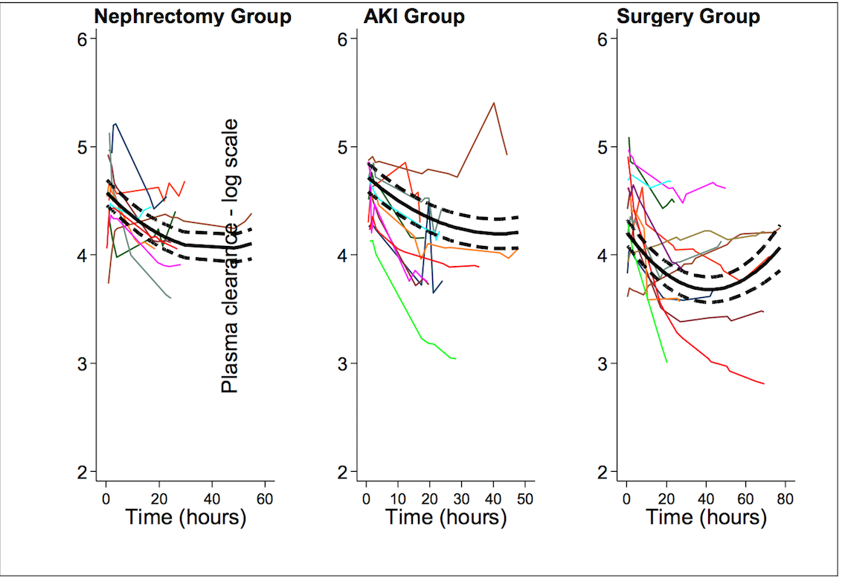
Supplementary Figure 1: The effect of time on plasma clearance (Cl_{P}) of Iohexol. Figures are presented as logarithmic transformation of Cl_{P} and are adjusted for baseline creatinine (SCr) and baseline eGFR by clinical groups. The predictions and their uncertainties (thick lines) are made for a patient with average level of baseline SCr of 72µmol/L and baseline level of eGFR 82mL/min/1.73m².

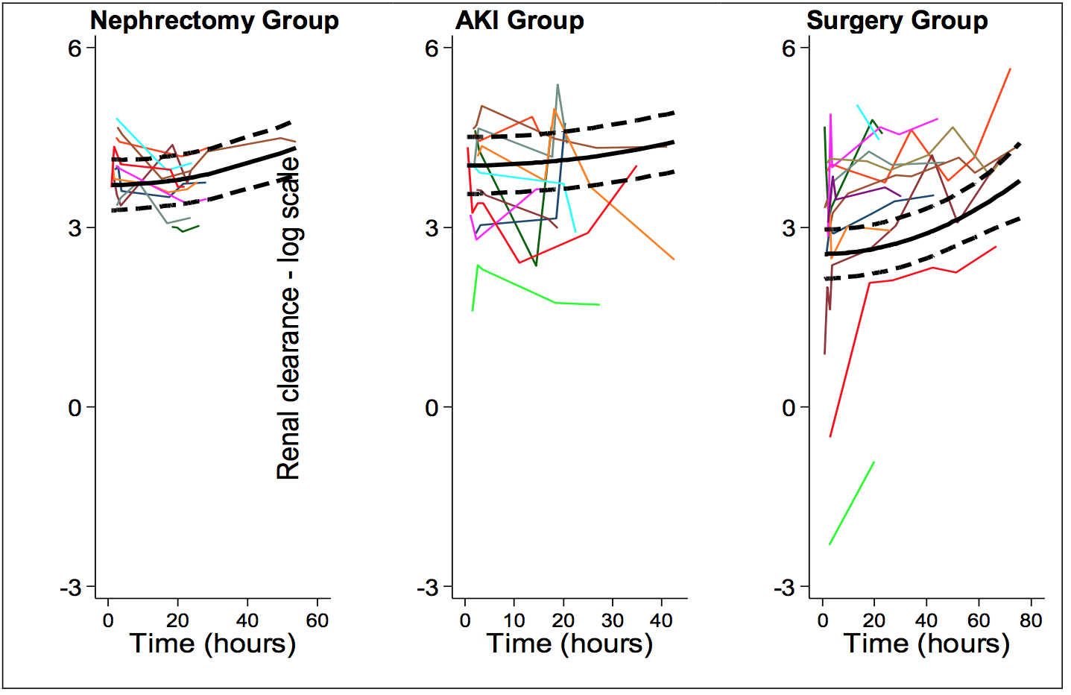
Supplementary Figure 2: The effect of time on renal clearance (Cl_{R}( of Iohexol. Figures are presented as logarithmic transformation of Cl_{R} and are adjusted for baseline creatinine (SCr) and baseline eGFR by clinical groups. The predictions and their uncertainties (thick lines) are made for a patient with average level of baseline SCr of 72µmol/L and baseline level of eGFR 82mL/min/1.73m².

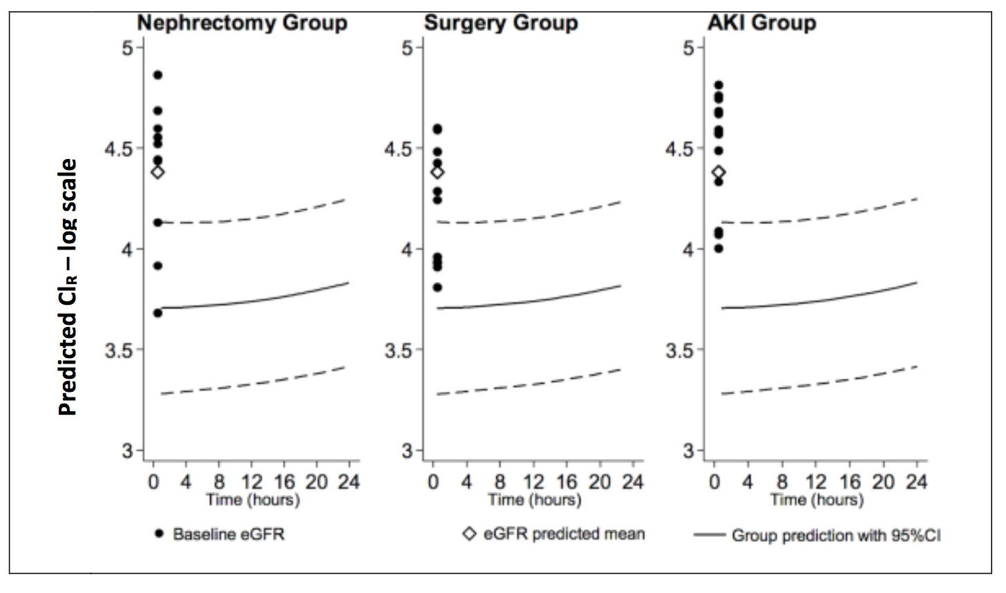
Supplementary Figure 3: Predicted renal clearance (Cl_{R}) of Iohexol up to 24h only and baseline eGFR. Figures are represented as logarithmic transformation of GFR. The dots represent individual baseline eGFR at time 0, and the solid lines represent the expected group mean Cl_{R} with the dashed lines representing 95% confidence intervals. The predicted log-transformed means of eGFR are: Nephrectomy group =4.381137; Surgery group =4.195352; AKI group =4.4906. A 50% reduction in baseline eGFR translates into a difference between log values of approximately 0.7 between log baseline eGFR and predicted Cl_{R}.

