**Gastroenterology**

Clinical features and HLA association of 5-Aminosalicylate (5-ASA) induced nephrotoxicity in inflammatory bowel disease

**Authors**

Graham A Heap

Kenji So

Mike Weedon

Naomi Ebney

Claire Bewshea

Abhey Singh

Vito Annesse

John Beckly

Dorien Buurman

Rakesh Chaudhary

Andrew T Cole

Sheldon Cooper

Tom Creed

Fraser Cummings

Nanne KH D'Boer

Renata D'Inca

Richard D'Souza

Tawfique K Daneshmend

Michael Delaney

Anjan Dhar

Natalie Direkze

Paul Dunckley

Daniel Gaya

Richard Gearry

Steve Gore

Jonas Halfvarson

Ailsa Hart

Chris J Hawkey

Frank Hoentjen

Tariq Iqbal

Peter Irving

Simon Lal

Ian Lawrance

Charlie Lees

Steve Lewis

Melanie Lockett

Stephen Mann

John Mansfield

Craig Mowat

Chris Mulgrew

Frank Muller

Charles Murray

Richard Oram

Tim Orchard

Miles Parkes

Rosemary Phillips

Richard Pollok

Graham Radford-Smith

Shaji Sebastian

Sandip Sen

Asheesh Sharma

Tariq Shirazi

Mark Silverberg

Laurie Solomon

Giacomo C Sturniolo

Mark Thomas

Mark Tremelling

Epameinondas V Tsianos

David Watts

Sean Weaver

Rinse Weersma

Emma Wesley

Arthur Holden

Tariq Ahmad

**Author contribution statement**

TA and A.Holden conceived the study. GAH, KS, NE, AS, TA collated submitted cases. CB project managed the study. GAH, KS, NE, AS, TA, TKD, A.Hart, IL, S.Lewis, C.Mulgrew, RD’S, RO, TS, EW performed adjudication of submitted cases. GAH performed clinical data analysis. GAH and MW performed genetic analysis. VA, JB, DB, RC, ATC, SC, TC, FC, NKHD, RD’I, TKD, MD, AD, ND, PD, DG, RG, SG, JH, A.Hart, CJH, FH, TI, PI, S.Lal, IL, CL, SL, ML, SM, JM, C.Mowat, FM, CM, TO, MP, R.Phillips, R.Pollock, GRS, S.Sebastian, S.Sen, A.Sharma, MS, LS, GCS, M.Thomas, M.Tremelling, ET, DW, SW, RW submitted a substantial number of cases and aided drafting of the manuscript. GAH and TA wrote the manuscript, which was reviewed by all authors.

**Acknowledgements**

The International Serious Adverse Events Consortium (iSAEC) funded the sample collection and genotyping. Study feasibility and initiation was supported by unrestricted educational grants from Ferring Pharmaceuticals and Warner Chilcott UK. The National Institute for Health Research (NIHR) provided research nurse support to facilitate recruitment at all research sites located in England. The Swedish Research Council (521-2011-2764) and the Örebro University Hospital Research Foundation aided recruitment at Örebro University hospital, Sweden. We would like to thank Crohn’s and Colitis UK for funding support and publicising this study to its members. A Wellcome Trust Institutional Strategic Support Award (WT097835MF) generously supported the work in this study. Genotyping was undertaken at the Broad Institute, USA. We would like to thank all the clinicians who assisted with sample collection as part of the IBD Pharmacogenetics Study Group (listed in the Supplementary Information) and the International IBD Genetics Consortium as well as Suzie Marriott for her assistance during the trial initiation. We would like to acknowledge The International Serious Adverse Events Scientific Management Committee members for their helpful comments. We would also like to thank all the patients for their time and participation.

**Competing financial interests**

The authors disclose the following conflicts of interest:

GAH has received travel support from Dr Falk Pharma and Tillotts Pharma UK.

AS has no financial disclosures

CB has no financial disclosures

IL has received educational grants, speaking endorsements and is a member of the advisory board for Shire, Freeing and Colazide.

S.Sebastian has received honoraria, travel and educational grants from Merck, AbbVie, Warner Chilcott, Ferring and Takeda.

VA has received unrestricted research grants from Giuliani, Sofar and Ferring; Speaker fees from Ferring, Nycomed and Chiesi and travel support from Giuliani, Ferring, Sofar and Chiesi.

DRG as received travel support and speaker fees from Ferring, Warner Chilcott UK, Shire, Tillotts and Dr Falk Pharma.

RD’I has no financial disclosures

NKHdB has no financial disclosures

JH has received honorarium for lectures or consultancy from Ferring and Swedish Orphan.

TA has received unrestricted research grants or travel support from Ferring, Dr Falk Pharma and Warner Chilcott UK

**Abstract**

Background & Aims

Nephrotoxicity is a rare idiosyncratic reaction to 5-aminosalicylate (5-ASA) therapies. The aims of this study are to describe the clinical features of this rare complication and identify clinically useful genetic markers so these drugs can be avoided, or monitoring intensified, in high-risk patients.

Methods

Inflammatory bowel disease patients were recruited from 89 sites around the world. Inclusion criteria included normal renal function prior to commencing 5-ASA, ≥50% rise in creatinine any time after starting 5-ASA and physician opinion implicating 5-ASA strong enough to justify drug withdrawal. An adjudication panel identified definite and probable cases from structured case report forms. A genome wide association study was then undertaken with these cases and 4,109 disease controls.

Results

After adjudication, 151 cases of 5-ASA induced nephrotoxicity were identified. 68% of cases were males, with nephrotoxicity occurring at a median age of 39.4 years (range 6–79 years). The median time for development of renal injury after commencing 5-ASA was 3.0 years (95% CI 2.3 – 3.7). Only 30% of cases recovered completely after drug withdrawal with 15 patients requiring permanent renal replacement therapy. A genome-wide association study identified a suggestive association in the HLA region (P=1x10-**7**) with 5-ASA induced nephrotoxicity. A sub-group analysis of patients who had a renal biopsy demonstrating interstitial nephritis (n=55) significantly strengthened this association (P=4x10-9, Odds Ratio3.1).

Conclusions

This is the largest and most detailed study of 5-ASA induced nephrotoxicity to date. It highlights the morbidity associated with this condition and identifies for the first time a significant genetic predisposition to a drug induced renal injury.

**Introduction**

5-aminosalicylate (5-ASA) medications are the most frequently prescribed class of drug to induce and maintain remission in patients with mild-to-moderately active ulcerative colitis 1. Originally administered in combination with sulfapyridine as sulfasalazine, 5-ASA is now more often coated with a resin/gel or as a pro-drug/dimer to enhance distal bowel delivery through preparations such as mesalazine, olsalazine and balsalazide 2. The use of these agents in long-term maintenance therapy over decades inevitably leads to prolonged drug exposure and therefore long-term toxicity is an important consideration.

Nephrotoxicity associated with 5-ASA agents was first described in animal models and case reports in the 1970s and has since been reported multiple times to both sulfasalazine and the more modern 5-ASA agents 3–8. In 1990 the UK Committee on Safety of Medicines issued an alert on nephrotoxic reactions to mesalazine 9. Data from clinical trials suggest an annual risk of 0.26% and data from a questionnaire sent to gastroenterologists estimated an incidence of 1 case per 4000 patient years 10,11. A review of the UK General Practice Research Database calculated the incidence at 0.17 cases per 100 patients per year but the authors noted that only 13% of these patients had a histological diagnosis of interstitial nephritis 12. Regular monitoring of renal function for the duration of therapy is recommended, although the cost-effectiveness of this approach has not been demonstrated.

Rare idiosyncratic drug reactions are often notoriously difficult to characterise due to the small number of cases available to individual researchers. The International Serious Adverse Events Consortium was launched in 2007 to facilitate the collection of large cohorts of patients who developed these rare serious drug side effects 13. Members of this consortium have recently demonstrated the utility of using small numbers of well-characterised cases to identify strong, clinically useful genetic risk factors for serious adverse drug reactions using genome-wide association study methodologies. Good examples of this approach are the identification of HLA-B*57:01 as a major determinant of cholestatic liver injury associated with flucloxacillin and our previously published identification of an association between HLA-DRB1*07:01 and thiopurine induced pancreatitis 14,15.

In this study we describe in detail, for the first time, a cohort of patients with inflammatory bowel disease (IBD) who developed nephrotoxicity subsequent to 5-ASA administration. We use this cohort to characterise the clinical features of this serious adverse event and then perform the first genome wide association study to identify genetic risk factors for the development of a drug-induced renal injury.

**Methods**

*Patient Recruitment*

## Individual study sites identified and recruited patients with 5-ASA induced nephrotoxicity. This study was open to recruitment at 118 UK research sites (73.8% of the 160 acute NHS trusts in the UK) as well as 45 international sites. In total 77 sites from the UK and 12 sites from outside the UK recruited one or more patients. The protocol was approved by the National Research Ethics Committee South West, Exeter, UK (10/H0203/76) and by all local research and development offices.

Inclusion criteria for patient recruitment required the presence of all of the following:

* Patient administered any 5-ASA compound for treatment of inflammatory bowel disease (Crohn’s disease, ulcerative colitis or IBD-unclassified)
* Patient aged 6 or over
* Normal creatinine or estimated glomerular filtration rate (eGFR) prior to first administration of 5-ASA or a creatinine that returned to the normal range after cessation of therapy
* Greater than or equal to 50% rise in serum creatinine any time after introduction of 5-ASA
* Physician opinion implicating 5-ASA strong enough to justify drug withdrawal, even if temporary

Cases were identified from recruiting sites through systematic searches of historical records and pathology databases. A selected number of patients were identified though a 2001-2002 UK survey of gastroenterologists 10. We invited clinicians who had submitted adverse drug reaction reports to the Medicines and Healthcare Products Regulatory Agency (MHRA) to consider recruiting patients. To further case identification we also undertook direct advertising to patients through the national patient newsletter. Cases were recruited who developed nephrotoxicity between 1988 and 2013 (73% of cases were diagnosed with renal injury after the year 2000).

*Case adjudication*

An anonymised case report form detailing demographic, clinical and drug history was completed with the aid of hospital records. Two 6ml EDTA blood samples were taken at this visit for DNA extraction (BD Vacutainer, USA). The case report forms also requested creatinine levels and their corresponding dates at four time points: 1) at baseline (usually before 5-ASA commenced, but not exclusively), 2) at the recording of first abnormal creatinine value, 3) the worst creatinine value and 4) the best recovered creatinine value. After data collection, the last normal creatinine value before development of renal injury was also obtained, if it was available (92/151 cases), to enable better characterisation of the time period. If a renal biopsy was performed, the anonymised report was requested.

To assess patient eligibility for entry to this study, at least three gastroenterologists and at least one nephrologist reviewed each case for causality at a dedicated in-person adjudication panel meeting. For each case the evidence implicating the 5-ASA as the cause of nephrotoxicity was assessed using an adapted version of the validated Liverpool Adverse Drug Reaction Causality Assessment Tool displayed in Supplementary Figure 1 16. Patients were classified as definite, probable, possible or unlikely cases of 5-ASA nephrotoxicity based on the adjudicator’s independent assessment that the nephrotoxicity was due to 5-ASA treatment. The panel discussed all cases before a final adjudication decision was reached. Only individuals classified as probable or definite cases of 5-ASA induced nephrotoxicity were taken forward for clinical and genetic analyses.

Concomitant administration of any medications known to cause nephrotoxicity classified the patient as a possible case and these cases were excluded. This included the use of a) Antibiotics: penicillins, cephalosporins, ciprofloxacin, sulphonamides, rifampicin, b) Diuretics: furosemide, bumetanide, thiazides, c) Non-steroidal anti-inflammatory drugs, d) Proton pump inhibitors, e) allopurinol, f) cimetidine, g) indinivir. The presence of uncontrolled diabetes, uncontrolled hypertension or peripheral vascular disease also classified the patient as a possible case of 5-ASA induced nephrotoxicity and they were not taken forward for analysis. A patient treated with 5-ASA for microscopic colitis was recruited in error but was excluded during the adjudication process.

Definite cases required the development of renal injury upon rechallenge with 5-ASA. Cases classified as probable demonstrated a temporal relationship with 5-ASA administration with no other identifiable risk factors for renal injury as described above.

*DNA Extraction and Genotyping*

DNA was extracted from EDTA stabilised blood using the Qiagen Autopure LS with Puregene chemistry. Samples were genotyped on the Illumina Infinium HumanCoreExome beadchip (Illumina, USA), which contains 264,909 haplotype tagging SNP markers, and 244,593 exome focused markers by the Broad Institute (Boston, USA).

*Clinical data analysis*

Paper case report forms were entered into the electronic database before independent, two-person, un-blinded data cleaning was undertaken to ensure data quality prior to analysis. All data was analysed in R 3.0.2. Listwise deletion was used for missing data. Normality was tested for by the Shapiro-Wilks normality test (P<0.05 considered non-parametric). Non-parametric data is presented with median values and the 95% confidence intervals of the median with comparisons performed by a Wilcoxon signed rank test or chi-squared test as appropriate. Logistic and multivariate regression was conducted in R with pre-set variables (no stepwise regression). The definition of a return to baseline creatinine was a return to the upper limit of the local hospital labs normal range or 120 µmol/l if this range was not known.

*Genome-wide and HLA Imputation and association analyses*

Three samples failed DNA extraction and were unavailable for genetic analysis. Genotyping was performed on the remaining 148 cases adjudicated as definite or probable 5-ASA induced nephrotoxicity using the HumanCoreExome SNP Chip. Genotypes were called using Gencall 17. We excluded SNPs with a HWE *P*<0.0001 and a genotype success rate <0.99. We excluded indels. Exclusion criteria for case samples were genotyping success rate < 0.98 and a heterozygosity rate > 4SD (no samples were removed based on these criteria). To improve calling of low-frequency variants we used zCall 18. After running zCall, SNPs were excluded if they had a HWE P<0.0001, MAF<0.01 or if they were duplicated. This left 264,088 autosomal SNPs for imputation. The control patients with Crohn’s disease and ulcerative colitis were obtained from the UK IBD Genetics Consortium as part of the Wellcome Trust Case Control Consortium (WTCCC 1 for Crohn’s disease and WTCCC 2 for Ulcerative Colitis) 19,20. There were 1748 CD control samples genotyped on the Affymetrix 500K SNP chip and 2361 UC samples genotyped on the Affymetrix 6 SNP chip available for this analysis. Preliminary QC had already been performed on the 1748 CD and 2361 UC samples 19,20. From these two control cohorts, we excluded SNPs with a genotyping success rate < 0.99, MAF<0.01 and a HWE *P*<0.0001. This left 396,255 (CD) and 727,195 (UC) autosomal SNPs. To exclude ethnic outliers we performed principal components analysis using GCTA21. To generate the principal components we used a set of 36,702 SNPs that were imputed with R2>0.99 in the cases (see below) and directly genotyped in the two control cohorts and were not in strong linkage (r2<0.2).

Four 5-ASA nephrotoxicity cases and 62 control samples were excluded for being >4SD from the first or second principal components. We used KING 22 to test for cryptic relatedness between samples. If a case and control pair of samples had a kinship coefficient >0.2 we excluded the control sample, otherwise we excluded one of the pair of samples at random. One case and 13 control samples were excluded because of relatedness to other case or control samples. After exclusions this left 143 “probable” and “definite cases”. The ratio of Crohn’s disease to ulcerative colitis patients in the control group (59%) was similar to that in the case cohort (60%).

*Genome-wide and HLA Imputation and association analyses*

As previously 15, we used minimac 23 to impute into the European phase1 version 3 (20101123) SNP and indels reference panel to prevent spurious associations due to variations in genotyping chips between cohorts. 76% of the 9,412,474 SNPs with MAF>1% frequency were imputed at R2 >0.6 in the cases; 75% in the CD controls and 82% in the UC controls. As each of the three case and control cohorts used a different SNP genotyping chip we focused subsequent association analyses on a very conservative subset of 2,883,071 SNPs that had an imputation R2 >0.95 in all three cohorts. For dedicated imputation of the HLA region we used SNP2HLA 24 and imputed into the T1DGC reference panel of 5,224 individuals that have had classical HLA alleles typed as well as SNPs and indels by the immunochip. 8398 of the 8961 variants in the T1DGC panel were captured with an INFO score > 0.8. Mach2dat 25 was used to perform association analyses for the genome-wide analyses, and PLINK 26 was used to perform association analyses for the HLA imputed analyses.

*Data access*

Phenotype and genotype data for cases is freely available upon request from the iSAEC Data Access Committee for users who comply with the Consortium’s Data Release and IP Policy 13. Data will be available from https://dataportal.saeconsortium.org/ within 12 months of genotype completion. Raw genotype data is freely available to researchers upon request. For further data access details please contact: saec@c2b2.columbia.edu.

Genotype data for the WTCCC Ulcerative colitis and Crohn’s disease cases are available from the European Genome-Phenome Archive at https://www.ebi.ac.uk/ega/home.

**Results**

Patient identification and adjudication

## Through our international network of research sites we recruited a total of 204 IBD patients with suspected 5-ASA-induced nephrotoxicity. All cases underwent a rigorous assessment of causality at an adjudication panel composed of nephrologists and gastroenterologists using a validated tool 16. After this panel meeting the development of nephrotoxicity could be confidently assigned to the administration of 5-ASA medications for 151 out of 204 patients. Of these 151 cases, 5 were classified as definite cases of 5-ASA induced nephrotoxicity, as they had a second episode of kidney injury when re-challenged with the agent. The remaining 146 cases were classified as probable cases.

## Clinical features of 5-ASA induced nephrotoxicity

The 151 patients who were adjudicated as definite or probable cases comprised 58 patients with Crohn’s disease, 88 patients with ulcerative colitis and 5 patients with IBD unclassified. 68% of cases recruited were male. The median age at diagnosis of Crohn’s disease was 29.5 years (95% CI 25.2 – 33.9) while the median age for ulcerative colitis was 29.7 years (26.7 – 32.8). 146 patients (97%) self identified as being of white ethnicity, 2 patients did not provide a reply while 3 patients reported mixed ancestry. A summary of the disease activity and location in the two years prior to development of renal disease is show in Table 1.

## The median duration of 5-ASA treatment prior to first detection of a raised creatinine was 3.0 years (95% CI 2.3 – 3.7). 13% of cases reported an abnormal creatinine within the first 12 months of treatment. For 27% of patients we were unable to find a creatinine between the initiation of the drug and the first abnormal creatinine measurement. In these patients the median time from starting the drug to detection of nephrotoxicity was 4 years (95% CI 2.73 – 5.28) while the cohort with interval measurements had a median time of 2.5 years (95% CI 1.70 – 3.36, P=6x10-4). There was no significant difference in creatinine level at detection of abnormal renal function (P=0.75) or in the rate of recovery (P=0.72) between these two groups.

## The majority of patients (91%) received oral 5-ASA alone with an average daily dose of 2.3g (95% CI 2.1 – 2.5g). 12 patients received a mix of oral and rectal 5-ASA, while 1 patient received only rectal 5-ASA preparations. The majority of patients were treated with mesalazine (Supplementary Table 1), however, most available 5-ASA preparations are represented in the data. Figure 1 demonstrates the median creatinine levels and the time period at which these levels were collected at each time point for all 151 patients who developed nephrotoxicity. The density estimates for this plot are shown in Supplementary Figure 2 and 3.

## 45 patients (30%) demonstrated full recovery of renal function within the follow-up period (median follow-up period 5.10 years 95% CI 4.17 – 6.02). We undertook a multivariate regression analysis to investigate if any clinical features were predictive of renal function recovery after 5-ASA cessation (Supplementary Table 2). This analysis suggested that the length of 5-ASA treatment (P=0.05) and the average dose of 5-ASA (P=0.03) inversely correlated with the likelihood of renal function recovery suggesting cumulative toxicity. It has been suggested that patients who develop nephrotoxicity and stop the agent within 10 months of starting are more likely to recover to a normal creatinine 27. We were unable to replicate this association in our data (P=0.53), however, patients who did recover renal function appeared to have been taking 5-ASA for a shorter period of time before developing nephrotoxicity (Median 794 days, 95% CI 459.13 – 1128.87 vs. Median 1461 days, 95% CI 1008.80 – 1597.20, P=0.02, Figure 2). 43% of patients were treated with steroids, which was not associated with a shorter time to recovery (P=0.20) or an increased rate of recovery (P=0.10).

15 out of 151 patients (9.9%) received renal replacement therapy, which for 13 patients took the form of a renal transplant. The remaining two patients were dialysis dependent at the date of study end. A multivariate regression analysis identified peak creatinine (P=0.008), treatment with steroids (P=0.037) and presence of a renal biopsy (P=0.045) as predictive of the need for renal replacement therapy (Supplementary Table 3).

In total 76 patients adjudicated as definite or probable underwent a renal biopsy, 57 of which demonstrated clear evidence of interstitial nephritis. Of these 58% demonstrated only chronic inflammatory changes in the interstitium, with 22% and 20% demonstrating acute or acute on chronic interstitial inflammation respectively. The remaining 19 biopsies demonstrated evidence of glomerulosclerosis or were non-diagnostic.

Genetic determinants of 5-Aminosalicylate (5-ASA) induced nephrotoxicity

The idiosyncratic nature of 5-ASA induced nephrotoxicity suggests that there may be a genetic basis for its development. To investigate this we undertook a genome wide association study with the 151 cases described above and a control cohort of 1748 Crohn’s and 2361 ulcerative colitis cases.

The strongest association signal for the development of nephrotoxicity was in the HLA region (rs3135349, Odds ratio 2.04, P=1x10-7) (see Figure 3 for Manhattan and QQ plots). We therefore performed dedicated HLA imputation using SNP2HLA in to the T1DGC reference panel. The top SNP after imputation was rs3135356, (OR=2.0, 95% CI 1.55 – 3.10, P=1x10-7. The results are shown in Table 2. This association was present in patients with Crohn’s disease and ulcerative colitis when tested independently (P=1x10-7 and P=3x10-7).

We recognise that despite the strict adjudication methods undertaken to assign causality of nephrotoxicity to the administration of 5-ASA compounds there might be other factors that we have not captured in our data collection that could impact on renal function. To further refine the phenotype definition we therefore studied only those samples classified as definite or probable, who also had a renal biopsy demonstrating interstitial nephritis (passed genetic QC n=55). Limiting the association analyses to the biopsy positive cases significantly strengthened the HLA association signal, despite the smaller number of cases, with the most associated SNP remaining rs3135356 (Figure 4), but with an odds ratio 3.1, and a genome-wide significant P-value (P=4x10-9). This was robust to correction for the first 20 principle components OR=3.13, P=1x10-8. The most associated HLA allele from this analysis was HLA-DRB1*03:01 (P=5x10-7, Odds Ratio 2.76). This variant was not associated with duration of therapy prior to development of nephrotoxicity or the likelihood of recovery (P=0.63 & P=0.22).

**Discussion**

We present here an analysis of the clinical features of patients with IBD who developed nephrotoxicity after administration of 5-ASA compounds. We have conducted the first ever genome wide association study of drug-induced renal injury and gone on to identify a marker within the HLA region associated with 5-ASA induced nephrotoxicity. The data from our cohort suggests that 5-ASA induced nephrotoxicity may present at any age and is more common in male patients. The histological hallmark is a chronic tubulointerstitial nephritis. Renal injury was detected after a median treatment time of 3 years following which only 30% of our cohort fully recovered renal function. In 10% of our cases, 5-ASA induced nephrotoxicity necessitated permanent renal replacement therapy.

Many drugs have been implicated in the development of interstitial nephritis, but proving causality is difficult. 5-ASA induced nephrotoxicity has been reported previously in case reports including a case of with a positive re-challenge 28. These reports, combined with the 151 cases here (including the five definite cases) provide compelling evidence that 5-ASA is able to cause renal injury and should be suspected in any patient with deteriorating renal function on these agents.

The temporal association between the use of 5-ASA and development of renal injury, the improvement on drug withdrawal (although this only occurs in 30% of patients) and the five patients who were re-challenged with 5-ASA with subsequent worsening of renal function provide evidence that the renal damage is likely to be drug related. The relationship between an increased likelihood of recovery and drug dose and duration also suggests a pathogenic role for the 5-ASA agents in interstitial nephritis development. However there has been a suggestion that the nephrotoxicity observed in IBD patients might be an extra-intestinal manifestation of disease rather than a result of drug toxicity 12,31. Four of the patients in this study had evidence of granulomatous interstitial nephritis with non-caseating granulomas seen on biopsy (1 patient with Crohn’s disease, 2 with ulcerative colitis and 1 with IBD unclassified). This rare form of interstitial nephritis is most commonly seen in acute drug reactions but there are isolated case reports of patients with IBD developing interstitial nephritis with or without granulomas, some of whom have not been exposed to 5-ASAs 32–34.

Current British Society of Gastroenterology guidelines (2011) recommend monitoring of renal function annually in patients taking 5-ASA agents, the European Crohn’s and Colitis Organisation (2012) recommends monitoring in high risk patients while the American Gastroenterology Society (2010) recommends periodic monitoring noting evidence for a defined frequency is lacking 35–37. The utility of these approaches has not been demonstrated, however, it has been noted that many patients do not have regular renal function monitoring whilst using 5-ASA 38. Indeed data from this study suggests that the median time from the last normal creatinine to the first abnormal value, which represents how often a patient is having a blood test, is 1.98 years with a range of 2 days to 15.3 years.

5-ASA agents are normally tolerated by the majority of patients suggesting an underlying genetic or environmental pre-disposition to the development of renal injury in a small subset of patients. The type of renal injury seen with 5-ASA appears to be consistent with the changes occasionally seen with long-term lithium use 39. Lithium ingestion over a prolonged period of time (usually greater than 2 years) has rarely been associated with the development of a chronic focal interstitial cortical fibrosis with mononuclear cell infiltrate – a chronic interstitial nephritis 40. Analogous to the renal injury seen with 5-ASA this typically occurs after a prolonged period of drug exposure and once identified by routine blood testing often fails to improve even after drug withdrawal 41.

We have not attempted to replicate the association of rs3135356 in an independent population. The collection of cases described here required a collection period of 2 years and the involvement of 89 centres, and as such, further sample collection was felt to be unfeasible. An association between another HLA class II allele, HLA-DRB1*01:02 and the rare syndrome of tubulointerstitial nephritis and uveitis (TINU) has been described in the literature 42. The association was only seen in patients with this syndrome and not in control patients with interstitial nephritis alone. This association is clearly distinct from the drug induced renal injury displayed here and is likely to reflect their separate aetiologies.

Carriage of the risk allele is associated with a 3 fold increased risk of renal injury after 5-ASA administration. The high frequency of this SNP and the low frequency of the adverse event limits its clinical utility and we cannot recommend its use in guiding treatment choice or monitoring intervals.

We describe here an analysis of the clinical features of patients with IBD who developed chronic renal damage after administration of 5-ASA compounds. We have conducted the first ever association study of drug-induced renal injury and identify a genome wide association with a class II allele. The rare condition appears to be more common in male patients, can occur after many years of drug administration and even once recognised is only reversible in approximately one third of patients. Although the cost effectiveness of regular renal function measurements has yet to be demonstrated, the potential for serious long-term sequelae should necessitate its regular monitoring.

**References**

1. Feagan BG, Macdonald JK. Oral 5-aminosalicylic acid for maintenance of remission in ulcerative colitis. Cochrane database Syst. Rev. 2012;10:CD000544.

2. Sandbor WJN, Er SBH. Systematic review : the pharmacokinetic profiles of oral mesalazine formulations and mesalazine pro-drugs used in the management of ulcerative colitis. 2003:29–42.

3. Chester AC, Diamond LH, Schreiner GE. Hypersensitivity to salicylazosulfapyridine: renal and hepatic toxic reactions. Arch. Intern. Med. 1978;138:1138–9.

4. Calviño J, Romero R, Pintos E, et al. Mesalazine-associated tubulo-interstitial nephritis in inflammatory bowel disease. Clin. Nephrol. 1998;49:265–7.

5. Dwarakanath a D, Michael J, Allan RN. Sulphasalazine induced renal failure. Gut 1992;33:1006–7.

6. Alivanis P, Aperis G, Lambrianou F, et al. Reversal of refractory sulfasalazine-related renal failure after treatment with corticosteroids. Clin. Ther. 2010;32:1906–10.

7. Popoola J, Muller a F, Pollock L, et al. Late onset interstitial nephritis associated with mesalazine treatment. BMJ 1998;317:795–7.

8. Arend LJ, Springate JE. Interstitial nephritis from mesalazine: case report and literature review. Pediatr. Nephrol. 2004;19:550–3.

9. UK Committee on Safety of Medicines. *Current Problems No 30: Nephrotoxicity associated with mesalazine (Asacol)*.; 1990:2.

10. Muller a F, Stevens PE, McIntyre a S, et al. Experience of 5-aminosalicylate nephrotoxicity in the United Kingdom. Aliment. Pharmacol. Ther. 2005;21:1217–24.

11. Gisbert JP, Luna M, González-Lama Y, et al. Effect of 5-aminosalicylates on renal function in patients with inflammatory bowel disease: 4-year follow-up study. Gastroenterol. Hepatol. 2008;31:477–484.

12. Staa TP Van, Travis S, Leufkens HGM, et al. 5-aminosalicylic acids and the risk of renal disease: a large British epidemiologic study. Gastroenterology 2004;126:1733–9.

13. Contreras JL, Floratos A, Holden AL. The International Serious Adverse Events Consortium ’ s data sharing model. 2013;31:17–19.

14. Daly AK, Donaldson PT, Bhatnagar P, et al. HLA-B*5701 genotype is a major determinant of drug-induced liver injury due to flucloxacillin. Nat. Genet. 2009;41:816–819.

15. Heap GA, Weedon MN, Bewshea CM, et al. HLA-DQA1-HLA-DRB1 variants confer susceptibility to pancreatitis induced by thiopurine immunosuppressants. Nat. Genet. 2014;epub.

16. Gallagher RM, Kirkham JJ, Mason JR, et al. Development and inter-rater reliability of the Liverpool adverse drug reaction causality assessment tool. PLoS One 2011;6:e28096.

17. Oliphant A, Barker DL, Stuelpnagel JR, et al. BeadArray technology: enabling an accurate, cost-effective approach to high-throughput genotyping. Biotechniques 2002;Suppl:56–8, 60–1.

18. Goldstein JI, Crenshaw A, Carey J, et al. zCall: a rare variant caller for array-based genotyping: genetics and population analysis. Bioinformatics 2012;28:2543–5.

19. Barrett JC, Hansoul S, Nicolae DL, et al. Genome-wide association defines more than 30 distinct susceptibility loci for Crohn’s disease. Nat Genet 2008;40:955–962.

20. Anderson CA, Boucher G, Lees CW, et al. Meta-analysis identifies 29 additional ulcerative colitis risk loci, increasing the number of confirmed associations to 47. Nat. Genet. 2011;43:246–252.

21. Yang J, Lee SH, Goddard ME, et al. GCTA: a tool for genome-wide complex trait analysis. Am. J. Hum. Genet. 2011;88:76–82.

22. Manichaikul A, Mychaleckyj JC, Rich SS, et al. Robust relationship inference in genome-wide association studies. Bioinformatics 2010;26:2867–73.

23. Howie B, Fuchsberger C, Stephens M, et al. Fast and accurate genotype imputation in genome-wide association studies through pre-phasing. Nat. Genet. 2012;44:955–959.

24. Jia X, Han B, Onengut-Gumuscu S, et al. Imputing amino acid polymorphisms in human leukocyte antigens. PLoS One 2013;8:e64683.

25. Li Y, Willer CJ, Ding J, et al. MaCH: using sequence and genotype data to estimate haplotypes and unobserved genotypes. Genet. Epidemiol. 2010;34:816–34.

26. Purcell S, Neale B, Todd-Brown K, et al. PLINK: a tool set for whole-genome association and population-based linkage analyses. Am. J. Hum. Genet. 2007;81:559–575.

27. World MJ, Stevens PE, Ashton MA, et al. Nephrology Dialysis Transplantation Mesalazine-associated interstitial nephritis. 1996:614–621.

28. Manenti L, Rosa A De, Buzio C. Mesalazine-associated interstitial nephritis: twice in the same patient. Nephrol Dial Transpl. 1997;12:2031.

29. Mahmud N, O’Toole D, O’Hare N, et al. Evaluation of renal function following treatment with 5-aminosalicylic acid derivatives in patients with ulcerative colitis. Aliment. Pharmacol. Ther. 2002;16:207–15.

30. Patel H, Barr A, Jeejeebhoy KN. Renal effects of long-term treatment with 5-aminosalicylic acid. Can. J. Gastroenterol. 2009;23:170–6.

31. Waters AM, Zachos M, Herzenberg AM, et al. Tubulointerstitial nephritis as an extraintestinal manifestation of Crohn’s disease. Nat. Clin. Pract. Nephrol. 2008;4:693–7.

32. Bijol V, Mendez GP, Nose V, et al. Granulomatous interstitial nephritis: a clinicopathologic study of 46 cases from a single institution. Int J Surg Pathol 2006;14:57–63.

33. Izzedine H, Simon J, Piette A, et al. Primary chronic interstitial nephritis in Crohn’s disease. Gastroenterology 2002;123:1436–1440.

34. Colvin RB, Traum AZ, Taheri D, et al. Granulomatous interstitial nephritis as a manifestation of Crohn disease. Arch. Pathol. Lab. Med. 2014;138:125–7.

35. Kornbluth A, Sachar DB. Ulcerative colitis practice guidelines in adults: American College Of Gastroenterology, Practice Parameters Committee. Am. J. Gastroenterol. 2010;105:501–23; quiz 524.

36. Dignass A, Assche G Van, Lindsay JO, et al. The second European evidence-based Consensus on the diagnosis and management of Crohn’s disease: Current management. J. Crohns. Colitis 2010;4:28–62.

37. Mowat C, Cole A, Windsor A, et al. Guidelines for the management of inflammatory bowel disease in adults. Gut 2011;60:571–607.

38. Siddique N, Farmer C, Muller AF. Do gastroenterologists monitor their patients taking 5-amino-salicylates following initiation of treatment. Frontline Gastroenterol. 2014:flgastro–2014–100452–.

39. Hestbech J, Hansen HE, Amdisen A, et al. Chronic renal lesions following long-term treatment with lithium. Kidney Int. 1977;12:205–13.

40. Hansen HE, Hestbech J, Sørensen JL, et al. Chronic interstitial nephropathy in patients on long-term lithium treatment. Q. J. Med. 1979;48:577–591.

41. MARKOWITZ GS, RADHAKRISHNAN J, KAMBHAM N, et al. Lithium Nephrotoxicity: A Progressive Combined Glomerular and Tubulointerstitial Nephropathy. J. Am. Soc. Nephrol. 2000;11:1439–1448.

42. Mackensen F, David F, Schwenger V, et al. HLA-DRB1*0102 is associated with TINU syndrome and bilateral, sudden-onset anterior uveitis but not with interstitial nephritis alone. Br. J. Ophthalmol. 2011;95:971–5.

43. Satsangi J, Silverberg MS, Vermeire S, et al. The Montreal classification of inflammatory bowel disease: controversies, consensus, and implications. Gut 2006;55:749–53.

**Table 1**

**Montreal classification of disease location and severity in the two years prior to development of nephrotoxicity in 151 5-ASA nephrotoxicity cases**

Ulcerative Colitis classification 43:

E1 – Ulcerative Proctitis; E2 – Left sided UC; E3 – Extensive UC; Ex – Unknown

S0 – Clinical remission; S1 – Mild UC; S2 – Moderate UC requiring steroid or immunomodulator; S3 – Severe UC requiring admission or colectomy

Crohn’s disease classification 43:

L1 – Ileal; L2 – Colonic; L3 – Ileocolonic; L4 – Isolated upper

B1 – Non-stricturing, non-penetrating; B2 – Stricturing; B3 – Penetrating

|  |  |  |  |  |  |  |  |
| --- | --- | --- | --- | --- | --- | --- | --- |
| **Ulcerative Colitis (n=93)** | | | | **Crohn’s Disease (n=58)** | | | |
|  | **Extent** |  | **Severity** |  | **Location** |  | **Behaviour** |
| **E1** | 5.5% | **S0** | 14.0% | **L1** | 5.2% | **B1** | 81.1% |
| **E2** | 20.9% | **S1** | 36.6% | **L2** | 56.9% | **B2** | 17.0% |
| **E3** | 69.2% | **S2** | 45.2% | **L3** | 37.9% | **B3** | 1.9% |
| **Ex** | 4.4% | **S3** | 4.3% | **L4** | 0.0% |  |  |

**Table 2**: Top GWAS association signals from the combined GWAS and HLA Imputation analysis.

|  |  |  |  |  |  |  |  |  |  |
| --- | --- | --- | --- | --- | --- | --- | --- | --- | --- |
| SNP | Cohort | Chr | Position (hg19) | Effect Allele | Control risk allele Freq. | Risk allele Freq. | OR (SE) | OR (95% CI) | P value |
| rs3135356 | All | 6 | 32391516 | A | 0.17 | 0.29 | 2.00 (0.13) |  | 1x10-7 |
|  | Biopsy only |  |  |  |  | 0.39 |  | 3.11 (0.19) | 4x10-9 |
| rs12204929 | All | 6 | 119396266 | T | 0.05 | 0.11 | 2.79 (0.20) |  | 4x10-7 |
|  | Biopsy only |  |  |  |  | 0.10 |  | 2.26 (0.34) | 0.02 |
| rs10488193 | All | 7 | 12274220 | G | 0.11 | 0.21 | 2.15 (0.15) |  | 3x10-6 |
|  | Biopsy only |  |  |  |  | 0.25 |  | 2.74 (0.23) | 1x10-5 |

**Figure 1: Boxplots for the cohort of 151 5-ASA induced nephrotoxicity cases demonstrating time from treatment commencement with 5-ASA to development of nephrotoxicity and subsequent recovery.**



Serial boxplots demonstrating the median creatinine levels for n=151 patients taken at each of the 5 time study points detailed in the Methods (note n=92 for Last normal group). The position of the boxplot on the x-axis corresponds to the median time point from starting 5-ASA at which these creatinine values were obtained (the width of the boxplot is the 95% confidence interval of this value). The drug was started at Time point 0 for all patients. The arrow labelled “Stop” illustrates the median time at which the agent was stopped after commencement (with the 95% CI of this value illustrated with the grey box). Outlier values have not been visualised. Patients who underwent renal replacement therapy were excluded from the “Best Recovered” group.

**Figure 2**

**Time from initiation of 5-ASA agents to the development of nephrotoxicity and recovery of renal function to baseline level**



**This graph displays the time in days from initiation of 5-ASA agents to the development of nephrotoxicity by the recovery status. The horizontal line illustrates the median for each cohort.**

**Figure 3 A:** Genome wideManhattan plot (including HLA imputation)

Blue line (P=1x10-5), Red line (P=5x10-8)

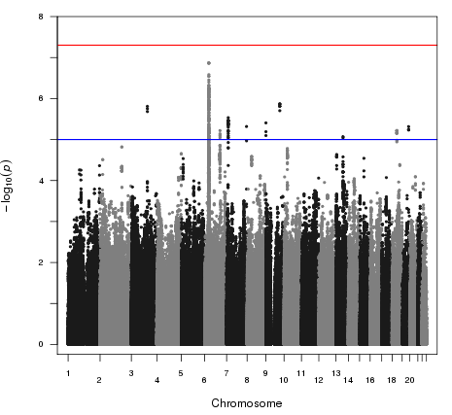

**B:** QQ plot (including HLA-imputation)

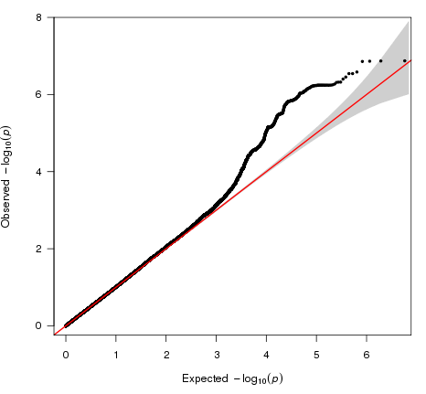

**Figure 4 A:** Genome wideManhattan plot (including HLA imputation) excluding cases that did not have a renal biopsy demonstrating interstitial nephritis (n=55) for all SNPs with a MAF >0.05.

Blue line (P=1x10-5), Red line (P=5x10-8)

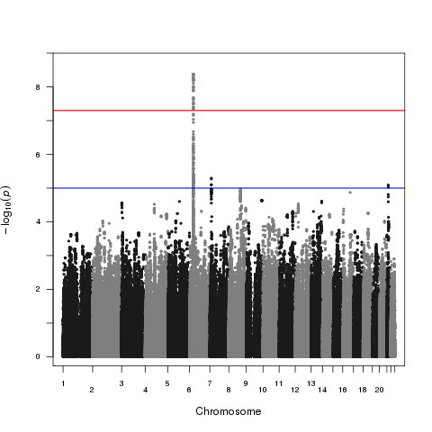

**B:** QQ plot (including HLA imputation) excluding cases that did not have a renal biopsy demonstrating interstitial nephritis (n=55)

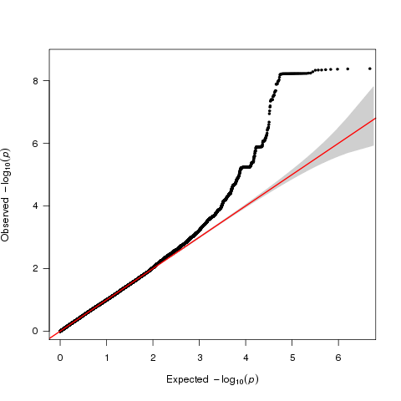

**Supplementary Information**

**IBD Pharmacogenetics Study Group**

Dr Achuth Shenoy

Dr Ailsa Hart

Dr Alex Moran

Dr Alison Simmons

Dr Alistair McNair

Dr Andrew Muller

Dr Andrew T Cole

Dr Andy Bell

Dr Anjan Dhar

Dr Anurag Agrawal

Dr Asheesh Sharma

Dr Azhar Ansari

Dr Cathryn Edwards

Dr Charles Murray

Dr Charlie Lees

Prof Chris Hawkey

Dr Colin Jones

Dr Craig Mowat

Dr Daniel Gaya

Dr David Grimes

Dr David Reffett

Dr David Watts

Dr David Wilson

Dr Deven Vani

Dr Simon Everett

Dr Emma Greig

Prof Epameinondas V Tsianos

Dr Frank Hoentjen

Dr Fraser Cummings

Dr Giacomo C Sturniolo

Dr Graham Heap

Dr Graham Radford Smith

Dr Ian Gooding

Dr Ian Lawrance

Dr Ian London

Dr Jeremy Saunders

Dr Joel Mawdsley

Dr John Beckly

Dr John Green

Dr John Mansfield

Dr John McLindon

Dr Jon Simmons

Dr Jonas Halfvarson

Dr Jonathan Quinlan

Dr Jonathon Snook

Dr Juliette Loehry

Dr Laurie Solomon

Dr M v Herwaarden

Dr Marcus Harbord

Dr Mark Silverberg

Dr Mark Smith

Dr Mark Thomas

Dr Mark Tremelling

Dr Melanie Lockett

Dr Miles Parkes

Dr Nanne KH Boer

Dr Natalie Direkze

Dr Nick Croft

Prof Pradeep Bhandari

Dr Paul Dunckley

Dr Peter Irving

Dr Rachel Cooney

Dr Rakesh Chaudhary

Dr Renata D'Inca

Dr Richard Gearry

Dr Richard Pollok

Dr Rinse Weersma

Dr Rosemary Phillips

Dr Sandip Sen

Dr Sarah Jowett

Dr Sean Weaver

Dr Shailesh Karanth

Dr Shaji Sebastian

Dr Sheldon Cooper

Dr Simon Campbell

Dr Simon Lal

Dr Steve Gore

Dr Steve Lewis

Dr Steven Mann

Dr Subramaniam Ramakrishnan

Dr Sumith Abeygunasekara

Dr Tariq Ahmad

Dr Tariq Iqbal

Prof Tim Orchard

Dr Tom Creed

Dr Udi Shmueli

Dr Vito Annesse

**Supplementary Table 1: Number of cases treated with available 5-ASA agents who developed nephrotoxicity.**

|  |  |
| --- | --- |
| **5-ASA Treatment** | **n** |
| Sulfasalazine Alone | 1 |
| Balsalazide Alone | 1 |
| Mesalazine Alone | 125 |
| Mesalazine and Sulfasalazine | 14 |
| Mesalazine and Balsalazide | 3 |
| Mesalazine and Olsalazine | 5 |
| Unknown | 2 |

**Supplementary Table 2: Multivariate analysis for the recovery of renal function with the following factors.**

|  |  |  |  |  |
| --- | --- | --- | --- | --- |
|  | **Estimate** | **Std. Error** | **Z value** | **P value** |
| Age at abnormal renal function | -3.13E-02 | 1.77E-02 | -1.769 | 0.077 |
| Sex (Male/Female) | 3.93E-01 | 5.51E-01 | 0.712 | 0.476 |
| Diagnosis (CD/UC) | 7.84E-01 | 5.43E-01 | 1.445 | 0.149 |
| Steroid Use (Yes/No) | 4.06E-01 | 5.17E-01 | 0.784 | 0.433 |
| Days on 5-ASA treatment | -1.21E-03 | 6.18E-04 | -1.958 | 0.050 (*) |
| Worst renal function (Creatinine) | -2.34E-03 | 1.92E-03 | -1.221 | 0.222 |
| Average 5-ASA dose | -1.03E-03 | 4.68E-04 | -2.194 | 0.028 (*) |
| Cumulative 5-ASA Dose | 2.73E-07 | 2.44E-07 | 1.119 | 0.263 |

**Supplementary Table 3: Multivariate analysis for the use of renal replacement therapy with the following factors.**

|  |  |  |  |  |
| --- | --- | --- | --- | --- |
|  | **Estimate** | **Std. Error** | **Z value** | **P value** |
| Diagnosis (CD/UC) | 4.66E-01 | 1 | 0.407 | 0.684 |
| Sex (Male/Female) | -1.83E+00 | 1 | -1.359 | 0.174 |
| Steroid Use (Yes/No) | -4 | 2.01E+00 | -2.091 | 0.037 (*) |
| Days on 5-ASA treatment | -5.17E-04 | 0 | -1.829 | 0.067 |
| Worst renal function (Creatinine) | -1.28E-02 | 0 | -2.673 | 0.008 (**) |
| Average 5-ASA dose | 7.94E-04 | 0 | 1.406 | 0.160 |
| Renal Biopsy | 6 | 2.93E+00 | 2.008 | 0.045 (*) |
| Renal Biopsy demonstrating interstitial nephritis | -7.69E-01 | 1 | -0.637 | 0.524 |

**Supplementary Figure 1: Adjudication panel decision chart, adapted from Gallagher et al as previously published in Heap et al** 15,16**.**

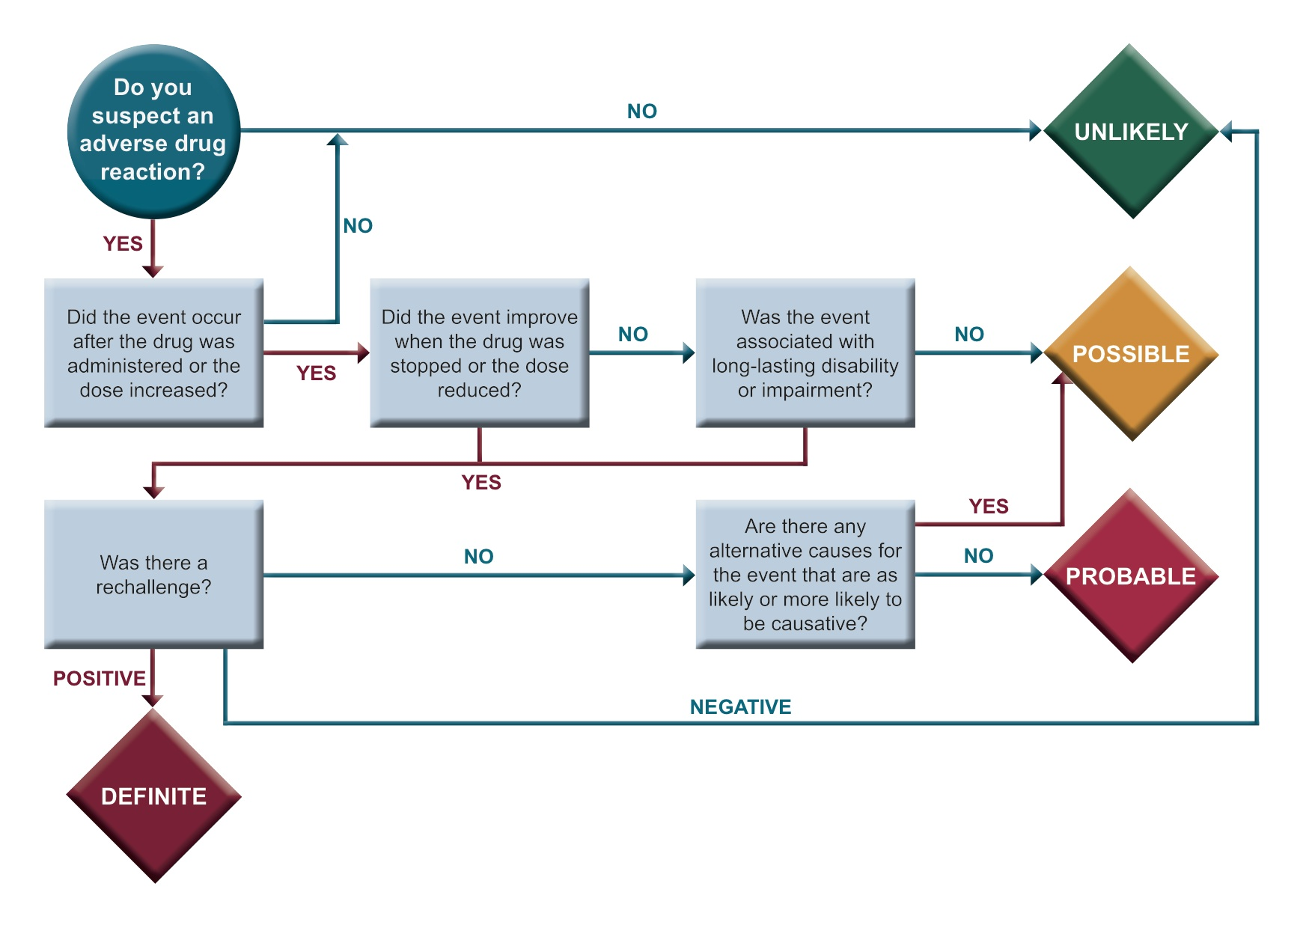

**Supplementary Figure 2: Density estimates for 151 patients demonstrating the time points from commencement of 5-ASA at which creatinine values were taken for 4 of study time points requested (see Methods). The horizontal position of the boxplots in Figure 1 along the x-axis was determined by the median values of these density estimates. The “Baseline values” group have been excluded from this plot.**



**Supplementary Figure 3: Density estimates for 151 patients demonstrating the creatinine values obtained for 4 of the study time points requested (see Methods). The vertical position of the boxplots along the y-axis in Figure 1 was determined by the median values of these density estimates. The “Baseline values” group have been excluded from this plot.**

