Effects of Nebivolol on Biomarkers in Elderly Patients with Heart Failure
Anil K Taneja¹, David Gaze², Andrew JS Coats³, Dan Dumitrascu⁴, Lenka Spinorova⁵, Paul Collinson⁶, Michael Roughton⁷, Marcus D Flather⁸ on behalf of the SENIORS Investigators

Author affiliations:
¹ Consultant Acute Medicine and Cardiology, Barts Health NHS Trust [Whipps Cross University hospital]. Hon Senior Lecturer Royal Brompton Hospital [2004-06] and Clinical Research fellow NHLI/Imperial College [ 2001-04], London.
² Department of Chemical Pathology, St George’s Hospital, London
³ Norwich Research Park Professor-at-large, UEA, Norwich, UK. Professor Coats was the co-principal investigator of the SENIORS trial [Formerly Professor of Cardiology, Imperial College] with the now-deceased Professor Philip Poole-Wilson
⁴ Professor of Medicine, Cluj-Napoca , Romania
⁵ Institute of Clinical Pharmacology, University Hospital Magdeburg, Germany.
⁶ Professor of Cardiovascular Biomarkers , St George’s Hospital
⁷ Statistician, Imperial College
⁸ Consultant Cardiologist and Director of Clinical Trials, Royal Brompton Hospital and Hon Senior Lecturer Imperial College, London [till 2012]. Now Clinical Professor of Medicine, University of East Anglia and Director of Research and development at Norwich and Norfolk University Hospitals.

Version 12
July 2013

Corresponding Author
Dr Anil K Taneja BSc MBBS MRCP (UK) MRCP (Ire) MSc MD
Email: aniltaneja00@hotmail.com anilkumar.taneja@bartshealth.nhs.uk
Previously Royal Brompton Hospital
[Presently moved to Barts Health NHS Trust -Whipps Cross University Hospital, London]
Sydney Street, London SW3 6NP
National Heart and Lung Institute
Dovehouse Street, London SW3 6LY
ABBREVIATIONS
NT-Pro BNP N-Terminal Brain Natriuretic Peptide
Pro ANP Pro Atrial Natriuretic Peptide
ET-1 Endothelin-1
sFAS Soluble Fas
sFas-L Soluble Fas- Ligand
TNF Tumour Necrosis Factor
TNF-a Tumour Necrosis Factor _alpha
SUA Serum Uric Acid
SDMA Symmetrical DiMethyl Arginine
ADMA Asymmetrical DiMethyl Arginine
PNE Peripheral Nor Epinephrine
HF Heart Failure
NO Nitric Oxide
SENIORS Study of the Effects of Nebivolol Intervention
On OUtcomes and Rehospitalisation in
Seniors with Heart Failure
LVEF Left ventricular Ejection Fraction
NYHA New York Heart Association
STARS-BNP Systolic Heart Failure Treatment supported by BNP

ABSTRACT
Background: Heart failure activates neurohormones, and elevated levels of brain natriuretic peptide (BNP) are associated with adverse outcomes. The SENIORS trial showed that nebivolol, a beta-1 antagonist with vasodilating properties, reduced the composite outcome of all cause mortality or cardiovascular hospital admissions in older patients with heart failure. We explored the effects of nebivolol on the underlying mechanisms by looking at a range of neurohormones, cytokines and markers of nitric oxide activity.
Methods: SENIORS randomised 2128 patients >70 years old with chronic heart failure to nebivolol or placebo. N-terminal pro-brain natriuretic peptide, (NT-BNP),pro atrial natriuretic peptide (Pro-ANP), Endothelin-1(ET-1),peripheral norepinephrine (PNE), soluble Fas (sFas),soluble Fas-ligand (sFas-L), Tumour necrosis factor-alpha (TNF-α),serum uric acid (SUA),SDMA (symmetrical dimethyl arginine), Arginine,Citrulline and asymmetrical dimethyl arginine(ADMA) were measured at baseline (before study drug), at 6 months and 12 months.
Results: One hundred and six patients were enrolled and 75 had a baseline and at least one follow up sample. There were no significant differences in neurohormones cytokines or nitric oxide markers measured between the two groups at six or twelve months. NT-Pro BNP showed a numerical increase in the nebivolol group compared to placebo (P=0.08) and sFas showed a numerical increase in patients on placebo (P=0.08). Mean baseline LVEF was 35% and at 12 months was 43% on Nebivolol group and 34% on placebo (P=0.01).
Conclusion: There were trends but no clear changes in neurohormones, cytokines or markers of nitric oxide activity in this study. This may be because the study was underpowered to detect differences. Further studies are required to clarify the effects of beta blockers on biomarkers in heart failure.

INTRODUCTION
Heart failure (HF) is a common condition in the elderly, associated with a high risk of mortality and morbidity. Several large randomised trials have shown that beta blockers reduce the risk of death and heart failure hospital admissions in patients with HF¹. This has also been shown in elderly patients in the SENIORS trial ². However the underlying mechanisms of benefit of beta blockers in HF are poorly understood especially in the elderly. Beta blockers exert their benefits by reducing sympathetic activity, by reducing the workload of the heart and by exerting beneficial effects on the ventricular remodeling process ^{3, 4}. However there is very little randomised trial evidence to demonstrate these effects. Cardiomyocyte necrosis and/or apoptosis may be induced via activation of TNF and the Fas/FasL system and inflammatory cytokines play an important role in the pathogenesis and progression of heart failure ⁵. It is not known if beta-blockers would reduce levels of natriuretic peptides, and/or markers of apoptosis and of ventricular remodelling, and sympathetic activation in HF, especially in the elderly. Nebivolol has a vasodilating action mediated by a nitric oxide enhancing mechanism with possible beneficial effects on endothelial function. This effect has not been tested in randomized controlled outcome clinical trials ⁶. We undertook a pre-specified sub-study of SENIORS ², to explore the effects of nebivolol on several key biomarkers that reflect neurohormonal activation and apoptosis, and also to assess effects the nitric oxide pathway in elderly HF patients with both reduced and preserved LV ejection fraction.

METHODS
The main SENIORS study was a parallel group, randomised, double-blind, multicentre, multinational trial comparing nebivolol with placebo in 2128 elderly patients with chronic heart failure on optimum standard therapy⁷. Patients aged >70 years with a history of stable chronic heart failure were eligible. This sub-study was conducted at 21 participating sites from 4 European countries [Romania, Czech Republic, Germany and UK; Figure 1]. The study was performed in compliance with good clinical practice and followed the recommendations of the Declaration of Helsinki. The relevant national and local ethics review boards and regulatory authorities approved the protocol. Written informed consent was obtained from all patients before enrolment.

Blood samples were obtained at the baseline (prior to first dose of active study drug), and at 6 months and 12 months. Samples were centrifuged and stored below - 20⁰ C for a maximum of 12 weeks and were then sent in dry ice to a central Laboratory at St George’s Hospital, London for storage and analysis. Samples were also sent to the Institute of Clinical Pharmacology, University Hospital Magdeburg, Germany for analysis of ADMA, SDMA, Arginine and Citrulline. On receipt at the central laboratory, the samples were logged and stored at -70 degrees C with strict temperature quality control. Samples from different time points [baseline, 6 and 12 months] were all analysed at the same time. Parameters were analysed using the following Quality approved methods:

NT- proBNP assay: The Electrochemi-luminescence immunoassay “ECLIA”.
Normal levels : NT-Pro BNP = 125 pg/ml in young and 425 pg/m ml in elderly .
Pro ANP assay: Biomedica Medizinprodukte GmbH & Co Enzyme Immunoassay . Normal values: <1945 fmols/ml
TNF-alpha assay: Immunometric Assay : IMMULITE¨ TNFα.
Normal values : < 8 pg/ml
sTNFR-1 assay: Quantikine. Immunoassay. R&D System.
Normal values : <1.2 pg/ml
sFas assay: Quantikine Human sFas Immunoassay. Normal values: < 2.6 pg/ml
Fas-L assay: Quantikine. Human Fas Ligand/TNFSF6 Immunoassay.
Normal values: <20 pg/ml
ADMA & SDMA & Citrulline & Arginine assays: By liquid chromatography/mass spectrometry with the isotope dilution technique. Normal values: <0.5 pg/ml.
ET-1 assay: Parameter Human ET-1 Immunoassay. Normal values: <0.6 pg/ml
SUA assay: Synchron LX® Systems. Normal values: Serum or Plasma 0.5 to 12.0 mg/dl 30 to 714 µmol/L.
PNE assay: High-performance liquid chromatography method. Kit Used: Causon RC et al. 1981. Normal levels: below 0.2 nmol/l as <0.2.

Research Grant: The substudy design was approved by the SENIORS Steering Committee and funded by a research grant from Menarini International who assisted with the study coordination, transportation of samples and statistical analysis. The authors confirm that statistical analysis and data interpretation was carried out independently of the sponsor.
Statistical Methods
The main hypothesis was that nebivolol therapy should be associated with a reduction in NT-Pro BNP compared to placebo group. Other biomarkers were measured on an exploratory basis. The primary outcome was a comparison of the level of NT-ProBNP in patients allocated nebivolol or placebo at 6 and 12 months. The levels of other markers including ANP, uric acid, ET-1, TNF-A, sTNF-R1, sFAS, ADMA, SDMA, Citrulline, Arginine,PNE,FAS-L being secondary analyses. A sample size calculation based on the results from other studies showed that a study of 112 patients could detect a plausible 20% proportional difference with expected levels of NT-Pro BNP levels of 520 ng/L (SD 156 ng/L) between Nebivolol and Placebo] with 80% and alpha 0,05. Patients were included in the analyses if they had a baselin value and at least one further value at 6 or 12 months. Due to the skewed nature of most of the biomarkers, comparisons between nebivolol and placebo were performed on log transformed values as well as on the untransformed values . Values for changes in nebivolol and placebo over time were analysed using ANOVA with covariate adjustment for baseline imbalances. For each of the change versus baseline variables Shapiro-Wilk and Kolmogorov-Smirnov tests of normality were applied. We also performed an exploratory analysis of changes in the biomarkers over the observation period of the whole group (without division into nebivolol or placebo).

RESULTS
106 patients were enrolled into the study and all had baseline blood samples taken. Details of patient and sample flow are shown in Figure 1. 106 blood samples were taken at baseline, 88 samples at 6 months and 75 at twelve months. After taking into account missing samples, and matching baseline samples with at least one follow up, 75 samples at baseline, 74 samples at 6 months and 71 samples at 12 months were included in the analysis.

Baseline characteristics
Baseline characteristics and use of non-trial medication were well matched between patients in the substudy and the overall SENIORS population [Tables 1a and b]. Mean age was 76 years, 40% women, 81% prior coronary heart disease and ejection fraction was 37% with similar proportions of patients below or above an LVEF of 35%.

The mean levels of the thirteen measured parameters at baseline, six months and at twelve months are shown in Table 2. Overall there were no significant differences between nebivolol and placebo for any of the biomarkers measured. Levels of NT-Pro BNP showed a numerical rise in the nebivolol group at 12 months follow up compared to placebo [p=0.08] [Figure 2 and Table 2]. Levels of sFAS similarly showed a numerical rise in the nebivolol group compared to placebo group at 12 months (p= 0.08] [Table 2 and Figure 3].

Effect of beta blockers on LVEF
Mean left ventricular ejection fraction (±standard deviation) at baseline, in the nebivolol group was 35.4% (±13.3) and 37.6% (±11) in the placebo group. The mean LVEF at 12 months was 43.3 (±12.8) % and 34 (±4.2) % in the nebivolol and the placebo groups respectively (p=0.012).

DISCUSSION
This is one of the few studies to explore the effects of nebivolol on biomarkers in heart failure within the context of a randomised controlled trial. We did not find any significant trends in any of the biomarkers measured but there was a numerical rise in NT pro BNP in the nebivolol group compared to placebo over time. There was also a rise in EF in the nebivolol group compared to placebo.

Raised concentrations of BNP are associated with increased mortality and repeat hospital admissions, independent of age, previous myocardial infarction, NYHA class, and left-ventricular ejection fraction.⁸ Studies that have evaluated the effect of beta blockers on the levels of natriuretic peptides are mostly small and non randomised and report inconsistent effects on BNP. ^{8, 9,10,11,12,13,14} Some of these have shown reductions in BNP over time with beta blockers while others suggest no difference or even an increase in BNP. Changes in BNP In observational studies may not be the direct result of beta blocker treatment but due to other confounding factors including concomitant medications and general improvements in HF over time.

In a double-blind randomised crossover study of the effects of 8 weeks treatment of bisoprolol and losartan on natriuretic peptides in 24 hypertensive patients, bisoprolol treatment induced an increase in natriuretic peptides levels while these remained unchanged with losartan¹⁵. In contrast a non-randomised study of 25 heart failure and 25 controls showed that carvedilol was associated with a significant drop in plasma NT-proBNP levels over 3 months¹⁶. NT-proBNP levels showed a positive correlation with heart failure severity as evaluated by NYHA classification both before and after starting carvediol or bisoprolol and a similar prognostic ability of NT-proBNP was shown in the substudy of the COPERNICUS trial ^{17, 18,19}. In COPERNICUS levels of NT Pro BNP increased over the first 30 days in carvedilol treated arm but then decreased during the further follow up. These patients all had severe LV systolic dysfunction [LVEF<25%]. Combining metoprolol or cardvedilol with an ACE inhibitor produced reductions in BNP, but as these were uncontrolled observational study the study designs cannot reliably link these reductions to beta blocker use ²⁰. The CARMEN substudy randomised patients to carvedilol or enalapril or both [carvedilol & enalapril] therapies.²¹ The study reported an increase in BNP & NT-Pro BNP levels with carvedilol alone in stable heart failure patients but a reduction in BNP levels in patients in the other two groups by 6 months ²¹. In the CHRISTMAS study (n=305), carvedilol was associated with increased levels of natriuretic peptides over 6 months in patients with ischaemic left ventricular systolic dysfunction.²² In another small study, 16 patients with mild and stable heart failure randomised to metoprolol or placebo were followed for six weeks ²³. Levels of natriuretic peptides were seen to increase during the study period on the active treatment arm. The COMET study showed a heterogenous response of the plasma levels of BNP in patients on a beta blocker.²⁴ The effects of beta blockers on BNP concentrations may be complex and dependent on multiple interacting factors. Adrenergic stimulation has been shown to inhibit the release of natriuretic peptides, and in these circumstances beta blockade may be associated with an increase in natriuretic peptide concentrations , whereas the improvement in left ventricular dimensions and systolic function may have the opposite effect^{8, 25, 26}. Thus, although the addition of beta-blockers is well documented to be an effective treatment for heart failure, it may not be consistently associated with reduced BNP levels. One possible explanation may be that beta-blockers down regulate natriuretic peptide-clearance receptors²⁷. If this is the case, natriuretic peptide levels will not be lowered despite improvements in LV systolic function reversal. Luchner et al reported that the plasma concentrations of atrial natriuretic peptide, BNP/ NT-ProBNP, and their messenger, cyclic guanosine monophosphate, were higher in patients who received beta-blockers, including metoprolol and bisoprolol, than in those who did not. ^{28.}

TNF-a is said to promote apoptosis and sTNFR-1, protects the heart from TNF-a . sTNFR-1 combines with TNF-a and keeps it away from promoting apoptosis ²⁹ . Our study showed no appreciable change in levels of TNF-a in either group. However, levels of sTNFR-1 were observed to show trend of increase in both the groups. The EARTH trial ³⁰ showed that the use of chronic selective endothelin A blockade in patients with chronic heart failure, treated with ACE inhibitors, beta- blockers, or spironolactone does not attenuate cardiac remodelling or improve symptoms and ET-1 may not be important in the mechanism of action of beta-1 receptor blocker in heart failure patients. ET-1 is a powerful vasoconstrictor and induces endothelial dysfunction but in our study we could not detect any differences in ET-1 levels between nebivolol and placebo..

The moderate decrease in sFAS in the Nebivolol group compared with placebo may indicate an inhibition or a slowing of the apoptosis process. Serum Uric acid (SUA) showed a moderate elevation in the nebiviolol group although this difference was not statistically significant. Nebivolol has been shown to enhance nitric oxide activity in experimental models and also expresses activity in humans through NO mechanisms ADMA, endogenous competitive inhibitor of NO synthase which is associated with impaired endothelium-dependent NO mediated vasodilation did not show any major change with nebivolol treatment.³¹,³². Elevated plasma norepinephrine levels did not predict benefit from carvedilol suggesting that there is no simple relation between activation of the sympathetic nervous system and beta-adrenergic receptor function in heart failure. ³³ As beta blockers may inhibit the effects of raised catecholamines rather that reducing their levels it is perhaps not surprising little effect was seen with nebivolol in this study.

Limitations of the study;
Our study has several limitations. The sample size of the study was smaller than we anticipated with a larger variability than we had anticipated which will lead to reduced power to detect moderate differences in biomarkers. The sub-study included patients with both low and preserved EF and these two groups may have had a different response to beta blockade, because of the differing underlying pathophysiology of these two distinct heart failure syndromes.

Conclusions
Our study is one of the few randomised studies of beta blockers in heart failure to measure levels of NT-Pro BNP and other biomarkers and the only one to evaluate the effects of nebivolol in elderly patients. Contrary to our prior hypothesis, Nebivolol was associated with trend of higher levels of NT-Pro BNP versus placebo group in spite of being associated with better clinical outcomes in the main SENIORS trials. In addition there were no significant differences found in many other neurohormones shown to be involved in the underlying mechanism of heart failure. These observations indicate that there is no simple relationship between the neurohormonal system and beta-adrenergic receptor function and the influence of beta blockers on key pathophysiological mechanisms in heart failure needs further evaluation.

REFERENCES

- Shibata MC, Flather MD, Wang D. Systematic review of the impact of beta blockers on mortality and hospital admissions in heart failure. Eur J Heart Fail. 2001 Jun;3(3):351-7
- Flather MD, Shibata MC, Coats AJ, Van Veldhuisen DJ, Parkhomenko A, Borbola J, Cohen-Solal A, Dumitrascu D, Ferrari R, Lechat P, Soler-Soler J, Tavazzi L, Spinarova L, Toman J, Bohm M, Anker SD, Thompson SG, Poole-Wilson PA; SENIORS Investigators. Randomized trial to determine the effect of nebivolol on mortality and cardiovascular hospital admission in elderly patients with heart failure. Eur Heart J. 2005 Feb;26(3):215-25.
- Bristow MR. Mechanism of action of beta-blocking agents in heart failure Am J Cardiol. 1997 Dec 4;80(11A):26L-40L.
- Mason RP, Giles TD, Sowers JR. Evolving mechanisms of action of beta blockers: focus on nebivolol. J Cardiovasc Pharmacol. 2009 Aug;54(2):123-8
- Koichi Setsuta, Yoshihiko Seino, Takeshi Ogawa, Toshiaki Ohtsuka, Kohji Seimiya, Teruo Takano, Ongoing Myocardial Damage in Chronic Heart Failure is Related to Activated Tumor Necrosis Factor and Fas/Fas Ligand System. Circ J 2004; 68: 747 –750
- Kamp O, Metra M, Bugatti S, Bettari L, Dei Cas A, Petrini N, Dei Cas L. Nebivolol: haemodynamic effects and clinical significance of combined beta-blockade and nitric oxide release. Drugs. 2010;70(1):41-56

- Shibata MC, Flather MD, Bohm m, borbola j, Cohen-solal A, dumitrascu D, Ferrari R, lechat P, Parkhomenko A, Soler- Soler J, Tavazzi L, Toman J, Van veldhuisen DJ, Coats AJ, Poole-Wilson P; Study of the effects of Nebivolol Intervention on outcomes and Rehospitalisation in Seniors with Heart Failure. Int J cardiol 2002 Nov;86(1):77-85.
- Stanek B, Frey B, Hülsmann M, Berger R, Sturm B, Strametz-Juranek J, Bergler-Klein J, Moser P, Bojic A, Hartter E and Pacher R. Prognostic evaluation of neurohumoral plasma levels before and during beta-blocker therapy in advanced left ventricular dysfunction. JACC 2001;38(2) 436-442.
- de Groote P, Delour P, Lamblin N, Dagorn J, Verkindère C, Tison E, Millaire A, Bauters C. Effects of bisoprolol in patients with stable congestive heart failure. Ann Cardiol Angeiol (Paris). 2004 Jul;53(4):167-70
- Yoshizawa A , Yoshikawa A T, Nakamura W, Satoh T, Moritani K, Suzuki M, Baba K, Iwanaga S, Mitamura H, AND Ogawa S. Brain Natriuretic Peptide Response Is Heterogeneous During b-Blocker Therapy for Congestive Heart Failure. Journal of Cardiac Failure Vol. 10 No. 4 2004.
- Frantz RP, Olson LJ, Grill D, Moualla SK, Nelson SM, Nobrega TP, Hanna RD, Backes RJ, Mookadam F, Heublein D, Bailey KR, Burnett JC Carvedilol therapy is associated with a sustained decline in brain natriuretic peptide levels in patients with congestive heart failure. Am Heart J. 2005 Mar;149(3):541-7.

- Berger R, Huelsman M, Stecker K, et al. B-type natriuretic peptide predicts sudden death in patients with chronic heart failure. Circulation. 2002; 105:2391–2396.
- Richards AM, Doughty R, Nicholls MG, MacMahon S, Sharpe N, Murphy J,Espiner EA,Frampton C,Yandle TG, for the Australia-New Zealand Heart Failure Group Prognostic utility and prediction of benefit from carvedilol in chronic ischemic left ventricular dysfunction. J Am Coll Cardiol 2001; 37(7):1781-1787.
- Yoshimoto T, Naruse M, Tanabe A, Naruse K, Seki T, Imaki T, et al. Potentiation of natriuretic peptide action by the beta-adrenergic blocker carvedilol in hypertensive rats: a new antihypertensive mechanism. Endocrinology 1998; 139:81–8.
- van den Meiracker AH, Lameris TW, van de Ven LL, Boomsma F. Increased plasma concentration of natriuretic peptides by selective beta1-blocker bisoprolol. J Cardiovasc Pharmacol. 2003 Oct;42(4):462-8
- Gundogdu F, Bozkurt E, Kizitunc A, Sevimli S, Arsian S, Gurlertop Y, Senocak H, Karakelleoglu S. The effect of beta-blocker (carvedilol) therapy on N-terminal pro-brain natriuretic peptide levels and echocardiographic findings in patients with congestive heart failure. Echocardiography 2007 Feb;24(2):113-7.
- Li N, Li Y, Wang F, Jiang W, Huang J, Xu Z, Hua L, Hua C, Huang Y, Wu Y, Li F. Does NT-proBNP remain a sensitive biomarker for chronic heart failure after administration of a beta-blocker? Clin Cardiol 2007 Sep;30(9):469-74

- Hartmann F, Packer M, Coats AJ, Fowler MB, Krum H, Mohacsi P, Rouleau JL, Tendera M, Castaigne A, Anker SD, Amann-Zalan I, Hoersch S, Katus HA. Prognostic impact of plasma N-terminal pro-brain natriuretic peptide in severe chronic congestive heart failure: a substudy of the Carvedilol Prospective Randomized Cumulative Survival (COPERNICUS) trial. Circulation. 2004 Sep 28;110(13):1780-6.
- Franz Hartmann, Milton Packer, Andrew J.S. Coats, Michael B Fowler, Henry Krum, Paul Mohacsi,Jean L Rouleau, Michal Tendera, Alain Castaigne, Jurgen Trawinski, Ildiko Amann-Zalan, Silke Hoersch and Hugo A. Katus. NT-pro BNP in severe chronic heart failure:rationale, designand preliminary results of the COPERNICUS nt-pro BNP substudy. Eur Journal of Heart Failure Vol 6;3:343-350.
- Fung JW, Yu CM, Yip G, Chan S, Yandle TG, Richards AM, Nicholls MG, Sanderson JE. Effect of beta blockade (carvedilol or metoprolol) on activation of the renin-angiotensin-aldosterone system and natriuretic peptides in chronic heart failure. Am J Cardiol. 2003 Aug 15;92(4):406-10.
- Rosenberg J, Gustafsson F, Remme WJ, Riegger GA, Hildebrandt PR. Effect of Beta-blockade and ACEI on B-type Natriuretic peptides in Stable patients with Systolic heart failure. Cardiovascular Drugs and therapy 2008; 22(4); 305-31.
- Cleland J.G.F. Ray S, Dalle Mulle J Can natriuretic peptides be used to monitor response to carvedilol in patients with ischaemic left ventricular systolic dysfunction? Circulation 2006:106(Suppl II)[Abstract 3487.

- Davis M.E., Richards A.M., Nichollis M.G., Yandie T.G., Frampton C.M., Troughton R. W., Introduction of metoprolol increases plasma B-type cardiac natriuretic peptides in mild, stable heart failure. Circulation 2006;113:977-985.
- Lars G. Olsson, Kari Swedberg, John G.F. Cleland, Philip A. Spark, Michel Komajda, Marco Metra, Christian Torp-Pedersen, Willem J. Remme, Armin Scherhag, Philip Poole-wilson Comet Investigators. Prognostic importance of plasma NT-pro BNP in chronic heart failure in patients treated with a β-blocker: Results from the Carvedilol Or Metoprolol European Trial (COMET) trial. Eur Journal of Heart Failure. Vol 9;8:795-801.
- Christensen G, Aksnes G, Ilebekk A, Kiil F. Release of atrial natriuretic factor during selective cardiac alpha- and beta-adrenergic stimulation, intracoronary Ca2+ infusion, and aortic constriction in pigs. Circ Res 1991;68: 638–44.
- The RESOLVD Investigators. Effects of metoprolol CR in patients with ischemic and dilated cardiomyopathy: the randomized evaluation of strategies for left ventricular dysfunction pilot study. Circulation 2000; 101: 378–84.
- Yoshimoto T, naruse m, irie K, Tanabe A, Seki T, Tanaka M, imaki T, Naruse K, Muraki T, matsuda Y, Demura H. Beta-adrenoceptor antagonist propanolol potentiates hypotensive action of natriuretic peptides. Eur J Pharmacol1998 Jun 12;351(1):61-6.
- Luchner A, Burnett JC Jr, Jougasaki M, Hense H, Riegger GAJ, Schunkert H. Augmentation of the cardiac natriuretic peptides by betareceptor antagonism: evidence from a population-based study. J Am Coll Cardiol 1998; 32:1839–44.
- Ferrari R, Bachetti T, Confortini R, et al. Tumor necrosis factor soluble receptors in patients with various degrees of congestive heart failure. Circulation 1995; 92:1479–86.
- Lukas E. Spieker and Thomas F. Lüscher. Endothelin receptor antagonists in heart failure—a refutation of a bold conjecture? European Journal of Heart Failure. Volume 5, Issue 4, August 2003, Pages 415-417
- Scherrer-Crosbie M, Ullrich R, Bloch KD, et al. Endothelial nitric oxide synthase limits left ventricular remodeling after myocardial infarction in mice. Circulation. 2001; 104:1286–1291.
- Usui M, Matsuoka H, Miyazaki H, Ueda S, Okuda S, Imaizumi T. Increased endogenous NO synthase inhibitor in patients with congestive heart failure. Life Sci 1998; 62:2425-2430.
- Richards AM, Doughty R, Nicholls MG, Macmahon S, Ikram H, Sharpe N, Espiner EA, Frampton C, Yandle TG. Neurohormonal prediction of benefit from Carvedilol in ischaemic left ventricular dysfunction. Australia-NewZealand Heart Failure Group. Circulation 1999 Feb 16;99(6):786-92.

Acknowledgements

LEGENDS OF TABLES AND FIGURES

Table 1a Baseline characteristics

Table 1b Medications at baseline

Table 2 Showing absolute values of the parameters at baseline, 6 months and 12 months in placebo and Nebivolol groups and comparison of treatment effects between these 2 groups.

Figure 1 : Flow diagram showing the patients enrolled into the NH study and samples collected along with the details of samples excluded from the analysis. It also shows the samples transported, received by core laboratory and analysed.

Figure 2a Graph showing changes in levels of Natriuretic peptides [Pro NT-BNP and Pro ANP] in placebo and Nebivolol groups by 6 and then at 12 months

Figure 2b Graph showing changes in levels of markers of apoptosis [TNF, sTNFR-1, sFas and sFas-L] in placebo and Nebivolol groups by 6 and then at 12 months

Figure 2c Graph showing changes in levels of markers of endothelial function [ ET-1, SUA ] and sympathetic activity marker PNE in placebo and Nebivolol groups by 6 and then at 12 months.

Table 1a. Baseline characteristics

Baseline characteristic | Neurohormonal substudy  Total N= 75 |  | Whole group | p-value between grp comparisons for NH study
 | Nebivolol  (36) | Placebo  (39) | N=75
Gender  F  M | 18(50%)  18(50%) | 13(33%)  26(67%) | 31(41.3%)  44(58.67%) | (0.143)
Age (yrs)  Mean (SD)  Median | 75.9(3.7)  75.7 | 74.5(3.9)  74.2 | 75.2(3.8)  75.2 | 0.120
Hyperlipidaemia | 18(50%) | 14(36%) | 32(42.7%) | 0.217
Hypertension | 22(61%) | 24(61%) | 46(61.33%) | 0.970
Diabetes | 6( 17%) | 8( 20%) | 14(18.67%) | 0.669
SBP (SD)(mmHg) | 142.7(22.8) | 139.2(20.6) | 140.9(21.6) | 0.499
DBP (SD)(mmHg) | 80.3(9.1) | 81.8(12.2) | 81.1(10.8) | 0.564
Heart rate (SD)(per min) | 77.6(12.4) | 78.4(17.8) | 78(15.4) | 0.771
P/h/o CAD | 31(86%) | 30(77%) | 61(81.3%) | 0.308
P/h/o MI | 13(36%) | 18( 46%) | 31(41.33%) | 0.378
Arrhythmia | 18 (50%) | 24 (63%) | 42(56%) | 0.315
NYHA  I  II  III  IV | 2(6%)  25(69%)  9(25%)  0(0%) | 0(0%)  23(59%)  16(41%)  0(0%) | 2(2.7%)  48(64.0%)  25(33.33%)  0(0%) | 0.140
LVEF (%)(S.D) | 35.9(13.3) | 37.6(11%) | 36.6(12.1%) | 0.607

Table1b. Medications at baseline

Baseline characteristic | Neurohormonal substudy  Total N= 75 |  | p-value between grp comparisons for NH substudy | SENIORS main  Study
 | *Nebivolol  (36) | Placebo  (39) |  | Nebivolol (1067) | Placebo (1061)
On Diuretic | 32(86%) | 33(85%) | 0.586 | 916 (85.9 %) | 910 (85.8%)
On ACE inhibitors/A-2 antagonists | 28(78%) | 31(77%) | 0.857 | 880 (82.5%) | 884(83.3 %)
Cardiac Glycoside | 14(39%) | 19(48%) | 0.392 | 415(38.9 %) | 420(39.6 %)
Aldosterone antagonist | 13(36%) | 17(44%) | 0.509 | 298(27.9 %) | 272(25.6 %)
Antiarrhythmic | 4(11%) | 1(3%) | 0.138 | 91 (8.5 %) | 119(11.2 %)
Nitrates | 22(41%) | 21(54%) | 0.525 | 509(48%) | 530(50%)

Table 2. Absolute values and differences of biomarkers measured at baseline, 6 months and 12 months in placebo and Nebivolol groups and comparison of treatment effect at 12 months

Parameters  Means(S.D.) | Baseline |  | Six months |  |  | Twelve months
Parameters  Means(S.D.) | Nebivolol (36) | Placebo (39) | Nebivolol  (35) |  | Placebo (39) | Nebivolol (32) | Placebo (39)
NT-ProBNP  pg/ml | 1718 (3166) | 1955 (2848) | 1460 (1525) |  | 1372 (1548) | 1864 (2534) | 1034 (915)
NT-ProBNP  pg/ml | 1718 (3166) | 1955 (2848) | P = 0.475 |  |  | P= 0.082
Pro ANP (SD)  fmol/ml | 1637 (592) | 1566 (772) | 1692 (676) |  | 1549 (737) | 1552 (713) | 1541 (697)
Pro ANP (SD)  fmol/ml | 1637 (592) | 1566 (772) | P=0.458 |  |  | P=0.798
TNF-a (SD)  pg/ml | 8.9 (4.4) | 9.6 (6.3) | 12.0 (15.6) |  | 10.4 (5.6) | 8.9(3.3) | 9.8(4.4)
TNF-a (SD)  pg/ml | 8.9 (4.4) | 9.6 (6.3) | P=0.144 |  |  | P=0.622
sTNFR-1 (SD)  pg/ml | 1593 (565) | 1912 (1037) | 1653 (729) |  | 2060 (1417) | 2028 (936) | 2261 (1187)
sTNFR-1 (SD)  pg/ml | 1593 (565) | 1912 (1037) | P=0.367 |  |  | P=0.664
SUA (SD)  mg/dl | 0.29 (0.09) | 0.33 (0.11) | 0.32 (0.07) |  | 0.31 (0.08) | 0.33 (0.08) | 0.32 (0.08)
SUA (SD)  mg/dl | 0.29 (0.09) | 0.33 (0.11) | P=0.491 |  |  | P=0.328
sFAS (SD)  pg/ml | 2807 (1600) | 2687(1409) | 2682(1626) |  | 3117(2054) | 2992(1208) | 3584(1646)
sFAS (SD)  pg/ml | 2807 (1600) | 2687(1409) | P=0.303 |  |  | P=0.077
Fas-L (SD)  pg/ml | 71.7(98.7) | 76(81.7) | 70.8(93.9) |  | 53.7 (45.4) | 71.7(70.4) | 51.9 (53)
Fas-L (SD)  pg/ml | 71.7(98.7) | 76(81.7) | P=0.252 |  |  | P=0.183
ADMA (SD)  Pg/ml | 0.52(0.10) | 0.54(0.08) | 0.55(0.09) |  | 0.56(0.09) | 0.52(0.09) | 0.54(0.08)
ADMA (SD)  Pg/ml | 0.52(0.10) | 0.54(0.08) | P=0.772 |  |  | P=0.754
Citrulline  Pg/ml | 45.9(14.6) | 52.5(14.8) | 52.5(12.1) | 56.4(15.8) |  | 50.9(11.4) |  | 52.7(13.4)
Citrulline  Pg/ml | 45.9(14.6) | 52.5(14.8) | P=0.90 |  |  | P=0.711
Arginine  Pg/ml | 69.23(20.47) | 73.35(24.16) | 65.83(23.06) | 72.59(23.00) |  | 66.99(18.48) |  | 66.74(22.48)
Arginine  Pg/ml | 69.23(20.47) | 73.35(24.16) | P=0.267 |  |  | P=0.617
SDMA  Pg/ml | 0.67(0.21) | 0.74(0.21) | 0.75(0.21) | 0.80(0.30) |  | 0.75(0.24) |  | 0.78(0.28)
SDMA  Pg/ml | 0.67(0.21) | 0.74(0.21) | P=0.81 |  |  | P=0.587
PNE(SD)  Nmol/ml | 0.91(1.28) | 0.67(0.92) | 0.92(1.08) |  | 0.95 (1.14) | 0.72(0.61) | 0.66 (0.61)
PNE(SD)  Nmol/ml | 0.91(1.28) | 0.67(0.92) | P=0.786 |  |  | P=0.703
ET-1(SD)  pg/ml | 12.72 (11.6) | 12.15(10.5) | 11.48(8.8) |  | 12.03(10.95) | 16.02(13.24) | 16.74(12.37)
ET-1(SD)  pg/ml | 12.72 (11.6) | 12.15(10.5) | P=0.666 |  |  | P=0.887

Figure 1 : Flow diagram showing the patients enrolled into the NH study and samples collected along with the details of samples excluded from the analysis. It also shows the samples transported, received by core laboratory and analysed.

ACTIVE CENTRES
Romania : 8
Czech Rep : 6
UK : 6
Germany : 1
106 patients enrolled
Ro: 47
CZ Rep: 29
UK: 23
Ger: 07
98 samples received=106 baseline samples minus 8 samples missing or un satis-factory
* 10 excuded from analysis (including 4 deaths)
98 – 10 = 88

6 months follow up
88 patients
80 samples received=88 six months samples minus 8 samples missing or unsatis-factory

* 9 excluded from analysis
80 – 9 = 71
12 months or
Final follow up
71 patients

71 final follow up samples received

*Total of 16 samples missing or in unsatisfactory condition = 8 baseline + 8 six months
TOTAL samples collected and frozen
106+88+71 = 265

Samples received by core laboratory in satisfactory condition
98 baseline + 80 six months + 71 twelve months = 249
- Samples able to analyse [minimum of baseline and one follow up sample necessary]
- 75 baseline + 74 six months + 71 twelve months

*
Reasons for exclusion | No of patients | Comments
Drop outs [Discontinued study drugs, withdrawn consent or due to adverse event ] | 15 | 6 drop outs before 6 months F up and another 9 between 6 & 12 mths F up.
Deaths | 4 | 3 were in placebo arm and 1 in Neb (Only baseline samples available)
Samples missing/not received by core lab or received in unsatisfactory condition /not labelled | 16 | 8 from baseline and another 8 were 6 months samples

Figure 2a Graph showing changes in levels of Natriuretic peptides [Pro NT-BNP and Pro ANP] in placebo and Nebivolol groups at 6 and 12 months

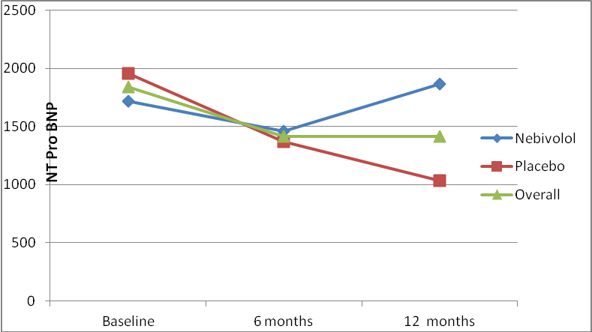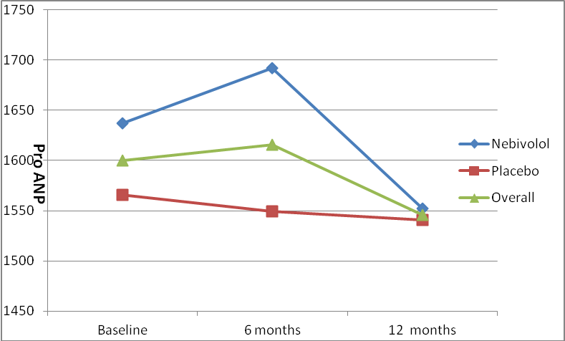

Figure 2b Graph showing changes in levels of markers of apoptosis [TNF, sTNFR-1, sFas and sFas-L] in placebo and Nebivolol groups by 6 and then at 12 months
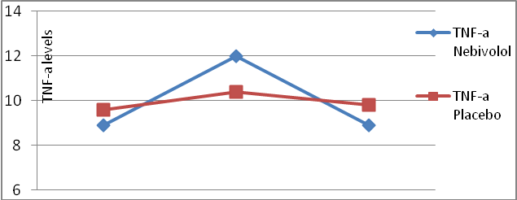
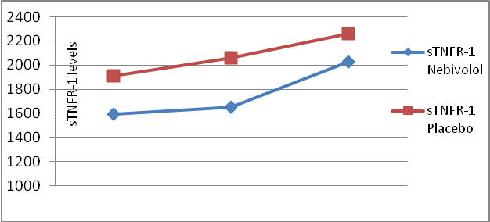
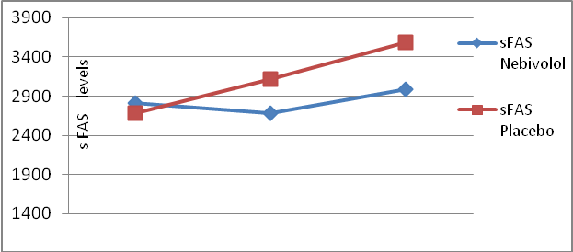
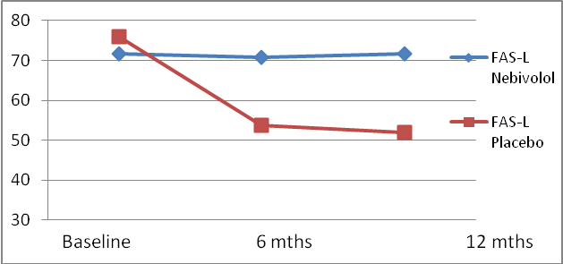

Figure 2c Graph showing changes in levels of markers of endothelial function SUA, ET-1] and sympathetic activity [PNE] in placebo and Nebivolol groups by 6 and then at 12 months.

