Clinical variables | Missing data Female/Male | Female (n=82) | Male (n=84) | P- value
Age (years) | 0/0 | 61.6 (6.8) | 60.0 (8.3) | 0.144
Duration of diabetes (years) | 13/9 | 9.8 (7.2) | 10.9 (8.1) | 0.389
Body Mass Index (kg/m²) | 2/0 | 30.8 (6.9) | 29.8 (5.0) | 0.273
Waist circumference (cm) | 5/4 | 101.6 (14.0) | 102.2 (12.0) | 0.768
Systolic blood pressure (mmHg) | 4/1 | 138.4 (17.5) | 141.2 (15.2) | 0.272
Diastolic blood pressure (mmHg) | 4/1 | 81.2 (9.0) | 83.2 (9.6) | 0.172
HbA1c (mmol/mol) | 2/1 | 59.4 (18.1) | 56.0 (17.6) | 0.208
Total cholesterol (mmol/L) | 1/0 | 4.3 (0.91) | 3.9 (0.71) | <0.001
Triglyceride (mmol/L) | 1/0 | 1.4 (0.74) | 1.6 (0.89) | 0.159
HDL-cholesterol (mmol/L) | 1/0 | 1.4 (0.36) | 1.2 (0.35) | <0.001
LDL-cholesterol (mmol/L) | 2/1 | 2.3 (0.80) | 2.0 (0.62) | <0.001
Total-/HDL cholesterol ratio | 1/0 | 3.5 (1.01) | 3.5 (0.90) | 0.462
Creatinine (µmol/L) | 0/0 | 63.6 (13.2) | 81.1 (23.4) | <0.001
eGFR (mls/min/173m²) | 0/0 | 88.1 (84.6-91.5) | 89.0 (85.1-93.0) | 0.284
Microalbuminuria mg/µmol* | 5/6 | 1.67 (1.18-2.37) | 3.21 (2.20-4.67) | 0.050
Table 1.
LDL: low-density lipoprotein; HDL: high-density lipoprotein; eGFR: estimated glomerular filtration rate.
* median (inter-quartile range)

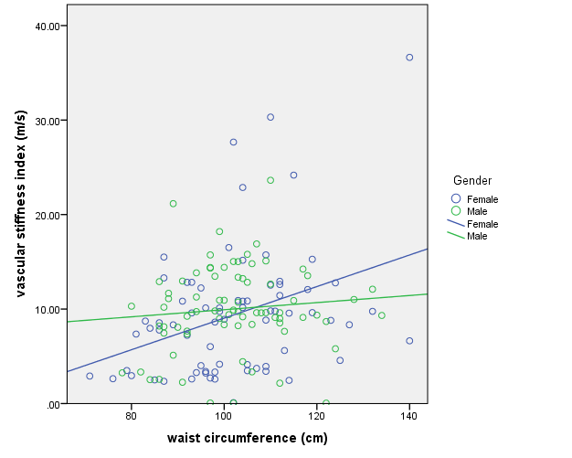
Figure 1
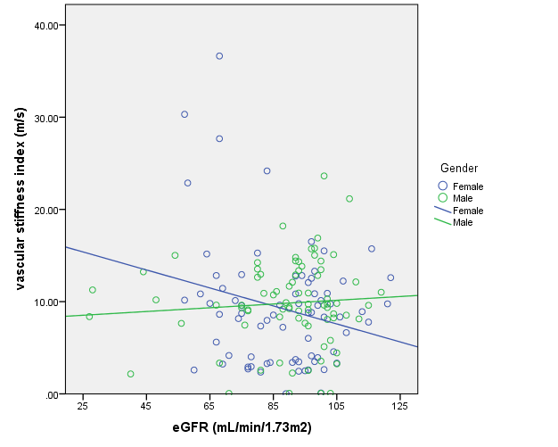
Figure 2

