The Relationship between Distance and Change in Surface ECG Morphology during Pacemapping as a guide to Ablation of Ventricular Arrhythmias –Implications for the spatial resolution of pacemapping.
Short title: Li et al. Quantitative analysis of pacemapping.
Anthony Li, MD¹, Joseph Samuel Davis, MS², Jeremiah Wierwille, PhD², Keith Herold, PhD², Dennis Morgan, MS³, Elijah Behr, MD¹, Stephen Shorofsky PhD⁴, Magdi Saba, MD¹
¹Cardiovascular Sciences Research Centre, St. George’s University of London, London, UK; ²Fischell Department of Bioengineering, Clark School of Engineering, University of Maryland, College Park, Maryland; ³St. Jude Medical, St. Paul, Minnesota, USA; ⁴Division of Cardiology, Department of Medicine, University of Maryland Medical System, Baltimore, Maryland.
Corresponding Author:
Dr Anthony Li
Cardiovascular Sciences Research Centre
St. George’s University of London
Blackshaw road
London. SW17 0RE
Tel 0208 725 1390
Email: ali@sgul.ac.uk
Journal Subject Terms: Arrhythmias, Catheter Ablation and Implantable Cardioverter-Defibrillator, Electrophysiology, Clinical Studies, Cardiomyopathy, Chronic Ischemic Heart Disease.
Word count: 5,083

Abstract

Background
Pace-mapping is used to localise the exit site of ventricular arrhythmia (VA). Although the relationship between distance and change in QRS morphology is its basis, this relationship has not been systematically quantified.

Methods and Results
Patients (n=68) undergoing VA ablation between March 2012 and July 2013 were recruited. Pace-mapping was targeted to areas of voltage > 0.5mV. Linear mixed effects models were constructed of distance against morphology difference measured by the root mean square error (RMSE) sum across all 12 ECG leads (E12).
40/68 (58%) patients had structural heart disease, 21/40 (53%) ischaemic. 935 pacing points were collected, generating 6219 pacing site pair combinations (3087 (50%) ventricular bodies, 756 (12%) outflow tract, 162 (3%) epicardial. In multivariable analysis, increase in E12 was predicted by increasing distance (0.07 per mm; 95% CI 0.07, 0.08; p<0.001). Compared to the LV, E12 values were lower in the RV (p = 0.037) and LVOT (p < 0.001) and higher in LV-RV pairs (p = 0.021) and LV epicardium (p = 0.08). There was no difference in E12 in the RVOT compared to RVOT-LVOT (p = 0.75) pairs. Structural heart disease or inadvertent pacing in scar was not associated with changes in E12, however the presence of latency and split potentials were associated with higher and lower E12 values, respectively (p<0.001).

Conclusions
A robust positive relationship exists between distance and QRS morphological change when restricting pacing points to areas of voltage >0.5mV. Significant differences in the spatial resolution of pace-mapping exist within the heart.
Keywords: Pacemapping, Spatial resolution, VT ablation, VE ablation

Introduction
Pace-mapping has been shown to be useful in determining the site of origin or exit site of ventricular arrhythmias (VA) in both idiopathic and scar related etiologies, particularly when sustained ventricular tachycardia is poorly tolerated or ventricular ectopy occurs at a low frequency.^{1,2}
The aim of this study is to quantify the effect of change in distance between pacing sites on the change in QRS morphology in different regions of the heart. To our knowledge, there has been no systematic study of this relationship across the whole heart reported in the literature to date. Establishing this relationship could form the basis for a pace-mapping guidance system that could lead to improvements in the mapping process and ultimately to improved procedural efficiency.

Methods

Patient characteristics
The subjects of this study were 68 consecutive patients who underwent 74 VA ablation procedures at St. George’s Hospital between March 2012 and July 2013. The study was approved by the National Research Ethics Service and individual written informed consent was obtained. Cardiac etiology was established by conventional diagnostic criteria. Patients underwent either transthoracic echocardiogram (TTE) or cardiac MRI (cMRI) pre-procedurally. Coronary angiography was performed in all cases of structural heart disease and was discretional in normal hearts, defined as absence of structural abnormality established by TTE or cMRI.

Mapping protocol
All studies were performed on patients in the fasting state and whose antiarrhythmic drug therapy was discontinued for at least 5 half-lives, except in patients with VT storm or those on amiodarone. Scar-dependent VT ablation was performed under general anesthesia and VE cases under light sedation. Sub-xiphoid epicardial approach was undertaken based on clinical etiology, data from pre-procedural imaging or prior procedural mapping. In general, dual left ventricular access using trans-septal and retrograde aortic approach was employed in scar-dependent VT cases. In cases where catheter reach or contact was deemed to be poor, a steerable sheath (Agilis NxT, St Jude Medical, St Paul, Mn, USA) was employed. Anticoagulation during left ventricular procedures was maintained with unfractionated Heparin. Participants were studied in a biplane fluoroscopic lab with ECG electrodes placed in a standard configuration. Patients underwent electroanatomical mapping using the Ensite Velocity System (St. Jude Medical, St Paul, MN, USA). Correction for respiratory motion was routinely applied at the start of the case. Surface ECG and intracardiac electrograms were simultaneously recorded and logged on Labsystem Pro software (Bard Electrophysiology, Lowell, MA, USA). All studies were performed with surface ECG filter settings at 0.5-100Hz with a 50Hz notch filter enabled. Bipolar electrograms were recorded with filter settings at 30-300Hz. Multipolar catheters were introduced into the coronary sinus and right ventricle in all cases. Mapping data was continuously recorded on the Velocity platform to allow data extraction and post processing.
Mapping and ablation were performed with a 3.5mm open irrigated radiofrequency ablation catheter, with 2mm inter-electrode distance (ThermoCool SF, Biosense-Webster, Diamond Bar, CA, USA). For VT cases, voltage mapping was performed during sinus rhythm concentrating on areas of abnormal voltage, with a fill threshold of 10mm at the outset with established definitions used to determine normal myocardium (> 1.5mV), border zone (0.5-1.5mV) and dense scar (< 0.5mV). For VE cases, voltage mapping was performed where there was a clinical suspicion of structural abnormalities.
If there was infrequent ectopy at baseline, intravenous isoprenaline infusion was used and titrated according to response.
Pacing point collection was performed during sinus rhythm from the distal bipolar pair of the mapping catheter. Adequate contact and stability was judged by a combination of fluoroscopic appearance, proximity to the geometry surface and electrogram amplitude and morphology consistency. Pacing was performed at 2 ms pulse width at a cycle length or coupling interval equal to the clinical VA or if haemodynamically unstable at that rate or unknown, at 400 ms. Pacing was initiated at low output and increased and continued until ≥ 3 consecutive captured beats with identical morphology were obtained. Pacing sites were restricted to areas of myocardium > 0.5 mV as displayed on the voltage map and were initially distributed widely then focussed in on the putative site of origin (SO) or exit site of the targeted VA. Geometry, pacing site location and ECG morphology data were exported from the mapping system and imported into custom software for offline analysis.

Data analysis
Sinus rhythm intracardiac electrograms from the beat preceding each pacing train were analysed post- procedure. Electrogram amplitude and morphology characteristics were recorded and defined as follows: Fractionated (multiple intrinsic deflections (> 3 sharp deflections), amplitude ≤ 0.5 mV, duration ≥ 133 ms, and amplitude: duration ≤ 0.005 mV/ms). Late (isolated component ≥ 20 ms after the end of surface QRS). Split potential: a double component electrogram within the QRS inscription separated by an isoelectric line.³ Stimulation to QRS onset (S-QRS) interval and electrogram duration were measured using electronic callipers at 200 mm/s sweep speed.
In essence, the paced QRS morphology from a single pacing site was quantitatively compared to the paced QRS morphology from a second pacing site and the difference plotted against the distance between the pacing sites that generated the 2 QRS morphologies. Each pacing point collected was compared against all other pacing sites within the same procedure such that all possible pair combinations were included. Distances were measured automatically by custom software run on the Ensite Velocity platform (St. Jude Medical, St Paul, MN, USA) and were taken as the direct Euclidean distance between 2 points in 3D space as shown in Equation 1.
Equation 1
To quantify the difference in morphology between surface ECGs generated by distinct pacing sites, the ECG signal underwent post processing by superimposing the QRS complexes and then alignment was achieved using the maximum of the 12 lead composite signal (maximum energy) and then verified visually. The composite signal was taken as the addition of the sum of the absolute values of all used leads at each time point for each pacing site. The alignment that maximizes this value is then used to compute the morphological difference. The root mean square error (E) parameter was used to compare the surface ECGs between two sites and is expressed in mV. In typical use, E is a comparative measure between two individual waveforms. To compare all 12 ECG leads simultaneously, the definition of E can be extended by summing the E value for each of the 12 leads to obtain the E12 as shown in Equation 2 where i represents one of the leads in the 12-lead ECG, j represents each recorded time point in the ECG data set up to a total of N time points. The voltages with respect to the isoelectric line are represented by V where V and V^{r} represent two pace-map points being compared.
Equation 2
The value of E12 is zero for identical 12-lead ECG tracings and increasingly larger for data sets that have greater dissimilarity, thus providing a direct measure of the similarity between two ECG traces. Two examples of the relationship between E12 and QRS morphology are shown in Figure 1. An example distance-E12 dataset from a single patient is shown in Figure 2.
In our previous work (unpublished), several quantitative measures were used to construct the distance similarity graphs. Use of the E12 parameter provided the highest correlation values when compared to the most commonly used measure – the correlation coefficient (Corr). In contrast to the Corr, the E12 parameter theoretically has no upper limit and therefore provides better quantification of the morphology difference between pacing sites that are furthest apart and would therefore be expected to be most dissimilar.
In order to analyse the effect of various parameters on the distance-E12 relationship, continuous data were transformed into categorical data based on pre-defined cut-offs. As each E12-distance point is generated from 2 discrete pacing sites, the effect of an abnormal parameter at either one of the pacing sites or at both pacing sites was analysed separately to determine the presence of an effect on the E12-distance relationship.
Electrogram duration was defined as abnormal if > 56 ms and S-QRS as abnormal if > 40 ms.^{4,5} We designated a pacing threshold above 8 mV at 2 ms pulse width as abnormal, which represented values above the 90th centile in our normal heart cohort.

Statistical analysis
Statistical analysis was carried out with R version 2.15.2 (R Foundation for Statistical Computing, Vienna, Austria) and STATA version 13.0 (StataCorp, College Station, Texas, USA). The distribution of continuous variables was assessed for normality using the Shapiro-Wilk test. Comparisons between groups of continuous data were carried out by t-test after controlling for equality of variance with Levene’s test. Non-normal distributed variables were analysed with Mann-Whitney U test and categorical data were compared with the Chi-square test. In order to account for the within patient variation due to repeated measurements of each patient and remove the multiple testing bias, univariable and multivariable linear mixed effects models with unstructured covariance matrix, using patient ID as random effect, were used to investigate the factors associated with E12. The linear mixed effects models provided regression coefficients and 95% confidence intervals of the effect of each of the factors on E12 (mV). Ggplot2 plotting system for R and two-way scatter plots in STATA were used to illustrate the association of E12 with distance. For the multivariable model, variables found univariably significant (see supplementary data sheet) were entered in the linear mixed effects model. When analysing the effect of pacing and electrogram characteristics at pacing sites on E12, where univariable analysis demonstrated a significant association with an abnormal parameter that occurred in "either" and "both" pacing points in the pair, "either" was placed into the multivariable model and if this was non-significant, the model was re-run to include an abnormal parameter in "both" pacing points in the pair.
Receiver operator curve analysis was performed to determine cut off values of E12 to predict correlation template matches of 90% and 95% representing “good” and “excellent” 12 lead QRS morphology matches respectively. P < 0.05 was considered to be statistically significant.

Results
Patient demographics are shown in table 1. Median age of the cohort was 59 years (IQR 28) and was predominantly male (68%). Overall, 40 (58%) of patients had structurally abnormal hearts with the predominant etiology being ischemic (53%). In contrast to those with normal hearts, those with structural heart disease were predominantly male (88% vs. 39%), older (61 SD 15 years vs. 49 SD 16 years) and had significantly more comorbidities including higher NYHA class, more renal disease (Creatinine 100 SD 43 g/dL vs. 72 SD 13 g/dL), lower ejection fraction (42% SD 14 vs. 58% SD 7), more AF (28% vs. 4%), more implanted devices (100% vs. 3%), higher amiodarone (40% vs. 0%) and heart failure medication use.
In total, 74 procedures were performed of which 44 (59%) were undertaken in structurally abnormal hearts. In contrast to procedures on normal hearts, procedures for patients with structural abnormalities were performed predominantly for VT (64% vs. 20%), and were mainly indicated for reduction or prevention of ICD shocks (59% vs. 4%) and performed largely under general anaesthesia (82% vs. 27%). Endocardial only approach was undertaken in 69 (93%).
Mapping data are shown in table 2. Two patients in the normal heart cohort underwent voltage mapping. All patients with structural heart disease underwent voltage mapping with a median of 112 points (IQR 160) acquired. Overall, 935 pacing sites were analysed of which 440 (47%) pacing points were performed in the LV, 197 (21%) in the RV, 157 (17%) in the RVOT and 82 (9%) in the LVOT. A total of 59 (6%) pacing points were collected from the epicardium of which 30 were from the epicardial LV. These generated 6219 paired combinations which were used to evaluate the distance-E12 relationship; of these, 2334 (38%) were LV pairs, 753 (12%) were RV pairs, 430 (7%) RVOT pairs, 326 (5%) LVOT pairs and 162 (3%) epicardial pairs. The remainder were combinations across chambers. Median distances between pacing sites was 32 mm (Range 0.91-233, IQR 28). Median E12 between pacing sites was 5.65 mV (range 0.56-19.76; IQR 4).

Comparison of E12 to correlation coefficient
Receiver operator curve (ROC) analysis was used to establish cut-offs for E12. Using an E12 cut-off of <3.88 had a sensitivity of 90% and specificity of 81% for predicting a Corr match of ≥ 90% (Area under the curve (AUC) 0.934; 95% CI 0.92, 0.95; p<0.001). An E12 cut-off of <3.30 had a sensitivity of 92% and specificity of 86% for predicting a Corr match of ≥ 95% (Area under the curve (AUC) 0.951; 95% CI 0.94, 0.96; p<0.001).

Variables affecting E12-Distance relationship
Full univariable analyses are shown in the supplementary data sheet. For the multivariable analysis, variables that were adjusted for included distance, location, electrogram duration, stimulation to QRS interval, electrogram amplitude < 0.5mV, the presence of split potentials and COPD.

The effect of distance on E12
The overall distance-E12 relationship is shown in figures 3 and 4. Using linear mixed effects modelling, multivariable analysis demonstrated a significant positive association of distance with similarity as measured by E12 (0.07 per mm; 95% CI 0.07, 0.08; p<0.001) such that per mm increase in distance, E12 increased by 0.07. When analysed by distance categories, the association was significant between 10-50 mm with the highest E12 change per mm distance between 10-20 mm, estimate 0.13 (95% CI 0.10, 0.17; p ≤ 0.001).

The effect of patient demographics on E12
Of the demographic variables, only the presence of chronic obstructive pulmonary disease demonstrated a significant association with increased E12 values, estimate 1.43; 95% CI 0.21, 2.66; p = 0.02. Neither the presence of structural heart disease, LVEF, nor the peri-procedural use of antiarrhythmic therapy were significantly associated with changes in E12.

The effect of location on E12
When analysing E12 values by location, small differences were seen (Figure 4). Compared to LV pacing point pairs, significantly lower E12 values were seen in the RV (-0.44; 95% CI -0.86, -0.03; p = 0.037) and the LVOT (-1.07; 95% CI -1.63, -0.50; p < 0.001) pairs and higher E12 values in LV-RV pairs (1.70; 95% CI 1.08, 2.32; p = 0.021). E12 values were higher in epicardial LV pairs, however differences were not statistically significant (1.06; 95% CI -0.15, 2.27; p = 0.08). Compared to RV pacing point pairs, no difference in E12 values was seen in the RVOT (p = 0.186), however epicardial RV pairs had higher values (1.23; 95% CI 0.46, 2.01; p = 0.002). Compared to RVOT pairs, there was no difference in E12 compared to LVOT (p = 0.20) or RVOT-LVOT (p = 0.75) pairs.

The effect of underlying substrate on E12
The frequency of abnormal electrograms seen during sinus rhythm just prior to onset of pacing is shown in full in the supplementary data table 2. In multivariable analysis, only S-QRS interval > 40 ms in either pacing site of the pair remained associated with higher E12 values (0.24; 95% CI 0.12, 0.36; p < 0.001). The presence of split potentials at either pacing site of the pair was associated with lower E12 values (-0.51; 95% CI -0.74, -0.27; p < 0.001). Neither pacing threshold > 8 mA, low electrogram amplitude (<1.5 mV or <0.5 mV) nor electrogram duration > 56 ms were shown to be associated with E12 in multivariable analysis.

Discussion
The main findings from this study are:
- The change in surface ECG morphology between pacing points as measured by E12 is strongly and predictably related to distance when restricted to non-scar areas and remains robust across a population with structurally normal and abnormal hearts and within both ventricles.
- There are differences in the resolution of pacemapping between cardiac chambers.

The relationship between distance and change in morphology
The E12-distance relationship was seen to be remarkably robust throughout the population with few variables seen to affect this relationship. Most notable is the lack of association with the presence of, or burden of scar as evaluated by LV ejection fraction. This may be partly explained by the protocol whereby we intended to limit pacing to sites free of scar and thus represented initial breakout and conduction through predominantly normal tissue. Whilst we aimed to pace within tissue > 0.5 mV, guided by the voltage map appearance in scar cases and assumed in normal hearts, unintentional pacing in scar may have occurred as the fill threshold was set to 10 mm on the colour map and subtle scar may have been missed on conventional imaging. However, even when inadvertent pacing within scar occurred, evidenced by low amplitude electrograms, no effect on E12 was seen. Of the abnormal electrogram criteria analysed, only pacing latency and was shown to be significantly associated with higher E12 values and could be explained by the longer path taken by the activation wavefront through an isthmus or around a line of conduction block such that the breakout occurs at a distance from the catheter tip. The association of split potentials and lower E12 values is difficult to explain but may be accounted for by the position of the catheter tip and the breakout of the activation wavefront relative to a line of block. The positive association between the presence of COPD and higher E12 values is interesting and may suggest that a chest with a higher volume can alter the relationship. However the association with BMI was not significant and so may not be fully accounted for by chest surface area alone, but may be more influenced by the ratio of heart size to chest volume.
Prior studies have reported on this relationship using semi-quantitative scoring systems in the RVOT.^{2,6,7} Only one other study has attempted to quantify this relationship using the correlation coefficient during sequential unipolar pacing from a quadripolar catheter with 5 mm inter-electrode distance positioned within the RV apex. That study demonstrated a mean decrease of 3% in the correlation coefficient per mm distance using the paced ECG morphology from the distal pole as the reference.⁸

Resolution of pacemapping
Analysis of our data stratified by distance indicates that the relationship is strongest for pacing sites within a distance of 10-50 mm. The greatest change in E12 per mm distance is within the 10-20 mm range. Below 10mm and above 50mm, the association becomes non-significant. These data are in keeping with the limited existing data on the resolution of pacemapping, to identify the exit site or site of origin of a ventricular arrhythmia, using the standard surface ECG configuration. In the study by Azegami et al, semi-quantitative ECG morphology analysis established that the mean maximum distance between best pacemap match points in the RVOT of patients undergoing ablation for idiopathic VA was 18 ± 5mm (range 11-26 mm).⁶ In another study, the spatial resolution of pacemapping in the RVOT in a similar group of patients was 1.8 ± 0.6 cm² when considering morphologies with ≥ 11/12 leads that matched.² In the only study reporting spatial resolution of pacemapping in the LV, Sinno et al. performed pacemapping restricted to areas of endocardial voltage < 1.5 mV in patients undergoing ablation for ischaemic VT. The investigators established that the area in which matching pacemaps ≥ 10/12 leads can be achieved was 3.86 ± 1.9 cm² at exit sites within border zone tissue, and 1.41 ± 1.6 cm² for non-exit sites within dense scar.⁹ In contrast to our protocol, where areas of preserved voltage were targeted for pacing, the study by Sinno et al. concentrated pacemapping efforts in areas of abnormal voltage <1.5 mV and were thus likely to have captured isthmus sites where morphology matches could be found but where pacing latency could be prolonged, increasing the area where similar pacemap matches could be found.
To our knowledge, there is currently no reported data comparing the resolution of pacemapping in different areas of the heart. Our data suggests that differences exist between and within chambers although it is unclear what effect clinically these differences have. When compared to pacing site pairs in the LV, E12 values were significantly lower in the RV and LVOT suggesting a lower spatial resolution. Little data exists for morphology mapping in the RV beyond a small number of case series. However, the RV is fundamentally different in structure, being thin-walled, asymmetric and deformable, and in a more anterior position within the chest cavity. As the RV free wall comprises the majority of the endocardial RV surface area and abuts the anterior chest wall, this may limit the vector of excitation away from the chest wall electrodes and thus reduce the range of morphology changes throughout the cavity when compared to the LV which lies more centrally within the chest. Differences in outflow tract compared to the ventricular body in the LV but not the RV could be explained by preferential conduction pathways within the aortic cusps. In support of this hypothesis, analysis of our data for S-QRS times showed pacing latency was significantly longer in the LVOT compared to the RVOT (p<0.001).
When comparing values across chambers, adjusted E12 estimates were higher in LV-RV pairs compared to LV pairs but no different in LVOT-RVOT pairs compared to RVOT pairs. Higher adjusted E12 values may indicate more abrupt changes in morphology across the inter-ventricular septum, which in this instance is likely to be due to a change in bundle branch morphology, supported by evidence from VT mapping studies involving septal tachycardias.¹⁰ In contrast, mapping data from the outflow tracts suggests a more continuous change in ECG morphology between outflow tracts in both the frontal plane axis and precordial transition, consistent with our findings.¹¹

Clinical implications
Considerable experience is required to determine a next suitable site to achieve a closer pacemap match. In practice, sites are selected arbitrarily and the process repeated iteratively until the closest pacemap match is achieved, which is time inefficient and can have negative implications for the patient and physician. Quantifying how much the surface ECG morphology changes per unit distance and showing its consistency across a mixed population of patients could lead to improvements in the pacemapping process whereby mapping could become automated. With this knowledge, one could envisage an automated system that could use the E12-distance relationship graph in an individual patient to predict the distance from an existing pacing site that the exit site of a VT/VE resides, by their morphological difference. In this manner, when using 3 pacing points, the exit site can be “triangulated”.
Differences in spatial resolution within different cardiac chambers may be due to limitations imposed by the current ECG recording technique that may be optimised by the addition of further leads, potentially reducing the area of ablation and time required to achieve a successful outcome.

Limitations
Pacing in bipolar mode and with a 3.5mm tip ablation catheter may have resulted in capture of a larger area of myocardium than during unipolar pacing or pacing from catheters with small size electrodes. The use of non-contact force sensing catheters may have potentially resulted in underestimation of the local electrogram amplitude and thus the overestimation of scar in certain areas where adequate contact is difficult to achieve. However, care was taken to ensure good contact, employing both trans-aortic and trans-mitral access to the left ventricle, and taking voltage points with a single bipole after scrutinizing each for its quality. All low voltage sites were confirmed with high density point collection locally to minimise the chance of poor contact creating false scar. While complete electro-anatomical maps were performed in patients with documented cardiomyopathy, these were not routinely performed in the cohort with normal cardiac structure and function on pre-procedural imaging, and so small areas of scar not detected by conventional imaging modalities due to subtle cardiomyopathic processes may have been missed.

Conclusions
We have shown that a robust and predictable positive relationship exists between distance and ECG morphological change as measured by RMSE when restricting pacing sites to areas of myocardial voltage >0.5mV in both structurally normal and abnormal hearts. This may lead to improvements in pacemapping when used as part of an automated navigation system where the relationship could be used to determine the distance a mapping catheter should be moved in order to produce a certain change in ECG morphology. Differences in spatial resolution within different cardiac chambers exist and maybe due to limitations imposed by the current ECG recording technique.

Acknowledgements
This work was supported by a fellowship grant from St Jude Medical. Statistical support was provided by Mr Emmanouil Bagkeris at University College London.

Disclosures
Dr Anthony Li received fellowship support from St Jude Medical. Mr Dennis Morgan is an employee of St Jude Medical. Dr Magdi Saba and Dr Stephen Shorofsky received a moderate grant from St Jude Medical and have ownership of intellectual property. All other authors report no conflicts.

References
1. Josephson ME, Waxman HL, Cain ME, Gardner MJ, Buxton AE. Ventricular activation during ventricular endocardial pacing. II. Role of pace-mapping to localize origin of ventricular tachycardia. Am J Cardiol. 1982;50:11–22.
2. Bogun F, Taj M, Ting M, Kim HM, Reich S, Good E, Jongnarangsin K, Chugh A, Pelosi F, Oral H, Morady F. Spatial resolution of pace mapping of idiopathic ventricular tachycardia/ectopy originating in the right ventricular outflow tract. Heart Rhythm. 2008;5:339–344.
3. Bogun F, Krishnan S, Siddiqui M, Good E, Marine JE, Schuger C, Oral H, Chugh A, Pelosi F, Morady F. Electrogram characteristics in postinfarction ventricular tachycardia: effect of infarct age. J Am Coll Cardiol. 2005;46:667–674.
4. Codreanu A, Odille F, Aliot E, Marie P-Y, Magnin-Poull I, Andronache M, Mandry D, Djaballah W, Régent D, Felblinger J, de Chillou C. Electroanatomic characterization of post-infarct scars comparison with 3-dimensional myocardial scar reconstruction based on magnetic resonance imaging. J Am Coll Cardiol. 2008;52:839–842.
5. Brunckhorst CB, Stevenson WG, Soejima K, Maisel WH, Delacretaz E, Friedman PL, Ben-Haim SA. Relationship of slow conduction detected by pace-mapping to ventricular tachycardia re-entry circuit sites after infarction. J Am Coll Cardiol. 2003;41:802–809.
6. Azegami K, Wilber DJ, Arruda M, Lin AC, Denman RA. Spatial resolution of pacemapping and activation mapping in patients with idiopathic right ventricular outflow tract tachycardia. J Cardiovasc Electrophysiol. 2005;16:823–829.
7. Gerstenfeld EP, Dixit S, Callans DJ, Rajawat Y, Rho R, Marchlinski FE. Quantitative comparison of spontaneous and paced 12-lead electrocardiogram during right ventricular outflow tract ventricular tachycardia. J Am Coll Cardiol. 2003;41:2046–2053.
8. Saba S, Feld G, Yang S, MacAdam D, Su W, Link MS, Homoud MK, Foote C, Estes NA, Wang PJ. Testing of a new real-time computer algorithm as an aid to pace mapping and entrainment with concealed fusion. Am J Cardiol. 2001;87:1301–1305.
9. Sinno MC, Yokokawa M, Good E, Oral H, Pelosi F, Chugh A, Jongnarangsin K, Ghanbari H, Latchamsetty R, Morady F, Bogun F. Endocardial ablation of postinfarction ventricular tachycardia with nonendocardial exit sites. Hear Rhythm. 2013;10:794–799.
10. Waxman HL, Josephson ME. Ventricular activation during ventricular endocardial pacing: I. Electrocardiographic patterns related to the site of pacing. Am J Cardiol. 1982;50:1–10.
11. Hutchinson MD, Garcia FC. An organized approach to the localization, mapping, and ablation of outflow tract ventricular arrhythmias. J Cardiovasc Electrophysiol. 2013;24:1189–1197.

Tables
Table 1: Patient demographics
 | Normal heart  n=28 (41%) | Scar  n=40 (59%)
Age | 49±16 | 61±15*
Gender male n(%) | 11 (39) | 35(88)*
NYHA class n(%)  I  II  III  IV | 21(75)  3(11)  0  0 | 20  13*  5  0
Scar aetiology n(%)  Ischaemic  DCM  ARVC  Other |  | 21(53)  5(13)  3(7)  11(27)
BSA (m²) | 1.98±0.23 | 2.04±0.19
Baseline creatinine | 72±13 | 100±43*
Ejection fraction (%) | 58±7 | 42±14*
Medical history n(%)  DM  COPD  HT  CVA  AF | 2(7)  1(4)  3(11)  0  1(4) | 7(18)  5(13)  7(18)  2(5)  11(28)*
Device n(%)  None  ICD  CRT-D  CRT-P | 27  1  0  0 | 13(33)  18(45)  7(18)  2(4)
ICD indication  Primary prevention  Secondary prevention | 0  1 | 14  11
Medication n(%)  Beta-blocker  Amiodarone  Sotalol  Lidocaine  Mexiletene  Verapamil  Flecainide  ACEi/ARB  Statin  Aldosterone | 16  0  0  0  0  2  3  6  4  0 | 32(80)  16(40)*  1(3)  1(3)  3(8)  0  1(3)  30(75)*  25(63)*  9(23)*
*Indicates p<0.05
Table 2 Mapping Characteristics
 | Normal heart  n=316 | Scar  n=619 | P value* | Total  n=935
PM location n(%)  LV  RV  LVOT  RVOT  Epicardial LV  Epicardial RV | 63(20)  74(23)  65(21)  104(33)  8(2)  2(1) | 377(61)  123(20)  17(3)  53(9)  22(3)  27(4) |  | 440(47)  197(21)  82(9)  157(17)  30(3)  29(3)
Cycle length (ms) med(IQR) | 460(100) | 500(100) | 0.002
Pacing threshold (mV), n(%), med(IQR) | 197(62), 2.25(3.05) | 457(74), 2.20(2.18) | 0.183 | n=655
Endocardial voltage (mV) med(IQR) | 1.78(2.65) | 1.64(2.29) | 0.266
Voltage distribution n(%)  Normal tissue  Border zone  Dense scar | 181(57)  98(31)  37(12) | 332(54)  213(34)  74(12) |  | 513(55)  311(33)  111(12)
EGM duration (ms) med(IQR) | 39(19) | 45(25) | <0.001
EGM multiple deflections n(%) | 77(24) | 240(39) | <0.001
Presence of late potential n(%) | 1(0.3) | 13(2) | 0.043
Presence of His/Purkinje potentials n(%) | 10(3.2) | 3(0.5) | 0.002
Stimulation to QRS onset (ms) med(IQR) | 26(11) | 31(16) | <0.001

*P values calculated using Mann-Whitney U and Chi-square tests.

Figure legends
Figure 1: In panel A, 2 pace-map points in close proximity to each other are compared, while in panel B, the same pace-map point (dotted line) is compared to a more distant pace-map (solid line), and has a larger E12.
Figure 2: An example distance-E12 dataset constructed from 13 individual pacemaps yielding 78 pacemap pair combinations taken from a patient with ischaemic cardiomyopathy who underwent endocardial mapping.
Figure 3: Linear regression model of E12 versus distance in mm for the entire dataset.
Figure 4: Plots of E12 versus distance according to location. eLV: Epicardial LV, eRV: Epicardial RV

Figures
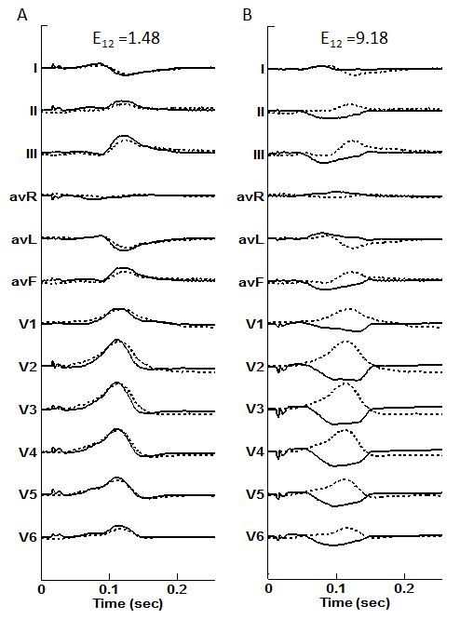
Figure 1

Figure 2

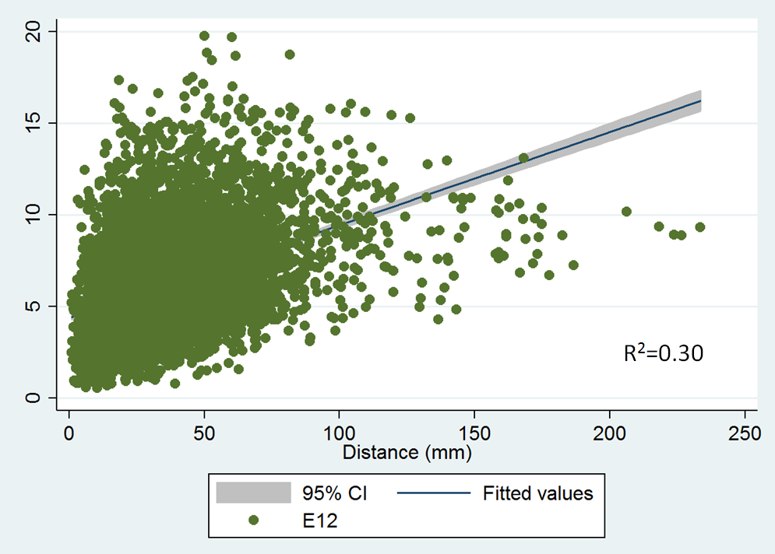
Figure 3

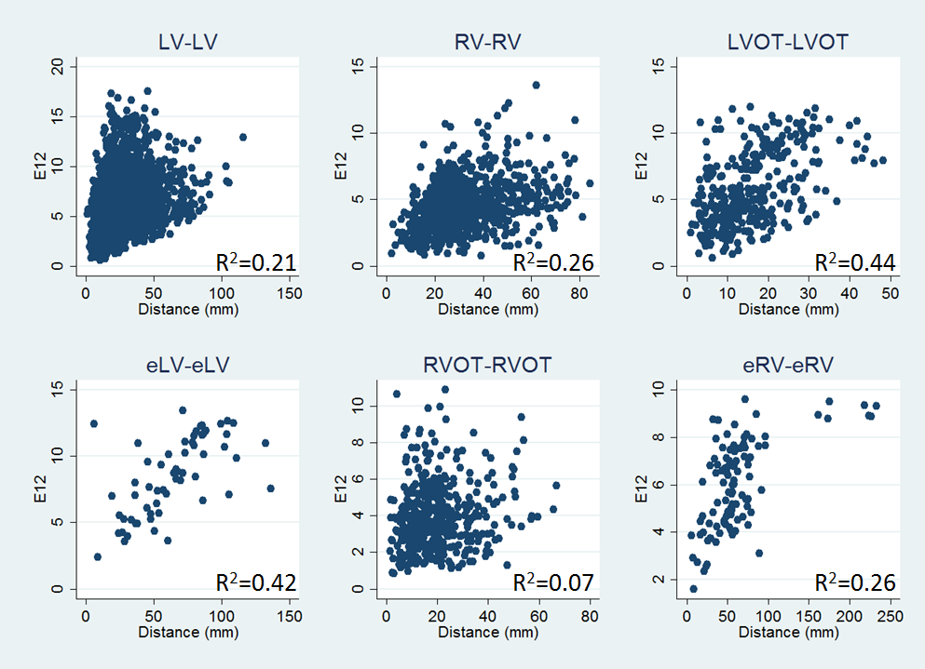
Figure 4

