Title:
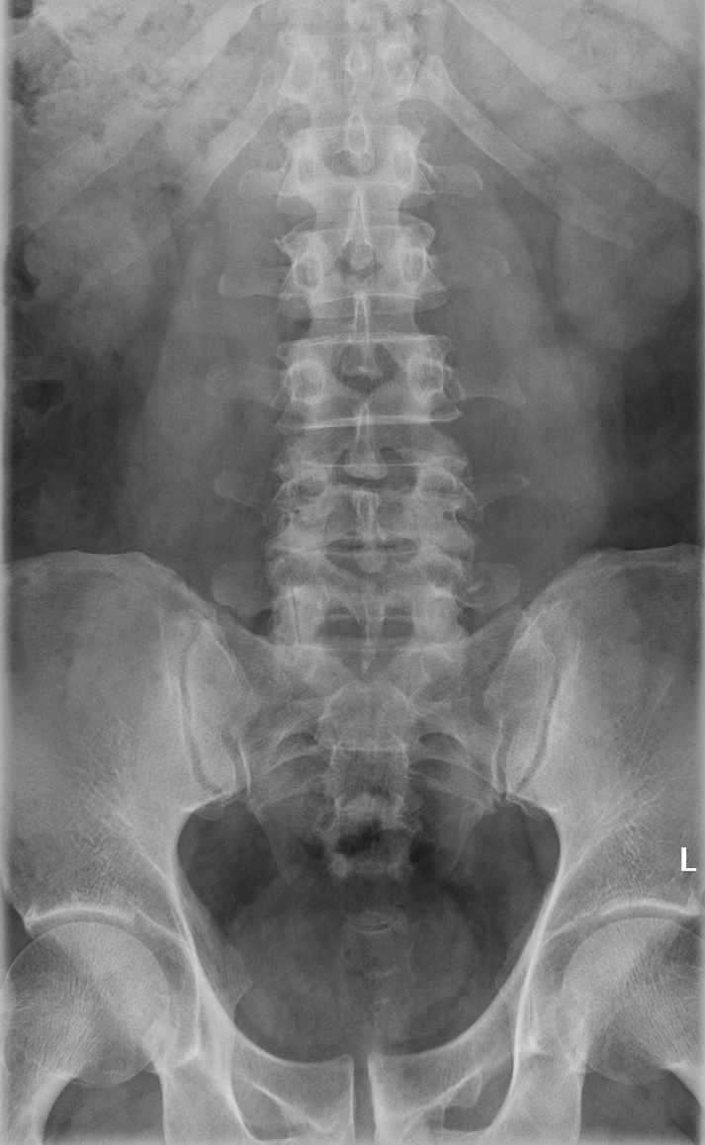
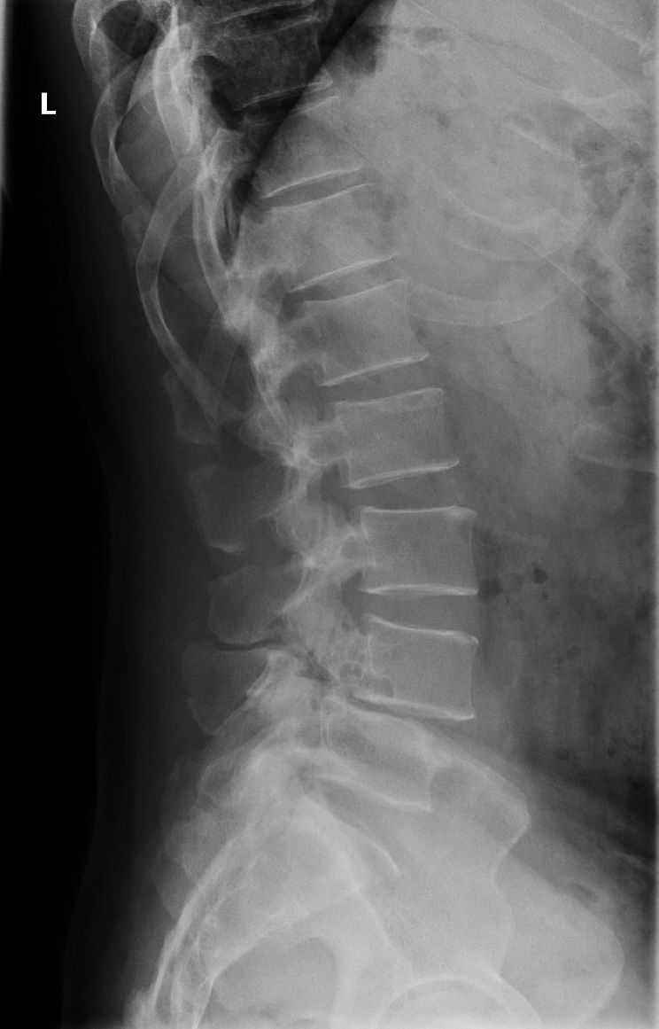
Extreme lateral interbody fusion relieves symptoms of spinal stenosis and low-grade spondylolisthesis by indirect decompression in complex patients.

Authors:
Erlick AC Pereira, MA, DM, FRCS(Neuro.Surg) ^{1,2}
Mohammad Farwana, BSc ¹
Khai S Lam, BMBS, BSc, FRCS(Orth) ¹

Affiliation:
1 Spinal Unit, Department of Orthopaedic Surgery, Guy’s and St Thomas’ NHS Foundation Trust and Evelina London Children’s Hospital
2 Academic Neurosurgery Unit, St George’s, University of London

Contact:
Mr. Erlick Pereira
Consultant Neurosurgeon
Atkinson Morley Neurosciences Centre
St George’s University Hospital
London SW17 0QT
United Kingdom
Tel: +44 208 725 4173
Fax: +44 208 725 4452
Email: eacp@eacp.co.uk

Conflicts of interest and Sources of Funding
None declared.

