The prevalence and significance of the Early Repolarization pattern in Sudden Arrhythmic Death Syndrome (SADS) families
Running title: SADS ER
Greg Mellor MB BChir¹*, Christopher P Nelson PhD.²*, Claire Robb BSc¹, Hariharan Raju PhD.¹, Yanushi Wijeyeratne MBBS¹, Christian Hengstenberg MD^{3,4}, Wibke Hengstenberg MD³, Michael Papadakis MD¹, Sanjay Sharma MD¹, Nilesh J Samani MD FRCP ², Elijah R Behr MD FRCP¹
¹Cardiac Research Centre, St. George’s University of London, UK
²Department of Cardiovascular Sciences, University of Leicester, UK and National Institute for Health Research Leicester Cardiovascular Biomedical Research Unit, Leicester, UK.
³Deutsches Herzzentrum München, Klinik für Herz- und Kreislauferkrankungen, Technische Universität München, Munich, Germany
⁴Deutsches Zentrum für Herz- und Kreislauf-Forschung (DZHK) e.V. (German Center for Cardiovascular Research), Partner Site Munich Heart Alliance, Munich, Germany

*These authors contributed equally to the manuscript.
Address for correspondence: Dr. Elijah R Behr
Cardiac Research Centre
St. George’s, University of London
Blackshaw Road
London, SW17 0QT
Telephone: +44 208 725 2994
Fax: +44 208 725 3416
Email: ebehr@sgul.ac.uk
Word Count 5546
Title page 187
Abstract 236
Text 3052
References 1501
Tables 364
Figure Legends 188

Journal Subject Terms – Sudden Cardiac Death, Clinical Studies

Abstract
Background
The early repolarization (ER) pattern is associated with sudden death and has been shown to be heritable. Its significance when identified in families affected by sudden arrhythmic death syndrome (SADS) remains unclear.
Methods and Results
We analyzed 12-lead ECGs of 401 first-degree relatives of individuals who had died from SADS. The prevalence of ER patterns was compared to family-clustered controls. ER was more common in SADS family members than in controls (21% vs. 8%, OR 5.14, 95% CI 3.37-7.84) independent of the presence of a familial cardiac diagnosis. Both ascending and horizontal ER patterns were more common. In addition ER was investigated for associations with findings from ajmaline provocation (n=332), exercise ECG (n=304) and signal-averaged ECG (n=118) when performed. ER was associated with a trend toward late depolarization, in general was suppressed with exercise and was unaffected by ajmaline. Inferior and horizontal patterns were, however, more likely to persist during exercise. Augmentation of ER with ajmaline was rare.
Conclusions
The ER pattern is more common in SADS family members than controls adjusted in particular for relatedness. The increased prevalence is irrespective of ER subtype and the presence of other inherited arrhythmia syndromes. ER may therefore represent an underlying heritable arrhythmia syndrome or risk factor for sudden death in the context of other cardiac pathology. The differing response of ER subtypes to exercise and ajmaline provocation suggests underlying mechanisms of both abnormal repolarization and depolarization.
Key Words: Early Repolarization
Sudden Arrhythmic Death Syndrome
Signal averaged ECG
Ajmaline
Exercise Test

Introduction
The early repolarization (ER) pattern was long thought to be benign and of little clinical significance¹. More recently ER, defined by J-point elevation in the inferior and/or lateral leads, has been associated with idiopathic ventricular fibrillation² leading to recognition of Early Repolarization Syndrome (ERS) as a novel arrhythmia syndrome³. In addition there is increasing evidence for the role of ER as a risk factor for arrhythmic events in the context of other inherited arrhythmia syndromes^{4,5}. Several studies have suggested the ER pattern is a heritable phenotype^{6,7} and variants in genes encoding cardiac ion channels^{8–10} have been identified in individuals and families with ERS.
Sudden arrhythmic death syndrome (SADS) is defined as a sudden unexplained death where post-mortem examination reveals a structurally normal heart and toxicological analysis is negative¹¹. Familial assessment of SADS relatives is recommended and may reveal evidence of an inherited cardiac condition in 22-53% of families^{12–15} with ion channel disease the principal finding.
ER has previously been shown to be more common in SADS relatives¹⁶; however there was no differentiation by ST-segment morphology which has since been shown to distinguish between high and low risk forms¹⁷. Furthermore association with signal-averaged ECG findings and the response of the ER pattern to exercise and sodium channel provocation have not been investigated in the setting of familial SADS.
We therefore examined the prevalence of ER in SADS relatives compared to a family-clustered control population, analyzing ascending and horizontal forms, and characterized the behavior of ER in investigations commonly used in assessment of SADS families.
Method
Study Population
We studied first-degree relatives of 184 individuals who died from SADS referred consecutively to the inherited cardiac conditions (ICC) clinics at St. George’s Hospital, London and University Hospital Lewisham between 2002 and 2014 (See figure 1). Of 526 first-degree relatives, 401 (76%) were included in the study. Relatives aged ≤16 at the time of first assessment were excluded as they were typically assessed through a separate paediatric service. The investigation of families and diagnosis of relatives was as per contemporary accepted guidelines ³ and has been described in detail previously¹⁴. All individuals had a 12 lead ECG. Further investigations were arranged at the discretion of the attending physician and in view of previous findings. All participants gave written consent. Non-Caucasian individuals (n=24) were excluded from comparison with the control population. The local institutional review committee approved the study. All individuals gave informed consent.
Control Population
Controls (n=1884 from 505 families) were taken from the GRAPHIC (Genetic Regulation of Arterial Pressure of Humans in the Community) cohort, which has been previously described in detail^{18,19}. Briefly, the GRAPHIC study recruited Caucasian nuclear families from the UK general population. Families were included if both parents were aged 40-60 years with 2 offspring >18 years of age. Assessment included a medical history, clinical examination and 12-lead ECG. All GRAPHIC subjects where ER information was available were included in the control group.
ECG analysis
The resting 12-lead ECG performed at the initial clinic visit for SADS relatives and at recruitment for GRAPHIC controls was used for analysis. Baseline automated ECG measurements were taken with manual verification of values outside accepted normal ranges. For SADS families, ER was reported manually by a single cardiologist (GM) and borderline cases were adjudicated by consensus with a senior cardiologist (ERB). ER was defined as ≥0.1mV J-point elevation in 2 contiguous leads in the inferior and/or lateral leads as per accepted modern criteria^{2,20,21} (see figure 2). ER was classified as notched if there was a positive upstroke in the terminal R wave. Otherwise it was described as slurred. The associated ST-segment was classified as rapidly ascending if there was ≥0.1mV ST elevation 100ms after the peak of the J point, or horizontal/descending otherwise. While this definition differs slightly from a very recent consensus document ²¹ it is in keeping with that used by Tikkanen et. al. when first demonstrating the prognostic benefit of ST segment gradient¹⁷. Similar criteria, described previously⁶, were used for the control population. J-point amplitude was categorized in 0.1mV increments (i.e. 0.10-0.19mV; 0.20-0.29mV etc.) and considered high amplitude if ≥0.2mV. Sokolow-Lyon isolated voltage criteria >35mm were used to denote LVH. The Brugada type 1 ECG pattern was defined as per accepted definitions²².
Ajmaline provocation testing
Ajmaline (1mg/kg) was administered intravenously over 5 minutes. Standard and high precordial leads were examined. The test was classed positive if a type 1 Brugada ECG pattern was induced in at least one precordial lead. Heart rate, QRS duration and J-point amplitude in the inferior and lateral leads were measured at baseline and at the time of peak effect of ajmaline (defined by maximal QRS duration). J-point amplitude was categorized in 0.1mV increments as described above. The J-point response was classified as ‘reduced’ if the J-point amplitude reduced by ≥0.1mV or was not present at peak ajmaline effect in either inferior or lateral territory; ‘unchanged’ if the amplitude remained the same, or; ‘augmented’ if the amplitude increased by ≥0.1mV in either inferior or lateral territory.
Exercise ECG
Exercise testing was performed using the full Bruce protocol. Heart rate and J-point amplitude in the inferior and lateral leads were measured at rest, peak exercise and 1, 3 and 5 minutes into recovery. In cases where ER was present on the ETT but not the index ECG, J-point amplitude was not analyzed. Heart rate recovery was defined as the change in heart rate from peak exercise to 5 minutes recovery. Ventricular ectopy, where present, was recorded as ‘simple’ if there were isolated ventricular ectopics occurring early in exercise or in recovery only. ‘Complex’ ectopy was defined as either: multifocal ectopics; ventricular ectopy increasing with exercise or occurring as couplets or non-sustained VT. The response to exercise was classified as ‘suppressed’ if ER was no longer present at peak exercise. Otherwise the response was classified as ‘persistent’.
Signal-Averaged ECG Analysis
Signal-averaged ECG (SAECG) analysis was performed in the study population group with acquisition of at least 300 cardiac cycles (filter setting 40-250Hz). Late potentials were defined by ≥2 of the following parameters being abnormal: filtered QRS duration (fQRS) ≥ 114ms; duration of low amplitude signals (<40μV) in the terminal filtered QRS complex (LAS₄₀) ≥ 38ms; root-mean-square voltage of terminal 40ms of filtered QRS complex (RMS₄₀) ≤ 20μV²³.
Statistical methods
Study characteristics were compared between the case and control groups using mixed models adjusting for family structure as a random effect. A logistic regression was performed in a mixed model on ER status adjusting for family as a random effect and family history of SADS as the covariate of interest. Further covariates were assessed as fixed effects and two-way interactions were investigated with covariates retained in the model if found to significantly improve the model fit. All models therefore included adjustments for age, sex, age and sex interaction, LVH and QTc interval as fixed effects. Subtypes of ER were assessed in the same way. Subgroup analyses were performed in families with and without a familial ICC diagnosis in the study population group against all controls.
Sub-group analyses of ajmaline provocation, exercise ECG and SAECG traits were conducted using a univariate mixed-model accounting for family as a random effect.
Results
The mean age of the SADS relatives was 39.5 years and 173 (43%) were male. 6% were non-Caucasian. The median number of relatives assessed per family was 2 (range 1-8). The cohort comprised 194 (48%) siblings, 157 (39%) parents and 50 (12%) children of SADS victims. An ICC was diagnosed in 108 individuals from 75 families with Brugada syndrome, BrS, (89 individuals from 60 families) the most frequent diagnosis (See figure 3). The control cohort was a Caucasian population with a mean age of 39.3 where 951 (51%) were male. Information on Brugada syndrome and ICC diagnoses were not available in the control cohort. Clinical characteristics and ECG findings of SADS relatives and controls are summarized in table 1.
Prevalence and associations of ER
The ER pattern was seen in 20.7% of SADS relatives and in 8.1% of the control population (OR 5.14, 3.37-7.34). ER appeared more common in males (28.9% vs. 12.1%) and in younger individuals with a significant interaction (P = 0.003) between age and sex observed. Both ascending (9.7% vs. 4.5%; OR=4.34, 2.55-7.37) and horizontal (11.0% vs. 3.8%; OR=3.64, 2.27-5.84) ER were more common in SADS relatives than in controls, as was ER in either the inferior or lateral leads (OR=4.86, 2.59-9.14, and OR=4.07, 2.28-7.26, respectively). ER was more common in SADS relatives regardless of whether an ICC was diagnosed (OR=4.86, 2.73-8.65) or not (OR=6.12, 3.45-10.73). However, ER was less common in individuals diagnosed with BrS than in those where no diagnosis was made (OR 0.206, 0.072-0.590, see figure 3). Results are summarized in table 2 and further in supplementary data.
Ajmaline Provocation
Ajmaline provocation was performed in 332 family members from 159 families and was positive in 86 (26%). ER was present on the index ECG in 69 cases (21%) and was more common where the test was negative (29% vs. 14%, p=0.02). At peak ajmaline effect, the J-point was reduced in 56%, unchanged in 38% and augmented in 6%. J-point augmentation was associated with a positive ajmaline result (p<0.001). Responses were similar in inferior and lateral leads (p=0.62). The heart rate and QRS duration increase seen at peak ajmaline effect was similar in the reduced, persistent and augmented groups (p, heart rate=0.17; p, QRSd=0.31). Results are summarized in the supplementary data.
Exercise ECG
An exercise ECG was performed in 304 family members from 151 families. ER was present on the resting ECG in 66 (22%; 10% ascending, 12% horizontal). Of these 66, ER was seen on the pre-test ECG at the time of exercise in 51.
Ventricular ectopy was seen during exercise in 52 (17%). Complex ectopy was more common in patients with horizontal ER (OR=4.2, 1.2 – 14.4) compared to those with either ascending or no ER.
The majority of ER was suppressed at peak exercise. ER in the lateral leads (n=25) was suppressed in all cases. ER in the inferior leads persisted at peak exercise in 11 (27%) of cases (figure 4). Horizontal ER also persisted at peak exercise more frequently than ascending ER (34.6% vs. 8.0%, p=0.032). Persistence at peak exercise was not associated with prior syncope (p=0.925). There were no cases of ER augmentation with exercise. Results are summarized in the supplementary data.
Signal-averaged ECG
SAECG was performed in 123 family members. The noise level was unacceptably high in 5 cases. Analysis was therefore carried out in 118 from 64 families. ER was present in 26 (22%; 11 ascending, 15 horizontal). The SAECG was abnormal in 23% of cases with no difference between individuals with and without ER (p=0.132). However, individuals with ER demonstrated a longer mean fQRS (115±12ms vs. 109±9ms, p=0.021), lower mean RMS₄₀ (29±13μV vs. 39±21μV, p=0.034) and a trend toward longer mean LAS₄₀ (36±10ms vs. 32±8ms, p=0.055). Ascending ER was associated with a longer mean fQRS (p=0.032) whereas there was a trend toward LAS₄₀ and RMS₄₀ being longer (p=0.073) and lower (p=0.059) respectively in those with horizontal ER. Results are summarized in the supplementary data.
Discussion
We have shown that the ER pattern is more common in first-degree SADS relatives than in the general population. Nunn et al. previously found ER was present in 23% of SADS family members compared to 11% of controls. However, the control cohort used was small (matched 1:1) and comprised of unrelated individuals. The use of a family based control population in this study and controlling for the effect of relationships within families improves the accuracy of the comparison and therefore our findings support and extend this previous work. The prevalence of ER was increased irrespective of the presence or not of an ICC being diagnosed in the family supporting ERS both as a primary heritable arrhythmia syndrome and as a marker of increased risk in the context of other inherited arrhythmia syndromes, notably BrS⁴ and long QT syndrome⁵.
We have also shown for the first time that this increase in prevalence is not driven by one particular subtype of ER; the prevalence of ER in SADS relatives was increased irrespective of ST segment morphology and ECG territory. This was unexpected as it has been shown in large general population cohorts that ER in the inferior leads and ER with a horizontal ST segment confer an increased risk of sudden death while ER in the lateral leads or with a rapidly ascending ST segment is benign¹⁷. However, SADS relatives represent a different population with a high prevalence of genetic cardiac disease and a proven malignant course in family members. It is therefore more appropriate to compare this population to studies of idiopathic VF and ERS. The prevalence of ER in idiopathic VF has been reported between 23% and 42%^{2,24,25}. Only Rosso et al. have presented an analysis of data in idiopathic VF survivors stratified by ST segment and while they found that the association with IVF was strongest for horizontal ER, 30% of idiopathic VF cases with ER had the rapidly ascending form²⁶. The distinction in prognosis between ascending and horizontal ER made in the general population may not therefore translate into higher risk groups such as SADS families and highlights the likely heterogeneity within the ER phenotype.
The physiological mechanisms underlying ER remain unclear. The presence of late potentials and the response of ER to exercise and ajmaline provocation may, however, give insight into such mechanisms.
SAECG and late potentials
The majority of individuals with ER in our study had SAECG recordings within normal limits. Several previous studies have also shown abnormal SAECG results are uncommon in ERS patients^{2,27} or at least in proportions similar to idiopathic VF survivors without ER²⁵. However, Roten et al. showed that 39% of IVF survivors with ER had an abnormal SAECG²⁸ with a higher proportion where the ER pattern persisted during isoproterenol infusion. In addition, Abe et al. used 24 hour continuous signal averaged ECG monitoring and found the incidence of late potentials was higher in IVF survivors with ER than without with no difference in repolarisation markers between the two groups²⁹. We found ER was associated with longer mean fQRS, LAS₄₀ and lower mean RMS₄₀. The interpretation of SAECG findings, particularly where the ER pattern is manifest in the X, Y or Z leads is unclear and the significance of abnormal results has not been validated. However, taken in line with interpretation in previous studies, delayed depolarization may contribute to the ER phenotype in at least a proportion of cases.
Exercise ECG
ER in the lateral leads or ER with an ascending ST segment universally suppressed with increased heart rates during exercise. In contrast horizontal ER in the inferior leads persisted in 29% of cases. Haissaguerre et al. commented that exercise “consistently reduced or eliminated ER”² in ERS while Letsas et al. also showed that ER disappeared at peak exercise in 44/47 healthy individuals with ER ³⁰ but neither commented on differences between ascending and horizontal ER. Our group has previously shown that horizontal ER is more likely to persist during exercise and was also associated with a history of prior syncope³¹. The number of individuals with syncope in this study was small and we did not see such an association.
Ajmaline provocation
Similarly to previous studies^{32,33} the J-point was suppressed or remain unchanged with ajmaline provocation in the majority of cases. Suppression of ER may be due in part to the ajmaline-induced increase in QRS duration obscuring the J wave or to the increase in heart rate²⁸ seen at peak ajmaline effect. Augmentation of ER in response to ajmaline was uncommon (n=4) and BrS was diagnosed in 3 such cases. It has previously been suggested that ERS and BrS are closely related and should be considered as a spectrum of ‘J-wave syndromes’³⁴. ER which augments with ajmaline may therefore represent such a syndrome. However, ER was less common in those diagnosed with BrS and J-point augmentation occurred in only a small minority. Therefore a common mechanism underlying ER and BrS is unlikely in the majority of our cases.
Horizontal versus Ascending ER
Ascending and horizontal ER were both seen more commonly in SADS relatives than in controls, with odds ratios of similar magnitude. Individuals with ascending ER were younger and more often male in keeping with previous studies¹⁷. Ascending ER was associated with longer fQRS durations (p=0.03) and suppressed during exercise (p=0.02). In contrast horizontal ER was associated with a lower RMS₄₀ (p=0.06) and was more likely to persist at peak exercise (p=0.02) accompanied by complex ventricular ectopy during exertion. In addition, three of the four cases of ER augmentation with ajmaline had horizontal ER although the differences in ajmaline response were not significant (p=0.49).
The contrasting demographic associations SAECG features and acute response to exercise between ascending and horizontal ER can be taken as further evidence of phenotypic heterogeneity within ER. There are likely to be distinct underlying mechanisms with horizontal ER involving a greater degree of depolarization abnormality.
Limitations
The study was a retrospective analysis and therefore may be susceptible to bias. Small cohort size limits the analysis of SAECG parameters. The control population consisted only of Caucasian individuals, the majority of whom were of British heritage (n=365, 91%). Therefore results of this study may not be applicable to other populations due to underlying ethnic differences in ER prevalence and subtypes. Due to the retrospective nature of the study, molecular autopsy was not available for the vast majority of the cohort and genetic testing was carried out in only a proportion of phenotype positive individuals. Therefore no suitable analysis based upon genotype was possible.
Conclusion
The ER pattern is more common in first-degree SADS relatives than in family-clustered controls regardless of the presence of an ICC diagnosis. Both ascending and horizontal patterns are seen more frequently. ER of both subtypes may therefore represent a primary heritable arrhythmia syndrome or a risk factor for sudden death in the young. Investigation with SAECG, exercise testing and ajmaline provocation suggests phenotypic heterogeneity within ER with differing physiological mechanisms that may include delayed depolarization.
Sources of Funding
ERB reports grants from Biotronik and non-financial support from St Jude Medical. CPN and NJS are funded by the British Heart Foundation. NJS is a NIHR Senior Investigator. The GRAPHIC Study was funded by the British Heart Foundation.
Disclosures
None.
References
1. Wasserburger RH, Alt WJ. The normal RS-T segment elevation variant. Am J Cardiol. 1961;8:184–192.
2. Haïssaguerre M, Derval N, Sacher F, Jesel L, Deisenhofer I, de Roy L, Pasquié J-L, Nogami A, Babuty D, Yli-Mayry S, De Chillou C, Scanu P, Mabo P, Matsuo S, Probst V, Le Scouarnec S, Defaye P, Schlaepfer J, Rostock T, Lacroix D, Lamaison D, Lavergne T, Aizawa Y, Englund A, Anselme F, O’Neill M, Hocini M, Lim KT, Knecht S, Veenhuyzen GD, Bordachar P, Chauvin M, Jais P, Coureau G, Chene G, Klein GJ, Clémenty J. Sudden cardiac arrest associated with early repolarization. N Engl J Med. 2008;358:2016–2023.
3. Priori SG, Wilde A a, Horie M, Cho Y, Behr ER, Berul C, Blom N, Brugada J, Chiang C-E, Huikuri H, Kannankeril P, Krahn A, Leenhardt A, Moss A, Schwartz PJ, Shimizu W, Tomaselli G, Tracy C. Executive summary: HRS/EHRA/APHRS expert consensus statement on the diagnosis and management of patients with inherited primary arrhythmia syndromes. Europace. 2013;15:1389–1406.
4. Kawata H, Morita H, Yamada Y, Noda T, Satomi K, Aiba T, Isobe M, Nagase S, Nakamura K, Fukushima Kusano K, Ito H, Kamakura S, Shimizu W. Prognostic significance of early repolarization in inferolateral leads in Brugada patients with documented ventricular fibrillation: a novel risk factor for Brugada syndrome with ventricular fibrillation. Heart Rhythm. 2013;10:1161–1168.
5. Laksman ZWM, Gula LJ, Saklani P, Cassagneau R, Steinberg C, Conacher S, Yee R, Skanes A, Leong-Sit P, Manlucu J, Klein GJ, Krahn AD. Early repolarization is associated with symptoms in patients with type 1 and type 2 long QT syndrome. Heart Rhythm. 2014;11:1632–1638.
6. Reinhard W, Kaess BM, Debiec R, Nelson CP, Stark K, Tobin MD, Macfarlane PW, Tomaszewski M, Samani NJ, Hengstenberg C. Heritability of early repolarization: a population-based study. Circ Cardiovasc Genet. 2011;4:134–138.
7. Noseworthy P a, Tikkanen JT, Porthan K, Oikarinen L, Pietilä A, Harald K, Peloso GM, Merchant FM, Jula A, Väänänen H, Hwang S-J, O’Donnell CJ, Salomaa V, Newton-Cheh C, Huikuri H V. The early repolarization pattern in the general population: clinical correlates and heritability. J Am Coll Cardiol. 2011;57:2284–2289.
8. Haïssaguerre M, Chatel S, Sacher F, Weerasooriya R, Probst V, Loussouarn G, Horlitz M, Liersch R, Schulze-Bahr E, Wilde A, Kääb S, Koster J, Rudy Y, Le Marec H, Schott JJ. Ventricular fibrillation with prominent early repolarization associated with a rare variant of KCNJ8/KATP channel. J Cardiovasc Electrophysiol. 2009;20:93–98.
9. Burashnikov E, Pfeiffer R, Barajas-Martinez H, Delpón E, Hu D, Desai M, Borggrefe M, Häissaguerre M, Kanter R, Pollevick GD, Guerchicoff A, Laiño R, Marieb M, Nademanee K, Nam G-B, Robles R, Schimpf R, Stapleton DD, Viskin S, Winters S, Wolpert C, Zimmern S, Veltmann C, Antzelevitch C. Mutations in the cardiac L-type calcium channel associated with inherited J-wave syndromes and sudden cardiac death. Heart Rhythm. 2010;7:1872–1882.
10. Watanabe H, Nogami A, Ohkubo K, Kawata H, Hayashi Y, Ishikawa T, Makiyama T, Nagao S, Yagihara N, Takehara N, Kawamura Y, Sato A, Okamura K, Hosaka Y, Sato M, Fukae S, Chinushi M, Oda H, Okabe M, Kimura A, Maemura K, Watanabe I, Kamakura S, Horie M, Aizawa Y, Shimizu W, Makita N. Electrocardiographic characteristics and SCN5A mutations in idiopathic ventricular fibrillation associated with early repolarization. Circ Arrhythm Electrophysiol. 2011;4:874–881.
11. Mellor G, Raju H, de Noronha S V, Papadakis M, Sharma S, Behr ER, Sheppard MN. Clinical Characteristics and Circumstances of Death in the Sudden Arrhythmic Death Syndrome. Circ Arrhythm Electrophysiol. 2014;7:1078–1083.
12. Behr E, Wood D a, Wright M, Syrris P, Sheppard MN, Casey a, Davies MJ, McKenna W. Cardiological assessment of first-degree relatives in sudden arrhythmic death syndrome. Lancet. 2003;362:1457–1459.
13. Tan HL, Hofman N, van Langen IM, van der Wal AC, Wilde A a M. Sudden unexplained death: heritability and diagnostic yield of cardiological and genetic examination in surviving relatives. Circulation. 2005;112:207–213.
14. Behr ER, Dalageorgou C, Christiansen M, Syrris P, Hughes S, Tome Esteban MT, Rowland E, Jeffery S, McKenna WJ. Sudden arrhythmic death syndrome: familial evaluation identifies inheritable heart disease in the majority of families. Eur Heart J. 2008;29:1670–1680.
15. van der Werf C, Hofman N, Tan HL, van Dessel PF, Alders M, van der Wal AC, van Langen IM, Wilde A a M. Diagnostic yield in sudden unexplained death and aborted cardiac arrest in the young: the experience of a tertiary referral center in The Netherlands. Heart Rhythm. 2010;7:1383–1389.
16. Nunn LM, Bhar-Amato J, Lowe MD, Macfarlane PW, Rogers P, McKenna WJ, Elliott PM, Lambiase PD. Prevalence of J-point elevation in sudden arrhythmic death syndrome families. J Am Coll Cardiol. 2011;58:286–290.
17. Tikkanen JT, Junttila MJ, Anttonen O, Aro AL, Luttinen S, Kerola T, Sager SJ, Rissanen H a, Myerburg RJ, Reunanen A, Huikuri H V. Early repolarization: electrocardiographic phenotypes associated with favorable long-term outcome. Circulation. 2011;123:2666–2673.
18. Tobin MD, Tomaszewski M, Braund PS, Hajat C, Raleigh SM, Palmer TM, Caulfield M, Burton PR, Samani NJ. Common variants in genes underlying monogenic hypertension and hypotension and blood pressure in the general population. Hypertension. 2008;51:1658–1664.
19. Tobin MD, Kähönen M, Braund P, Nieminen T, Hajat C, Tomaszewski M, Viik J, Lehtinen R, Ng GA, Macfarlane PW, Burton PR, Lehtimäki T, Samani NJ. Gender and effects of a common genetic variant in the NOS1 regulator NOS1AP on cardiac repolarization in 3761 individuals from two independent populations. Int J Epidemiol. 2008;37:1132–1141.
20. Tikkanen JT, Anttonen O, Junttila MJ, Aro AL, Kerola T, Rissanen H a, Reunanen A, Huikuri H V. Long-term outcome associated with early repolarization on electrocardiography. N Engl J Med. 2009;361:2529–2537.
21. Macfarlane PW, Antzelevitch C, Haissaguerre M, Huikuri H V., Potse M, Rosso R, Sacher F, Tikkanen JT, Wellens H, Yan G-X. The Early Repolarization Pattern: A Consenus Paper. J Am Coll Cardiol. 2015;66:470–477.
22. Antzelevitch C, Brugada P, Borggrefe M, Brugada J, Brugada R, Corrado D, Gussak I, LeMarec H, Nademanee K, Perez Riera AR, Shimizu W, Schulze-Bahr E, Tan H, Wilde A. Brugada syndrome: report of the second consensus conference: endorsed by the Heart Rhythm Society and the European Heart Rhythm Association. Circulation. 2005;111:659–670.
23. Marcus FI, McKenna WJ, Sherrill D, Basso C, Bauce B, Bluemke D a, Calkins H, Corrado D, Cox MGPJ, Daubert JP, Fontaine G, Gear K, Hauer R, Nava A, Picard MH, Protonotarios N, Saffitz JE, Sanborn DMY, Steinberg JS, Tandri H, Thiene G, Towbin J a, Tsatsopoulou A, Wichter T, Zareba W. Diagnosis of arrhythmogenic right ventricular cardiomyopathy/dysplasia: proposed modification of the task force criteria. Circulation. 2010;121:1533–1541.
24. Rosso R, Kogan E, Belhassen B, Rozovski U, Scheinman MM, Zeltser D, Halkin A, Steinvil A, Heller K, Glikson M, Katz A, Viskin S. J-point elevation in survivors of primary ventricular fibrillation and matched control subjects: incidence and clinical significance. J Am Coll Cardiol. 2008;52:1231–1238.
25. Derval N, Simpson CS, Birnie DH, Healey JS, Chauhan V, Champagne J, Gardner M, Sanatani S, Yee R, Skanes AC, Gula LJ, Leong-Sit P, Ahmad K, Gollob MH, Haissaguerre M, Klein GJ, Krahn AD. Prevalence and characteristics of early repolarization in the CASPER registry: Cardiac arrest survivors with preserved ejection fraction registry. J Am Coll Cardiol. 2011;58:722–728.
26. Rosso R, Glikson E, Belhassen B, Katz A, Halkin A, Steinvil A, Viskin S. Distinguishing “benign” from “malignant early repolarization”: the value of the ST-segment morphology. Heart Rhythm. 2012;9:225–229.
27. Nam G-B, Kim Y-H, Antzelevitch C. Augmentation of J waves and electrical storms in patients with early repolarization. N Engl J Med 2008;358:2078–2079.
28. Roten L, Derval N, Sacher F, Pascale P, Scherr D, Komatsu Y, Ramoul K, Daly M, Denis A, Shah AJ, Hocini M, Jaïs P, Haïssaguerre M. Heterogeneous response of J-wave syndromes to beta-adrenergic stimulation. Heart Rhythm. 2012;9:1970–1976.
29. Abe A, Ikeda T, Tsukada T, Ishiguro H, Miwa Y, Miyakoshi M, Mera H, Yusu S, Yoshino H. Circadian variation of late potentials in idiopathic ventricular fibrillation associated with J waves: insights into alternative pathophysiology and risk stratification. Heart Rhythm. 2010;7:675–682.
30. Letsas KP, Charalampous C, Korantzopoulos P, Tsikrikas S, Bramos D, Kollias G, Efremidis M, Sideris A. Novel indexes of heterogeneity of ventricular repolarization in subjects with early repolarization pattern. Europace. 2012;14:877–881.
31. Bastiaenen R, Raju H, Sharma S, Papadakis M, Chandra N, Muggenthaler M, Govindan M, Batchvarov VN, Behr ER. Characterization of early repolarization during ajmaline provocation and exercise tolerance testing. Heart Rhythm. 2013;10:247–254.
32. Roten L, Derval N, Sacher F, Pascale P, Wilton SB, Scherr D, Shah A, Pedersen MEF, Jadidi AS, Miyazaki S, Knecht S, Hocini M, Jaïs P, Haïssaguerre M. Ajmaline attenuates electrocardiogram characteristics of inferolateral early repolarization. Heart Rhythm. 2012;9:232–239.
33. Kawata H, Noda T, Yamada Y, Okamura H, Satomi K, Aiba T, Takaki H, Aihara N, Isobe M, Kamakura S, Shimizu W. Effect of sodium-channel blockade on early repolarization in inferior/lateral leads in patients with idiopathic ventricular fibrillation and Brugada syndrome. Heart Rhythm. 2012;9:77–83.
34. Antzelevitch C, Yan GX. J wave syndromes. Heart Rhythm. 2010;7:549–558.

 |  |  |  | SADS relatives* |  |  | Control Population
 | SADS relatives* | Control Population | P | No ER | ER | P | No ER | ER | P
n | 377 | 1884 | - | 297 (79) | 80 (21) | - | 1733 (92) | 151 (8) | -
Age, years | 39.6 (15) | 39.3 (15) | 0.638 | 40.0 (15) | 38.4 (16) | 0.429 | 39.6 (15) | 34.8 (14) | <0.001
Male sex | 163 (43) | 951 (51) | 0.010 | 116 (39) | 47 (59) | 0.002 | 837 (48) | 114 (76) | <0.001
Heart rate, min⁻¹ | 72 (14) | 65 (10) | <0.001 | 73 (14) | 70 (13) | 0.113 | 66 (10) | 63 (10) | 0.002
PR interval, ms | 156 (26) | 155 (23) | 0.766 | 153 (23) | 166 (33) | <0.001 | 155 (23) | 155 (22) | 0.871
QRS duration, ms | 92 (13) | 93 (10) | 0.090 | 92 (13) | 91 (10) | 0.382 | 93 (11) | 96 (9) | 0.002
QTc, ms | 415 (27) | 410 (20) | <0.001 | 418 (26) | 405 (28) | <0.001 | 411 (20) | 404 (17) | <0.001
LVH † | 14 (4) | 57 (3) | 0.628 | 6 (2) | 8 (10) | 0.002 | 44 (3) | 13 (11) | <0.001
Table 1. Baseline characteristics of SADS relatives and control populations with comparisons between those with and without ER. Continuous variables are expressed as mean (SD), categorical variables are expressed as n (%). LVH= isolated voltage criteria for left ventricular hypertrophy (Sokolow-Lyon); ms=milliseconds. * Data only listed for Caucasian relatives † LVH data missing for 104 controls

 | All SADS relatives |  |  | Families with ICC diagnosis |  |  | Families with no diagnosis
ER Type | OR | 95%CI | p | OR | 95%CI | p | OR | 95%CI | p
All ER | 5.14 | 3.37-7.84 | <0.001 | 4.86 | 2.73-8.65 | <0.001 | 6.12 | 3.49-10.73 | <0.001
Ascending ER | 4.34 | 2.55-7.37 | <0.001 | 4.38 | 2.26-8.46 | <0.001 | 4.72 | 2.25-9.90 | <0.001
Horizontal ER | 3.64 | 2.26-5.84 | <0.001 | 3.28 | 1.69-6.36 | <0.001 | 4.36 | 2.33-8.16 | <0.001
Notched ER | 2.60 | 1.55-4.34 | <0.001 | 1.65 | 0.77-3.51 | 0.197 | 3.94 | 2.05-7.58 | <0.001
Slurred ER | 3.17 | 1.95-5.15 | <0.001 | 3.87 | 2.05-7.29 | <0.001 | 2.67 | 1.34-5.31 | 0.005
Inferior ER | 4.86 | 2.59-9.14 | <0.001 | 5.17 | 2.29-11.71 | <0.001 | 4.77 | 2.09-10.87 | <0.001
Lateral ER | 4.07 | 2.28-7.26 | <0.001 | 3.86 | 1.76-8.47 | 0.001 | 4.63 | 2.15-9.98 | <0.001
Inf-lat ER | 2.40 | 1.10-5.23 | 0.027 | 1.45 | 0.46-4.50 | 0.524 | 3.87 | 1.48-10.11 | 0.006

Table 2. Odds ratios for presence of ER compared to control population stratified by ER subtype and presence of familial ICC diagnosis in SADS relatives. Multivariable analysis corrects for age, sex, ethnicity, familial clustering, and QTc interval and voltage criteria for LVH. OR=Odds Ratio, ER=Early Repolarisation, ICC=Inherited cardiac condition
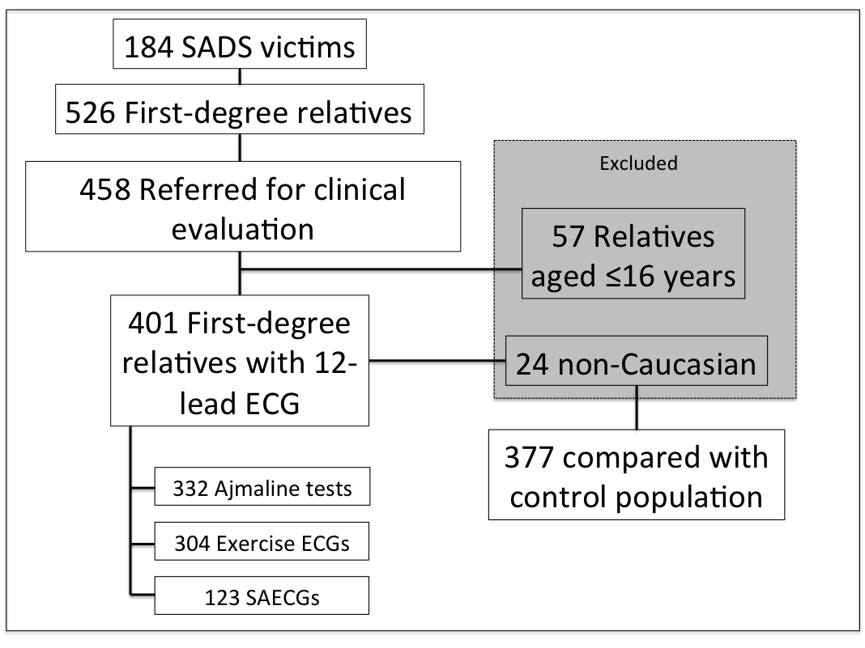
Figure 1. Study Population. 401 First-degree relatives underwent 12-lead ECG. The majority also had exercise and ajmaline tests. Approximately 30% also underwent a signal-averaged ECG. Since the control population contained Caucasian individuals only, non-Caucasians were excluded from this comparison. SAECG=Signal-averaged ECG.
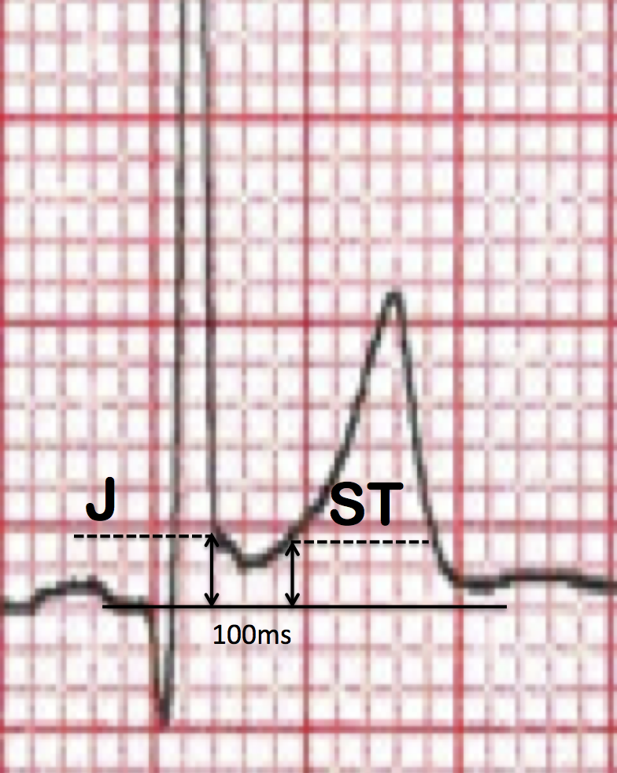
Figure 2. ECG example of rapidly ascending ER. ‘J’ denotes the J-point amplitude. J-point ≥0.1mV in two consecutive leads was considered positive. ‘ST’ denotes the ST segment amplitude 100ms after the J-point. ST elevation ≥0.1mV was classified as rapidly ascending. Otherwise ER was classified as horizontal/descending.

Figure 3. Summary of ICC diagnoses with ER proportions. ER was less common in relatives diagnosed with BrS than where no diagnosis was made (OR 0.206, 0.072-0.590, p=0.003) LQTS=Long QT Syndrome, BrS/LQTS=Brugada and Long QT overlap syndrome, DCM=Dilated Cardiomyopathy, CPVT=Catecholaminergic Polymorphic Ventricular Tachycardia
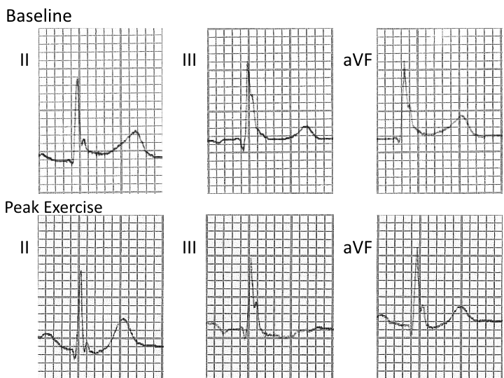
Figure 4. ER persisting with exercise. The inferior leads of ECGs from a single individual are shown. ECGs are recorded at rest, pre-exercise and at time of peak exercise. ER with a notched J-point and horizontal ST segment is seen in all inferior leads at rest. The J-point notching persists, with minimal reduction in amplitude at peak exercise.

