Insulin resistance is associated with skeletal muscle weakness in COPD

Claire E Wells¹, Michael I Polkey², Emma H Baker¹

¹Institute of Infection and Immunity (mail point J1A), St George’s, University of London, UK
²NIHR Respiratory Biomedical Research Unit, Royal Brompton & Harefield NHS Foundation Trust and Imperial College, London, UK

Corresponding author: Professor Emma H Baker. Institute of Infection and Immunity (mail point J1A), St George’s, University of London, Cranmer Terrace, London SW17 0RE. United Kingdom. Tel: +44 (0)20 8725 5383, email: ebaker@sgul.ac.uk

Word count abstract: 236
Word count text: 2482

Summary at a glance
We tested the hypothesis that insulin resistance contributes to COPD-associated skeletal muscle weakness. A one unit increase in insulin resistance was associated with a 5.9 (2.0-9.8)kg decrease in quadriceps strength and 4.2 (1.3-14.3)fold increased risk of quadriceps weakness. Further studies are required to determine the therapeutic potential of insulin-sensitising drugs in COPD.

ABSTRACT
Background and objective. Quadriceps weakness is seen across all GOLD stages of COPD and is associated with increased morbidity and mortality. As quadriceps weakness is only weakly associated with FEV₁, mechanisms other than airflow obstruction are implicated. We tested the hypothesis that insulin resistance contributes to skeletal muscle weakness in people with stable COPD.
Methods. Fifty one COPD patients (no exacerbations preceding 6 weeks, no rehabilitation preceding 3 months) without known diabetes mellitus underwent assessment of skeletal muscle, including measurement of quadriceps maximal voluntary contraction (QMVC). Physical activity was measured over 7 days using a multisensory biaxial accelerometer armband. Insulin resistance (HOMA2 IR) was calculated from fasting blood glucose and insulin concentrations.
Results. QMVC was 30±13kg (74±25% predicted) and 16 (31%) participants had quadriceps weakness. There was a negative univariate correlation between HOMA2 IR and QMVC (r=-0.446, p=0.002). HOMA2 IR was greater in people with quadriceps weakness (1.59±0.99) than those without (1.11±0.55, p=0.032). On multivariate analysis, with age, sex, weight, BODE index and step count/ day included in the model, a one unit increase in insulin resistance was associated with a 5.9 (2.0-9.8)kg decrease in QMVC (p=0.004) and a 4.2 (1.3-14.3)-fold increased risk of quadriceps weakness (p=0.02).
Conclusions. Insulin resistance is associated with skeletal muscle weakness in COPD, independent of potential confounders. Further studies are required to explore underlying mechanisms and determine whether insulin-sensitising drugs could augment pulmonary rehabilitation in building skeletal muscle strength in COPD.

Key words: Exercise; Insulin Resistance; Muscle, Skeletal; Obstructive Pulmonary Diseases; Quadriceps Muscle

Short title: Insulin resistance and muscle in COPD

INTRODUCTION
Skeletal muscle weakness, particularly of the lower limbs, is common in people with chronic obstructive pulmonary disease (COPD). Lower limb strength, measured as isometric quadriceps maximal voluntary contraction (QMVC), is reduced by around 30% in COPD patients compared to age- and sex- matched controls¹ and around one third of COPD patients have quadriceps weakness.² Skeletal muscle weakness in COPD predicts reduced exercise performance,³ increased use of healthcare resources,⁴ impaired health-related quality of life⁵ and increased mortality,⁶ independent of severity of airflow obstruction. Quadriceps muscle weakness is incompletely explained by body anthropomorphics and COPD severity.
Insulin resistance, defined as an impaired physiological response of glucose utilisation to a given insulin concentration, is common in COPD. Metabolic syndrome, a clinical indicator of insulin resistance, is found in 21-53% patients with COPD and is 1.3-1.5 times more common in people with COPD than in those with normal lung function.⁷ Insulin resistance, calculated from fasting blood glucose and insulin concentrations (HOMA IR), is greater in individuals with COPD than in non-smoking matched controls.⁸ In both younger⁹ and older adults¹⁰ without COPD or diabetes mellitus there is an independent negative association between insulin resistance and quadriceps strength. Although the mechanisms underlying this association are undoubtedly complex, insulin resistance at baseline predicts accelerated decline in skeletal muscle strength over the following 3 years.¹¹ Taken together these findings raise the hypothesis that insulin resistance contributes to development of the skeletal muscle weakness associated with COPD. The aim of our study was to determine whether there is a relationship between insulin resistance and quadriceps weakness in people with stable COPD, independent of potential confounders including age, sex, weight, airflow obstruction, smoking history, physical activity, comorbidities and metabolic syndrome.

METHODS

Study overview

This was a cross-sectional study. All participants gave written informed consent. The study was approved by the National Research Ethics Committee [10/H0721/75] and conducted in accordance with the Declaration of Helsinki.

Study population and data collection

Fifty one stable patients with COPD attending secondary care clinics, with no exacerbations or change in medication in the preceding 6 weeks or pulmonary rehabilitation in the preceding 3 months, were recruited. All were >40 years old, had >10 pack year smoking history and FEV₁:FVC <70% predicted. Participants were mobile and free from neuromuscular disease that could limit mobility or reduce muscle strength. People with a prior physician-diagnosis of diabetes mellitus requiring treatment were excluded from the study.

Participants underwent assessment of COPD severity, including spirometry, COPD assessment test (CAT), modified Medical Research Council (mMRC) dyspnoea score, and self-reported exacerbation history (worsening of symptoms requiring antibiotic and/or corticosteroid treatment) in the previous year. Oxygen saturations were measured on air. Comorbidities (self-report and medication use) were recorded. Weight and height were measured. Metabolic syndrome was defined according to the joint interim statement of the International Diabetes Federation Task Force on Epidemiology and Prevention.⁷ Participants were considered to have metabolic syndrome if they had any three of the following [1]: increased waist circumference (males >102 cm, females >88 cm); increased triglycerides (≥1.7 mmol.L⁻¹, or on treatment); reduced HDL cholesterol (≤1.0 mmol.L⁻¹ in men, ≤1.3 mmol.L⁻¹ in women, or on treatment); increased blood pressure (systolic ≥130 mmHg and/or diastolic ≥85 mmHg, or on treatment); raised fasting glucose (>5.5 mmol.L⁻¹, or on treatment).

Muscle studies
Isometric quadriceps maximal voluntary contraction force (QMVC) was measured in the dominant leg. Participants were seated with the knee at 90º flexion and the pelvis and trunk fixed.¹² Participants extended their leg as hard as possible against an inextensible strap connected to a load cell (Synectic design Ltd, Lancs. UK). They performed the manoeuvre at least 3 times with 30-60 seconds rest between attempts and the greatest of 3 reproducible measurements was recorded in kg. Quadriceps weakness was defined as patients in whom ((observed QMVC-predicted QMVC)/8.58) was <-1.645.²

Rectus femoris cross-sectional area (RF_{CSA}) was measured by a trained operator using 2D-mode ultrasonography and a 2-5 MHz convex probe (C60) (SonoSite, Washington, USA).¹³ RF_{CSA} was the average of three consecutive measurements within 10%. QMVC/RF_{CSA} (force/cross sectional area) was used as a measure of muscle quality.

Insulin resistance
Fasting blood glucose and insulin concentrations were measured. The Homeostasis Assessment Model (HOMA) was used to derive a measure of insulin resistance from these measurements. This model is based on the concept of a hepatic-beta cell feedback loop, such that elevated fasting glucose reflects a compensatory mechanism to maintain fasting insulin levels as insulin secretion falls and fasting insulin is elevated in direct proportion to reduced insulin sensitivity.¹⁴ The mathematical feedback model based on these hypotheses estimates the degrees of beta function and insulin sensitivity that would equate to the steady state plasma glucose and insulin levels for an individual. A modified model (HOMA2) is available as an online calculator.¹⁴ The model derives estimates of steady state beta cell function (%B) and insulin sensitivity (%S), which are expressed as percentages of a normal reference population and adjusted so that values of each in normal young adults are 100%. Insulin resistance (HOMA2 IR) is the reciprocal of %S (100/%S). Values in healthy young adults should approximate 1.0.

Physical activity
Physical activity was measured by a multisensor accelerometer (SenseWear Pro® armband; BodyMedia; Pittsburgh, Pennsylvania) worn on the upper right arm. The device measures step count, duration of activity and energy expenditure and has been validated for use in patients with COPD.¹⁵ Data recorded during 6 consecutive days (excluding the days when the monitor was collected and returned) were used to calculate daily step count and physical activity level (PAL= total energy expenditure/resting energy expenditure. Indicative values: extremely inactive <1.4; sedentary 1.4-1.69, moderately active 1.7-1.99).¹⁶

Statistical analysis

Data were described as mean with standard deviation or 95% confidence intervals, and proportions, as appropriate. Continuous data were compared using independent t-tests; proportions were compared using Fisher’s exact test. Univariate relationships between quadriceps strength, size and quality, insulin resistance and lung function were explored using partial correlations controlling for age, sex and weight. Factors significantly associated with quadriceps maximal voluntary contraction (QMVC) on univariate analysis were included in multivariate regression analysis with QMVC as the dependent variable and in logistic regression analysis with quadriceps weakness as the dependent variable. All statistical tests were two-sided, with significance set at 0.05, and calculated using IBM SPSS statistics 21.

RESULTS
Fifty one participants were recruited. Baseline characteristics are shown in table 1.
Skeletal muscle and physical activity
Quadriceps maximal volume contraction (QMVC) was 30±13kg, 74±25% predicted. Sixteen (31%) participants met the criteria for quadriceps weakness. Rectus femoris cross-sectional area (RFCSA) was 476±173mm², with force per cross sectional area being 0.065±0.022kg/mm².
Participants managed an incremental shuttle walk distance of 287±187 metres. They walked for 122±59 minutes per day, averaging 3634±2530 steps, with a physical activity level of 1.28±0.25.
Insulin resistance, but not airflow obstruction, is inversely associated with quadriceps strength
As age, sex and body weight have a well-recognised influence on quadriceps strength, partial correlations controlling for these variables were performed. Insulin resistance (HOMA2 IR) was inversely correlated with quadriceps strength (QMVC) (r=-0.446, p=0.002, figure 1). Neither FEV₁ % predicted (r=0.198, p=0.187), nor FEV1:FVC (r=0.158, p=0.294) were significantly correlated with QMVC.
There was a non-significant trend to association between insulin resistance (HOMA2-IR) and quadriceps size (RFCSA) (r=-0.275, p=0.064) and force per cross-sectional area (r=-0.289, p=0.051). Neither FEV₁ % predicted nor FEV₁:FVC were significantly associated with either of these quadriceps characteristics.
Individual relationships between factors considered to have potential to influence quadriceps strength and QMVC were assessed using univariate linear regression (table 2). Age, sex, weight, BODE index, step count/day and physical activity level (PAL) were individually associated with QMVC. On multivariate analysis, with age, sex, weight, BODE index and step count/day included in the model (PAL was excluded because of strong correlation with step count/day), insulin resistance (HOMA2 IR) was independently inversely associated with QMVC (table 2). Each one unit increase in insulin resistance was associated with a 5.9 (2.0-9.8)kg decrease in quadriceps strength (p=0.004).
Patients with quadriceps weakness are more insulin resistant than those without
Characteristics of patients with and without quadriceps weakness are compared in table 3. Patients with quadriceps weakness had significantly greater insulin resistance than those without (figure 2).
Individual relationships between factors considered to have potential to influence quadriceps strength and the presence or absence of quadriceps weakness were assessed using univariate logistic regression (table 4). Step count/day, BODE index and Charlson index were significantly individually associated with the quadriceps weakness. On multivariate analysis, with step count/day, BODE index and Charlson index included in the model, insulin resistance (HOMA2 IR) was independently inversely associated with quadriceps weakness (table 4). Each one unit increase in insulin resistance was associated with a 4.2 (1.3-14.3)fold increased risk of quadriceps weakness (p=0.02).

DISCUSSION
We have shown that insulin resistance is negatively associated with quadriceps muscle strength in COPD, and that COPD patients categorised as having quadriceps weakness have greater insulin resistance than those without. The relationship between insulin resistance and quadriceps weakness was independent of age, sex and weight as well as other potential confounding variables. Although this cross-sectional study was unable to determine the direction of this relationship, it raises the possibility that insulin resistance could contribute to the development of skeletal muscle weakness in COPD.
Significance of the findings
Insulin plays a key role in regulating muscle protein metabolism and insulin resistance can alter the balance between protein synthesis and degradation. For example, people with type 2 diabetes mellitus have reduced ability to spare protein after a 60 hour fast¹⁸ and reduced net protein balance.¹⁸ Insulin stimulates mitochondrial protein synthesis, which is crucial for maintaining mitochondrial functional activity.¹⁹ Insulin resistance causes endothelial dysfunction and impaired vasodilation.²⁰ This can slow the increase in microvascular blood flow in skeletal muscle in response to moderate exercise, contributing to exercise limitation.²¹ Early onset of peripheral neuropathy in people with insulin resistance could also contribute to skeletal muscle impairment.²² Insulin resistance is associated with hyperglycaemia, which has an independent effect on skeletal muscle. In vitro, hyperglycaemia directly activates pathways involved in skeletal muscle atrophy, with activation of caspase 3, degradation of myofibrillar proteins and activation of the ubiquitin–proteasomal degradation pathway.^{23, 24} In vivo, hyperglycaemia is associated with suppression of muscle protein synthesis and net negative muscle protein balance, which can be reversed by euglycaemia, independent of plasma insulin concentrations.²⁵
The association between insulin resistance and skeletal muscle weakness could be explained by shared aetiologies. Cigarette smoking impairs insulin action and reduces glucose uptake.²⁶ It is associated with reduced skeletal muscle strength, increased fatigability and greater muscle fibre atrophy in smokers without COPD,²⁷ although neither current smoking nor total pack year smoking load determined quadriceps weakness in our patient cohort. Physical inactivity is a well-recognised risk factor for insulin resistance²⁸ and is associated with quadriceps wasting in COPD, even in people with mild airflow obstruction.²⁷ Intermuscular adipose infiltration is common in people with insulin resistance²⁹ or COPD³⁰ and is associated with reduced muscle strength and impaired physical function.²⁹ Intermuscular adipose infiltration may account for our finding that insulin resistance was not associated with reduced quadriceps muscle size. Large, but poor quality, muscles have been described in people with type 2 diabetes mellitus without chronic lung disease. Park and colleagues found that arm and leg muscle mass assessed by dual-energy X-ray absorptiometry was increased in older adults with diabetes, but that strength per unit regional muscle mass was decreased in both upper and lower extremities.³¹ Longer duration of diabetes and poor glycaemic control were associated with even poorer muscle quality.
An alternative explanation for our findings is the converse hypothesis; specifically that skeletal muscle atrophy in COPD could cause insulin resistance. Under insulin-stimulated conditions, skeletal muscle removes 70-90% of a glucose load.³² Type 1 (oxidative) skeletal muscle fibres have a high mitochondrial profile and capillary density, actively express the glucose transporter GLUT-4 and are very insulin sensitive.³² Type 2d/x (glycolytic) fibres have low mitochondrial content, capillary density and GLUT 4 expression and are relatively insulin resistant.³² In COPD, there is a fibre-type shift from type 1 to type 2x fibres,²⁷ potentially increasing the insulin resistance of skeletal muscle. Additionally, COPD patients have a 28% reduction in GLUT4 protein expression in quadriceps compared to matched controls.³³ Despite this, quadriceps glucose uptake and metabolism was found to be at least as great in COPD patients as in matched controls on computed axial and positron emission tomography.³⁴ Interestingly, metabolic and mitochondrial alterations in skeletal muscle, including fibre-type shift, reductions in oxidative capacity, mitochondrial density and peroxisome proliferator-activated receptor gamma coactivator 1, increased mitochondrial DNA oxidative damage and excessive ROS production, are common to both COPD and diabetes mellitus.³⁵
Critique of the Method
To our knowledge, this is the first study to show an association between insulin resistance and skeletal muscle impairment in people with COPD. Few COPD studies include fasting blood samples as part of the protocol, which limits their ability to assess this interesting pathology. However an important limitation of our study is that it was cross-sectional and we are unable to comment on the direction of association.

The tests we used to characterise insulin resistance and skeletal muscle had limitations. HOMA2 IR gives an estimate of insulin resistance useful for group or population studies, but intravenous euglycaemic, hyperinsulinaemic clamp studies would be required for more detailed characterisation of insulin resistance. Although we also assessed the quadriceps size by ultrasound, we assessed contractility as maximal voluntary contraction force, which depends to some extent on volition. Although each patient performed the manoeuvre at least 3 times and the greatest of 3 reproducible measurements was taken, it is possible that this could have underestimated true strength. Ideally we should also have investigated the effect of insulin resistance in upper limb muscles, where reduced physical activity is a less important confounder when assessing weakness. However we were able to adjust our analysis for daily step count and physical activity level, demonstrating that the association between insulin resistance and quadriceps weakness was independent of physical activity.
Summary
Insulin resistance is common in COPD and is associated with quadriceps weakness, independent of age, weight, sex, COPD severity, smoking history, physical activity, comorbidities, as measured by the Charlson Index, and metabolic syndrome. Although the directions of association and underlying mechanisms have not been fully established, this has potential therapeutic implications. If insulin resistance is a contributing mechanism in the development of skeletal muscle weakness, interventions to increase insulin sensitivity have potential to help patients to improve muscle strength. In support of this, 6 months open label treatment with the insulin-sensitising drug metformin increased inspiratory muscle strength, with an associated improvement in dyspnoea and health status in 17 COPD patients with diabetes mellitus.³⁵ Conversely if skeletal muscle abnormalities contribute to the high prevalence of insulin resistance seen in people with COPD, pulmonary rehabilitation could improve the metabolic profile and slow the development of further co-morbidities. Further research is now required to explore insulin resistance as a potential therapeutic target in COPD patients with skeletal muscle weakness.
ACKNOWLEDGEMENTS
The authors are grateful to Mr CP Wells and Mr David Tropman for assistance in developing the equipment used to make the muscle measurements, to the clinical research facility at St George’s for assistance in conduct of the study, to Dr Greg Kinney, University of Colorado, and Professor Paul Jones, St George’s, University of London for insightful comments on the manuscript and to Dr Andrew Hitchings for statistical advice.

Author contributions: CW and EB had the idea for the study. CW recruited patients and collected the data and EB drafted the manuscript. All authors contributed to the design of the study, analysis of data and preparation of the final manuscript. EB is the guarantor of the paper, taking responsibility for the integrity of the work as a whole, from inception to published article.

Funding: CW and EB’s salaries were paid by St George’s, University of London. MIP’s contribution to this work was supported by the NIHR Respiratory BRU at the Royal Brompton and Harefield NHS Foundation Trust and Imperial College, who part fund his salary.

REFERENCES
- Man WD, Hopkinson NS, Harraf F, Nikoletou D, Polkey MI, Moxham J. Abdominal muscle and quadriceps strength in chronic obstructive pulmonary disease. Thorax. 2005; 60:718-22
- Seymour JM, Spruit MA, Hopkinson NS, Natanek SA, Man WD, Jackson A, Gosker HR, Schols AM, Moxham J, Polkey MI, Wouters EF. The prevalence of quadriceps weakness in COPD and the relationship with disease severity. Eur Respir J. 2010;36:81-8
- Gosselink R, Troosters T, Decramer M. Peripheral muscle weakness contributes to exercise limitation in COPD. Am J Respir Crit Care Med. 1996; 153:976–980
- Decramer M, Gosselink R, Troosters T, Verschueren M, Evers G. Muscle weakness is related to utilization of health care resources in COPD patients. Eur Respir J. 1997; 10:417–423
- Mostert R, Goris A, Weling-Scheepers C, Wouters EF, Schols AM. Tissue depletion and health related quality of life in patients with chronic obstructive pulmonary disease. Respir Med 2000, 94:859-867
- Swallow EB, Reyes D, Hopkinson NS, Man WD, Porcher R, Cetti EJ, Moore AJ, Moxham J, Polkey MI. Quadriceps strength predicts mortality in patients with moderate to severe chronic obstructive pulmonary disease. Thorax. 2007;62:115-20
- Wells CE, Baker EH. Metabolic syndrome and diabetes mellitus in COPD. European Respiratory Monographs 2013; 59:117-134.
- Eker S, Ayaz L, Tamer L, Ulubas B. Leptin, visfatin, insulin resistance, and body composition change in chronic obstructive pulmonary disease. Scand J Clin Lab Invest. 2010;70:40-4.
- Gysel T, Calders P, Cambier D, Roman de Mettelinge T, Kaufman JM, Taes Y, Zmierczak HG, Goemaere S. Association between insulin resistance, lean mass and muscle torque/force in proximal versus distal body parts in healthy young men. J Musculoskelet Neuronal Interact. 2014;14:41-9.
- Barzilay JI, Cotsonis GA, Walston J, Schwartz AV, Satterfield S, Miljkovic I, Harris TB; Health ABC Study. Insulin resistance is associated with decreased quadriceps muscle strength in nondiabetic adults aged >or=70 years. Diabetes Care. 2009;32:736-8.
- Park SW, Goodpaster BH, Strotmeyer ES, Kuller LH, Broudeau R, Kammerer C, de Rekeneire N, Harris TB, Schwartz AV, Tylavsky FA, Cho YW, Newman AB; Health, Aging, and Body Composition Study. Accelerated loss of skeletal muscle strength in older adults with type 2 diabetes: the health, aging, and body composition study. Diabetes Care. 2007;30:1507-12
- Edwards RHT, Young A, Hosking GP, Jones DA: Human skeletal muscle function: description of tests and normal values. Clin Sci Mol Med 1977; 52:283-290
- Seymour JM, Ward K, Sidhu PS, Puthucheary Z, Steier J, Jolley CJ, Rafferty G, Polkey MI, Moxham J. Ultrasound measurement of rectus femoris cross-sectional area and the relationship with quadriceps strength in COPD. Thorax. 2009;64:418-23
- University of Oxford Diabetes Trials Unit. HOMA2 IR calculator. Available from http://www.dtu.ox.ac.uk/index.php?maindoc=/homa/index.php (accessed 7/11/14)
- Patel SA, Benzo RP, Slivka WA, Sciurba FC. Activity monitoring and energy expenditure in COPD patients: a validation study. COPD 2007; 4:107-112.
- Rausch-Osthoff AK, Kohler M, Sievi NA, Clarenbach CF, van Gestel AJ. Association between peripheral muscle strength, exercise performance, and physical activity in daily life in patients with Chronic Obstructive Pulmonary Disease. Multidiscip Respir Med. 2014;9:37
- Duska F, Tuma P, Mokrejs P, Kubena A, Andel M. Analysis of factors influencing nitrogen balance during acute starvation in obese subject with and without type 2 diabetes. Clin Nutr 2007;26:552e8
- Gougeon R, Pencharz PB, Marliss EB. Effect of NIDDM on the kinetics of whole body protein metabolism. Diabetes 1994;43:318e28
- Guillet C, Boirie Y. Insulin resistance: a contributing factor to age-related muscle mass loss? Diabetes Metab. 2005;31 Spec No 2:5S20-5S26
- Urban MH, Ay L, Funk GC, Burghuber OC, Eickhoff P, Wolzt M, Valipour A. Insulin resistance may contribute to vascular dysfunction in patients with chronic obstructive pulmonary disease. Wien Klin Wochenschr. 2014;126:106-12
- Bauer TA, Reusch JE, Levi M, Regensteiner JG. Skeletal muscle deoxygenation after the onset of moderate exercise suggests slowed microvascular blood flow kinetics in type 2 diabetes. Diabetes Care. 2007;30:2880-5.
- Sumner CJ, Sheth S, Griffin JW, Cornblath DR, Polydefkis M. The spectrum of neuropathy in diabetes and impaired glucose tolerance. Neurology 2003;60:108-111.
- Du J, Wang X, Miereles C, Bailey JL, Debigare R, Zheng B, Price SR, Mitch WE. Activation of caspase-3 is an initial step triggering accelerated muscle proteolysis in catabolic conditions. J Clin Invest. 2004;113:115–123
- Russell ST, Rajani S, Dhadda RS, Tisdale MJ. Mechanism of induction of muscle protein loss by hyperglycaemia. Exp Cell Res. 2009;315:16–25
- Biolo G, De Cicco M, Lorenzon S, Dal Mas V, Fantin D, Paroni R, Barazzoni R, Zanetti M, Iapichino G, Guarnieri G. Treating hyperglycemia improves skeletal muscle protein metabolism in cancer patients after major surgery. Crit Care Med. 2008;36:1768-75
- Attvall S, Fowelin J, Lager I, Von Schenck H, Smith U. Smoking induces insulin resistance -a potential link with the insulin resistance syndrome. J Intern Med. 1993;233:327-32
- Mathur S, Brooks D, Carvalho CR. Structural alterations of skeletal muscle in COPD. Front Physiol. 2014;5:104. doi: 10.3389/fphys.2014.00104.
- Watz H, Waschki B, Kirsten A, Müller KC, Kretschmar G, Meyer T, Holz O, Magnussen H. The metabolic syndrome in patients with chronic bronchitis and COPD: frequency and associated consequences for systemic inflammation and physical inactivity. Chest. 2009;136:1039-46
- Boettcher M, Machann J, Stefan N, Thamer C, Häring HU, Claussen CD, Fritsche A, Schick F. Intermuscular adipose tissue (IMAT): association with other adipose tissue compartments and insulin sensitivity. J Magn Reson Imaging. 2009;29:1340-5
- Shields GS, Coissi GS, Jimenez-Royo P, Gambarota G, Dimber R, Hopkinson NS, Matthews PM, Brown AP, Polkey MI. Bioenergetics and intermuscular fat in chronic obstructive pulmonary disease-Associated quadriceps weakness. Muscle Nerve. 2015;51:214-21.
- Park SW, Goodpaster BH, Strotmeyer ES, de Rekeneire N, Harris TB, Schwartz AV, Tylavsky FA, Newman AB. Decreased muscle strength and quality in older adults with type 2 diabetes: the health, aging, and body composition study. Diabetes. 2006;55:1813-8
- Lira VA, Benton CR, Yan Z, Bonen A. PGC-1alpha regulation by exercise training and its influences on muscle function and insulin sensitivity. Am J Physiol Endocrinol Metab. 2010;299:E145-61.
- Green HJ, Burnett ME, D'Arsigny CL, O'Donnell DE, Ouyang J, Webb KA. Altered metabolic and transporter characteristics of vastus lateralis in chronic obstructive pulmonary disease. J Appl Physiol (1985). 2008;105:879-86.
- Sancho-Muñoz A, Trampal C, Pascual S, Martínez-Llorens J, Chalela R, Gea J, Orozco-Levi M. Muscle glucose metabolism in chronic obstructive pulmonary disease patients. Arch Bronconeumol. 2014;50:221-7.
- Puente-Maestu L, Lázaro A, Humanes B. Metabolic derangements in COPD muscle dysfunction. J Appl Physiol (1985). 2013;114:1282-90.
- Sexton P, Metcalf P, Kolbe J. Respiratory effects of insulin sensitisation with metformin: a prospective observational study. COPD. 2014;11:133-42.

Table 1. Baseline characteristics of participants
Characteristic | Value
Number | 51
Age (years) | 70±8
Sex | 32 men (63%), 19 women (37%)
Body mass index (kg/m²) | 24.9±4.6
Pack year smoking history (years) | 57±41
Current smokers | 13 (26%)
Charlson Index (age unadjusted) | 1.35±0.69
FEV₁ (litres) | 1.39±0.64
FEV₁ (% predicted) | 55±20
FEV₁:FVC | 49±13
GOLD stage (airflow obstruction)  1  2  3  4 | 6 (12%)  24 (47%)  15 (29%)  6 (12%)
CAT score | 19±8
mMRC score | 1.7±1.1
Exacerbations in previous year (n) | 1.7±2.1
Oxygen saturations (%) | 95.6±3.3
BODE Index | 3.7±2.7
Inhaled corticosteroids | 41 (80%)
Long term oral corticosteroids | 3 (6%)
Metabolic syndrome | 27 (53%)
Fasting blood glucose (mmol/L) | 5.6±1.1
HOMA2 IR | 1.26±0.74
Values are given as mean ± standard deviation or number (percentage) of patients
Abbreviations: FEV₁, forced expiratory volume in one second; FVC, forced vital capacity; GOLD, Global Initiative for Chronic Obstructive Lung Disease; CAT, COPD assessment test; mMRC score, modified Medical Research Council (UK) scale for dyspnoea; BODE, body mass index, airflow obstruction, dyspnoea and exercise capacity; HOMA2 IR, homeostasis model assessment (2) insulin resistance

Table 3. Univariate and multivariate linear regression to determine the relationship between quadriceps strength (QMVC) and patient characteristics
 | Univariate analysis |  | Multivariate analysis
Potential confounders | Regression coefficient (95% CI) | P value | Regression coefficient (95% CI) | P value
Age | -0.78  (-1.23 to -0.34) | <0.001 | -0.63  (-0.97 to -0.30) | <0.001
Sex | 13.07  (6.12 to 20.01) | <0.001 | 9.76  (4.36 to 15.16) | <0.001
Weight | 0.35  (0.11 to 0.59) | 0.004 | 0.32  (0.10 to 0.53) | 0.003
FEV₁ % predicted | 0.17  (-0.02 to 0.36) | 0.076
Current smoking | 2.24  (-6.50 to 10.97) | 0.609
Pack year smoking history | 0.05  (-0.04 to 0.15) | 0.245
Step count/ day | 0.002  (0.001 to 0.004) | 0.002 | 0.000  (-0.002 to 0.001) | 0.854
Physical activity level | 15.99  (0.60 to 31.39) | 0.042
BODE Index | -2.54  (-3.79 to -1.29) | <0.001 | -1.43  (-2.77 to -0.09) | 0.037
Exacerbations in previous year | -0.29  (-2.13 to 1.55) | 0.754
Charlson Index | -2.51  (-8.06 to 3.05) | 0.369
Metabolic syndrome | 1.99  (-5.63 to 9.61) | 0.602
Use of inhaled corticosteroids | -1.83  (-11.42 to 7.77) | 0.704
Insulin resistance added to multivariate model
HOMA2 IR |  |  | -5.87  (-9.78 to -1.96) | 0.004
Model R square =0.658
Factors considered to have potential to influence quadriceps strength based on biological plausibility were identified. Univariate linear regression was used to identify factors individually associated with quadriceps maximal voluntary contraction (QMVC) for inclusion in multivariate linear regression analysis. Where two explanatory variables were highly correlated with one another (step count/day with physical activity level), the one with the stronger relationship with the dependent variable was taken forward to the multivariate analysis.
Abbreviations: CI, confidence intervals; HOMA2 IR, homeostasis model assessment (2) insulin resistance; FEV₁, forced expiratory volume in one second; BODE, body mass index, airflow obstruction, dyspnoea and exercise capacity
Table 3. Characteristics of patients with and without quadriceps weakness
 | Quadriceps weakness | No quadriceps weakness | P value
Number | 16 | 35
Age (years) | 73±8 | 69±8 | 0.157
Sex (% women) | 7 (44%) | 12 (34%) | 0.365
Weight (kg) | 73±17 | 70±14 | 0.593
FEV₁ (% predicted) | 50±21 | 57±19 | 0.214
Current smokers | 1 (6%) | 12 (34%) | 0.031
Smoking history  (pack years) | 51±32 | 61±44 | 0.417
Step count/day | 2495±1794 | 4136±2664 | 0.035
Physical activity level | 1.16±0.35 | 1.32±0.18 | 0.036
BODE Index | 5.4±2.4 | 2.9±2.4 | 0.001
Number of exacerbations in previous year | 1.1±2.2 | 2.0±2.0 | 0.139
Charlson Index | 1.69±0.95 | 1.20±0.47 | 0.017
Metabolic syndrome | 9 (56%) | 18 (51%) | 0.494
Use of inhaled corticosteroids | 12 (75%) | 29 (83%) | 0.381

Values are given as mean ± standard deviation or number (percentage) of patients and compared using independent t tests or Fisher’s exact test respectively. P<0.05 was considered significant (indicated in bold).
Abbreviations: FEV₁, forced expiratory volume in one second; BODE, body mass index, airflow obstruction, dyspnoea and exercise capacity

Table 4. Univariate and multivariate logistic regression to determine the relationship between the presence or absence of quadriceps weakness and patient characteristics
 | Univariate analysis |  | Multivariate analysis
Potential confounders | Odds ratio  (95% CI) | P value | Odds ratio  (95% CI) | P value
Age | 1.06  (0.98 to 1.15) | 0.158
Sex | 0.67  (0.20 to 2.25) | 0.518
Weight | 1.01  (0.97 to 1.05) | 0.585
FEV₁ % predicted | 0.98  (0.95 to 1.01) | 0.212
Current smoking | 0.13  (0.02 to 1.09) | 0.060
Pack year smoking history | 0.99  (0.98 to 1.01) | 0.416
Step count/ day | 1.000  (0.999 to 1.000) | 0.042 | 1.000  (0.999 to 1.001) | 0.913
Physical activity level | 0.036  (0.00 to 1.72) | 0.092
BODE Index | 1.53  (1.15 to 2.03) | 0.003 | 1.82  (1.05 to 3.17) | 0.014
Exacerbations in previous year | 0.76  (0.53 to 1.10) | 0.149
Charlson Index | 2.81  (1.09 to 7.28) | 0.033 | 8.17  (1.52 to 43.93) | 0.014
Metabolic syndrome | 1.21  (0.37 to 3.99) | 0.749
Use of inhaled corticosteroids | 0.62  (0.15 to 2.60) | 0.514
Insulin resistance added to multivariable model
HOMA2 IR |  |  | 4.24  (1.26 to 14.29) | 0.020
Model R square = 0.406 (Cox & Snell) or 0.573 (Nagelkerke)
Results of binary logistic regression analyses are shown. The odds ratio (Exp (B)) indicates the change in likelihood of quadriceps weakness per unit change of each co-variable indicated. Sex difference represents males compared to females, metabolic syndrome represents those with compared to those without metabolic syndrome. P values <0.05 indicate statistically independent determinants of quadriceps weakness in the regression equation (indicated in bold).
Abbreviations: HOMA2 IR, homeostasis model assessment (2) insulin resistance; FEV₁, forced expiratory volume in one second; BODE, body mass index, airflow obstruction, dyspnoea and exercise capacity

FIGURE LEGENDS
Figure 1. Insulin resistance is inversely associated with quadriceps strength
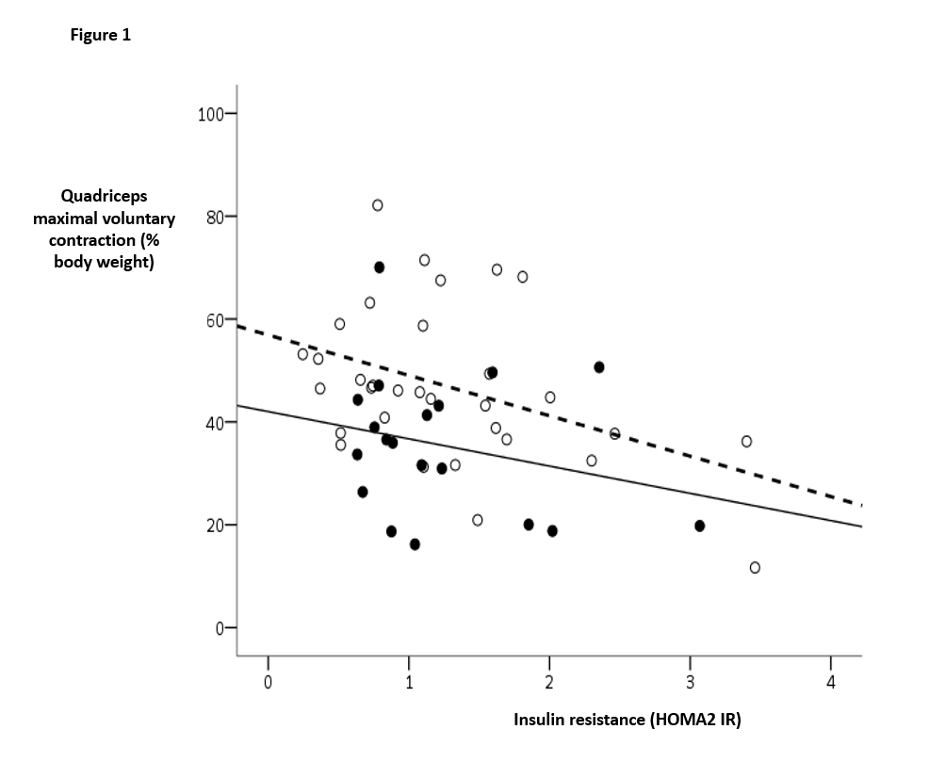
Regression plot, demonstrating the relationship between insulin resistance (HOMA2 IR) and quadriceps maximal voluntary contraction (QMVC, expressed as percentage body weight). Open circles and the dotted regression line represent men, filled circles and the continuous regression line represent women. HOMA2 IR was negatively correlated with QMVC after adjustment for age, sex and body weight (r=-0.446, p=0.002).

Figure 2. Insulin resistance is significantly greater in COPD patients with quadriceps weakness than in those without
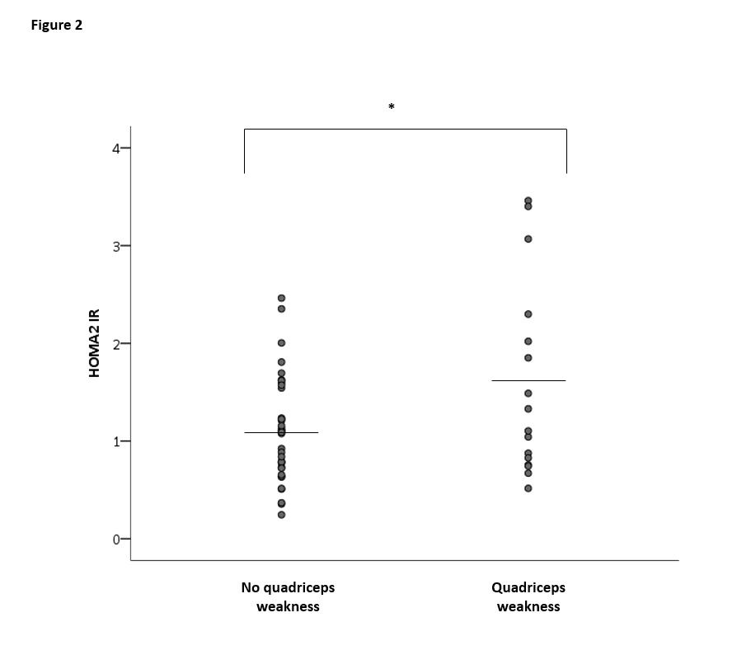

Dots indicate values for individual participants, bars indicate the mean value for the group. *p=0.032 (independent t test)

