Seeking the Optimal Relation between Oxygen Saturation and Hemoglobin Concentration in Adults with Cyanosis from Congenital Heart Disease

Craig S. Broberg MD ^{1,2}
Ananda R. Jayaweera PhD ¹
Gerhard P. Diller MD ²
Sanjay K. Prasad MD ²
Swee Lay Thein MD ³
Bridget E. Bax, PhD ⁴
John Burman MD ²
Michael A. Gatzoulis MD PhD ²

Affiliations:
¹ Adult Congenital Heart Disease Program, Oregon Health and Science University, Portland, Oregon
² Royal Brompton and Harefield NHS Trust, National Heart and Lung Institute, Imperial College, London, United Kingdom
³ Department of Haematological Medicine, Kings College London School of Medicine and Kings College Hospital, London, United Kingdom
⁴ Child Health, St. George’s University of London, United Kingdom

Locations where work was performed
Patients were recruited and seen at the Royal Brompton Hospital. Additional blood testing done at Kings College Hospital and St. George’s Hospital. Analysis performed at Oregon Health and Science University.

Running Title: Optimal hemoglobin in cyanosis

Corresponding Author:
Craig Broberg, MD
UHN 62, Division of Cardiology
3181 SW Sam Jackson Pk Rd
Portland, OR 97239
(503) 494-8750
Fax (503) 494-8550
brobergc@ohsu.edu

Word Count: 3,746

Abstract

In patients with cyanosis from congenital heart disease, erythropoiesis is governed by many factors that may alter the expected relation between oxygen saturation (O_{2sat}) and hemoglobin concentration. We sought to define the relation between O_{2sat} and hemoglobin in such patients and to predict an ideal hemoglobin concentration for a given O_{2sat.} Adults with congenital heart defects and cyanosis were studied prospectively with blood tests and exercise testing. Non-optimal hemoglobin was defined as any evidence of inadequate erythropoiesis; namely iron, folate, or B₁₂ deficiency, raised erythropoietin, reticulocytosis, or a right-shifted oxygen-hemoglobin curve. For patients without these factors, a linear regression equation of hemoglobin vs.O_{2sat} was used to predict the optimal hemoglobin for all patients. Of 65 patients studied, 21 met all pre-study criteria for optimal hemoglobin. For all patients there was no correlation between O_{2sat} and hemoglobin (r=-0.24), whereas there was a strong linear correlation for those meeting criteria for optimal hemoglobin (r=-0.888, p<0.001). The optimal hemoglobin regression equation was hemoglobin = 60.5- (0.474 x O_{2sat}). A negative correlation was found between the hemoglobin difference (predicted minus measured) and exercise duration on cardiopulmonary exercise testing (R = -0.402, p=0.007) and 6-minute walk distance (R=-0.478, p<0.001). In conclusion, a strong relation between O_{2sat} and hemoglobin concentration can be shown in stable cyanotic patients and used to predict an optimal hemoglobin. This relation may be useful in defining a functional anemia in this group.
Key Words: hypoxia, oxygen, heart defects, congenital, hemoglobin
Introduction
In the clinical care of cyanotic patients with congenital heart disease, there is a need to assess the appropriateness of a measured hemoglobin level for a given oxygen saturation (O_{2sat}). Although multiple factors may influence both the hemoglobin and the O_{2sat}, a tool to predict the optimal relation between hemoglobin and O_{2sat} would be valuable, particularly for situations where the hemoglobin may be significantly below expected such as post-operative states or following severe hemoptysis. We hypothesized that by controlling for factors that may alter this relationship, particularly those that may limit erythropoiesis such as iron deficiency, an ideal linear relation could be found. We further hypothesized that patients with an optimal hemoglobin may be clinically advantaged, as measured by exertional capacity. We therefore prospectively measured variables that could potentially alter the hemoglobin-O_{2sat} association in order to determine the their optimal relation.

Methods
We prospectively enrolled consecutive adults with congenital heart disease in a descriptive cross-sectional study. Patients were included if they had a known congenital defect with right to left shunt. We included patients with a wide range of O_{2sat}, including some previously repaired patients with normal oxygen saturations at the time of the study. The majority of patients had coexisting pulmonary hypertension (Eisenmenger physiology). Patients gave consent and the protocol was approved by institutional ethics review. All tests were obtained within a 24 hour period. Other data from this study have been previously reported.^{7,8}
O_{2sat} was measured via transcutaneous spectrometry in the finger after 5 minutes of rest in sitting position. All patients performed a 6 minute walk test, and distance walked was recorded in meters. Patients performed treadmill exercise with measured oxygen consumption (V_{O2}) and ventillatory efficiency (V_{e}/V_{CO2}), as previously described.⁸
Blood was drawn in the morning in a non-fasting state via a venous cannula in the antecubital region. All of the following were measured; hemoglobin concentration, packed cell volume, platelet count, basic serum chemistries, liver function tests, iron, ferritin, transferin saturation, red blood cell vitamin B₁₂, folate, thyroid stimulating hormone, and serum erythropoietin. Percent hypochromic cells and reticulocyte count were measured by automated coulter counter (Advia 120, Bayer, United Kingdom). P₅₀ of the O₂ -hemoglobin dissociation curve was also measured (Hem-O-Scan, American Instrument Company, Silver Spring, Maryland). Whole blood viscosity over a range of shear was measured using a rotational viscometer. Viscosity was then remeasured after the hematocrit was diluted to 45% using autologous serum.⁷
After collection of all data, we identified patients with any evidence of potentially inadequate or excessive erythropoiesis, based on at least one of the following a priori criteria: evidence of iron deficiency, B₁₂ or folate deficiency, elevated serum erythropoietin, reticulocytosis, hypochromia, or significant rightward shift of the O₂ -hemoglobin dissociation curve (details provided, Table 1). We also excluded patients based on various clinical criteria, including acute hospitalization, therapeutic phlebotomy within the last 6 months, or recent significant hemoptysis (requiring hospitalization). Patients with a patent ductus arteriosus and differential cyanosis were also excluded from the optimal category because of uncertainty of what the mean O_{2sat} would be. Patients using supplemental oxygen regularly were excluded because their O_{2sat} at room air may not accurately reflect their average daily saturation.
After exclusion of any patient who met the above criteria, a plot of O_{2sat} and measured hemoglobin was made. A linear relation was defined, together with confidence intervals around this relation. Based on the regression equation, values for the predicted hemoglobin were made and the difference between the predicted and measured hemoglobin was obtained (Hb_{difference}) for each patient. Clinical variables between patients with and without an optimal hemoglobin were compared using Student’s t-test, and correlations using Pearson’s coefficient. Data were expressed as mean ± SD, and p<0.05 was considered statistically significant. No adjustment was made for multiple comparisons.

Results
Sixty-five patients were studied (mean age 36 ± 12 years, 67% women). For the group, resting O_{2sat} was 81 ± 8%, hemoglobin 19.6 ± 2.9 g/dl, and hematocrit 60 ± 8%. The anatomical diagnoses are shown in Table 2. No patients were found to have significant renal, liver or thyroid dysfunction.
Of the patients studied, 44 met at least one criteria for exclusion, and the majority of them met more than one criteria (Table 1). Exclusions based on clinical grounds included 16 using supplemental oxygen, 8 with differential cyanosis, 10 with recent phlebotomy, and 2 with recent hemoptysis. The most common exclusion criterion was iron deficiency, many of whom met additional criteria associated with iron deficiency (such as phlebotomy, hemoptysis, P₅₀ shift, or erythropoietin elevation). After exclusions, 21 patients met all criteria for adequate erythropoiesis.
For the entire cohort, there was no significant relation between O_{2sat} and hemoglobin (r=-0.24, p=ns, Figure 1). In contrast, when patients with evidence of inadequate erythropoiesis were excluded, a strong linear relation was found (r=-0.888, p<0.001). The slope and intercept for the regression line defined a predicted optimal hemoglobin as:
Hb_{predicted} = – 0.474 (O_{2sat}) + 60.5
Hb_{predicted} for a given O_{2sat} including upper and lower confidence intervals were calculated (Table 3 and Figure 2).
In order to establish the clinical relevance of our predicted line, we sought correlations with functional parameters. Those with optimal hemoglobin had better 6-minute walk test distance (409 ± 117 vs. 337 ± 116 m, p=0.026) and treadmill exercise duration (7.32 ± 2.67 vs. 5.30 ± 2.20 min, p=0.007). Correlation coefficient values between Hb_{difference} and outcome variables are shown (Table 4). There was a significant inverse correlation with 6-minute walk distance (Figure 3) and exercise duration such that a larger difference (ie hemoglobin less than expected) was associated with poorer function. There was a similar but weaker relation with the Ve/V_{CO2} slope and heart rate reserve. These same variables did not correlate with measured hemoglobin (Figure 3, Table 4). Correlation with peak V_{O2} and percent of maximum predicted V_{O2} did not reach statistical significance. Blood viscosity was not different between optimal and non-optimal groups, even after adjustment for hematocrit (53 ± 9 vs. 48 ± 10 kPa/s respectively at high shear, p=0.31, and 4.36 ± 0.6 vs. 4.40 ± 1.0 kPa/s at low shear, p=0.91).

Discussion
The concept of determining an ideal set point for erythropoiesis in congenital heart disease with cyanosis is not new. An “optimal hematocrit” between oxygen delivery and hyperviscosity was studied decades ago,¹² although limited by the use of ex-vivo models.¹³ Few clinical studies address this relationship, largely only in children/adolescents.^{3,13} A linear relationship has been shown, though less steep than ours,¹³.^{4,14} There is a right-shift of the oxyhemoglobin dissociation curve in iron deficient children.¹⁵ We also previously reported a less steep relation in iron-replete adults with Eisenmenger.³ Our current study, by comparison, was more fastidious with exclusions, which accounts for the steeper slope and narrower confidence limits found. Hence, the present study shows a strong linear relationship between hemoglobin and O_{2sat} that clinically distinguishes patients based on exercise capacity. It can be simplified as:
Hb_{predicted} = 61 – (O_{2sat} / 2)
Because all patients with an O_{2sat} below 75% met criteria for being non-optimal, it is impossible to predict the optimal hemoglobin for such a patient. Extrapolation of our data would predict a very high hemoglobin, which may not be achievable without serious hyperviscosity. However, any patient with O_{2sat} < 70% is arguably not in a state of balanced erythropoiesis since this must reflect increased tissue oxygen extraction. The highest hemoglobin in our optimal group was 25 g/dl (packed cell volume 73%), in a stable patient. We previously reported no adverse effects of viscosity on exercise capacity in this population.⁷ Hyperviscosity and its related symptoms are likely far more complex than ex-vivo methods can measure, and very different at the capillary level in particular. Daily activity varies from patient to patient and will also affect the drive to erythropoiesis.
Presence of an optimal hemoglobin does not mean the patient is asymptomatic, since many factors contribute to symptomatology in this group. We do not address whether manipulation of hemoglobin levels to an “optimal” level as defined here has any impact on symptoms, exercise capacity, or prognosis, though we and others have shown improvement after treatment of iron deficiency in chronic cyanosis.^{16,17} Exercise capacity also has multiple determinants. The purpose of comparing exercise data here was solely to determine if the predictive formula had any functional relevance. Based on the fact that at least a component of exertional capacity correlated with hemoglobin difference but not hemoglobin concentration itself (Figure 3), the relation we defined seems to have clinical significance. We know of no other means of validating our results.
Other limitations deserve comment. As an initial exploration of this relation, we had no guidance on which factors would be most important. Gender differences were not considered as our study did not have a large enough sample size to justify a separate analysis of men vs. women. We did not study patients with Fontan physiology though often such patients are mildly cyanotic. We have no reason to suspect this relation would not be relevant to this group also, though this deserves further investigation. We do not think our prediction formula should be applied to other cyanotic conditions, such as lung disease, nor to children with congenital heart defects.

Support and Acknowledgments
The study was funded by the Clinical Research Committee, Royal Brompton Hospital. Dr. Broberg has received support from the Waring Trust through Royal Brompton Hospital and the Tartar Trust through Oregon Health and Science University. Professor Gatzoulis and the Royal Brompton Adult Congenital Heart Centre have received support from the British Heart Foundation, London, UK and unrestricted research funds from Actelion UK.

1. Wood P. The Eisenmenger syndrome or pulmonary hypertension with reversed central shunt. Br Med J 1958;2:701-709,755-762.
2. Rosove MH, Perloff JK, Hocking WG, Child JS, Canobbio MM, Skorton DJ. Chronic hypoxaemia and decompensated erythrocytosis in cyanotic congenital heart disease. Lancet 1986;2:313-5.
3. Diller GP, Dimopoulos K, Broberg CS, Kaya MG, Naghotra US, Uebing A, Harries C, Goktekin O, Gibbs JS, Gatzoulis MA. Presentation, survival prospects, and predictors of death in Eisenmenger syndrome: a combined retrospective and case-control study. Eur Heart J 2006;27:1737-42 (Epub 2006 Jun 22).
4. Gidding SS, Stockman JA, 3rd. Erythropoietin in cyanotic heart disease. Am Heart J 1988;116:128-32.
5. Tyndall MR, Teitel DF, Lutin WA, Clemons GK, Dallman PR. Serum erythropoietin levels in patients with congenital heart disease. J Pediatr 1987;110:538-44.
6. Torres A, Jr., Skender KM, Wohrley JD, Aldag JC, Raff GW, Bysani GK, Geiss DM. Pulse oximetry in children with congenital heart disease: effects of cardiopulmonary bypass and cyanosis. J Intensive Care Med 2004;19:229-34.
7. Broberg CS, Bax BE, Okonko DO, Rampling MW, Bayne S, Harries C, J. DS, Uebing A, Khan AA, Thein S, Gibbs JS, Burman J, Gatzoulis MA. Blood viscosity and its relation to iron deficiency, symptoms, and exercise capacity in adults with cyanotic congenital heart disease. J Am Coll Cardiol 2006;48:356-365.
8. Broberg CS, Ujita M, Prasad S, Li W, Rubens M, Bax BE, Davidson SJ, Bouzas B, Gibbs JS, Burman J, Gatzoulis MA. Pulmonary arterial thrombosis in eisenmenger syndrome is associated with biventricular dysfunction and decreased pulmonary flow velocity. J Am Coll Cardiol 2007;50:634-42.
9. Felker GM, Adams KF, Jr., Gattis WA, O'Connor CM. Anemia as a risk factor and therapeutic target in heart failure. J Am Coll Cardiol 2004;44:959-66.
10. Milligan DW, Roberts BE, Davies JA. Iron deficiency and whole blood viscosity in polycythaemia. Br J Haematol 1982;51:501-3.
11. Kontras SB, Bodenbender JG, Craenen J, Hosier DM. Hyperviscosity in congenital heart disease. J Pediatr 1970;76:214-20.
12. Crowell JW, Smith EE. Determinant of the optimal hematocrit. J Appl Physiol 1967;22:501-4.
13. Berman W, Jr., Wood SC, Yabek SM, Dillon T, Fripp RR, Burstein R. Systemic oxygen transport in patients with congenital heart disease. Circulation 1987;75:360-8.
14. Gidding SS, Bessel M, Liao YL. Determinants of hemoglobin concentration in cyanotic heart disease. Pediatr Cardiol 1990;11:121-5.
15. Gidding SS, Stockman JA, 3rd. Effect of iron deficiency on tissue oxygen delivery in cyanotic congenital heart disease. Am J Cardiol 1988;61:605-7.
16. Gaiha M, Sethi HP, Sudha R, Arora R, Acharya NR. A clinico-hematological study of iron deficiency anemia and its correlation with hyperviscosity symptoms in cyanotic congenital heart disease. Indian Heart J 1993;45:53-5.
17. Tay EL, Peset A, Papaphylactou M, Inuzuka R, Alonso-Gonzalez R, Giannakoulas G, Tzifa A, Goletto S, Broberg C, Dimopoulos K, Gatzoulis MA. Replacement therapy for iron deficiency improves exercise capacity and quality of life in patients with cyanotic congenital heart disease and/or the Eisenmenger syndrome. Int J Cardiol. [in press, Epub 2010 Jun 24.]

Figure Legends

Figure 1: Scatter plot for hemoglobin concentration vs. resting oxygen saturation. For the entire population, there was no significant relation between hemoglobin and oxygen saturation (dotted line). For patients meeting the criteria for adequate erythropoiesis, a strong linear relation was found (solid line). Regression equations for optimal patients and for all patients are shown.

Figure 2. Predicted O₂ saturation-hemoglobin relation. The relation is based on the regression slope obtained for optimal patients. Upper and lower confidence limits shown. Raw values provided in Table 3.

Figure 3: Correlations between hemoglobin and measured walk distance. Panel A. The relation between 6 minute walk distance and measured hemogloin was poor. Panel B The relation between 6 minute walk distance and predicted-measured hemoglobin was more significant. A negative hemoglobin difference indicated hemoglobin was higher than predicted.

TABLE 1
Variable | Cutoff | Normal Range | N excluded
Transferrin saturation | < 20% | 20 – 45 | 23
RBC Folate (mcg/l) | < 200 | 164 – 900 | 0
Vitamin B₁₂ (ng/l) | <180 | 180 – 900 | 1
Serum erythropoietin (IU/l) | >25 | Variable | 9
Reticulocyte count (%) | > 2 | < 2% | 9
Hypochromic cell count (%) | >6 | < 6% | 7
P₅₀ of the O₂-Hb dissociation curve (mmHg) | > 29 | 25 – 29 | 9

Table 1. Pre-study criteria for determination of adequate erythropoiesis. Patients who met all of these criteria were considered to have optimal hemoglobin. Number of patients excluded is also shown. Additional clinical exclusions are listed in the text. RBC = red blood cell.
TABLE 2
Diagnosis | N
Atrial septal defect | 4
Ventricular septal defect | 27
Atrioventricular septal defect | 8
Patent ductus arteriosus | 8
Truncus arteriosus | 6
Transposition of the great arteries | 5
Pulmonary atresia | 2
Other Complex | 5
Total | 65

Table 2: Study population by anatomical lesion. Number of patients with each defect are shown.
TABLE 3
Oxygen Saturation (%) | Predicted Hemoglobin (g/dl) | lower CI (g/dl) | upper CI (g/dl)
93 | 16.4 | 14.7 | 18.2
90 | 17.8 | 16.4 | 19.3
87 | 19.3 | 17.9 | 20.6
85 | 20.2 | 18.9 | 21.5
83 | 21.2 | 19.8 | 22.5
80 | 22.6 | 21.0 | 24.1
77 | 24.0 | 22.2 | 25.8
75 | 25.0 | 22.9 | 27.0
73 | 25.9 | 23.6 | 28.2

Table 3: Prediction of optimal hemoglobin for a given oxygen saturation. CI = 95% confidence limit.

TABLE 4
Functional Variables | Measured Hb |  | Hb difference
 |  |  | (Predicted - Measured)
 | R | P | R | P
Six-minute walk distance (m) | -0.061 | 0.652 | -0.478 | <0.001
Exercise Duration (minutes) | -0.195 | 0.203 | -0.402 | 0.007
Peak Oxygen Consumption (ml/kg/min) | -0.189 | 0.230 | -0.286 | 0.066
Ventilatory efficiency (Ve/VCO₂) slope | 0.145 | 0.359 | 0.319 | 0.039
Heart rate reserve (beats per minute) | -0.139 | 0.358 | -0.322 | 0.029

Table 4. Correlations between exercise parameters and hemoglobin. Correlations with measured hemoglobin were not significant, whereas correlation with hemoglobin difference were significant. The negative relationship indicates that patients with a larger difference (ie hemoglobin lower than expected) had poorer exercise capacity.

Figure 1

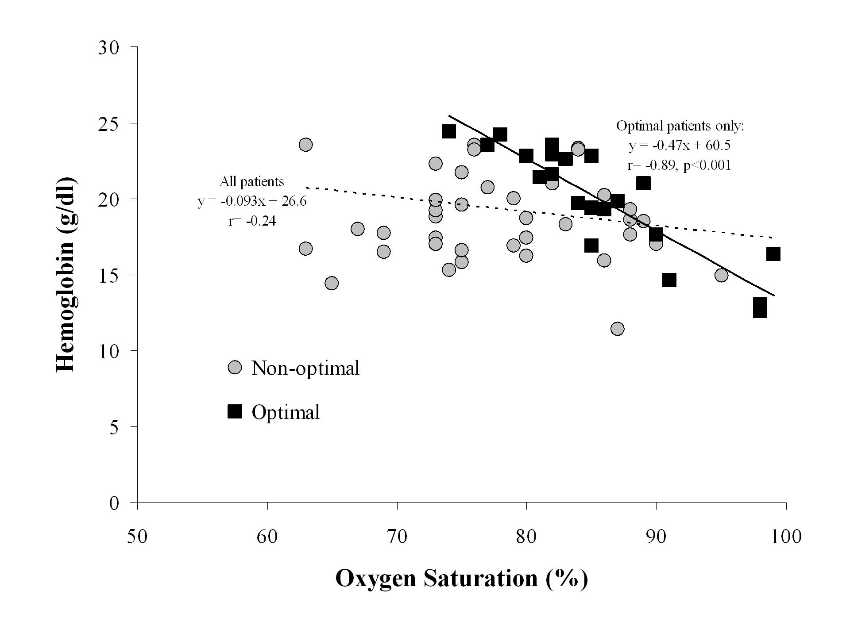
Figure 2
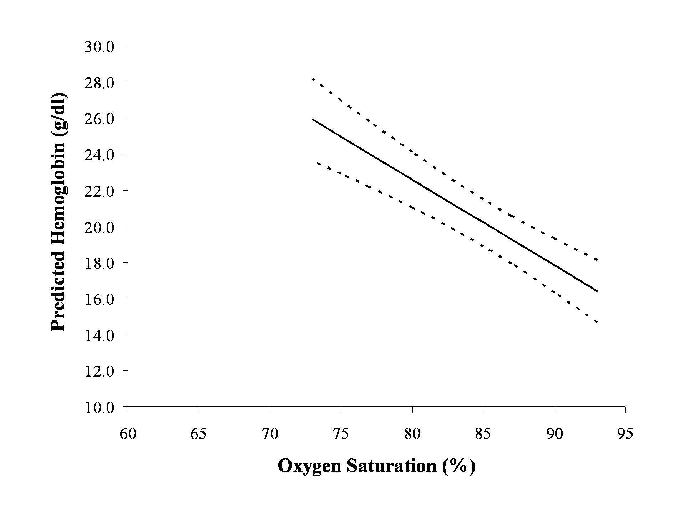
Figure 3
